Exercise 1 Look and write
bike – five apples – slide - Mike

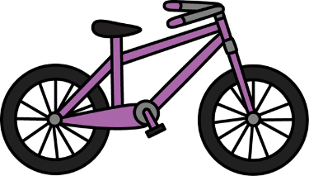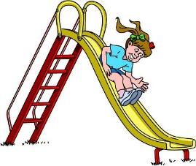

Exercise 2 Read and match
a) He is riding a bike. |  | 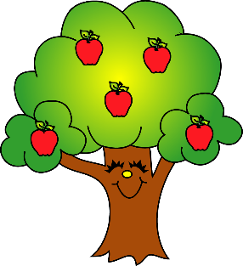
b) Five boys are playing on the slide. |  | 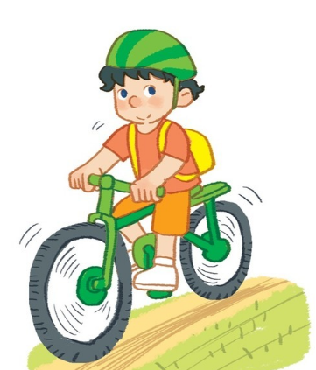
c) There are five apples on the tree. |  | 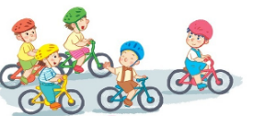
d) Five boys are riding bike. |  | 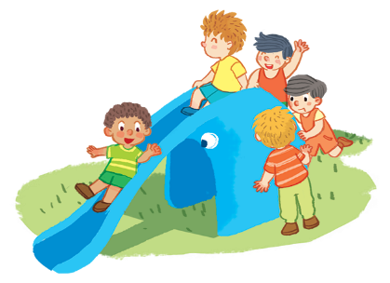
Exercise 3 Read and complete
five apples – bike – Mike – kite – five boys – nine – tie - like

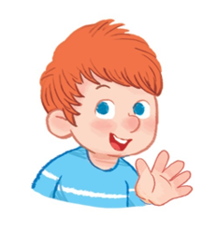
a) He is ……………………… b) There are …..…………on the plate.
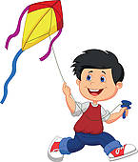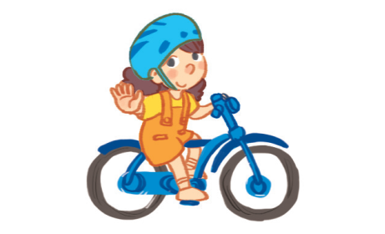
c) He is flying a …………………… d) She is riding a ……………………
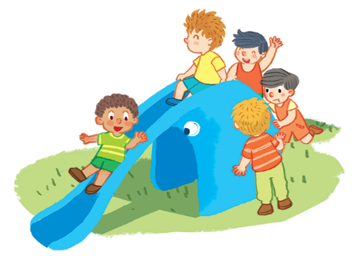
e) ………………are playing on the slide. f) It’s number ……………………
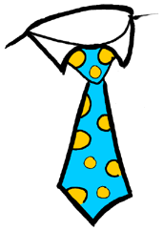
g) I ………………apples. h) It is a ……………………
Exercise 4 Put the words in the correct order
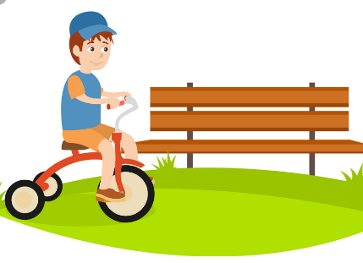 | a) riding – a bike – He – the park – around - is  ……………………………………………………………….
b) There – five apples – are – the tree – on

……………………………………………………………….

c) the – slide – Five boys – are – playing – on

……………………………………………………………….

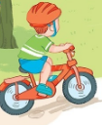 | d) Mike – a bike – is – riding  ……………………………………………………………….
 | e) a kite – flying – He – is  ……………………………………………………………….

Exercise 5 Find the word which has a different sound in the part underlined
a) bike | b) five | c) like | d) chips
a) lake | b) cake | c) game | d) hand
a) ride | b) slide | c) fish | d) Mike
a) plate | b) hat | c) lake | d) gate
a) box | b) mop | c) pot | d) son
a) Tim | b) nine | c) fish | d) milk
a) egg | b) hen | c) bed | d) tree
a) son | b) box | c) mother | d) honey
Exercise 6 Read and tick () or cross ()
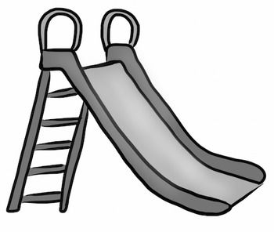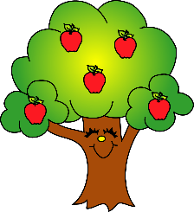
a) I can see a slide. b) There are five apples on the tree.
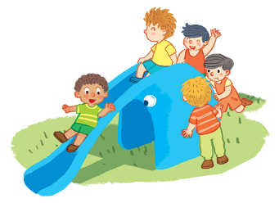
c) He’s flying a kite. d) Five boys are playing on the slide.
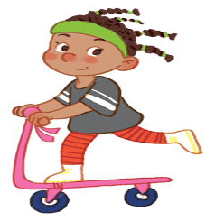
e) There are five apples. f) She’s riding a bike.

