Exercise 1 Look and write
beach – ice cream – tea - peach

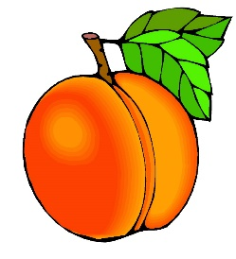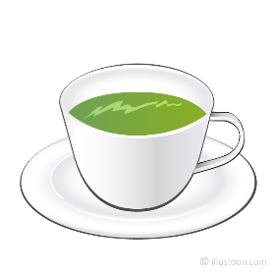

Exercise 2 Read and match
a) He’s eating an ice cream. |  | 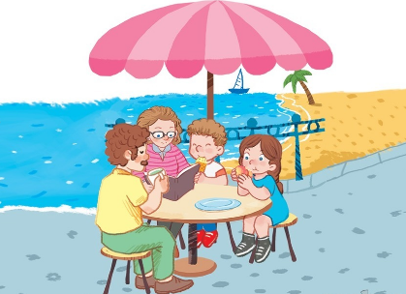
b) The family’s near the beach. |  | 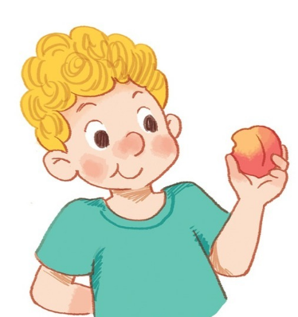
c) He’s eating a peach. |  | 
d) He’s drinking tea. |  | 

Exercise 3 Look and write
teachers – ice cream – tea – peaches – reading - eating

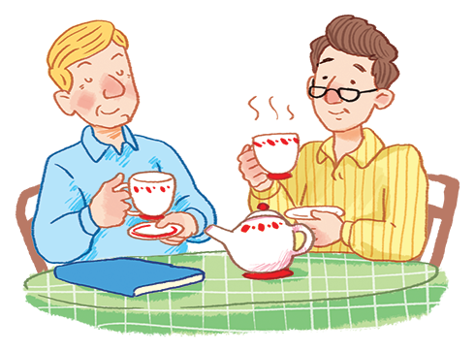
a) They are having …………….. b) They are having ……………..

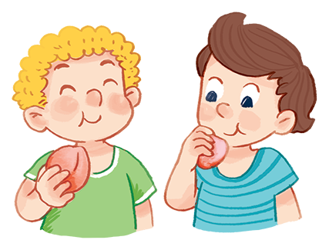
c) They are having …………….. d) They are ……………..

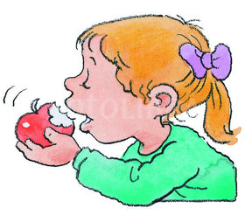
e) Three boys are ……………..books. f) She is …………….. an apple.
Exercise 4 Put the words in the correct order
 | 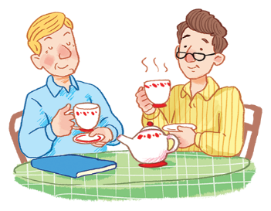 | 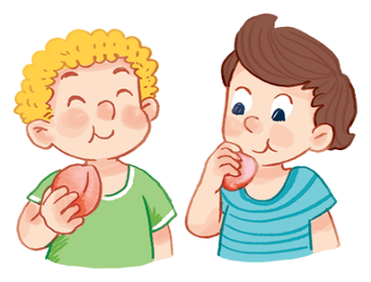
a) having – They – are – ice cream | b) having – They – tea - are | c) peaches – having – They - are
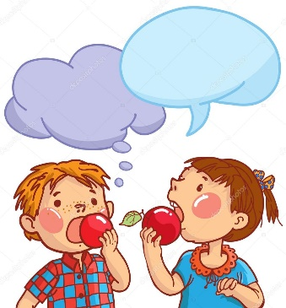 |  | 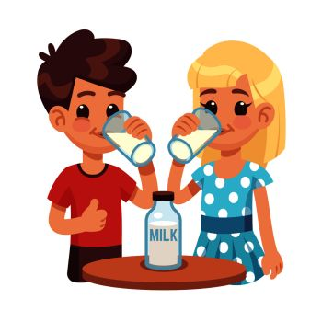
d) They – are – apples - having | e) They – are – rice - having | f) milk – They – having - are
Exercise 5 Read and write
He | She | They

a) ………………are having ice cream. b) ………………is having chips.

c) ………………are having peaches. d) ………………is having chips.
Exercise 6 Look and tick () or cross ()
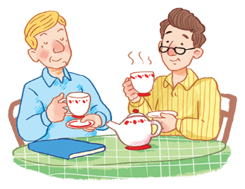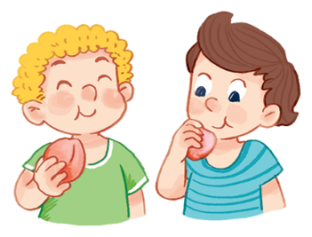
a) They are having ice cream. b) They are having peaches.
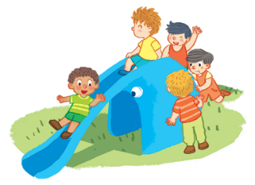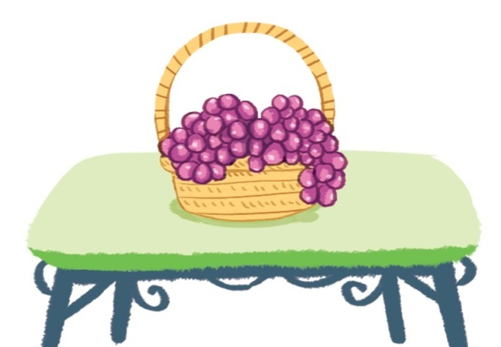
c)Five boys are riding bike. d) The grapes are under the table.
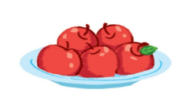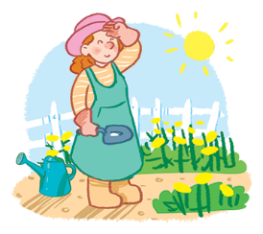
e) There are five apples on the plate. f) Can you see the mother ?
Exercise 7 Find the word which has a different sound in the part underlined
a) bike | b) five | c) milk | d) ride
a) beach | b) leaf | c) read | d) egg
a) head | b) bread | c) beach | d) ready
a) ice cream | b) teacher | c) read | d) bear
a) repeat | b) sail | c) tea | d) peach
a) Tim | b) nine | c) fish | d) milk
a) egg | b) hen | c) bed | d) tree

