Unit 6 At the breakfast table
Exercise 1 Look and write
head – breakfast – bread - sweater

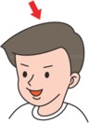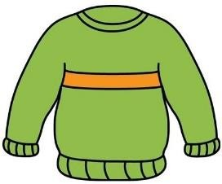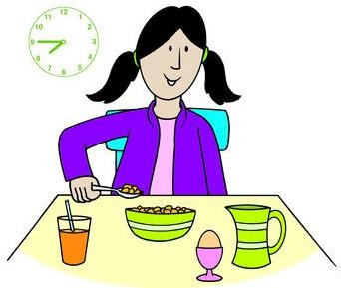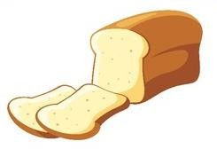

Exercise 2 Read and match
a) This is my head.
b) I have bread for breakfast.
c) The weather is sunny |  | 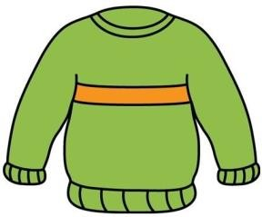
d) I have a sweater. |  | 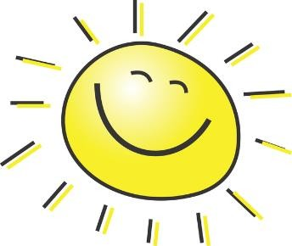
pg. 1

Unit 6 At the breakfast table
Exercise 3 Look and tick (✓) or cross (✗)

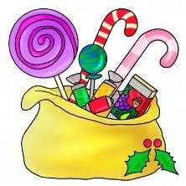
a) I like ice cream. b) I like sweets. c) I have sweaters.

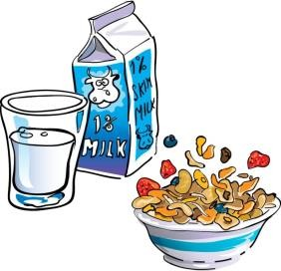
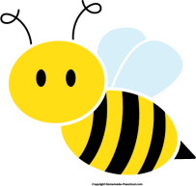

- It’s my breakfast.
- This is my head.
- I can draw a sheep.

Exercise 4 Read and complete

a) What do you have ? | b) What do you have ? | c) What is this ?
I have ………………. | I have a ……………. | This is my …………….
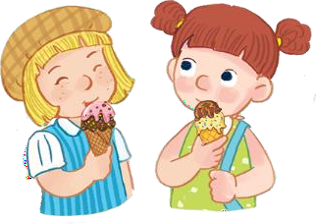

d) What do you like ? e) What is this ? f) What are they doing ?

I …………. sweets. It’s my ………………. They are eating ……………….

pg. 2

Unit 6 At the breakfast table
Exercise 5 Put the words in the correct order
 |  | 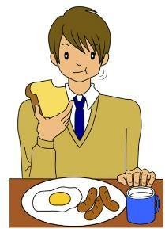
 | a) bread – have – I | b) breakfast – have – I | c) sweets – have - I
 | ……………………………………. | ……………………………………. | ……………………………………
 |  | 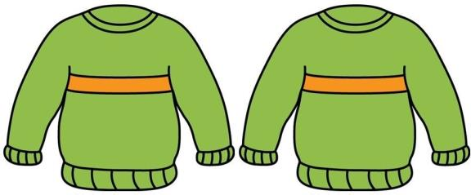 | 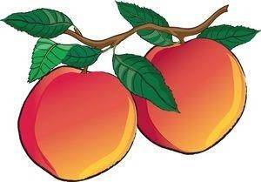
 | d) This – head – is - my | e) We – sweaters – have | f) peaches – I - have
 | ……………………………………. | …………………………………… | ……………………………………
Exercise 6 Find the word which has a different sound in the part underlined
a) head b) sweater c) bread d) bee

a) bed b) leg c) feet d) head

a) bread b) see c) tree d) queen

a) ice cream b) teacher c) read d) bear
a) red b) ten c) sheep d) sweater

a) lake b) cake c) game d) bag

a) teacher b) hen c) bed d) head

a) feet b) tree c) bread d) street

a) hot b) honey c) box d) mop

pg. 3

Unit 6 At the breakfast table
Exercise 7 Look and circle the best answer
0.This is my ………. 1. I have ……….

head b. face c. feet a. sweets b. cakes c. bread
a.
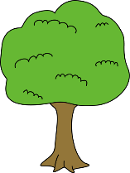

2 .I have a………. 3. I can draw a ……….
a. coat b. sweater c. T- shirt a. lemon b. tree c. apple
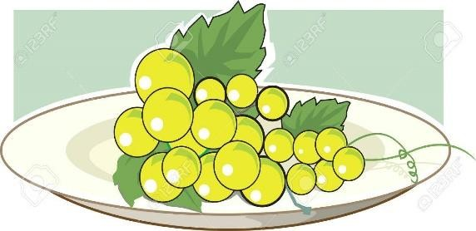
- My sister likes ………. 5. I have ……………….

a. apples b. bread c. sweets a. apples b. peaches c. grapes

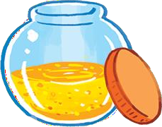
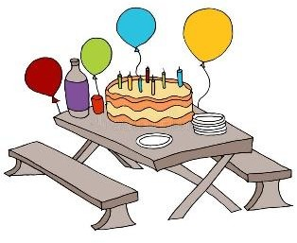

- Can you see the ……….? 7. The cake is on the……….

a. sweets b. honey c. peach a. chair b. bag c. table

pg. 4

