Exercise 1 Look and write
boat – couch - boat - coast

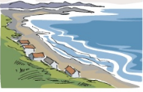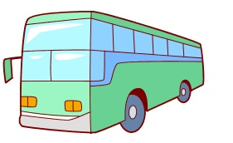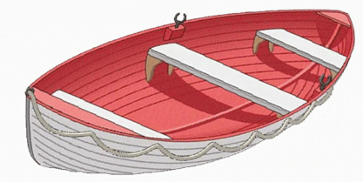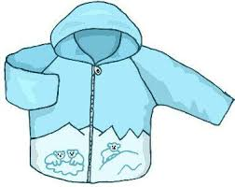

Exercise 2 Read and match
a) I can see the coach.
b) I have a coat.
c) I can see the coast.
d) I have a boat.

Exercise 3 Look and tick () or cross ()
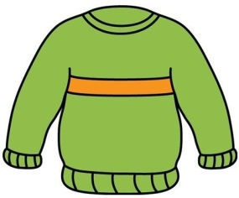
a) I have a car. b) I have a coat. c) I have a sweater.
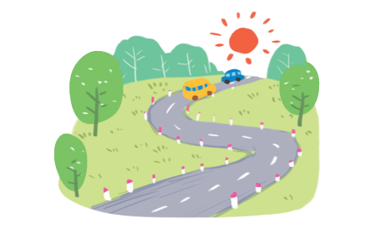
d) I can see the coach. e) I can see a boat. f) I can see a road.
Exercise 4 Read and complete
a) What can you see ? b) What can you see? c) What do you have ?
I can see the…………. I can see ………………. I have a……………….
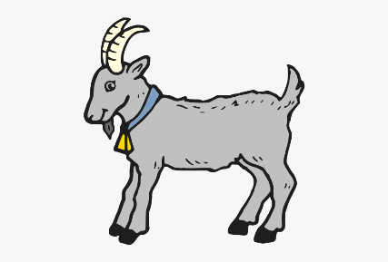
d) What do you have ? e) What can you see ? f) What can you see ?
I …………. a coat. I can …………. a road. I can see a ………………
Exercise 5 Put the words in the correct order
a) the – coast – can – see- I | b) boat – a - have – I | c) see – can – a goat – I
……………………………………. | ……………………………………. | ……………………………………
d) coach – the – I – see - can | e) I – see – a – road - can | f) I – blue – coat – have - a
……………………………………. | …………………………………… | ……………………………………
Exercise 6 Find the word which has a different sound in the part underlined
a) road | b) box | c) boat | d) coat
a) plate | b) cake | c) plate | d) coach
a) pig | b) bike | c) kite | d) five
a) gate | b) face | c) peach | d) lake
a) milk | b) chip | c) fish | d) nine
a) green | b) sweater | c) tree | d) feet
a) bread | b) weather | c) breakfast | d) beach
a) head | b) read | c) peach | d) leaf
a) hot | b) honey | c) box | d) mop
Exercise 7 Look and circle the best answer

0.The ………… is nice. 1. Let’s go on a …………
a. weather b. sweater a. coat b. coast c. coach
2 .Let’s go to the ………… 3. I have a …………
a. coach b. coast c. boat a. boat b. car c. bike
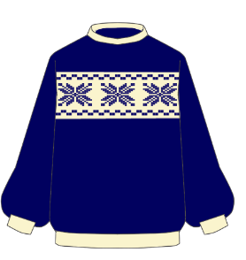
4. This is my ………….. 5. I have a blue ……………….
a. dress b. sweater c. coat a. sweater b. coat c. shirt
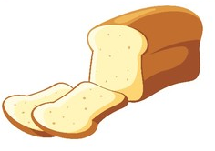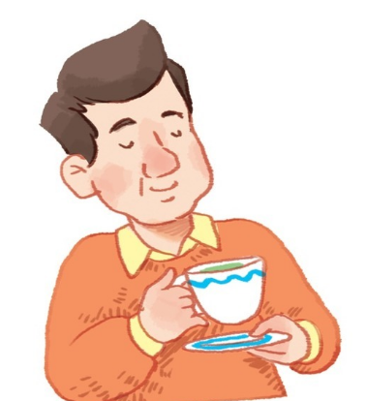
6. My favourite food is ………………. 7. He’s drinking……………….
a. sweets b. bread c. peach a. milk b. tea

