Exercise 1 Look and write
scooter – balloon – school - food

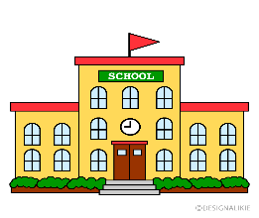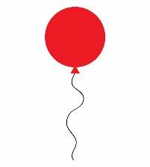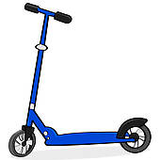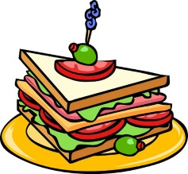

Exercise 2 Read and match
a) He’s holding a balloon.
b) This is my school. |  | 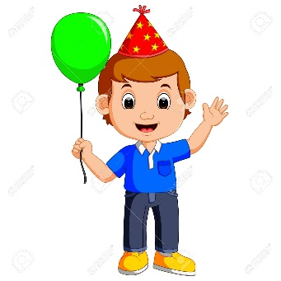
c) He’s riding a scooter. |  | 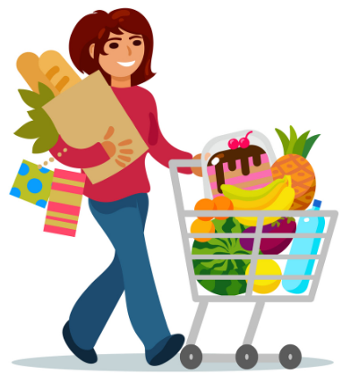
d) She’s buying food. |  | 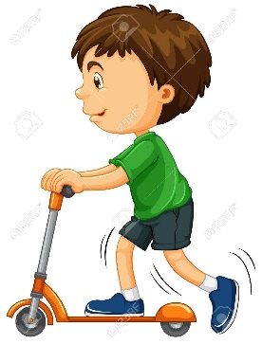

Exercise 3 Look and tick () or cross ()
a) He’s holding a ball. b) She’s buying food. c) He’s riding a bike.
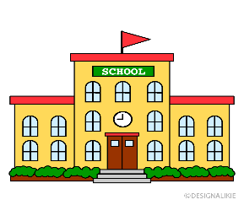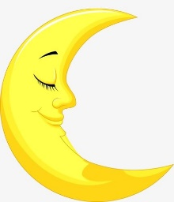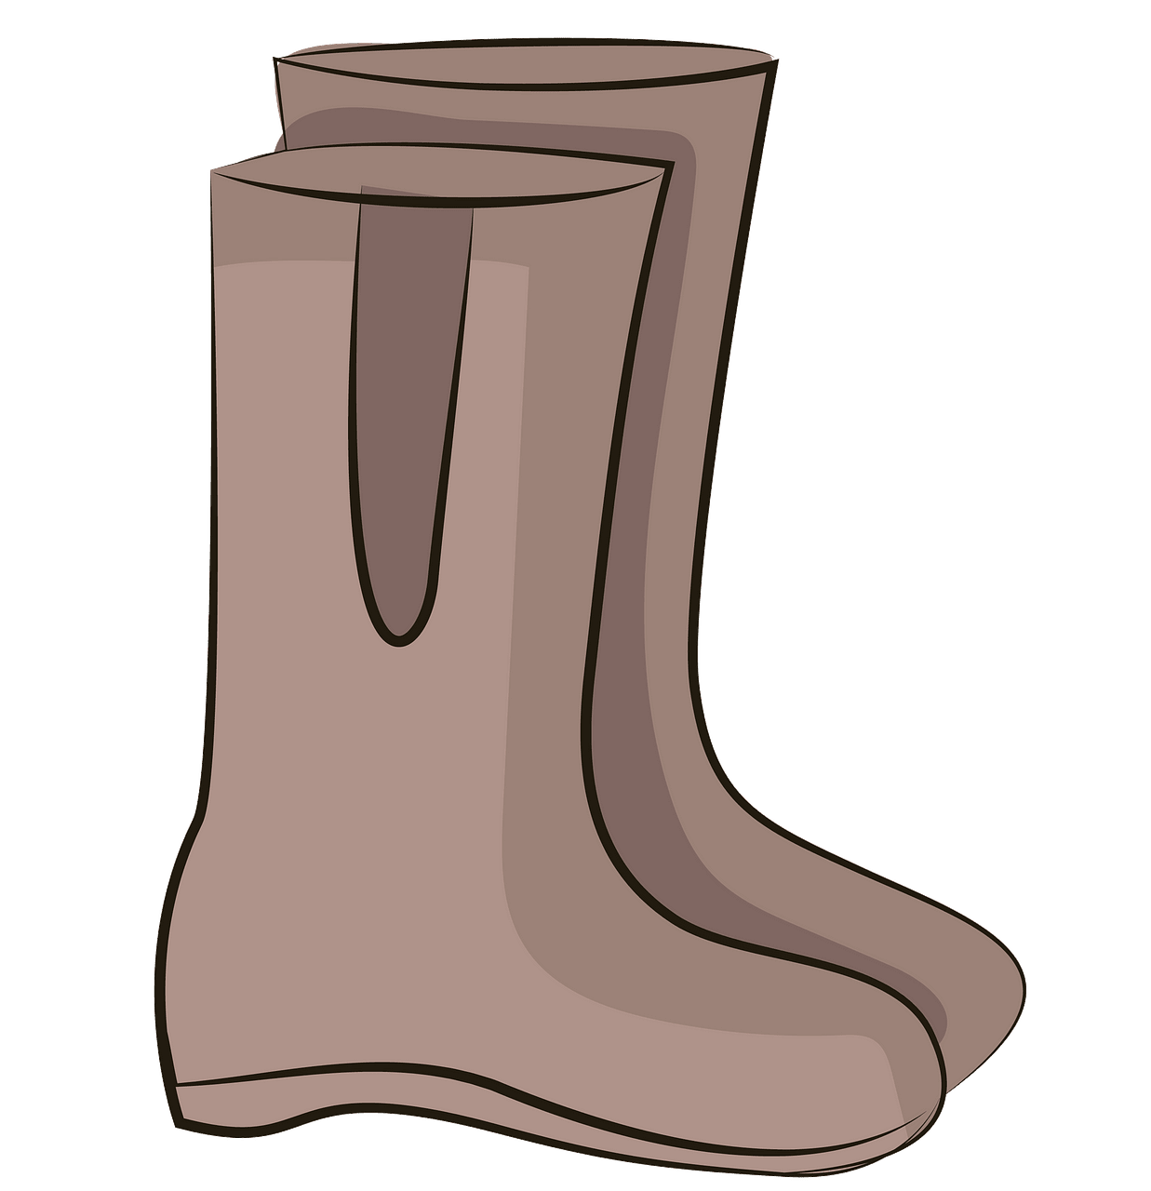
d)This is my school. e) I can see the moon. f) I like my boots.
Exercise 4 Read and complete
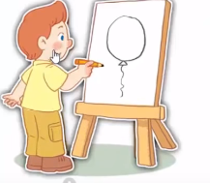
a) She’s………..a balloon. b) He’s holding a………… c) He’s …………a scooter.
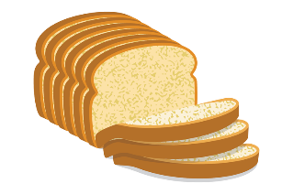
d) This is my………….. e) I can see the ………… f) My favorite food is …………
Exercise 5 Put the words in the correct order
a) He – drawing – is – balloon - a | b) a school – I – see - can | c) see – can – the - moon – I
……………………………………. | ……………………………………. | ……………………………………
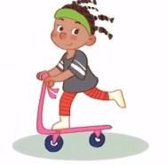 | 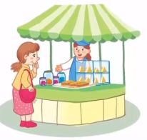 | 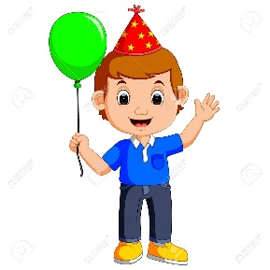
d) scooter – is – She – riding - a | e) buying – food – She - is | f) holding – He’s – a - balloon
……………………………………. | …………………………………… | ……………………………………
Exercise 6 Find the word which has a different sound in the part underlined
a) road | b) scooter | c) moon | d) balloon
a) food | b) good | c) boots | d) mop
a) school | b) moon | c) coast | d) scooter
a) gate | b) face | c) peach | d) lake
a) mop | b) box | c) bottle | d) food
a) green | b) sweater | c) tree | d) feet
a) bread | b) weather | c) breakfast | d) beach
a) like | b) bike | c) milk | d) Mike
a) coast | b) coach | c) coat | d) school
Exercise 7 Look and circle the best answer
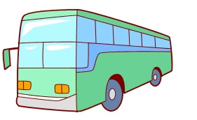
0.He’s drawing a ………… 1. Let’s go on a …………
a. balloon b. ball c. car a. coat b. coast c. coach
2. She’s riding a ………… 3. …………is buying food.
a. coach b. scooter c. bike a. He b. They c. She
4. He is………… a balloon. 5. I can see the …………
a. holding b. riding c. drawing a. star b. moon c. school
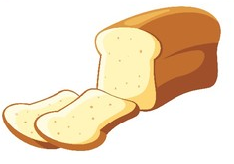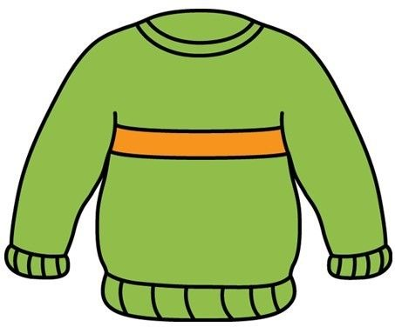
6. My favourite food is ………………. 7. I have a …………
a. sweets b. bread c. peach a. coat b. sweater c. gloves

