Exercise 1 Look and write
mouse – trousers – house – blouse - clouds

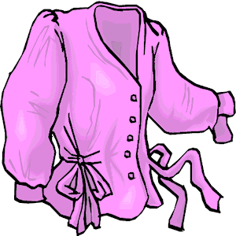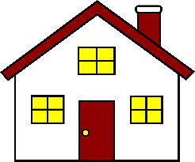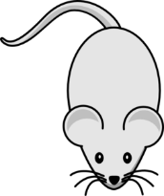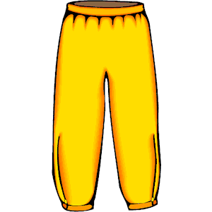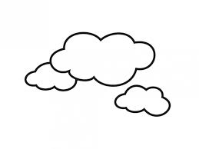

Exercise 2 Read and match
a) Look at the trousers .
b) Look at the house.
c) We can see clouds in the sky.
d) Look at the blouse.
e) Look at the mouse.

Exercise 3 Look and tick () or cross ()
a) Look at the sweater. b) Look at the blouse. c) This is my house.
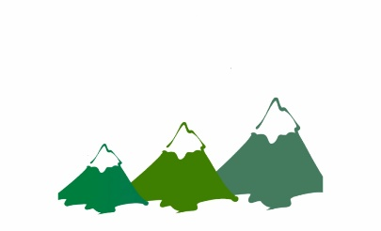
d)Look at the monkey. e) We can see moutains. f) We can see clouds.
Exercise 4 Read and complete
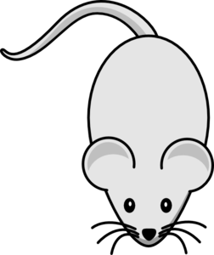
a) It ………..a mouse. b) Look at the ………… c) These are my …………
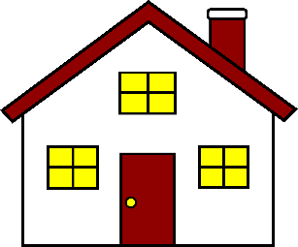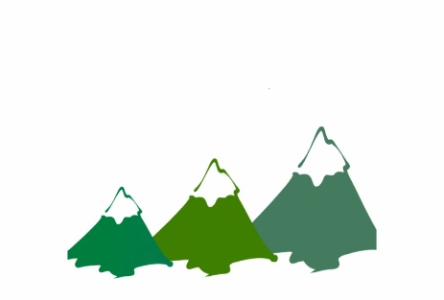
d) This is my………….. e) We can see ………… f) We can see …………

Exercise 5 Put the words in the correct order
 |  | 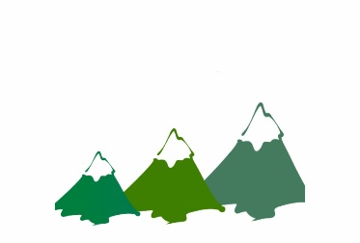
a) the – mouse – at - Look | b) Look – house – the - at | c) see – We – moutains - can
……………………………………. | ……………………………………. | ……………………………………
d) blouse – Look – the - at | e) trousers – at – the - Look | f) We – see – can - clouds
……………………………………. | …………………………………… | ……………………………………
Exercise 6 Find the word which has a different sound in the part underlined
a) school | b) scooter | c) blouse | d) balloon
a) food | b) good | c) boots | d) trousers
a) school | b) moon | c) coast | d) scooter
a) blouse | b) mouse | c) clouds | d) coach
a) lake | b) cake | c) gate | d) peach
a) sheep | b) head | c) see | d) feet
a) bread | b) weather | c) breakfast | d) beach
a) coach | b) boat | c) coast | d) cloud
a) like | b) kite | c) chips | d) bike
Exercise 7 Look and circle the best answer
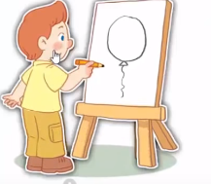
0.He’s drawing a ………… 1. Look at the …………
a. balloon b. ball c. car a. coat b. sweater c. trousers
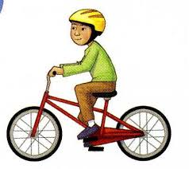
2. He’s riding a ………… 3. Look at the …………
a. coach b. scooter c. bike a. sweater b. blouse c. coat
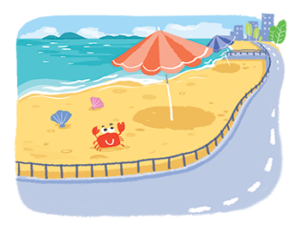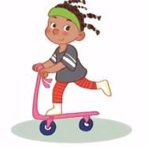
4. I can see the………….… 5. …………is riding a scooter
a. coach b. coast c. coat a. he b. she c. they
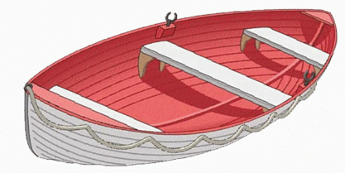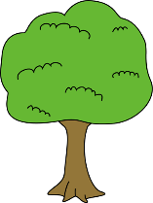
6. I have a ………….… 7. I can draw a ………….…
a. boat b. car c. bike a. flower b. tree c. bee

