UNIT 16

WORKSHEET

Reading and writing
1. Look and complete.
  1. g __ __ __ __ __ __ __ |   2. d __ __ |   3. c __ __
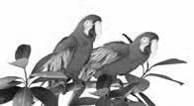  4. p __ __ __ __ __ | 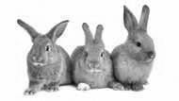  5. r __ __ __ __ __ | 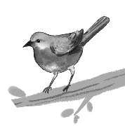  6. b __ __ __

2. Read and match. Then write the answers.
  1.  I have a pet. Its favourite food is fish. What is it?  It’s a ______________. | a.  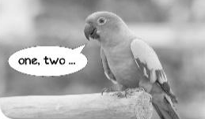
  2.  I have a pet. It can speak English. What is it?  It’s a ______________. | 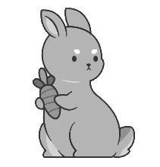  b.
3.  I have a pet. It has long ears. What is it?    It’s a ______________. | c.  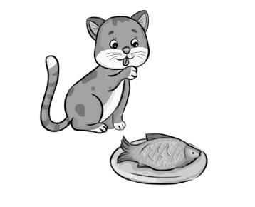

Key:
1.
1. goldfish 2. dogs 3. cats 4. parrots 5. rabbits 6. bird
2.
1. It’s a cat. – c 2. It’s a parrot. – a 3. It’s a rabbit. – b

