UNIT 19

worksheet

1. Read and circle a, b or c.
 | 1. a. He’s skipping.  b. He’s running.  c. He’s walking.
 | 2. a. She’s skipping.  b. She’s painting.  c. She’s skating.
 | 3. a. She’s cycling.  b. She’s skipping.  c. She’s running.
2. Look and write.
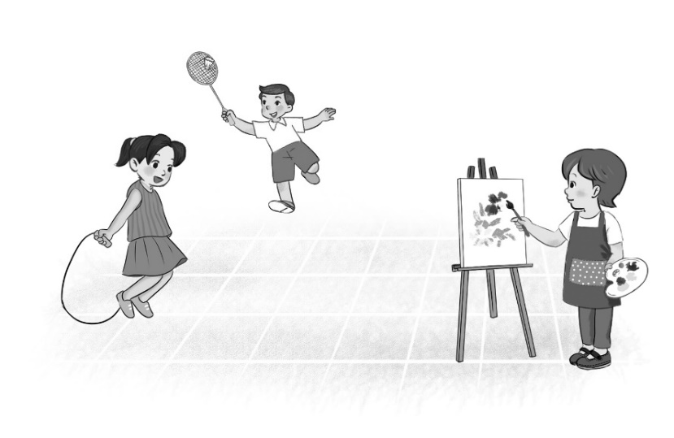
1. What’s Mai doing?
She’s ______________________________________________________.
2. What’s Nam doing?
He’s ______________________________________________________.
3. What’s Lucy doing?
__________________________________________________________.

Key:
1.
1. b 2. a 3. a
2.
1. skipping 2. playing badminton 3. She’s painting

