UNIT 6

worksheet

1. Complete the words.
SCHOOL

  1. art __ __ __ __ 󠄀 |   2. class__ __ __ __ 󠄀 |  |   3. computer  __ __ __ __ 󠄀 |  | 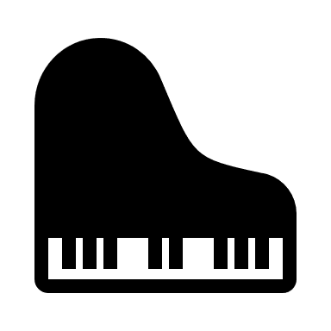  4. music __ __ __ __
  5. __ __ __ __ __ __ __ 󠄀 |  | 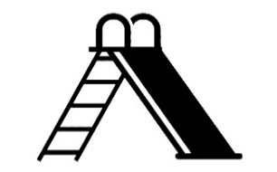  6. __ __ __ __ __ __ __ __ __ __ 󠄀 |  |   7. __ __ __

2. Let’s talk.
Ask your friend Let’s go to the ______. Write their name and the place(s) they want to go.
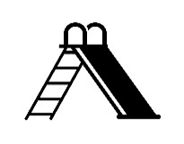

Friend 1  Minh | Friend 2  ______ | Friend 3  ______ | Friend 4  ______ | Friend 5  ______ | Friend 6  ______
music room | ______ | ______ | ______ | ______ | ______

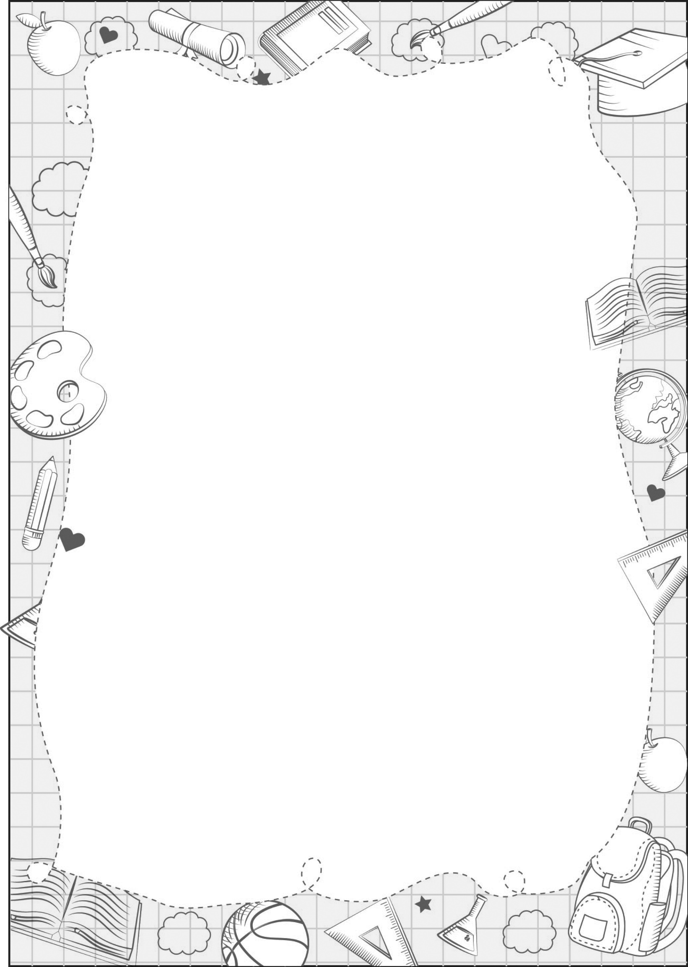
art room, classroom, computer room, gym, library, music room, playground, school
Is this our ____? - Yes, it is./ No, it isn’t.
Let’s go to the _______. - OK, let’s go.

