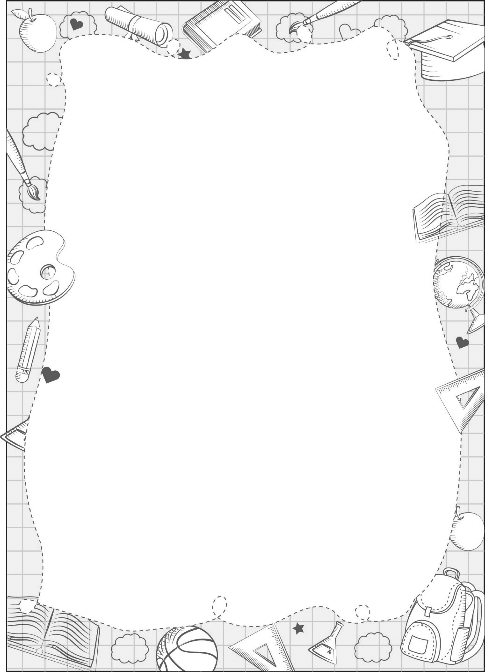
UNIT 9

worksheet

Listen and colour.

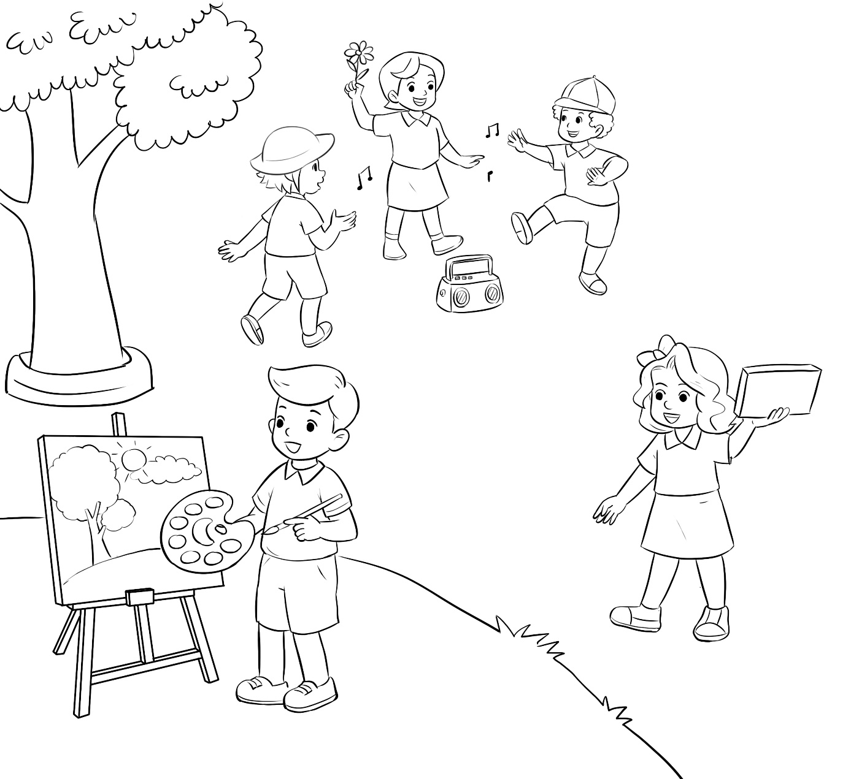

Audio script:
Listen and colour.
Hello, I’m Mai. Let’s go to the playground with me. Linh, Lucy and Bill are dancing. Linh is wearing a hat. It’s orange. Colour the hat orange. Mary has a new book. It’s yellow. Nam has a beautiful painting. Colour the sun red and the tree green.

Key:
orange hat – yellow book – red sun – green tree

