Name: ...............................................TEST¹⁶ Date: Thursday, December 07, 2017
Class:4^{A1} Mrs. Dung Phone: 01664.409.436
I. LISTENING
Task 1. Listen and tick . There is one example.

Example: | 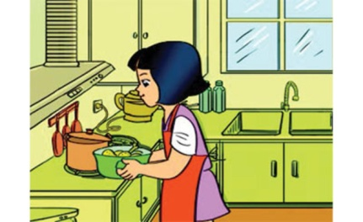 | 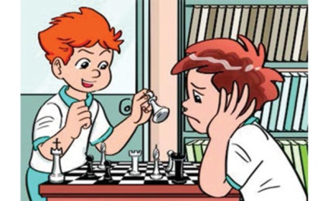
 | A. | B. 

1.
  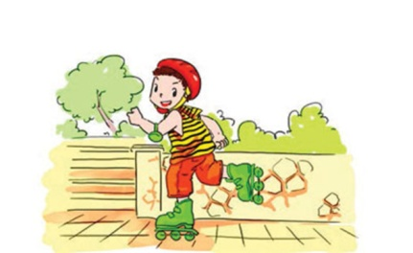 | 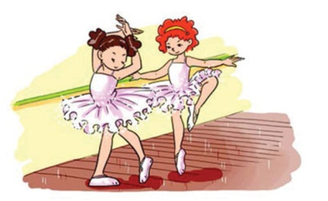
  A. | B.
2.
  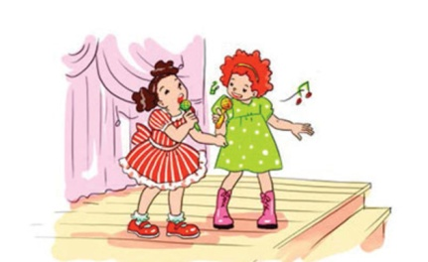 | 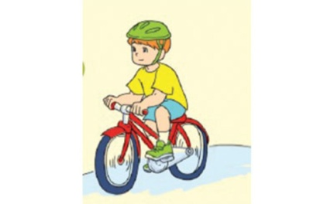
  A. | B.
3.
  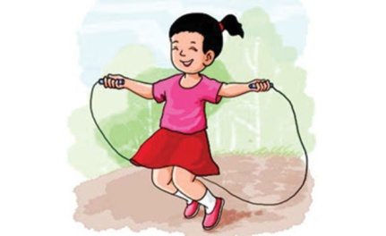 | 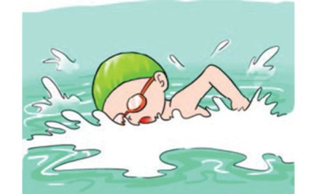
  A. | B.
4.
  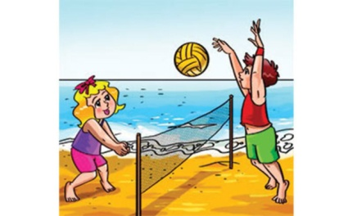 | 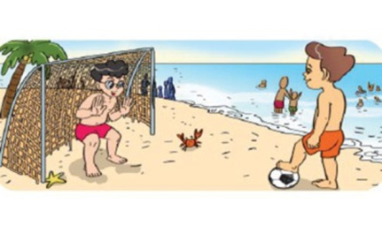
  A. | B.
5.
  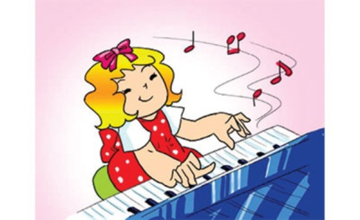 | 
  A. | B.
Task 2. Listen and tick or cross . There are two examples.

Examples: | 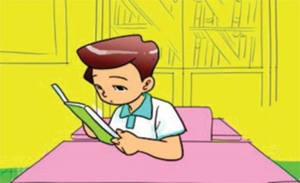 | 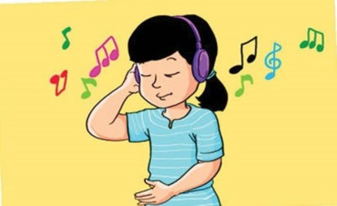
 | A. | B.

  1.
  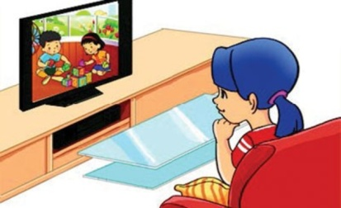
  2.
  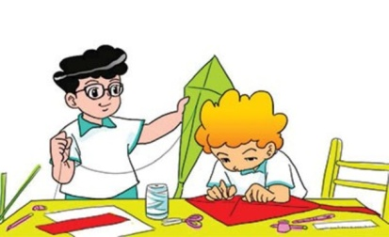
  3.
  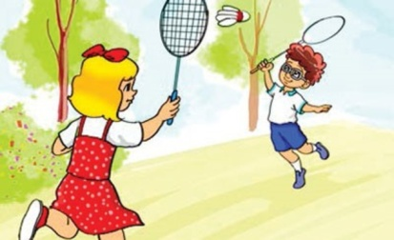
  4.
  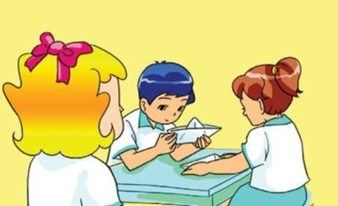
  5.
  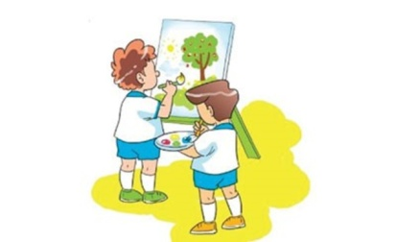
Task 3. Listen and write YES or NO. There is one example (0).

0. Tommy’s from Trung Vuong Primary School.
  YES

1. He’s in Class 4B. | _______
2. He has Music and Science on Thursdays. | _______
3. The teacher is singing in Music class now. | _______
4. Tommy played volleyball in PE class. | _______
5. Yesterday was Monday. | _______
II. READING AND WRITING
Task 1. Look and write. There is one example.

Example: | adecn → d a n c e | 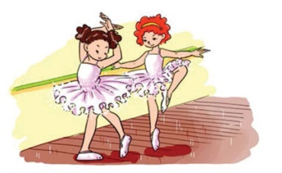

  1. msiw → _ _ _ _ | 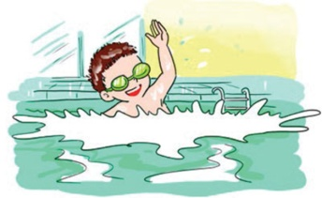
  2. gsin →_ _ _ _ | 
  3. koco → _ _ _ _ | 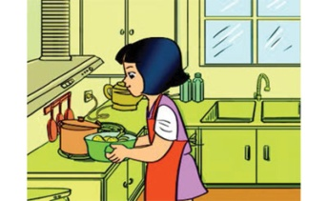
  4. wdar → _ _ _ _ | 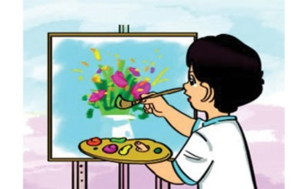
5. ksaet → _ _ _ _ _ | 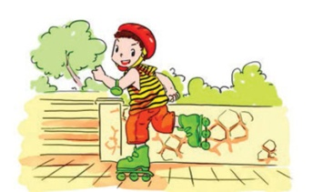

Task 2. Read and tick or cross . There are two examples.

 | I have English today. | I have Maths today.
Examples: | 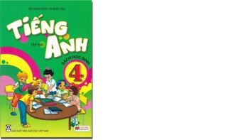 | 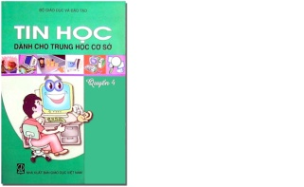
 | A. | B.

1. | Mai has Vietnamese, English and Art today. | 2. | Nam has Music, Vietnamese and Science today. | 3. | Mary has Maths on Monday, Thursday and Friday.
 | 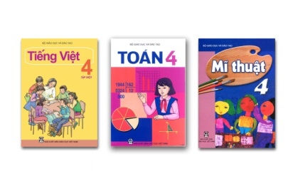 |  | 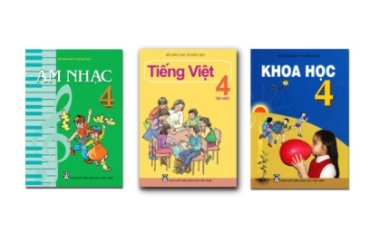 |  | 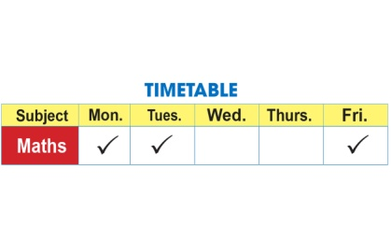
4. | Peter has PE on Wednesday and Friday. | 5. | Sam has IT on Monday and Thursday.
 | 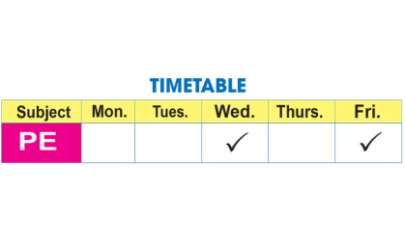 |  | 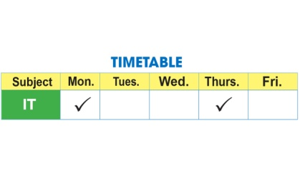
Task 3. Read this. Select a word from the box to fill each gap. There is one example.

(0) Hello, I’m Mimi from Mayan Primary School. It’s (1)________ today. I’m in class now. We have Art and (2) _______ today . We are surfing the (3)_______ for our IT project. Yesterday was Sunday. I was not at school. I had a (4) _________ party with a lot of classmates. We had lots of fun. We had a big birthday cake. We watched videos, listened to music and (5)_______.
  Hello | 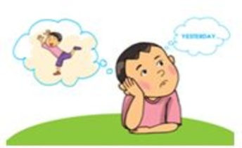  danced | 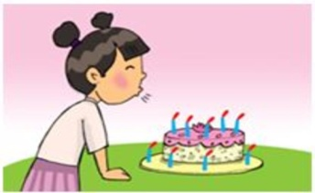  birthday
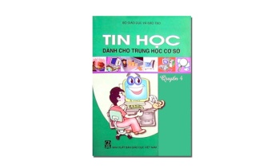  IT |   Internet | 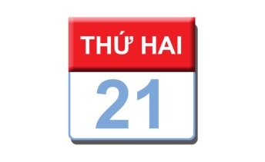  Monday

Đáp án
I. LISTENING
Task 1. Listen and tick . There is one example.
1. A 2. A 3. B 4. A 5. B
Task 2. Listen and tick or cross . There are two examples.
1. 2. 3. 4. 5.
Task 3. Listen and write YES or NO. There is one example (0).
1. YES 2. NO 3. NO 4. YES 5. YES
II. READING AND WRITING
Task 1. Look and write. There is one example.
1. swim 2. sing 3. cook 4. draw 5. skate
Task 2. Read and tick or cross . There are two examples.
1. 2. 3. 4. 5.
Task 3. Read this. Select a word from the box to fill each gap. There is one example.
1. Monday 2. IT 3. Internet 4. birthday 5. danced

