

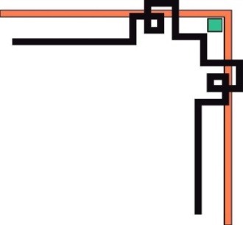
NGUYEN LAN SECONDARY SCHOOL



LESSON PLAN ENGLISH 7
Teacher: Vũ Thị Thu Giang

Date of planning: 5/4/2023  Date of teaching: 7/4/2023  Week: 29 | UNIT 8: FESTIVALS AROUND THE WORLD  Period 86- Lesson 8.2: Grammar
I. OBJECTIVES:
By the end of the lesson, Ss will be able to:
1. Knowledge:
* Grammar:
- Identify and understand how to use adjectives ending in -ing and -ed.
- Use adjectives ending in -ing and -ed to describe festivals and reactions to festivals.
2. Competence:
- General competences: form and / or improve such competencies as group work, independent working, pair work, linguistic competence, and cooperative learning.
- Specific competences:
- Improve communicative competence related to the use of language (vocabulary, phonetics, grammar):
- For a language lesson: Ss are expected to use vocabulary about festivals and understand the main grammatical points, then do the tasks assigned in the textbook.
- For a skills lesson: Ss are expected to use adjectives ending in -ing and -ed to describe festivals and reactions to festivals.
3. Quality / behavior:
- Being hard-working and attentive in class.
- Have a positive attitude towards the lesson.
II. TEACHING AIDS:
- Grade 7 textbook, Unit 8 (SB p. 82)
- Computer (connected to the Internet is the best)- Projector / TV/ PPT slides / Active teach )
III. PROCEDURE:

1. WARM UP (5’)
* Aims:
- To activate students’ prior knowledge and get students involved in the lesson.
- To set the context for introducing new structures.
* Content: Play game to get Ss involved in the lesson and to set the context for the lesson.
* Outcome: Ss know the context of the lesson.
* Organisation: T-Ss, Ss-T
Teacher’s and Student’s activities | Content
Game  - T divides Ss into 2 teams and guess the name of the festival.  - T asks some questions:  Are you interested in these festivals?  Why?  - T write on the board: I am interested in these festivals because these festivals are interesting.  - T asks Ss to give comment about two adjectives: interested / interesting  - T sets the scene for the new lesson: T tells Ss that they are going to learn about adjectives ending in -ed and -ing.  - T writes the title on the board: Unit 8: Festivals around the world  Lesson 8.2: Grammar | Game rules:  - There are 6 questions with picture  - Guess the name of the festival  - 1 correct answer = 1 point.  - The root of them is the same but the ending is different.
2. PRESENTATION (4’)
VOCABULARY
* Aims: Get to know some new words
* Content: Ss read the results of a survey.
* Outcome: Know new words
* Organisation : T-Ss, Ss-T.
Teacher’s and Student’s activities | Content
- T introduces some vocabulary by showing pictures.  - SS look at the pictures and guess the meaning of the words.  - SS repeat the words individual and in chorus.  - Ss write down.  * Check vocab: Matching | * New words  - monument (n): đài tưởng niệm  - custom(n): phong tục  - conduct (v): tiến hành  - historical site (n): di tích lịch sử
2. PRESENTATION (14’)
GRAMMAR
* Aims:
- To lead into and introduce the Grammar Box
- To provide Ss with chances to practice the form of adjectives
* Content:
- Ss study the Grammar Box to complete the exercise.
* Outcome: Ss learn about adjectives ending with -ing and -ed in contexts.
* Organisation: T-Ss, Ss-T, Group work.
Teacher’s Student’s activities |  |  | Content
Exercise 1,2 – SB p.82  Read the results of a survey from 500 teenagers around the world. Do you find any of these surprising?  - T asks Ss to read the text and the table, invites some students to share the things that they find surprising.  - T asks Ss to pay attention to the blue words and list adjectives ending in -ing and -ed.  - T asks some questions to direct Ss to figure out the rule of adjectives ending in -ing and -ed such as:  Who is interested in foreign customs and culture?  What are exciting?  - Ss give the rule adjectives ending in -ing and -ed based on T’s direction. |  |  | 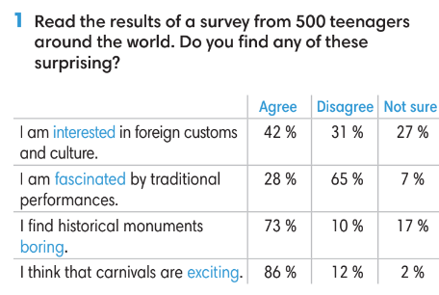  Ex:  A: It’s surprising that 42% of teenagers are interested in foreign customs and culture. However, many students are not interested in that.  B: It’s surprising that most teenagers think that carnivals are exciting. It’s a good sign.
Grammar box  - T asks Ss to read the grammar box and then explain the grammar rules to them.  - Ask Ss to give more examples. |  |  | 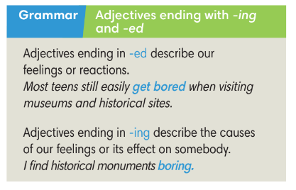  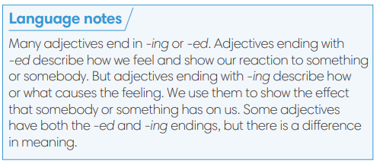
Exercise 3 – SB p82.  Complete the table below.  - T asks Ss to look at exercise 3.  - T calls a student to read the instruction then checks Ss’ understanding of it.  - T asks Ss to finish Exercise 3 individually and then check in pairs.  - T checks Ss answers. |  |  | Answer keys:  
3. PRACTICE (13’)
* Aim:
- To provide Ss grammar exercises to practice
* Content:
- Ss read and complete a conversation.
- Ss make sentences with adjectives.
* Outcome: Ss know how to use adjectives ending with -ing and -ed in sentences.
* Organisation : T-Ss, Ss-T, Pair work, Ss-Ss
Teacher’s and Student’s activities |  |  |  | Content
Exercise 4 – SB p.82  Add an -ed or -ing ending to the adjectives in the conversation.  - T asks Ss to look at exercise 4.  - T calls a student to read the instruction then checks Ss’ understanding of it.  - Ss finish Exercise 4 individually and then check in pairs.  - T checks Ss answers and asks Ss to provide reasons for their answers.  - T asks some Ss to read the dialogue in front of the class. |  |  |  | Answer keys: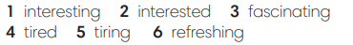
Exercise 5 – SB p.82  Make statements with the adjectives and clues given. Change the form of the adjectives if necessary.  - T asks Ss to look at exercise 5.  - T calls a student to read the instruction then checks Ss’ understanding of it.  - Ss finish Exercise 5 individually and then check by playing a game: Lucky number  - T asks some Ss to answers and then confirm. |  |  |  | Answer keys: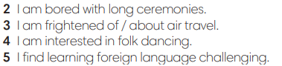
4. PRODUCTION ( 6’)

*Aim: To help students applying the vocabulary items and grammar points related to the topic in communicating.
* Content: Ss discuss festivals.
* Outcome: Ss describe how he/ she feels about a festival.
* Organisation: T-Ss, Ss-Ss, Ss-T, Pair work
Teacher’s Student’s activities |  | Content
Exercise 6 – SB p.82  In pairs, name a festival and your partner will describe how he/ she feels about it. Use the adjectives in Exercise 3.  - T asks Ss to look at exercise 6 (SB page 82).  - T calls a student to read the instruction and example then checks Ss’ understanding of it.  - T models the activity in front of the class.  - T asks Ss to work in pairs to finish Exercise 6.  - T walk around to listen and notes down common mistakes for delayed feedback.  - T calls some groups to come to the front of the class, make conversations.  - T asks the rest to give comments on their classmates’ performance.  - T gives feedback on Ss’ work. |  | 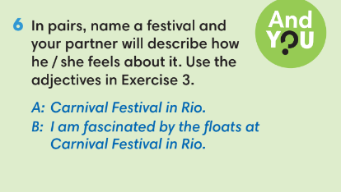
5. WRAP-UP & HOME WORK (3’)
- T asks Ss to talk about what they have learnt in the lesson.
Adjectives ending in -ing and -ed incorrectly.
* HOME WORK
- Do exercises in the workbook page 70.
- Prepare for Lesson 8.3: Reading.

