Week 8 - Period 22  Date of planning: …../…./……  Date of teaching: …../…../…... | UNIT 3: PEOPLES OF VIET NAM  Lesson 7: Looking back and Project

A. Objectives
1. Knowledge: By the end of the lesson, students will be able to recycle the language from the previous sections and consolidate and apply what they have learnt in Unit 3 by doing various activities and exercises.
- Vocabulary: Vocabulary related to “Peoples of Viet Nam”.
- Grammar: Question words, articles: a/ an/ the.
2. Competence: Group work, individual work, pair work, linguistic competence, cooperative learning and communicative competence.
3. Behavior: Students have serious attitude while working together. They know how to look back the knowledge they have learnt and master.
B. Teaching aids:
1. Teacher: Textbooks, teaching plan, teacher’s book…
2. Students: Textbooks, notebooks…
C. Procedures:
1. Checking: During the lesson.
2. New lesson:
Teacher’s and students’ activities | The main contents
1. Warm up (5’)
a, Aim: To warm up the class and lead in the lesson.
b, Contents: Ss work individually to write how to make yellow sticky rice.
c, Outcome: Ss can write a paragraph about how to make yellow sticky rice well.
d, Organization:
- T calls 2 students to come to the board and complete the words.  - Ss work individually.  - T checks and corrects as a class and leads ss to the new lesson. | * Jumble words  + socumets => costumes  +thecni => ethnic  + vsredie => diverse +niuqeu => unique  + tuculre => cultural
2. Practice (30’)
a, Aim: Help students review vocabularies and grammar they have learnt in Unit 3 and help Ss talk about the cultural groups of Viet Nam.
b, Contents:
+ Ss work in pairs to complete the sentences with the words/ phrases from the box.
+ Ss work individually to use the correct form of the words in brackets to finish the sentences.
+ Ss work in pairs to make questions for the underlined parts in the passage.
+ Ss work individually to find and correct the error.
+ Ss work individually to fill each gap with a, an or the to complete the passage.
+ Ss work in pairs to play a game.
c, Outcome: Ss can review vocabularies and grammar they have studied in Unit 3 and do related exercises correctly. Also, Ss can talk about the cultural groups of Viet Nam well.
d, Organization:
- T lets Ss repeat the words as a class to practice pronunciation.  - Next, Ss can complete this exercise in pairs.  - Ss do the exercise in pairs.  - T corrects as a class.  - T asks Ss to do exercise 2.  - Ss work individually to do the task.  - After that, T lets some Ss read the sentences aloud. Ss do it.  - T checks and corrects.  - T lets Ss read the passage aloud. Clarify any difficulties.  - Ss work in pairs to do the task. Then Ss give the answers.  - T checks and corrects.  - T tells Ss to read the sentences carefully and try to find the error relating to articles in each sentence.  - Ss work individually to do the task. Then Ss give the answers.  - T checks and corrects.  - T asks Ss to complete this task individually. Ss do it. Then Ss give the answers.  T gives correction.  - T asks Ss to work in pairs. Let them recall what they have learnt about the cultural groups of Viet Nam.  - Ss take turns to ask each other questions about the topic. The person asking can look at the book. The first person to get five correct answers is the winner.  - If time allows, Ss switch partners and play again.  - T asks Ss to complete the self-assessment. Discuss as a class what difficulties remain and what areas Ss have mastered. Ss do it individually.  - T provide further practice on the weak areas of the class. | I. Vocabulary  1. Complete the sentences with the words/ phrases from the box.  Key:  1.cultural groups  2. communal, activities  3. costumes, diverse  4. ethnic  5. unique  2. Use the correct form of the words in brackets to finish the sentences.  Key:  1. cultural 2. peaceful  3. richness 4. diversity  5. traditional  II. Grammar  3. Make questions for the underlined  parts in the passage.  Key:  1.What are these houses built on?  2. Where is the entrance?  3. Which house is the largest, tallest and most elaborate building in the village?  4. What is it used for?  5. Who can sleep in this house?  4. Each sentence has an error. Find and correct it.  Key:  1. a -> the  2. a -> the  3. an -> the  4. the semi-nomadic life -> a semi-nomadic life  5. an -> the  5. Fill each gap with a, an or the to complete the passage.  Key:  1. an 2. a 3. the  4. the 5. the 6. the  III. Communication  6. GAME: Cultural Knowledge Challenge  Example:  A: Are you ready?  B: Yes.  A: What is the population of the largest ethnic group?  B: About 74 million. It’s the Viet or Kinh.  A: Very good! Your turn.  B: OK. What is the population of the smallest group?  A: I think it’s the Odu group.  B: Exactly!
3. Application (8’)
PROJECT: ETHNIC FASHION SHOW
a, Aim: To help Ss know how to do project about Ethnic fashion show.
b, Contents: Ss work in groups to do project.
c, Outcome: Ss can know how to do project about Ethnic fashion show well.
d, Organization:
(1) T asks Ss to work in groups. T gives Ss about five minutes to discuss the question. Ss work in groups to discuss.  (2) T lets Ss work independently. T encourages Ss to use imagination and make their own costume designs (at home, or in class if possible, and with the materials available). T tells Ss to be creative. Ss do it.  (3) In the next class, T helps Ss organize an exhibition of the costume designs they have made among the groups or class members. T lets them talk about their designs. | PROJECT: Ethnic fashion show  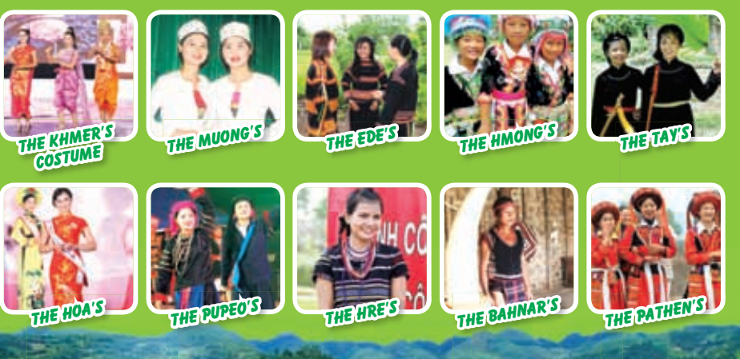
3. Consolidation and guides for homework (2’)
* Consolidation:
- Consolidates ss more about the main content of the lesson and asks ss to remember
+ Vocabulary relating to the topic “Peoples of Viet Nam”
+ Grammar: Questions + Articles
* Homework: Asks Ss to:
- Redo all exercises in notebook.
- Review all vocab, grammar and skills of Unit 1,2,3.

