CLIL 2: (Literature): Animal In Fiction
(Time: 1 period)
Class | Date of teaching | Attendance

I. OBJECTIVES
By the end of the lesson, students are expected to achieve the following objectives:
- read a text about “Diary of cricket” a very famous book by To Hoai.
- identify keys information about a fiction (title, author, country of origin, etc.).
- review adjectives and use them to describe main character of the book.
- use book fact file related vocabulary words to talk about other fictions
- write a fact file and a short summary about a book.
- Knowledge:
- Vocabulary: Understand the meaning of the key words or word collocations: fiction, authors name, title, main characters, country of origin, etc.
- Grammar: Use the grammar structures presented in the lesson: present simple tense, think of, famous about
- Competencies:
- General competencies:
Form and/or improve such competencies as group work, independent working, pair work, linguistic competence, and cooperative learning.
- Specific competencies:
Improve competences related to language learning: reading, writing skills and the use of language (vocabulary, phonetics, grammar)
- For a language lesson: Students are expected to know the meaning of the keywords and grammatical structures used to summarize a book.
- For a skills lesson: Students are expected to
- read for general ideas and for specific information about book information
- develop specific and detailed writing
- Qualities:
- Be hard-working and attentive in class
- Have better understanding of the book morals: love nature, friendship, etc.
- Love reading books
II. PREPARATIONS
Teacher: Textbooks, worksheet, PowerPoint slides, video clip, TV, projector, loudspeaker
Students: Textbooks, notebooks
III. PROCEDURE
ACTIVITY 1: WARM-UP – SUPER EYES GAME
- Aim: to get students be ready and excited about the lesson
- Content: see, remember, say information about some book covers
- Products: Ss answer the correct information about the pictures
- Implementation:
TEACHER AND STUDENTS’ ACTIVITIES | CONTENTS
Step 1: Task delivering  - T shows and hides the pictures quickly  - T lets students look at some book covers. Try to remember the information from the covers the answers for 2 questions.  Step 2: Task performance  - Students say a loud the answers  Step 3: Report and discussion  - Teacher discusses with the students about the books covers and information on the covers.  Step 4: Judgment  Teacher comments on the answer. Teacher gets students to guess what they are going to learn about. | Pictures of some book covers  Questions: How many books are there? What are the books about?
  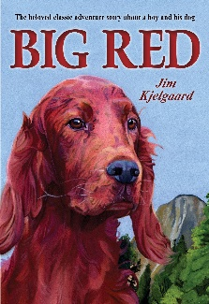 | 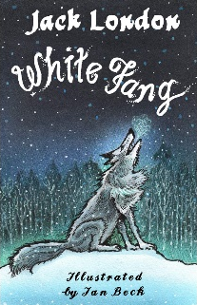
  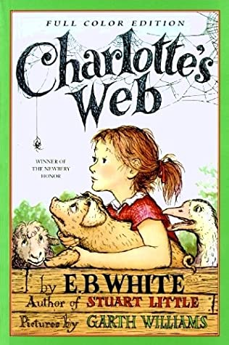 | 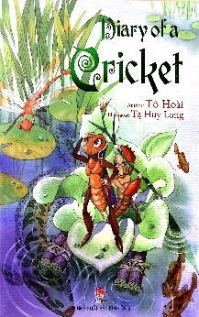
ACTIVITY 2: KNOWLEDGE FORMATION
Pre -reading
- Aim: to activate students’ prior knowledge about the topic.
- Content: Students work in pair to ask and answer some questions.
- Products: Students are able to apply their own words to answer the questions.
- Implementation:
TEACHER AND STUDENTS’ ACTIVITIES | CONTENTS
Step 1: Task delivering  - Teacher ask students to work in pairs to ask and answer the questions.  Step 2: Task performance  - Students work in pairs. One student asks and the other answers  Step 3: Report and discussion  - Teacher asks some pairs to act out  Step 4: Judgment  - Teacher comments on the answer. Teacher gets students to guess what they are going to learn about. This will lead to the lesson naturally | Orientation questions  - Have you ever read these books before?  - Share what they know about the books.  - Do you know what fiction is mean?  - Today, we are reading about one of the books (from 4 covers in Warm up game), can you guess which one is?
Pre-teaching of vocabulary
- Aim: To provide students with some lexical items before reading the text
- Content: Learn some vocab related the topic
- Products: Read and understand the meaning of words
- Implementation:
TEACHER AND STUDENTS’ ACTIVITIES | CONTENTS
Step 1: Task delivering  - Teacher uses different techniques to teach vocab (pictures, situation, explanation, slides)  - Ask students to listen and repeat the words  Step 2: Task performance  - Students listen to the teacher and repeat the words in chorus and individually  - Copy all the words  Step 3: Report and discussion  - Call someone to read aloud all the new words  Step 4: Judgment  - Teacher checks and corrects students’ pronunciation | fiction /ˈfɪk.ʃən/ (n) the type of book or story that is written about imaginary characters and events and not based on real people and facts  author /ˈɔː.θər/ (n) the writer of a book, article, play, etc.  title /ˈtaɪ.təl / (n) the name of a book, film, painting, etc.  main character /meɪn ˈˈkær.ək.tər/ (n) a central character that acts as the focus of the audience's emotional attachment to the story.  country of origin /kʌntri ɒvˈɒr.ɪ.dʒɪn/ (n) is the country where something or someone comes from.
ACTIVITY 3: PRACTICE While – reading
Task 1
- Aim: to provide students with the main idea of the text and give them a reason/ motivation to read.
- Content: Students read the text and choose the correct cover of the book
- Products: Students say the title of the book and author’s name.
- Implementation:
TEACHER AND STUDENTS’ ACTIVITIES | CONTENTS
Step 1: Task delivering  - Teacher asks students to look at Student’s Book page 104, read the text and look at the book cover in Exercise 1 to choose the matching one.  Step 2: Task performance  - Students work individually to read and choose the book cover.  Step 3: Report and discussion  - Teacher calls some students to answer  Step 4: Judgment  - Teacher checks and corrects students’ pronunciation  - Teacher checks the exercise with the students | Exercise 2  Read the text. Which of the books from exercise 1 is the text about?  Answers:  The text is about “Diary of cricket” a very famous book by To Hoai
Task 2
- Aim: to get students to practice their comprehensive reading skills and help them understand more deeply the content of the text.
- Content: Read the text and complete a fact file
- Products: Students fill in the correct information for the fact file
- Implementation:
TEACHER AND STUDENTS’ ACTIVITIES | CONTENTS
Step 1: Task delivering  - Teacher asks students to look at Exercise 2 - SB page 104, read the text again and work in groups of four to answer the questions.  - Teacher ask them to identify the information.  Step 2: Task performance  - Students work in group to read the text again and discuss the information to fill in the fact file  - Students underline the information they found in the text  Step 3: Report and discussion  - Invite members of some groups to present their fact file  Step 4: Judgement  - Teacher checks the answer with the whole class | Exercise 3: Read the text again and complete the fact file  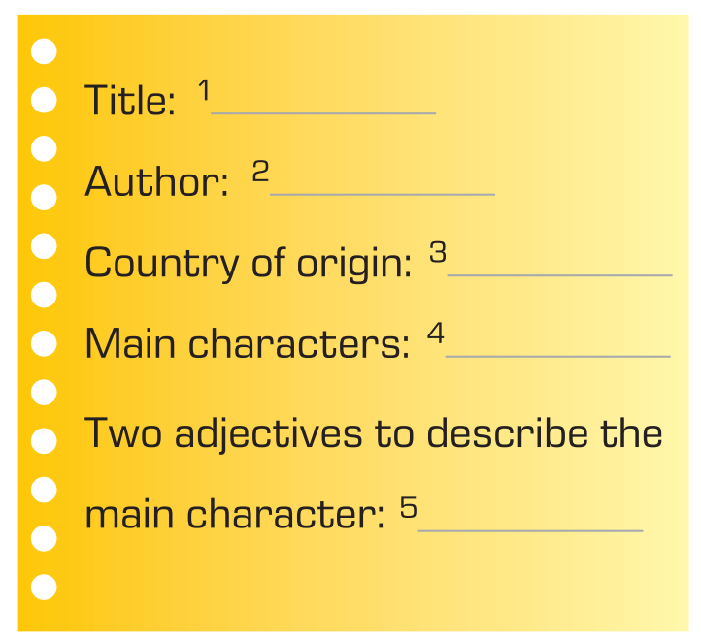  Answers:  1 Diary of a cricket / 2 To Hoai  3 Vietnam / 4 Dế Mèn (a cricket)  5 kind, helpful
Information Exchange:  Step 1: Task delivering  - Teacher puts students in pairs, has them to form a question for each information using their own work.  - T sets a time limit for students to work in pair, practice asking and answering about the book  Step 2: Task performance  - Students work in pairs to ask and answer about information about the book.  - Students need to compare their answer and do peer check  - Teacher goes around the class, provides support when needed and takes note.  - Students do group check after finishing  Step 3: Report and discussion  - Students volunteer to role play the dialogue in front of the class  Step 4: Judgement  - Teacher gives comment and checks with the whole class. | - Exercise 4: Work in pairs. Take turn to ask your teacher questions about the books  - Suggested questions  - Question 1: What is the book title?  - Question 2: Who wrote the book? / What is the author’s name?  - Question 3: Where is the book from?  - Question 4: Who are the main characters? / What are the main characters’ name?  - Question 5: Can you describe the main character using 2 adjectives?
ACTIVITY 4: APPLICATION Post – reading
      - Aim:
- To help students reflect on what they’ve known and what they’ve learnt about “Diary of a cricket”.
- To help apply the learnt knowledge to write a summary of a book about an animal.
      - Content:
- ask and answer questions related to the book with partner
- write a summary of a book about an animal
3. Products: Students can recall the name of ethnic groups, national holidays and traditional festivals; Students’ perfect fact file writing.
4. Implementation:
TEACHER AND STUDENTS’ ACTIVITIES | CONTENTS
Task 4  Step 1: Task delivering  - Teacher provides students with simple summaries of story books about animals.  - Teacher asks students to read through all the questions of the task and guides them on how to make notes of key information while reading the given materials by using a graphic organizer.  - Teacher gives an example of the graphic organizer using the summary of "Diary of cricket".  Step 2: Task performance  - Students create their own notes using the given summaries or their own knowledge about their favourite book about an animal.  - Teacher facilitates while students are making notes with the graphic organizer.  - Students exchange their notes with a partner and check their friends’ one.  Step 3: Report and discussion  - Teacher calls some students to present their graphic organizer.  Step 4: Judgement  - Teacher checks and give feedbacks for their notes.  Task 5  Step 1: Task delivering  - Teacher has students complete the task by using their notes in task 4 and the sample summary of "Diary of cricket".  Step 2: Task performance  - Students write a short summary (60 – 80 words) based on the graphic organizer.  - Teacher facilitates while students are writing.  - Students exchange their writing to check their friends’ one.  Step 3: Report and discussion  - Teacher calls some students to show their writing on the board.  Step 4: Judgement  - Teacher checks and give feedbacks for their writing.  ***T might ask Ss to prepare this content in advance so their writing can be better and more diverse. | Exercise 4  Graphic organizer illustration
  Diary of cricket
  Author | …
  When | …
  What it’s about
  What you like | …
  Other interesting information | …
HOME ASSIGNMENT
- Students take note of the homework: Write a short summary of another story book about an animal they’ve read or found on the Internet. Encourage them to ask or search for more information to put in the writing.
IV. FEED-BACK:
With class
………………………………………………………………………………
With class
………………………………………………………………………………
With class
………………………………………………………………………………
Notes:
…………………………………………………………………………………
…………………………………………………………………………………
…………………………………………………………………………………

