Date of planning:  Date of teaching: | ENGLISH 7  UNIT 2: FAMILY AND FRIENDS  Lesson 1: Vocabulary
I. OBJECTIVES:
By the end of the lesson, students will be able to:
- have an overview of the topic “Family and Friends”.
- use vocabulary and grammar points to talk about clothes and appearance.
1. Knowledge:
*Vocabulary: an understanding of the meaning of keywords or word collocations below:
Type of clothes and footwear | Boots, dress, hoodie, jacket, jeans, pyjamas, shirt, shoes, shorts, T-shirt, tracksuit, trainers
Accessories | Baseball cap, glasses, handbag, necklace, scarf
Describing words | Size/Shape: baggy, tight  Material: leather, woolly, cotton  Colour/Pattern: plain, checked, striped, logo

* Grammar: expressions to talk about clothes and appearance, preference
I prefer ___.
I often wear pyjamas when I go to bed.
2. Competence:
To know the meaning of the keywords used to talk about clothes, and understand the main grammatical points, then do the tasks assigned in the textbook. To use the vocabulary about clothes to practice talking about preference and do a class survey about what the other classmates often wear.
3.Quality/Behavior: To teach Ss to be hard-working and attentive in class. Ss have a positive attitude to working in groups, individual work, pair work, cooperative learning and working.
II. TEACHING AIDS:
- Teacher: Grade 7 textbook, Unit 2 (SB p.20-21, WB p.15-16), laptop/computer connected to the Internet, loudspeaker, projector/TV, PPT slides…
- Students: Text books, studying equipment…
- Method: Active teach, T-WC; group works; individual ……
III. PROCEDURE:
1. WARM UP( 3’)
* Aims:
- To activate Ss’ prior knowledge and get students involved in the lesson.
- To set the context for introducing new words.
* Content: Play Super Eyes game to get students involved in the lesson and to set the context for the lesson.
* Outcome: Students name some types of clothes they’ve already known.
* Organisation: Teacher’s instructions…

Teacher’s & Student’s activities | Content
Extra activity 1: Super Eyes game  - T explains the game rules then checks instructions.  - T uses the PPT slides to lead the game.  - T tells students that they are learning more words of clothes in today lesson.  - T sets the context for the lesson: Write the title on the board Unit 2: Family and Friends / Lesson 2.1: Vocabulary  - T asks Ss to name some more types of clothes they’ve already known. | Game rules:  - Look at the pictures.  - Remember as many clothing items as you can  - Recall the words you remember  - 1 correct words = 1 point.
2. PRESENTATION 1 (11’) VOCABULARY
ACTIVITY 1:
* Aims:
- To reinforce the words of clothes that students have already known.
- To teach more new words
- To lead into the next activity.
- To reinforce the meaning and spelling of the words
* Content: Some brief notes; Some things about types of clothes.
* Outcome: Know new words about clothes.
* Organisation: Teacher’s instructions….

Teacher’s & Student’s activities |  | Content
1. (8’) What clothes can you see in the picture?  Exercise 1 (SBp20)  - T asks Ss to open their SB page 20, look at exercise 1.  - T calls a student to read the instruction then checks Ss’ understanding of it.  - T elicits the meaning of words in the Vocabulary Box and quickly checks Ss’ understanding of vocabulary by asking them to look at the picture in SB and say all the clothing items they see.  - T plays the audio track 2.01 for students to listen and repeat.  - T asks students to work in pairs to find two things from the vocabulary list that are NOT in the picture. |  | Prompts:  What clothes can you see in the picture?  I see ….  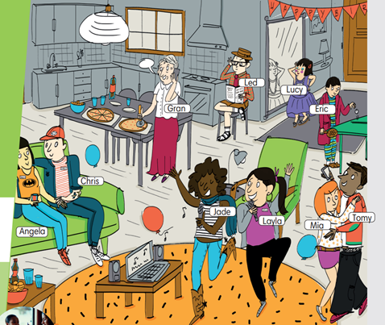  
Extra activity 2 (3’): Look and Say  - T asks Ss to look at the slide, slowly displays the vocabulary  - T tells Ss to say the words one by one  - Ss join the activity as the whole class.  - T tells Ss to remember the words using 3 groups: Clothes, Footwear, Accessories. |  | 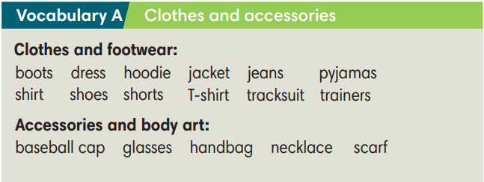
3. PRACTICE 1 (9’)
ACTIVITY 2:
* Aims:
- To provide students with chances to practice pronouncing new words.
* Content: Some brief notes; Some things about types of clothes.
* Outcome: Know new words about clothes and classify them into types.
* Organisation: Teacher’s instructions…

Teacher’s & Student’s activities | Content
Extra activity 3 (5’): Find Someone Who  - T models the activity with the whole class by saying: “Look at the picture in your SB, find someone wearing boots.”  - T divides class into pairs/small groups.  - T gives and checks instructions for the game.  - Ss play the game in pairs/small groups  - T corrects Ss’ pronunciation if any. | Game rules:  - Look at the pictures.  - Student A says: “Find someone wearing…..”  - Student B finds and says the name.  - 1 correct answer = 2 points.
2. (4’) Write the items under each picture (2-6)  (Exercise 2 – SB p.20)  - T asks Ss to look at exercise 2 (SB page 20).  - T calls a student to read the instruction then checks Ss’ understanding of it.  - T sets a time limit and asks Ss to work in groups of five to complete the exercise.  - T calls groups to give answers then checks as the whole class.  - T drills the vocabulary and corrects Ss’ pronunciation if any. | Answer keys:  (1) tracksuit (2) hoodie (3) necklace  (4) trainers (5) pyjamas (6) boots
4. PRACTICE 2 (11’)
ACTIVITY 3 + 4:
* Aims:
- To help Ss use the new vocabulary in collocations.
- To practice the vocabulary and models related to the topic in communication
* Content: Some brief notes about the exercise; some keywords about clothes, type of clothes, preferences; some note about pronunciation.
* Outcome: Have a vocabulary about clothes; know how to talk about clothes and preferences.
* Organisation: Teacher’s instructions…

Teacher’s & Student’s activities | Content
3. (4’) Complete the sentences with the words below.  (Ex 3, p.11)  Activity 6: Exercise 3 – SB p.21  Look at the photos. Choose the correct word.  - T asks Ss to look at exercise 3 (SB page 21).  - T calls a student to read the instruction then checks Ss’ understanding of it.  - T asks Ss to read the given words aloud, checks their understanding of the words.  - T sets a time limit and asks Ss to work in groups of four to complete the exercise.  - T calls groups to give answers then checks as the whole class.  - T corrects Ss’ pronunciation if any. | Answer keys:  a. plain T-shirt  b. striped shirt  c. baggy jeans  d. woolly hat
4. (7’): In pairs, do the Fashion Quiz. Then look at page 101 and check how similar or different you are.  (Exercise 4 – SB p. 21)  - T asks students to look at their SB p.21 – Exercises 4  Step 1:  - T writes the heading words on board:  Size/Shape – Material – Colour/Pattern  - T asks Ss to find the words in the text that match the heading words.  - Ss work individually, find the words.  - Ss raise their hand to give answers.  - T confirms the answers, corrects Ss’ pronunciation if any.  Step 2:  - T presents the Quiz prompts:  - T asks students to do the quiz individually first, then compare  their answers in pairs.  - Ss work individually, find the words.  - Ss raise their hand to share the answers in pairs.  - T checks grammar, corrects Ss’ pronunciation if any. | 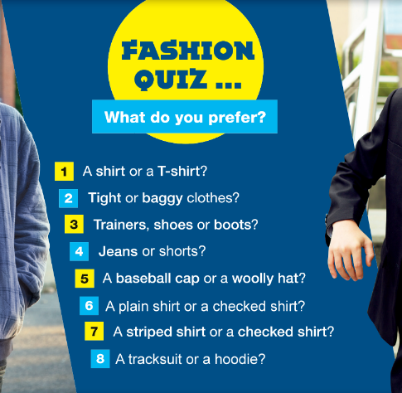  Correct headings:  
  Student A: What do you prefer? A shirt or a T-shirt?
  Student B: I prefer a T-shirt. What about you?
4. PRODUCTION (7’)
ACTIVITY 5:
* Aims: To help Ss practice applying the vocabulary items and grammar points related to the topic in speaking.
* Content: Ss work in groups to talk about their clothes and appearance.
* Outcome: Ss talk about their clothes and appearance using vocabulary and grammar points.
* Organisation: Teacher’s instructions…..
Teacher’s & Student’s activities | Content
5. Work in group of three. Interview two friends and complete the table.  (Exercise 5 – SB p.21)  - T asks Ss to look at exercise 5 (SB page 21).  - T calls a student to read the instruction then checks Ss’ understanding of it.  - T asks students to work in groups of three to interview each other and complete the table.  - T invites some students to report their results to the class using the present simple statements (i,e., Lan usually goes to bed at 9.30 pm.)  - T asks the rest to give comments on their classmates’ performance. T gives feedback on Ss’ work. | 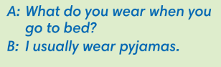  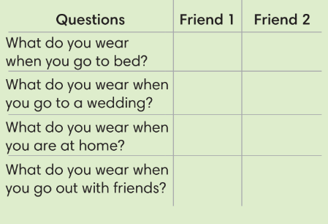

WRAP-UP & HOME WORK (3’)

- T asks Ss to talk about what they have learnt in the lesson.
- Vocabulary of types of clothes and accessories.
- Grammar points: Expressions to talk about preference and daily outfit.
* HOME WORK
- Do exercises in the workbook page 15-16.
- Prepare for Lesson 2: Grammar 1.

Date of planning:  Date of teaching: | UNIT 2: FAMILY AND FRIENDS  Lesson 2: Grammar
I. OBJECTIVES:
By the end of the lesson, students will be able to:
- use Present Continuous to talk about present activities.
1. Knowledge:
* Grammar:
- write affirmative, negative and question forms of the Present Continuous tense correctly.
- use the Present Continuous tense to talk about present activities and describe friends in class.
2. Competence: Students know to use vocabulary about activities, and understand the main grammatical points, then do the tasks assigned in the textbook; use the Present Continuous tense to talk about present activities and describe friends in class.
3. Quality/ behavior: To teach Ss to be hard-working and attentive in class. Ss have a positive attitude to working in groups, individual work, pair work, cooperative learning and working.
II. TEACHING AIDS:
- Teacher: Grade 7 textbook, Unit2 (SB p. 22), laptop/computer connected to the Internet, loudspeaker, projector/TV, PPT slides…
- Students: Text books, studying equipment…
- Method: Active teach, T-WC; group works; individual ……
III. PROCEDURE:

1. WARM UP (4’)
* Aims:
- To activate students’ prior knowledge and get students involved in the lesson.
- To set the context for introducing new structures.
* Content: Play Guessing game to get students involved in the lesson and to set the context for the lesson.
* Outcome: Students know the context of the lesson.
* Organisation : T_ Ss , …
Teacher’s Student’s activities | Content
Extra activity 1: Guessing Game  - T divides Ss into 2 teams. Team boys and team girls.  - T explains the game rules then checks instructions.  - T corrects Ss if necessary.  - T set the scene for the new lesson: T tells Ss that they can describe what Dr Strange is doing by looking at the pictures.  They will learn more structures to describe people and present activities.  - T writes the title on the board Unit 2: Family and Friends / Lesson 2.2: Grammar | Game rules:  - Look at the pictures.  - Choose A – B - C  - 1 correct answer = 1 point.
2. LEAD-IN (3’)
* Aims: To lead into the new lesson.
* Content: Describe people and their activities in the picture on the slide.
* Outcome: Make guesses about the picture then give answers.
* Organisation : T_ Ss , …
Teacher’s Student’s activities | Content
Extra Activity 2: See – think – wonder.  - T shows a picture on the slide then asks students three questions.  (1) What do you see in the picture?  (2) Who are they?  (3) What are they doing?  - T sets a time limit for Ss’ quick discussion.  - Ss work in pairs to make guesses about the picture then give answers.  - T calls some Ss to give answers then note them down on the board.  - T tells Ss that they’re going to read a dialogue in exercise 1 (SB p.22) to check all the answers. | 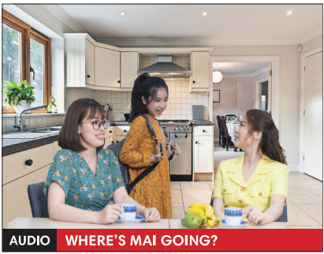
3. PRESENTATION (11’)
(Questions and answers in the Present Continuous tense)
ACTIVITY 1 + 2:
Aims:
- To present the grammar point in context.
- To lead into the next activity.
- To help Ss recognize all the forms of Present Continuous Tense.
- To provide Ss with chances to work cooperatively.
- To explain the grammar point for Ss.
* Content: Read Rose’s blog and find out new words. Learn the Present Simple.
* Outcome: Know more new words. Understanding the reading document; the topic of the lesson, grammar points…
* Organisation : T_ Ss , ..
Teacher’s Student’s activities |  |  |  | Content
1. (4’) Look at the photo. What is Mai doing? Then read and listen to check.  (Exercise 1 – SB p.22)  - T asks Ss to open their SB page 12, look at exercise 1.  - T calls a student to read the instruction then checks Ss’ understanding of it.  - T asks Ss to read the dialogue to find the answer for the question.  - Ss work individually.  - T calls some Ss to give answers then shows the answers on the slide.  - T asks Ss to look at the sentences and elicits the tense of those for Ss (all forms in the Present Simple Continuous). |  |  |  | Answer keys:  Mai is getting ready for school.  Some other sentences in the dialogue:  I’m brushing my hair.  I’m going to school.
2. (7’) Find more examples of Present Continuous in the dialogue in Exercise 1.  (Exercise 2 – SB p.22)  - T asks Ss to look at exercise 2.  - T calls a student to read the instruction then checks Ss’ understanding of it.  - T asks Ss to work in groups of three to complete the activity.  - T calls groups to give answers then shows the answers on the slide to check as the whole class.  THE GRAMMAR NOTES  - T shows the Grammar Notes for all forms of the Present Continuous tense then elicits information from Ss.  - T explains the grammar points and tells Ss that they’re going to use the Present Continuous tense to talk about things that happening now.  - T shows the grammar notes again, then Ss can read aloud. |  |  |  | 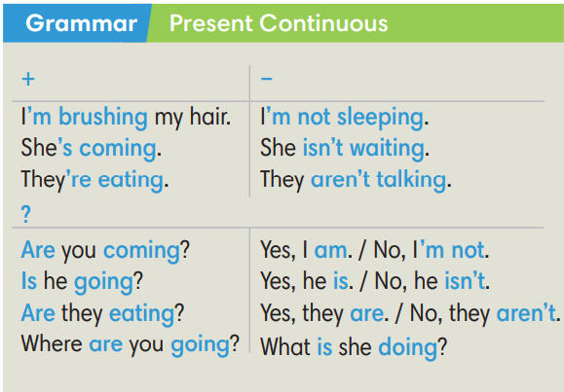
3. PRACTICE (15’)
ACTIVITY 3 + 4:
Aim:
- To help students practice completing the correct forms of the verbs with corresponding singular/plural subjects.
- To help students identify the correct form of the verbs in present continuous tense.
* Content: Complete the text/sentences with the correct form of the verbs.
Understand the text; grammar points; present continuous tense.
* Outcome: Know how to form a sentence with the correct form of the verbs. Understand the conversation; the topic of the lesson, vocabulary, grammar points…
* Organisation : T_ Ss .…..
Teacher’s Student’s activities |  | Content
Extra activity 3 (6’): Space Mission Game.  - T explains the game rules then checks instructions.  - Ss join in the game individually or in teams.  - T corrects Ss if any. |  | Game rules:  - Read the sentence  - Put the correct verbs in the brackets.  - Raise your hand to give answers.  - Get points.
3. (4’) Make affirmative and negative sentences in Present Continuous.  (Exercise 3 – SB p.22)  - T asks Ss to look at exercise 3.  - T calls a student to read the instruction then checks Ss’ understanding of it.  - T asks Ss to work in individually.  - T calls students to give answers then shows them on the slide to check as the whole class.  - T corrects Ss if any. |  | Answer key:  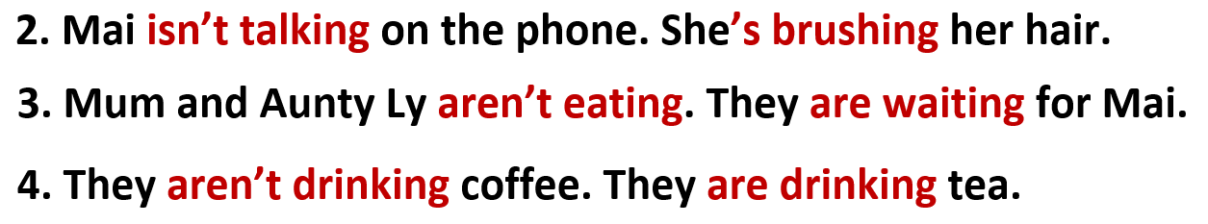
4. (5’) Make questions in Present Continuous. In pairs, look at the photo and answer the questions.  (Exercise 4 – SB p.22)  - T asks Ss to look at exercise 4.  - T calls a student to read the instruction then checks Ss’ understanding of it.  - T asks Ss to work in in pairs.  - T calls some pairs to give answers then shows them on the slide to check as the whole class.  - T corrects Ss if any.  *Extra Activity: Teacher can get some exercises from Workbook page 17 for Ss to practice in class. |  | Answer key:  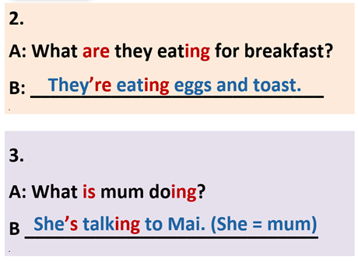
4. PRODUCTION ( 7’)
ACTIVITY 5:
*Aim: To help students applying the vocabulary items and grammar points related to the topic in communicating.
* Content: Ss describe themselves and their partners (what they are doing or wearing).
* Outcome: Ss know how to express themselves and describe others.
* Organisation: T_Ss…

Teacher’s Student’s activities |  |  | Content
5. Ask and answer about what your friends are doing or wearing.  (Exercise 5 – SB p.22)  - T asks Ss to look at exercise 5 (SB page 22).  - T calls a student to read the instruction then checks Ss’ understanding of it.  - T models the activity in front of the class.  - T divides Ss into new pairs, asks them to make conversations to ask and answer about their classmates.  - T walk around to listen and notes down common mistakes for delayed feedback.  - T calls some groups to come to the front of the class, make conversations.  - T asks the rest to give comments on their classmates’ performance.  - T gives feedback on Ss’ work. |  |  | 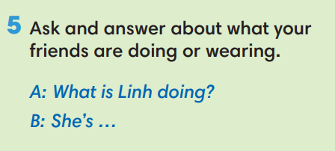
WRAP-UP & HOME WORK (2’)

- T asks Ss to talk about what they have learnt in the lesson.
- The present continuous tense: all forms
* HOME WORK
- Do exercises in the workbook page 17.
- Prepare for Lesson 1.3: Reading.

Date of planning:  Date of teaching:  WEEK: | UNIT 2: FAMILY AND FRIENDS  Lesson 3: Reading and Vocabulary
I. OBJECTIVES:
By the end of the lesson ss will be able to:
- find specific detail in a letter and talk about family activities.
1. Knowledge:
*Vocabulary: an understanding of the vocabulary about family activities and some adjectives.
New words | Vietnamese meaning
- take care of the garden (np) | chăm sóc vườn
- sing karaoke (np) | hát karaoke
- plan for a trip (np) | chuẩn bị cho một chuyến đi
- excited (adj) | cảm thấy hào hứng
- relaxed (adj) | cảm thấy thư thái

* Grammar: Reading skills: the ability to find specific details in a letter.
2. Competence: Understand and know the meaning of the keywords used to talk about family activities, vote for top three exciting activities then do the tasks assigned in the textbook; locate information and find specific details in a letter (scanning skill); identify the main ideas of the paragraphs in the text or the text itself (skimming skill).
3. Quality/ behavior: To teach Ss to be hard-working and attentive in class. Ss have a positive attitude to working in groups, individual work, pair work, cooperative learning and working.
II. TEACHING AIDS:
- Teacher: Grade 7 textbook, Unit 2 (SB p.23, WB p.18), laptop/computer connected to the Internet, loudspeaker, projector/TV, PPT slides…
- Students: Text books, studying equipment…
- Method: Active teach, T-WC; group works; individual ……
III. PROCEDURE:

1. WARM-UP (5’)
* Aim:
- To help Ss review some activities they have known.
- To lead into the next activity.
* Content: Game: Relax Game (about family activities to relax)
* Outcome: Ss can talk about some family activities to relax.
* Organisation: T_ Ss …
Teacher’s &Student’s activities |  | Content
Extra activity 1: Relax Game  - T explains the game rules then checks instructions.  - T uses slide to lead the game.  - T asks Ss the question “What do these families do to relax?” – T elicits the picture and ask student to guess the meaning before they unscramble the word.  - Ss raise their hands if they have the answer.  - T asks students to read aloud the sentence after each play.  - T tells students that they are reading about family activities.  - T writes the title for the new lesson:  Unit 2/Lesson 3: Reading and vocabulary. |  | Game rules:  - Look at the picture  - Unscramble the word to see the activity  - Open the star to get point.
2. PRE-READING (8’)
ACTIVITY 1 + 2:
* Aim:
- To activate Ss’ background knowledge of the topic.
- To get student think about family activities.
- To provide Ss with reasons for reading the text in the next stage.
* Content: To discuss Ss’s family activities by reading and answering T’s questions.
* Outcome: Know new words, and grammar points when talking about one’s family activities.
* Organisation: T, Ss …
Teacher’s & Student’s activities | Content
1. (3’) Look at the photo. What are the family member doing?  (Exercise 1 – SB p.23)  - T shows the slide, reads aloud the questions  1- What are the family members doing?  2- How do they feel?  - T asks a students to look at the photos and find the answers.  - 1- They are doing gardening together.  - 2- They feel happy.  - T emphasizes about the photo “Doing gardening together makes the family members happy.”  - T mentions that doing gardening is one of family activities. | 
2. (5’): Work in pairs. What do family members do to relax? Compare your answers with another pair.  (Exercise 2 – SB p.23)  - T asks students to recall some family activities that they have known from the warm-up game.  - T tells students to work in pairs to talk about what their family.  - Ss can use the list in warm-up game for reference: what family members often do to relax.  - T invites some students to share their answers with the whole class using the given prompts.  A: What do family members do to relax?  B: We often go hiking together. | 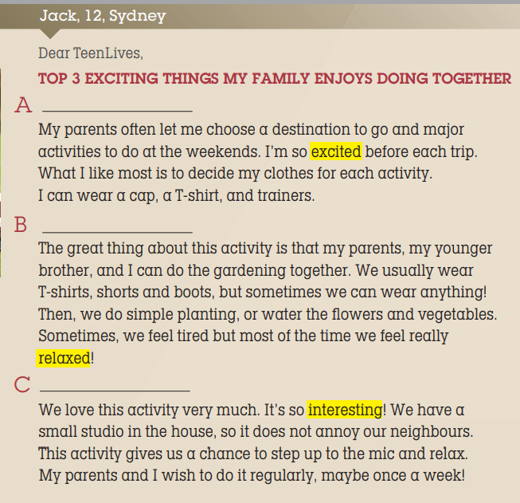
2. WHILE-READING 1 (7’)
ACTIVITY 3:
*Aim:
- To reinforce words of family activities.
- To help students practice identifying the general meaning of each paragraph.
- To help students practice matching the correct heading with each paragraph.
* Content: Read the letter from Jack then choose the best heading for it.
* Outcome: To know more new words about family activities. Understand more about using the words in contexts.
* Organisation: T, Ss …
3. Read the letter from Jack to TeenLives Magazine. Choose the best heading (1-3) for the paragraph (A-C)  (Exercise 3 – SB p.23)  - T asks Ss to look at exercise 3 (SB page 23).  - T calls a student to read the instruction then checks Ss’ understanding of it.  Step 1: Understanding the HEADINGS  - T asks Ss to look at the slide, read and match the heading with the pictures to elicit the Ss’ comprehension.  Step 2: Match the headings  - T and Ss review TIPS for reading and match the headings.  (Ss learnt the TIPS from Unit 1 already)  - T sets a time limit and asks Ss to work in pairs to complete the activity.  - T elicits the ideas from Ss, asks them in which line of the paragraph they see the answers.  - T asks Ss to explain their answers by referring to the clues the text.  - T confirms the answers then drills the pronunciation of the phrases and corrects Ss’ pronunciation if any. | Answer keys: A – B – C stand for the paragraphs.  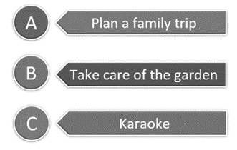
2. WHILE-READING 2 (5’)
ACTIVITY 4:
*Aim: To help students practice reading for specific information in an article.
* Content: To use the vocabulary of family activities grammar points to do the exercises.
* Outcome: To know more new words about family activities to relax. Understand more about using the words in contexts.
* Organisation: T, Ss …
4. Read the letter again. Choose the correct answer.  (Exercise 4 – SB p.23)  - T asks Ss to look at exercise 4 (SB page 23).  - T calls a student to read the instruction then checks Ss’ understanding of it.  - T and Ss review TIPS: reading for specific information.  (Ss learnt the TIPS from Unit 1 already)  - T tells student to read the text again individually to complete Exercise 4.  - When finished, T asks them to compare their answers in pairs and check with them.  - T asks students to point to relevant details in the text. | 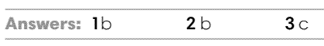
3. WHILE-READING 3 (5’)
ACTIVITY 5:
* Aim:
- To provide more vocabulary in context.
- To help Ss practice reading for specific information.
* Content: Discuss in groups the meanings of the adjectives by understanding the content of the given texts.
* Outcome: Understanding and explaining the meaning of the adjectives about feelings.
* Organisation: T, Ss ….
5. Look at the highlighted adjectives in the text. What do they mean?  (Exercise 5 – SB p.23)  - T asks students to find the highlighted adjectives in the text and discuss in groups of three the meanings of these words.  - T checks the answers with students.  - T uses slide to drill the pronunciations.  - T corrects Ss’ pronunciation if any. | 4. Answer keys:  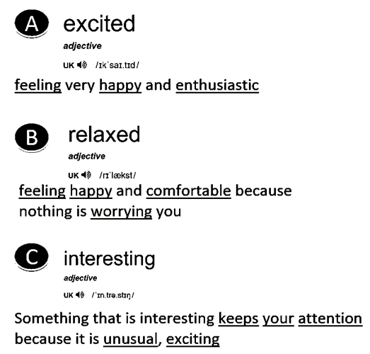
4. POST-READING (7’)
ACTIVITY 6:
* Aim: To encourage students to talk about their family members’ exciting activities.
* Content: To discuss the Ss’s exciting family activities.
* Outcome: Making sentences to talk about their family activities. Commenting about the sentences of others.
* Organization: T, Ss...
6. Work in group of four. Vote for the top three exciting activities that a family can do. Then share with your class.  (Exercise 6 – SB p.23)  - T asks Ss to look at exercise 6 (SB page 23).  - T calls a student to read the instruction then checks Ss’ understanding of it.  - T asks a student to read the example then models the activity in front of the class.  - T asks students to work in groups of four to discuss the  activities a family can do.  - T sets a time limit and monitors Ss while they are working in groups.  - When finished, T asks each group to vote for the three most  exciting activities and share with the class.  - T notes down common mistakes for delayed feedback.  - T asks the rest to give comments on their classmates’ performance.  - T gives feedback on Ss’ work. | 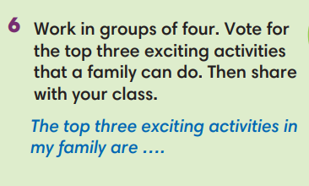
WRAP-UP & HOME WORK (4’)
- T asks Ss to talk about what they have learnt in the lesson.
- Vocabulary of family activities and adjectives.
- Reading a letter about family activities
- Some tips for reading skills
* HOME WORK
- Do exercises in the workbook page 18.
- Prepare for Lesson 2.4: Grammar 2.

====================

Date of planning:  Date of teaching: | UNIT 2: FAMILY AND FRIENDS  Lesson 4: Grammar 2
I. OBJECTIVES:
By the end of the lesson students will be able to:
- use Present Simple and Present Continuous to talk about what usually happens and is happening around now.
1. Knowledge:
* Grammar:
- Identify the Present Simple and Present Continuous (rules and time expressions)
- Talk about what usually happens and is happening around now
2. Competence: Understand and use vocabulary about habits and routines, and understand the rules and time expression of present simple and present continuous, then do the tasks assigned in the textbook; use the correct tense of verbs to form a question about daily routines or things happening at the speaking time or in a period of time.
3. Quality/ behavior: To teach Ss to be hard-working and attentive in class. Ss have a positive attitude to working in groups, individual work, pair work, cooperative learning and working.
II. TEACHING AIDS:
- Teacher: Grade 7 textbook, Unit 2 (SB p. 24), laptop/computer connected to the Internet, loudspeaker, projector/TV, PPT slides…
- Students: Textbooks, studying equipment…
- Method: Active teach, T-WC; group works; individual ……
III. PROCEDURE:

1. WARM UP (5’)
* Aim:
- To create a positive classroom atmosphere to start a new lesson.
- To help Ss review the words of hobbies and interests.
* Content: Game: Tom & Jerry (with the simple present)
* Outcome: Ss use the correct form of the verb in the Present Simple tense and Present Continuous tense.
* Organisation: T, Ss ..….

Teacher’s & Student’s activities |  | Content
Extra activity 1: Tom & Jerry Game  - T asks Ss to prepare 3 letter cards A, B and C (T may ask Ss to prepare them before the lesson.)  - T explains the game rules then checks instructions.  - Ss join in the game individually.  - T corrects Ss if necessary.  - T tells students to talk more about interests and hobbies by asking two questions:  What do you like doing in your free time?  How often do you do these activities? |  | Game rules:  - Read the sentence  - Show the letter card A, B or C to give answers.  - 1 correct answer = 1 point.  - 1 wrong answer => Tom catches Jerry.
2. LEAD-IN (3’)
*Aim:
- To lead into the new lesson.
- To provide Ss with reasons for listening to the text in exercise 1 (SB p.24).
* Content: Ss answer the questions about the activities.
* Outcome: Get the right answers on time.
* Organisation: T_ Ss ..….

Teacher’s & Student’s activities | Content
Extra activity 2: See – think – wonder.  - T shows a picture on the slide then asks students four questions.  (1) What can you see in the picture?  (2) What is the girl doing?  - T sets a time limit for Ss’ quick discussion.  - Ss work in pairs to make guesses about the picture then give answers.  - T calls some Ss to give answers then checks with the whole class.  - T introduces Kim. “This is Kim. She is talking about her routines.” | 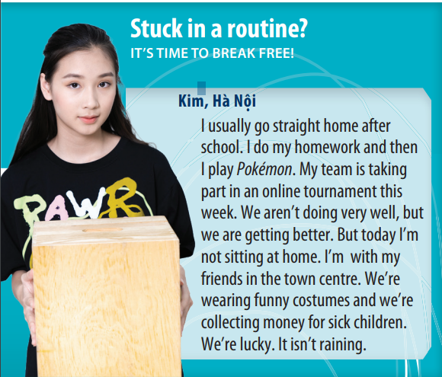
3. PRESENTATION (11’)
ACTIVITY 1 + 2:
*Aim:
- To present the grammar point in context.
- To lead into the next activity.
- To introduce to students the uses and time expressions of the Present Simple and Present Continuous tense.
- To explain the grammar point for Ss.
* Content: To practice using the present simple and present continuous in context by choosing the correct answer.
* Outcome: Practicing the use of the present simple and present continuous by writing the correct form of the verbs.
* Organisation: T, Ss ..….
Teacher’s & Student’s activities | Content
1. (7’) Read the text and answer the questions.  (Exercise 1 – SB p24)  - T asks Ss to open their SB page 24, look at exercise 1.  - T calls a student to read the instruction then checks Ss’ understanding of it.  - T calls four students to read for questions.  - T tells Ss that they are going to read the text to find answers.  - Ss work individually, read and note down the answers to the given questions.  - T calls some Ss to give answers then shows the answers on the slide. | Answer keys:  1. Kim usually goes straight home, does her homework and then plays Pokémon.  2. No, they aren’t (but they’re getting better).  3. Today she’s with her friends in the town canter, collecting money for sick children.
2. (4’) Find two more examples in the text for each rule below.  (Exercise 2 – SB p24)  - T goes through the Grammar box with students.  - T asks them which tense we use with adverbs of frequency such as always, usually, often (Present Simple).  - T asks them which tense we use to talk about something happening now, this week, today (Present Continuous).  - T reminds students that we use the Present Continuous not only for things happening exactly now but also for things happening around now, such as “I’m reading a great book.” (I’m not reading at this minute but I’m in the middle of reading the book.).  - T uses slide to show the grammar notes again.  - T asks Ss to look at exercise 2.  - T calls a student to read the instruction then checks Ss’ understanding of it.  - T asks Ss to work in groups of three to read the complete the activity.  - T calls groups to give answers then shows the answers on the slide to check as the whole class. | 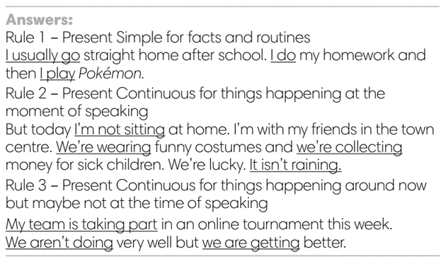
4. PRACTICE 1 (3’)
ACTIVITY 3:
* Aims: To help students identify the use of Present Simple and Present continuous.
* Content: Choose the correct option to complete the sentence.
* Outcome: Choose the option correctly in grammar and use present simple and present continuous to explain their options.
* Organisation: T, Ss, ….
Teacher’s & Student’s activities | Content
3. Choose the correct option  (Exercise 3 – SB p24)  - T elicits the example sentence with students.  - T asks them why the Present Continuous is the correct form to use (because it’s referring only to this semester, not as a permanent fact).  - T encourages students to discuss the other sentences in pairs,  to decide on the correct form and the reasons for this.  - T calls some students to share their answers.  - T corrects Ss’ pronunciation if any.  - T confirms the answers. | Answer keys:  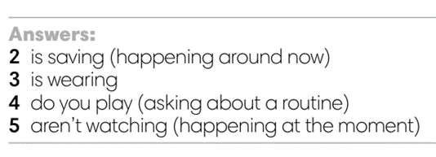
4. PRACTICE 2 (13’)
ACTIVITY 4:
* Aims: To help students practice making sentences in the Present Simple and Present Continuous.
* Content: Making correct sentences.
* Outcome: Making sentences describe someone’s usual life and what they’re doing by using present simple and present continuous.
* Organisation: T, Ss , Individual, Pair work, ….
Teacher’s & Student’s activities | Content
4. Make sentences with but to describe Paula’s usual life and what she’s doing now.  (Exercise 4 – SB p.24)  - T asks Ss to look at exercise 4.  - T calls a student to read the instruction then checks Ss’ understanding of it.  - T reminds students that we use but to link two contrasting ideas.  - T explains that in this instance, the contrast is between what usually happens and what is happening at the moment.  - T asks Ss to work in individually to write.  - Students write full sentences in their notebooks.  - T calls students to give answers then shows them on the slide to check as the whole class.  - T corrects Ss if any.  Further practice:  There are two more exercises from workbook.  - T uses the slides to lead the activity if time. | 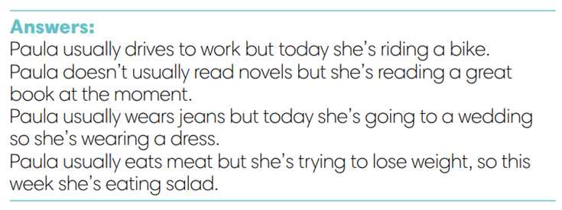
4. Production (7’)
ACTIVITY 5:
* Aims: To help students applying the vocabulary items and grammar points related to the topic in communicating.
* Content: Do class survey; interview partners using the cues words.
* Outcome: Use vocabulary items and grammar points related to the topic to interview partners.
* Organisation: T. Ss , Individual, Pair work, ….

Teacher’s & Student’s activities | Content
5. Class survey. Interview your classmates and write their names to complete the sentences.  (Exercise 5 – SB p.24)  - T asks Ss to look at exercise 5 (SB page 24).  - T calls a student to read the instructions then checks Ss’ understanding of it.  - T explains to the students that they are going to walk around  class and survey their friends.  - T elicits the questions that students may use to ask their friends.  - T models the activity in front of the class.  - T asks students to stand up and walk around the class and  interview other students to complete the sentences.  - T walk around to listen and notes down common mistakes for delayed feedback.  - T invites some students to report their sentences to the class.  - T asks the other students to give comments on their classmates’ performance.  - T gives feedback on Ss’ work. | 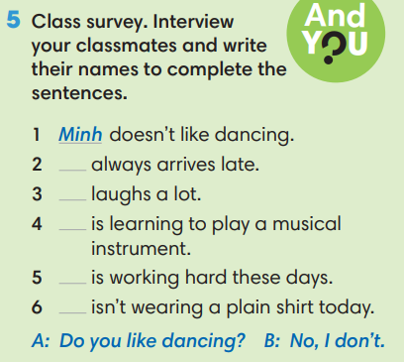
WRAP-UP & HOME WORK (3’)
- T asks Ss to talk about what they have learnt in the lesson.
- The present simple and present continuous tense: rules and time expressions
* HOME WORK
- Do exercises in the workbook page 19.
- Prepare for Lesson 2.5: Listening and vocabulary.
=========================

Date of planning: Date of teaching: | UNIT 2: FAMILY AND FRIENDS  Lesson 5: Listening and Vocabulary
I. OBJECTIVES:
By the end of the lesson student will be able to:
- identify specific details in a conversation and talk about personalities.
1. Knowledge:
* Vocabulary: use vocabulary of personalities to describe people.
* Grammar: make sentences in the Present Simple and Present Continuous to describe people’s interest and habit correctly.
2. Competence: Understand and use adjectives of personalities, do the tasks assigned in the textbook. Listen and identify specific details in a conversation and talk about personalities.
3. Quality/ behavior: To teach Ss to be hard-working and attentive in class. Ss have a positive attitude to working in groups, individual work, pair work, cooperative learning and working.
II. TEACHING AIDS:
- Teacher: Grade 7 textbook, Unit 2 (SB p. 25, WB p.20), laptop/computer connected to the Internet, loudspeaker, projector/TV, PPT slides…
- Students: Text books, studying equipment…
- Method: Active teach, T-WC; group works; individual ……
III. PROCEDURE:
1. WARM UP + LEAD-IN (10’)
ACTIVITY 1:
* Aim:
- To activate students’ prior knowledge and get students involved in the lesson.
- To set the context for introducing new words.
- To get students to think about the topic.
- To provide Ss with reasons for more discussions
* Content: Play SONGS game to practice the listening skill.
* Outcome: Know more new words in context. Improve pronunciation.
* Organisation: T, Ss ..
Teacher’s &Student’s activities | Content
Extra activity 1 (5’): SONGS  - T greets students  - T introduces the Warm-up song  - T explains How-to-play steps then checks instructions.  - Ss join the activity as the whole class.  - T uses slides to conduct the activity.  - T introduces that all the words are adjectives of Personalities.  - T elicits the meaning and drill the pronunciation of the words.  - T sets the scene for the new lesson: T tells Ss that they are going to learn more words of personalities by doing a listening task.  - T writes the title on the board Unit 2: Family and Friends / Lesson 2.5: Listening and Vocabulary. | How to play:  - Read the list of given words  - Listen to a song, put a tick next to the word you hear.  - 1 correct answer = 1 point
1. (5’) Tell your partner about the personalities of two people in your family.  (Exercise 1 – SB p.25)  - T asks students to work in pairs to talk about the personalities  of two people in their family.  - Ss work in pairs to think and share.  - T invites some students to share with the class.  - T notes down the adjectives that students used to talk about  personalities on the board.  - T tells Ss that they’re going to learn adjectives in the next steps of the lesson. | 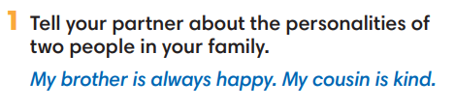
2. PRE-LISTENING (18’)
ACTIVITY 2 + 3:
*Aim:
- To activate Ss’ prior knowledge of the topic.
- To pre-teach words of personalities
- Introduce the Vocabulary Box
- To reinforce words of personalities
- To develop Critical Thinking
- To reinforce words of personalities
* Content: Some brief notes; vocabulary about personalities. Use them to complete the exercise.
* Outcome: Know some more new words about personalities. Chose the correct words to answer the questions.
* Organisation: T, Ss …
Teacher’s &Student’s activities | Content
Extra activity 2 (10’): Multiple Choice Game  (pre-teach vocabulary)  - Teacher introduces that Ss will learn more words of personalities by joining a game.  - T explains the game rules then checks instructions.  - Ss join the game in team. Ss take turns to answer each question.  - Teacher leads the game and asks students to read aloud each word or phrase.  - When the game ends, teacher shows all the new words again for students to read. | How to play:  - Look at the slides and read the definitions  - Read the words of personalities  - Choose 1, 2 or 3 to match the word with the definition  - 1 correct answer = 1 point
2. (4’) Tick (V) the positive adjectives and cross (X) the negative ones.  (Exercise 2 - SB p.252)  - T asks Ss to look at exercise 2.  - T calls a student to read the instruction then checks Ss’ understanding of it.  - T elicits the meaning of Positive and Negative  - T asks Ss to work in pairs or small groups to read then complete the activity.  - T calls groups to give answers to check as the whole class.  - T encourages students to make sentences with these adjectives. | 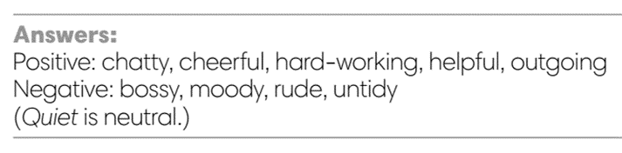
3. (4’) Minh, Nam and Linh are talking about Mai. Read their opinions and complete each gap with a word from the Vocabulary box. Listen and check.  (Exercise 3 - SB p.25)  - T asks Ss to look at exercise 3.  - T calls a student to read the instruction then checks Ss’ understanding of it.  - T asks students to look at the photo of Mai and discuss Mai's  personality in groups of three or four.  - T plays the audio and ask students to complete the gaps.  - T plays the audio again for Ss to check with the answers.  - T checks as the whole class. | Answer keys:  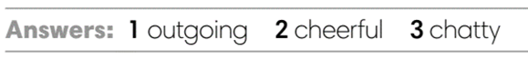
3. WHILE-LISTENING (8’)
ACTIVITY 4:
* Aim:
- To help Ss identify specific details in a conversation.
- To provide Ss with chances to think and talk about personalities.
* Content: Listen and understand the audio track to complete the exercise.
* Outcome: Understanding the personalities by matching the correct answers.
* Organisation: T_ Ss …
Teacher’s &Student’s activities | Content
4. Listen to a talk between Minh and Nam. Mark the sentences V (right), X (wrong), ? (doesn’t say).  (Exercise 4 - SB p.25)  - T asks Ss to look at exercise 4 in student book page 25.  - T calls a student to read the instruction then checks Ss’ understanding of it.  - T tells students to read the statements before listening.  - T asks students to listen and mark the sentences (i.e., v, x, ?).  - T plays the audio and have students do the exercise.  - T tells Ss to check their answers in pairs.  - T plays the audio again and checks the answers with the  whole class.  - Teacher encourages students to give the evidence that they hear from the audio track to prove their answer. | 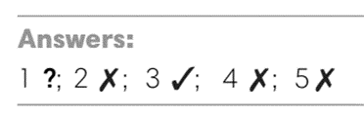
4. POST-LISTENING (6’)
ACTIVITY 5:
*Aim: TTo help students applying the vocabulary items related to the topic in communicating.
* Content: Work in pairs to describe one’s personalities by using adjectives.
* Outcome: Think and share about individual personality.
* Organisation : T, Ss ..
Teacher’s &Student’s activities | Content
5. In pairs, choose three adjectives from the Vocabulary Box to describe.  (Exercise 5 - SB p.25)  - T asks Ss to look at exercise 5 in student book page 25.  - T calls a student to read the instruction then checks Ss’ understanding of it.  - T asks Ss to work in pairs to read then complete the activity.  - T sets a time limit for students.  - Students work in pair to think and share.  - Teacher invites different students to talk about their partner. | 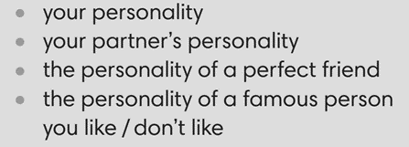
WRAP-UP & HOME WORK ( 2’)

- T asks Ss to talk about what they have learnt in the lesson.
- Vocabulary of personalities
* HOME WORK
- Do exercises in the workbook page 20.
- Prepare for Lesson 2.6: Speaking.

=====================

Date of planning:  Date of teaching: | UNIT 2: FAMILY AND FRIENDS  Lesson 6: Speaking
I. OBJECTIVES:
By the end of the lesson student will be able to:
- improve speaking skills by giving and responding to news.
1. Knowledge:
* Vocabulary: use the expressions of giving and responding to news.
* Grammar: make dialogue in the Present Simple, Present Continuous with expressions of giving and responding to news.
2. Competence: Ss understand and use the expressions of giving and responding to news as well as the other related topics to the lesson content, do the tasks assigned in the textbook. Listen and read a dialogue for comprehension and practice in giving and responding news.
3. Quality/ behavior: To teach Ss to be hard-working and attentive in class. Ss have a positive attitude to working in groups, individual work, pair work, cooperative learning and working.
II. TEACHING AIDS:
- Teacher: Grade 7 textbook, Unit 2 (SB p. 26, WB p.21), laptop/computer connected to the Internet, loudspeaker, projector/TV, PPT slides…
- Students: Text books, studying equipment…
- Method: Active teach, T-WC; group works; individual ……
III. PROCEDURE:
1. WARM UP + LEAD-IN (5’)
* Aim:
- To create a positive classroom atmosphere to start a new lesson.
- To review adjectives of personalities.
- To lead into the topic.
* Content: Play Minion Games to recall the vocabulary in previous lessons.
* Outcome: Students choose the correct answers by using the vocabulary in previous lessons.
* Organization of implementation: T- Ss
Teacher’s & Student’s activities |  | Content
Extra activity 1: Minion Games  - T greets students and asks Ss what topic they learnt from last lesson.  - Students discuss and list out all words they remember from previous lesson.  - T introduces the Minion Games and How to play steps  - T uses the slides to lead the game.  - When Ss finish the game, T shows a picture of Mai and reminds students of Mai’s friends’ opinions about her.  - T introduces that Mai and one friend will be the main characters in today lesson.  - T writes the title of new lesson: Unit 2 / Lesson 6 - Speaking |  | How to play:  - Read the sentence carefully.  - Choose A or B to fill in the blank.  - 1 correct answer = 1 point.
2. PRE-SPEAKING (15’)
ACTIVITY 1 + 2:
* Aim:
- To activate Ss’ prior knowledge of the topic.
- To present the prompts of news
- To introduce 3 questions
- To introduce the Speaking Box
- To identify the different news and response
* Content: Listen to the conversation to answer the questions about Kim and Mai’s news.
* Outcome: Know about giving and receiving news. Understand the conversation.
* Organisation: Teacher’s instructions…

Teacher’s & Student’s activities |  |  | Content
1. (5’) Listen. What is the news from Mai and Kim?  (Exercise 1 – SB p.261)  - Set the scene: T tells Ss to look at the picture in their student book page 26. Today, Mai meets Kim, and they are giving each other some news.  - T encourages students to predict what news Mai and Kim may give.  - T asks Ss to read exercise 1 directions and check understanding.  - T plays the audio for students to listen  - Ss listen and note down in their notebooks what they can here.  - T calls some students to share their answers and checks as the whole class.  - T shows the three questions in OUT OF CLASS part  - T introduces that the three questions are asked to update news from our friends.  - T sets the transition for the next step of the lesson: “Now, let’s learn more of expressions to give and respond to the news.” |  |  | Key answers:  Mai: My mum’s sister is staying with us, and we all love her.  Kim:  - My dance class is going well.  - We’ve got a new teacher. She’s great, friendly, and cheerful!
2. (10’) In pairs, complete the Speaking Box with the phrases below.  (Exercise 2 – SB p. 26)  - T asks Ss to look at exercise 2.  - T calls a student to read the instruction then checks Ss’ understanding of it.  - T asks students to read the three expressions of responding, elicits the meaning if needed.  - You’re kidding!  - Cool!  - Poor you!  - T raises the questions: When do we say the phrases?  - T allows students to discuss in pairs or small groups before sharing the answers to teacher.  - T confirms the correct answers.  - T tells students to look at the Speaking Box and complete the missing phrases.  - T calls groups to give answers to check as the whole class.  - T tell students to practice reading aloud the Speaking Box  - T explains that the news we give can be surprising, positive, or negative. So that we respond differently to each type of news.  - T tells students to read the Speaking Box again and say which expression is used for surprising/ positive/ negative news. |  |  | Answer keys:  - You’re kidding! In response to surprising news  - Cool! to say something is positive  - Poor you! if something bad has happened to the others  Answer keys:  1 – Cool!  2 – Poor you!  3 – You’re kidding!
3. WHILE-SPEAKING (13’)
ACTIVITY 3:
* Aim:
- To reinforce expressions of giving and responding to news
- To practice using the new expression in context
- To reinforce expressions of giving and responding to news
* Content: Choose the correct answer to talk about news.
* Outcome: Understand the use of expressions to communicate.
* Organisation: T, Ss ..….
Teacher’s & Student’s activities |  |  |  | Content
3. (10’) Choose the correct option.  (Exercise 3 - SB p.26)  - T goes through the Speaking Box with students again.  - T asks Ss to look at exercise 3.  - T calls a student to read the instruction then checks Ss’ understanding of it  - T asks Ss to work in pairs to read then complete the activity.  - T checks as the whole class.  Pair work task 1  - T sets a limit for students to work in pairs to practice the 4 situations in Exercise 3 as a role play.  - T invites some pairs of students to act out the roleplay in front of the class.  Pair work task 2: Use the Speaking Box and replace the current response by another suitable expression  - Ss work in pair, practice the dialogue, then act out. |  |  |  | Answer keys:  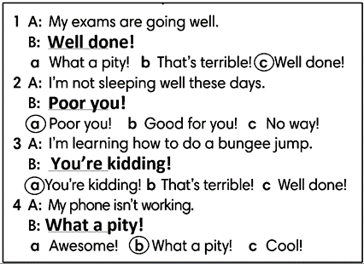
Extra activity 2 (3’): Extended Practice to reinforce the new expressions
- T shows 4 pieces of news with multiple choice responses.
- T asks Ss to read and classify the news as surprising (S), positive (P) or negative (N).
- T tells Ss to choose the correct response for each news.
- Ss read, say, and choose the answers as the whole class.
- T checks and confirms the correct answers.
4. POST-SPEAKING ( 8’)
ACTIVITY 4:
*Aims: To help students applying the new language and skills related to the topic in communicating.
* Content: Give and receive the news from each other’s.
* Outcome: To practice speaking by sharing both bad and good news; use expressions in communicating.
* Organisation : T, Ss .…

Teacher’s & Student’s activities | Content
4. Work in pairs. Student A gives some good and bad news. Student B responds to the news. Use the Speaking box.  (Exercise 4 - SB p.26)  - T tells student to look at the speaking box in their student book again and prepare for the task.  - T gives students time to think about what they are going to say in their roleplays.  - If students have difficulty thinking of true pieces of news, T encourages them to use their imagination.  - T encourages stronger students to give some very first examples.  - Students work in the same pairs from the last activity and practice their role plays, focus on using the correct intonation.  - T tells students to do the activity with their books closed, so that their reactions can be natural, and they don’t just read from the Speaking box.  - Teacher invites pairs to act out their roleplays in front of the class. | 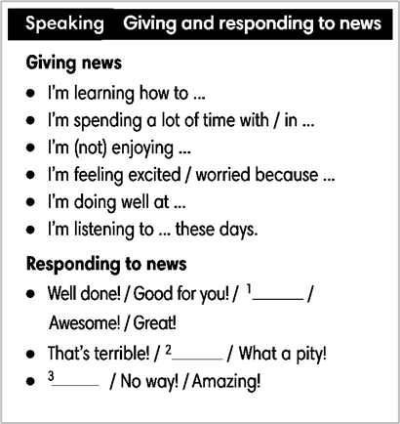
WRAP-UP & HOME WORK (2’)
- T asks Ss to talk about what they have learnt in the lesson.
- Expressions of giving and responding to news
* HOME WORK
- Do exercises in the workbook page 21.
- Prepare for Lesson 2.7: English In Use

Date of planning:  Date of teaching: | UNIT 2: FAMILY AND FRIENDS  Lesson 7: English in Use
I. OBJECTIVES:
By the end of the lesson, Ss are able to:
- use prepositions of time to talk about when something happens.
1. Knowledge:
* Grammar:
- Use correctly prepositions IN – ON – AT in time expressions
- Talk about when something happens
2. Competence: Ss understand and use the vocabulary about after school activities and understand the use of IN – ON – AT in time expressions, then do the tasks assigned in the textbook. use the correct tense of verbs, prepositions of time to form a question and answer to talk about when something happens.
3. Quality/ behavior: To teach Ss to be hard-working and attentive in class. Ss have a positive attitude to working in groups, individual work, pair work, cooperative learning and working.
II. TEACHING AIDS:
- Teacher: Grade 7 textbook, Unit 2 (SB p. 27), laptop/computer connected to the Internet, loudspeaker, projector/TV, PPT slides…
- Students: Text books, studying equipment…
- Method: Active teach, T-WC; group works; individual ……
III. PROCEDURE:
1. WARM UP (5’)
* Aim:
- To create a positive classroom atmosphere to start a new lesson.
- To review after school activities and early introduce IN – ON - AT.
* Content: Game: Space Shuttle Game (about after school activities)
* Outcome: Ss guess and choose the correct picture.
* Organization of implementation
Teacher’s & Student’s activities | Content
Extra activity 1: Space Shuttle Game  - T asks Ss What do they often do after school?  - T tells students that they are playing a game with activities.  - T explains the game rules then checks instructions.  - T uses the slides to lead the game  - Ss join in the game individually.  - T corrects Ss if necessary.  - T tells students to recall all after school activities from the game. | Game rules:  - Look at the picture. Read the sentence  - Guess and choose the correct after school activity.  - 1 correct answer makes the shuttle space move
2. LEAD-IN (3’)
* Aim:
- To lead into the new lesson.
- To provide Ss with reasons for reading the cartoon in exercise 1 (SB p.27).
* Content: Discuss in groups and give the answer about the girl in the pictures.
* Outcome: Guess the correct answers to the questions.
* Organisation: T_ Ss ..….
Teacher’s & Student’s activities | Content
Extra activity 2: See – think – wonder.  - T shows the cartoon pictures on the slide then asks students four questions.  (1) What can you see in the pictures?  (2) Who are in the pictures?  (3) What’s the girl doing in each picture?  (4) Is the girl happy?  - T sets a time limit for Ss’ quick discussion.  - Ss work in pairs to make guesses about the pictures then give answers.  - T calls some Ss to give answers then checks with the whole class.  - T introduces Holly. “This is Holly. She is tired because she has too many extra classes after school.” | 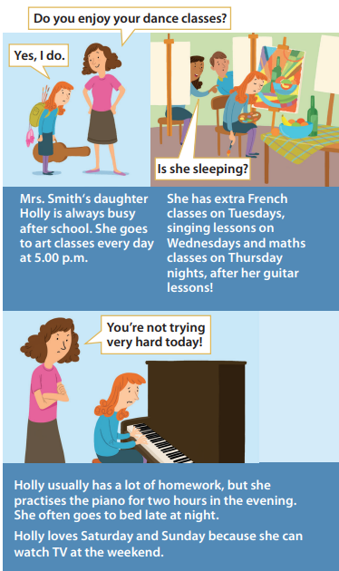
3. PRESENTATION (11’)
ACTIVITY 1 + 2:
* Aim:
- To present the grammar point in context of a cartoon.
- To introduce the Grammar Box through the reading tasks
- To introduce to Grammar Box
- To explain the grammar point for Ss.
* Content: Read the cartoon about Holly to practice grammar.
* Outcome: Do the exercise to improve grammar.
* Organisation : T_ Ss ..….
Teacher’s & Student’s activities | Content
1. (7’) Read the cartoon. How many extra classes does Holly have?  (Exercise 1 – SB p27)  - T asks Ss to open their SB page 27, look at exercise 1.  - T calls a student to read the instruction then checks Ss’ understanding of it.  - T tells Ss that they are going to read the cartoon to find the answers.  - Ss work individually, read, and note down the answers to the given question.  - T calls some Ss to give answers then shows the answers on the slide.  - T tell students that IN – ON – AT are the prepositions of time. | 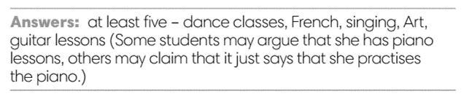
2. (4’) How many examples of prepositions can you find in the cartoon in thirty seconds?  (Exercise 2 – SB p27)  - T asks Ss to open their SB page 27, look at exercise 2.  - T calls a student to read the instruction then checks Ss’ understanding of it.  - T gives students the thirty-second time limit and asks them  how many prepositions they found.  - T elicits the prepositions and the words that come after them the text.  Discuss the Language box with the class  - T uses slide to show the grammar notes again.  - T goes through the Grammar box with students.  - T asks Ss to work in groups of three to read all uses of IN – ON – AT, elicits the meanings if needed. | 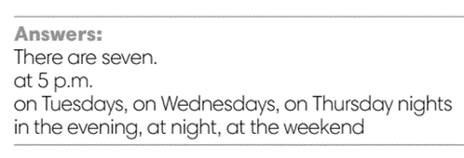  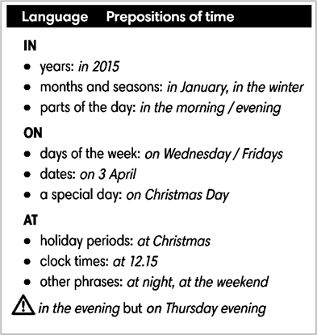
4. PRACTICE 1 (3’)
ACTIVITY 3:
* Aim: To help students identify the use of IN – ON – AT in time expressing.
* Content: Use the prepositions to complete the sentence.
* Outcome: Write correct prepositions using in, at or on.
* Organisation : T_ Ss.. ….

Teacher’s & Student’s activities | Content
3. Write correct prepositions: in, at or on.  (Exercise 2 – SB p27)  - T elicits the example sentence with students.  - T encourages students to discuss the other sentences in pairs,  to decide on the correct form and the reasons for this.  - T calls some students to share their answers.  - T corrects Ss’ pronunciation if any.  - T confirms the answers. | 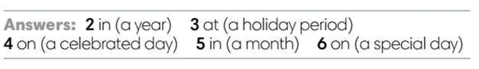
5. PRACTICE 2 (6’)
ACTIVITY 4:
* Aim: To reinforce the use of IN – ON - AT.
* Content: Use the prepositions to complete the sentence.
* Outcome: Write correct prepositions using in, at or on.
* Organisation : T_ Ss.. ….

Teacher’s & Student’s activities | Content
4. Complete the text with in, at or on.  (Exercise 4 – SB p.27)  - T asks Ss to look at exercise 4.  - T calls a student to read the instruction then checks Ss’ understanding of it.  - T asks Ss to work in individually to write.  - Students write the answers in their books.  - T calls students to give answers then shows them on the slide to check as the whole class.  - T corrects Ss if any.  Further practice:  THE STAMP GAME:  How to play:  - Read the sentence  - Fill in the blank with IN, ON or AT  - 1 correct answer gets 2 points | 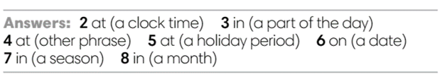
6. PRODUCTION (7’)
ACTIVITY 5:
*Aim: To help students applying the vocabulary items and grammar points related to the topic in communicating.
* Content: Ss ask and answer the questions in pairs.
* Outcome: Cross-check writing pieces and follow the writing rubric.
* Organisation: T_ Ss .…….

Teacher’s & Student’s activities | Content
5. In pairs, ask and answer the questions:  - What do you do after school?  - What do you often do at the weekend?  (Exercise 5 – SB p.27)  - T asks Ss to look at exercise 5 (SB page 27).  - T calls a student to read the instructions then checks Ss’ understanding of it.  - T explains to the students that they are going to work in pair for this task  - T elicits the questions that students may use to ask their friends.  - T models the activity in front of the class.  - T asks some strong students to stand up and recall some after-school activities that they’ve learn from the warm-up game.  - T writes the activities on boards for reference  - Students work in pairs to complete the task.  - T walk around to listen and notes down common mistakes for delayed feedback.  - T invites some students to present their dialogue to the class.  - T asks the other students to give comments on their classmates’ performance.  - T gives feedback on Ss’ work. | 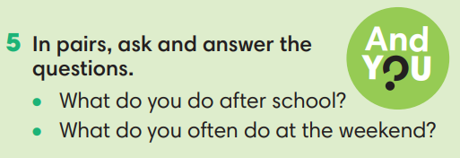
WRAP-UP & HOME WORK (3’)
- T asks Ss to talk about what they have learnt in the lesson.
- Time expressions IN – ON – AT
- Talk about when something happens
* HOME WORK:
- Do exercises in the workbook page 22.
- Prepare for Lesson 2.8: Vocabulary in action and Pronunciation

======================

Date of planning:  Date of teaching: | UNIT 2: FAMILY AND FRIENDS  Lesson 8: Vocabulary in Action and Pronunciation
I. OBJECTIVES:
By the end of the lesson student will be able to:
1. Knowledge:
* Vocabulary: review vocabulary
- The lexical items related to: clothes, accessories and adjectives of personalities to describe people
- Present simple and present continuous
* Pronunciation: Correctly pronounce words that contain the sounds /æ/ and /e/
2. Competence: Students develop communication skills, presentation skills, and creativity; being collaborative and supportive in pair work, teamwork, and actively join in class activities.
3. Quality/ behavior: To teach Ss the love of talking about clothes and describing people, and develop self-study skills. Ss have a good attitude to working in groups, individual work, pairwork, cooperative learning, and working
II. TEACHING AIDS:
- Teacher: Grade 7 textbook, Unit 2 (SB p.27), laptop/computer connected to the Internet, loudspeaker, projector/TV, PPT slides… .
- Students: Text books, studying equipment…
- Method: Active teach, T-WC; group works; individual ……
III. PROCEDURE:
1. WARM UP + LEAD-IN (4’)
*Aims:
- To create an active atmosphere in the class before the lesson.
- To lead into the new lesson.
* Content: Game: NAME 3 THINGS CHALLENGE (family and friends)
* Outcome: Students say words relating to the given topic quickly.
* Organisation : Teacher’s instructions…
Teacher’s & Student’s activities | Content
Extra activity 1: NAME 3 THINGS CHALLENGE  * Teacher asks students to spend 1 minutes to quickly review all vocabulary they have learnt in Unit 2 before they play a warm-up game.  - T tells students that they are going to play a game called NAME 3 THINGS CHALLENGE  - T explains the game rules then checks instructions.  - Teacher uses the slides to show the challenge  - Ss join in the game pairs or in small groups.  - Teacher listens to the Ss answers and calls several Ss to check for the whole class.  - T tells Ss that they can remember better with Glossary Table and asks Ss to open their Student Book page 28 – Exercise 1. | Game rules:  - Choose a number to get the challenge  - Read the topic word  - Say 3 words relating to that topic quickly.
2. REVIEW VOCABULARY (14’)
ACTIVITY 1 + 2 + 3:
*Aim:
- To introduce the glossary and its uses.
- To give further practice in making sentences using the Glossary.
* Content: Revise what they have learnt during the unit. Glossary and its uses.
* Outcome: Remember the new words and describe what a person you know usually wears and what he/she is wearing today.
* Organisation : Teacher’s instructions…
Teacher’s & Student’s activities | Content
1. (5’) Use the Glossary to find.  (Exercise 1 – Student Book page 28)  - Teacher introduces the Glossary Table.  - T asks Ss to look at exercise 1 in student book page 28  - T has students use the glossary to find the words which belong to the correct category  - T asks students to work in pairs and quickly do the task.  - T allows students to peer check first.  - T checks and confirms the answers. | Answer key:  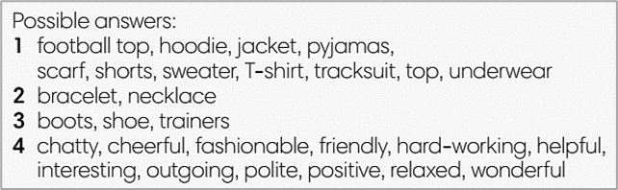
2. (5’) Use the glossary to describe what a person you know usually wears and what he/she is wearing today.  (Exercise 2 – Student Book page 28)  - T reminds students about the model sentences to describe what people are wearing.  - T asks students to do this activity individually. Have students read all the sentences carefully to make sure they check the grammar carefully  - T lets them share their sentences in pairs.  - T invites some students to give the describing sentences.  - T checks the grammar, pronunciation if needed. | e.g.  My best friend usually wears jeans. Today she’s wearing a dress.
3. (4’) Complete the Word Friends..  (Exercise 3 – Student Book page 28)  - T asks students to complete the sentences with suitable words.  - T asks students to work individually and check in pairs.  - T invites students to share their answers.  - T confirms the correct answers.  Extra-Practice  TIME TO TALK: Use the Word Friends and make sentence for you  - T encourage students to make sentences using the word friends in exercise 3  - Ss work in pairs to share true information about themselves | Answer key:  1. well  2. part / money  3. to
3. PRONUNCIATION (14’)
3.1. Presentation (4’)
* Aims:
- To present new sounds
- To help students identify how to pronounce the sounds /æ/ and /e/
* Content: Game: HEAR AND CLAP to practice pronunciation.
* Outcome: Pronoun some sounds after each play.
* Organisation: Teacher’s instructions…
Teacher’s & Student’s activities | Content
Extra activity 2: HEAR AND CLAP GAME  - T tells students that they are going to play a game called HEAR AND CLAP  - T explains the game rules then checks instructions.  - Teacher uses the slides to lead the game  - Ss join in the game pairs or in small groups.  - T listens to the Ss answers and calls several Ss to check for the whole class.  - T asks students to say the word again to practice some sounds after each play. | Game rules:  - Hear the sound  - Read the words  - Clap your hands 1 or 2 times to choose the word you hear.
3.2. Practice (10’)
ACTIVITY 4:
* Aims:
- To help students practice pronouncing these sounds in words.
- To help students pronounce the sounds /æ/ and /e/ correctly in sentences.
- To help students identify the sounds /æ/ and /e/ correctly in words.
* Content: Listen to the sample pronunciation to choose the correct answer.
* Outcome: Read and write the words correctly.
* Organisation : Teacher’s instructions…

Teacher’s & Student’s activities | Content
4a. Listen to the underlined vowel(s) in each word and describe which sound you hear. Write the word in the correct column.  (Exercise 4a– Student Book page 28)  - T calls some students to read out the words first.  - T plays the recording for them to listen and underline vowel(s) in each word.  - T asks Ss to write the word in the correct column.  /æ/ and /e/  - T invites some students to share their answers.  - T confirms the correct ones. | 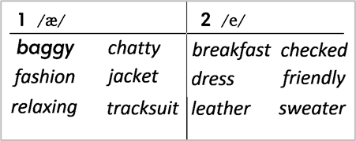
4b. Listen, check and repeat.  (Exercise 4b– Student Book page 28)  - T plays the recording for them to listen and repeat the words they hear.  - T asks Ss to pay close attention to the two sounds.  - T plays the recording again if needed.  - T explains to students the difference between the two sounds if needed.  - T invites some students to say some words they know that include the two sounds.  - T confirms the correct answers. | (Teacher can play the pronunciation guide video of this unit for students to watch and learn).
4. FURTHER PRACTICE (5’)
* Aim: To reinforce the student's recognition of the targeted sounds.
* Content: Game: ODD ONE OUT - practice the pronunciations by choosing the word that has a different sound.
* Outcome: Differentiate the sounds to practice the pronunciations. Saying the sounds correctly.
* Organisation: Teacher’s instructions…
Teacher’s & Student’s activities | Content
Extra activity 3: ODD ONE OUT  - T explains the game rules then checks instructions.  - Teacher uses the slides to lead the activity  - Ss join the activity in pairs or in small groups.  - T listens to the Ss answers and calls several Ss to check for the whole class.  - T asks students to say the word again to practice some sounds after each question. | Game rules:  - Read and choose A, B or C to odd out one word  - Explain by correctly saying the sounds
WRAP-UP & HOME WORK ( 3’)
- Teacher asks students to talk about what they have learnt in the lesson.
* HOME WORK
- Find more words relating to clothes, personalities that have the sounds /æ/ and /e/

==================
Date of planning:  Date of teaching: | UNIT 2: FAMILY AND FRIENDS  Lesson 9: Revision
I. OBJECTIVES:
By the end of the lesson, Ss are able to:
1. Knowledge:
* Vocabulary: revise words related to clothes, accessories, personalities, and time expressions.
* Grammar: review present simple, present continuous tense to describe people, talk about after school activities, give and respond to news.
2. Competence: Ss understand and use the vocabulary of the unit, do the tasks assigned in the textbook. Participate in a guided conversation to give and respond to news using given information.
3. Quality/ behavior : To teach Ss to be hard-working and attentive in class. Ss have a positive attitude to working in groups, individual work, pair work, cooperative learning and working.
II. TEACHING AIDS:
- Teacher: Grade 7 textbook, Unit 2 (SB p. 29, WB p.23), laptop/computer connected to the Internet, loudspeaker, projector/TV, PPT slides…
- Students : Text books, studying equipment….
- Method: Active teach, T-WC; group works; individual ……
III. PROCEDURE:

- WARM-UP (4’)

*Aims:
- To create a positive classroom atmosphere to start a new lesson.
- To lead into the review lesson.
* Content: Game: SUPER EYES
* Outcome: Ss understand that they are going to review Unit 2.
* Organisation: Teacher’s instructions…
Teacher’s & Student’s activities | Content
Extra activity 1: SUPER EYES  - Set the scene: T asks students to do quick exercises for eyes such as look up and down, look left and right, row the eyes  - T tells students that they are going to play a game called SUPER EYES  - T explains the game rules then checks instructions.  - Teacher uses the slides to show the collages  - Ss join in the game pairs or in small groups.  - Teacher shows the collage again with displayed answers to check for the whole class.  - T tells Ss that they are going to review Unit 2. | Game rules:  - Look carefully at a collage of different small pictures  - The collage will disappear in a few seconds  - Recall as many words about the collage as you can remember.
- REVIEW VOCABULARY (17’)

ACTIVITY 1 + 2 + 3:
* Aims:
- To help students reviews topic words and word friends from the unit
- - To review vocabulary with critical thinking
- To review vocabulary in context
* Content: Do the exercise to revise the vocabulary of Unit 1.
* Outcome: Understand the vocabulary to do the exercise correctly.
* Organisation : Teacher’s instructions….
Teacher’s & Student’s activities | Content
Extra activity 2: (5’) SUPER MIND  - T tells students to open the Glossary box in student book page 28  - T introduce the SUPER MIND game and rules  - T shows the slides of the game  - Ss take turns to choose the numbers for their teams.  - Ss discuss and list out all words related to the topic they get.  - T calls some Ss to give answers and confirms the winner. | How to play:  - Play in team  - Choose a number to open a block  - Read the topic word  - Write as many words related to the topic as you can  - The faster finisher gets points
1. (3’) Choose the odd one out  (Exercise 1 – Student Book page 29)  - T asks Ss to look at exercise 1 in student book page 29  - T calls a student to read the instruction then checks Ss’ understanding of it.  - T asks Ss to work in pairs to read then complete the activity.  - T encourages students to give the reason for their answer.  - T checks as the whole class. | Answer keys:  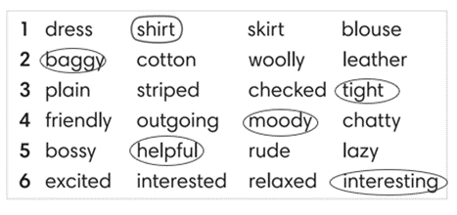
2. (6’) Complete the second sentence so that it means the same as the first one. In pairs, say if the sentences are true for you.  (Exercise 2 – Student Book page 29)  - T asks Ss to look at exercise 2 in student book page 29  - T calls a student to read the instruction then checks Ss’ understanding of it.  - T asks Ss to work in pairs to read then complete the activity.  - Ss work in pair to complete the task and compare the answers.  - T checks as the whole class.  Exercise 2 - Time to talk:  - T asks Ss to work in pairs to share their facts.  - Ss work in pairs to say which statements are true for them. | Answer keys:  2. is boring / 3. annoyed / 4. shocking / 5. Relaxed  Example:  Number 1 is true for me. I’m not into fashion.  Number 4 is not true for me.
3. (3’) Complete Word Friend in the text. Use the words in correct form.  (Exercise 3 – Student Book page 29)  - T asks Ss to look at exercise 3 in student book page 29  - T calls a student to read the instruction then checks Ss’ understanding of it.  - T asks Ss to work in pairs to read then complete the activity.  - Ss work in pair to complete the task and compare the answers.  - T checks as the whole class. | Answer keys:  2. to 5. brushing  3. getting 6. lose  4. annoyed 7. get
3. REVIEW GRAMMAR ( 24’)
ACTIVITY 4 + 5 + 6:
*Aim:
- To help students revise the form and use of the present simple, present continuous. Preposition of time
- To help students practice the present simple and present continuous
- To help students practice the present simple and time expression in a communicative activity
- To help student practice speaking skill in a task: give and respond to news
* Content: Use the present simple and present continuous to complete the exercises.
* Outcome: Use the present simple and present continuous for communication and writing.
* Organisation : Teacher’s instructions….
Teacher’s & Student’s activities | Content
Extra activity 3: (3’) Read the grammar boxes and review the grammar points.  - T asks Ss to look at the grammar box and read the example.  - T shows slides for detail review grammar  - Ss read the review content together before they do some grammar tasks. | 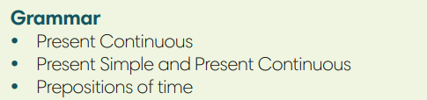
4. (5’) Complete the sentences with Present Simple or Present Continuous form of verbs in brackets.  (Exercise 4 – Student Book page 29)  - T asks Ss to look at exercise 4 in student book page 29  - T calls a student to read the instruction then checks Ss’ understanding of it.  - T asks Ss to work in pairs to read then complete the activity.  - Ss work in pairs to complete the task and compare the answers.  - T checks as the whole class. | Answer keys:  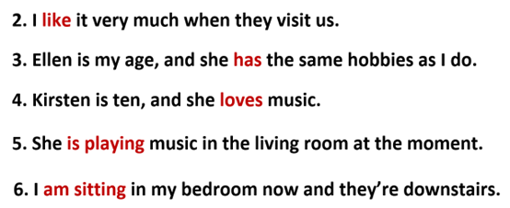
5. (8’) Write answers to the questions.  Use at, in or on with a time expression. Then compare with a partner.  (Exercise 5 – Student Book page 29)  Step 1: Time to write  - T asks Ss to look at exercise 5 in student book page 29  - T calls a student to read the instruction then checks Ss’ understanding of it.  - T elicits an example.  - T sets a time limit for Ss to write sentences  - Ss write their sentences in their notebooks.  Step 2: Time to pair  - T asks Ss to work in pairs and share their sentences by asking and answering.  - T calls a pair of strong students to demonstrate the dialogue in front of the class.  - Ss work in pairs to practice asking and answering.  - T encourages some pairs to roleplay the dialogue in front of the class. | 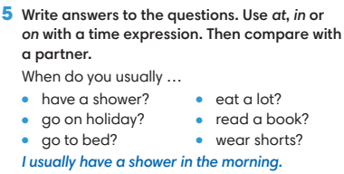
6. (8’) Work in pairs. Student A, use the information below to give and respond to news. Student B, look at page 102.  (Exercise 6 - Student Book page 29)  Student A  1. Greet Student B and ask what’s new in his / her life.  2. Listen and respond to Student B’s news  *you’re learning how to make webpages  *your computer isn’t working at the moment  - T asks Ss to look at exercise 6.  - T calls a student to read the instruction then checks Ss’ understanding of it.  - T asks Ss to work in pairs to prepare for their dialogues  - T sets a time limit and walk around as a monitor while Ss are discussing.  - Ss work in pairs to practice the speaking task  - T moves around and takes notes for any issues that need improving from students work.  - T encourages some strong students to role-play their dialogues in front of the class.  - T gives some general feedback for Ss’ performances. | 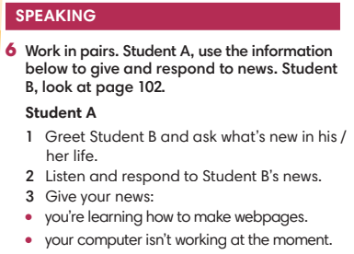
WRAP-UP & HOME WORK ( 2’)
- T asks Ss to talk about what they have learnt in the lesson.
- Review Unit 2 vocabulary and grammar.
- Write a personal introduction for a webpage.
* HOMEWORK
- Do exercises in the workbook page 23
- Prepare for REVIEW 1

