Date of planning:  Date of teaching: | ENGLISH 7  UNIT 3: ANIMALS’ MAGIC  Lesson 1: Vocabulary
I. OBJECTIVES:
By the end of the lesson, students will be able to:
- have an overview of the topic “Animals’ Magic”.
- use vocabulary and grammar points to talk about animals.
1. Knowledge:
- Vocabulary: an understanding of the meaning of keywords below:
Animal names | Pets: parrot, rabbit, tortoise.
Animal names | Farm animals: chicken, cow, donkey.
Animal names | Wild animals: bear, chimp, elephant, giraffe, kangaroo, tiger, zebra.
Animal names | Insects: bee, butterfly, fly.
Animal body parts | claw, feather, fur, mouth, tail, wing.

2. Competence:
To know the meaning of the keywords used to talk about animals and their body parts, then do the tasks assigned in the textbook. To use the vocabulary about animals to practice talking about them.
3. Quality/Behavior: To teach Ss to be hard-working and attentive in class. Ss have a positive attitude to working in groups, individual work, pair work, cooperative learning and working.
II. TEACHING AIDS:
- Teacher: Grade 7 textbook, Unit 3 (SB p.30-31, WB p.24-25), laptop/computer connected to the Internet, loudspeaker, projector/TV, PPT slides…
- Students: Text books, studying equipment…
- Method: Active teach, T-WC; group works; individual ……
III. PROCEDURE:
1. WARM UP (3’)
* Aims:
- To create a positive classroom atmosphere.
- To activate Ss’ prior knowledge and get students involved in the lesson.
- To lead into the next activity.
* Content: Play What do you see? to get students involved in the lesson and to set the context for the lesson.
* Outcome: Students guess the animals’ name correctly, and name more animals they’ve already known.
* Organisation: Teacher’s instructions…

Teacher’s & Student’s activities | Content
Extra activity 1: What do you see?  - T explains the game rules then checks instructions.  - T sets the context for the lesson: Write the title on the board Unit 3: Animals’ Magic / Lesson 3.1: Animals.  - T asks Ss to name more animals they’ve already known. | Game rules:  - Look at a part of each picture.  - Guess the animal you see.  - 1 correct answer = 1 point.
2. PRESENTATION 1 (5’)
ACTIVITY 1:
* Aims:
- To activate Ss’ prior knowledge of the topic.
- To present animal names.
* Content: Some brief notes; Some things about animals.
* Outcome: Know new words about animals.
* Organisation: Teacher’s instructions….

Teacher’s & Student’s activities |  | Content
1. In pairs, match the animals in the picture with the words below. Listen and check.  (Ex 1, p.30)  - T asks Ss to open their SB page 30, look at exercise 1.  - T calls a student to read the instruction then checks Ss’ understanding of it.  - T sets a time limit for Ss to work in pairs and complete the exercise.  - T plays the audio, lets all Ss listen and check.  - T shows answers on the slide and drills all the animal names.  Further discussion:  - T asks more questions to encourage Ss to think and speak.  (1) Which animal is a pet?  (2) Is zebra a wild animal?  - T tells Ss that they are going to put these animals in groups in the next activity. |  | Answer keys:
  A. butterfly | G. zebra | M. tortoise
  B. fly | H. donkey | N. rabbit
  C. elephant | I. kangaroo | O. tiger
  D. chimp | J. parrot | P. bear
  E. giraffe | K. cow
  F. bee | L. chicken
3. PRACTICE 1 (10’)
ACTIVITY 2:
* Aims:
- To help Ss practice pronouncing new words.
- To help Ss classify animals into different groups.
- To let Ss work cooperatively.
* Content: Some brief notes; Some things about animals.
* Outcome: Know new words about animals and classify them into categories.
* Organisation: Teacher’s instructions….
Teacher’s & Student’s activities | Content
Extra activity 2 (5’): Work in groups. Classify animals into categories below. Read the words again.  - T calls a student to read the instruction then checks Ss’ understanding of it.  - T sets a time limit and ask Ss to work in groups to complete the activity.  - T calls groups to give answers then checks as the whole class.  - T drills the words and corrects Ss’ pronunciation if any.
  Pets | parrot, rabbit, tortoise
  Farm animals | chicken, cow, donkey
  Wild animals | Bear, chimp, elephant, kangaroo, tiger, zebra, giraffe
  Insects | Bee, butterfly, fly
2. (5’) In groups, think of two or more animals for each category. Then compare with another group.  (Ex 2, p.30)  - T asks Ss to look at exercise 2 (SB page 30).  - T calls a student to read the instruction then checks Ss’ understanding of it.  - T asks Ss to read the given sentences then checks their understanding by asking them to give one example for each category.  - T sets a time limit and asks Ss to work in groups to complete the activity then compare their answers.  - T calls groups to give answers, writes them on the board.  - T shows possible answers on the slide and compliments groups.  - T corrects Ss’ pronunciation if any. | Possible answers:  1. bear, bat  2. cow, pig, sheep, chicken  3. bear, cat, monkey  4. cheetah, horse, dog, deer  5. snake, hippo, polar bear  6. lion, tiger, crocodile, shark
4. PRESENTATION 2 (5’)
ACTIVITY 3:
* Aims:
- To encourage Ss to guess the meaning of words from the picture cues.
- To present vocabulary of animal body parts.
* Content: Some brief notes about the exercise; some keywords about clothes, type of clothes, preferences; some note about pronunciation.
* Outcome: Have a vocabulary about clothes; know how to talk about clothes and preferences.
* Organisation: Teacher’s instructions …
Teacher’s & Student’s activities | Content
3. Guessing the animals!  (Adapted from Ex 3, p.30-31)  Stage 1: Eliciting  - T asks Ss to look Vocabulary Box B (SB page 30).  - T calls some Ss to read the given words aloud then elicits the meaning of words from Ss (remember not to confirm right or wrong ideas in this stage).  Stage 2: Presenting  - T shows the instructions of the game on the slide.  - T calls a student to read the instructions then checks Ss’ understanding of it.  - T shows the picture one by one and asks all Ss to give answers at the same time.  - T confirms answers and drills the key words (claw, fur, feather, mouth, tail, wing) on the slide.  - T checks the meaning of key words again (claw, fur, feather, mouth, tail, wing).  - T corrects Ss’ pronunciation if any.  Further discussion:  - T plays the audio, lets Ss listen and repeat the phrases. | Answer keys:  1. The feathers of a duck. 2. The eye of an elephant  3. The mouth of a kangaroo. 4. The claws of a chicken.  5. The wing of a fly. 6. The tail of a monkey.  7. The fur of a rabbit.
4. PRACTICE 2 (13’)
ACTIVITY 4 + 5:
* Aims:
- To help Ss use learnt vocabulary in context.
- To help Ss know more facts about animals.
- To lead into a productive activity.
* Content: Some brief notes about the exercise; some keywords about animals; some facts about animals.
* Outcome: Have a vocabulary about animals; know how to talk about animals.
* Organisation: Teacher’s instructions….
Teacher’s & Student’s activities
4. (6’) In pairs, mark the sentences T (true) or F (false). Check your answers on page 101. Which facts do you find surprising?  (Ex 4, p.31)  - T asks Ss to look at exercise 4 (SB page 31).  - T calls a student to read the instruction then checks Ss’ understanding of it.  - T asks some Ss to read the given sentences aloud.  - T sets a time limit and asks Ss to work in pairs to discuss and decide T or F.  - T calls pairs to give answers, writes them on the board.  - T then asks Ss to look for the answers on page 101.  - T corrects Ss’ pronunciation if any.  Further discussion:  - T encourages Ss to discuss the facts they find surprising and give reasons for them. | Answer keys:
  1. T | 3. T | 5. T | 7. T
  2. F | 4. T | 6. T | 7. T
5. (7’) Listen and fill in the blanks. Read the descriptions.  (Adapted from Ex 5, p.31)  - T asks Ss to look through the five descriptions on the slide and read them in their mind.  - T elicits from Ss the type of word that they may fill in each blank then guides them to take notes while listening.  - T plays the audio, lets Ss work individually and listen twice.  - T elicits answers from Ss, write them on the board then checks as the whole class.  - T shows all the answers on the board then asks Ss to read the descriptions one by one.  Further discussion:  - T asks some Yes / No questions about the above animals and calls Ss to give answers.  Possible questions:  (1) Does a tiger eat meat?  (2) Is a chicken good at flying? | Answer keys:  1. This animal eats meat. It’s dangerous. It has a long tail. It lives in India. It’s got striped fur. It’s a tiger.  2. This animal eats grass. It lives in Europe. It’s strong and it works hard. It’s like a small horse. It’s a donkey.  3. This animal is also very dangerous. It’s very good at swimming – and smelling blood. It has very sharp teeth. It lives in the sea. It’s a shark.  4. This animal lives all over the world. It often lives on farms. People keep it for food. It has feathers and wings but it’s not good at flying. It’s a chicken.  5. This animal eats leaves. It lives in Africa. It’s got a long tail and a very long neck. It’s a giraffe
4. PRODUCTION (7’)
ACTIVITY 6:
* Aims:
- To provide Ss with chances to ask and answer about animals.
- To help Ss to apply the vocabulary they have learnt to talk about animals.
* Content: Ss play Guessing game to talk about their animals.
* Outcome: Ss talk about animals using vocabulary and grammar points.
* Organisation: Teacher’s instructions…..
Teacher’s & Student’s activities | Content
6. Guessing game. Work in pairs.  (Ex 6, p.31)  - T asks Ss to look at exercise 6 (SB page 31).  - T calls a student to read the instruction then checks Ss’ understanding of it.  - T asks a pair to read the sample dialogue on the slide then asks some new pairs to make new dialogues to ask and answer about other animals.  - T divides Ss into pairs, models the activity in front of the class then asks Ss to make conversations about animals.  - T sets a time limit and monitors Ss while they are working in groups.  - T notes down common mistakes for delayed feedback.  - T calls some pairs to come to the front of the class, make conversations about animals.  - T asks the rest to give comments on their classmates’ performance.  - T gives feedback on Ss’ work. | 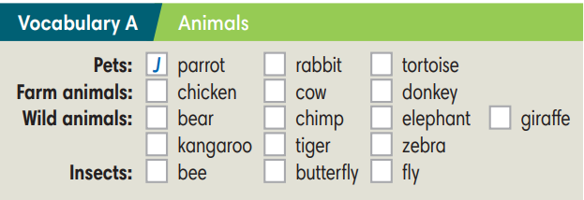  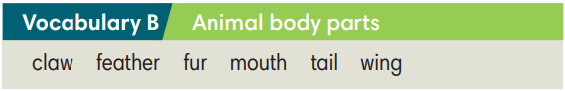

WRAP-UP & HOME WORK (2’)

- T asks Ss to talk about what they have learnt in the lesson.
- Vocabulary of animal names.
- Vocabulary of animal body parts.
* HOME WORK
- Do exercises in the workbook page 24-25.
- Prepare for Lesson 2: Grammar 1.

Date of planning:  Date of teaching: | UNIT 3: ANIMALS’ MAGIC  Lesson 2: Grammar
I. OBJECTIVES:
By the end of the lesson, students will be able to:
- use was and were to talk about the past.
1. Knowledge:
* Grammar:
- form correct sentences in past simple with was/were.
- ask and answer questions with was/were.
- use was/were to talk about the past.
2. Competence: Students understand the main grammar point, then do the tasks assigned in the textbook; use was/were to practice talking about the past.
3. Quality/ behavior: To teach Ss to be hard-working and attentive in class. Ss have a positive attitude to working in groups, individual work, pair work, cooperative learning and working.
II. TEACHING AIDS:
- Teacher: Grade 7 textbook, Unit 3 (SB p.32, WB p.26), laptop/computer connected to the Internet, loudspeaker, projector/TV, PPT slides…
- Students: Text books, studying equipment…
- Method: Active teach, T-WC; group works; individual ……
III. PROCEDURE:

1. WARM UP (3’)
* Aims:
- To create a positive classroom atmosphere.
- To help students review the vocabulary they have learnt in the previous lesson.
- To lead into the next activity.
* Content: Play game: Who am I? to get students involved in the lesson and to set the context for the lesson.
* Outcome: Students know the context of the lesson.
* Organisation : T_ Ss , …
Teacher’s Student’s activities | Content
Extra activity 1: Who am I?  - T explains the game rules then checks instructions.  - T sets the context for the lesson: Write the title on the board Unit 3: Animals’ Magic / Lesson 3.2: Grammar. | Game rules:  - Read the descriptions.  - Guess what animal is it. Read aloud.  - 1 correct answer => get points.
2. LEAD-IN (3’)
* Aims:
- To lead into the new lesson.
- To provide students with reasons for listening to the dialogue in exercise 1 (SB p.32).
* Content: Describe the animals and people in the picture on the slide.
* Outcome: Make guesses about the picture then give answers.
* Organisation: T_ Ss , …
Teacher’s Student’s activities | Content
Extra Activity 2: See – think – wonder.  - T shows a picture on the slide then asks students four questions.  (1) What animal do you see?  (2) How are the chimps?  (3) How many people are there?  (4) Are the kids excited?  - T sets a time limit for Ss’ quick discussion.  - Ss work in pairs to discuss then give answers.  - T calls some Ss to give answers then note them down on the board.  - T tells Ss that they’re going to read the conversation in exercise 1 (SB p.32) to check all the answers. | 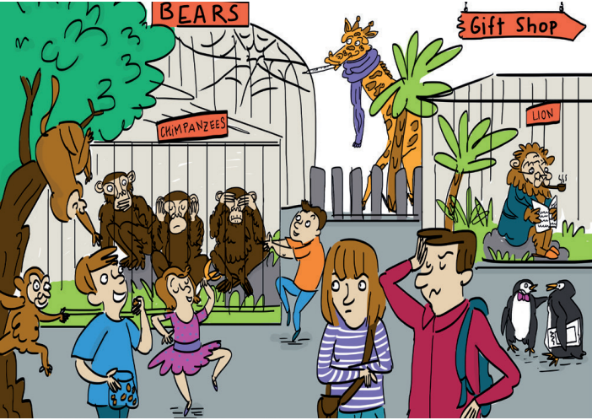
3. PRESENTATION (10’)
ACTIVITY 1 + 2:
Aims:
- To present the grammar point in context.
- To introduce to students the use of TO BE in past simple.
- To lead into the next activities.
- To provide Ss with chances to spot the sentences with was / were.
- To provide Ss with chances to work cooperatively.
- To explain the grammar point for Ss.
* Content: Read the conversation between Kyle and Zadie and find out new words. Learn the Past Simple.
* Outcome: Know more new words. Understanding the reading document; the topic of the lesson, grammar points…
* Organisation: T_ Ss , …
Teacher’s Student’s activities |  |  |  | Content
1. (5’) Read and listen. What does Kyle say about the twins?  (Ex 1, p.32)  - T asks Ss to open their SB page 32, look at exercise 1.  - T calls a student to read the instruction then checks Ss’ understanding of it.  - T plays the audio, let’s all Ss listen and calls Ss to give answers.  Further discussion:  - T asks one more question to encourage Ss to think and speak.  (1) When did Kyle go to the zoo? – Yesterday.  - T tells Ss that they are going to learn more about the past simple tense. |  |  |  | Answer key:  The twins weren’t excited. They were crazy.
2. (5’) Find more example of was / were in the dialogue in exercise 1.  (Ex 2, p.32)  - T asks Ss to open their SB page 32, look at exercise 2.  - T calls a student to read the instruction then checks Ss’ understanding of it.  - T asks Ss to work in groups of three to read the complete the activity.  - T calls groups to give answers then shows the answers on the slide to check as the whole class.  - T shows the grammar notes on the slide then explains the grammar points and tells Ss that they’re going to use was / were to talk about the past in next activities. |  |  |  | 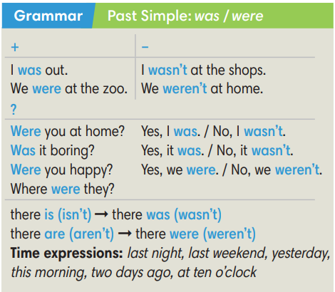
3. PRACTICE (20’)
ACTIVITY 3 + 4:
*Aim:
- To help Ss identify subject-verb agreement.
- To prepare for the next activity.
- To help Ss practice using was / were in context.
- To help Ss prepare for the next activity.
* Content: Complete the text/sentences with the correct form of the verbs.
Understand the text; grammar points; past simple tense.
* Outcome: Know how to form a sentence with the correct form of the verbs. Understand the conversation; the topic of the lesson, vocabulary, grammar points…
* Organisation : T_ Ss …
Teacher’s Student’s activities |  | Content
Extra activity 3 (6’): Ring the Golden Bell Game.  (Adapted from Ex 3, WB p.26)  - T explains the game rules then checks instructions.  - Ss join in the game individually.  - T corrects Ss if any. |  | Game rules:  - Read the sentences carefully.  - Choose a word in brackets to fill in the blank.  - 1 correct answer = 1 point.
3. (4’) Complete the dialogue with was / were / wasn’t / weren’t. Listen and check.  (Ex 3, p.32)  - T asks Ss to look at exercise 3 (SB page 32).  - T calls a student to read the instruction then checks Ss’ understanding of it.  - T asks Ss to underline the subject in each sentence and tell if it is singular or plural.  - T sets a time limit for Ss to work in groups and complete the exercise.  - T calls groups to give and explain their answers.  - T corrects Ss’ pronunciation if any.  - T plays the audio, lets Ss listen and check. |  | Answer key:
  2. was | 4. Were | 6.  Was | 8.  weren’t | 10. was
  3. were | 5. were | 7. wasn’t | 9.  were | 11. was
(5’) Extra activity 4: Lucky Wheel Game.  (Adapted from Ex 4, SB p.32)  - T explains the game rules then checks instructions.  - Ss join in the game individually.  - T corrects Ss if any. |  | Game rules:  - Read the sentences carefully.  - Find a mistake in each sentence then correct it.  - 1 correct answer => spin the wheel for points.
4. (5’) Use the words below to make sentences about the cartoon. Use there was / there were.  (Ex 4, SB p.32)  - T asks Ss to look at exercise 4 (SB page 32).  - T calls a student to read the instruction then checks Ss’ understanding of it.  - T sets a time limit, asks Ss to work in groups to write as many sentences with there was / there were as they can about the cartoon.  - T calls groups to read their sentences then shows possible answers on the slide.  - T corrects Ss’ grammar on the board if any. |  | 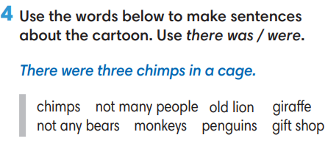
4. PRODUCTION (7’)
ACTIVITY 5:
*Aim: To help Ss to apply the grammar point they have learnt to talk about the past.
* Content: Ss make conversation about animals (where and when they were).
* Outcome: Ss know how to use past simple tense to make a conversations about their place and activities in the past.
* Organisation: T_Ss …

Teacher’s Student’s activities |  |  | Content
5. Complete the table with the places below. In pairs, guess your partner’s answers.  (Ex 5, p.32)  - T asks Ss to look at exercise 5 (SB page 32).  - T calls a student to read the instruction then checks Ss’ understanding of it.  - T asks a pair to read the sample dialogue on the slide then asks some new pairs to make new dialogues to ask and answer about other places and time.  - T divides Ss into pairs, models the activity in front of the class then asks Ss to make conversations about animals.  - T sets a time limit and monitors Ss while they are working in groups.  - T notes down common mistakes for delayed feedback.  - T calls some pairs to come to the front of the class, make conversations about the past.  - T asks the rest to give comments on their classmates’ performance.  - T gives feedback on Ss’ work. |  |  | 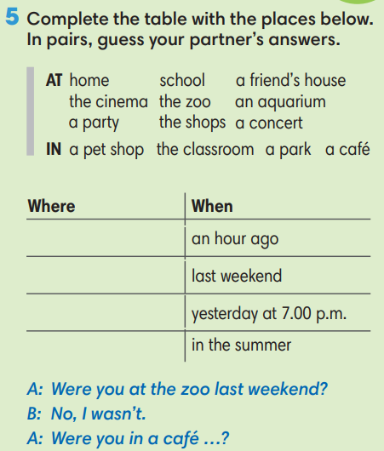
WRAP-UP & HOME WORK (2’)

- T asks Ss to talk about what they have learnt in the lesson.
- Vocabulary of animal names.
- Vocabulary of animal body parts.
* HOME WORK
- Do exercises in the workbook page 26.
- Prepare for Lesson 3: Reading and Vocabulary.

Date of planning:  Date of teaching: | UNIT 3: ANIMALS’ MAGIC  Lesson 3: Reading and Vocabulary
I. OBJECTIVES:
By the end of the lesson ss will be able to:
- find specific details in an article and talk about behaviours.
1. Knowledge:
* Vocabulary: an understanding of the vocabulary about family activities and some adjectives.
New words | Pronunciation | Vietnamese meaning
- adolescent (n) | /ˌæd.əˈles.ənt/ | A teenager
- adolescent (a) | /ˌæd.əˈles.ənt/ | Describe a time just before becoming an adult.
- adventure (n) | /ədˈven.tʃɚ/ | An unusual, exciting and possibly dangerous activity.
- aggressive (a) | /əˈɡres.ɪv/ | Behave violently towards other people.
- unthinking (n) | /ʌnˈθɪŋ.kɪŋ/ | Not base on careful thought.
- teenage (a) | /ˈtiːn.eɪdʒ/ | Aged between 13 and 19.

* Grammar: Reading skills:
- the ability to find specific details in a text (scanning skill).
- the ability to guess the meaning of new vocabulary in context.
2. Competence: Understand and know the meaning of the keywords used to talk about teenage behaviours, and understand the main grammatical points, then do the tasks assigned in the textbook; locate information and find specific details in an article (scanning skill); guess the meaning of new vocabulary in context.
3. Quality/ behavior: To teach Ss to be hard-working and attentive in class. Ss have a positive attitude to working in groups, individual work, pair work, cooperative learning and working.
II. TEACHING AIDS:
- Teacher: Grade 7 textbook, Unit 3 (SB p.33, WB p.27), laptop/computer connected to the Internet, loudspeaker, projector/TV, PPT slides…
- Students: Text books, studying equipment…
- Method: Active teach, T-WC; group works; individual ……
III. PROCEDURE:

1. WARM-UP (5’)
* Aim:
- To help Ss review the grammar point they have learnt in lesson 3.2.
- To create a positive classroom atmosphere.
* Content: Game: The Secret Chest Game (about watching habits)
* Outcome: Ss can talk about their watching habits.
* Organisation: T_ Ss …
Teacher’s &Student’s activities |  | Content
Extra activity 1: The Secret Chest Game  - T explains the game rules then checks instructions.  - T asks Ss the question “Do you often watch TV?” after the last question of the game.  - Ss raise their hands if the answer is “Yes”.  - T will ask Ss to tell more about their watching habits in the next activity. |  | Game rules:  - Read the sentences.  - Show fingers for answers.  - A gold coin = 2 points; A silver coin = 1 point.
2. PRE-READING (10’)
ACTIVITY 1:
* Aim:
- To activate Ss’ background knowledge of the topic.
- To pre-teach vocabulary.
- To prepare for the next activity.
- To prepare for the next activity.
* Content: To discuss Ss’s activities by reading and answering T’s questions.
* Outcome: Know new words, and grammar points when talking about teenage behaviours.
* Organisation: T, Ss …
Teacher’s & Student’s activities | Content
Extra activity 2 (5’):  (Extra exercise)  - T explains the game rules then checks instructions.  - T checks Ss’ understanding of each verb phrase after every question.  Further discussion:  - T tells Ss that they are going to read more about teenage behaviours.  - T sets the context for the lesson: Write the title on the board Unit 3: Animals’ Magic / Lesson 3.3: Reading and Vocabulary. | Game rules:  - Read the given word / phrase.  - Choose the correct picture.  - 1 correct answer = 2 points.
1. (5’) In pairs, look at the words and phrases below. Which things do teenagers typically do?  (Ex 1, p.33)  - T asks Ss to look at exercise 1 (SB page 33).  - T calls a student to read the instruction then checks Ss’ understanding of it.  - T sets a time limit and asks Ss to work in pairs to complete the activity.  - T calls some pairs to give ideas then writes them on the board.  - T tells Ss that they are going to find the answers in the reading text in the next activity. | 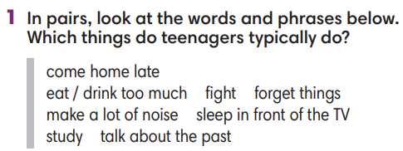
2. WHILE-READING 1 (20’)
ACTIVITY 2 + 3 + 4:
*Aim:
- To help Ss practice scanning skill.
- To teach topic-related vocabulary in context.
- To help Ss pull out tips for finding specific information in a text.
- To help Ss practice finding specific information in a text.
* Content: Read about the teenage behaviours.
* Outcome: To know more new words about teenage behaviours. Understand more about using the words in contexts.
* Organisation: T, Ss …
2. (5’) Which of the activity in exercise 1 does it mention?  (Ex 2, p.33)  - T asks Ss to look at exercise 2 (SB page 33).  - T calls a student to read the instruction then checks Ss’ understanding of it.  - T sets a time limit and asks Ss to work in pairs to complete the activity.  - T elicits the ideas from Ss, asks them in which line of the paragraph they see the answers.  - T confirms the answers then drills the pronunciation of the phrases and corrects Ss’ pronunciation if any.  Further discussion:  - T and students discuss tips for finding specific information in a text. | Answer keys:  1. make a lot of noise / 2. Do dangerous things / 3. Fight
3. (8’) Read the text again. Mark the sentences right, wrong or doesn’t say.  (Ex 3, p.33)  - T asks Ss to look at exercise 3 (SB page 33).  - T calls a student to read the instruction then checks Ss’ understanding of it.  - T elicits from Ss tips to find specific information in the text.  - T sets a time limit and asks Ss to work in groups to complete the exercise.  - T calls groups to give answers and the reasons for them.  - T confirms the answers.  - T corrects Ss’ pronunciation if any.  Further discussion:  - T and students reinforce tips for finding specific information in a text. | Answer keys:  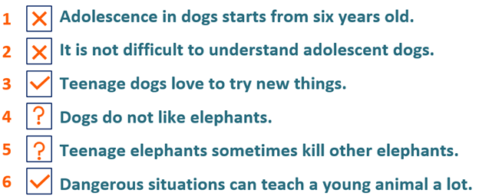
4. (7’) Choose the meaning of the highlighted words in the text.  (Ex 4, p.33)  - T asks Ss to look at exercise 4 (SB page 33).  - T calls a student to read the instruction then checks Ss’ understanding of it.  - T elicits from Ss tips to guessing the meaning of new vocabulary in a text.  - T sets a time limit and asks Ss to work in groups to choose the meaning.  - T calls groups to give answers and the reasons for them.  - T confirms the answers.  - T corrects Ss’ pronunciation if any.  Further discussion:  - T and students discuss on the tips to guess the meaning of new vocabulary in a text. | Answer keys:  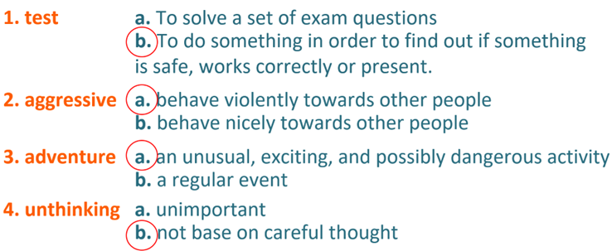
4. POST-READING (7’)
ACTIVITY 5:
* Aim: To encourage Ss to talk about teenage behaviours using the topic-related vocabulary.
* Content: To discuss the teenage behaviours.
* Outcome: Making sentences to talk about a teenager they know. Commenting about the sentences of others.
* Organization: T, Ss...
5. In pairs, tell about a teenager you know. Ask and answer questions using the verbs in exercise 1.  (Ex 5, p.33)  - T asks Ss to look at excersise 5 (SB page 33).  - T calls a student to read the instruction then checks Ss’ understanding of it.  - T asks a student to read the example then models the activity in front of the class.  - T asks Ss to work in pairs and talk about one of the teenagers they know.  - T sets a time limit and monitors Ss while they are working in pairs.  - T notes down common mistakes for delayed feedback.  - T calls some students to come to the front of the class to speak.  - T asks the rest to give comments on their classmates’ performance.  - T gives feedback on Ss’ work. | 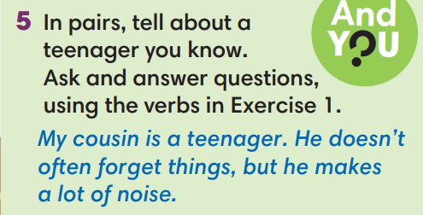
WRAP-UP & HOME WORK (3’)
- T asks Ss to talk about what they have learnt in the lesson.
- Vocabulary of teenage behaviours.
- Reading skills.
* HOME WORK
- Do exercises in the workbook page 27.
- Prepare for Lesson 3.4: Grammar 2.

====================
Date of planning:  Date of teaching: | UNIT 3: ANIMALS’ MAGIC  Lesson 4: Grammar 2
I. OBJECTIVES:
By the end of the lesson students will be able to:
- use Past Simple of regular verbs to talk about the past.
1. Knowledge:
* Grammar:
- remember the forms of regular verbs in Past Simple.
- write past simple forms of regular verbs.
- use past simple forms of regular verbs to talk about the past.
2. Competence: Understand and use verbs to talk about activities in the past, and understand the main grammatical points, then do the tasks assigned in the textbook; use the questions and answers in past simple correctly to talk about the past.
3. Quality/ behavior: To teach Ss to be hard-working and attentive in class. Ss have a positive attitude to working in groups, individual work, pair work, cooperative learning and working.
II. TEACHING AIDS:
- Teacher: Grade 7 textbook, Unit 3 (SB p. 34), laptop/computer connected to the Internet, loudspeaker, projector/TV, PPT slides…
- Students: Textbooks, studying equipment…
- Method: Active teach, T-WC; group works; individual ……
III. PROCEDURE:

1. WARM UP (4’)
* Aim:
- To create a positive classroom atmosphere to start a new lesson.
- To help Ss review the vocabulary they have learnt in Lesson 3.3.
* Content: Game: Minion Game (with the past simple tense)
* Outcome: Ss use the correct form of the verb in the Past Simple tense.
* Organisation: T, Ss ..….

Teacher’s & Student’s activities |  | Content
Extra activity 1: Minion Game  - T explains the game rules then checks instructions.  - Ss join in the game individually.  - T corrects Ss if necessary. |  | Game rules:  - Read the sentence carefully.  - Choose A or B to fill in the blank.  - 1 correct answer = 1 point.
2. LEAD-IN (2’)
*Aim:
- To lead into the new lesson.
- To provide Ss with reasons for listening to the dialogue in exercise 1 (SB p.34).
* Content: Ss answer the questions about Nam.
* Outcome: Get the right answers on time.
* Organisation: T_ Ss ..….

Teacher’s & Student’s activities | Content
Extra activity 2: See – think – wonder.  - T shows a picture on the slide then asks students four questions.  (1) What do you see in the picture?  (2) What is he doing?  (3) Where is he?  (4) How does he feel?  - T sets a time limit for Ss’ quick discussion.  - Ss work in pairs to make guesses about the picture then give answers.  - T calls some Ss to give answers then note them down on the board.  - T tells Ss that they’re going to read the conversation in exercise 1 (SB p.34) to check all the answers. | 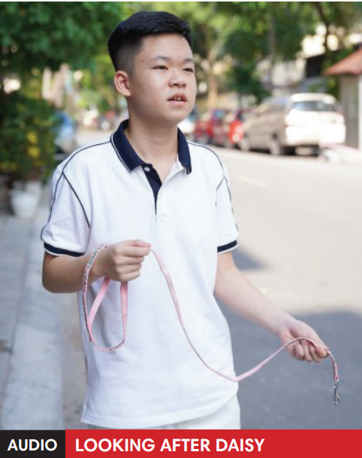
3. PRESENTATION (13’)
(Questions and answers in the Present Simple tense)
ACTIVITY 1 + 2:
*Aim:
- To present the grammar point in context.
- To lead into the next activity.
- To introduce the forms of regular verbs in Past Simple.
- To introduce the everyday phrases and expressions pulled out from the conversation shortly.
* Content: To practice using the past simple in context by choosing the correct answer.
* Outcome: Practicing the use of the past simple by writing the correct form of the verbs.
* Organisation: T, Ss ..….
Teacher’s & Student’s activities | Content
1. (5’) Listen. Why is Nam worried?  (Ex 1, p.34)  - T asks Ss to open their SB page 34, look at exercise 1.  - T calls a student to read the instruction then checks Ss’ understanding of it.  - T tells Ss that they are going to listen to a conversation between Mai and Nam.  - Ss work individually, listen and note down the answers to the given questions.  - T calls some Ss to give answers then shows the answers on the slide.  Answer keys:  Nam is worried because he can’t find Kim’s dog.  - T set the scene for the new lesson: T tells Ss that they are going to read a conversation to see what happened with him in the past.  - T writes the title on the board Unit 3: Animals’ Magic / Lesson 3.4: Grammar 2. | 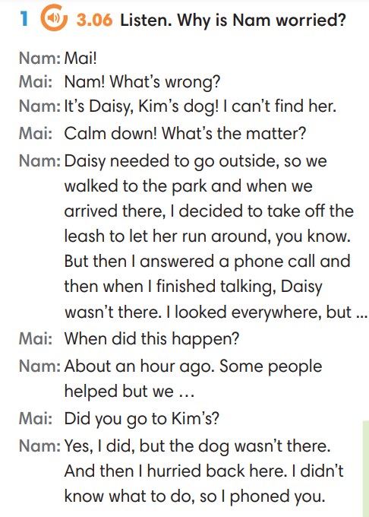
2. (4’) Find more example of the Past Simple in the dialogue.  (Ex 2, p.34)  - T asks Ss to look at exercise 2.  - T calls a student to read the instruction then checks Ss’ understanding of it.  - T asks Ss to work in groups of three to read the complete the activity.  - T calls groups to give answers then shows the answers on the slide to check as the whole class. | 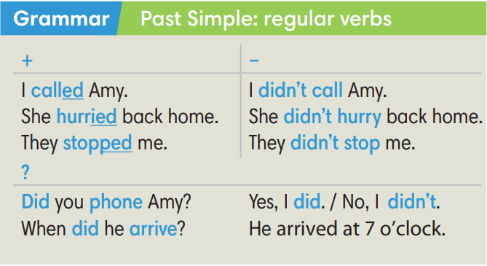
Extra activity 3 (4’): Find and underline the phrases below in the dialogue.  (Out of class box)  - T asks Ss to look at the Out of class box, find and underline the phrases in the dialogue.  - T calls students to read the phrases and asks for meaning basing on the conversation.  - T corrects Ss’ pronunciation if any.  - T shows the grammar notes, explains the grammar points and tells Ss that they’re going to use them to talk about the past. | 
4. PRACTICE (17’)
ACTIVITY 3:
* Aims:
- To help Ss practice writing form of regular verbs in Past Simple.
- To help Ss practice pronouncing verbs with -ed ending then classify them.
- To help Ss practice writing form of regular verbs in Past Simple in context.
* Content: Choose the correct form of the verb in the past simple tense.
* Outcome: Choose the form correctly in grammar and use the past simple to explain their options.
* Organisation: T, Ss, ….
Teacher’s & Student’s activities | Content
Extra activity 4 (6’): Tom and Jerry Game.  (Adapted from ex3 SB p.34)  - T explains the game rules then checks instructions.  - Ss join in the game individually.  - T corrects Ss’ pronunciation if any. | Game rules:  - Read the questions carefully.  - Choose A, B or C.  - Check answers with Tom and Jerry.  - 1 correct answer = 2 points.
3. (7’) Write past simple form of the verb below then put them in the correct column. Listen and check.  (Ex 3 SB p.34)  - T asks Ss to look at exercise 3.  - T calls a student to read the instruction then checks Ss’ understanding of it.  - T sets a time limit for Ss to complete the exercise in groups of four.  - T calls groups to give answers then checks as the whole class.  - T corrects Ss’ pronunciation if any. | Answer keys:  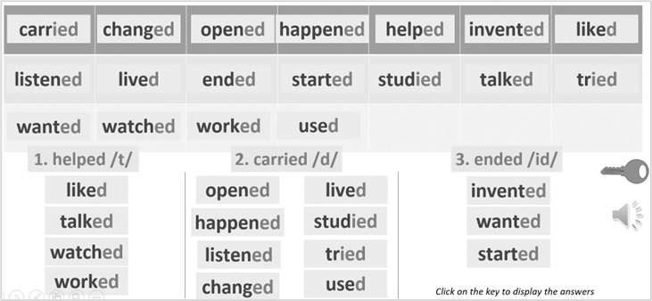
4. (4’) Write past simple form of the verb below then put them in the correct column. Listen and check.  (Ex 4 SB p.34)  - T asks Ss to look at exercise 4.  - T calls a student to read the instruction then checks Ss’ understanding of it.  - T sets a time limit for Ss to complete the exercise in pairs.  - T calls groups to give answers then checks as the whole class.  - T corrects Ss’ pronunciation if any. | Answer keys:
  2. didn’t want | 4. agreed | 6. shouted | 8. walked
  3. needed | 5. decided | 7. suggested | 9. didn’t like
4. PRODUCTION (7’)
ACTIVITY 5:
* Aims: To let Ss make questions and answers about the past.
* Content: Interview partners using the cues words.
* Outcome: Use vocabulary items and grammar points related to the topic to interview partners.
* Organisation: T. Ss , Individual, Pair work, ….

Teacher’s & Student’s activities | Content
5. In pairs, make questions from the promts. The go to page 101 to find answers.  (Ex 5, p.34)  - T asks Ss to look at excersise 5 (SB page 34).  - T calls a student to read the instruction then checks Ss’ understanding of it.  - T divides Ss into new pairs, then sets a time limit for them to complete the activity.  - T asks pairs to ask and answer questions.  - T walk around to listen and notes down common mistakes for delayed feedback.  - T calls some pairs to come to the front of the class, make conversations.  - T asks the rest to give comments on their classmates’ performance.  - T gives feedback on Ss’ work. | 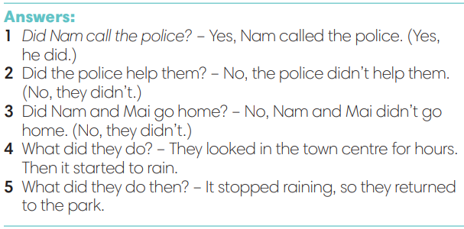
WRAP-UP & HOME WORK (3’)
- T asks Ss to talk about what they have learnt in the lesson.
- The past simple tense with regular verbs.
* HOME WORK
- Do exercises in the workbook page 28.
- Prepare for Lesson 3.5: Listening and vocabulary.
=========================
Date of planning: Date of teaching: | UNIT 3: ANIMALS’ MAGIC  Lesson 5: Listening and Vocabulary
I. OBJECTIVES:
By the end of the lesson student will be able to:
- can identify specific details in a conversation and talk about pets.
1. Knowledge:
* Vocabulary: use vocabulary of pets and Word Friends about looking after pets.
* Grammar: make sentences in Present Simple and Past Simple to talk about pets.
2. Competence: Understand and use words about pets and Word Friends about looking after pets, do the tasks assigned in the textbook. Listen and identify specific details in a conversation and talk pets.
3. Quality/ behavior: To teach Ss to be hard-working and attentive in class. Ss have a positive attitude to working in groups, individual work, pair work, cooperative learning and working.
II. TEACHING AIDS:
- Teacher: Grade 7 textbook, Unit 3 (SB p. 35, WB p.29), laptop/computer connected to the Internet, loudspeaker, projector/TV, PPT slides…
- Students: Text books, studying equipment…
- Method: Active teach, T-WC; group works; individual ……
III. PROCEDURE:
1. WARM UP + LEAD-IN (8’)
ACTIVITY 1:
* Aim:
- To create a positive classroom atmosphere to start a new lesson.
- To review what students have learnt from previous lesson
- To lead into the lesson
* Content: Play Hidden Symbols game.
* Outcome: Know more new words in context. Improve pronunciation.
* Organisation: T, Ss ..
Teacher’s &Student’s activities | Content
Extra activity 1 (5’): Hidden Symbols  - Teacher introduces the Hidden Symbols Game  - T explains How-to-play steps then checks Ss’ comprehension  - T uses slides to lead the game.  - Ss join the game in small groups | How to vote:  - Choose a number  - Solve a riddle or do a task  - Raise your hand to answer  - 1 point = 1 star / 1 bomb = no point
Extra activity 2 (3’): Guessing Activity  - T asks student that if they remember the key sentence in slide riddle 6.  - T displays the sentence: Ali wants a pet but what kind to get?  - T shows the picture of Ali and a part of the reading text.  - T allows students to discuss and guess the answer massively  - T encourages Ss to give the reason for their guessing.  - Ss work in pairs to do the task  - T tells Ss that they’re going to learn more words of about having and taking care of a pet in the next step of the lesson. | 
2. PRE-LISTENING (14’)
ACTIVITY 1 + 2:
*Aim:
- To activate Ss’ prior knowledge of the topic.
- To pre-teach word friends of taking care of a pet
- To present Word Friends about having and taking care of a pet.
* Content: Some brief notes; vocabulary about pets. Use them to complete the exercise.
* Outcome: Know some more new words about pets. Chose the correct words to answer the questions.
* Organisation: T, Ss …
Teacher’s &Student’s activities | Content
1. (10’) Read the text and decide which of the pets is good for Ali.  (Exercise 1 – SB p. 35)  - T asks Ss to look at exercise 1.  - T calls a student to read the instruction then checks Ss’ understanding of it.  STEP 1: CLASS VOTE  - T shows the reading text A and B and asks Ss to read and vote A or B.  A – dogs / B - cats  - Ss read and vote by giving their thumb up for A or B  STEP 2: THE ADVANTAGES AND DISADVANTAGES  - T tells Ss to work in small groups to read the text again and find the information to fill in the column displayed in teacher’s slide. The advantages and disadvantages of having a dog or a cat.  - Ss work in groups to read, information and fill in the column  - From the information, T encourages Ss to compare with Ali’s condition to decide which pet is for her.  - T calls volunteers to share the answer and confirm the possible one.  => A cat can be a good idea. | 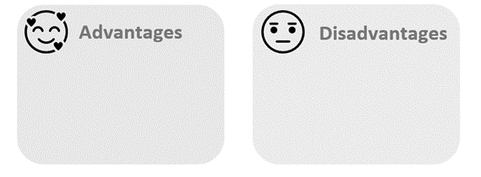
2. (4’) Check if you understand this Word Friends.  Then listen to Ali talking to a friend.  Number the Words Friends in the order you hear them.  (Exercise 2 – SB p.35)  - T asks Ss to look at exercise 2.  - T calls a student to read the instruction then checks Ss’ understanding of it.  STEP 1: Understand the Words Friends  Task: Match the phrases with the corresponding pictures.  - T uses slides to lead the activities  - T asks Ss to work in groups of three to read then match  - T calls groups to give answers to check as the whole class.  STEP 2: Listen and number  - T plays the audio for students to listen and number the phrases.  - T checks the answers with the whole class.  - T displays all the Word Friends again for Ss to read aloud. | Answer keys:  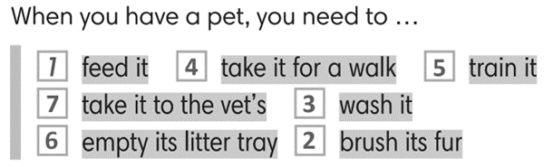
3. WHILE-LISTENING (5’)
ACTIVITY 3:
* Aim:
- To help Ss identify specific details in a conversation
- To provide Ss with chances to think and talk about pets
* Content: Listen and understand the audio track to complete the exercise.
* Outcome: Think and talk about pets by matching the correct answers.
* Organisation: T_ Ss …
Teacher’s &Student’s activities | Content
3. Listen to five dialogues and choose the correct answers.  (Exercise 3 - SB p.35)  - T asks Ss to look at exercise 3 in student book page 35.  - T calls a student to read the instruction then checks Ss’ understanding of it.  - T asks students to read the sentences carefully  - T asks Ss to work in pairs to listen then complete the activity and peer check for the first listening.  - T plays the audio again and checks as the whole class.  - Teacher asks students to give the evidence that they hear from the audio track to prove their answer. | Answer keys: 2-b, 3-b, 4-c, 5-b
4. POST-LISTENING (12’)
ACTIVITY 4:
*Aim: To help students applying the vocabulary items related to the topic in communicating.
* Content: Work in pairs to talk about pets.
* Outcome: Think and talk about pets.
* Organisation: T, Ss ..
Teacher’s &Student’s activities | Content
Extra activity 3 (6’): Fill in the blanks.  Read a dialogue again and fill in the blanks.  - T provides Ss the script of dialogue 1 from exercise 3.  - T tells Ss to read and fill in the blanks.  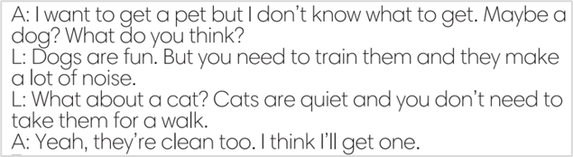  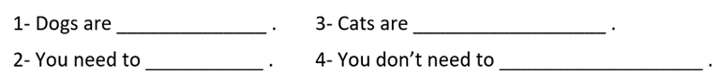  - T explains that they are some criteria students should think of when they choose a pet.  - Ss work individually and raise their hands to answer.  - T listens to Ss’ answer and checks as the whole class | Key answers: 1-fun / 2-train them / 3-quiet and clean / 4-take them for a walk
4. (6’) In groups, say which animal you would like as a pet and why. Use the phrases below to help you.  (Exercise 4 - SB p.35)  - T asks Ss to look at exercise 4 in student book page 35.  - T calls a student to read the instruction then checks Ss’ understanding of it.  - T asks Ss to work in groups to read then complete the activity.  - T sets a time limit for students.  - Students work in groups to think and share.  - Teacher invites different students to talk about their partner. | 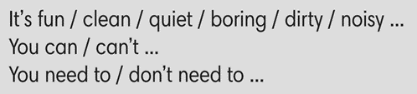
WRAP-UP & HOME WORK ( 2’)

- T asks Ss to talk about what they have learnt in the lesson.
- Word Friends: Have and take care of a pet
* HOME WORK
- Do exercises in the workbook page 29.
- Prepare for Lesson 3.6: Speaking.

=====================

Date of planning:  Date of teaching: | UNIT 3: ANIMALS’ MAGIC  Lesson 6: Speaking
I. OBJECTIVES:
By the end of the lesson student will be able to:
- make and respond to apologies.
1. Knowledge:
* Vocabulary: review some pet-related actions, learn some apologizing expressions.
* Grammar: make dialogue in the Present Simple with apologizing expressions.
2. Competence: Ss understand and use the vocabulary of apologizing expressions and other related topics to the lesson content, do the tasks assigned in the textbook. Listen for comprehension then make and response to some apologies.
3. Quality/ behavior: To teach Ss to be hard-working and attentive in class. Ss have a positive attitude to working in groups, individual work, pair work, cooperative learning and working.
II. TEACHING AIDS:
- Teacher: Grade 7 textbook, Unit 3 (SB p. 36, WB p.30), laptop/computer connected to the Internet, loudspeaker, projector/TV, PPT slides…
- Students: Text books, studying equipment…
- Method: Active teach, T-WC; group works; individual ……
III. PROCEDURE:
1. WARM UP + LEAD-IN (5’)
* Aim:
- To create a positive classroom atmosphere to start a new lesson.
- To review pet-related actions.
- To lead into the topic.
* Content: Play Mind-map to recall the vocabulary in previous lessons.
* Outcome: Students talk about pets by using the vocabulary in previous lessons.
* Organization of implementation: T- Ss
Teacher’s & Student’s activities |  | Content
Extra activity 1: Mind-map  - T writes the words “all things you need to do when you have a pet” on board and asks students to work in pairs/small group.  - Students discuss and list out all words they remember from previous lesson.  - Students use a mind-map to present their ideas.  - Teacher encourages students to stand up and share their answers in front of the class.  - Teachers explains that students find some of the warm-up words in the new lesson.  Unit 3 – Lesson 6: Speaking |  | 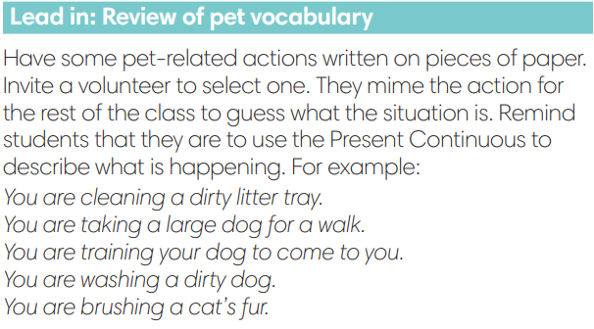
2. PRE-SPEAKING (20’)
ACTIVITY 1 + 2:
* Aim:
- To activate Ss’ prior knowledge of the topic.
- To start a class discussion
- To listen and identify specific information to answer the questions
- To read and identify specific information to answer the questions
- To introduce the Speaking Box
- To reinforce the apologizing expressions
- To classify statements of accepting and not accepting apologies.
* Content: Listen to the conversation to answer the questions about Kim and Nam.
* Outcome: Know about the apologizing expressions. Understand the conversation.
* Organisation: Teacher’s instructions…

Teacher’s & Student’s activities |  |  | Content
1. (5’) Look at the photos. How do you think Nam and Kim are feeling? Why? Listen and read to check your answers.  (Exercise 1 - SB p.36)  - Set the scene: T tells Ss to remember what happened in the dialogue of Unit 3 – Lesson 4.  - T has Ss work in pairs or small groups to discuss and find the answers for the questions.  - Ss do the tasks in pairs or in small groups.  - T calls some volunteer Ss to say aloud the possible answers.  - T plays the audio for Ss to check then confirms the answers.  - T provides information from unit 3-lesson 4: Nam was with Kim's dog, but it disappeared. He looked for it, but he doesn’t know where it is. |  |  | Answer keys:  Nam is feeling sad and embarrassed because he can’t find Kim’s dog.  Kim is feeling shocked and sad because Nam lost her dog.
2. (7’) Tick (v) the words and phrases from the dialogue.  (Exercise 2 – SB p.36)  - T asks students 2 questions then has Ss to discuss in pairs.  Who is doing the apologising?  Why do they feel they need to apologise?  - T confirms the answers:  - Nam is apologising for losing the dog.  - Kim is apologising for being rude.  - T asks Ss to look at exercise 2.  - T calls a student to read the instruction then checks Ss’ understanding of it.  - T sets a time limit for Ss to work in groups  - T calls groups to give answers to check as the whole class.  - T provides explanations and tell the whole class to read aloud the words and phrases from the Speaking Box together. |  |  | Answer keys:  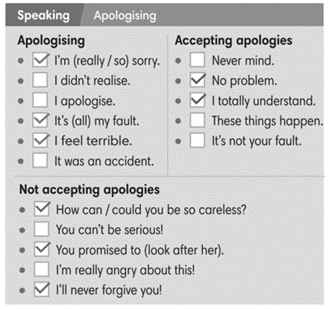
Extra activity 2 (3’): Minion Game  - T has Ss get ready for the game in team and explains the game rules.  - T uses Pptx slides to lead the games  - Ss in each team take turns to play.  - T rewards points for the winner then asks Ss to read the expressions aloud together. |  |  | Game rules:  - Read the sentence carefully.  - Choose A or B to fill in the blank.
3. (5’) Use the Speaking Box to complete the dialogues. Sometimes more than one answer is possible. Listen and check.  (Exercise 3 – SB p.36)  - T asks Ss to look at exercise 3.  - T calls a student to read the instruction then checks Ss’ understanding of it.  - T sets a time limit for Ss to work in groups  - T calls groups to give answers to check as the whole class. |  |  | Answer keys:  2. No problem.  3. It’s not your fault.  4. How can you be so careless?
3. WHILE-SPEAKING (10’)
ACTIVITY 3 + 4:
* Aim:
- To reinforce the apologizing expressions
- To practice the “apologizing” dialogue
* Content: Complete the conversations to express apologies.
* Outcome: Understand the use of apologizing expressions to communicate.
* Organisation: T, Ss ..….
Teacher’s & Student’s activities |  |  |  | Content
3. (5’) Act out the dialogue in exercise 3 – SB p.36 (Exercise 3 - SB p.23)  - T sets a limit for students to work in pairs to practice the dialogue as a role play.  - T invites some pairs of students to act out the roleplay in front of the class.  - Ss work in pair, practice the dialogue, then act out. |  |  |  | 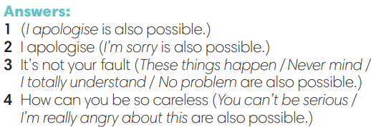
4. In pairs, follow the instructions. Use the  Speaking box to help you.  (Exercise 4 – SB p.36)  - T asks Ss to look at exercise 4.  - T calls a student to read the instruction then checks Ss’ understanding of it.  - T sets a time limit for Ss to work in pairs.  - Ss work in pairs to discuss on the given situation then build up the dialogue.  - T invites some pairs of students to perform in front of the class  - T provides corrections when needed. |  |  |  | 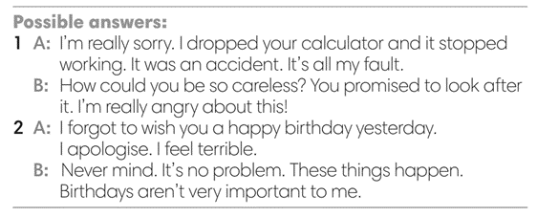
4. POST-SPEAKING (8’)
ACTIVITY 4:
*Aims: To help students applying the new language and skills related to the topic in communicating.
* Content: Express apologies to each other’s.
* Outcome: To practice apologizing expression by create a new situation and act out.
* Organisation : T, Ss .…

Teacher’s & Student’s activities | Content
Extra activity 3: Adaptation for Exercise 4 (SB p.36)  In pairs, create a new situation and act out.  - T tells student to look at the speaking box in their student book again and prepare for the task.  - T gives students time to think about what they are going to say in their roleplays.  - T encourages stronger students to introduce a situation as an example for the whole class, e.g. You lost your friend’s toy. You go home late.  - Students work in the same pairs from the last activity and practice their role plays, focus on using the correct intonation.  - Teacher invites pairs to act out their roleplays in front of the class. | 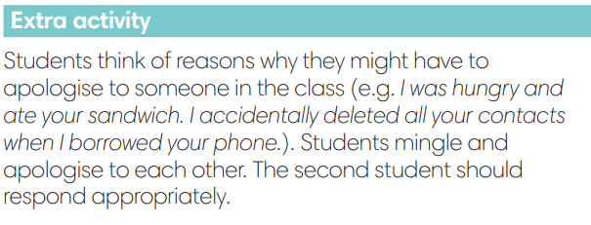
WRAP-UP & HOME WORK (2’)
- T asks Ss to talk about what they have learnt in the lesson.
- Apologizing expressions
* HOME WORK
- Do exercises in the workbook page 30.
- Prepare for Lesson 3.7: Writing.

Date of planning:  Date of teaching: | UNIT 3: ANIMALS’ MAGIC  Lesson 7: Writing
I. OBJECTIVES:
By the end of the lesson, Ss are able to:
- write a biography.
1. Knowledge:
* Vocabulary: use vocabulary of common topics (age / jobs / places / family, etc.) to write a biography (of a famous person).
* Grammar: make sentences in the Past Simple tense correctly.
2. Competence: Ss understand and use the vocabulary of common topics (age / jobs / places / family, etc.), do the tasks assigned in the textbook. Write a biography of a famous person.
3. Quality/ behavior: To teach Ss to be hard-working and attentive in class. Ss have a positive attitude to working in groups, individual work, pair work, cooperative learning and working.
II. TEACHING AIDS:
- Teacher: Grade 7 textbook, Unit 3 (SB p. 47, WB p.31), laptop/computer connected to the Internet, loudspeaker, projector/TV, PPT slides…
- Students: Text books, studying equipment…
- Method: Active teach, T-WC; group works; individual ……
III. PROCEDURE:
1. WARM UP (4’)
* Aim:
- To create a positive classroom atmosphere to start a new lesson.
- To lead in to the sample writing.
- To early introduce some information about Steve Irwin
* Content: Game: Telepathy Game (about an expert called Steve Irwin)
* Outcome: Ss guess and choose the correct picture.
* Organization of implementation
Teacher’s & Student’s activities | Content
Extra activity 1: Telepathy Game  - Set the scene: T tells Ss that she / he’s going to give some sentences about an expert called Steve Irwin.  - T explains the game rules then checks instructions.  - Ss join in the game individually.  - T set the scene for the new lesson: T tells Ss that they are going to read and write a biography in this lesson.  - T writes the title on the board Unit 3: Animals’ Magic / Lesson 3.7: Writing. | Game rules:  - Read the sentence  - Make guesses and choose A or B as the correct picture.  - 1 correct answer = 1 point.
2. LEAD-IN (3’)
* Aim:
- To get students to think about the topic.
- To provide Ss with reasons for reading the sample writing in exercise 1 (SB p.37).
* Content: Discuss in groups and give the answer about the an expert called Steve Irwin in the picture.
* Outcome: Guess the correct answers to the questions.
* Organisation: T_ Ss ..….
Teacher’s & Student’s activities | Content
Extra activity 2: See – think – wonder.  - T shows a picture of Steve Irwin on the slide then asks students four questions.  (1) How old was he?  (2) Where was he from?  (4) What was his job?  - T sets a time limit for Ss’ quick discussion.  - Ss work in pairs to make guesses about the picture then give answers.  - T calls some Ss to give answers then note them down on the board for checking later.  - T tells Ss that they’re going to read the conversation in exercise 1 (SB p.37) to check all the answers. | 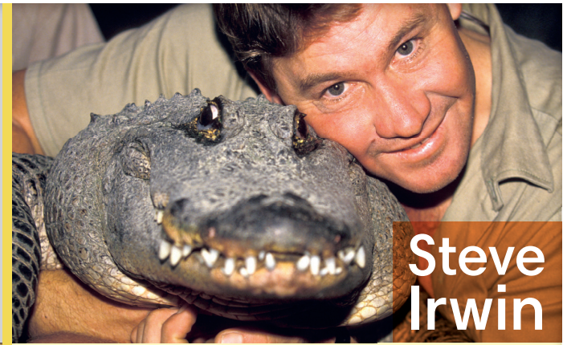
3. PRE-WRITING (13’)
ACTIVITY 1 + 2 + 3 + 4:
* Aim:
- To activate Ss’ prior knowledge of the topic.
- To lead in to the next activitiy.
- To study the Writing Box.

- To help Ss focus on personal information while reading the sample.
- To provide Ss the localized content to write about.
- To practice sentence building by filling in the blanks before Ss can write a complete text.
* Outcome: Do the exercise to improve grammar.
* Organisation : T_ Ss ..….
Teacher’s & Student’s activities | Content
1. (3’) Read Steve Irwin’s biography and  answer the questions.  (Exercise 1 – SB p.37)  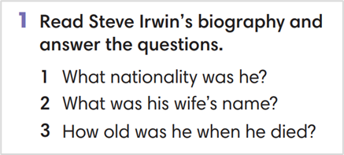  - T calls a student to read the instruction then checks Ss’ understanding of it.  - T has Ss work in pair and find the answers for the questions  - T encourages Ss to underlines the key sentences in the reading.  - T calls some volunteer students to give their answers then checks for the whole class. | Answer key:  1. Australian  2. Terri  3. forty-four years old (although he could have been forty-three if his birthday was after September)
2. (4’) Look at Steve’s biography again.
Find all the examples of Past Simple.
(Exercise 2 – SB p.37)
- T asks Ss to look at exercise 2.
- T calls a student to read the instruction then checks Ss’ understanding of it.
- T asks Ss to work in groups of three to read then complete the activity.
- T calls groups to give answers then shows the answers on the slide to check as the whole class.
3. (3’) Study the Writing box. Which of the phrases can you find in Steve’s biography?  (Exercise 3 – SB p.37)  - T asks Ss to look at exercise 3.  - T calls a student to read the instruction then checks Ss’ understanding of it.  - T asks Ss to work in pairs to read then complete the activity.  - T checks as the whole class. | 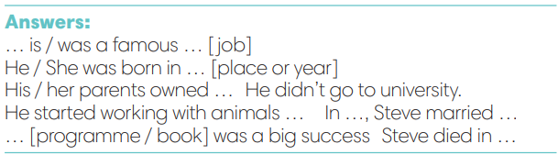
4. (3’) What do you know about Trinh Công Son?  Read the fact box and complete it with Past Simple form of the verbs in brackets.  (Exercise 4 – SB p.37)  - T asks Ss to look at the writing box and the sample writing again.  - T asks Ss to work individually, complete the facts about Trinh Cong Son  - T sets a time limit for the activity.  - T tells Ss to pair, share, and compare the answers.  - T shows the slides and check as the whole class. | 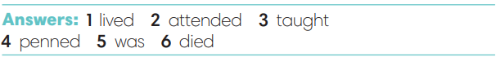
4. WHILE-WRITING (8’)
ACTIVITY 5:
* Aim: To provide students task to apply useful expressions from Writing Box in writing sentences with Past Simple tense.
* Content: Use the past simple tense to write a short biography.
* Outcome: Write a short biography of a famous people using the vocabulary and grammar points of the unit.
* Organisation : T_ Ss.. ….

Teacher’s & Student’s activities | Content
5. Write a short biography (60-80 words) of Trinh Cong Son. Use the fact box and the Writing Box from Exercise 4  (Exercise 5 – SB p.37)  - T calls a student to read the instructions then checks Ss’ understanding of it.  - T asks Ss to work individually to write a biography of Trinh Cong Son base on the Fact box and Writing Box  - T sets a time limit for the task and walk around as a monitor while Ss are writing. | 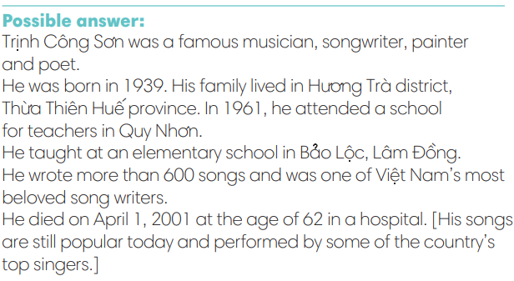
5. POST-WRITING (6’)
* Aim:
- To let Ss do peer-check.
- To give general comments on Ss’ writing pieces.
* Content: Ss swap their writing and check.
* Outcome: Ss’s biography is followed the writing rubric.
* Organisation : T_ Ss.. ….

Teacher’s & Student’s activities | Content
Extra activity 3: In pairs, swap your writing then check.  - T explains the writing rubric before checking.  - T asks Ss to swap their writing pieces, use the given writing rubric then do cross-check.  - T gives feedback on common mistakes of Ss’ work.  - T may collect Ss’ writing for detailed comments. | Writing rubric:  (1) Does the writing include details?  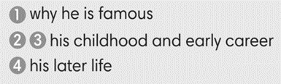  (2) Does the writing meet word limit (60-80 words)?  (3) Does the writing make any vocabulary and grammar mistakes?
WRAP-UP & HOME WORK (2’)
- T asks Ss to talk about what they have learnt in the lesson.
- A biography of a famous person
* HOME WORK:
- Do exercises in the workbook page 31.
- Prepare for Lesson 3.8

======================

Date of planning:  Date of teaching: | UNIT 3: ANIMALS’ MAGIC  Lesson 8: Vocabulary in Action and Pronunciation
I. OBJECTIVES:
By the end of the lesson student will be able to:
1. Knowledge:
* Vocabulary: review vocabulary about animals, adjectives, looking after pets
- phrasal verbs of pet-looking activities
- word friends and word family
* Pronunciation: Listen and identify the rhyming words
2. Competence: Students develop communication skills, and creativity; be collaborative and supportive in pair work, and teamwork; actively join in class activities.
3. Quality/ behavior: To teach Ss the love of talking about relating topics of unit 3 and using word friends or phrasal verbs in pair work or group work, and develop self-study skills. Ss have a good attitude to working in groups, individual work, pairwork, cooperative learning, and working
II. TEACHING AIDS:
- Teacher: Grade 7 textbook, Unit 3 (SB p.38), laptop/computer connected to the Internet, loudspeaker, projector/TV, PPT slides… .
- Students: Text books, studying equipment…
- Method: Active teach, T-WC; group works; individual ……
III. PROCEDURE:
1. WARM UP + LEAD-IN (5’)
*Aims:
- To create an active atmosphere in the class before the lesson.
- To lead into the new lesson.
* Content: Game: NAME 3 THINGS CHALLENGE (animals)
* Outcome: Students say words relating to the given topic quickly.
* Organisation: Teacher’s instructions…
Teacher’s & Student’s activities | Content
Extra activity 1: NAME 3 THINGS CHALLENGE  * Teacher asks students to spend 1 minutes to quickly review all vocabulary they have learnt in Unit 3 before they play a warm-up game.  - T tells students that they are going to play a game called NAME 3 THINGS CHALLENGE  - T explains the game rules then checks instructions.  - Teacher uses the slides to show the challenge  - Ss join in the game pairs or in small groups.  - Teacher listens to the Ss answers and calls several Ss to check for the whole class.  - T tells Ss that they can remember better with Glossary Table and asks Ss to open their Student Book page 38 – Exercise 1. | Game rules:  - Choose a number to get the challenge  - Read the topic word  - Say 3 words relating to that topic quickly.
2. REVIEW VOCABULARY (18’)
(GLOSSARY TALBE)
ACTIVITY 1 + 2 + 3:
*Aim:
- To introduce the glossary and its uses.
- To give further practice in making sentences using the Glossary.
* Content: Revise what they have learnt during the unit. Glossary and its uses.
* Outcome: Remember the new words and animals’ name.
* Organisation : Teacher’s instructions…
Teacher’s & Student’s activities | Content
1. (7’) In pairs, say the names of there animals that you think are:  1. quiet  2. noisy  3. dangerous  4. cute  5. lively  (Exercise 1 – Student Book page 38)  - Teacher introduces the Glossary Table.  - T asks Ss to look at exercise 1 in student book page 38  - T has students use the glossary to find the words which belong to the correct category  - T asks students to work in pairs and quickly do the task.  - T allows students to peer check first.  - T checks and confirms the answers.  The answers can be variety depends on Ss’ choice. | 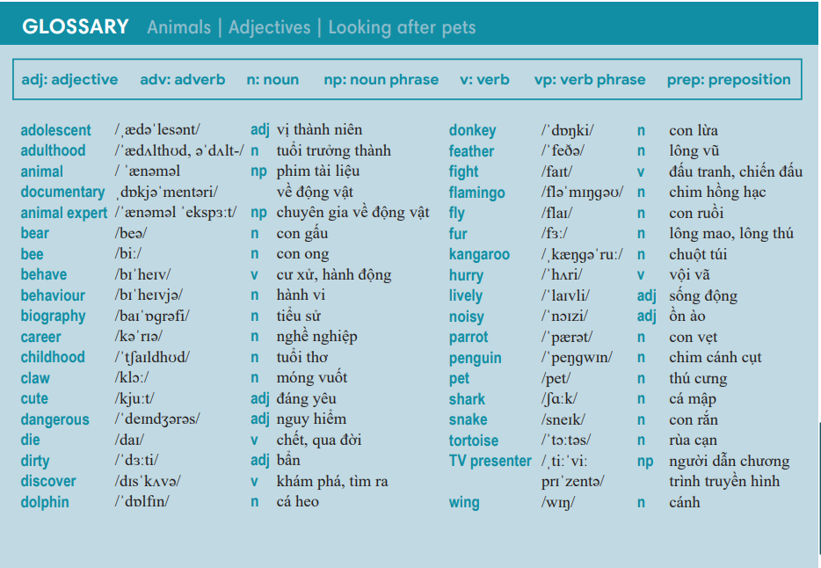
2. (6’) Complete the sentences with the prepositions below.  In pairs, say if you agree with the statements or not.  (Exercise 2 – Student Book page 38)  - T asks students to complete the sentences with suitable prepositions  - T asks students to work individually and check in pairs.  - T invites students to share their answers.  - T confirms the correct answers.  TIME TO TALK:  - Ss work in pairs to share if they agree or disagree to the statements in the exercise. | Answer key:  2. after / 3. for / 4. to / 5. for
3. (5’) Complete the sentences with the correct form of the word in bold.  (Exercise 3 – Student Book page 38)  - T asks Ss to open their SB page 38, look at exercise 3.  - T calls a student to read the instruction then checks Ss’ understanding of it.  - T gives students a time limit to work individually.  - T allows Ss to share their answers massively before checking the final ones as the whole class.  - T provides the meanings, pronunciations of the words in the exercise  Childhood / behaviour / adolescence / presenter  - T has students pronounce the words in pairs. | Answer key:  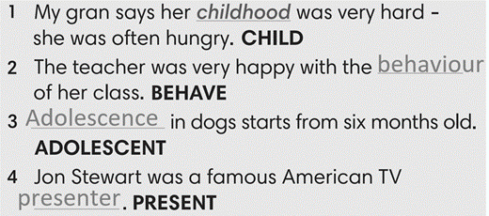
3. PRONUNCIATION (19’)
3.1. Presentation (13’)
ACTIVITY 4:
* Aims:
- To present the list of rhyming words
- To help students identify the rhyming words
- To help students listen and identify rhyming words in pairs.
* Content: Do exercises to practice pronunciation.
* Outcome: Say the rhyming words correctly.
* Organisation: Teacher’s instructions…

Teacher’s & Student’s activities | Content
4. (7’) Complete the sentences. Use the words below that rhyme with the underlined words. There are two extra words.  (Exercise 4 – SB p38)  - Teacher uses the slides to lead the activity  - T calls a student to read the instruction then checks Ss’ understanding of it.  - T gives students a time limit to work individually.  - T allows Ss to share their answers massively before checking the final ones as the whole class.  TIME TO SAY  - T have students say the rhyming words in pairs/ group | Answer keys:  2- wing, 3-hurry, 4-snake, 5-fly, 6-zoo, 7-bear
Extra activity 2 (6’): Defeat The Goalkeeper Game  - T introduces the game and explains the rules.  - T calls some students to read out the words first.  - T plays the audio tracks for them to listen choose.  - T invites some students to share their answers.  - T confirms the answer using the slide and rewards points for the winner team. | Game rules:  - Read the questions carefully.  - Choose the answer A or B to defeat the goalkeeper.  - 1 correct answer = 1 point.
3.2. Practice (6’)
* Aims: To enhance the rhyming words
* Content: Play Phonic Game to practice pronunciation.
* Outcome: Say the words with the correct rhymes.
* Organisation : Teacher’s instructions…

Teacher’s & Student’s activities | Content
Extra activity 3: Phonics Game  - T has Ss to play the game in pairs, explains the rules.  - T sets a time for students to play in pairs, walks around and provides support when needed. | Game rules:  - Student A says a word (from the phonics list)  - Student B says a word that rhymes with Student A’s word  - Swap the role.
WRAP-UP & HOME WORK (3’)
- Teacher asks students to talk about what they have learnt in the lesson.
- Use a Glossary to review
- Identify rhyming words
* HOME WORK
- Find more rhyming words
- Prepare for Unit 3 – Lesson 9: Revision

==================
Date of planning:  Date of teaching: | UNIT 3: ANIMALS’ MAGIC  Lesson 9: Revision
I. OBJECTIVES:
By the end of the lesson, Ss are able to:
1. Knowledge:
* Vocabulary: revise words related to animals, adjectives, looking after pets
* Grammar: review phrasal verbs of looking after pets and past simple tense to talk about a famous person or write a biography.
2. Competence: Ss understand and use the vocabulary of the unit, do the tasks assigned in the textbook; write a biography.
3. Quality/ behavior : To teach Ss to be hard-working and attentive in class. Ss have a positive attitude to working in groups, individual work, pair work, cooperative learning and working.
II. TEACHING AIDS:
- Teacher: Grade 7 textbook, Unit 3 (SB p. 39, WB p.32), laptop/computer connected to the Internet, loudspeaker, projector/TV, PPT slides…
- Students : Text books, studying equipment….
- Method: Active teach, T-WC; group works; individual ……
III. PROCEDURE:

- WARM-UP (4’)

*Aims:
- To create a positive classroom atmosphere to start a new lesson.
- To lead into the review lesson.
* Content: Game: SUPER EYES
* Outcome: Ss understand that they are going to review Unit 3.
* Organisation: Teacher’s instructions…
Teacher’s & Student’s activities | Content
Extra activity 1: SUPER EYES  - Set the scene: T asks students to do quick exercises for eyes such as look up and down, look left and right, row the eyes  - T tells students that they are going to play a game called SUPER EYES  - T explains the game rules then checks instructions.  - Teacher uses the slides to show the collages  - Ss join in the game pairs or in small groups.  - Teacher shows the collage again with displayed answers to check for the whole class.  - T tells Ss that they are going to review Unit 3. | Game rules:  - Look carefully at a collage of different small pictures  - The collage will disappear in a few seconds  - Recall as many words about the collage as you can remember.
- REVIEW VOCABULARY (12’)
ACTIVITY 1 + 2:
* Aims:
- To help students reviews topic words and word friends from the unit
- To review vocabulary in context
* Content: Do the exercise to revise the vocabulary of Unit 3.
* Outcome: Understand the vocabulary to do the exercise correctly.
* Organisation : Teacher’s instructions….
Teacher’s & Student’s activities | Content
Extra activity 2: (5’) SUPER MIND  - T tells students to open the Glossary box in student book page 39.  - T introduce the SUPER MIND game and rules  - T shows the slides of the game  - Ss take turns to choose the numbers for their teams.  - Ss discuss and list out all words related to the topic they get.  - T calls some Ss to give answers and confirms the winner. | How to play:  - Play in team  - Choose a number to open a block  - Read the topic word  - Write as many words related to the topic as you can  - The faster finisher gets points
1. (3’) Write the names of animals for the definitions.  (Exercise 1 – Student Book page 39)  - T asks Ss to look at exercise 1 in student book page 39  - T calls a student to read the instruction then checks Ss’ understanding of it.  - T asks Ss to work in pairs to read then complete the activity.  - T checks as the whole class. | Answer keys:  2-kitten, 3-spider, 4-tiger, 5-penguin, 6-flamingo, 7-kangaroo, 8-giraffe
2. (4’) Complete sentences. Then in pairs, say if the sentences are true for you.  (Exercise 2 – Student Book page 39)  - T asks Ss to look at exercise 2 in student book page 39  - T calls a student to read the instruction then checks Ss’ understanding of it.  - T asks Ss to work in pairs to read then complete the activity.  - Ss work in pair to complete the task and compare the answers.  - T checks as the whole class. | Answer keys:  2-fur/ empty, 3-takes, 4-make, 5-feed, 6-miss
3. REVIEW GRAMMAR ( 21’)
ACTIVITY 3 + 4 + 5:
*Aim:
- To help students revise the form and use of the past simple.
- To help students practice the past form of to be.
- To help students practice the past form of verbs.
- To help student practice writing a biography
* Content: Use the past simple tense to complete the exercises.
* Outcome: Use the past simple tense for communication and writing.
* Organisation : Teacher’s instructions….
Teacher’s & Student’s activities | Content
Extra activity 3: (3’) Read the grammar box
- T tells Ss to look at the grammar box and read the example.
- T has Ss to work individually to apply the grammar to write some sentences in the notebooks using the grammar boxes.
- Students think and write the sentences
- T sets a time limit for the activity.
- T invites some students to read their sentences and provide corrections when needed.
3. (5’) Complete the sentences with was, wasn’t, were, or weren’t.  (Exercise 3 – Student Book page 39)  - T asks Ss to look at exercise 3 in student book page 39  - T calls a student to read the instruction then checks Ss’ understanding of it.  - T asks Ss to work in pairs to read then complete the activity.  - Ss work in pair to complete the task and compare the answers.  - T checks as the whole class. | Answer keys:  2-was, 3-was, 4-wasn’t, 5-was, 6-Were, 7-were, 8-was
4. (5’) Complete the text with the Past Simple forms of the verbs below.  (Exercise 4 – Student Book page 39)  - T asks Ss to look at exercise 4 in student book page 39  - T calls a student to read the instruction then checks Ss’ understanding of it.  - T asks Ss to work in pairs to read then complete the activity.  - Ss work in pair to complete the task and compare the answers.  - T checks as the whole class. | Answer keys:  2-hurried, 3-needed, 4-changed, 5-studied, 6-called, 7-didn’t want, 8-asked, 9-talked, 10-didn’t answer
5. (8’) Your teacher is organizing a writing contest about famous people. Write a biography (60-80 words) about a famous person who takes great care of animals.  (Exercise 5 – Student Book page 39)  - T asks Ss to look at exercise 5.  - T calls a student to read the instruction then checks Ss’ understanding of it.  - T asks Ss to work individually to write basing on the writing box in student book page 37  - T sets a time limit and walk around as a monitor while Ss are writing.  - T asks Ss to swap their writing pieces for peer check.  - Ss work in pairs to write and give feedback for their partner’s writing product.  - T may collect Ss’ writing for detailed comments. | You should write about:  - why he / she became famous  - his / her childhood and career  - his / her later life
WRAP-UP & HOME WORK (2’)
- T asks Ss to talk about what they have learnt in the lesson.
- Review Unit 3 vocabulary and grammar.
- Write a biography for the class writing contest.
* HOMEWORK
- Do exercises in the workbook page 32.
- Prepare for Unit 4/Lesson 4.1: Vocabulary

