Date of planning: 16/1/2023  Date of teaching: 17/1/2023 | UNIT 5: FOOD AND DRINK  Period 55: Vocabulary
I. OBJECTIVES:
By the end of the lesson, Ss will be able to:
- have an overview of the topic “Food and drink”.
- use vocabulary and grammar points to talk about food.
1. Knowledge:
* Vocabulary: an understanding of the meaning of keywords or word collocations below:
Food and drink with countries | somtum (ThaiLand), pasta (Italy), Peking duck (China), summer rolls (Vietnam), bubble tea (Taiwan, China), sake (Japan)
Adjectives to describe foods | creamy, crispy, mild, fresh, sour, spicy

* Grammar: My favourite food:

MY FAVOURITE FOOD
My favourite food is from Italy.
It has a creamy red sauce on it.
I know. Is it pasta?

2. Competence:
To know the meaning of the keywords used to talk about food and drinks, understand the main grammatical points, then do the tasks assigned in the textbook.
3. Quality/Behavior: To teach Ss to be hard-working and attentive in class. Ss have a positive attitude to working in groups, individual work, pair work, cooperative learning and working.
II. TEACHING AIDS:
- Teacher: Grade 7 textbook, Unit 5 (SB p.50-51, WB p.42-43), laptop/computer connected to the Internet, loudspeaker, projector/TV, PPT slides…
- Students: Text books, studying equipment…
- Method: Active teach, T-WC; group works; individual ……
III. PROCEDURE:
1. WARM UP( 5’)
* Aims:
- To activate Ss’ prior knowledge and get students involved in the lesson.
- To set the context for introducing new words.
* Content: Play 3 seconds game to get students involved in the lesson and to set the context for the lesson.
* Outcome: Students name some types of food and drink they’ve already known.
* Organisation: Teacher’s instructions…

Teacher’s & Student’s activities | Content
Extra activity 1: Three seconds game:  - T divides the class into 4 teams, explains the game rules then checks instructions.  - T tells students that they are learning some dishes from all over the world.  - T sets the context for the lesson: Write the title on the board Unit 5: Food and drink / Lesson 5.1: Vocabulary.  - T tells Ss that they are learning some food and drink from all over the world. | Game rules:  - Two minutes for preparation (list all foods and drinks that Ss know).  - Each team takes turn to say one kind of food and drink.  - The team can’t say the word in 3 seconds or repeat the word is out of the game.
2. Presentation 1 (5’) VOCABULARY
(Types of food and drinks)
ACTIVITY 1:
* Aims:
- To reinforce the types of food and drink that students have already known.
- To teach six types of food and drink.
- To lead into the next activity.
* Content: Some brief notes; Names of some kinds of food and drink from all over the world.
* Outcome: Know new words about types of food and drink.
* Organisation: Teacher’s instructions….

Teacher’s & Student’s activities |  | Content
1. Match the photos (1-6) with the names of food and drink (a-f). Listen to check your answers.  (Ex 1 – SB p.50)  - T asks Ss to open their SB page 50, look at Exercise 1.  - T calls a student to read the instruction then checks Ss’ understanding of it.  - T elicits the meaning of words.  - Then, T asks students to look at Exercise 1 and complete.  - Ss can work in pairs or small groups to finish the task.  - T plays the audio for Ss to listen, check and repeat.  - T checks pronunciation of Ss and invites some Ss to say the words in front of the class. Re-correct if needed.  - T asks S. to list more dishes from other countries.  - Divide the class into two groups to find as many dishes as possible. The team with more words and correct countries get more points.  - Find out which dishes Ss like most and least. And why? |  | Answer keys:  a-3 / b-4 / c-5 / d-6 / e-1 / f-2
3. PRESENTATION 2 (10’)
(Types of food and drink; adjectives to describe food and drink)
ACTIVITIES 2 & 3:
* Aims:
- To teach vocabulary of food and drink.
- To introduce adjectives used to describe food and drink to Ss.
* Content: Some brief notes; Names of some dishes; Adjectives used to describe food and drink.
* Outcome: Know new words about types of food and drink, and adjectives used to describe them.
* Organisation: Teacher’s instructions …
Teacher’s & Student’s activities | Content
2. Listen to three people describing dishes from their countries. Match the speech of each person to a photo. Write the name of the food next to the photo.  (Ex 2, p.51)  - T asks Ss to look at the pictures on page 51, check again all names and origins of dishes.  - T encourages Ss to describe the dishes: ingredients and taste.  - T introduces new words from Exercise 3, p.51: creamy, crispy, mild, spicy, sour, fresh. T checks Ss’ pronunciation.  - T asks students to list all dishes with these adjectives. (Find more dishes which are crispy: French fries, snack, biscuits, etc.)  - T play the recordings, Ss listen, try to note down information and finish Exercise 2. | Answer keys:  (1) Marco - pasta (2) Thuỷ - summer rolls (3) Nok - somtum
3. Listen again and write the words that describe these foods.  (Ex 3, p.51)  - T asks Ss to finish Exercise 3 basing on memory.  - T plays the recording and check the answers. Ss repeat. | Answer keys:  Thuỷ: fresh  Nok: spicy, sour  Marco: mild, creamy
4. PRACTICE 1 (6’)
ACTIVITY 4:
* Aims:
- To provide Ss with chances to practice pronouncing new words.
- To help Ss use the new vocabulary in contexts.
* Content: Ss fill in the blanks with the adjectives describing food and drink.
* Outcome: Ss can use the adjective describing food and drink in contexts.
* Organisation: Teacher’s instructions….
Teacher’s & Student’s activities | Content
4. In pairs, complete the sentences with the words given in the box.  (Ex 4, p.51)  - T asks Ss to look at Exercise 4 (SB p  age 51).  - T calls a student to read the instruction then checks Ss’ understanding of it.  - T gives Ss 3 minutes to fill in the blank.  - T checks Ss’ answers.  - Ss work in pairs to make more sentences using these words. | Answer keys:  (1) fresh (2) mild (3) spicy  (4) creamy (5) crispy
5. PRACTICE 2 (5’)
ACTIVITY 5:
* Aims:
- To provide Ss with more words related to the topic.
- To help Ss use the new vocabulary in collocations.
* Content: Ss identify the vocabulary mentioned in the audio.
* Outcome: Ss can use the the new vocabulary in collocations.
* Organisation: Teacher’s instructions….
Teacher’s & Student’s activities | Content
5. Listen again. Cross out the ingredients and features that are not mentioned.  (Ex 5, p.51)  - T asks Ss finish Exercise 5 basing on memory.  - T plays the recording and checks Ss’ answers. Ss repeat.  - T makes a list of ingredients and features for students to guess what dish is that, note down all new words. | Answer keys:  (1) limes, noodles (2) garlic  (3) flour, eggs, salt
6. PRODUCTION (6’)
ACTIVITY 6:
* Aims: To help Ss practice applying the vocabulary items and grammar points related to the topic in speaking.
* Content: Ss work in pairs to talk about their favourite food.
* Outcome: Ss talk about their favourite food using vocabulary and grammar points.
* Organisation: Teacher’s instructions …
Teacher’s & Student’s activities | Content
6. Work in pairs. Student A, choose a favourite food and describe it to Student B. Student B, guess the food that you hear. Then change roles.
(Ex 6, p.51)

- T asks Ss to look at Exercise 6 (SB p.51).
- T calls a student to read the instruction then checks Ss’ understanding of it.
- T asks Ss to work in pairs following examples.
- T invites 3-5 students to describe one dish and the class guesses the name of that dish.
Example:
My favorite food is from Japan. It has rice and raw fish.
Sushi

WRAP-UP & HOME WORK (3’)

T asks Ss to talk about what they have learnt in the lesson.
- Vocabulary of food and drink.
- Grammar points: Present simple and adjectives to describe food and drink.
* HOME WORK
- Do exercises in the workbook page 42-43.
- Prepare for Lesson 2: Grammar 1.

Date of planning: 26/1/2023  Date of teaching: 27/1/2023 | UNIT 5: FOOD AND DRINK  Period 2: Grammar 1
I. OBJECTIVES:
By the end of the lesson, students will be able to:
- use quantifiers when buying food from the supermarket.
1. Knowledge:
* Grammar:
- identify and understand how to use quantifiers.
- talk about quantifiers of food and drink.
- use quantifiers when buying food from the supermarket.
2. Competence: Ss know to use vocabulary about food and drink, and understand the main grammatical points, then do the tasks assigned in the textbook; use the quantifiers of food and drink correctly.
3. Quality / behavior: To teach Ss to be hard-working and attentive in class. Ss have a positive attitude to working in groups, individual work, pair work, cooperative learning and working.
II. TEACHING AIDS:
- Teacher: Grade 7 textbook, Unit 5 (SB p.52), laptop/computer connected to the Internet, loudspeaker, projector/TV, PPT slides…
- Students: Text books, studying equipment…
- Method: Active teach, T-WC; group works; individual ……
III. PROCEDURE:

1. WARM UP ( 4’)
* Aims:
- To activate students’ prior knowledge and get students involved in the lesson.
- To set the context for introducing new structures.
* Content: Play Guessing game to get Ss involved in the lesson and to set the context for the lesson.
* Outcome: Ss know the context of the lesson.
* Organisation: Teacher’s instructions….
Teacher’s and Student’s activities | Content
Extra activity 1: Guessing Game  - T divides Ss into 2 teams.  - T invites 2 students from each team, come to the board.  - T explains the game rules then checks instructions.  - T writes the title on the board Unit 5: Food and drink / Lesson 5.2: Grammar | Game rules:  ✔ 2 Ss from 2 teams receive a word from teacher and then draw.  ✔ Other Ss guess the food.  ✔ The faster team gets 1 point.
2. REVIEW ( 4’)
* Aims:
- To reinforce the vocabulary of food Ss already know.
- To set the context for introducing new structures.
* Content: Play Game to get Ss involved in the lesson and to set the context for the lesson.
* Outcome: Ss know the context of the lesson.
* Organisation: Teacher’s instructions….
Teacher’s and Student’s activities |  | Content
Extra activity 2: Game: Countable or uncountable noun?  - T sets the scene for the new lesson: T tells Ss that they are going to learn about food quantifiers. |  | Game rules:  ✔ T says one food item.  ✔ If the word is countable, Ss stand up. If the word is uncountable, Ss sit down.  ✔ The faster team gets 1 point.
3. LEAD-IN ( 3’)
ACTIVITY 1a:
* Aims: To lead into the new lesson.
* Content: Ss read and listen to a telephone conversation and answer questions.
* Outcome: Ss can identify quantifiers in the conversation and give answers.
* Organisation : T-Ss.
Teacher’s and Student’s activities | Content
1. Read and listen to a telephone conversation between Lan and her mother, Mrs. Hiền. Answer the questions.
(Ex 1, p.52)

- T asks Ss to close the book and listen to the telephone conversation.
- Ss listen, try to understand the content and note down all food vocabulary.
- T writes Ss’ answers on the board to check later.
4. PRESENTATION (8’)
(Quantifiers)
ACTIVITY 1b:
* Aims:
- To introduce the Grammar Box
- To present the grammar point in context.
- To lead into the next activity.
* Content: Ss read and listen to a telephone conversation between Lan and her mother, Mrs. Hiền. Answer the questions.
* Outcome: Ss can recognize quantifiers in a conversation and use them to answer questions.
* Organisation: T-Ss, Ss-T
Teacher’s & Student’s activities |  |  |  | Content
2. Read and listen to a telephone conversation between Lan and her mother, Mrs. Hiền. Answer the questions.  (Ex 1, p.52)  - T shows grammar box of food quantifiers.  - T explains any unknown words.  - T plays the recording again, Ss note down all food quantifiers.  - Ss open the book, look at Exercise 1 page 52.  - T asks students to read and underline all food and quantifiers.  - Ss read 3 questions and underline key words.  - T asks Ss to answer questions in 2 minutes and check. |  |  |  | 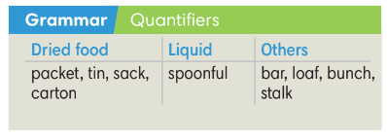  Answer keys:  1. a sack of rice  2. a couple of big bottles of water  3. a few packets of cereal
5. PRACTICE (16’)
ACTIVITIES 2 and 3:
* Aim:
- To help Ss match quantifiers with food.
- To provide Ss with chances to work cooperatively.
- To explain the grammar point for Ss.
- To provide Ss grammar exercises to practice using quantifiers.
* Content:
- Ss match quantifiers with food.
- Ss can recognise quantifiers in an audio recording.
* Outcome: Ss know how to use quantifiers to say about quantity of food.
* Organisation : T-Ss, Ss-T, Pair work
Teacher’s and Student’s activities |  |  |  |  | Content
3. (4’) Match the quantifiers with the food and drink (1-6). Write 1-6 in the boxes below.  (Ex 2 SB p.52)  - T and Ss go through all food and quantifiers.  - T asks Ss to work in pairs and match the quantifiers with the food.  - T checks Ss’ answers. |  |  |  |  | Answer keys:  1. sack  2. stalk  3. tin  4. packet  5. loaf  6. bottle
(5’) Extra activity 3: Game.  - T divides the class into 4 groups. |  |  |  |  | Game rules:  ✔ Teachers write food quantifiers on the board.  ✔ Ss have 1 minute to prepare and then take turns to write the food in its quantifier column.  ✔ The team with the most correct answers is the winner.
4. (7’) Lan is at the supermarket to buy the following items. Listen and write the number.  (Ex 3 SB p.52)  - T asks Ss to read instructions and questions.  - Ss listen to the recording and finish Exercise 3.  - T checks Ss’ answers. |  |  |  |  | Answer key:  a - 4/ four b - 4/ four c - 0  d - 3/ three e - 4/ four  f - 1/ one g - 3/ three
6. PRODUCTION ( 7’)
ACTIVITY 4:
*Aim: To help students applying the vocabulary items and grammar points related to the topic in communicating.
* Content: Ss describe themselves and their partners (what they like and dislike).
* Outcome: Ss know how to express themselves and describe others.
* Organisation: T_Ss…

Teacher’s & Student’s activities |  |  | Content
5. Play a chain game. Line up and add to the sentences some different food items with quantities like this.  (Ex 4, p.52)  - T asks Ss to read the game rules.  - T asks 10 Ss each turn to play, continue until all Ss have joined.  - T notes down all mistakes for later feedback. |  |  | 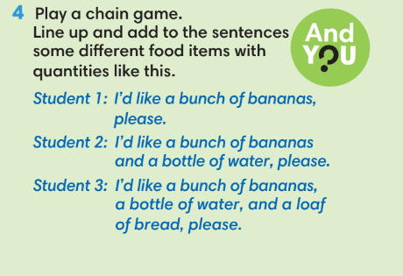  Game rules:  ✔ Ss add food items with quantifiers  + S1: I’d like a bunch of bananas, please.  + S2: I’d like a bunch of bananas and a bottle of water, please.  + S3: I’d like a bunch of bananas and a bottle of water and a load of bread, please.
WRAP-UP & HOME WORK (3’)
- T asks Ss to talk about what they have learnt in the lesson.
✔ Food quantifiers.
* HOME WORK
- Do exercises in the workbook page 44.
- Prepare for Lesson 5.3: Reading and Vocabulary.

Date of planning:30/1/2023  Date of teaching: 31/1/2023 | UNIT 5: FOOD AND DRINK  Period 3: Reading and Vocabulary
I. OBJECTIVES:
By the end of the lesson Ss will be able to:
- locate information and find specific details in an article (scanning skill).
- identify the main ideas of the paragraphs in the text or the text itself (skimming).
1. Knowledge:
* Vocabulary: about food and floating markets in Vietnam.

New words | Vietnamese meaning
1. floating market | chợ nổi
2. pomelo | bưởi
3. durian | sầu riêng
4. coconut-leaf cake | bánh lá dừa
5. banana pancakes | bánh chuối
6. local snacks | đồ ăn vặt địa phương
7. sold overseas | bán ra nước ngoài
8. famous for | nổi tiếng vì
9. different types of | các loại khác nhau

* Grammar:
- Reading skills: The ability to find specific details in an article (scanning skill).
2. Competence: Understand the meaning of the keywords used to talk about food in floating markets, then do the tasks assigned in the textbook; locate information and find specific details in an article (scanning skill); identify the main ideas of the paragraphs in the text or the text itself (skimming skill).
3. Quality/behavior: To teach Ss to be hard-working and attentive in class. Ss have a positive attitude to working in groups, individual work, pair work, cooperative learning and working.
II. TEACHING AIDS:
- Teacher: Grade 7 textbook, Unit 5 (SB p.53, WB p.45), laptop/computer connected to the Internet, loudspeaker, projector/TV, PPT slides …
- Students: Text books, studying equipment …
- Method: Active teach, T-WC; group works; individual …
III. PROCEDURE:
1. WARM-UP (5’)
* Aim:
- To help Ss review some phrases they have known.
- To lead into the next activity.
* Content: Game: Lucky number ( about quantifiers).
* Outcome: Ss choose the correct quantifier when talking about a type of food.
* Organisation: T-Ss, Ss-T
Teacher’s & Student’s activities | Content
Extra activity 1: Lucky number  - T explains the game rules then checks instructions.  - T uses slide to lead the game.  - T asks Ss to say the food item before choosing the quantifier.  - Ss raise their hands if they have the answer.  - T asks students to read aloud the phrase after each play.  - T tells students that they are going to read about food market.  - T writes the title for the new lesson:  Unit 5 - Lesson 5.3: Reading and Vocabulary. | Game rules:  - Look at the picture (food items).  - Give one quantifier going with that food item (exclude many/ much/ some/ a lot of).  - Choose randomly one number (1-9) to see your score.
2. PRE-READING (5’)
ACTIVITY 1:
* Aim:
- To activate Ss’ background knowledge of the topic.
- To get Ss think about markets in Vietnam.
- To provide Ss with reasons for reading the text in the next stage.
* Content: Ss look at the photos and say which products sold at the two markets.
* Outcome: Ss can describe the two floating markets and find main idea of the two texts.
* Organisation: T-Ss; Ss-T
Teacher’s & Student’s activities |  | Content
1. Look at the photos. What are being sold?
(Ex 1, SB p.53)
- T asks Ss to look at two pictures to describe them.
1. What do you see in the picture?
2. What is special about these markets?
3. What are being sold?
4. Have you ever been to a market like this?
- T explains to Ss that reading skill they need to use is scanning for specific information which are normally numbers, dates, places and important things.
- Before scanning, T asks Ss to do skimming and find main idea of these two texts.
3. WHILE-READING (14’)
ACTIVITY 2 + 3:
*Aim:
- To read two texts and do reading tasks.
- To help students practise finding specific details in the texts.
* Content: Ss read the texts and answer the questions.
* Outcome: Ss can identify specific information in the texts and learn more about floating markets in Việt Nam.
* Organisation: T-Ss, Ss-T
2. (8’) Read the texts above and tick () the appropriate boxes.  (Ex 2, p.53)  Step 1: Scan the text  - T asks Ss to scan the article and underline important information.  - T gives Ss 1 minute to remember all above information.  - T asks Ss to close the book. T asks some questions to check Ss memory and reading skills.  1. What are being sold at Cái Răng/ Ngã Bảy Floating markets?  2. Where is Cái Răng market?  3. How many boats/ tourists are there at Cái Răng market?  4. Tell me one local snack from Cái Răng market.  5. When did Ngã Bảy market start?  6. What is Ngã Bảy market famous for?  Step 2: Exercise 2 – SB p.53  - T asks Ss to look at Exercise 2 (SB p.53).  - T calls a student to read the instructions then checks Ss’ understanding of it.  - T asks Ss to find these key words from the texts and finish Exercise 2.  - T asks Ss to check answers with partner before checking with the whole class. |  | Answer keys:  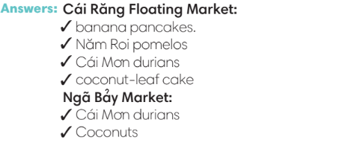
3. (6’) Read the text 1 and 2 again. Mark the sentences (right), (wrong), ? (doesn’t say)  (Ex 3, p.53)  - T asks Ss to look at excersise 3 (SB page 53).  - T calls a student to read the instruction then checks Ss’ understanding of it.  - T tells Ss to read the text again individually to  complete Exercise 3.  - When finished, T asks Ss to compare their answers in pairs and check with them.  - T asks Ss to point to relevant details in the text. |  | Answer keys:  1 ? 2 3 4 5 ? 6
4. POST-READING (17’)
ACTIVITIES 4 & 5:
* Aim:
- To provide more word friends and practice talking about food market in Vietnam
* Content: To fill the blanks with phrases related to the reading topic.
* Outcome: Ss can use the Word Friends to complete phrases related to the reading topic and more similar phrases.
* Organisation: T-Ss, Ss-T, Ss-Ss, Pair work, Invidual work
4. (7’) Complete the phrases below with the Word Friends.  (Ex 4, p.53)  - T asks Ss to say aloud all phrases and guess the meaning.  - T explains the meaning of these phrases to Ss.  - T asks Ss to finish Exercise 4 and then check the answers.  - T divides the class into 3 groups to find more phrases using these new words. |  | Answer keys:  1 different types of  2 famous for  3 later than  4 a bit  5 local snacks  6 floating market
(5’) Tic-tac-toe game.  - T tells Ss that they are going to play a game to reinforce word friends and practice talking about food and drinks in Việt Nam.  - T tells Ss the game rules.  - T checks Ss’ pronunciation if needed. |  | Game rules:  - T divides the class into 2 teams.  - T gives one keyword (word friends from Exercise 4).  - Each team takes turns to make a sentence with these words. If the answer is correct, that team place one X or O.
5. (7’) Take turns to talk about food markets in your area.  Ex 5 – SB p.53  - T asks Ss to look at exercise 5 (SB page 53).  - T calls a student to read the instruction then checks Ss’ understanding of it.  - T asks a student to read the example.  - T helps Ss to brainstorm which information they should include: location, time, types of products, what is famous at the market, etc.  - T asks Ss to work individually.  - T invites some volunteers to present in front of the class.  - T notes down common mistakes for later feedback.  - T asks the rest to give comments on their classmates’ performance.  - T gives feedback on Ss’ work.  - T asks Ss to work in pairs to give feedbacks to their partner. |  | Answer:  - They are just back in their bedrooms surfing the internet.
WRAP-UP & HOME WORK (4’)
- T asks Ss to talk about what they have learnt in the lesson.
- Vocabulary of food
- Reading an article about food market in Vietnam
- Give a presentation

* HOME WORK
- Do exercises in the workbook page 45.
- Prepare for Lesson 5.4: Grammar 2.

Date of planning: 1/2/2023  Date of teaching: 2/2/2023 | UNIT 5: FOOD AND DRINK  Period 4: Grammar 2
I. OBJECTIVES:
By the end of the lesson students will be able to:
- use a, an, the correctly to talk about food and drink.
1. Knowledge:
* Vocabulary: about food and drink
* Grammar:
- Understand usage of articles: a, an, the.
- Use a, an, the to talk about food and drink.
2. Competence: Understand the main grammatical points, then do the tasks assigned in the textbook. Use a, an, the correctly to talk about food and drink.
3. Quality/ behavior: To teach Ss to be hard-working and attentive in class. Ss have a positive attitude to working in groups, individual work, pair work, cooperative learning and working.
II. TEACHING AIDS:
- Teacher: Grade 7 textbook, Unit 5 (SB p.54), laptop/computer connected to the Internet, loudspeaker, projector/TV, PPT slides…
- Students: Text books, studying equipment…
- Method: Active teach, T-WC; group works; individual ……
III. PROCEDURE:

1. WARM UP (3’)
* Aim:
- To create a positive classroom atmosphere to start a new lesson.
- To review the use of a, an, the and food and drink vocabulary.
* Content: Game: Word Jumble
* Outcome: Ss understand how to use a, an, the and revise food and drink vocabulary.
* Organisation: T-Ss.

Teacher’s & Student’s activities |  | Content
Extra activity 1: Word Jumble Game  - T explains the game rules then checks instructions.  - T shows on slides 5 sentences with word jumble.  - Ss join in the game individually.  - T corrects Ss if necessary.  - T tells Ss that, today they will learn about article a, an, the.  - T writes the title on the board Unit 5: Food and drink / Lesson 5.4: Grammar 2. |  | Game rules:  - Read the sentence carefully.  - Arrange the words to make sentences.  - 1 correct answer = 1 point.
2. LEAD-IN (3’)
*Aim:
- To lead into the new lesson.
* Content: Ss look at the picture and guess.
* Outcome: Ss understand the context of the following dialogue.
* Organisation: T-Ss, Ss-Ss, T-Ss.
Teacher’s & Student’s activities | Content
Extra activity 2: See – think – wonder.  - T shows a picture on the slide then asks students four questions.  (1) What can you see in the picture?  (2) What is she doing?  - T sets a time limit for Ss’ quick discussion.  - Ss work in pairs to make guesses about the picture then give answers.  - T calls some Ss to give answers then checks with the whole class. | Answer keys:  1- A girl and a smart phone.  2- The girl is ordering some food and drink.
3. PRESENTATION (13’)
ACTIVITY 1 + 2:
*Aim:
- To present the grammar point in context.
- To lead into the next activity.
- To introduce the Grammar Notes and explain the grammar point.
* Content:
- Ss discuss with each other which food they order online.
- Ss find the articles a, an, the in the dialogue.
* Outcome: Ss understand how to use a, an, the in contexts.
* Organisation: T-Ss, Ss-T, Ss-Ss.

Teacher’s & Student’s activities | Content
1. (7’) Class vote: What kinds of food do you order online?
(Ex 1, SB p.54)
- T asks Ss questions:
(1) Have you ever ordered food online?
(2) Which application / website did you use?
(3) Which food did you order?
- T writes Ss’ answers on the board and Ss do a class vote.
2. (6’) Study the Grammar box. Find examples of articles in the dialogue.  (Ex 2, SB p.54)  - T asks Ss to work in pairs, read the dialogue and underline all a, an, the.  - T asks 2 Ss to read the dialogue out loud. While they are reading, other Ss say “stop” when they find a, an, the.  - T asks Ss to look at the Grammar Box in SB p.54.  - T uses slide to display the Language Note.  - T encourages Ss to make sentences using a, an, the.  - Each S makes sentences using a, an, the.  - T asks 3 to 5 Ss to give examples and check. | 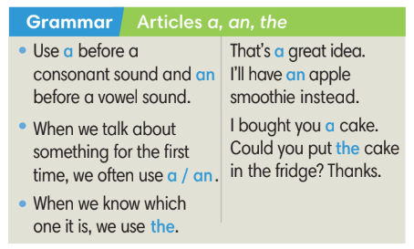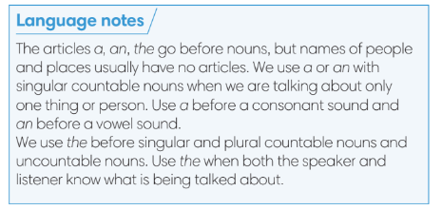
4. PRACTICE (16’)
ACTIVITY 3:
* Aims:
- To help Ss practise using a, an, the.
- To help Ss practise the new grammar points in contexts.
- To practise solving some types of grammar exercises.
* Content:
- Game: Find the mistake.
- Fill in the blanks with a, an, the.
- Match two parts of the sentences.
* Outcome: Ss can use a, an, the correctly and can make sentences using these articles.
* Organisation: T-Ss, Ss-T, Ss-Ss.
Teacher’s & Student’s activities | Content
(3’) Extra activity 3: Find the mistake game.  - T explains the game rules then checks instructions.  - Ss work in 4 groups.  - T collects Ss answer and checks. | Game rules:  - Read the paragraph carefully. (The paragraph has some mistakes of using a, an, the).  - Find all mistakes from the paragraph.  - 1 correct answer = 1 point.
(3’) 3. Fill in the blanks with the correct articles.  (Ex 3 SB p.54)  - T elicits the direction with Ss.  - T encourages Ss to finish Exercise 3 individually and find the reasons for the answers.  - T calls some Ss to share their answers and the reasons. | Answer key:  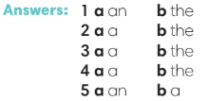
(3’) Match the two parts of the sentences 1-8 with a-h.  (Ex 3 WB p.46)  - T asks Ss to read the instructions and checks their understanding.  - Ss work in pairs to finish Exercise 3.  - T checks Ss’ answers. | Answer keys:  1 h 2 g 3 a 4 b  5 e 6 c 7 d 8 f
(3’) Extra activity 4: Sentence making.
- T asks Ss to work in groups of 3. 1 student makes sentences with a, another makes sentences with an and the last one uses the.
- T sets time limit. After 30 seconds, Ss change the role.
(4’) Extra activity 5: Hot potato game.  - T explains the game rules then checks instructions.  - T collects Ss answer and checks. | Game rules:  ✔ The student has the ball needs to make a sentence with one article.  ✔ The next student receives the ball and article from the previous student.  ✔ 1 correct answer = 1 point.
5. PRODUCTION (7’)
ACTIVITY 4:
* Aims: To help Ss applying the vocabulary items and grammar points related to the topic in communicating.
* Content: Ss ask and answer about food.
* Outcome: Ss can use the articles a, an, the and vocabulary about food in conversation.
* Organisation: T-Ss, Ss-T, Ss-Ss, Pair work.

Teacher’s & Student’s activities | Content
4. Uses the ideas in Exercise 3 to ask and answer questions about food with your partner.  (Ex 4, SB p.54)  - T asks Ss to look at Exercise 4 (SB p.54).  - T calls a student to read the instructions and example.  - T explains to Ss that they are going to do the task in pairs.  - T asks 3 groups to model the activity in front of the class.  - T asks the other Ss to give comments on their classmates’ performance.  - T asks Ss to line up into 2 lines, facing each other. Ss work in pair with the opposite Ss.  - After each 20 seconds, T says “switch”, Ss move one step to change partners.  - T walks around to note down any mistakes for later feedback. | 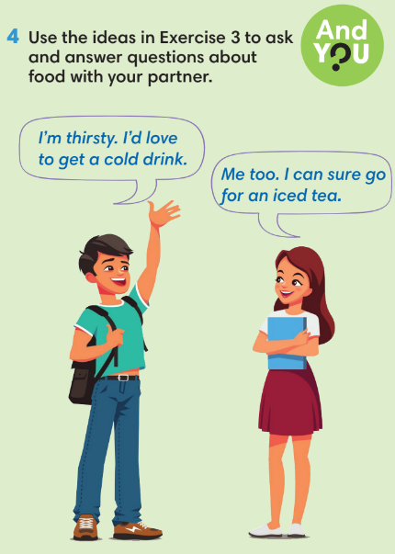
WRAP-UP & HOME WORK (3’)
- T asks Ss to talk about what they have learnt in the lesson.
✔ Articles: a, an, the.
* HOME WORK
- Do exercises in the workbook page 46.
- Prepare for Lesson 5.5: Listening and vocabulary.
___________________________________________
Date of planning: 1/2/2023 Date of teaching: 3/2/2023 | UNIT 5: FOOD AND DRINK  Period 5: Listening and Vocabulary
I. OBJECTIVES:
By the end of the lesson, students will be able to:
- identify specific details in a TV program and talk about food recipe.
1. Knowledge:
* Vocabulary: Use vocabulary to talk about food and cooking instructions.
New words | Vietnamese meaning
1. liter(s) of water | lít nước
2. spoon(s) of fish sauce | thìa nước mắm
3. lime leave(s) | lá chanh
4. stalk(s) of lemongrass | cọng xả
5. clove(s) of garlic | tép tỏi
6. gram(s) of shrimp | lạng tôm
7. chopped green onion(s) | hành thái nhỏ
8. gram of mushroom(s) | lạng nấm
9. lime(s) | chanh
10. sliced chillies | ớt thái mỏng

* Grammar: Make sentences using quantifiers and articles.
2. Competence: Understand and use the vocabulary of food and cooking instructions, then do the tasks assigned in the textbook. Listen and identify specific details in a TV program and talk about food recipe.
3. Quality / behavior: To teach Ss to be hard-working and attentive in class. Ss have a positive attitude to working in groups, individual work, pair work, cooperative learning and working.
II. TEACHING AIDS:
- Teacher: Grade 7 textbook, Unit 5 (SB p.55, WB p.47), laptop/computer connected to the Internet, loudspeaker, projector/TV, PPT slides …
- Students: Text books, studying equipment …
- Method: Active teach, T-WC; group works; individual …
III. PROCEDURE:
1. WARM UP + LEAD-IN (5’)
Game: Word chain – Let’s go to the supermarket.
* Aim:
- To activate Ss’ prior knowledge and get students involved in the lesson.
- To early introduce some words of food recipe.
* Content: Ss play Word chain game.
* Outcome: Ss can name different types of ingredients.
* Organisation: T-Ss, Ss-T.
Teacher’s & Student’s activities | Content
Extra activity 1: Game: Word chain – Let’s go to the supermarket.  - T divides the class into 4 groups and introduces the Warm-up game  - T explains How-to-play steps then checks instructions.  - T sets the scene for the new lesson: T tells Ss that they are going to learn more how to cook a dish by listening for details.  - T writes the title on the board Unit 5: Food and drink / Lesson 5.5: Listening and Vocabulary | Game rules:  - One student starts: I went to the supermarket. I bought a sack of rice.  - The second student: I went to the supermarket. I bought a sack of rice and four tins of tuna.  - The next student continues to add more ingredients.  - Game ends when one student fails to remember all ingredients.
2. PRE-LISTENING (15’)
ACTIVITIES 1 + 2:
*Aim:
- To lead into the topic.
- To set the scene for the new content and introduce the vocabulary.
- To practise using vocabulary to make sentences.
* Content:
- Ss discuss which foreign foods they’d like to eat.
- Ss listen and fill in the blanks with the correct amount of ingredients.
- Guessing game.
* Outcome: Know some more new words about news and entertainment. Chose the correct words to answer the questions.
* Organisation: T-Ss, Ss-T, Group work.
Teacher’s &Student’s activities | Content
1. (5’) Are there any foreign foods you like to eat? What are they? What do they taste like?  Ex 1 - SB p.55  - T asks Ss to work in pairs and answer those questions.  - T conducts a quick class vote to find out what is the most favorite food? What are ingredients?  - T asks Ss to look at the picture to describe the dish and ingredients. | 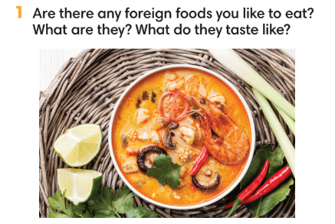
2. (5’) Listen and write the amount of each ingredient you hear.  Ex 2 - SB p.55  - Ss close the book. T plays the recording.  - Ss note down all ingredients that they hear.  - Ss open the book and check the answers.  - T plays the recording. Ss listen and write the amount of each ingredient.  - T plays the recording again. Ss repeat each sentence and check the answer.  - T encourages students to make sentences with these  phrases. | Answer keys:  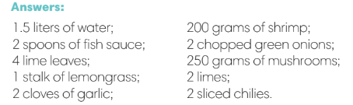
(5’) Extra activity 2: Guessing game.  - T explains the rules to Ss. | Game rules:  ✔ 2 Ss from 2 teams get 1 dish.  ✔ These Ss describe the ingredients, others guess the name of the dish.  ✔ The faster team gets 1 point.
3. WHILE-LISTENING (14’)
ACTIVITIES 3 & 4:
* Aim:
- To help Ss identify specific details in a conversation.
- To provide practice of using vocabulary in contexts.
* Content: Listen and understand to the audio track and complete the exercises.
* Outcome: Identify specific details in a cooking instruction.
* Organisation: T-Ss, Ss-T, Ss-Ss.
Teacher’s & Student’s activities | Content
3. (7’) Listen to how to cook the dish. Choose the correct answer.  Ex 3 - p.55  - T asks Ss to look at Exercise 3 in SB p.55.  - T calls a student to read the instruction then checks Ss’ understanding of it.  - T explains that Ss are listening for details including amounts, ingredients, time, steps…  - T asks Ss to look at the questions and underline key words.  - T encourages Ss to guess the answers.  - T provides meanings of all new words.  - T plays the audio and have students do the exercise.  - T tells Ss to check their answers in pairs.  - Ss work individually then in pairs to complete the task.  - T plays the audio again and checks the answers with the whole class.  - T encourages Ss to give the evidences that they hear from the audio track to prove their answers. | Answer keys:  
4. (7’) Listen again. Number the words in the order you hear them.  - T asks Ss to look at Exercise 4 in SB p.55.  - T calls a student to read the instruction then checks Ss’ understanding of it.  - Before Ss listen, T asks them to number the words from memory.  - T plays the audio and stops by one sentence. Ss repeat and check the answers. | Answer keys:  
4. POST-LISTENING (8’)
ACTIVITY 5:
*Aim: To help students applying the vocabulary items related to the topic in communicating.
* Content: Work in pairs to describe how to cook a dish.
* Outcome: Can use vocabulary about food and cooking instruction to describe how to cook a dish.
* Organisation: T-Ss, Ss-Ss
Teacher’s &Student’s activities | Content
5. In pairs, describe how to cook a dish.  Ex 5 - SB p.55  - T asks Ss to look at Exercise 5 in SB p.55.  - T calls a student to read the instruction then checks Ss’ understanding of it.  - T asks one student to read the example.  Example: First, you heat the pan, and then you add two raw eggs. You cook it for 1 - 3 minutes. Then, you…  - T asks Ss to work in pairs.  - T sets a time limit for Ss.  - T invites some pairs to share in front of the class. | 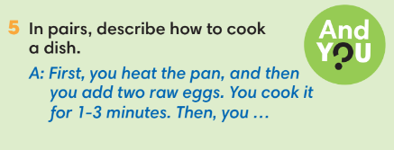
WRAP-UP & HOME WORK ( 3’)

- T asks Ss to talk about what they have learnt in the lesson.
- How to cook a dish.
* HOME WORK
- Do exercises in the workbook page 47.
- Prepare for Lesson 5.6: Speaking.
=====================

Date of planning: 6/2/2023  Date of teaching: 7/2/2023 | UNIT 5: FOOD AND DRINK  Period 6: Speaking
I. OBJECTIVES:
By the end of the lesson, students will be able to:
- use vocabulary and phrases to make conversations at a restaurant.
1. Knowledge:
* Vocabulary: Use the phrases to order food at a restaurant.
* Grammar: Make a conversation to order food at a restaurant using vocabulary and phrases.
2. Competence: Ss can use vocabulary and phrases to order food, and do the tasks assigned in the textbook. Ss can make conversations at a restaurant.
3. Quality/behavior: To teach Ss to be hard-working and attentive in class. Ss have a positive attitude to working in groups, individual work, pair work, cooperative learning and working.
II. TEACHING AIDS:
- Teacher: Grade 7 textbook, Unit 5 (SB p.56, WB p.48), laptop/computer connected to the Internet, loudspeaker, projector/TV, PPT slides…
- Students: Text books, studying equipment…
- Method: Active teach, T-WC; group works; individual ……
III. PROCEDURE:
1. WARM UP + LEAD-IN (5’)
* Aim:
- To create a positive classroom atmosphere to start a new lesson.
- To review words of food and drink.
- To lead in to the topic.
* Content: Pictionary Game
* Outcome: Ss review vocabulary about food and drink
* Organization of implementation: T-Ss, Ss-Ss, Ss-T.
Teacher’s & Student’s activities |  | Content
Extra activity 1: Pictionary Game  - T divides Ss into 2 teams.  - When Ss finish the game, T tells Ss that, they are using the vocabulary to do some speaking tasks today.  - T writes the title of new lesson: Unit 5/ Lesson 5.6 - Speaking |  | Game rules:  - 2 representatives from 2 teams go to the board and receive a word from T (food and drink vocabulary).  - 2 Ss draw and the team will guess.  - 1 correct answer = 1 point.  - After one word, change the person who draws.
2. PRE-LISTENING (19’)
ACTIVITY 1 + 2:
* Aim:
- To activate Ss’ prior knowledge of the topic.
- To lead into the topic.
- To present phrases of ordering food at a restaurant.
- To introduce the Speaking Box.
* Content: Some vocabularies related to films, and types of films. Listen to the conversation to answer the questions about Nam and Mai’s plan.
* Outcome: Knowledge about types of films. Understand the conversation.
* Organisation: T-Ss, Ss-T, Pair work

Teacher’s & Student’s activities |  |  | Content
1. (5’) What do you usually order when you go to a restaurant?
Ex 1 - SB p.56

- T asks Ss if they have been to a restaurant and which food they ordered.
- T notes down Ss’ answers on the board for next activities.
- T asks if Ss know any phrases/ structures to order food at a restaurant.
- T introduces to Ss that they will learn how to order food at a restaurant in this lesson.
2. (6’) Listen to the dialogue between the waiter and the customers at a restaurant. Tick () the questions you hear.  Ex 2 - SB p.56  - T asks Ss to look at Exercise 2, SB p.56.  - T calls a student to read the instruction then checks Ss’ understanding of it.  - T asks Ss to look at the questions, underline key words and explain all new words.  - T asks Ss to guess the answers before listening.  - T plays the audio, Ss listen and finish exercise 2.  - T asks Ss to work in pairs and read the conversation, underline useful structures to order food. |  |  | Answer keys:  Tick: 1, 4, 5
(8’) Extra activity 2: Speaking box.  - T goes through the Speaking box and asks Ss to find the phrases that are used in the dialogue.  - When Ss have finished, T asks them to work in pairs to create a short conversation using these phrases.  - T invites different pairs to act out their dialogues in front of the class and then provide feedbacks. |  |  | 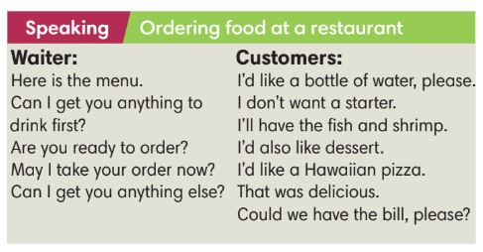
3. WHILE-SPEAKING (10’)
ACTIVITY 3:
* Aim:
- To reinforce the expressions of ordering food at a restaurant.
- To practise using the new expressions in contexts.
* Content: Complete the dialogue about ordering food at a restaurant.
* Outcome: Understanding more about cinema expressions. Knowing the dialogue to buy movie tickets.
* Organisation: T-Ss, Ss-T, Ss-Ss
Teacher’s & Student’s activities |  |  |  | Content
3. (5’) Complete the dialogue with the sentences a-f. Listen and check.  (SB p.56 - Exercise 3)  - T asks Ss to complete the exercises individually and the check with partners.  - T plays the audio for Ss to check. |  |  |  | Answer keys:  1 e 2 c 3 a 4 b 5 f 6 d
(5’) Extra activity 3: Game
- T divides the class into 2 groups. Ss make 2 lines facing each other.
- Each pair includes one customer and one waiter. Ss take turns to say phrases and structure to order food at a restaurant. The S of that pair needs to respond.
4. POST-SPEAKING ( 8’)
ACTIVITY 4:
*Aims: To help Ss applying the new language and skills related to the topic in communicating.
* Content: Work in groups to practise a conversation at a restaurant.
* Outcome: Ss can use the expressions correctly to order food at restaurants.
* Organisation: T-Ss, Ss-Ss.

Teacher’s & Student’s activities | Content
4. Work in groups of three. One person is the waiter and the other two are customers. Practice a conversation at a restaurant.  (Exercise 4 - SB p.56)  - T asks Ss to work in groups of three. Ss prepare a menu for a restaurant first.  - T invites 3 random Ss to make a conversation in front of the class. Other Ss listen and provide feedback.  - T tells Ss to look at the Speaking box in their student books again and work in groups to prepare for the task.  - T set time for Ss to prepare and practise speaking.  - T walks around the class to listen and provide feedback.  - T asks 5 groups to practise the conversation in front of the class.  - T do a quick class vote to find the most favorite group with the best menu and speaking skills. | 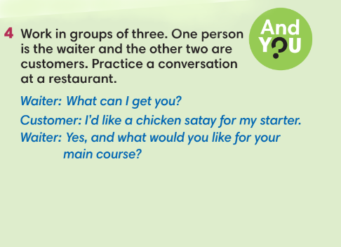
WRAP-UP & HOME WORK (3’)
- T asks Ss to talk about what they have learnt in the lesson.
phrases to order food at a restaurant.
* HOME WORK
- Do exercises in the workbook page 48.
- Prepare for Lesson 5.7: Writing.

=====================

Date of planning: 6/2/2023  Date of teaching: 9/2/2023 | UNIT 5: UNIT 5: FOOD AND DRINK  Period7: Writing
I. OBJECTIVES:
By the end of the lesson, Ss are able to:
- write an email of invitation.
1. Knowledge:
* Vocabulary: use vocabulary and structures to write an email of invitation.
* Grammar: make sentences using food quantifiers correctly.
2. Competence: Ss can use vocabulary of food and quantifiers in sentences, and do the tasks assigned in the textbook. Ss can write an email of invitation.
3. Quality/behavior: To teach Ss to be hard-working and attentive in class. Ss have a positive attitude to working in groups, individual work, pair work, cooperative learning and working.
II. TEACHING AIDS:
- Teacher: Grade 7 textbook, Unit 5 (SB p.57, WB p.49), laptop/computer connected to the Internet, loudspeaker, projector/TV, PPT slides …
- Students: Text books, studying equipment …
- Method: Active teach, T-WC; group works; individual …
III. PROCEDURE:
1. WARM UP (5’)
* Aim:
- To create a positive classroom atmosphere to start a new lesson.
- To lead into the sample writing.
* Content: Extra activity: Prepare for an upcoming birthday party.
* Outcome: Ss understand the background of the lesson.
* Organization of implementation: T-Ss, Ss-T
Teacher’s & Student’s activities | Content
Extra activity 1:
- T asks Ss to find a few Ss whose birthdays coming soon.
- T tell Ss to imagine what they need to prepare for a birthday party.
(1) Location, date, time.
(2) Food and drink.
(3) Decoration.
(4) Guest list.
- When Ss mention about inviting friends for birthday party, T asks Ss to tell which information they need to provide?
- T writes the title on the board Unit 5: Food and drink. Lesson 5.7: Writing.
2. LEAD-IN (5’)
ACTIVITY 1
* Aim:
- To get Ss to think about the topic.
- To provide Ss with reasons for reading the sample writing in Exercise 2 (SB p.57).
* Content: Discuss in groups and answer the questions about the people.
* Outcome: Guess the correct answers to the questions.
* Organisation: T-Ss, Ss-T, Pair work
Teacher’s & Student’s activities | Content
1. What are they cooking? Why are they cooking outside?  (Ex 1 – SB p.57)  - T asks Ss to look at pictures and answers questions.  - T sets a time limit for Ss’ quick discussion.  - Ss work in pairs to make guesses about the pictures then give answers.  - T calls some Ss to give answers then note them down on the board for checking later.  - T tells Ss that they’re going to read the email in Exercise 2 (SB p.57) to check all the answers. | Answer keys:  They are cooking chicken barbecue.  Because they are having a barbecue party.
3. PRE-WRITING (16’)
ACTIVITIES 2 + 3:
Aim:
- To activate Ss’ prior knowledge of the topic.
- To lead into the next activity.
- To study the structure of an email.
- To help Ss focus on detailed information while reading the sample.
- To provide Ss an outline and phrases before writing.
* Content: Work in pairs, read the email and answer the questions.
* Outcome: Understand the main points and structure of the sample email.
* Organisation: T-Ss, Ss-T.
Teacher’s & Student’s activities | Content
2. (6’) In pairs, read the email and answer the questions.  (Ex 2 – SB p.57)  - T calls a S to read the instruction then checks Ss’ understanding of it.  - T asks Ss to underline key words of questions.  - T has Ss work in pairs and find the answers for the questions  - T encourages Ss to underline the key sentences in the reading.  - T calls some volunteer Ss to give their answers then checks for the whole class. | Answer keys:  1. Richard  2. Because he wanted to invite Thanh to a barbecue at his house next Saturday.  3. A barbecue party at Richard’s house next Saturday.  4. Thanh should dessert.
3. (6’) Answer the questions about the structure of the email.  (Ex 3 – SB p.57)  - T asks Ss to look at Exercise 3 SB p.57.  - T calls a S to read the instruction then checks Ss’ understanding of it.  - T asks Ss to work finish Exercise 3 and underline the information from the email.  - T shows the answers on the slide to check as the whole class. | Answer keys:  1 b 2 b 3 b 4 a 5 a
(4’) Extra activity 2: An email outline and useful language.  - T asks Ss to look at the sample email again.  - T asks Ss to work in pairs, make the outline for the sample email and underline useful phrases that they can use.  - T sets a time limit for the activity.  - T collect Ss answer and check. | 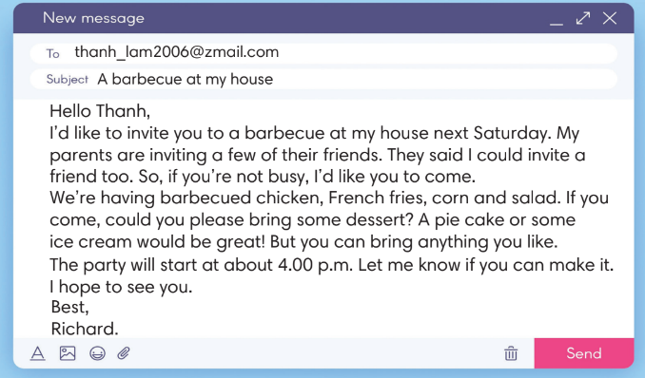
4. WHILE-WRITING (10’)
ACTIVITY 4:
Aim:
- To provide Ss task to apply useful expressions from Writing Box in writing an email.
* Content: Use the Writing Box to practise writing an invitation email.
* Outcome: Write an invitation email.
* Organisation: T_ Ss.. ….

Teacher’s & Student’s activities | Content
4. It’s your birthday next week. You want to invite your friend, Minh. Write an email (60-80 words) to invite him to the party.  (Ex 4 – SB p.57)  - T calls a student to read the instructions then checks Ss’ understanding of it.  - T asks Ss to brainstorm and make an outline basing on these questions:  (1) where / when it is?  (2) how to get there?  (3) what dishes there will be?  (4) what to bring?  - T sets a time limit for the task and walk around as a monitor while Ss are writing. | 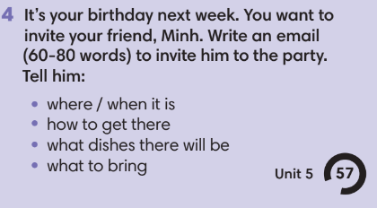
5. POST-WRITING (6’)
*Aim:
- To let Ss do peer-check.
- To give general comments on Ss’ writing pieces.
* Content: Ss swapping their writing in pairs.
* Outcome: Cross-check writing pieces and follow the writing rubric.
* Organisation: T_ Ss .…….

Teacher’s & Student’s activities | Content
Extra activity 3: In pairs, swap your writing then check.  - T explains the writing rubric before checking.  - T asks Ss to swap their writing pieces, use the given writing rubric then do cross-check.  Writing rubric:  (1) where / when it is?  (2) how to get there?  (3) what dishes there will be?  (4) what to bring?  - T gives feedback on common mistakes of Ss’ works.  - T may collect Ss’ writing for detailed comments. | Writing rubric:  (1) where / when it is?  (2) how to get there?  (3) what dishes there will be?  (4) what to bring?
WRAP-UP & HOME WORK (3’)
- T asks Ss to talk about what they have learnt in the lesson.
- A personal introduction for a webpage.
* HOME WORK:
- Do exercises in the workbook page 49.
- Prepare for Lesson 5.8: Vocabulary in action and pronuciation.

Date of planning: 6/2/2023  Date of teaching: 10/2/2023 | UNIT 5: FOOD AND DRINK  Period 8: Vocabulary In Action and Pronunciation
I. OBJECTIVES:
By the end of the lesson, Ss will be able to:
- review vocabulary about food and drink, and correctly pronounce some 2-syllable words with suitable stress.
1. Knowledge:
* Vocabulary: Review vocabulary
- The lexical items related to quantifiers, food and drink, food adjectives, parts of a meal.
* Pronunciation: Listen and identify word stress of 2-syllable words then correctly pronounce the words correctly with stress.
2. Competence: Ss develop communication skills, presentation skills, and creativity; being collaborative and supportive in pair work, teamwork, and actively join in class activities.
3. Quality/behavior: To teach Ss the love of talking about food and drink, and develop self-study skills. Ss have a good attitude to working in groups, individual work, pairwork, cooperative learning, and working.
II. TEACHING AIDS:
- Teacher: Grade 7 textbook, Unit 5 (SB p.58, WB p.50), laptop/computer connected to the Internet, loudspeaker, projector/TV, PPT slides… .
- Students: Text books, studying equipment…
- Method: Active teach, T-WC; group works; individual ……
III. PROCEDURE:
1. WARM UP + LEAD-IN (4’)
*Aims:
- To create an active atmosphere in the class before the lesson.
- To lead into the new lesson.
* Content: Game: HANGMAN (food and drink)
* Outcome: Ss can recall the vocabulary of Unit 5.
* Organisation: Teacher’s instruction.
Teacher’s & Student’s activities | Content
Extra activity 1: Game: Hangman.  * T asks Ss to spend 1 minute to quickly review all vocabulary they have learnt in Unit 5 before they play a warm-up game.  - T explains the game rules then checks instructions.  - Ss join in the game pairs or in small groups.  - T tells Ss that they can remember better with Glossary Table and asks Ss to open their Student Book page 18 – Exercise 1. | Game rules:  - T gives letter quantity of one word.  - Ss say one letter each turn.  - If the letter is wrong, T starts drawing the hangman.
2. REVIEW VOCABULARY (25’)
ACTIVITY 1 + 2 + 3:
*Aim:
- To introduce the glossary and its uses.
- To give further practice with vocabulary of Unit 5.
* Content: Revise what they have learnt during the unit. Glossary and its uses.
* Outcome: Remember the new words.
* Organisation: T-Ss, Ss-T, Ss-Ss, Pair work, Group work.
Teacher’s & Student’s activities | Content
1. (5’) Use the glossary to find.  (Ex 1 – SB p.58)  - T introduces the Glossary Table.  - T asks Ss to look at Exercise 1 in student book page 58.  - T has Ss use the glossary to find the words which belong to the correct category.  - T asks Ss to work in pairs and quickly do the task.  - T allows Ss to peer check first.  - T checks and confirms the answers. | Answer keys:  1. A counter word used for liquids – litre, spoonful.  2. Three Asian foods and drinks – sake, bubble tea, Peking duck, somtum.  3. Two foods that are main course – pasta, pancake, summer roll.
2. (5’) In pairs, say how you feel about the food below.  (Ex 2 – SB p.58)  - T asks Ss to say how they feel about each food, using the model sentences.  - Ss share their answers in pairs.  - T invites some Ss to share their answers in front of the class.  (7’) Extra-Practice  TIME TO TALK: Use the Glossary to make sentences about food that Ss like/ don’t like and reasons.  - Ss work in groups of 4 to share information about which food they like/ don’t like and reasons.  - T asks some groups to share in front of the class to get feedbacks. | e.g.  1. I love pasta. It’s so creamy.  2. I don’t really like pomelo very much. I think it is too sour.  3. I like somtum because it is spicy.
3. (3’) Match the pictures 1-4 with the words from the glossary.  (Ex 3 – SB p.58)  - T asks Ss to open SB page 58 and look at Exercise 3.  - T calls a S to read the instruction then checks Ss’ understanding of it.  - T gives Ss a time limit to work individually.  - T allows Ss to share their answers before checking the final ones as the whole class. | Answer keys:  1. lemongrass  2. pasta  3. smoothie  4. pancake
(5’) Extra activity 2: Guessing game.  - T divides the class into 4 groups. | Game rules:  - 4 Ss each turn see a picture in the slide.  - The first S to say the word get one point.
3. PRONUNCIATION (14’)
3.1. Presentation ( 4’)
ACTIVITY 4
* Aims:
- To present the list of 2-syllable words.
- To help Ss identify stress and pronounce the word correctly.
* Content: Listen to the words and sort them according to their stress.
* Outcome: Ss can recognize the stress of some 2-syllable words.
* Organisation: Teacher’s instructions …
Teacher’s & Student’s activities | Content
4. (4’) Listen to the words below and write them in the correct group according to the word stress.  (Ex 4 – SB p.58)  - T calls a S to read the instruction of Exercise 4 then checks Ss’ understanding of it.  - T calls some students to read aloud the words and guess the stress of each word.  - T plays the audio for Ss to check their guess and finish exercise 4. | Answer keys:  Oo: chicken, muffin, pasta, pizza, tuna  oO: dessert
3.2. Practice (10’)
ACTIVITY 5:
* Aims:
- To help students listen and identify word stress
* Content: Listen to the sample pronunciation and repeat.
* Outcome: Pronoune the words correctly.
* Organisation: Teacher’s instructions…

Teacher’s & Student’s activities | Content
5. (4’) Listen, check and repeat.
(Ex 5 – SB p.58)
- T plays the audio for Ss to repeat.
- T asks 5 Ss to read the words out loud in front of the class.
- T corrects Ss pronunciation if needed.
(5’) Extra activity 2: Game  - T divides the class into 2 teams and then invites 10 Ss from each team to make one line. | Game rules:  - Listen to the word (T prepares an audio).  - If the stress is on 1st syllable, Ss jump to the left side. If the stress is on 2nd syllable, Ss jump to the right side.  - Ss with wrong answer is out. The team with more Ss left in the line get more points.
WRAP-UP & HOME WORK (2’)
- Teacher asks students to talk about what they have learnt in the lesson.
- use a Glossary to review.
- identify stress of 2-syllable words.
* HOME WORK
- Find more 2-syllable words.
- Prepare for Unit 5 – Lesson 9: Revision.

Date of planning: 13/2/2023  Date of teaching: 14/2/2023 | UNIT 5: FOOD AND DRINK  Period 9: Revision
I. OBJECTIVES:
By the end of the lesson, Ss are able to:
1. Knowledge:
* Vocabulary: Review vocabulary and grammar in the unit.
* Grammar: Review quantifiers and articles.
2. Competence: Ss understand and use the vocabulary of the unit to do the tasks assigned in the textbook. Ss can talk about their favourite food and write an invitation email.
3. Quality/ behavior : To teach Ss to be hard-working and attentive in class. Ss have a positive attitude to working in groups, individual work, pair work, cooperative learning and working.
II. TEACHING AIDS:
- Teacher: Grade 7 textbook, Unit 5 (SB p.59, WB p.50), laptop/computer connected to the Internet, loudspeaker, projector/TV, PPT slides …
- Students: Textbooks, studying equipment …
- Method: Active teach, T-WC; group works; individual …
III. PROCEDURE:

- WARM-UP (4’)
*Aims:
- To create a positive classroom atmosphere to start a new lesson.
- To lead into the review lesson.
* Content: Game: SUPER EYES
* Outcome: Ss understand that they are going to review Unit 5.
* Organisation: Teacher’s instructions …
Teacher’s & Student’s activities | Content
Extra activity 1: SUPER EYES  - Set the scene: T asks Ss to do quick exercises for eyes such as look up and down, look left and right, row the eyes  - T tells Ss that they are going to play a game called SUPER EYES  - T explains the game rules then checks instructions.  - T uses the slides to show the collages.  - Ss join in the game in pairs or in small groups.  - T shows the collage again with displayed answers to check for the whole class.  - T tells Ss that they are going to review Unit 5. | Game rules:  - Look carefully at a collage of different small pictures  - The collage will disappear in a few seconds.  - Recall as many words about the collage as you can remember.
- REVIEW VOCABULARY (21’)

ACTIVITIES 1 + 2 + 3:
* Aims:
- To help students reviews vocabulary and word friends from the unit.
- To review vocabulary in contexts.
* Content: Do the exercise to revise the vocabulary of Unit 5.
* Outcome: Understand the vocabulary to do the exercises correctly.
* Organisation : Teacher’s instructions….
Teacher’s & Student’s activities | Content
Extra activity 2: (4’) Game - Hangman  - T asks Ss to look at vocabulary of Unit 5 from the Glossary box SB p.58.  - T introduces the game rules. | Game rules:  - T shows the letter number of an unknown word.  - Ss guess by saying one letter.  - If the answer is wrong, teacher starts drawing the hang man.
1. (4’) Put the words into the correct column.  (Ex 1 – SB p.59)  - T asks Ss to look at Exercise 1 in student book page 59.  - T calls a S to read the instruction then checks Ss’ understanding of it.  - T asks Ss to work in pairs to read then complete the activity.  - T encourages Ss to give the reason for their answers.  - T checks as the whole class. | Answer keys:  - Containers: carton, sack, tin.  - Food: pancake, pasta, cereal.  - Flavours: sour, spicy, mild.  - Drinks: smoothie, sake, bubble tea.
2. (4’) In pairs, describe the food and drinks below that you have regularly. Choose two things you like best.  (Ex 2 – SB p.59)  - T asks Ss to look at Exercise 2 in student book page 59  - T calls a S to read the instruction then checks Ss’ understanding of it.  - T asks Ss to work in pairs to discuss which food and drinks they like best and describe them to each other.  - T corrects pronunciation if needed. | 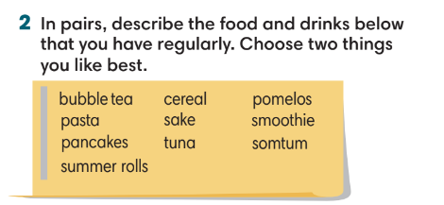
3. (4’) Take turns to tell your partner about your favorite food. Use these ideas.  (Ex 3 – SB p.59)  - T asks Ss to look at Exercise 3 in student book page 59  - T calls a S to read the instruction then checks Ss’ understanding of it.  - Ss work in groups of 4 to share their ideas.  - T checks as the whole class. | 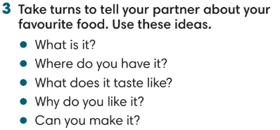
Extra activity 3: (5’) Game – Unscramble words  - T divides the class into 4 teams and explains game rule.  - T prepares a few sentences using word friends in Unit 5. | Game rules:  - Ss receive 10 bags with unscramble words of 10 sentences (words are written and cut into pieces).  - 1 correct sentence = 1 point.
3. REVIEW GRAMMAR ( 10’)
ACTIVITIES 4 + 5:
*Aims:
- To reinforce the grammar of Unit 5.
* Content: Use articles and quantifiers correctly to complete the task.
* Outcome: Ss can use articles and quantifiers correctly in sentences.
* Organisation: T-Ss, Ss-T, Pair work.
Teacher’s & Student’s activities | Content
4. (3’) Complete the text with the missing articles.  (Ex 4 – SB p.59)  - T helps Ss to review grammar before doing this task.  - Ss work individually.  - T checks Ss answers. | Answer keys:  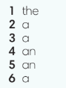
5. (3’) Match the quantifiers (1-4) with the food (a-d). Then match with the pictures.  (Ex 5 – SB p.59)  - T asks Ss to look at Exercise 5 in student book page 59  - T calls a S to read the instruction then checks Ss’ understanding of it.  - T asks Ss to work individually and then share the answers in pairs.  - T checks as the whole class, asks Ss for the reasons of their answers. | Answer keys:  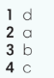
Extra activity 4: (4’) Game – Whisper.  - T divides the class into 4 teams and explains game rule.  - T prepares a recipe with a number of sentences. | Game rules:  - T gives sentence one by one.  - Ss take turn to whisper until the last S of the team get it and write on the board.  - 1 correct sentence = 1 point.  - Guess the dish name correctly = 3 points.
4. WRITING (7’)
ACTIVITY 6:
*Aims:
- To help student practise writing an invitation email.
* Content: Write a email to invite your best friend to a party.
* Outcome: Ss can use the learnt expressions to write an invitation email.
* Organisation: T-Ss, Ss-T.
Teacher’s & Student’s activities | Content
6. Your family is holding a house-warming party this weekend. Write an email (60-80 words) to invite your best friend to come to the party.  (Ex 6 – SB p.59)  - T asks Ss to look at exercise 6.  - T calls a S to read the instruction then checks Ss’ understanding of it.  - Ss finish writing individually.  - T goes around to give feedback while Ss are writing.  - T invites some Ss to share their email. | 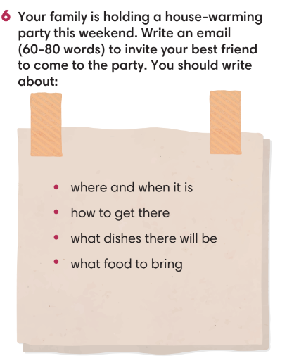
WRAP-UP & HOME WORK ( 3’)
- T asks Ss to talk about what they have learned in the lesson.
- Review vocabulary and grammar of Unit 5.
- An email of invitation.
* HOMEWORK
- Do exercises in the workbook page 13.
- Prepare for Unit 6/Lesson 6.1: Vocabulary

