Date of planning: 14/2/2023  Date of teaching: 16/2/2023 | ENGLISH 7  UNIT 6: SCHOOLS  Period 10: Vocabulary
I. OBJECTIVES:
By the end of the lesson, Ss will be able to:
- know the meaning of the new words and talk about favorite subjects
- use the targeted language to practice talking about favorite school activities.
1. Knowledge:
* Vocabulary: an understanding of the meaning of keywords below:
School subjects | biology, chemistry, geography, literature, mathematics, physical education (PE), physics, civic education, information technology (IT)
New words |  | Pronunciation | Definition | Vietnamese meaning
biology | (n) | /baɪˈɒl.ə.dʒi/ | the scientific study of the natural processes of living things | Sinh học
chemistry | (n) | /ˈkem.ɪ.stri/ | the scientific study of the basic characteristics of substances and the ways in which they react or combine | Hóa học
geography | (n) | /dʒiˈɒɡ.rə.fi/ | the study of the systems and processes involved in the world's weather, mountains, seas, lakes, etc. and of the ways in which countries and people organize life within an area | Địa lý
literature | (n) | /ˈlɪt.rə.tʃər/ | written artistic works, especially those with a high and lasting artistic value | Văn học
mathematics | (n) | /ˌmæθˈmæt.ɪks/ | the study of numbers, shapes, and space using reason and usually a special system of symbols and rules for organizing them | Toán
physical education (PE) | (n) | /ˌfɪz.ɪ.kəl ed.jʊˈkeɪ.ʃən/ | classes at school in which children do exercise and learn to play sport, or the area of study relating to such classes | Thể dục
physics | (adj) | /ˈfɪz.ɪks/ | the scientific study of matter and energy and the effect that they have on each other | Vật lý
civic education | (adj) | /ˈsɪv.ɪk ˌedʒ.ʊˈkeɪ.ʃən/ | study of the theoretical, political and practical aspects of citizenship, as well as its rights and duties | Giáo dục công dân
information technology | (adj) | /ɪn.fəˌmeɪ.ʃən tekˈnɒl.ə.dʒi/ | the science and activity of using computers and other electronic equipment to store and send information | Tin học/ Công nghệ thông tin

* Grammar: School activities with do, take and have (collocations) – do/ take homework, have class, have lunch, have/ take a lesson, do/ take an experiment, have/ take a break, take roll, have/ take a test.
2. Competence:
- To know the meaning of the new words and talk about favorite subject, then do the tasks assigned in the textbook.
- To use the targeted language to practice talking about favorite school activities.
3. Quality/Behavior: To teach Ss to be hard-working and attentive in class. Ss have a positive attitude to working in groups, individual work, pair work, cooperative learning and working.
II. TEACHING AIDS:
- Teacher: Grade 7 textbook, Unit 6 (SB p.60-61, WB p.51-52), laptop/computer connected to the Internet, loudspeaker, projector/TV, PPT slides…
- Students: Text books, studying equipment…
- Method: Active teach, T-WC; group works; individual ……
III. PROCEDURE:
1. WARM UP( 5’)
* Aims:
- To review previous lesson vocabulary.
* Content: Game - Word Jumble Race (food and drink – Unit 5).
* Outcome: Ss review vocabulary from previous unit.
* Organisation: T-Ss, Ss-T, Group work.
Teacher’s & Student’s activities | Content
Extra activity 1: Game - Word Jumble Race:  - T divides the class into 4 teams, explains the game rules then checks instructions.  - T corrects grammar and pronunciation mistakes while Ss take part in the game | Game rules:  - T give 10 sentences (using vocabulary from Unit 5) for each team. Each sentence is written and cut into words. Remember to keep the sentences separately.  - All teams arrange the sentences.  - The first team to finish is the winner.
2. PRESENTATION 1 (9’)
ACTIVITY 1:
* Aims:
- To teach new words.
- To lead in to next activity.
* Content: Ss decide which subject they like or dislike.
* Outcome: Ss know new words about school subjects.
* Organisation: T-Ss, Ss-T, Pair work.

Teacher’s & Student’s activities |  | Content
1. Complete the table below using the words in the box.  (Ex 1 – SB p.60)  - T reads all new words and asks Ss to repeat.  - T checks Ss’ pronunciation. Have 3 to 5 Ss to read in front of the class.  - T checks meaning of each word with Ss, explain what these subjects are about: e.g. Biology – the scientific study of the natural processes of living things.  - T asks Ss to open their SB page 60, look at Exercise 1.  - T calls a S to read the instruction then checks Ss’ understanding of it.  - Ss work in pairs to check which subject they like/ don’t like and which day they study that subject.  - T conducts a survey to find out the most liked/ least liked subjects and their positions in the timetable. |  | 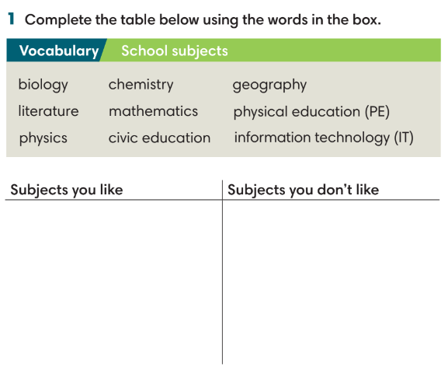
3. PRESENTATION 2 (9’)
ACTIVITIES 2 & 3:
* Aims:
- To teach Ss about school timetable.
- To learn collocations.
- To help Ss use the new vocabulary in context.
* Content: Listen to a school timetable; fill the gaps with do, take or have.
* Outcome: Identify information in a timetable; understand how to use do, take or have to talk about school activities.
* Organisation: T-Ss, Ss-T, Individual work, Group work.
Teacher’s & Student’s activities | Content
2. (5’) Listen to Nam talking about his school timetable. Answer the following questions.  (Ex 2 – SB p.60)  - T asks Ss to look at Exercise 2 on page 60, read all 3 questions, underline key words.  - Ss guess the answers before listening:  1. a number: 8, 9, 10  2 and 3. days of the weeks: Monday, Tuesday, etc.  - T play the recording, Ss listen and finish Exercise 2. | Answer keys:  1 – 9.  2 – everyday in the morning.  3 – Wednesday.
3. (4’) Fill in the gaps with do, take or have to make Word Friends. Some gaps can be filled with two words.  (Ex 3 – SB p.60)  - Ss finish Exercise 3.  - T check Ss answers and explain the meaning if needed.  - Ss work in groups of to make 8 sentences using 8 collocations. The first team to finish is the winner. | Answer keys:  1. do/ take 2. have 3. have 4. take/ have  5. do/ take 6. take/ have 7.take 8. take/ have
4. PRACTICE (11’)
ACTIVITY 4:
* Aims:
- To find out activities of each subject.
- To provide more words related to the topic.
* Content: Match subjects with activities; Game – Hangman.
* Outcome: Ss know the activities of each school subject and practise the collocations they have learnt.
* Organisation: T-Ss, Ss-T, Individual work.
Teacher’s & Student’s activities | Content
4. (6’) Match the subjects with the activities.  (Ex 4 – SB p.61)  - T asks Ss to look at Exercise 4 (SB p.61).  - T calls a S to read the instruction then checks Ss’ understanding of it.  - T gives Ss 2 minutes to complete.  - T checks Ss’ answers. | Answer keys:  1. chemistry 2. art 3. physical education  4. information technology 5. mathematics  6. geography
(5’) Extra activity 2: Game – Hangman.  (Adapted from Exercise 3 – WB p.52)  - T gives the clue and total letter quantity of the words.  - Ss guess it by suggesting letters within a certain number of guesses. | Answer keys:  1. (vertical): compete.  2. equation  3. build  4. flag  5. draw  6. experiment  7. paint
5. PRODUCTION (8’)
ACTIVITY 5:
* Aims: To help Ss practice applying the vocabulary items and grammar points related to the topic in speaking.
* Content: Ss work in pairs to talk about their favourite school subjects.
* Outcome: Ss talk about their favourite subjects using vocabulary and grammar points.
* Organisation: T-Ss, Pair work, Group work.
Teacher’s & Student’s activities | Content
5. Work in pairs. Tell your friend about the subject and the activities in that subject that you like most.  (Ex 5 – SB p.61)  - T asks Ss to look at Exercise 5 (SB page 61).  - T calls a S to read the instruction then checks Ss’ understanding of it.  - T asks Ss to work in pairs following examples.  Extra activity 3: Game – Guessing game.  - T divides the class into 2 groups.  - Change the representative in the following turn. | Game rules:  - 2 Ss from each group receive a secret subject.  - These students need to describe activities of that subject for the team to guess.  - The faster team is the winner.  Example:  We study new words, practice listening, reading, writing and speaking.  English

WRAP-UP & HOME WORK (3’)

T asks Ss to talk about what they have learnt in the lesson.
- Vocabulary subjects and activities.
- Grammar points: School activities with do, make and have.
* HOME WORK
- Do exercises in the workbook page 51-52.
- Prepare for Lesson 6.2: Grammar 1.

Date of planning:14/02/2023  Date of teaching:17/2/2023 | UNIT 6: SCHOOLS  Period 11: Grammar 1
I. OBJECTIVES:
By the end of the lesson, Ss will be able to:
- Use vocabulary about school activities.
- Use must, mustn’t, should and shouldn’t to talk about things at school and at home.
1. Knowledge:
* Grammar:
- Identify and understand how to use modal verbs.
- Use modal verbs to talk about activities at school and at home.
2. Competence: Ss know to use vocabulary about school activities, and understand the main grammatical points, then do the tasks assigned in the textbook; use must, mustn’t, should and shouldn’t to talk about things at school and at home.
3. Quality / behavior: To teach Ss to be hard-working and attentive in class. Ss have a positive attitude to working in groups, individual work, pair work, cooperative learning and working.
II. TEACHING AIDS:
- Teacher: Grade 7 textbook, Unit 6 (SB p.62), laptop/computer connected to the Internet, loudspeaker, projector/TV, PPT slides…
- Students: Text books, studying equipment…
- Method: Active teach, T-WC; group works; individual ……
III. PROCEDURE:

1. WARM UP (4’)
* Aims:
- To activate students’ prior knowledge and get students involved in the lesson.
- To set the context for introducing new structures.
* Content: Play game to get Ss involved in the lesson and to set the context for the lesson.
* Outcome: Ss know the context of the lesson.
* Organisation: T-Ss, Ss-T
Teacher’s and Student’s activities | Content
Extra activity 1: Game  - T divides Ss into 2 teams, board into 2 columns:  + Column A: Activities Ss are allowed to do at school  + Column B: Activities Ss are not allowed at school  - T explains the game rules then checks instructions.  - T sets the scene for the new lesson: T tells Ss that they are going to learn how to use modal verbs.  - T writes the title on the board: Unit 6: Schools  Lesson 6.2: Grammar 1 | Game rules:  ✔ 1 minute to list all activities.  ✔ Ss take turns to write activities into 2 columns.  ✔ 1 correct answer = 1 point.
2. LEAD-IN (6’)
* Aims: To lead into the dialogue.
* Content: Ss study the Vocabulary box.
* Outcome: Ss understand new words from the Vocabulary box.
* Organisation : T-Ss, Ss-T.
Teacher’s and Student’s activities | Content
Extra activity 2: Vocabulary box.  (SB p.62)  - T asks Ss to work in pairs, list habits of good students and the opposite ones.  - T shows the vocabulary box, pronounces words and asks Ss to repeat.  - T explains meaning of new words.  - T asks Ss to make sentences with these words and then check. | 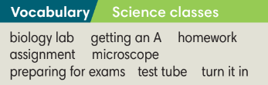
3. PRESENTATION (11’)
ACTIVITIES 1 + 2:
* Aims:
- To introduce the Grammar Box.
- To present the grammar point in context.
- To provide Ss with chances to work cooperatively.
- To lead into the next activity.
* Content:
- Ss read and listen to a dialogue about school rules and answer questions.
- Ss study the Grammar Box to complete the exercise.
* Outcome: Ss learn about school rules and can use must, mustn’t, should and shouldn’t in contexts.
* Organisation: T-Ss, Ss-T, Group work.
Teacher’s Student’s activities |  |  | Content
1. (4’) Listen. Which rules are Mai and Nam talking about?  (Ex 1 – SB p.62)  - T divides the class into 4 groups.  - Each group needs to note down the sentence with must, mustn’t, should and shouldn’t.  - T plays the recording and check Ss answers. |  |  | Answer keys:  They are talking about rules of studying.
2. (7’) Study the Grammar box. Listen to the dialogue again and complete sentences with must, mustn’t, should and shouldn’t.  (Ex 2 – SB p.62)  STEP 1: Introduce the Grammar Box  - T goes through the Grammar Box with Ss  - T reminds Ss that the should/ shouldn’t refers to advice or an opinion whereas must/ mustn’t is used for obligation and rules.  STEP 2: Exercise 2  - T asks Ss to look at exercise 2.  - T calls a S to read the instruction then checks Ss’ understanding of it.  - T asks Ss to finish Exercise 2 before listening to the recording.  - T plays the recording for Ss to check answers.  *The grammar note  - T shows the Grammar Notes.  - T tells Ss to read the notes carefully. |  |  | 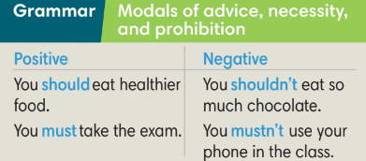  Answer keys:  1 must 2 shouldn’t 3 must  4 musn’t
5. PRACTICE (14’)
ACTIVITIES 3 and 4:
* Aim:
- To help Ss understand the difference between should/ shouldn’t, must/ mustn’t.
- To provide Ss grammar exercises to practice using the above modal verbs.
* Content:
- Ss write sentences with should/ shouldn’t, must/ mustn’t.
- Ss discuss which classroom rules are the most important.
* Outcome: Ss know how to use should/ shouldn’t, must/ mustn’t in sentences.
* Organisation : T-Ss, Ss-T, Pair work
Teacher’s and Student’s activities |  |  |  | Content
3. (5’) Look at the rules in the classroom poster from Linda’s classroom. Write a sentence for each picture. Use must, mustn’t, should or shouldn’t.  (Ex 3 – SB p.62)  - T asks Ss to look at Exercise 3.  - T calls a S to read the instruction then checks Ss’ understanding of it.  - T and Ss discuss the example and analyze why ‘must’ is used.  - T asks Ss to work in individually to finish Exercise 3 and find out which rule is same for their school.  - T calls Ss to give answers then shows them on the slide to check as the whole class. |  |  |  | Answer keys: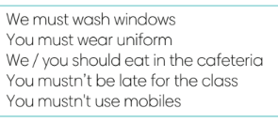
4. (5’) Class vote: Which three classroom rules are the most important?  (Ex 4 – SB p.62)  - T asks Ss work in pairs and list classroom rules.  - T collects Ss answers and write on the board.  - T conducts class vote to find three rules are considered to be the most important and reasons.  - T asks Ss if they could change one rule, what would they change? |  |  |  | 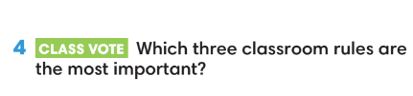
(4’) Extra activity 3.
- T gives Ss the topic “Taking a test”
- T divides class into 4 groups to make sentences using must, mustn’t, should or shouldn’t
- T asks Ss to give answers in front of the class and give feedback.
6. PRODUCTION ( 7’)
ACTIVITY 5:
*Aim: To help students applying the vocabulary items and grammar points related to the topic in communicating.
* Content: Ss discuss a student’s school rules and compare with rules of their school.
* Outcome: Ss understand school rules and practice using must, mustn’t, should or shouldn’t.
* Organisation: T-Ss, Ss-Ss, Pair work
Teacher’s Student’s activities |  | Content
5. In pairs, discuss Linda’ school rules. Compare your classroom rule with Linda’s.  (Ex 5 – SB p.62)  - T asks Ss to look at Exercise 5 (SB page 62).  - T calls a student to read the instruction then checks Ss’ understanding of it.  - T models the activity in front of the class.  - T asks Ss to work in pairs, find the similarities and differences between their classroom rules with Linda’s.  - T walks around to listen and notes down common mistakes for later feedback.  - T calls some groups to come to the front of the class and make conversations.  - T asks the rest to give comments on their classmates’ performance.  - T gives feedback on Ss’ work. |  | 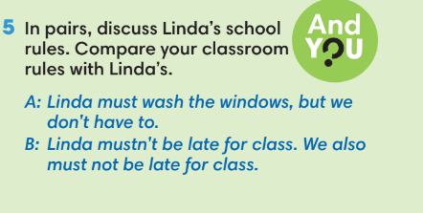
WRAP-UP & HOME WORK (3’)
T asks Ss to talk about what they have learnt in the lesson.
✔ Must, mustn’t, should, shouldn’t.
* HOME WORK
- Do exercises in the workbook page 53.
- Prepare for Lesson 6.3: Reading and Vocabulary.

Date of planning:20/2/2023  Date of teaching: 21/2/2023 | UNIT 6: SCHOOLS  Period12: Reading and Vocabulary
I. OBJECTIVES:
By the end of the lesson, Ss will be able to:
- locate information and find specific details in a text (scanning skill).
- identify the main ideas of the paragraphs in the text or the text itself (skimming).
1. Knowledge:
* Vocabulary: an understanding of the vocabulary about subjects Vietnamese students study.

New words | Vietnamese meaning
1. computer programs | chương trình máy tính
2. foreign languages | ngoại ngữ
3. geographical characteristics | đặc điểm địa lý
4. information technology | công nghệ thông tin
5. design | thiết kế
6. heritage | di sản
7. healthy | khỏe mạnh

* Grammar:
- Reading skills: Find main ideas and specific details in a text about the school system in Việt Nam.
2. Competence: Understand the meaning of the keywords used to talk about school system in Việt Nam, then do the tasks assigned in the textbook; locate information and find specific details in a text (scanning skill); identify the main ideas of the paragraphs in the text or the text itself (skimming skill).
3. Quality/behavior: To teach Ss to be hard-working and attentive in class. Ss have a positive attitude to working in groups, individual work, pair work, cooperative learning and working.
II. TEACHING AIDS:
- Teacher: Grade 7 textbook, Unit 6 (SB p.63, WB p.54), laptop/computer connected to the Internet, loudspeaker, projector/TV, PPT slides …
- Students: Text books, studying equipment …
- Method: Active teach, T-WC; group works; individual …
III. PROCEDURE:
1. WARM-UP (5’)
* Aim:
- To help Ss review grammar they have learnt.
- To lead into the next activity.
* Content: Game: Lucky number (about must, mustn’t, should, shouldn’t).
* Outcome: Ss recall the modal verbs from previous lesson.
* Organisation: T-Ss, Ss-T.
Teacher’s & Student’s activities | Content
Extra activity 1: Lucky number  - T explains the game rules then checks instructions.  - T uses slide to lead the game.  - Ss raise their hands if they have the answer.  - T tells Ss that they are going to read about school system in Vietnam.  - T writes the title for the new lesson:  Unit 6/Lesson 3: Reading and vocabulary. | Game rules:  - T shows key words on the slide.  - Ss make sentences using must, mustn’t, should, shouldn’t.  - Choose randomly one number (1-9) to see your score.
2. PRE-READING (5’)
ACTIVITY 1:
* Aim:
- To activate Ss’ background knowledge of the topic.
- To get Ss think about their schools.
* Content: Ss change the statements so that they are true about their schools.
* Outcome: Ss understand the facts about their schools and prepare for reading the text.
* Organisation: T-Ss, Ss-T, Pair work.
Teacher’s & Student’s activities |  | Content
1. Change the statements so that they are true about your school.  (Ex 1 – SB p.63)  - T asks Ss to work in pairs and find statements that are not true and change them.  - T collects Ss answer and discuss with the whole class. |  | 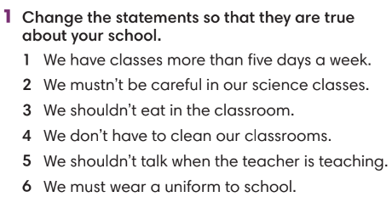
3. WHILE-READING (15’)
ACTIVITY 2 + 3:
*Aim:
- To read two texts and do reading tasks.
- To help students practise finding main ideas of the text.
- To help students practice reading for specific information in a text.
* Content: Ss read the texts and answer the questions.
* Outcome: Ss can identify specific information in the texts and learn more about the school system in Việt Nam.
* Organisation: T-Ss, Ss-T.
2. (4’) Read the text and choose the best title  (Ex 2 – SB p.63)  Step 1: Scan the text  - T asks Ss to look at Exercise 2 (SB page 63).  - T explains to Ss that they need to do skimming and find main ideas.  - T sets time limit for Ss to find main ideas and finish Exercise 2.  - T asks Ss to check answers with their partners before checking with the whole class and explain reasons for their answers. |  | Answer keys:  Subjects Vietnamese student study
3. (6’) Read the text again and fill in the gaps to complete the sentences.  (Ex 3 – p.63)  Step 1: Scanning  - T asks Ss to read the text again, underline key information and try to remember.  - T sets time limitation such as 3 minutes.  - T explains any new words if needed.  - T asks Ss to close the book and answer some questions about the text basing on memory.  1. Which subject is listed first?  2. What do students learn in maths lessons?  3. List one subject that requires Ss to do experiment.  4. Which language is the most common in the school system?  5. What do students learn in information technology class?  Step 2: Exercise 3  - T asks Ss to look at Exercise 3 (SB page 63).  - T asks Ss to predict what types of words might fill in the gap such as adjectives, verbs, nouns, etc.  - T tells Ss to read the text again individually to  complete Exercise 3.  - T asks Ss to underline these sentences in the text and check Ss’ answers. |  | Answer keys:  1 secondary  2 Vietnamese  3 algebra; geometry  4 chemistry  5 geography  6 English
4. POST-READING (17’)
ACTIVITIES 4 & 5:
* Aim:
- To study the Vocabulary box.
- To use words from Vocabulary box in contexts.
* Content:
- Find the phrases from the Vocabulary box in the text.
- Play Game: Tic-tac-toe (Vocabulary box).
- Talk about Ss’ favourite class.
* Outcome: Ss can understand the new words and talk about their favourite class.
* Organisation: T-Ss, Ss-T, Ss-Ss, Group work, Pair work.
4. (5’) Find the phrases below in the text. How do you say them in your language?  (Ex 4 – SB p.63)  - T asks Ss to work in pairs, find these phrases in the text and explain the meaning.  - T collects and checks Ss answers. |  | 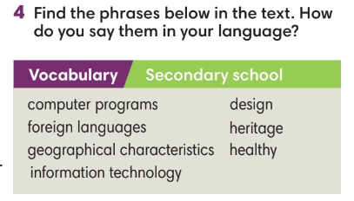
(5’) Tic-tac-toe game.  - T tells Ss that they are going to play a game to use words from Vocabulary box in the context by making sentences.  - T tells Ss the game rules.  - T corrects Ss’ answers if needed. |  | Game rules:  - T divides the class into 2 teams.  - T gives one keyword (in the Vocabulary box from Exercise 4).  - Each team takes turns to make a sentence with these words. If the answer is correct, that team places one X or O.
5. (7’) Work in groups of three or four. Tell your friends about your favorite class.  (Ex 5 – SB p.63)  - T asks Ss to look at Exercise 5 (SB page 63).  - T calls a S to read the instruction then checks Ss’ understanding of it.  - T asks a S to read the example.  - T set time limitation for Ss to prepare and then share in groups of four.  - T invites some volunteers to present in front of the class and notes down useful or interesting sentences.  - T asks the rest to give comments on their classmates’ performance and then provides teacher’s feedback.  - T asks Ss to walk around the class, find the person with the same favorite class to share their ideas. |  | 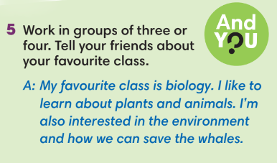
WRAP-UP & HOME WORK (3’)
- T asks Ss to talk about what they have learnt in the lesson.
- Vocabulary of school subjects.
- Reading a text about subjects Vietnamese students study.
- Group discussion.
* HOME WORK
- Do exercises in the workbook page 54.
- Prepare for Lesson 6.4: Grammar 2.

====================

Date of planning:20/2/2023  Date of teaching: 23/2/2023 | UNIT 6: SCHOOLS  Period13: Grammar 2
I. OBJECTIVES:
By the end of the lesson, Ss will be able to:
- use “used to” to talk about routines and states that finished in the past and are no longer true.
1. Knowledge:
* Vocabulary:
* Grammar:
- Use “used to” to talk about school activities in the past.
2. Competence: Understand the main grammatical points, then do the tasks assigned in the textbook. Use “used to” correctly when talking about activities.
3. Quality/ behavior: To teach Ss to be hard-working and attentive in class. Ss have a positive attitude to working in groups, individual work, pair work, cooperative learning and working.
II. TEACHING AIDS:
- Teacher: Grade 7 textbook, Unit 6 (SB p.64), laptop/computer connected to the Internet, loudspeaker, projector/TV, PPT slides…
- Students: Text books, studying equipment…
- Method: Active teach, T-WC; group works; individual ……
III. PROCEDURE:

1. WARM UP (5’)
* Aim:
- To create a positive classroom atmosphere to start a new lesson.
- To review the use of vocabulary for school activities.
* Content: Game (school activities).
* Outcome: Ss review vocabulary about school activities.
* Organisation: T-Ss, Ss-T.
Teacher’s & Student’s activities |  | Content
Extra activity 1: Game.  - T explains the game rules then checks instructions.  - T writes on the board names of subjects (maths, geography, language, physical education, information technology, etc.).  - T divides Ss into 4 groups. Each group receives some cards with school activities.  - T corrects Ss if necessary.  - T tells Ss that, today they will learn about used to to talk about school activities in the past. |  | Game rules:  - Read the school activities carefully.  - Put the cards into correct subject.  - The fastest team is the winner.
2. LEAD-IN (4’)
*Aim:
- To lead into the new lesson.
* Content: Ss list activities they used to do when they are younger but don’t do them now.
* Outcome: Ss prepare for the new lesson about “used to”.
* Organisation: T-Ss, Ss-T.
Teacher’s & Student’s activities | Content
Extra activity 2
- T asks Ss to list activities they used to do when they are younger but don’t do them now.
- T divides the board into 2 to record all answers for following activities.
3. PRESENTATION (13’)
ACTIVITY 1 + 2:
*Aim:
- To present the grammar point in context.
- To lead into the next activity.
- To introduce the Grammar Notes and explain grammar points.
* Content:
- Ss discuss with each other which school activies they used to do.
- Ss study the Grammar box to learn how to use used to/ didn’t use to.
* Outcome: Ss understand how to use used to to talk about school activities.
* Organisation: T-Ss, Ss-T, Pair work, Group work.
Teacher’s & Student’s activities | Content
1. (7’) In pairs, read the text, look at the pictures and discuss the primary school activities you used to do, but don’t do any longer.  (Ex 1 – SB p.64)  - T asks Ss to look and describe the activities in the pictures.  - T explains any new words if needed.  - Ss work in pairs to read the text.  - T calls volunteers to read in front of the class.  - T asks Ss to underline school activities in the text.  - Ss work in groups of 4 to discuss about their school activities which they used to do. | 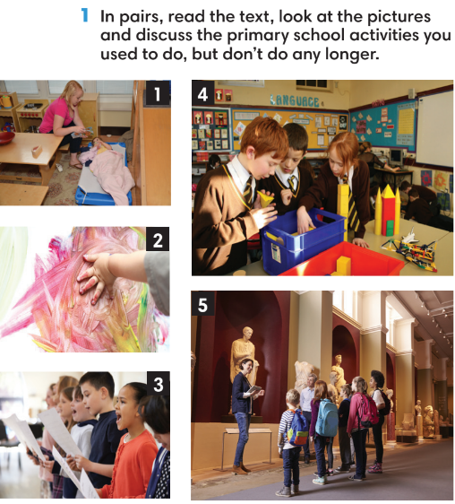
2. (6’) Study the Grammar box. Find examples of used to and didn’t use to in the dialogue.  (Ex 2 – SB p.64)  - T asks Ss to look at the Grammar Box in SB p.64 and explains the usage of “used to” to talk about activities used to do in the past but don’t do now.  - T asks Ss to read the dialogue again and underline used to and didn’t use to in the dialogue to finish Exercise 2.  - T checks Ss’ answers. | 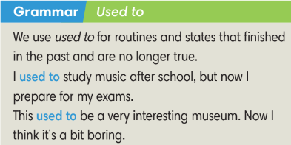
4. PRACTICE (15’)
ACTIVITIES 3:
* Aims:
- To provide Ss with language notes.
- To help Ss practice making negatives and questions with used to.
- To help Ss practice new grammar points in context.
- To practice solving some types of grammar exercises.
* Content:
- Ss study the Language notes.
- Ss use used to and didn’t use to to make sentences.
- Play Game: Hot potato (practice using used to and didn’t use to).
* Outcome: Ss can use used to and didn’t use to correctly to make sentences.
* Organisation: T-Ss, Ss-T, Ss-Ss.
Teacher’s & Student’s activities | Content
(6’) Extra activity 3: Language notes.  - T shows the Language notes on the slide.  - T asks Ss to provide examples of all three form of used to (positive, negative and question).  - T uses activities from Lead-in, divide the class into 3 groups to make sentences using 3 forms of used to. | 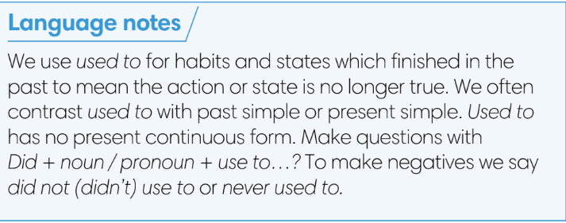
3. (4’) Peter does the following activities this year. Write about what Peter used to do and didn’t use to do last year.  (Ex 3 – SB p.64)  - T asks Ss to read the instructions and checks their understanding.  - Ss work individually to finish exercise 3.  - T checks Ss’ answers. | Answer keys:  1. He didn’t use to play football.  2. He used to paint pictures.  3. He didn’t use to build a website.  4. He used to compete in a game.  5. He didn’t use to study algebra.
(5’) Extra activity 4: Game – Hot potato.  - T explains the game rules then checks instructions.  - T collects Ss’ answers and checks. | Game rules:  ✔ The S who has the ball needs to make a sentence with used to (positives, negatives or questions).  ✔ The next S receives the ball and makes another sentence.  ✔ 1 correct answer = 1 point.
5. Production (5’)
ACTIVITY 4:
* Aims: To help Ss applying the vocabulary items and grammar points related to the topic in communicating.
* Content: Ss ask and answer about activities they used to do in the past.
* Outcome: Ss can use used to in conversation.
* Organisation: T-Ss, Ss-T, Ss-Ss, Pair work.

Teacher’s & Student’s activities | Content
4. Think back to when you were in primary school or kindergarten. In pairs, tell your partner what you used to do.  (Ex 4 – SB p.64)  - T asks Ss to look at exercise 4 (SB page 64).  - T calls a S to read the instructions and example.  - T explains to Ss that they are going to do the task in pairs.  - T asks 3 groups to model the activity in front of the class.  - T asks the other Ss to give comments on their classmates’ performance.  - T asks Ss to line up into 2 lines, facing each other. Ss takes turn to say the sentence to their partner.  - After each 20 seconds, T say “switch”, Ss move one step to change partners.  - T walks around to note down any mistakes for later feedback. | 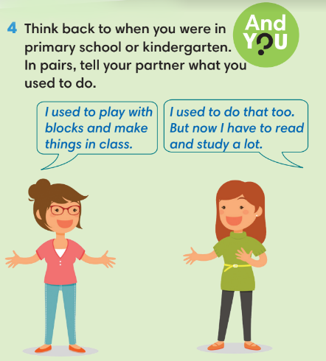
WRAP-UP & HOME WORK (3’)
- T asks Ss to talk about what they have learnt in the lesson.
✔ Used to.
* HOME WORK
- Do exercises in the workbook page 55.
- Prepare for Lesson 6.5: Listening and vocabulary.
Date of planning: 20/2/2023 Date of teaching: 24/2/2023 | UNIT 6: FOOD AND DRINK  Period 14: Listening and Vocabulary
I. OBJECTIVES:
By the end of the lesson, Ss will be able to:
- identify specific details in a conversation and talk about schools.
1. Knowledge:
* Vocabulary:
New words | Vietnamese meaning
1. breakfast club | câu lạc bộ bữa sáng
2. indoor gym | phòng gym trong nhà
3. music club | câu lạc bộ âm nhạc
4. sport club | câu lạc bộ thể thao
5. photography club | câu lạc bộ nhiếp ảnh
6. swimming pool | bể bơi

* Grammar: My school has a computer room and a basketball court…
2. Competence: Understand and use the vocabulary about school activities, then do the tasks assigned in the textbook. Listen and identify specific details in a a conversation and talk about schools.
3. Quality / behavior: To teach Ss to be hard-working and attentive in class. Ss have a positive attitude to working in groups, individual work, pair work, cooperative learning and working.
II. TEACHING AIDS:
- Teacher: Grade 7 textbook, Unit 6 (SB p.65, WB p.56), laptop/computer connected to the Internet, loudspeaker, projector/TV, PPT slides …
- Students: Text books, studying equipment …
- Method: Active teach, T-WC; group works; individual …
III. PROCEDURE:
1. WARM UP + LEAD-IN (5’)
* Aims:
- To activate Ss’ prior knowledge and get students involved in the lesson.
- To early introduce some vocabulary about school activities.
* Content: Ss review how to use used to.
* Outcome: Ss can recall how to use used to in sentences
* Organisation: T-Ss, Ss-T.
Teacher’s & Student’s activities | Content
Extra activity 1: Game – Review grammar used to.  - T reminds Ss about the usage of used to to talk about routines and states that finished in the past and are no longer true.  - T divides the class into 2 teams.  - T sets the scene for the new lesson: T tells Ss that they are going to learn more about school activities.  - T writes the title on the board Unit 6: Schools. Lesson 6.5: Listening and Vocabulary | Game rules:  - 1 student from team A makes a sentence with used to then choose randomly.  - 1 student from team B to make another sentence.  - 1 correct answer = 1 point.
2. PRE-LISTENING (5’)
ACTIVITY 1:
*Aims:
- To lead into the topic.
- To set the scene for the new content and introduce the vocabulary.
* Content: Look at the pictures and compare these activities to Ss’ school.
* Outcome: Ss can guess the activities shown in the pictures.
* Organisation: T-Ss, Ss-T.
Teacher’s & Student’s activities | Content
1. Look at these pictures. How is this school similar to yours?  (Ex 1 – SB p.65)  - T asks Ss to work in pairs and describe the pictures and find similarities and differences between their schools and the school in the book.  - T collects Ss’ answers and find out what is their most favorite activity at school. | 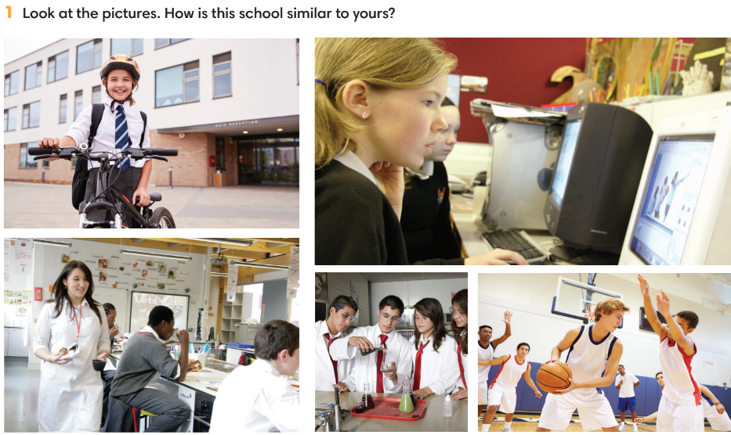
3. WHILE-LISTENING (19’)
ACTIVITIES 2, 3 & 4:
* Aims:
- To help Ss identify specific details in a conversation.
- To introduce the vocabulary.
- To practice using vocabulary to make sentences.
* Content: Listen and understand to the audio track and complete the exercises.
* Outcome: Identify specific details in a conversation.
* Organisation: T-Ss, Ss-T, Ss-Ss.
Teacher’s & Student’s activities | Content
2. (7’) Listen and complete the notes about schools in the UK. Fill in each blank with ONE word or number.  (Ex 2 – SB p.65)  - T calls a S to read the instruction then checks Ss’ understanding of it.  - T explains that Ss are listening for details including numbers, dates, names, places and important things.  - T asks Ss to look at the questions and underline key words.  - T encourages Ss to guess the answers.  - T provides meanings of all new words.  - T plays the audio and have Ss do the exercise.  - T tells Ss to check their answers in pairs.  - T plays the audio again and checks the answers with the whole class.  - T encourages Ss to give the evidence that they hear from the audio track to prove their answers. | Answer keys:  1. 22  2. 08.30; 4.00  3. music; drama; international  4. sport; photography; music  5. three/ 3
3. (5’) Listen again and mark the sentences T (true) or F (false).  (Ex 3 – SB p.65)  - T calls a S to read the instruction then checks Ss’ understanding of it.  - T asks Ss to finish exercise 3 basing on their memory.  - T plays the audio for Ss to check answers.  - T pauses the audio and ask Ss to repeat evidence.  - T asks Ss to correct all false statements. | Answer keys:  1. True  2. True  3. False  4. True  5. False
4. (7’) Put the following words into the correct column.  (Ex 4 – SB p.65)  - T explains the meaning of all words.  - Ss listen and repeat. T check Ss pronunciation.  - Ss do Exercise 4.  - T collects Ss answer and checks.  - T encourages Ss to work in pairs and make sentences using these words.  - T calls a few Ss to give examples and get feedback from the rest of the class. | Answer keys:  Before school: breakfast club  After school: indoor gym, music club, sport club, photography club, swimming pool
4. POST-LISTENING (13’)
ACTIVITY 5:
*Aims:
- To reinforce word friends.

- To practice using new words in context.
* Content:
- Play Game – Hot seat to review vocabulary.
- Use Word Friends to describe Ss’ school.
* Outcome: Can use vocabulary about school activities to talk about schools.
* Organisation: T-Ss, Ss-Ss, Ss-T, Group work.
Teacher’s & Student’s activities | Content
(5’) Extra activity 2: Game – Hot seat  - T divides the class into 2 teams and then explains the rule. | Game rules:  ✔ 2 Ss from 2 teams go to the board, back against the board.  ✔ 2 teams get one word from T (Word friends or from listening conversation).  ✔ Each team needs to describe until that S can guess the correct word.  ✔ The faster team gets 1 point.
5. (8’) Use the Word Friends and other words you know to describe your school.  (Ex 5 – SB p.65)  - T asks Ss to read the instructions and examples.  - Ss work in groups of four to describe their school using word friends.  - T walks around to provide feedback.  - T asks 2-3 groups to share their answers in front of the class. | 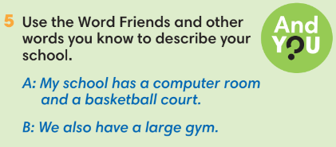
WRAP-UP & HOME WORK ( 3’)

- T asks Ss to talk about what they have learnt in the lesson.
- Describe a school.
* HOME WORK
- Do exercises in the workbook page 56.
- Prepare for Lesson 6.6: Speaking.

=====================

Date of planning:27/2/2023  Date of teaching: 28/2/2023 | UNIT 6: SCHOOLS  Period15: Speaking
I. OBJECTIVES:
By the end of the lesson, Ss will be able to:
- use vocabulary and phrases to talk about favorite subjects and activities at school.
1. Knowledge:
* Vocabulary: Use the phrases to talk about favorite subjects and activities at school.
* Grammar: Make a conversation about favorite subjects and activities at school.
2. Competence: Ss can use vocabulary and phrases to talk about their favorite subjects and activities at school, and do the tasks assigned in the textbook.
3. Quality/behavior: To teach Ss to be hard-working and attentive in class. Ss have a positive attitude to working in groups, individual work, pair work, cooperative learning and working.
II. TEACHING AIDS:
- Teacher: Grade 7 textbook, Unit 6 (SB p.66, WB p.57), laptop/computer connected to the Internet, loudspeaker, projector/TV, PPT slides…
- Students: Text books, studying equipment…
- Method: Active teach, T-WC; group works; individual ……
III. PROCEDURE:
1. WARM UP + LEAD-IN (5’)
* Aim:
- To create a positive classroom atmosphere to start a new lesson.
- To review words of subjects and school activities.
- To lead into the topic.
* Content: Game (school activities).
* Outcome: Ss review vocabulary about school activities.
* Organization of implementation: T-Ss, Ss-Ss, Ss-T.
Teacher’s & Student’s activities |  | Content
Extra activity 1: Game  - T divides Ss into 4 teams.  - Before starting the game, T writes 4 favorite subjects of Ss on the board.  - When Ss finish the game, T tells Ss that, they are using the vocabulary to do some speaking tasks today.  - T writes the title of new lesson: Unit 6/ Lesson 6.6 - Speaking |  | Game rules:  - Time limitation: 3 minutes and 1 minute for preparation.  - Ss take turns to write activities of each subject on the board.  - 1 correct answer = 1 point.
2. PRE-SPEAKING (9’)
ACTIVITY 1:
* Aims:
- To activate Ss’ prior knowledge of the topic.
- To lead into the topic.
* Content:
- Listen to the dialogue and answer the questions.
* Outcome: Ss understand how to use the model questions and answers to talk about subjects and school activities.
* Organisation: T-Ss, Ss-T, Pair work.
Teacher’s & Student’s activities |  |  | Content
1. (9’) Listen and answer the questions. Who likes science? Why does he/ she like science?  (Ex 1 – SB p.66)  - T shows pictures in SB p.66 on the slide.  - Ss work in pairs to describe them.  - T asks a few volunteers to answer the questions.  - T encourages Ss to guess why the character likes science.  - T plays the audio for Ss to listen and check pronunciation of any new words.  - T explains any new words if needed.  - Ss work in pairs to role-play the dialogue.  - T invites 2 groups to model in front of the class.  - Ss answer the question, underline evidence from the dialogue and useful vocabulary/ structures that they can use later. |  |  | Answer keys:  Minh likes science. He likes learning by doing and doesn’t like learning with only books.
3. WHILE-SPEAKING (20’)
ACTIVITIES 2, 3, 4:
* Aims:
- To introduce the Speaking Box.
- To reinforce the expressions of subjects and activities.
- To practise using the new expressions in contexts.
* Content:
- Study the Speaking box and find similar questions in the dialogue.
- Listen to the audio and do the tasks.
* Outcome: Ss understand how to use the model questions and answers to talk about subjects and school activities.
* Organisation: T-Ss, Ss-T, Pair work.
Teacher’s & Student’s activities |  |  |  | Content
2. (10’) Study the Speaking box. Find three similar questions in the dialogue.  (Ex 2 – SB p.66)  - T goes through the Speaking box and asks Ss to find three similar questions in the dialogue.  - When Ss have finished, T asks them to work in pairs to create a short conversation using these phrases.  - T invites different pairs to act out their dialogues in front of the class and then provide feedback. |  |  |  | Answer keys:  What is your favourite project?  What kind of experiments?  Do you like it?  Why not?  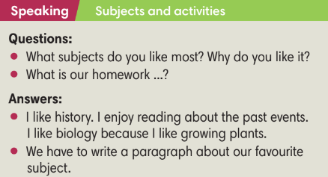
3. (5’) Listen to the activities. Circle the school subjects students are describing.  (Ex 3 – SB p.66)  - T asks Ss to look at all student names and school subjects.  - T plays the audio for students to check. |  |  |  | Answer keys:  Linh: music  Stephanie: maths  Bình: literature  Hạnh: chemistry  Dreck: geography
4. (5’) Listen again. Fill in each blank with ONE word.  (Ex 4 – SB p.66)  - T plays the audio again for Ss to finish Exercise 4.  - T asks Ss to check answers in pairs before checking with the whole class.  - T pauses the audio and ask Ss to repeat if needed. |  |  |  | Answer keys:  1 love  2 like  3 into  4 good  5 like
4. POST-SPEAKING ( 8’)
ACTIVITY 4:
*Aims: To help Ss applying the new language and skills related to the topic in communicating.
* Content: In pair, Ss discuss classroom activities they like and dislike.
* Outcome: Ss can talk about school activities.
* Organisation: T-Ss, Ss-Ss.
Teacher’s & Student’s activities | Content
5. In pair, discuss classroom activities you like and dislike. Find 1-2 classroom activities you both like.  (Ex 5 - SB p.66)  - T asks Ss to work in pairs for discussion.  - T invites 2 random students to make a conversation in front of the class. Other Ss listen and provide feedback.  - T tells students to look at the speaking box in their student book again and work in groups to prepare for the task.  - T sets time for Ss to prepare and practice speaking.  - T walks around the class to listen and provide feedback.  - T asks 5 groups to practice the conversation in front of the class.  - T does a quick class vote to find the most/ least favourite school activities. | 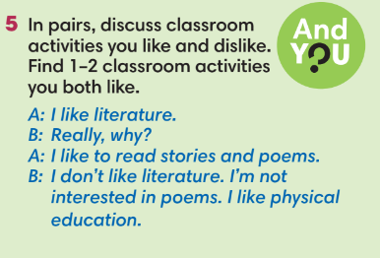
WRAP-UP & HOME WORK (3’)
- T asks Ss to talk about what they have learnt in the lesson.
favorite subjects and activities at school.
* HOME WORK
- Do exercises in the workbook page 57.
- Prepare for Lesson 6.7: English in use.

=====================

Date of planning:27/2/2023  Date of teaching:2/3/2023 | UNIT 6: SCHOOLS  Period16: English in use
I. OBJECTIVES:
By the end of the lesson, Ss are able to:
- use conjunctions and time expressions to write a paragraph about what activities you like or do not like at school.
1. Knowledge:
* Vocabulary:
* Grammar: Use conjunctions and time expressions correctly.
2. Competence: Ss can use conjunctions and time expressions in sentences, and do the tasks assigned in the textbook. Ss can write about their favourite activities at school.
3. Quality/behavior: To teach Ss to be hard-working and attentive in class. Ss have a positive attitude to working in groups, individual work, pair work, cooperative learning and working.
II. TEACHING AIDS:
- Teacher: Grade 7 textbook, Unit 6 (SB p.67, WB p.58), laptop/computer connected to the Internet, loudspeaker, projector/TV, PPT slides …
- Students: Text books, studying equipment …
- Method: Active teach, T-WC; group works; individual …
III. PROCEDURE:
1. WARM UP (5’)
* Aims:
- To create a positive classroom atmosphere to start a new lesson.
- To review words of school activities.
* Content: Game – After-school clubs.
* Outcome: Ss understand the background of the lesson.
* Organization of implementation: T-Ss, Ss-T, Ss-Ss
Teacher’s & Student’s activities | Content
Extra activity 1: Game – After-school clubs.  - T asks Ss to provide a few examples of after-school clubs.  - T divides the class into 2 groups. Each group writes down 5 after-school clubs.  - T explains the game rules then checks Ss’ comprehension.  - T introduces the new lesson and writes the title on the board Unit 6/ Lesson 6.7: English in use. | Game rules:  ✔ Two groups swap lists of after-school clubs.  ✔ Time limitation: 2 minutes.  ✔ Each group needs to list all activities relating to these after-school clubs.  ✔ 1 correct phrase = 1 point.
2. LEAD-IN (4’)
* Aims:
- To lead into the new lesson.
- To provide Ss with reasons for reading the dialogue in Exercise 1 (SB p.67).
* Content: Discuss in pairs to guess the subject mentioned in the following dialogue.
* Outcome: Guess what the dialogue is about to prepare for reading tasks.
* Organisation: T-Ss, Pair work.
Teacher’s & Student’s activities | Content
Extra activity 2: See – think – wonder.  - T shows the pictures from the SB on the slide then asks Ss to describe these pictures and find out which subject is mentioned.  - T sets a time limit for Ss’ quick discussion.  - Ss work in pairs to make guesses about the pictures then give answers.  - T calls some Ss to answer then checks with the whole class. | 
3. PRESENTATION (10’)
ACTIVITIES 1 + 2:
Aim:
- To present conjunctions and time expressions through a context.
- To introduce the Language Box through the reading tasks.
* Content: Read the dialogue and do the tasks.
* Outcome: Understand how to use conjunctions and time expressions in context.
* Organisation: T-Ss, Ss-T.
Teacher’s & Student’s activities | Content
1. (6’) Read the dialogue and complete the statements. Write Hương or Jasmin.  (Ex 1 – SB p.67)  - T asks Ss to open their SB page 67, look at Exercise 1.  - T calls a S to read the instruction then checks Ss’ understanding of it.  - T tells Ss that they are going to read the text to find the answers.  - Ss work individually, read, and note down the answers to the given questions.  - T calls some Ss to answer then shows the answers on the slide. | Answer keys:  1 Jasmin 2 Hương 3 Jasmin
2. (4’) Underline examples of conjunctions and time expressions in the dialogue.  (Ex 2 – SB p.67)  - T goes through the Language box with Ss and explains the meaning and usage of conjunctions and time expressions.  - T reminds Ss to use Present Simple with future time clauses.  - T asks Ss to read the dialogue again and underline conjunctions and time expressions. | 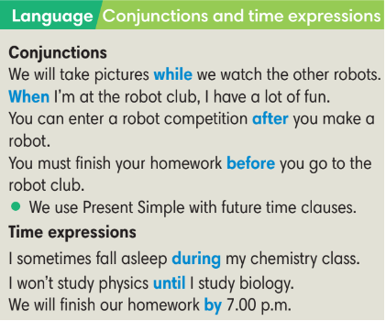  Answer keys:  1 while 2 after 3 until 4 when
4. PRACTICE (16’)
ACTIVITIES 3 + 4:
Aims:
- To reinforce the use of conjunctions and time expressions.
* Content: Use conjunctions and time expressions to complete the exercises.
* Outcome: Use conjunctions and time expressions correctly in sentences.
* Organisation: T-Ss, Ss-T, Individual work.
Teacher’s & Student’s activities | Content
3. (5’) Complete the sentences with the correct time expressions.  (Ex 3 – SB p.67)  - T asks Ss to open their SB page 67, look at Exercise 3.  - T calls a S to read the instruction then checks Ss’ understanding of it.  - T gives Ss a time limit to work individually.  - T allows Ss to share their answers before checking the final ones as the whole class.  - T provides the meanings of any new words if needed. | Answer keys:  1 for 2 before 3 by 4 during 5 when
4. (5’) Use the clues to complete the sentences.  (Ex 4 – SB p.67)  - T asks Ss to open their SB page 67, look at Exercise 4.  - T calls a S to read the instruction then checks Ss’ understanding of it.  - T gives Ss a time limit to work individually.  - T allows Ss to share their answers before checking the final ones as the whole class.  - T provides the meanings of any new words if needed. | Answer keys:  1 finishes school work  2 will have fun  3 finish your physics experiment  4 buys some parts  5 are buildings robots
(6’) Extra activity 3: Game.  - T tells Ss that they are playing a game with conjunctions and time expressions.  - T divides the class into 2 groups.  - T explains the game rules then checks instructions.  - T corrects Ss’s pronunciation and mistakes if necessary. | Game rules:  ✔ One S from team A makes a sentence with one conjunction or time expression.  ✔ After finishing, that S chooses randomly one S from team B and gives one conjunction or time expression.  ✔ 1 correct answer = 1 points.
5. PRODUCTION (7’)
ACTIVITY 5:
*Aims:
- To help students applying the vocabulary items and grammar points related to the topic in communicating.
* Content: Ss write a paragraph about the activities they like or do not like at school.
* Outcome: Ss can use conjuntions and time expressions in writing.
* Organisation: T-S, Individual work, Pair work.

Teacher’s & Student’s activities | Content
5. Write a paragraph of 5-6 sentences about the activities you like or do not like at school. Use the conjunctions and time expressions.  (Ex 5 – SB p.67)  - T asks Ss to look at Exercise 5 (SB page 67).  - T calls a S to read the instructions then checks Ss’ understanding of it.  - T lets Ss work individually to write their paragraphs first.  - Then T pairs Ss up and asks them to share their paragraphs and feedback.  - T invites some volunteers to share the paragraphs and provides feedback. | 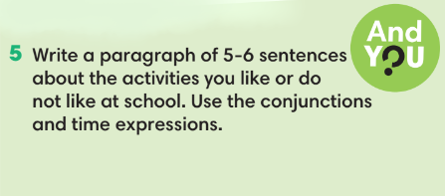
WRAP-UP & HOME WORK (3’)
T asks Ss to talk about what they have learnt in the lesson.
- Conjunctions and time expressions.
- Write about activities you like or do not like at school.
* HOME WORK:
- Do exercises in the workbook page 58.
- Prepare for Lesson 6.8: Vocabulary in action and pronuciation.

======================

Date of planning:27/2/2023  Date of teaching:4/3/2023 | UNIT 6: SCHOOLS  Period17: Vocabulary In Action and Pronunciation
I. OBJECTIVES:
By the end of the lesson, Ss will be able to:
- review vocabulary about school subjects and activities.
- correctly pronounce /ð/ and /θ/.
1. Knowledge:
* Vocabulary: Review vocabulary
- The lexical items related to school subjects and school activities.
* Pronunciation: /ð/: their, father,… /θ/: thing, tooth,…
2. Competence: Ss develop communication skills, presentation skills, and creativity; being collaborative and supportive in pair work, teamwork, and actively join in class activities.
3. Quality/behavior: To teach Ss the love of talking about food and drink, and develop self-study skills. Ss have a good attitude to working in groups, individual work, pairwork, cooperative learning, and working.
II. TEACHING AIDS:
- Teacher: Grade 7 textbook, Unit 6 (SB p.68, WB p.59), laptop/computer connected to the Internet, loudspeaker, projector/TV, PPT slides… .
- Students: Text books, studying equipment…
- Method: Active teach, T-WC; group works; individual ……
III. PROCEDURE:
1. WARM UP + LEAD-IN (5’)
*Aims:
- To create an active atmosphere in the class before the lesson.
- To lead into the new lesson.
* Content: Game: Hot seat (school subjects and activities).
* Outcome: Ss can recall the vocabulary of Unit 6.
* Organisation: T-Ss, Ss-Ss.
Teacher’s & Student’s activities | Content
Extra activity 1: Game: Hot seat.  * T asks Ss to spend 1 minute to quickly review all vocabulary they have learnt in Unit 6 before they play a warm-up game.  - T divides the class into 2 groups.  - T explains the game rules then checks instructions.  - T tells Ss that they can remember better with Glossary Table and asks Ss to open their Student Book page 68 – Exercise 1. | Game rules:  - 2 Ss from 2 groups go to the board, their backs facing the board.  - T writes 1 word on the board.  - Two teams explain the word for their teammates.  - The faster team gets 1 point.
2. REVIEW VOCABULARY (22’)
ACTIVITIES 1 + 2 + 3:
*Aims:
- To introduce the glossary and its uses.
- To give further practice with vocabulary of Unit 6.
* Content: Revise what they have learnt during the unit, using the Glossary.
* Outcome: Recall the vocabulary of Unit 6 and use them in sentences.
* Organisation: T-Ss, Ss-T, Pair work.
Teacher’s & Student’s activities | Content
1. (5’) Use the glossary to find.  (Ex 1 – SB p.68)  - T introduces the Glossary Table.  - T asks Ss to look at Exercise 1 in student book page 68.  - T has Ss use the glossary to find the words which belong to the correct category.  - T asks Ss to work in pairs and quickly do the task.  - T allows Ss to peer check first.  - T checks and confirms the answers. | Answer keys:  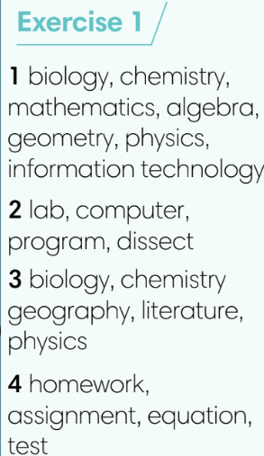
2. (5’) Use the glossary to complete the sentences. In pairs, say if the statements are true for you.  (Ex 2 – SB p.68)  - T asks Ss to complete the sentences with suitable words.  - T asks Ss to check answers in pairs.  - T invites Ss to share their answers.  - T confirms the correct answers.  (6’) Extra-Practice  TIME TO TALK: Use the Glossary to make sentences about school subjects and activities.  - Ss work in groups of 4 to make as many sentences as possible.  - T asks some groups to share in front of the class to get feedbacks. | Answer keys:  1 competing in a game.  2 musical instruments.  3 microscope.  4 literature.  5 healthy.
3. (6’) In pairs, discuss the differences between the words below.  (Ex 3 – SB p.68)  - T asks Ss to open their SB page 68, look at exercise 3.  - T calls a S to read the instruction then checks Ss’ understanding of it.  - T gives Ss a time limit for discussion.  - For each item, T invites 3 groups to share their ideas and then do a class vote for the best pairs. | Words for discussion:  1. biology/ biology lab.  2. chemistry/ physics.  3. English/ foreign languages.  4. literature/ history.  5. a test tube/ a microscope.
3. PRONUNCIATION (16’)
3.1. Presentation (5’)
ACTIVITY 4
* Aims:
- To learn how to pronounce the /ð/ and /θ/ sounds.
* Content: Listen to the words and sort them according to their sounds.
* Outcome: Learn how to pronounce the /ð/ and /θ/ sounds.
* Organisation: T-Ss, Ss-T.
Teacher’s & Student’s activities | Content
4. (4’) Listen to how we pronounce the /ð/ and /θ/ sounds. Listen and write the words in the blank.  (Ex 4 – SB p.68)  - T calls a S to read the instruction of Exercise 4 then checks Ss’ understanding of it.  - T asks Ss to guess the answer basing on their own pronunciation.  - T plays the audio for Ss to check their guess and finish Exercise 4.  - T asks Ss to repeat and corrects Ss’ pronunciation. | Answer keys:  /ð/: another, father, that, their, together.  /θ/: anything, healthy, thing, think, thought, tooth, through.
3.2. Practice (11’)
ACTIVITY 5:
* Aims:
- To help students practice full sentences with the /ð/ and /θ/ sounds.
* Content:
- In pairs, say sentences with the /ð/ and /θ/ sounds.
- Play a game to practise listening to the /ð/ and /θ/ sounds.
* Outcome: Can identify the /ð/ and /θ/ sounds and pronounce them correctly.
* Organisation: T-Ss, Ss-T, Ss-Ss.
Teacher’s & Student’s activities | Content
5. (5’) In pairs, say the sentences. Listen, check and repeat.  (Ex 5 – SB p.68)  - T plays the audio for Ss to repeat.  - Ss work in pairs to practice these sentences.  - T asks 5 pairs to read out loud in front of the class.  - T corrects Ss pronunciation if needed. | 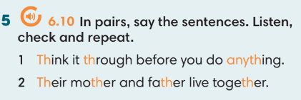
(6’) Extra activity 2: Game  - T divides the class into 2 teams and then invites 10 Ss from each team to make one line. | Game rules:  - Listen to the word (T prepares an audio).  - If Ss hear /ð/ sound, Ss jump on the left side. If Ss hear /ð/ sound, Ss jump on the right side.  - Ss with wrong answer is out. The team with more Ss left in the line get more points.
WRAP-UP & HOME WORK (2’)
Teacher asks students to talk about what they have learnt in the lesson.
- use a Glossary to review.
- /ð/ and /θ/ sounds
* HOME WORK
- Find more words with /ð/ and /θ/ sounds.
- Prepare for Unit 6 – Lesson 9: Revision.

==================

Date of planning:6/3/2023  Date of teaching:7/3/2023 Period13 | UNIT 6: SCHOOLS  Period18: Revision
I. OBJECTIVES:
By the end of the lesson, Ss are able to:
1. Knowledge:
* Vocabulary: Review vocabulary and grammar in the unit.
* Grammar: Practice making a dialogue about what should/ shouldn’t/ must/ mustn’t be done at school.
2. Competence: Ss understand and use the vocabulary of the unit to do the tasks assigned in the textbook. Ss can participate in a guided conversation to talk about school.
3. Quality/ behavior : To teach Ss to be hard-working and attentive in class. Ss have a positive attitude to working in groups, individual work, pair work, cooperative learning and working.
II. TEACHING AIDS:
- Teacher: Grade 7 textbook, Unit 6 (SB p.69, WB p.59), laptop/computer connected to the Internet, loudspeaker, projector/TV, PPT slides …
- Students: Textbooks, studying equipment …
- Method: Active teach, T-WC; group works; individual …
III. PROCEDURE:

- WARM-UP (4’)
*Aims:
- To create a positive classroom atmosphere to start a new lesson.
- To lead into the review lesson.
* Content: Game: SUPER EYES
* Outcome: Ss understand that they are going to review Unit 6.
* Organisation: T-Ss, Ss-Ss, Ss-T.
Teacher’s & Student’s activities | Content
Extra activity 1: SUPER EYES  - Set the scene: T asks Ss to do quick exercises for eyes such as look up and down, look left and right, row the eyes  - T tells Ss that they are going to play a game called SUPER EYES  - T explains the game rules then checks instructions.  - T uses the slides to show the collages.  - Ss join in the game in pairs or in small groups.  - T shows the collage again with displayed answers to check for the whole class.  - T tells Ss that they are going to review Unit 6. | Game rules:  - Look carefully at a collage of different small pictures.  - The collage will disappear in a few seconds.  - Recall as many words about the collage as you can remember.
- REVIEW VOCABULARY (19’)
ACTIVITIES 1 + 2:
* Aims:
- To help students reviews vocabulary and word friends from the unit.
- To review vocabulary in contexts.
* Content: Play a game and do the exercises to revise the vocabulary of Unit 5.
* Outcome: Understand the vocabulary to do the exercises correctly.
* Organisation: T-Ss, Ss-Ss, Ss-T.
Teacher’s & Student’s activities | Content
(4’) Extra activity 2: Game  - T asks Ss to look at vocabulary of school subject and class activities.  - T introduces game rules. | Game rules:  - T writes 2 words on the board.  - 2 Ss from 2 teams go to the board to guess the words by asking their teams questions (How many letters? Is it a school subject? etc.)  - 1 correct answer = 1 point.
1. (5’) Write the correct word for each definition.  (Ex 1 – SB p.69)  - T asks Ss to look at Exercise 1 in student book page 69.  - T calls a student to read the instruction then checks Ss’ understanding of it.  - T asks Ss to work in pairs to read then complete the activity.  - T encourages students to give the reason for their answers.  - T checks as the whole class. | Answer keys:  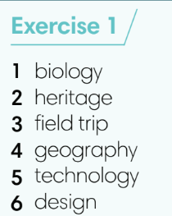
2. (5’) In pairs, ask and answer the following questions.  (Ex 2 – SB p.69)  - T asks Ss to look at Exercise 2 in student book page 69.  - T calls a S to read the instruction then checks Ss’ understanding of it.  - T asks Ss to work in pairs to read then complete the activity.  - Ss work in pair to complete the task and compare the answers.  - T checks as the whole class. | 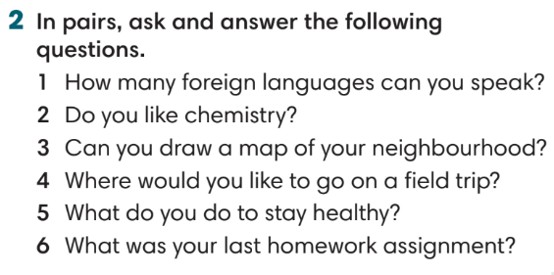
(5’) Extra activity 3: Game – Unscramble words.  - T divides the class into 4 teams and explains game rule.  - T prepare a few sentences using word friends in Unit 6. | Game rules:  - Ss receive 10 bags with unscramble words of 10 sentences. (Words are written and cut into pieces)  - 1 correct sentence = 1 point.
3. REVIEW GRAMMAR ( 12’)
ACTIVITIES 3 + 4:
*Aims:
- To reinforce the grammar of Unit 6: should/ shouldn’t/ must/ mustn’t.
* Content: Use should/ shouldn’t/ must/ mustn’t correctly to complete the tasks.
* Outcome: Ss can use should/ shouldn’t/ must/ mustn’t correctly in sentences.
* Organisation: T-Ss, Ss-T, Pair work.
Teacher’s & Student’s activities | Content
3. (4’) Complete the dialogue with the words below.  (Ex 3 – SB p.69)  - T helps Ss to review grammar before doing this task.  - Ss work individually.  - T checks Ss’ answers. | 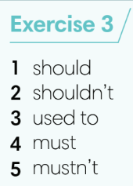
4. (5’) Choose the correct options.  (Ex 4 – SB p.69)  - T asks Ss to look at Exercise 4 in student book page 69.  - T calls a student to read the instruction then checks Ss’ understanding of it.  - T asks Ss to work individually and then share the answers in pairs.  - T checks as the whole class, asks Ss for the reasons of their answers. | Answer keys:  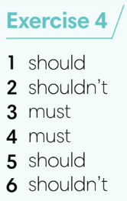
(4’) Extra activity 4: Game – Whisper.  - T divides the class into 4 teams and explains game rule.  - T prepares a few sentences with should/ shouldn’t/ must/ mustn’t. | Game rules:  - T gives 1 sentence to 1 student of each team.  - Ss take turn to whisper until the last student of the team get it and write on the board.  - 1 correct sentence = 1 point.
4. SPEAKING (7’)
ACTIVITY 5:
*Aims:
- To help Ss practice speaking skill in a conversation about which things they can do/ cannot do.
* Content: Discuss school rules using should/ shouldn’t/ must/ mustn’t.
* Outcome: Ss can use should/ shouldn’t/ must/ mustn’t in conversation.
* Organisation: T-Ss, Ss-T, Pair work.
Teacher’s & Student’s activities | Content
5. Work in pairs. Student A, tick four of the  boxes below and answer Student B’s  questions. Use should, shouldn’t, must, or  mustn’t in your responses.  (Ex 5 – SB p.69)  - T asks Ss to look at Exercise 5.  - T calls a S to read the instruction then checks Ss’ understanding of it.  - T sets a time limit and walks around as a monitor while Ss are discussing.  - Ss work in pairs to practice the speaking task.  - T moves around and takes notes for any issues that need improving from students work.  - T encourages some strong Ss to share in front of the class.  - T gives some general feedback for Ss’ performances. | 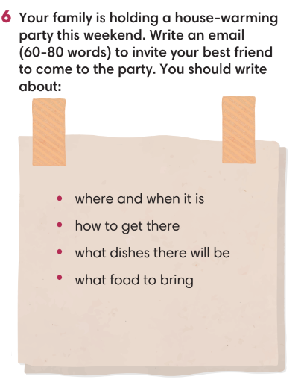
WRAP-UP & HOME WORK (3’)
T asks Ss to talk about what they have learned in the lesson.
- Review vocabulary and grammar of Unit 6.
- Conversation using should/ shouldn’t/ must/ mustn’t.
* HOMEWORK
- Do exercises in the workbook page 59.
- Prepare for Unit 7/Lesson 7.1: Vocabulary.

