Date of planning:15/3/2023  Date of teaching:16/3/2023 | UNIT 7: SHOPPING AROUND  Period 22: Vocabulary
I. OBJECTIVES:
By the end of the lesson, Ss are able to gain:
- know the meaning of the new words and talk about favorite subjects
- use the targeted language to practice talking about favorite school activities.
1. Knowledge:
* Vocabulary: an understanding of the meaning of keywords below:
Types of shops | bakery, bookshop, butcher’s, clothes shop, florist’s, greengrocer’s, newsagent’s, pharmacy, shoe shop
New words |  | Pronunciation | Definition | Vietnamese meaning
bakery | (n) | /ˈbeɪ.kər.i/ | a place where bread and cakes are made and sometimes sold | tiệm bánh mỳ
bookshop | (n) | /ˈbʊk.ʃɒp/ | a shop or website where books are sold | hiệu sách
butcher’s | (n) | /ˈbʊtʃ.əz/ | a shop where meat is prepared and sold | cửa hàng thịt
clothes shop | (n) | /kləʊðz ʃɒp/ | a shop or website where clothes are sold | cửa hàng quần áo
florist’s | (n) | /ˈflɒr.ɪst/ | a shop that sells cut flowers and plants for inside the house | cửa hàng hoa
greengrocer’s | (n) | /ˈɡriːŋ.ɡrəʊ.sər/ | a shop in which fresh vegetables and fruit are sold | cửa hàng rau quả
newsagent’s | (n) | /ˈnjuːzˌeɪ.dʒənt/ | a shop that sells newspapers and magazines, as well as some foods and things that people often buy such as cigarettes | sạp báo
pharmacy | (n) | /ˈfɑː.mə.si/ | a shop in which medicines are prepared and sold | hiệu thuốc
shoe shop | (n) | /ʃuː ʃɒp / | a shop or website where shoes are sold | cửa hàng giày

* Grammar:. Items at the shops and quantifiers.
2. Competence:
- General competences: form and / or improve such competencies as group work, independent working, pair work, linguistic competence, and cooperative learning.
- Specific competences:
- Improve communicative competence related to the use of language (vocabulary, phonetics, grammar):
- For a language lesson: Ss are expected to know the meaning of the new words and talk about their favorite food (ingredients, taste).
- For a skills lesson: Ss are expected to use the targeted language to practice talking about their favorite food.
3. Quality/Behavior:
- Being hard-working and attentive in class.
-Being confident when presenting in front of the class.
-Have a positive attitude towards the lesson.
II. TEACHING AIDS:
- Grade 7 textbook, Unit 7 (SB p.70-71, WB p.60-61)
- Computer (connected to the Internet is the best)
- Projector / TV/ PPT slides / Active teach
III. PROCEDURE:
1. WARM UP( 5’)
* Aims:
- To activate Ss’ prior knowledge and get students involved in the lesson.
- To set the context for introducing new words.
* Content: Game – 3 seconds.
* Outcome: Ss review vocabulary from previous unit.
* Organisation: T-Ss, Ss-T.
Teacher’s & Student’s activities | Content
Activity 1: 3 seconds  - T divides the class into 4 teams, explains the game rules then checks instructions.  - T bases on Ss answer and ask where they can buy these items: supermarket, market, shops, etc.  - T tells Ss that they are learning more types of shops.  - T sets the context for the lesson: Write the title on the board Unit 7: Shopping around / Lesson 7.1: Vocabulary | Game rules:  - 2 minutes for preparation (list all food and drinks that they know)  - Each team takes turn to say one kind of food and drink  The team can’t say the word in 3 seconds or repeat the word is out of the game
2. PRESENTATION 1 (10’)
ACTIVITY 2+3:
* Aims:
- To teach more new words
- To lead in to the next activity.
* Content: Ss learn about types of shops.
* Outcome: Ss know new words about types of shops.
* Organisation: T-Ss, Ss-T, Pair work,Ss-Ss.

Teacher’s & Student’s activities |  | Content
VOCABULARY  Activity 2: Exercise 1 (SBp70)  In pairs, ask and answer the questions.  - T asks Ss to open their SB page 70, look at exercise 1.  - T calls a student to read the instruction then checks Ss’ understanding of it.  - Ss work in pairs or small groups to ask and answer questions.  - T asks some Ss to share the answers in front of the class.  Activity 3: Game: Word chain.  - T divides the class into group of ten.  - Game rule:  - 1st student says “I went shopping and I bought an apple”  - 2nd student says “I went shopping and I bought an apple and a banana”  Continue until 1 student says incorrectly. |  | 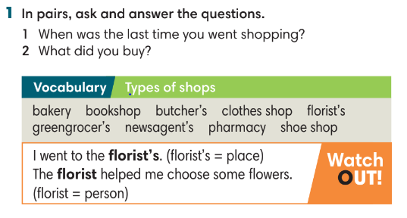
3. PRESENTATION 2 (7’)
ACTIVITIES 4 & 5:
* Aims:
- To study the Vocabulary box
* Content: label the shops, study word friends.
* Outcome: understand types of shops.
* Organisation: T-Ss, Ss-T, Pair work
Teacher’s & Student’s activities | Content
Activity 4: Exercise 2 (SBp71)  In pairs, use the words in the Vocabulary box to label the shops A-I in the picture. Use the clues below.  - T asks students to look at the pictures on page 71.  - T asks Ss to work in pairs and match shop with pictures and provide reasons for their answers. | Answer keys:    - T checks and provides meaning of all words.  - T asks Ss to read all the words and correct pronunciation.
Activity 5: Exercise 3 – SB p.71  Match the shops on the left with the items on the right.  - Ss work individually to finish Exercise 3.  - T check students answer. | Answer keys:    - T encourage Ss to list more items they can buy at these shops.
4. PRACTICE (7’)
ACTIVITY 6:
* Aims:
- To provide more words related to the topic
- To help Ss use the new vocabulary in collocations.
* Content: listen to a shopping list.
* Outcome: Ss know the types of shops and shopping list.
* Organisation: T-Ss, Ss-T, Individual work.
Teacher’s & Student’s activities | Content
Activity 5: Exercise 4 – SB p.71  Listen and complete Jas’s shopping list. What did he forget to buy?  - T reminds Ss about the difference of countable and uncountable nouns, quantifiers: a glass/ carton of milk, a loaf of bread.  - T asks some Ss to provide more examples of food and quantifiers.  - Before listening, T asks Ss to guess the answer.  - T plays the recording for Ss to check the answers. | Answer keys:  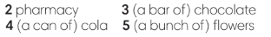  - T plays the recording again. Ss listen to find out what Jas forgot to buy and how they solved it.
5. PRODUCTION (10’)
ACTIVITY 6 + 7:
* Aims: To help Ss practice applying the vocabulary items and grammar points related to the topic in speaking.
* Content: Ss work in pairs to talk about their favourite shops.
* Outcome: Ss talk about their favourite shops using vocabulary and grammar points.
* Organisation: T-Ss, Ss-T
Teacher’s & Student’s activities | Content
Activity 6: Exercise 5 – SB p.71  Work in pairs. Ask and answer about your favorite shop. Use the following questions:  - T asks Ss to look at Exercise 5 (SB page 71).  - T calls a student to read the instruction then checks Ss’ understanding of it.  - Ss work in pairs to ask and answer all questions.  - T walks around the class and provides feedback.  - T invites some volunteers to provide answers in front of the class.  Activity 7: Interview  - T set a time limit of 2 minutes. Ss interview each other and note down all information that they have.  - After 2 minutes, T checks to find which Ss interview most partner and correct information. | 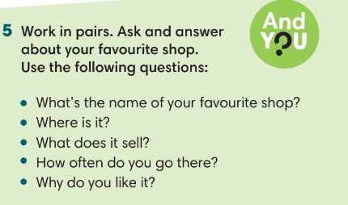

WRAP-UP & HOME WORK (3’)

- T asks Ss to talk about what they have learnt in the lesson.
- Vocabulary of shop.
- Grammar points: Items at the shops and quantifiers.
* HOME WORK
--Do exercises in the workbook page 60.
- Prepare for Lesson 2: Grammar 1.

Date of planning:15/3/2023  Date of teaching: 18/3/2023 | UNIT 7: SHOPPING AROUND  Period 23: Grammar 1
I. OBJECTIVES:
By the end of the lesson, Ss will be able to:
1. Knowledge:
* Grammar:
-Identify and understand how to use although, despite and in spite of.
-Use although, despite and in spite of to talk about shopping habits.

2. Competence:
- General competences: form and / or improve such competencies as group work, independent working, pair work, linguistic competence, and cooperative learning.
- Specific competences:
- Improve communicative competence related to the use of language (vocabulary, phonetics, grammar):
- For a language lesson: Ss are expected to use vocabulary about types of shops and understand the main grammatical points, then do the tasks assigned in the textbook.
For a skills lesson: Ss are expected to use although, despite and in spite of to talk about shopping habits.
3. Quality / behavior:
- Being hard-working and attentive in class.
- Have a positive attitude towards the lesson.

II. TEACHING AIDS:
- Grade 7 textbook, Unit 7 (SB p. 72)
- Computer (connected to the Internet is the best)
- Projector / TV/ PPT slides / Active teach
Language analysis
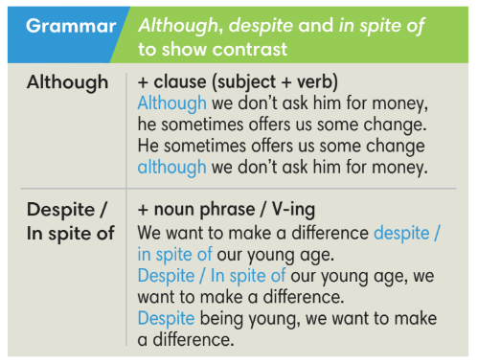
Assumptions
Anticipated difficulties | Solutions
1. Ss may not use although, despite and in spite of incorrectly. | Remind them regularly during the time of the lesson  Place a note on the board for Ss to see.  Give clear examples
2. Ss may not have sufficient speaking and co-operating skills. | Give clear instructions, give examples before letting Ss work in groups.  Provide feedback and help if necessary.

III. PROCEDURE:

1. WARM UP (5’)
* Aims:
- To activate students’ prior knowledge and get students involved in the lesson.
- To set the context for introducing new structures.
* Content: Play game to get Ss involved in the lesson and to set the context for the lesson.
* Outcome: Ss know the context of the lesson.
* Organisation: T-Ss, Ss-T
Teacher’s and Student’s activities | Content
Activity 1: Game  - T divides Ss into 2 teams:  - Ss receive types of shops from T.  - T sets the scene for the new lesson: T tells Ss that they are going to learn how to use although, despite and in spite of to talk about shopping habits.  - T writes the title on the board: Unit 7: Shopping around  Lesson 7.2: Grammar | Game rules:  - 2 minutes to list all items that Ss can buy from the shop.  - 1 correct answer = 1 point.
2. LEAD-IN (6’)
* Aims: To lead into the text.
* Content: Ss look and describe pictures.
* Outcome: Ss answer given questions.
* Organisation : T-Ss, Ss-T.
Teacher’s and Student’s activities | Content
Activity 2: Exercise 1 – SB p.72  Work in pairs. Look at the pictures. Which one is your favorite place to buy flowers?  - T asks Ss look at 2 pictures and find the difference of these places.  - Ss work in pairs to discuss which is their favorite place to buy flowers.  - T conducts a quick class vote and asks Ss to provide the reasons for their choices. | 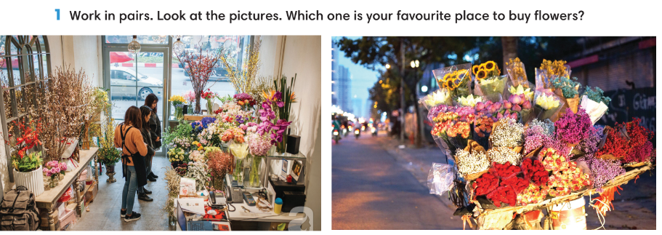
3. PRESENTATION (13’)
ACTIVITIES 3 + 4:
* Aims:
- To present the grammar point in context.
- To lead into the next activity.
- To introduce the Grammar Box
- To provide Ss with chances to work cooperatively.
- To explain the grammar point for Ss
* Content:
- Ss read a text using although and despite.
- Ss study the Grammar Box to complete the exercise.
* Outcome: Ss learn about school rules and can use although and despite in contexts.
* Organisation: T-Ss, Ss-T, Group work.
Teacher’s Student’s activities |  |  | Content
Activity 3: Exercise 2 – SB p.72  Read the text below. Underline although and despite. Answer the questions below.  - T asks Ss to read the text, list all new words and answer the questions. |  |  | Answer keys:  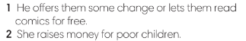  - Ss underline although, despite in the text, try to guess the difference and meaning.  - T checks Ss answer, explains all new words and summarize the difference between although, despite.
Activity 4: Exercise 3 – SB p72.  Study the Grammar box. Complete the sentences below, using although and despite/ in spite of.  STEP 1: Introduce the Grammar Box  - T goes through the Grammar Box with Ss  - T reminds students that although is followed by a clause whereas despite and in spite of are followed by a noun phrase, pronoun or V-ing.  - T provides at least 1 example for each word and then ask some Ss to make sentences.  STEP 2: Exercise 3  - T asks Ss to look at exercise 3.  - T calls a student to read the instruction then checks Ss’ understanding of it.  - T asks Ss to finish Exercise 3 individually and then check in pairs.  - T checks Ss answers. |  |  | Answer keys:  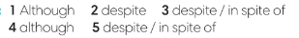
5. PRACTICE (11’)
ACTIVITIES 5 and 6:
* Aim:
- To help Ss understand the difference between although and despite/ in spite of.
- To provide Ss grammar exercises to practice
* Content:
- Ss write sentences with although and despite/ in spite of.
* Outcome: Ss know how to use although and despite/ in spite of in sentences.
* Organisation : T-Ss, Ss-T, Pair work, Ss-Ss
Teacher’s and Student’s activities |  |  |  | Content
Activity 5: Exercise 4 – SB p.72  In pairs, use your own ideas to complete the following sentences.  - T asks Ss to look at exercise 4.  - T calls a student to read the instruction then checks Ss’ understanding of it.  - Ss work in pairs to finish Exercise 4 and then share answers with other pairs.  - T check Ss answers and correct if needed. |  |  |  | 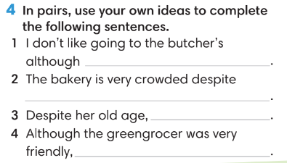
Activity 6: Game
- T divides the class into 4 groups and set time limit of 2 minutes for preparation.
- Each team makes clauses for other team to finish the sentence using although, despite and in spite of.
- After getting the clause, each team has 10 seconds to finish the sentence.
- 1 correct answer = 1 point.
6. PRODUCTION ( 7’)
ACTIVITY 7:
*Aim: To help students applying the vocabulary items and grammar points related to the topic in communicating.
* Content: Ss discuss shopping habits.
* Outcome: Ss talk about shopping habits using although, despite and in spite of.
* Organisation: T-Ss, Ss-Ss, Ss-T, Pair work
Teacher’s Student’s activities |  | Content
Activity 7: Exercise 5 – SB p.72  In groups of four, talk about the shopping habits of your family. Use although and despite.  - T asks Ss to look at exercise 5 (SB page 72).  - T calls a student to read the instruction and example then checks Ss’ understanding of it.  - T models the activity in front of the class.  - T asks Ss to work in groups of 4 to finish Exercise 5.  - T walk around to listen and notes down common mistakes for delayed feedback.  - T calls some groups to come to the front of the class, make conversations.  - T asks the rest to give comments on their classmates’ performance.  - T gives feedback on Ss’ work. |  | 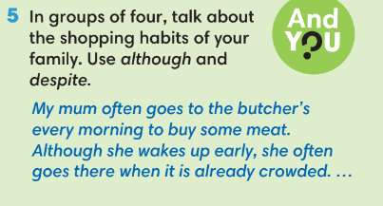
WRAP-UP & HOME WORK (3’)
- T asks Ss to talk about what they have learnt in the lesson.
- Although, despite, in spite of
* HOME WORK
- Do exercises in the workbook page 61.
- Prepare for Lesson 7.3: Reading.

Date of planning:19/3/2023  Date of teaching: 20/3/2023 | UNIT 7: SHOPPING AROUND  Period 24: Reading and Vocabulary
I. OBJECTIVES:
By the end of the lesson, Ss will be able to:
- locate information and find specific details in a text (scanning skill).
- identify the main ideas of the paragraphs in the text or the text itself (skimming).
1. Knowledge:
* Vocabulary: - an understanding of the vocabulary about markets in Vietnam.

New words | Vietnamese meaning
crowds of tourists | đám đông du khách
overlook | nhìn từ trên cao xuống
catalogue | catalog_danh mục
reasonable price | giá cả hợp lý

* Grammar:
- Reading skills: - Identify specific details about shopping in Hội An, Việt Nam.
2. Competence:
- General competences: form and / or improve such competencies as group work, independent working, pair work, linguistic competence, and cooperative learning.
- Specific competences:
- Improve communicative competence related to the use of language (vocabulary, phonetics, grammar):
- For a language lesson: Ss are expected to know the meaning of the keywords used to talk about school system in Vietnam.
- For a skills lesson:
- Ss are expected to locate information and find specific details in a text (scanning skill).
- Ss are expected to identify the main ideas of the paragraphs
3. Quality/behavior:
- Being hard-working and attentive in class
- Have a positive attitude towards the lesson
- Know more and respect the family time together.

II. TEACHING AIDS:
- Grade 7 textbook, Unit 7 (SB p.73, WB p.62).
- Computer (connected to the Internet is the best)
- Projector / TV/ PPT slides / Active teach
Assumptions
Anticipated difficulties | Solutions
1. Ss may pronounce the new words incorrectly. | Reinforce the pronunciation of the new words while presenting and practicing.
2. Ss may not have sufficient speaking and co-operating skills. | Give clear instructions, give examples before letting Ss work in pairs / groups.  Provide feedback and help if necessary.
3. Ss may not know how to scan for information. | Guide Ss to underline keywords in the question before finding them in the text.

III. PROCEDURE:
1. WARM-UP (5’)
* Aim:
- To help Ss review grammar they have learnt.
- To lead into the next activity.
* Content: Game: Lucky number (about although, despite, in spite of)
* Outcome: Ss recall the modal verbs from previous lesson.
* Organisation: T-Ss, Ss-T.
Teacher’s & Student’s activities | Content
Activity 1: Lucky number  - T explains the game rules then checks instructions.  - T uses slide to lead the game.  - Ss raise their hands if they have the answer.  - T tells students that they are going to read about shopping in Hoi An, Vietnam.  - T writes the title for the new lesson:  Unit 7/Lesson 3: Reading and vocabulary. | Game rules:  - T shows key words on the slide.  - Ss make sentences using although, despite, in spite of.  - Choose randomly one number (1-9) to see your score
2. PRE-READING (5’)
ACTIVITY 2:
* Aim:
- To activate Ss’ background knowledge of the topic.
* Content: Ss describe photos.
* Outcome: Ss provide simple facts about Hội An, Việt Nam.
* Organisation: T-Ss, Ss-T, Pair work.
Teacher’s & Student’s activities |  | Content
Activity 2: Exercise 1 – SB p.73  In pairs, look at the photos. What do you know about this place?  - T shows the pictures on slide and ask Ss to describe what they can see and guess the name of this place.  - Ss work in groups to discuss the questions.  - T collects Ss answer and check. |  | 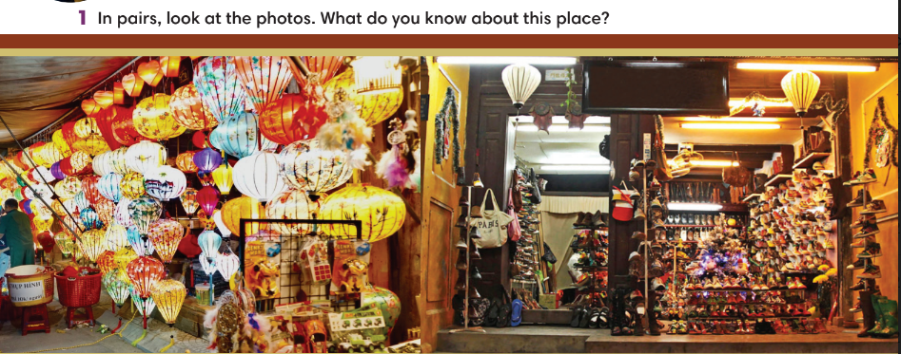
3. WHILE-READING (15’)
ACTIVITY 3 + 4:
*Aim:
- To read two texts and do reading tasks.
- To help students practice finding main ideas of the text.
- To help students practice reading for specific information in a text.
* Content: Ss read the texts and answer the questions.
* Outcome: Ss can identify specific information in the texts and learn more about Hội An, Việt Nam.
* Organisation: T-Ss, Ss-T.
Activity 3: Exercise 2 – SB p.73  Read the text. Where most likely can you find the information in the text?  - T asks some Ss to read the text out loud to check pronunciation.  - T lists all new words and provide the meaning.  - T asks Ss to look at Exercise 2 (SB page 73).  - T explain to Ss that they need to do skimming and find main ideas.  - T set time limit for Ss to find main ideas and finish exercise 2.  - T asks Ss to check answers with partner before checking with the whole class and explain reasons for their answers. |  | Answer keys:  
Activity 4: Exercise 3 – SB p.73  Read the text and write N for the night market and S for the shoe shop or B for both places.  Step 1: Scanning  - T asks Ss to read the text again, underline key information and try to remember.  - T set time limitation such as 3 minutes.  - T asks Ss to close the book and answer some questions about the text basing on memory.  1. How big is Hội An market?  2. Which river is mentioned in the text?  3. What can you see at night?  4. What can you buy at Hội An shoe shop?  5. When can you get 100% money back?  Step 2: Exercise 3  - T asks Ss to look at exercise 3 (SB page 73).  - T tells student to read the text again individually to  complete Exercise 3.  - T asks students to underline the evidence for their answers. |  | 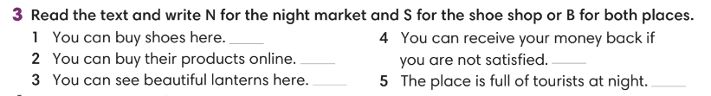  Answer keys:
4. POST-READING (17’)
ACTIVITIES 5 + 6 +7:
* Aim:
- To study the Vocabulary.
- To review new words from the text.
* Content:
- Complete the sentences using given words.
- Play Game: Hot seat.
- Describe one shop/ market.
* Outcome: Ss can understand the new words and talk about shop/ market.
* Organisation: T-Ss, Ss-T, Ss-Ss, Group work, Pair work.
Activity 5: Exercise 4 – SB p.73  Choose the words from the text to complete the sentences. Make changes to the words if necessary?  - T asks Ss to work in pairs, find these phrases in the text and explain the meaning.  - T asks Ss to work individually to finish Exercise 4 and then check Ss answers. |  | Answer keys:  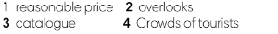
Activity 6: Hot seat game  - T tells Ss that they are play a game to remember new words from the text.  - T tells the game rules. |  | Game rules:  - T divides the class into 2 teams, each turn needs 2 representatives.  - T gives one new word (from the text).  - 2 representatives need to guess the word.  - 1 correct answer = 1 point.
Activity 7: Exercise 5 – SB p.73  Work in groups. Describe one shop or one market in your hometown. The present to the class.  - T asks Ss to look at exercise 5 (SB page 73).  - T calls a student to read the instruction then checks Ss’ understanding of it.  - T provides one example for Ss to understand.  - Ss work in groups of 4.  - T invites some volunteers to present in front of the class and notes down useful or interesting sentences.  - T asks the rest to give comments on their classmates’ performance and then provides teacher’s feedback. |  | 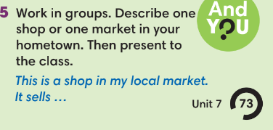
WRAP-UP & HOME WORK (3’)
- T asks Ss to talk about what they have learnt in the lesson.
- Identify specific details about shopping in Hội An, Việt Nam
- Group discussion
* HOME WORK
- Do exercises in the workbook page 62.
- Prepare for Lesson 7.4: Grammar 2.

====================

Date of planning:19/3/2023  Date of teaching: 23/3/2023 | UNIT 7: SHOPPING AROUND  Period 25: Grammar 2
I. OBJECTIVES:
By the end of the lesson, Ss will be able to:
- Use “be going to” and Present Continuous to talk about intentions and arrangements.
1. Knowledge:
* Vocabulary:
* Grammar:
- Use “be going to” and Present Continuous to talk about intentions and arrangements.
2. Competence:
- General competences: form and / or improve such competencies as group work, independent working, pair work, linguistic competence, and cooperative learning.
- Specific competences:
- Improve communicative competence related to the use of language (vocabulary, phonetics, grammar):
- For a language lesson: Ss are expected to use “be going to” and Present Continuous to talk about intentions and arrangements.
For a skills lesson: Ss are expected to use “be going to” and Present Continuous to talk about intentions and arrangements.
3. Quality/ behavior:
- Being hard-working and attentive in class.
- Have a positive attitude towards the lesson.

II. TEACHING AIDS:
- Grade 7 textbook, Unit 7 (SB p. 74)
- Computer (connected to the Internet is the best)
- Projector / TV/ PPT slides / Active teach
Language analysis
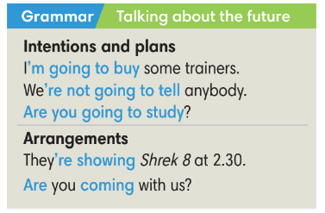
Assumptions
Anticipated difficulties | Solutions
1. Ss may use “be going to” and Present Continuous incorrectly. | Remind students the difference of “be going to” and Present Continuous.  Provide activities for practice.
2. Ss may not have sufficient speaking and co-operating skills. | Give clear instructions, give examples before letting Ss work in pairs / groups.  Provide feedback and help if necessary.

III. PROCEDURE:

1. WARM UP (5’)
* Aim:
- To create a positive classroom atmosphere to start a new lesson.
- To review the previous lesson.
* Content: Game (shop/ market)
* Outcome: Ss review vocabulary about shop and market.
* Organisation: T-Ss, Ss-T.
Teacher’s & Student’s activities |  | Content
Activity 1: Game  - T explains the game rules then checks instructions.  - T divides Ss into 4 groups. Time limitation is 2 minutes.  - T tells Ss that, today they will learn about “be going to” and Present Continuous to talk about intentions and arrangements. |  | Game rules:  - 4 groups note down all sentences to describe one shop or one market.  - 1 correct answer = 1 point.  - T corrects Ss if necessary.
2. LEAD-IN (4’)
*Aim:
- To lead into the new lesson.
* Content: Ss list activities they will do next week.
* Outcome: Ss prepare for the new lesson about intentions and arrangements.
* Organisation: T-Ss, Ss-T.
Teacher’s & Student’s activities | Content
Activity 2:
- T asks Ss to list activities they will do next week.
- T divides the board into 2 to record all answers for following activities.
3. PRESENTATION (13’)
ACTIVITY 3 + 4:
*Aim:
- To present the grammar point in context.
- To lead into the next activity.
- To introduce the Grammar Notes and explain grammar points.
* Content:
- Ss listen to a dialogue.
- Ss study the Grammar box to learn how to use “be going to” and Present Continuous to talk about intentions and arrangements.
* Outcome: Ss understand how to use “be going to” and Present Continuous to talk about intentions and arrangements.
* Organisation: T-Ss, Ss-T,
Teacher’s & Student’s activities | Content
Activity 3: Exercise 1 - SB p74  Listen. Tick () the activities Nam and Mai plan to do on Saturday.  - T asks Ss to look, describe the picture and then guess what they are talking about.  - Ss read all activities in Exercise 1, guess the answer.  - T plays the audio, Ss listen and finish Exercise 1.  - T check Ss answers. | Answer keys:  - T plays the audio again. Ss listen and say “stop” when they hear the evidence from the recording.
Activity 4: Exercise 2 - SB p74  Find more examples of be going to and Present Continuous in the voicemail message.  - T asks Ss to look at the Grammar Box in SB p.74 and explain the usage of “be going to” and Present Continuous to talk about the future. | 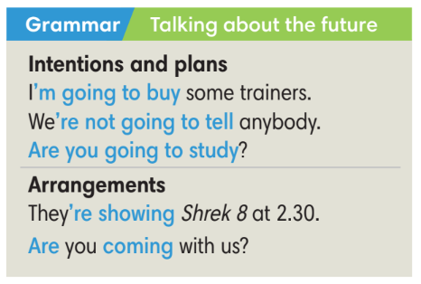  - T asks Ss to read the text again and underline be going to and Present Continuous to finish exercise 2.  - T checks Ss answers.
4. PRACTICE (15’)
ACTIVITIES 5 + 6 + 7:
* Aims:
- To provide Ss with language notes.
- To help Ss practice making sentences using be going to and Present Continuous.
- To help Ss practice new grammar points in context.
- To practice solving some types of grammar exercises.
* Content:
- Ss study the Language notes.
- Ss use be going to and Present Continuous to make sentences.
- Play Game: Hot potato (practice using be going to and Present Continuous.).
* Outcome: Ss can use be going to and Present Continuous correctly to make sentences.
* Organisation: T-Ss, Ss-T, Ss-Ss.
Teacher’s & Student’s activities | Content
Activity 5: Language notes
- T shows language notes on the slide.
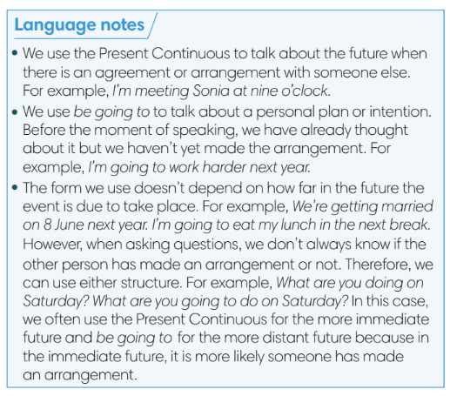
- T asks Ss to provide examples using be going to and Present Continuous to talk about the future.
Activity 6: Exercise 3 – SB p. 74  Complete the sentences with be going to and the verbs in brackets. Listen to Mai and Nam and check.  - T asks Ss to read the instructions and checks their understanding.  - Ss work individually to finish exercise 3 and then check in pairs.  - T plays the recording and ask Ss to repeat to check Ss answers and pronunciation. | Answer keys:  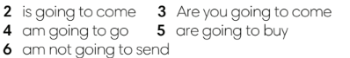
Activity 7: GAME: HOT POTATO  - T explains the game rules then checks instructions. | Game rules:  - The student has the ball needs to make a sentence with be going to or Present Continuous to talk about the future.  - The next student receives the ball and make another sentence.  - 1 correct answer = 1 point.  - T collects Ss answer and checks.
5. Production (5’)
ACTIVITY 8:
* Aims: To help Ss applying the vocabulary items and grammar points related to the topic in communicating.
* Content: Ss ask and answer about intentions and arrangements.
* Outcome: Ss can use be going to and Present Continuous in conversation.
* Organisation: T-Ss, Ss-T, Ss-Ss, Pair work.

Teacher’s & Student’s activities | Content
Activity 8: Exercise 4 – SB p.74  Work in pairs.  - T asks Ss to look at exercise 4 (SB page 74).  - T calls a student to read the instructions.  - T explains to the students that they are going to do the task in pairs.  - T sets time limitation of 3 minutes for Ss to prepare and work in pairs.  - T asks 3 groups to model the activity in front of the class.  - T asks the other students to give comments on their classmates’ performance.  - T asks Ss to line up into 2 lines, facing each other. Ss takes turn to say the sentence to their partner.  - After each 20 seconds, T say “switch”, Ss move one step to change the partner.  - T walks around to note down any mistakes for delayed feedback. | 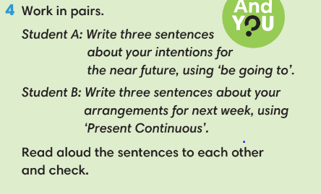
WRAP-UP & HOME WORK (3’)
- T asks Ss to talk about what they have learnt in the lesson.
- Be going to and Present Continuous.

* HOME WORK
- Do exercises in the workbook page 63.
- Prepare for Lesson 7.5: Listening and vocabulary.
Date of planning: 23/3/2023 Date of teaching:27/3/2023 | UNIT 7: SHOPPING AROUND  : Listening and Vocabulary
I. OBJECTIVES:
By the end of the lesson, Ss will be able to:
- identify specific details in a conversation and talk about schools.
1. Knowledge:
* Vocabulary: use vocabulary to talk about money.

New words | Vietnamese meaning
change | tiền lẻ, tiền trả lại
piggy bank | lợn tiết kiệm
pocket money | tiền tiêu vặt
price | giá tiền
purse | ví tiền
sales | giảm giá

* Grammar: give personal opinions about money.
2. Competence: - General competences: form and / or improve such competences as group work, independent working, pair work, linguistic competence, and cooperative learning.
- Specific competences:
- Improve communicative competence related to the use of language (vocabulary, phonetics, grammar):
- For a language lesson: Ss are expected to use words to talk about money, do the tasks assigned in the textbook.
- For a skills lesson: Ss are expected to identify specific details in a conversation and talk about money.

3. Quality / behavior:
- Being hard-working and attentive in class
- Have a positive attitude towards the lesson

II. TEACHING AIDS:
- Grade 7 textbook, Unit 7 (SB p. 75, WB p.64)
- Computer (accessible to the Internet is the best)
- Projector / TV/ PPT slides / Active teach
ASSUMPTIONS
Anticipated difficulties | Solutions
1. Ss may not find the correct details from listening tasks. | Ask students to underline key words.  Play the recoding and ask student to repeat.
2. Ss may not have sufficient speaking and co-operating skills. | Give clear instructions, give examples before letting Ss work in pairs / groups.  Provide feedback and help if necessary.

III. PROCEDURE:
1. WARM UP + LEAD-IN (5’)
* Aims:
- To review grammar points from previous lesson and get students involved in the lesson.
* Content: Ss review how to be going to and Present Continuous to talk about plans and arrangement.
* Outcome: Ss can recall how to use be going to and Present Continuous in sentences
* Organisation: T-Ss, Ss-T.
Teacher’s & Student’s activities | Content
Activity 1: Review grammar be going to and Present Continuous.  - T reminds Ss about the usage of be going to and Present Continuous to talk about plans and arrangement.  - T divides the class into 2 teams.  - T sets the scene for the new lesson: T tells Ss that they are going to learn how to listen for specific details and talk about money.  - T writes the title on the board Unit 7: Shopping around  Lesson 7.5: Listening and Vocabulary | Game rules:  - 1 student from team A makes a sentence bout plans and arrangement then choose randomly 1 student from team B to make another sentence.  - 1 correct answer = 1 point
2. PRE-LISTENING (11’)
ACTIVITY 2+3:
*Aims:
- To lead into the topic.
- To set the scene for the new content and introduce the vocabulary.
* Content: Read a quiz and finish a listening task.
* Outcome: Ss understand the quiz.
* Organisation: T-Ss, Ss-T, Pair work.
Teacher’s & Student’s activities | Content
Activity 2: Exercise 1 – SB p. 75  Listen and find the words and phrases below in the quiz. Then in pairs, complete the sentences.  - T asks Ss to real all words and the quiz.  - T provides the pronunciation and meaning of all words, asks some Ss to say the words in front of the class to check pronunciations.  - T asks questions to help Ss understand the vocabulary better.  + How much money do you have in your piggy bank?  + Do your parents give you pocket money?  + When is the best time for sales?  + Who has a wallet today?  - T plays the audio, Ss listen and work in pairs finish the quiz.  - Ss check the answers in pairs before T check.  Activity 3: Exercise 2 - SB p.75  In pairs, do the quiz. Check your answer on page 101.  - T asks Ss to work in pairs and do the quiz.  - T conduct a quick class vote to see the most common score. | Answer keys:
3. WHILE-LISTENING (13’)
ACTIVITIES 4 and 5:
* Aims:
- To help Ss use new words in a context
- To help Ss identify specific details in a conversation
* Content: Study word friends, listen to a radio phone-in.
* Outcome: Identify specific details in a conversation.
* Organisation: T-Ss, Ss-T, Ss-Ss.
Teacher’s & Student’s activities | Content
Activity 4: Exercise 3 - SB p.75  Complete the sentences with the highlighted verbs in the quiz. Make changes to the form.  - T provides the meaning of all words and give sentences with these words if needed.  - Ss finish Exercise 3 individually. | Answer keys:
Activity 5: Exercise 4 - SB p.75  Listen to a radio phone-in about money. Mark the sentences T (true) and F (false).  - T asks Ss to read instructions and all sentences and then guess the answers.  - T asks Ss to give reasons for their guess.  - T plays the recording, Ss listen and finish Exercise 3. | Answer keys:  - T asks Ss correct all false sentences and repeat the evidence from the audio.
4. POST-LISTENING (13’)
ACTIVITY 6 + 7:
*Aims:
- To reinforce word friends.
- To practice using new words in context
* Content:
- Play Game – Hot seat to review vocabulary.
- Discussion about money.
* Outcome: Can use vocabulary about school activities to talk about schools.
* Organisation: T-Ss, Ss-Ss, Ss-T, Group work.
Teacher’s & Student’s activities | Content
Activity 6: Game: Hot seat  - T divides the class into 2 teams and then explains the rule | Game rules:  - 2 Ss from 2 teams go to the board, back against the board.  - 2 teams get one word from teacher (Vocabulary, Word friend or from listening conversation).  - Each team needs to describe until that student can guess the correct word.  The faster team gets 1 point.
Activity 7: Exercise 5 - SB p.75  In pairs, discuss the sentences from Exercise 3  - T asks Ss to read the instructions and examples.  - Ss work in pairs to discuss sentences from Exercise 3.  - T walks around to provide feedback.  - T go through each sentence and collect Ss answers. | 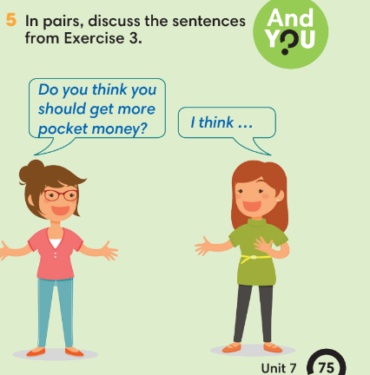
WRAP-UP & HOME WORK ( 3’)

- T asks Ss to talk about what they have learnt in the lesson.
Listen for specific details and talk about money.
* HOME WORK
- Do exercises in the workbook page 64.
- Prepare for Lesson 7.6: Speaking.

Date of planning:27/3/2023  Date of teaching:28/3/2023 | UNIT 7: SHOPPING AROUND  Period 27: Speaking
I. OBJECTIVES:
By the end of the lesson, Ss will be able to:
- use vocabulary and phrases to talk about favorite subjects and activities at school.
1. Knowledge:
* Vocabulary: use the phrases to shop for clothes and other things
* Grammar: make a conversation at clothes shop.
2. Competence:
- General competences: form and / or improve such competences as group work, independent working, pair work, linguistic competence, and cooperative learning.
- Specific competences:
- Improve communicative competence related to the use of language (vocabulary, phonetics, grammar):
- For a language lesson: Ss are expected to use vocabulary and phrases to shop for clothes and other things, do the tasks assigned in the textbook.
- For a skills lesson: Ss are expected to make a conversation at a clothes shop.

3. Quality/behavior:
- Being hard-working and attentive in class
- Have a positive attitude towards the lesson
II. TEACHING AIDS:
- Grade 7 textbook, Unit 7 (SB p. 76, WB p.65)
- Computer (accessible to the Internet is the best)
- Projector / TV/ PPT slides / Active teach
LANGUAGE ANALYSIS
Vocabulary: Vocabulary at clothes shop.
Expressions:
- Shop for clothes and other things: Use a Speaking Box

ASSUMPTIONS
Anticipated difficulties | Solutions
1. Ss may use the structures while speaking incorrectly. | Keep the useful expressions on the board for reference.  Encourage peer-check.
2. Ss may not have sufficient speaking and co-operating skills. | Give clear instructions, give examples before letting Ss work in pairs / groups.  Provide feedback and help if necessary.

III. PROCEDURE:
1. WARM UP + LEAD-IN (5’)
* Aim:
- To create a positive classroom atmosphere to start a new lesson.
- To review words of clothes and other things.
- To lead into the topic.
* Content: Game (clothes and accessories)
* Outcome: Ss review vocabulary about school activities.
* Organization of implementation: T-Ss, Ss-Ss, Ss-T.
Teacher’s & Student’s activities |  | Content
Activity 1: Game  - T divides Ss into 4 teams.  - T gives the topic is clothes and accessories.  - When Ss finish the game, T tells Ss that, they are using the vocabulary to do some speaking tasks today.  - T writes the title of new lesson: Unit 7/ Lesson 7 - Speaking |  | Game rules:  - Time limitation: 1 minute for preparation and 3 minutes for writing.  - Ss take turns to write all clothes and accessories.  - 1 correct answer = 1 point.
2. PRE-SPEAKING (6’)
ACTIVITY 2:
* Aims:
- To activate Ss’ prior knowledge of the topic.
- To lead into the topic.
* Content:
- Listen to the dialogue and answer the questions.
* Outcome: Ss understand how to use the model questions and answers to talk about clothes and other things.
* Organisation: T-Ss, Ss-T, Pair work.
Teacher’s & Student’s activities |  |  | Content
Activity 2: Exercise 1 – SB p.76  Is Nam going to buy the red trainers? Listen and check.  - T shows pictures in SB p.76 on the slide.  - Ss work in pairs to describe them.  - T asks Ss answers from a few volunteers.  - T encourages Ss to guess Nam is going to buy the trainers or not and give reasons for their answers.  - T plays the audio for Ss to listen, note down any new words and details.  - Ss check their guess.  - T asks further questions relating to the audio.  + How much are the trainers?  + What size is Nam?  + Are the trainers fit?  - Ss work in pairs to role play the dialogue.  - T invites 2 groups to model in front of the class.  - Ss underline evidence from the dialogue and useful vocabulary/ structures that they can use later. |  |  | Answer keys:
3. WHILE-SPEAKING (24’)
ACTIVITIES 3, 4, 5, 6:
* Aims:
- To introduce the Speaking Box.
- To reinforce the expressions of shopping for clothes.
- To practice using the new expressions in contexts.
* Content:
- Study the Speaking box and find similar questions in the dialogue.
- Complete the dialogue.
* Outcome: Ss understand the dialogue about shopping.
* Organisation: T-Ss, Ss-T, Individual work.
Teacher’s & Student’s activities |  |  |  | Content
Activity 3: Exercise 2 – SB p. 76  In pairs, underline eight phrases that are in the dialogue.  - T goes through the Speaking box and asks students to find three similar questions in the dialogue.  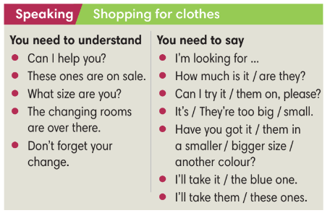  - When they have finished, T asks them to work in pairs to create a short conversation using these phrases.  - T invites different pairs to act out their dialogues in front of the class and the provide feedback. |  |  |  | Answer keys:  
Activity 4: Exercise 3 - SB p.76  Complete the dialogue with the phrases from the Speaking box. Listen and check.  - T asks Ss finish the dialogue and then check answers in pairs.  - T asks some pairs to read out loud in front of the class and other Ss give the comments.  - T plays the audio for students to check. |  |  |  | Answer keys:
Activity 5: Exercise 4 - SB p.76  Complete the sentences with one and ones.  - T asks Ss to look at the dialogue in Exercise 1 and 3 and explain the difference usage of one and ones.  - T asks Ss to finish Exercise 4.  Activity 6: Game  - T divides the class into 2 groups.  - Each team has 1 minute for preparation to write sentences describing the classroom.  - After 1 minutes, 1 representative from each team write all sentences on the board. The other team needs to write the follow-up sentence using one or ones.  Team A: This table is yellow.  Team B: But this one is black. |  |  |  | Answer keys:  - Each team has 1 minute for preparation to write sentences describing the classroom.  - After 1 minutes, 1 representative from each team write all sentences on the board. The other team needs to write the follow-up sentence using one or ones.  Team A: This table is yellow.  Team B: But this one is black.
4. POST-SPEAKING ( 8’)
ACTIVITY 7:
- *Aims: To help students applying the new language and skills related to the topic in communicating.
* Content: In pair, Ss make a conversation.
* Outcome: Ss can know how to buy and sell things.
* Organisation: T-Ss, Ss-Ss.
Teacher’s & Student’s activities | Content
Activity 7: Exercise 5 - SB p.76  In pairs, imagine you buy and sell things below, Student A is the customer, Student B is the shop assistant. Then change roles. Use the Speaking box to help you.  - T asks Ss to work in pairs for discussion.  - T invites 2 random students to make a conversation in front of the class. Other Ss listen and provide feedback.  - T tells students to look at the speaking box in their student book again and work in groups to prepare for the task.  - T set time for Ss to prepare and practice speaking.  - T walk around the class to listen and provide feedback.  - T asks 5 groups to practice the conversation in front of the class. | 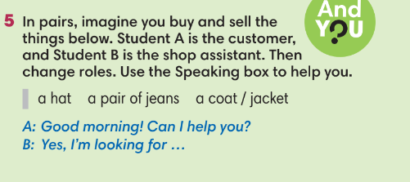
WRAP-UP & HOME WORK (3’)
- T asks Ss to talk about what they have learnt in the lesson.
- Shop for clothes and other things.
* HOME WORK
- Do exercises in the workbook page 65.
- Prepare for Lesson 7.7: Writing.

=====================

Date of planning: 27/3/2023  Date of teaching: 29/3/2023 | UNIT 7: SHOPPING AROUND  Period 28: English in use
I. OBJECTIVES:
By the end of the lesson, Ss are able to:
- use conjunctions and time expressions to write a paragraph about what activities you like or do not like at school.
1. Knowledge:
* Vocabulary: : use vocabulary and structures to write notes (making arrangements).
* Grammar: sentences to make arrangements.
2. Competence:
- General competences: form and / or improve such competences as group work, independent working, pair work, linguistic competence, and cooperative learning.
- Specific competences:
- Improve communicative competence related to the use of language (vocabulary, phonetics, grammar):
- For a language lesson: Ss are expected to use vocabulary of food, quantifiers and do the tasks assigned in the textbook.
For a skills lesson: Ss are expected to write an email of invitation.
3. Quality/behavior:
- Being hard-working and attentive in class
- Have a positive attitude towards the lesson
II. TEACHING AIDS:
- Grade 7 textbook, Unit 7 (SB p. 77)
- Computer connected to the Internet
- Projector / TV/ PPT slides / Active teach
Language analysis
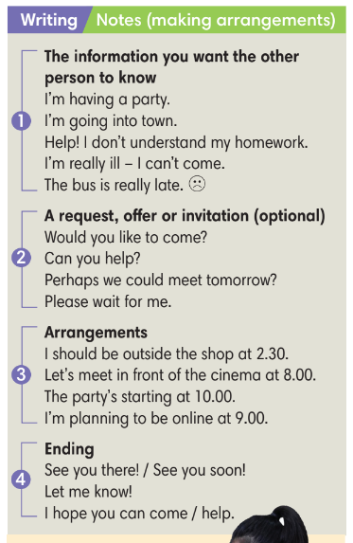

Assumptions
Anticipated difficulties | Solutions
1. Ss may write the structures incorrectly. | Keep the useful expressions on the board for reference.  Encourage peer-check.
2. Ss may not have sufficient speaking and co-operating skills. | Give clear instructions, give examples before letting Ss work in pairs / groups.  Provide feedback and help if necessary.
3. Ss may not use the wrong form of verb. | Remind Ss to use Present Continuous to make arrangements.

III. PROCEDURE:
1. WARM UP (5’)
* Aims:
- To create a positive classroom atmosphere to start a new lesson.
- To lead in to the sample writing.
* Content: Make a conversation.
* Outcome: Ss understand the background of the lesson.
* Organization of implementation: T-Ss, Ss-T, Ss-Ss
Teacher’s & Student’s activities | Content
Activity 1:
- T randomly divide SS into groups of 3. 1 is customer, 1 is shop assistant and the other is customer’s friend.
- The context is shopping and 3 Ss need to make a conversation using vocabulary and phrases from previous lessons.
- T invites some groups to act in front of the class and provide feedback.
- T tell Ss that they are learning how to write notes to make arrangements and writes the title on the board.
Unit 7: Shopping around.
Lesson 7.7: Writing.
2. LEAD-IN (5’)
* Aims:
- To get students to think about the topic.
- To provide Ss with reasons for reading the sample writing in exercise 1 (SB p.77).
* Content: choose the best format for a message.
* Outcome: know which type should be used for a message.
* Organisation: T-Ss, Ss-T, Pair work.
Teacher’s & Student’s activities | Content
Activity 2: Exercise 1 – SB p.77  Work in pairs. Choose the best format a-d for your messages in situation 1-4.  - Before doing Exercise 1, T asks Ss some questions to lead in.  + When do we need to leave notes/ messages?  + Have you ever left/ received notes/ messages?  + What was it about?  - T asks Ss to read instructions and then finish Exercise 1 in pairs.  - T sets a time limit for Ss’ quick discussion. | Answer key:
3. PRESENTATION (16’)
ACTIVITIES 3 + 4 +5:
Aim:
- To activate Ss’ prior knowledge of the topic.
- To lead in to the next activitiy.
- To study the structure of a note
- To help Ss focus on detailed information while reading the sample.
- To provide Ss an example of how to reply to a message.
* Content: Read the dialogue and do the tasks.
* Outcome: Understand the structure of messages to make arrangement.
* Organisation: T-Ss, Ss-T, Individual work.
Teacher’s & Student’s activities | Content
Activity 3: Exercise 2 – SB p.77  Read two messages from Mai. Which one includes an invitation? Which one only gives information?  - T calls a student to read the instruction then checks Ss’ understanding of it.  - T asks Ss finish Exercise 2 and then check Ss answers.  - Ss need to give evidence for their answers. | Answer keys:  
Activity 4: Exercise 3 – SB p.77  Underline the phrases in the Writing box which are in Mai’s message.  - T asks Ss to look at exercise 3.  - T calls a student to read the instruction then checks Ss’ understanding of it.  - T go through both messages with the Ss and find out the purpose of each phrases.  - Ss finish Exercise 3 individually.  Activity 5: Exercise 4 – SB p.77  Read two messages from Linh. Which message is a reply to Mai’s invitation? What surprise are Mai’s friends planning for her?  - T asks Ss to read instructions and check their understanding.  - T asks Ss to finish Exercise 4 individually. | Answer keys:  Answer key:
4. PRACTICE (10’)
ACTIVITIES 6 + 7:
Aims:
- To provide students task to apply useful expressions from Writing Box in writing notes.
* Content: Use given sentences to make arrangements.
* Outcome: Write notes to make arrangements.
* Organisation: T-Ss, Ss-T, Group work, Individual work.
Teacher’s & Student’s activities | Content
Activity 6: Game
- T divides the class into 4 groups. Ss takes turn to write a note using phrases from the Writing Box.
- After finishing, T collects Ss notes and votes for the best work.

Activity 7: Exercise 5 – SB p.77  Write a note to your friend.  - T calls a student to read the instructions then checks Ss’ understanding of it.  - T sets a time limit for the task and walk around as a monitor while Ss are writing. | 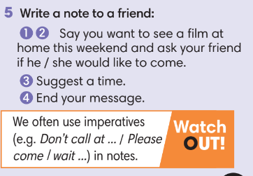
5. POST WRITTING (7’)
ACTIVITY 8:
*Aims:
- To let Ss do peer-check.
- To give general comments on Ss’ writing pieces.
* Content: Ss check in pairs.
* Outcome: Ss can write a message and provide feedbacks.
* Organisation: T-Ss, Ss-Ss.

Teacher’s & Student’s activities | Content
Activity 8: In pairs, swap your writing then check.
- After writing, Ss swap the note for cross check and then each student writes a note to reply to the friend’s note.
- T asks Ss to write 2 notes to reply (1 agree and 1 disagree and then suggest another time).
- T asks Ss pairs to read in front of the class to check and provide feedbacks.
WRAP-UP & HOME WORK (3’)
T asks Ss to talk about what they have learnt in the lesson.
- A note and a message to make arrangements.
* HOME WORK:
- Do exercises in the workbook page 66.
- Prepare for Lesson 7.8

Date of planning:  Date of teaching: | UNIT 7: SHOPPING AROUND  Lesson 8: Vocabulary In Action and Pronunciation
I. OBJECTIVES:
By the end of the lesson, Ss will be able to:
- review vocabulary about school subjects and activities.
- correctly pronounce /ð/ and /θ/.
1. Knowledge:
* Vocabulary: Review vocabulary - types of shops.
* Pronunciation: weak sound /ə/
2. Competence:
- Develop communication skills and creativity
- Be collaborative and supportive in pair work and teamwork
- Develop presentation skill
- Actively join in class activities
3. Quality/behavior:
- Love talking about relating topics to unit 7 and using word friends or phrasal verbs in pair work or group work
- Develop self-study skills
II. TEACHING AIDS:
- Grade 7 textbook, Unit 7 (SB p.78)
- Computer (accessible to the Internet is the best)
- Projector / TV/ PPT slides / Active teach
Assumptions
Anticipated difficulties | Solutions
1. Students may lack experience of group/ teamwork. | Encourage students to work in groups so that they can help each other.
2. Students may not have sufficient listening, speaking and co-operating skills. | - Play the recording, the replay depends on the students’ need and level.  - Encourage students to work in pairs, in groups so that they can help each other.  Provide feedback and help if necessary.

III. PROCEDURE:
1. WARM UP + LEAD-IN (5’)
*Aims:
- To create an active atmosphere in the class before the lesson.
- To lead into the new lesson.
* Content: Game: Hot seat (Unit 7)
* Outcome: Ss can recall the vocabulary of Unit 7.
* Organisation: T-Ss, Ss-Ss.
Teacher’s & Student’s activities | Content
Activity 1: GAME: HOT SEAT  * Teacher asks students to spend 1 minute to quickly review all vocabulary they have learnt in Unit 7 before they play a warm-up game.  - T divides the class into 2 groups.  - T explains the game rules then checks instructions.  - T tells Ss that they can remember better with Glossary Table and asks Ss to open their Student Book page 78 – Exercise 1. | Game rules:  - 2 students from 2 groups go to the board, sit back against the board.  - Teacher writes 1 word on the board.  - Two teams explain the word for their teammate.  - The faster gets 1 point.
2. REVIEW VOCABULARY (27’)
ACTIVITIES 2 + 3 + 4 + 5
*Aims:
- To introduce the glossary and its uses.
- To give further practice in making sentences using the glossary.
- To review vocabulary of Unit 7.
* Content: Revise what they have learnt during the unit, using the Glossary.
* Outcome: Recall the vocabulary of Unit 7 and use them in sentences.
* Organisation: T-Ss, Ss-T, Pair work, Individual work.
Teacher’s & Student’s activities | Content
Activity 2: Exercise 1 – Student Book page 78  Use the Glossary to find:  - Four places where you can keep your money: pocket, ..  - Eight types of shop:  - Two places where you can buy newspapers:  - Teacher introduces the Glossary Table.  - T asks Ss to look at exercise 1 in student book page 78  - T has students use the glossary to find the words which belong to the correct category  - T allows students to peer check first.  - T checks and confirms the answers. | Answer keys:  1. Four places where you can keep your money: purse, wallet, piggy bank.  2. Eight types of shop: bakery, butcher’s, clothes shop, florists’, greengrocer’s, newsagent’s, pharmacy, shopping center.  3. Two places where you can buy newspapers: newsagent’s, shopping center.
Activity 3: Exercise 2 – Student Book page 78  In pairs, complete the words in the text.  - T asks students to complete the sentences with suitable words.  - T asks students check answers in pairs.  - T invites students to share their answers.  - T confirms the correct answers.  Extra-Practice  TIME TO TALK: Use the Glossary to talk about shopping habits.  - Ss work in groups of 4 to discuss their shopping habits including their favorite shops, items and any advice for shopping.  - T asks some groups to share in front of the class to get feedback.. | Answer keys:  1. mistake  2. sales  3. prices  5. changing room  6. present
Activity 4: Exercise 3 – Student Book page 78  Complete the Word Friends in the sentences below. In pair, say if the sentences are true for you.  - T asks Ss to open their SB page 78, look at exercise 3.  - T calls a student to read the instruction then checks Ss’ understanding of it.  - Ss finish Exercise 3 individually.  - T gives students a time limit for Ss discussion.  - For each item, T invites 3 groups to share their ideas.  Activity 5: Game – Hangman.  - T uses the words from the Vocabulary Box.  - T provides the number of letters.  - Ss guess the word by guessing each letter.  - If one letter is wrong, T starts writing the hangman. Game ends when the hangman is done. | 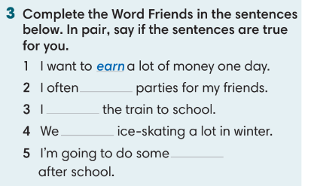
3. PRONUNCIATION (16’)
3.1. Presentation (5’)
ACTIVITY 6
* Aims:
- To learn how to pronounce weak sound /ə/.
* Content: Listen to the words and sort them according to their sounds.
* Outcome: Learn how to pronounce the /ə/ sound.
* Organisation: T-Ss, Ss-T, Ss-Ss.
Teacher’s & Student’s activities | Content
Activity 6: Exercise 4 – Student Book page 78  Listen and underline the words in each phrase with a weak sound /ə/. Listen again and check.  - T calls a student to read the instruction of Exercise 4 then checks Ss’ understanding of it.  - T asks Ss to guess the answer basing on their own pronunciation.  - T plays the audio for Ss to check their guess and finish exercise 4.  - T asks Ss to repeat and corrects Ss pronunciation. | Answer keys:  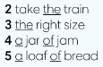
3.2. Practice (11’)
ACTIVITY 7:
* Aims:
-To help students practice the weak sound /ə/.
* Content:
- Play a game to practice listening to the /ə/ sound.
* Outcome: Can identify the /ð/ and /θ/ sounds and pronounce them correctly.
* Organisation: T-Ss, Ss-T, Ss-Ss.
Teacher’s & Student’s activities | Content
Activity 7: Game  - T divides the class into 2 teams.  - Each team has 1 minute for preparation and 3 minutes to write words/ phrases/ sentences with the weak sound /ə/.  - 1 correct answer = 1 point.  - T asks Ss to read in front of the class to check Ss pronunciation. | 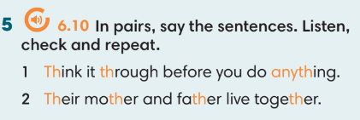
WRAP-UP & HOME WORK (2’)
Teacher asks students to talk about what they have learnt in the lesson.
Use a Glossary to review
weak sound /ə/
* HOME WORK
Find more words which contain the silent letters
Prepare for Unit 7 – Lesson 9: Revision

==================

Date of planning:  Date of teaching: | UNIT 7: SHOPPING AROUND  Lesson 9: Revision
I. OBJECTIVES:
By the end of the lesson, Ss are able to:
1. Knowledge:
* Vocabulary: Review vocabulary and grammar in the unit.
* Grammar: practice writing a note to make arrangements.
2. Competence:
- General competences: form and / or improve such competences as group work, independent working, pair work, linguistic competence, and cooperative learning.
- Specific competences:
- Improve communicative competence related to the use of language (vocabulary, phonetics, grammar)
- For a language lesson: Ss are expected to use vocabulary of the unit, do the tasks assigned in the textbook.
- For a skills lesson: Ss are expected to write a note to make arrangements.

3.Quality/ behavior :
- Being hard-working and attentive in class
- Have a positive attitude towards the lesson
II. TEACHING AIDS:
- Grade 7 textbook, Unit 7 (SB p. 79, WB p.67)
- Computer (accessible to the Internet is the best)
- Projector / TV/ PPT slides / Active teach
Language analysis
Vocabulary: types of shops.
Grammar: “be going to” and Present continuous; although, despite, in spite of.
Assumptions
Anticipated difficulties | Solutions
1. Ss may write the structures incorrectly. | Keep the useful expressions on the board for reference.  Encourage peer-check.
2. Ss may not have sufficient speaking and co-operating skills. | Give clear instructions, give examples before letting Ss work in pairs / groups.  Provide feedback and help if necessary.

III. PROCEDURE:

- WARM-UP (4’)
*Aims:
- To create a positive classroom atmosphere to start a new lesson.
- To lead into the review lesson.
* Content: Game: SUPER EYES
* Outcome: Ss understand that they are going to review Unit 7.
* Organisation: T-Ss, Ss-Ss, Ss-T.
Teacher’s & Student’s activities | Content
Activity 1: SUPER EYES  - Set the scene: T asks students to do quick exercises for eyes such as look up and down, look left and right, row the eyes  - T tells students that they are going to play a game called SUPER EYES  - T explains the game rules then checks instructions  - Teacher uses the slides to show the collages  - Ss join in the game pairs or in small groups.  - Teacher shows the collage again with displayed answers to check for the whole class.  - T tells Ss that they are going to review Unit 7 | Game rules:  - Look carefully at a collage of different small pictures  - The collage will disappear in a few seconds  - Recall as many words about the collage as you can remember.
- REVIEW VOCABULARY (20’)
ACTIVITIES 2, 3, 4, 5, 6:
* Aims:
- To help students reviews topic words and word friends from the unit
- To review vocabulary in contexts.
- To review vocabulary about types of shops.
- To review word friends
* Content: Play a game and do the exercises to revise the vocabulary of Unit 7.
* Outcome: Understand the vocabulary to do the exercises correctly.
* Organisation: T-Ss, Ss-Ss, Ss-T.
Teacher’s & Student’s activities | Content
Activity 2: Game  - T asks Ss to look at vocabulary of types of shops.  - T introduce the game rules | Game rules:  - T writes 2 word on the board.  - 2 Ss from 2 teams go to the board to guess the word by asking questions to their teams (how many letters? Does it sell food? etc.)  - 1 correct answer = 1 point.
Activity 3: Exercise 1 – Student Book page 79  Complete the sentences with one word in each gap.  - T asks Ss to look at exercise 1 in student book page 79.  - T calls a student to read the instruction then checks Ss’ understanding of it.  - T asks Ss to finish Exercise 1 individually and then check in pairs.  - T encourages students to give the reason for their answers.  - T checks as the whole class. | Answer keys:  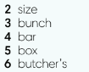
Activity 4: Exercise 2 – Student Book page 79  Complete the definitions with the words given.  - T asks Ss to look at exercise 2 in student book page 79  - T calls a student to read the instruction then checks Ss’ understanding of it.  - T asks Ss to work individually to read then complete the activity.  - T checks as the whole class. | 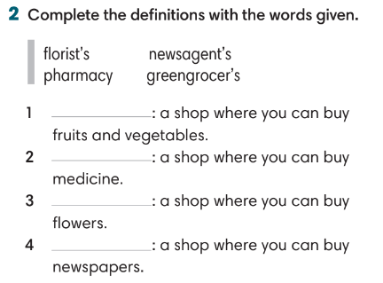
Activity 5: Exercise 3 – Student Book page 79  Choose the correct option. Then in pairs, read the conversation.  - T asks Ss to look at exercise 3 in student book page 79  - T calls a student to read the instruction then checks Ss’ understanding of it.  - T asks Ss to work individually to complete the activity and then check in pairs.  - T asks some pairs to read the conversation in front of the class to check their answers.  Activity 6: Game – Unscramble words.  - T divides the class into 4 teams and explains game rule.  - T prepare a few sentences using word friends in Unit 7. | 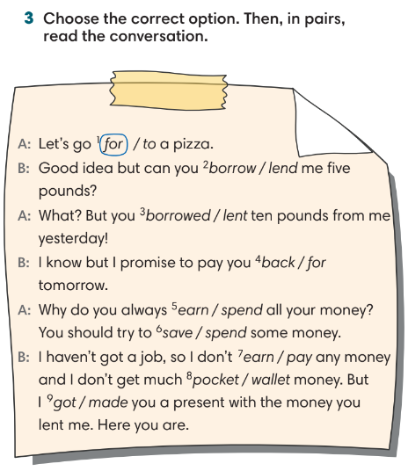  Game rules:  - Ss receive 10 bags with unscramble words of 10 sentences. (Words are written and cut into pieces)  - 1 correct sentence = 1 point.
3. REVIEW GRAMMAR ( 12’)
ACTIVITIES 7 + 8:
*Aims:
- To reinforce the grammar of unit 7: although, despite, in spite of.
- To reinforce the grammar of unit 7: be going to and Present Continuous
* Content: Use although/ despite/ in spite of, be going to and Present Continuous correctly to complete the tasks.
* Outcome: Ss can use although/ despite/ in spite of, be going to and Present Continuous correctly in sentences.
* Organisation: T-Ss, Ss-T, Pair work.
Teacher’s & Student’s activities | Content
Activity 7: Exercise 3 – Student Book page 79  Choose the correct option (A, B, or C)  - T helps Ss to review grammar before doing this task.  - Ss work individually.  - T checks Ss answers. | Answer keys:  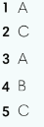
Activity 8: Exercise 4 – Student Book page 79  Choose the correct options  - T asks Ss to look at exercise 4 in student book page 79  - T calls a student to read the instruction then checks Ss’ understanding of it.  - T asks Ss to work individually and then share the answers in pairs.  - T checks as the whole class, asks Ss for the reasons of their answers. | Answer keys:  
Activity 8: Game – Whisper.  - T divides the class into 4 teams and explains game rule.  - T prepare a few sentences with grammar points of Unit 7. | Game rules:  - T gives 1 sentence to 1 student of each team.  - Ss take turn to whisper until the last student of the team get it and write on the board.  - 1 correct sentence = 1 point.
4. WRITING (6’)
ACTIVITY 9:
*Aims:
- To help student practice writing a note
* Content: write a message to make arrangement.
* Outcome: Ss can write a message to make arrangement.
* Organisation: T-Ss, Ss-T, Pair work.
Teacher’s & Student’s activities | Content
Activity 9: Exercise 6 – Student Book page 79  You want to buy a new pair of shoes for your mother this Sunday. Write a note to your close friend to invite him/ her to got to the shopping mall with you. You should write about:  - T asks Ss to look at exercise 6.  - T calls a student to read the instruction then checks Ss’ understanding of it.  - T asks Ss to write a note basing on 3 given ideas.  - T sets time for Ss to write.  - T walks around the class to correct any mistakes if needed.  - Ss check in pairs to find any mistakes.  - T invites some Ss to share their writing and other Ss comment. | 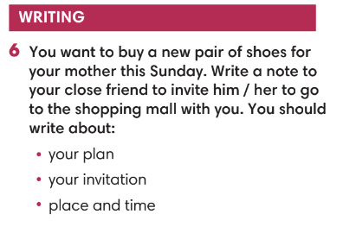
WRAP-UP & HOME WORK (3’)
T asks Ss to talk about what they have learnt in the lesson.
- Review Unit 7 vocabulary and grammar.
- A note of arrangement..
* HOMEWORK
- Do exercises in the workbook page 79
- Prepare for Unit 8 – Lesson 1: Vocabulary

