Date of planning:  Date of teaching: | ENGLISH 7  UNIT 8: FESTIVALS AROUND THE WORLD  Lesson 1: Vocabulary
I. OBJECTIVES:
By the end of the lesson, Ss are able to gain:
1. Knowledge:
* Vocabulary: an understanding of the meaning of keywords below:
Definition | Vietnamese meaning
flowers festival | lễ hội hoa
carnival | lễ hội hóa trang
Halloween | lễ hội Halloween
watch dancers | xem vũ công nhảy
wear colorful costumes | mặc quần áo màu sắc
dress up | thay đồ
sing folk songs | hát nhạc dân gian
hear people cheering | nghe thấy mọi người hò reo
decorate the city | trang trí thành phố
throw water on each other | té nước
eat special foods | ăn các món ăn đặc biêt
return home | trở về nhà

* Grammar:. describe festival activities.
2. Competence:
- General competences: form and / or improve such competencies as group work, independent working, pair work, linguistic competence, and cooperative learning.
- Specific competences:
- Improve communicative competence related to the use of language (vocabulary, phonetics, grammar):
- For a language lesson: Ss are expected to know the meaning of the new words and talk about their favorite food (ingredients, taste).
- For a skills lesson: Ss are expected to use the targeted language to practice talking about their favorite food.

3. Quality/Behavior:
- Being hard-working and attentive in class.
-Being confident when presenting in front of the class.
- Have a positive attitude towards the lesson.
II. TEACHING AIDS:
- Grade 7 textbook, Unit 8 (SB p.80-81, WB p.68-69)
- Computer (connected to the Internet is the best)
- Projector / TV/ PPT slides / Active teach
Assumptions
Anticipated difficulties | Solutions
1Ss may pronounce the new words incorrectly. | Reinforce the pronunciation of the new words while presenting and practicing.
2Ss may not have sufficient speaking and co-operating skills. | Give clear instructions, give examples before letting Ss work in pairs / groups.  Provide feedback and help if necessary.

III. PROCEDURE:
1. WARM UP( 5’)
* Aims:
- To activate Ss’ prior knowledge and get students involved in the lesson.
- To set the context for introducing new words.
* Content: Game – 3 seconds
* Outcome: Ss review cities/ provinces in Vietnam.
* Organisation: T-Ss, Ss-T
Teacher’s & Student’s activities | Content
Activity 1: 3 seconds  - T divides the class into 4 teams, explains the game rules then checks instructions.  - T tells Ss that they are learning about festival around the world.  - T sets the context for the lesson: Write the title on the board Unit 8: Festivals around the world / Lesson 8.1: Vocabulary | Game rules:  - 2 minutes for preparation (list all cities/ provinces in Vietnam that they know)  - Each team takes turn to say one city/ province.  - The team can’t say the word in 3 seconds or repeat the word is out of the game.
2. PRESENTATION 1 (10’)
ACTIVITY 2+3:
* Aims:
- To teach more new words
- To lead in to the next activity.
* Content: Ss learn about festivals around the world.
* Outcome: Ss know festivals around the world.
* Organisation: T-Ss, Ss-T, Pair work,Ss-Ss.

Teacher’s & Student’s activities |  | Content
VOCABULARY  Activity 2: Exercise 1 (SBp80)  Match the pictures with the names of the festivals around the world. Write the names on the pictures.  - Before the activity, ask students to name some Vietnamese festivals and write these on the board. For each festival ask students where it is celebrated, when it is celebrated, and some common activities found at this festival.  - T asks Ss to open their SB page 80, look at exercise 1.  - T calls a student to read the instruction then checks Ss’ understanding of it.  - T asks some Ss to describe the pictures.  - Ss work individually to finish Exercise 1.  - T check Ss answers.  Activity 3: Game: Word chain.  - T divides the class into group of ten. |  | 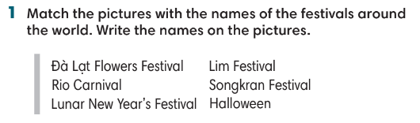  - Game rule:  - Ss take turns to say activities in festival.  - The following student needs to remember that activity and then add 1 more activity.  - Continue until 1 student says incorrectly.
3. PRESENTATION 2 (7’)
ACTIVITIES 4 & 5:
* Aims:
- To study festival activities.
* Content: Listen to festival activities and quiz.
* Outcome: Identify festival activities.
* Organisation: T-Ss, Ss-T, Pair work
Teacher’s & Student’s activities | Content
Activity 4: Exercise 2 (SBp80)  Listen and tick () the activities you hear.  - T asks students to look at the pictures on page 80.  - T goes through all phrases and provides meaning of all words.  - T plays the audio. Ss listen and finish Exercise 2. | Answer keys:  - T plays the audio again and asks Ss to repeat the evidence from the audio.
Activity 5: Exercise 3 (SBp81)  Read the quiz and choose the best option.  - T ask Ss to read the instructions and the quiz.  - Ss work in pairs and do the quiz.  - T checks Ss answers and ask Ss if they have been to these festivals. | Answer keys:
4. PRACTICE (10’)
ACTIVITY 6 & 7:
* Aims:
- To provide students with Word friends.
- To provide more words related to the topic
- To help Ss use the new vocabulary in collocations.
* Content: Study word friends
* Outcome: Ss know word friends and how to use in a context.
* Organisation: T-Ss, Ss-T, Individual work.
Teacher’s & Student’s activities | Content
Activity 6: Exercise 4 – SB p.81  Circle the best option in the following sentences.  - Ss work individually to finish Exercise 4 and then check in pairs.  - T check students answer.  Activity 7: Game  - T divides the class into 2 groups. | Answer keys:  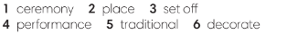  Game rules  2 Ss from 2 groups come to the board to receive one word from word friends. These Ss need to make one sentence using that word.  - 1 correct answer = 1 point.  - The faster student receives 1 more point.
5. PRODUCTION (10’)
ACTIVITY 8 + 9:
* Aims: To help Ss practice applying the vocabulary items and grammar points related to the topic in speaking.
* Content: Ss work in groups to talk about their favorite festivals.
* Outcome: Ss talk about their favorite festivals using vocabulary and grammar points.
* Organisation: T-Ss, Ss-T
Teacher’s & Student’s activities | Content
Activity 8: Exercise 5 – SB p.81  Work in groups. Choose one festival from Exercise 1 or your favorite festival. Make notes about the activities in this festival. Use the notes to tell the class about the festival.  - T asks Ss to look at Exercise 5 (SB page 81).  - T checks Ss understanding and provides one example.  - T asks Ss to work in groups of four to discuss their favorite festivals.  - T invites some volunteer to share their ideas in front of the class and receive feedbacks.  Activity 9: Interview  - T set a time limit of 4 minutes. Ss interview each other to find Ss with the same favorite festival. | 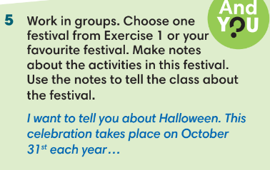

WRAP-UP & HOME WORK (3’)

- T asks Ss to talk about what they have learnt in the lesson.
- Vocabulary of festivals and festival activities.
Grammar points: how to describe a festival
* HOME WORK
-Do exercises in the workbook page 68-69.
- Prepare for Lesson 2: Grammar 1.

Date of planning:  Date of teaching: | UNIT 8: FESTIVALS AROUND THE WORLD  Lesson 2: Grammar 1
I. OBJECTIVES:
By the end of the lesson, Ss will be able to:
1. Knowledge:
* Grammar:
- Identify and understand how to use adjectives ending in -ing and -ed.
- Use adjectives ending in -ing and -ed to describe festivals and reactions to festivals.
2. Competence:
- General competences: form and / or improve such competencies as group work, independent working, pair work, linguistic competence, and cooperative learning.
- Specific competences:
- Improve communicative competence related to the use of language (vocabulary, phonetics, grammar):
- For a language lesson: Ss are expected to use vocabulary about festivals and understand the main grammatical points, then do the tasks assigned in the textbook.
- For a skills lesson: Ss are expected to use adjectives ending in -ing and -ed to describe festivals and reactions to festivals.
3. Quality / behavior:
- Being hard-working and attentive in class.
- Have a positive attitude towards the lesson.

II. TEACHING AIDS:
- Grade 7 textbook, Unit 8 (SB p. 82)
- Computer (connected to the Internet is the best)- Projector / TV/ PPT slides / Active teach
Language analysis
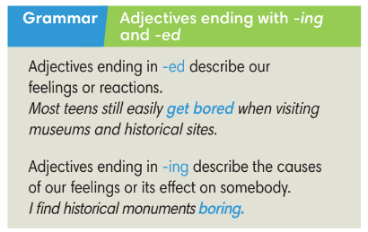
Assumptions
Anticipated difficulties | Solutions
1. Ss may not use adjectives ending in -ing and -ed incorrectly. | Remind them regularly during the time of the lesson  Place a note on the board for Ss to see.  Give clear examples
2. Ss may not have sufficient speaking and co-operating skills. | Give clear instructions, give examples before letting Ss work in groups.  Provide feedback and help if necessary.

III. PROCEDURE:

1. WARM UP (5’)
* Aims:
- To activate students’ prior knowledge and get students involved in the lesson.
- To set the context for introducing new structures.
* Content: Play game to get Ss involved in the lesson and to set the context for the lesson.
* Outcome: Ss know the context of the lesson.
* Organisation: T-Ss, Ss-T
Teacher’s and Student’s activities | Content
Activity 1: Game  - T divides Ss into 2 teams:  - The topic is adjectives.  - T sets the scene for the new lesson: T tells Ss that they are going to learn about adjectives ending in -ed and -ing.  - T writes the title on the board: Unit 8: Festivals around the world  Lesson 8.2: Grammar | Game rules:  - Ss has 2 minutes to take turns and write as many adjectives as they can.  - 1 correct answer = 1 point.
2. LEAD-IN (4’)
* Aims: To lead into the text.
* Content: Ss read the results of a survey.
* Outcome: Ss understand results of a survey.
* Organisation : T-Ss, Ss-T.
Teacher’s and Student’s activities | Content
Activity 2: Exercise 1 – SB p.82  Read the results of a survey from 500 teenagers around the world. Do you find any of these surprising?  - T asks Ss to read the text and the table, invites some students to share the things that they find surprising.  - T asks Ss to pay attention to the blue words to see any differences.  - T checks if any Ss know the difference in usage of adjectives ending in -ing and -ed. | 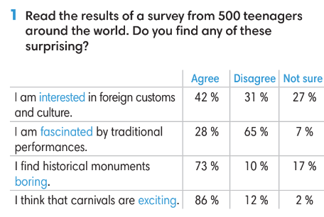
3. PRESENTATION (14’)
ACTIVITIES 3 + 4 + 5:
* Aims:
- To lead into the next activity.
- To introduce the Grammar Box
- To provide Ss with chances to practice the form of adjectives
* Content:
- Ss study the Grammar Box to complete the exercise.
* Outcome: Ss learn about adjectives ending with -ing and -ed in contexts.
* Organisation: T-Ss, Ss-T, Group work.
Teacher’s Student’s activities |  |  | Content
Activity 3: Exercise 2 – SB p.82  Find two more examples of each rule from the survey in Exercise 1.  - T asks Ss to read the grammar box and then explain the grammar rules to them.  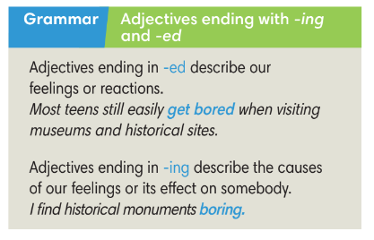 |  |  | - Ss find more examples from the survey in Exercise 1.  - T shows the language notes and explain to Ss.  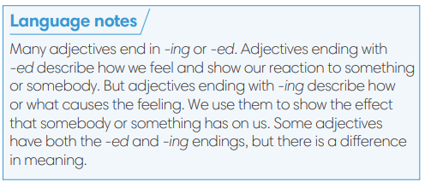
Activity 4: Exercise 3 – SB p82.  Complete the table below.  - T asks Ss to look at exercise 3.  - T calls a student to read the instruction then checks Ss’ understanding of it.  - T asks Ss to finish Exercise 3 individually and then check in pairs.  - T checks Ss answers.  Activity 5: Game.  - T divides the class into 4 groups. |  |  | Answer keys:  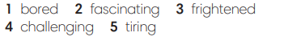  Game rules:  - Each team has 2 minutes to list all adjectives ending in -ing and -ed.  - After 2 minutes, Ss go to the board to write.  - 1 correct word = 1 point.
5. PRACTICE (13’)
ACTIVITIES 6, 7 and 8:
* Aim:
- To provide Ss grammar exercises to practice
* Content:
- Ss read and complete a conversation.
- Ss make sentences with adjectives.
* Outcome: Ss know how to use adjectives ending with -ing and -ed in sentences.
* Organisation : T-Ss, Ss-T, Pair work, Ss-Ss
Teacher’s and Student’s activities |  |  |  | Content
Activity 6: Exercise 4 – SB p.82  Add an -ed or -ing ending to the adjectives in the conversation.  - T asks Ss to look at exercise 4.  - T calls a student to read the instruction then checks Ss’ understanding of it.  - Ss finish Exercise 4 individually and then check in pairs.  - T checks Ss answers and asks Ss to provide reasons for their answers.  - T asks some Ss to read the dialogue in front of the class.  Activity 7: Game  - T divides the class into 4 groups.  - T choose randomly 1 adjective from previous game. Ss need to make one sentence using this word.  - 1 correct answer = 1 point. |  |  |  | Answer keys: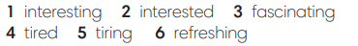
Activity 8: Exercise 5 – SB p.82  Make statements with the adjectives and clues given. Change the form of the adjectives if necessary.  - T asks Ss to look at exercise 5.  - T calls a student to read the instruction then checks Ss’ understanding of it.  - Ss finish Exercise 5 individually and then check in pairs.  - T asks some Ss to share the answers and then check. |  |  |  | Answer keys: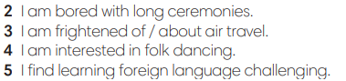
6. PRODUCTION ( 6’)
ACTIVITY 9:
*Aim: To help students applying the vocabulary items and grammar points related to the topic in communicating.
* Content: Ss discuss festivals.
* Outcome: Ss describe how he/ she feels about a festival.
* Organisation: T-Ss, Ss-Ss, Ss-T, Pair work
Teacher’s Student’s activities |  | Content
Activity 9: Exercise 6 – SB p.82  In pairs, name a festival and your partner will describe how he/ she feels about it. Use the adjectives in Exercise 3.  - T asks Ss to look at exercise 6 (SB page 82).  - T calls a student to read the instruction and example then checks Ss’ understanding of it.  - T models the activity in front of the class.  - T asks Ss to work in pairs to finish Exercise 6.  - T walk around to listen and notes down common mistakes for delayed feedback.  - T calls some groups to come to the front of the class, make conversations.  - T asks the rest to give comments on their classmates’ performance.  - T gives feedback on Ss’ work. |  | 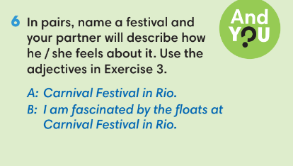
WRAP-UP & HOME WORK (3’)
- T asks Ss to talk about what they have learnt in the lesson.
Adjectives ending in -ing and -ed incorrectly.
* HOME WORK
- Do exercises in the workbook page 70.
- Prepare for Lesson 8.3: Reading.

Date of planning:  Date of teaching:  WEEK: | UNIT 8: FESTIVALS AROUND THE WORLD  Lesson 3: Reading and Vocabulary
I. OBJECTIVES:
By the end of the lesson, Ss will be able to:
1. Knowledge:
* Vocabulary: - an understanding of the vocabulary about festivals.

New words | Vietnamese meaning
offerings | lễ vật
ancestors | tổ tiên
parades | diễu hành
decorations | trang trí
festive event | lễ hội
host | tổ chức

* Grammar:
- Reading skills: - Read for specific details about festivals.
2. Competence:
- General competences: form and / or improve such competencies as group work, independent working, pair work, linguistic competence, and cooperative learning.
- Specific competences:
- Improve communicative competence related to the use of language (vocabulary, phonetics, grammar):
- For a language lesson: Ss are expected to know the meaning of the keywords used to talk about school system in Vietnam.
- For a skills lesson:
- Ss are expected to locate information and find specific details in a text (scanning skill).
- Ss are expected to identify the main ideas of the paragraphs in the text or the text itself (skimming skill).
3. Quality/behavior:
- Being hard-working and attentive in class
- Have a positive attitude towards the lesson
- Know more and respect the family time together.

II. TEACHING AIDS:
- Grade 7 textbook, Unit 8 (SB p.83, WB p.71).
- Computer (connected to the Internet is the best)
- Projector / TV/ PPT slides / Active teach

Assumptions
Anticipated difficulties | Solutions
1. Ss may pronounce the new words incorrectly. | Reinforce the pronunciation of the new words while presenting and practicing.
2. Ss may not have sufficient speaking and co-operating skills. | Give clear instructions, give examples before letting Ss work in pairs / groups.  Provide feedback and help if necessary.
3. Ss may not know how to scan for information. | Guide Ss to underline keywords in the question before finding them in the text.

III. PROCEDURE:
1. WARM-UP (5’)
* Aim:
- To help Ss review grammar they have learnt.
- To lead into the next activity.
* Content: Game: Lucky number (about adjectives ending in -ing and -ed)
* Outcome: Ss recall adjectives ending in -ing and -ed from previous lesson.
* Organisation: T-Ss, Ss-T.
Teacher’s & Student’s activities | Content
Activity 1: Lucky number  - T explains the game rules then checks instructions.  - T uses slide to lead the game.  - Ss raise their hands if they have the answer.  - T tells students that they are going to read about festivals in Vietnam.  - T writes the title for the new lesson:  Unit 8/Lesson 3: Reading and vocabulary. | Game rules:  - T shows adjectives ending in -ing and -ed on the slide.  - Ss make sentences.  - Choose randomly one number (1-9) to see your score
2. PRE-READING (10’)
ACTIVITY 2:
* Aim:
- To activate Ss’ background knowledge of the topic.
* Content: Ss say the meanings of the words in Vietnamese.
* Outcome: Ss understand all new words.
* Organisation: T-Ss, Ss-T, Pair work.
Teacher’s & Student’s activities |  | Content
Activity 2: Exercise 1 – SB p.83  In pairs, look at the words below. Underline these words in the texts. What do they mean in your language?  - T shows the pictures on slide and ask Ss to describe what they can see and guess the name of this activity.  - Ss work in pairs to guess the meaning of the words and then underline these words in the text.  - T collects Ss answer and check.  - T provides pronunciation and meanings of all words.  - T asks some volunteers to read the words out loud to check pronunciation.  Activity 3: Game: Whisper  - T tells Ss that they are play a game to remember new words from the text.  - T tells the game rules. |  | 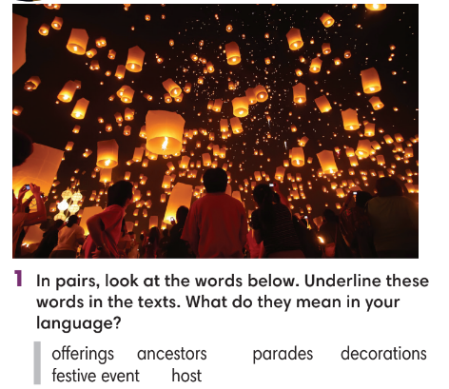  Game rules:  - T divides the class into 4 teams, 4 teams make 4 lines.  - T whispers one new word to the last student.  - Ss whisper until the student near the board goes and writes the word on the board.  1 correct answer = 1 point.
3. WHILE-READING (10’)
ACTIVITY 4 + 5:
*Aim:
- To read the text and do something reading tasks.
- To help students practice finding main ideas of the text.
- To help students practice reading for specific information in a text.
* Content: Ss read the texts and answer the questions.
* Outcome: Ss can identify specific information in the texts and learn more about festivals.
* Organisation: T-Ss, Ss-T.
Activity 4: Exercise 2 – SB p.83  Read the text. Where most likely can you find the information in the text?  - T asks some Ss to read the text out loud to check pronunciation.  - T lists all new words and provide the meaning.  - T asks Ss to look at Exercise 2 (SB page 83).  - T explain to Ss that they need to do skimming.  - T asks Ss to check answers with partner before checking with the whole class and explain reasons for their answers. |  | Answer keys:  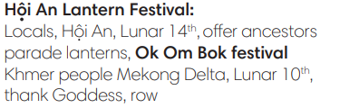
Activity 5: Exercise 3 – SB p.73  Read Texts 1 and 2 again. Mark the sentence (right), (wrong) or ? (doesn’t say)  - T asks Ss to look at exercise 3 (SB page 83).  - T tells student to read the text again individually to  complete Exercise 3.  - T asks students to underline the evidence for their answers. |  | 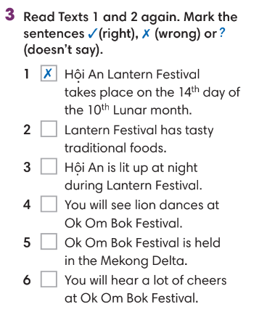  Answer keys:
4. POST-READING (17’)
ACTIVITIES 6 + 7 + 8:
* Aim:
- To study Word Friends
- To review new words from the text.
- To reinforce word friends and practice talking festivals.
* Content:
- Study word friends.
- Play Game: Hot seat.
- Talk about favorite festival activities.
* Outcome: Ss can understand the new words and talk about a festival.
* Organisation: T-Ss, Ss-T, Ss-Ss, Group work, Pair work.
Activity 6: Exercise 4 – SB p.83  Look at the highlighted phrases in the text and complete the Word Friends.  - T asks Ss to look at exercise 4 (SB page 83).  - T tells student to read the text again individually to  complete Exercise 4.  - After finishing, Ss provide the meaning of Word friends. |  | 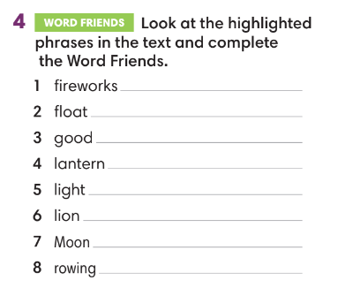
Activity 7: Hot seat game  - T tells Ss that they are play a game to remember new words from the text.  - T tells the game rules. |  | Game rules:  - T divides the class into 2 teams, each turn needs 2 representatives.  - T gives one new word (from the text).  - 2 representatives need to guess the word.  - 1 correct answer = 1 point.
Activity 8: Exercise 5 – SB p.83  In pairs, choose one festival that you both know. Decide what you like about it and what you don’t like about it.  - T asks Ss to look at exercise 5 (SB page 83).  - T calls a student to read the instruction then checks Ss’ understanding of it.  - T provides one example for Ss to understand.  - Ss work in pairs.  - T invites some volunteers to present in front of the class and notes down useful or interesting sentences.  - T asks the rest to give comments on their classmates’ performance and then provides teacher’s feedback. |  | 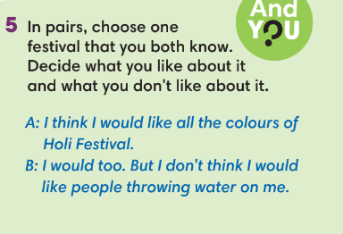
WRAP-UP & HOME WORK (3’)
- T asks Ss to talk about what they have learnt in the lesson.
- Read for specific details about festivals.
- Group discussion
* HOME WORK
- Do exercises in the workbook page 71.
- Prepare for Lesson 8.4: Grammar 2.

====================

Date of planning:  Date of teaching: | UNIT 8: FESTIVALS AROUND THE WORLD  Lesson 4: Grammar 2
I. OBJECTIVES:
By the end of the lesson, Ss will be able to:
1. Knowledge:
* Grammar: Contrast ideas using however and nevertheless.
2. Competence:
- General competences: form and / or improve such competencies as group work, independent working, pair work, linguistic competence, and cooperative learning.
- Specific competences:
- Improve communicative competence related to the use of language (vocabulary, phonetics, grammar):
- For a language lesson: Ss are expected to contrast ideas using however and nevertheless.
- For a skills lesson: Ss are expected to use however and nevertheless to show contrast.
3. Quality/ behavior:
- Being hard-working and attentive in class.
- Have a positive attitude towards the lesson.

II. TEACHING AIDS:
- Grade 7 textbook, Unit 8 (SB p. 84)
- Computer (connected to the Internet is the best)
- Projector / TV/ PPT slides / Active teach
Language analysis
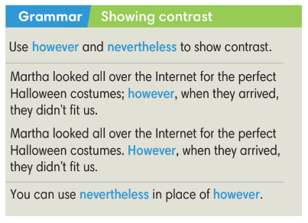
Assumptions
Anticipated difficulties | Solutions
1. Ss may use however and nevertheless incorrectly. | Provide activities for practice.
2. Ss may not have sufficient speaking and co-operating skills. | Give clear instructions, give examples before letting Ss work in pairs / groups.  Provide feedback and help if necessary.

III. PROCEDURE:

1. WARM UP (5’)
* Aim:
- To create a positive classroom atmosphere to start a new lesson.
- To review the previous lesson.
* Content: Game (festival activities).
* Outcome: Ss review vocabulary about school activities.
* Organisation: T-Ss, Ss-T.
Teacher’s & Student’s activities |  | Content
Activity 1: Game - A Jumble  - T explains the game rules then checks instructions.  - T divides Ss into 4 groups. Time limitation is 2 minutes.  - T tells Ss that, today they will learn about however and nevertheless to show contrast. |  | Game rules:  - T shows unscrambled letters of words in the slide (from previous lesson).  - Ss need to find and write as many words as they can.  - 1 correct answer = 1 point.  - T corrects Ss if necessary.
3. PRESENTATION (15’)
ACTIVITY 2 + 3:
*Aim:
- To present the grammar point in context.
- To lead into the next activity.
- To introduce the Grammar Notes and explain grammar points.
* Content:
- Ss read an email and label the photos.
- Ss study the Grammar box to learn how to use however, nevertheless.
* Outcome: Ss understand how to use however, nevertheless.
* Organisation: T-Ss, Ss-T,
Teacher’s & Student’s activities | Content
Activity 2: Exercise 1 - SB p84  Read the email and label the photos with the bold words.  - T asks Ss to look, describe the pictures.  - Ss read the email and find the bold words.  - Ss work in groups of 4 to discuss the meaning of these bold words.  - T asks answers from all groups and then check Ss answers. | Answer keys:  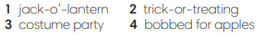  - T asks if any Ss has joined these activities.
Activity 3: Exercise 2 - SB p74  Find more examples of be going to and Present Continuous in the voicemail message.  - T asks Ss to look at the Grammar Box in SB p.74 and explain the usage of “be going to” and Present Continuous to talk about the future. | 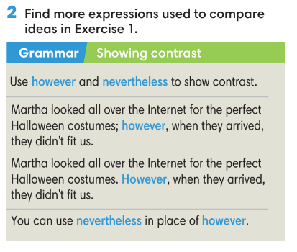  - T asks Ss to read the text again and underline however and nevertheless in Exercise 1.  - T checks Ss answers.
4. PRACTICE (13’)
ACTIVITIES 4 +5:
* Aims:
- To help Ss practice making sentences using however and nevertheless
- To help students practice making sentences with however and nevertheless
* Content:
- Ss use however and nevertheless to make sentences.
- Play Game: Hot potato (practice using however and nevertheless)
* Outcome: Ss can use used to and didn’t use to correctly to make sentences.
* Organisation: T-Ss, Ss-T, Ss-Ss.
Teacher’s & Student’s activities | Content
Activity 4: Exercise 3 - SB p84  Make one sentence from two. Use the word(s) in brackets in your sentences. Listen and check.  - T asks Ss to look at Exercise 3.  - T asks Ss to finish individually and then check in pairs.  - T plays the audio for Ss to check the answers. | Answer keys:  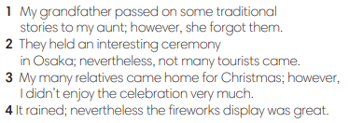
Activity 5: GAME: HOT POTATO  - T explains the game rules then checks instructions. | Game rules:  - The student has the ball needs to make a sentence with However and nevertheless to show contrast.  - The next student receives the ball and make another sentence.  - 1 correct answer = 1 point.  - T collects Ss answer and checks.
5. Production (9’)
ACTIVITY 6:
* Aims: To help Ss applying the vocabulary items and grammar points related to the topic in communicating.
* Content: Ss discuss their thoughts on a festival.
* Outcome: Ss can use however and nevertheless in a context.
* Organisation: T-Ss, Ss-T, Ss-Ss, Pair work.

Teacher’s & Student’s activities | Content
Activity 6: Exercise 4 – SB p.84  In pairs, compare your thoughts on a festival you both know of. Tell the class about it. You can use some of these words.  - T asks Ss to look at exercise 4 (SB page 84).  - T calls a student to read the instructions.  - T provides the meaning of any new words.  - T sets time limitation of 3 minutes for Ss to prepare and work in pairs.  - T asks 3 groups to model the activity in front of the class.  - T asks the other students to give comments on their classmates’ performance.  - T asks Ss to line up into 2 lines, facing each other. Ss takes turn to say the sentence to their partner.  - After each 20 seconds, T say “switch”, Ss move one step to change the partner.  - T walks around to note down any mistakes for delayed feedback. | 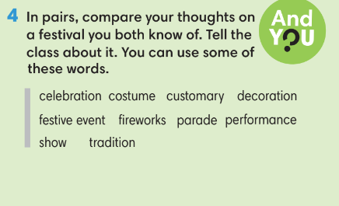
WRAP-UP & HOME WORK (3’)
- T asks Ss to talk about what they have learnt in the lesson.
- However and nevertheless
* HOME WORK
- Do exercises in the workbook page 72.
- Prepare for Lesson 8.5: Listening and vocabulary.
Date of planning: Date of teaching: | UNIT 8: FESTIVALS AROUND THE WORLD  Lesson 5: Listening and Vocabulary
I. OBJECTIVES:
By the end of the lesson, Ss will be able to:
1. Knowledge:
* Vocabulary: use vocabulary to talk about festivals.

New words | Vietnamese meaning
change | tiền lẻ/ tiền trả lại
get wet | bị ướt
pour water | đổ nước
roam around | đi lang thang
stay for | ở lại
throw water | ném nước
visit temples | đi thăm đền
2. Competence:
- General competences: form and / or improve such competences as group work, independent working, pair work, linguistic competence, and cooperative learning.
- Specific competences:
- Improve communicative competence related to the use of language (vocabulary, phonetics, grammar):
- For a language lesson: Ss are expected to use words to talk about festival activities, do the tasks assigned in the textbook.
- For a skills lesson: Ss are expected to listen for main ideas and specific details about a festival.

3. Quality / behavior:
- Being hard-working and attentive in class
- Have a positive attitude towards the lesson

II. TEACHING AIDS:
- Grade 7 textbook, Unit 8 (SB p. 85, WB p.73)
- Computer (accessible to the Internet is the best)
- Projector / TV/ PPT slides / Active teach

ASSUMPTIONS
Anticipated difficulties | Solutions
1. Ss may not find the correct details from listening tasks. | Ask students to underline key words.  Play the recoding and ask student to repeat.
2. Ss may not have sufficient speaking and co-operating skills. | Give clear instructions, give examples before letting Ss work in pairs / groups.  Provide feedback and help if necessary.

III. PROCEDURE:
1. WARM UP + LEAD-IN (5’)
* Aims:
- To review grammar points from previous lesson and get students involved in the lesson.
* Content: Ss review how to use however and nevertheless.
* Outcome: Ss can recall how to use however and nevertheless in sentences
* Organisation: T-Ss, Ss-T.
Teacher’s & Student’s activities | Content
Activity 1: Review grammar however and nevertheless  - T reminds Ss about the usage of however and nevertheless to show contrast.  - T divides the class into 2 teams.  - T sets the scene for the new lesson: T tells Ss that they are going to learn how to listen for specific details and talk about festival activities.  - T writes the title on the board Unit 8: Festivals around the world  Lesson 8.5: Listening and Vocabulary | Game rules:  - 1 student from team A makes a sentence using however and nevertheless then choose randomly 1 student from team B to make another sentence.  - 1 correct answer = 1 point.
2. PRE-LISTENING (5’)
ACTIVITY 2:
*Aims:
- To lead into the topic.
- To set the scene for the new content and introduce the vocabulary.
* Content: Look at the pictures and describe what they see.
* Outcome: Ss can guess the activities shown in the pictures.
* Organisation: T-Ss, Ss-T, Pair work.
Teacher’s & Student’s activities | Content
Activity 2: Exercise 1 – SB p. 85  What can you see in the photos A and B? In pairs, match the following sentences with the photos.  - T asks Ss to look and describe photos.  - Ss work in pairs to match the pictures with sentences. | Answer keys:
3. WHILE-LISTENING (19’)
ACTIVITIES 3 + 4 and 5:
* Aims:
- To help Ss identify main ideas in a conversation
- To help Ss identify specific details in a conversation
- To introduce Word Friends
* Content: Listen and understand to the audio track and complete the exercises.
* Outcome: Identify specific details in a conversation.
* Organisation: T-Ss, Ss-T, Ss-Ss.
Teacher’s & Student’s activities | Content
Activity 3: Exercise 2 - SB p.85  Listen and fill in the information about the festival.  - T asks Ss to look at Exercise 2 and identify the types of information they need to fill in.  - Ss listen to the audio and finish Exercise 2. | Answer keys:  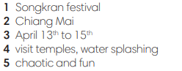
Activity 4: Exercise 3 - SB p.85  Listen again and choose the correct answer.  - T asks Ss to look at Exercise 3, read all questions and underline key words.  - Before listening, Ss guess the answers. | Answer keys:  - T plays the audio for Ss to repeat and provide evidence for the answers.
Activity 5: Exercise 4 - SB p.85  Complete the sentences with the correct words.  - T goes through all words with Ss. T provides meaning and pronunciation of all words.  - T asks Ss say the word to check pronunciation.  - T ask Ss to make sentences with these words. | Answer keys:  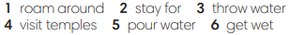
4. POST-LISTENING (13’)
ACTIVITY 6 + 7:
*Aims:
- To reinforce word friends.
- To practice using new words in context
* Content:
- Play Game – Hot seat to review vocabulary.
- Use Word Friends to describe festival activities.
* Outcome: Can use vocabulary about school activities to compare Songkan and New Year’s festival.
* Organisation: T-Ss, Ss-Ss, Ss-T, Group work.
Teacher’s & Student’s activities | Content
Activity 6: Game: Hot seat  - T divides the class into 2 teams and then explains the rule | Game rules:  - 2 Ss from 2 teams go to the board, back against the board.  - 2 teams get one word from teacher (Vocabulary, Word friend or from listening conversation).  - Each team needs to describe until that student can guess the correct word.  The faster team gets 1 point.
Activity 7: Exercise 5 - SB p.75  In pairs, compare Songkran with the New Year’s festival in your country.  - T asks Ss to read the instructions and examples.  - Ss work in pairs to discuss Exercise 5.  - T walks around to provide feedback.  - T go through each sentence and collect Ss answers | 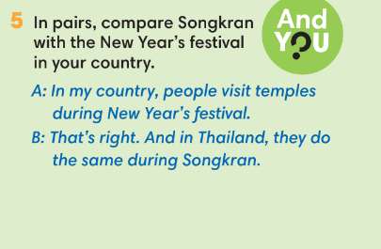
WRAP-UP & HOME WORK ( 3’)

- T asks Ss to talk about what they have learnt in the lesson.
Listen for specific details and talk about festivals.
* HOME WORK
- Do exercises in the workbook page 73.
- Prepare for Lesson 8.6: Speaking.

=====================

Date of planning:  Date of teaching: | UNIT 8: FESTIVALS AROUND THE WORLD  Lesson 6: Speaking
I. OBJECTIVES:
By the end of the lesson, Ss will be able to:
1. Knowledge:
* Vocabulary: Explain how to make a traditional dish for a Vietnamese festival.
* Grammar: Expressions of explaining a process: first, second, third, then, next, later, after that, finally.
2. Competence:
- General competences: form and / or improve such competences as group work, independent working, pair work, linguistic competence, and cooperative learning.
- Specific competences:
- Improve communicative competence related to the use of language (vocabulary, phonetics, grammar):
- For a language lesson: Ss are expected to use vocabulary and phrases to explain how to make a traditional dish for a Vietnamese festival, do the tasks assigned in the textbook.
- For a skills lesson: Ss are expected to use expressions of explaining a process.

3. Quality/behavior:
- Being hard-working and attentive in class
- Have a positive attitude towards the lesson
II. TEACHING AIDS:
- Grade 7 textbook, Unit 8 (SB p. 86, WB p.74)
- Computer (accessible to the Internet is the best)
- Projector / TV/ PPT slides / Active teach
LANGUAGE ANALYSIS
Vocabulary: Ingredients to make a dish.
Expressions:
- Explain a process: Use a Speaking Box

ASSUMPTIONS
Anticipated difficulties | Solutions
1. Ss may use the structures while speaking incorrectly. | Keep the useful expressions on the board for reference.  Encourage peer-check.
2. Ss may not have sufficient speaking and co-operating skills. | Give clear instructions, give examples before letting Ss work in pairs / groups.  Provide feedback and help if necessary.

III. PROCEDURE:
1. WARM UP + LEAD-IN (5’)
* Aim:
- To create a positive classroom atmosphere to start a new lesson.
- To review words of food.
- To lead into the topic.
* Content: Game (traditional food in Vietnam)
* Outcome: Ss review vocabulary about food.
* Organization of implementation: T-Ss, Ss-Ss, Ss-T.
Teacher’s & Student’s activities |  | Content
Activity 1: Game  - T divides Ss into 4 teams.  - T gives the topic is traditional foods in Vietnam.  - When Ss finish the game, T tells Ss that, they are using the vocabulary to do some speaking tasks today.  - T writes the title of new lesson: Unit 8/ Lesson 8 - Speaking |  | Game rules:  - Time limitation: 1 minute for preparation and 3 minutes for writing.  - Ss take turns to write all the word.  - 1 correct answer = 1 point.
2. PRE-SPEAKING (17’)
ACTIVITY 2 + 3 + 4:
* Aims:
- To activate Ss’ prior knowledge of the topic.
- To lead into the topic.
-To introduce the Speaking box
* Content:
- Listen to the dialogue and answer the questions.
* Outcome: Ss understand how to use Speaking box in a context.
* Organisation: T-Ss, Ss-T, Pair work.
Teacher’s & Student’s activities |  |  | Content
Activity 2: Exercise 1 – SB p.86  Class vote: make a list of six common traditional foods from your country. Which food is the most popular? Vote on them.  - T asks Ss to choose 6 traditional foods from the list in Activity 1.  - T conducts a class vote to find the most popular.  vocabulary/ structures that they can use later. |  |  | 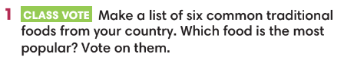
Activity 3: Exercise 2 – SB p.86  Look at the photos. What are the people doing? Listen and check.  - T asks Ss to look at Exercise 2 and describe these pictures.  - Ss work in pairs for discussion.  - T collects Ss answers.  - T plays the audio, Ss listen and finish Exercise 2. |  |  | Answer key:  - T asks Ss further questions:  + Do you like bánh chưng?  + Have you ever made bánh chưng before?  + When do you usually eat bánh chưng?  + Which ingredients are needed?
Activity 4: Exercise 3 – SB p. 86  Study the Speaking box. Find examples of the words in the dialogue.  - T goes through the Speaking box and ask Ss to find examples of the words in the dialogue. |  |  | 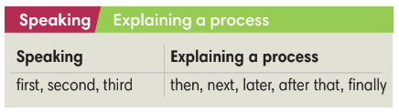  Answer keys:  - T asks Ss to make sentences using these words.
3. WHILE-SPEAKING (12’)
ACTIVITIES 5, 6:
* Aims:
- To reinforce the expressions of explaining a process.
- To practice using the new expression in context.
* Content:
- Use words from Speaking box to complete the instructions.
* Outcome: Ss understand how to write an instruction.
* Organisation: T-Ss, Ss-T, Individual work.
Teacher’s & Student’s activities |  |  |  | Content
Activity 5: Exercise 4 - SB p.86  Complete the instructions. Underline the best choice in brackets.  - T asks Ss to finish individually and then check in pairs.  - T asks volunteers to read the text in front of the class to check the answers as the whole class.  - T provides the meaning of new words if needed. |  |  |  | Answer keys:  
Activity 6: Game – Story telling  - T divides the class into 4 groups. |  |  |  | Game rules:  - Each student takes turn to say one sentence to make a story, remember to use words from Speaking box.  - T votes for the best story.
4. POST-SPEAKING ( 8’)
ACTIVITY 7:
- *Aims: To help students applying the new language and skills related to the topic in communicating.
* Content: In pair, Ss describe how to make a dish.
* Outcome: Ss can talk about how to make a dish.
* Organisation: T-Ss, Ss-Ss.
Teacher’s & Student’s activities | Content
Activity 7: Exercise 5 - SB p.86  In pairs, use some of the words below to describe how to prepare a dish. Use the now phrases from the Speaking box.  - T asks Ss to read the instructions and given words.  - T asks Ss to work in pairs for discussion.  - T invites 2 random students to make a conversation in front of the class. Other Ss listen and provide feedback.  - T tells students to look at the speaking box in their student book again and work in pairs to prepare for the task.  - T set time for Ss to prepare and practice speaking.  - T walk around the class to listen and provide feedback.  - T asks 5 groups to practice the conversation in front of the class. | 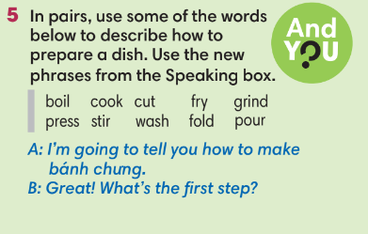
WRAP-UP & HOME WORK (3’)
- T asks Ss to talk about what they have learnt in the lesson.
- Explain how to make a traditional dish for a Vietnamese festival.
* HOME WORK
- Do exercises in the workbook page 74.
- Prepare for Lesson 8.7: Writing.

=====================

Date of planning:  Date of teaching: | UNIT 8: FESTIVALS AROUND THE WORLD  Lesson 7: English in use
I. OBJECTIVES:
By the end of the lesson, Ss are able to:
1. Knowledge:
* Grammar:
- Use Wh-question words to ask questions.
- Write a paragraph about your favorite festival.
2. Competence:
- General competences: form and / or improve such competencies as group work, independent working, pair work, linguistic competence, and cooperative learning.
- Specific competences:
- Improve communicative competence related to the use of language (vocabulary, phonetics, grammar):
- For a language lesson: Ss are expected to use question words, then do the tasks assigned in the textbook.
- For a skills lesson: Ss are expected to use the correct tense of verbs, phrasal verbs and conjunctions to write about their favorite festival.
3. Quality/behavior:
- Being hard-working and attentive in class
- Have a positive attitude towards the lesson
II. TEACHING AIDS:
- Grade 7 textbook, Unit 8 (SB p. 87)
- Computer (connected to the Internet is the best)
- Projector / TV/ PPT slides / Active teach
Language analysis
Question words
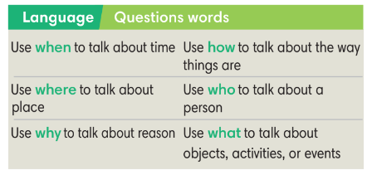

Assumptions
Anticipated difficulties | Solutions
1. Ss may use the wrong question words. | Give clear examples for Ss to distinguish all question words.
2. Ss may not have sufficient speaking and co-operating skills. | Give clear instructions, give examples before letting Ss work in pairs / groups.  Provide feedback and help if necessary.

III. PROCEDURE:
1. WARM UP (5’)
* Aims:
- To create a positive classroom atmosphere to start a new lesson.
- To review words of festival activities.
* Content: Game – Festivals.
* Outcome: Ss understand the background of the lesson.
* Organization of implementation: T-Ss, Ss-T, Ss-Ss
Teacher’s & Student’s activities | Content
Activity 1: GAME  - T asks Ss to provide a few examples of festival activities.  - T divides the class into 2 groups. Each group writes down 5 festivals.  - T explains the game rules then checks instructions.  - T introduces the new lesson and writes on board:  Unit 8/ Lesson 7: English in use | Game rules:  - Two group swap list of festivals.  - Time limitation: 2 minutes.  - Each group needs to list all festival activities belong to those 5 items.  - 1 correct phrase = 1 point.
2. LEAD-IN (4’)
* Aims:
- To lead into the new lesson.
-To provide Ss with reasons for reading the dialogue in exercise 1 (SB p.87).
* Content: Discuss in pairs to guess the subject mentioned in the following dialogue.
* Outcome: Guess what the dialogue is about to prepare for reading tasks.
* Organisation: T-Ss, Ss-T, Pair work.
Teacher’s & Student’s activities | Content
Activity 2: See – think – wonder.
- T shows the pictures from the SB on the slide then asks students to describe the picture.
- T sets a time limit for Ss’ quick discussion.
- Ss work in pairs to make guesses about the pictures then give answers.
- T calls some Ss to give answers then checks with the whole class.
3. PRESENTATION (10’)
ACTIVITIES 3 + 4:
Aim:
-To present questions words through a context.
-To introduce the Language Box through the reading tasks.
* Content: Read the text and do the tasks.
* Outcome: Understand how to use wh-question words in context.
* Organisation: T-Ss, Ss-T, Individual work.
Teacher’s & Student’s activities | Content
Activity 3: Exercise 1 – SB p87  Read the text and questions. Answer the questions.  - T asks Ss to open their SB page 87, look at exercise 1.  - T calls a student to read the instruction then checks Ss’ understanding of it.  - T tells Ss that they are going to read the text to find the answers.  - Ss work individually, read, and note down the answers to the given question.  - T calls some Ss to give answers then shows the answers on the slide. | Answer keys:  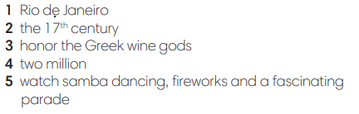
Activity 4: Exercise 2 – SB p87  Study the Language box and look at Exercise 1. Underline the Wh-question words in the text.  - T goes through language box with the Ss, explains the meaning and usage.  - T provides examples and check Ss understanding.  - T asks Ss to give examples using these words.  - T asks Ss to read the dialogue again and underline Wh-question words in the text. | 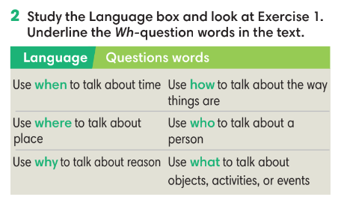
4. PRACTICE (16’)
ACTIVITIES 5 + 6 + 7:
Aims:
- To reinforce the use of question word.
* Content: Use wh-question words to complete the exercises.
* Outcome: Use wh-question words correctly in sentences.
* Organisation: T-Ss, Ss-T, Group work, Individual work.
Teacher’s & Student’s activities | Content
Activity 5: Exercise 3– SB p87  Write when, where, what, who, how or why to complete the questions. More than one can be used for each blank.  - T asks Ss to open their SB page 87, look at exercise 3.  - T calls a student to read the instruction then checks Ss’ understanding of it.  - T gives students a time limit to work individually.  - T allows Ss to share their answers massively before checking the final ones as the whole class.  - T provides the meanings of any new words if needed | Answer keys:
Activity 6: Exercise 4– SB p87  Make questions by putting the words in the correct order.  - T asks Ss to open their SB page 87, look at exercise 4.  - Ss finish Exercise 4 individually and then check the answers in pairs.  - T asks Ss to read the sentences out loud to check their answers. | Answer keys:  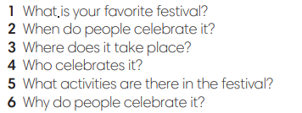
Activity 6: GAME  - T tells students that they are playing a game with question words.  - T explains the game rules then checks instructions. | Game rules:  - One student goes to the board to receive one word.  - Other Ss guess the words by asking question using question words.  - The first student to guess the right word gets 1 point.
5. PRODUCTION (7’)
ACTIVITY 7:
*Aims:
- To help students write about their favorite festival.
* Content: Ss write a paragraph about their favorite festival.
* Outcome: Ss can use describe their favorite festival in writing.
* Organisation: T-Ss, Ss-Ss.

Teacher’s & Student’s activities | Content
Activity 7: Exercise 5 – SB p.87  Use your answers from Exercise 4 to write 6-8 sentences about your favorite festival.  - T asks Ss to look at exercise 5 (SB page 87).  - T calls a student to read the instructions then checks Ss’ understanding of it.  - T lets students work individually to write their paragraphs first.  - Then T pairs students up and asks them to share their paragraphs and feedback.  - T invites some volunteers to share the paragraphs and provides feedback. | 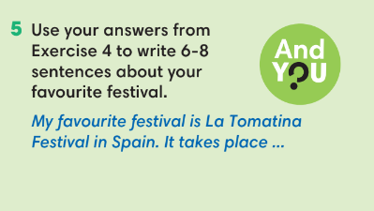
WRAP-UP & HOME WORK (3’)
T asks Ss to talk about what they have learnt in the lesson.
- Question words.
- Write about your favorite festival.
* HOME WORK:
Do exercises in the workbook page 75.
- Prepare for Lesson 8.8: Vocabulary in action and Pronunciation

======================

Date of planning:  Date of teaching: | UNIT 8: FESTIVALS AROUND THE WORLD  Lesson 8: Vocabulary In Action and Pronunciation
I. OBJECTIVES:
By the end of the lesson, Ss will be able to:
1. Knowledge:
* Vocabulary: review vocabulary – festivals and festival activities.
* Pronunciation: st-, sk-, sl- sound in the beginning of the word.
2. Competence:
- Develop communication skills and creativity
- Be collaborative and supportive in pair work and teamwork
- Develop presentation skill
- Actively join in class activities
3. Quality/behavior:
- Love talking about relating topics to unit 8 and using word friends or phrasal verbs in pair work or group work
- Develop self-study skills
II. TEACHING AIDS:
- Grade 7 textbook, Unit 8 (SB p.88)
- Computer (accessible to the Internet is the best)
- Projector / TV/ PPT slides / Active teach
Assumptions
Anticipated difficulties | Solutions
1. Students may lack experience of group/ teamwork. | Encourage students to work in groups so that they can help each other.
2. Students may not have sufficient listening, speaking and co-operating skills. | - Play the recording, the replay depends on the students’ need and level.  - Encourage students to work in pairs, in groups so that they can help each other.  Provide feedback and help if necessary.

III. PROCEDURE:
1. WARM UP + LEAD-IN (5’)
*Aims:
- To create an active atmosphere in the class before the lesson.
- To lead into the new lesson.
* Content: Game: Hot seat (school subjects and activities).
* Outcome: Ss can recall the vocabulary of Unit 8.
* Organisation: T-Ss, Ss-Ss.
Teacher’s & Student’s activities | Content
Activity 1: GAME: HOT SEAT  * Teacher asks students to spend 1 minute to quickly review all vocabulary they have learnt in Unit 8 before they play a warm-up game.  - T divides the class into 2 groups.  - T explains the game rules then checks instructions.  - T tells Ss that they can remember better with Glossary Table and asks Ss to open their Student Book page 88 – Exercise 1. | Game rules:  - 2 students from 2 groups go to the board, sit back against the board.  - Teacher writes 1 word on the board.  - Two teams explain the word for their teammate.  - The faster gets 1 point.
2. REVIEW VOCABULARY (20’)
ACTIVITIES 2 + 3 + 4 + 5
*Aims:
- To introduce the glossary and its uses.
- To give further practice in making sentences using the glossary.
- To review vocabulary of Unit 8.
* Content: Revise what they have learnt during the unit, using the Glossary.
* Outcome: Recall the vocabulary of Unit 8 and use them in sentences.
* Organisation: T-Ss, Ss-T, Pair work, Individual work.
Teacher’s & Student’s activities | Content
Activity 2: Exercise 1 – Student Book page 88  Find the words from the glossary to match with the pictures. Then write in the spaces.  - Teacher introduces the Glossary Table.  - T asks Ss to look at exercise 1 in student book page 88  - T has students use the glossary to find the words which belong to the correct category  - T allows students to peer check first.  - T checks and confirms the answers. | Answer keys:  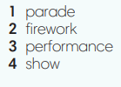
Activity 3: Exercise 2 – Student Book page 88  Write the correct words for each definition.  - T asks students to complete Exercise 2 and then check in pairs.  - T invites students to share their answers.  - T confirms the correct answers.  Extra-Practice  TIME TO TALK: Use the Glossary to talk about their favorite festival.  - Ss work in groups of 4 to discuss their favorite festival.  - T asks some groups to share in front of the class to get feedback. | Answer keys:  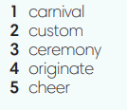
Activity 4: Exercise 3 – Student Book page 88  Complete the words in the sentences.  - T asks Ss to open their SB page 88, look at exercise 3.  - T calls a student to read the instruction then checks Ss’ understanding of it.  - Ss finish Exercise 3 individually and then check in pairs.  - T gives students a time limit for Ss discussion.  - For each item, T invites 3 groups to share their ideas.  Activity 5: Game – Hangman.  - T uses the words from the Vocabulary Box.  - T provides the number of letters.  - Ss guess the word by guessing each letter.  - If one letter is wrong, T starts writing the hangman. Game ends when the hangman is done. | Answer key:  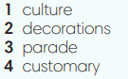
3. PRONUNCIATION (13’)
3.1. Presentation (5’)
ACTIVITY 6
* Aims:
- To learn how to pronounce st-, sk-, sl- sound in the beginning of the word.
- To help students practice st-, sk-, sl- sound in the beginning of the word.
* Content: Listen to the words and sort them according to their sounds.
* Outcome: Learn how to pronounce the st-, sk-, sl- sounds.
* Organisation: T-Ss, Ss-T, Ss-Ss.
Teacher’s & Student’s activities | Content
Activity 6: Exercise 4 – Student Book page 88  Listen to how we pronounce the st-, sk-, sl- sounds in the beginning of the words. In pairs, say the words.  - T plays the audio for Ss to listen and repeat.  - Ss work in pairs to practice these sounds.  - T invites some pairs to practice in front of the class. | Answer keys:  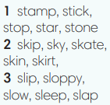
3.2. Practice (8’)
ACTIVITY 7 + 8:
* Aims:
- To help students practice st-, sk-, sl- sounds in the beginning of the word.
* Content:
- Write the words with st-, sk-, sl- sounds.
- Play a game to practise listening to the st-, sk-, sl- sounds.
* Outcome: Can identify the st-, sk-, sl- sounds and pronounce them correctly.
* Organisation: T-Ss, Ss-T, Ss-Ss.
Teacher’s & Student’s activities | Content
Activity 7: Exercise 5 – Student Book page 88  Listen to the words. Write if they start with a st-, sk-, sl- sounds.  - T plays the audio for Ss to listen and repeat.  - Ss finish Exercise 5 individually.  - T checks Ss answers. | 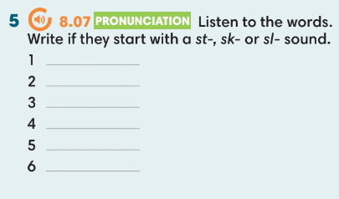
Activity 8: Game  - T divides the class into 2 teams.  - T asks Ss to read in front of the class to check Ss pronunciation. | Game rules:  - Each team has 1 minute for preparation and 3 minutes to write words with st-, sk-, sl- sound in the beginning of the word.  - 1 correct answer = 1 point.
WRAP-UP & HOME WORK (2’)
Teacher asks students to talk about what they have learnt in the lesson.
Use a Glossary to review
st-, sk-, sl- sound in the beginning of the word.
* HOME WORK
Find more words which contain the silent letters
Prepare for Unit 8 – Lesson 9: Revision

==================

Date of planning:  Date of teaching: | UNIT 8: FESTIVALS AROUND THE WORLD  Lesson 9: Revision
I. OBJECTIVES:
By the end of the lesson, Ss are able to:
1. Knowledge:
* Vocabulary: Review vocabulary and grammar in the unit.
* Grammar: practice speaking how to make a dish.
2. Competence:
- General competences: form and / or improve such competences as group work, independent working, pair work, linguistic competence, and cooperative learning.
- Specific competences:
- Improve communicative competence related to the use of language (vocabulary, phonetics, grammar)
- For a language lesson: Ss are expected to use vocabulary of the unit, do the tasks assigned in the textbook.
- For a skills lesson: Ss are expected to speak how to make a dish.

3.Quality/ behavior :
- Being hard-working and attentive in class
- Have a positive attitude towards the lesson
II. TEACHING AIDS:
- Grade 7 textbook, Unit 8 (SB p. 89, WB p.79)
- Computer (accessible to the Internet is the best)
- Projector / TV/ PPT slides / Active teach
Language analysis
Vocabulary: festivals, activities in festivals
Grammar: adjectives ending in -ing and -ed, although, despite, in spite of
Assumptions
Anticipated difficulties | Solutions
1. Ss may write the structures incorrectly. | Keep the useful expressions on the board for reference.  Encourage peer-check.
2. Ss may not have sufficient speaking and co-operating skills. | Give clear instructions, give examples before letting Ss work in pairs / groups.  Provide feedback and help if necessary.

III. PROCEDURE:

- WARM-UP (4’)
*Aims:
- To create a positive classroom atmosphere to start a new lesson.
- To lead into the review lesson.
* Content: Game: SUPER EYES
* Outcome: Ss understand that they are going to review Unit 8.
* Organisation: T-Ss, Ss-Ss, Ss-T.
Teacher’s & Student’s activities | Content
Activity 1: SUPER EYES  - Set the scene: T asks students to do quick exercises for eyes such as look up and down, look left and right, row the eyes  - T tells students that they are going to play a game called SUPER EYES  - T explains the game rules then checks instructions.  - Teacher uses the slides to show the collages  - Ss join in the game pairs or in small groups.  - Teacher shows the collage again with displayed answers to check for the whole class.  - T tells Ss that they are going to review Unit 8 | Game rules:  - Look carefully at a collage of different small pictures  - The collage will disappear in a few seconds  - Recall as many words about the collage as you can remember.
- REVIEW VOCABULARY (20’)
ACTIVITIES 2, 3, 4, 5:
* Aims:
- To help students reviews topic words and word friends from the unit
- To review vocabulary in contexts.
- To review adjectives ending in -ing and -ed
* Content: Play a game and do the exercises to revise the vocabulary of Unit 8.
* Outcome: Understand the vocabulary to do the exercises correctly.
* Organisation: T-Ss, Ss-Ss, Ss-T.
Teacher’s & Student’s activities | Content
Activity 2: Game  - T asks Ss to look at vocabulary of festivals and festival activities.  - T introduce the game rules | Game rules:  - T writes 2 word on the board.  - 2 Ss from 2 teams go to the board to guess the word by asking questions to their teams (how many letters? Is it in Vietnam? etc.)  - 1 correct answer = 1 point.
Activity 3: Exercise 1 – Student Book page 89  Complete the text with the words below.  - T asks Ss to look at exercise 1 in student book page 89.  - T calls a student to read the instruction then checks Ss’ understanding of it.  - T asks Ss to finish Exercise 1 individually and then check in pairs.  - T encourages students to give the reason for their answers.  - T checks as the whole class. | Answer keys:  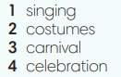
Activity 4: Exercise 2 – Student Book page 89  Complete the sentences below to make them true for you. In pairs, compare your answer.  - T asks Ss to look at exercise 2 in student book page 89  - T calls a student to read the instruction then checks Ss’ understanding of it.  - T helps Ss to review the usage of adjectives ending in -ing and -ed.  - T checks with Ss the meanings of all adjective in Exercise 2.  - Ss finish individually and then check in pairs. | 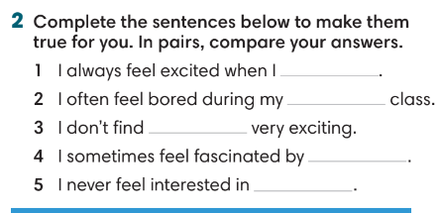
Activity 5: Exercise 3 – Student Book page 89  Complete the responses with the correct words.  - T asks Ss to look at exercise 3 in student book page 89  - T calls a student to read the instruction then checks Ss’ understanding of it.  - T asks Ss to work individually to complete the activity.  - T invites Ss to read the sentences in front of the class to check the answer. | Answer keys:  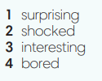
3. REVIEW GRAMMAR ( 12’)
ACTIVITIES 6 + 7:
*Aims:
- To reinforce the grammar of unit 7: although, despite, in spite of, unit 8: however, nevertheless
* Content: Use although, despite, in spite of, however, nevertheless correctly to complete the tasks.
* Outcome: Ss can use although, despite, in spite of, however, nevertheless correctly in sentences.
* Organisation: T-Ss, Ss-T, Pair work.
Teacher’s & Student’s activities | Content
Activity 6: Exercise 4 – Student Book page 89  Underline the correct option among the bold words.  - T helps Ss to review grammar before doing this task.  - Ss work individually.  - T checks Ss answers. | Answer keys:  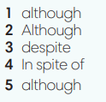
Activity 7: Game – Unscramble words.  - T divides the class into 4 teams and explains game rule.  - T prepare a few sentences using although, in spite of, despite. | Game rules:  - Ss receive 10 bags with unscramble words of 10 sentences. (Words are written and cut into pieces)  - 1 correct sentence = 1 point.
4. SPEAKING (6’)
ACTIVITY 8:
*Aims:
- To help student practice making a dialogue about steps to make a simple dish.
* Content: Describe how to make a dish.
* Outcome: Ss can describe how to make a dish.
* Organisation: T-Ss, Ss-T, Pair work.
Teacher’s & Student’s activities | Content
Activity 8: Exercise 5 – Student Book page 89  Work in pairs. Student A, think of a type of food you know how to prepare. Follow these ideas to explain to Student B how to prepare it. Student B, go to page 102.  - T asks Ss to look at exercise 5.  - T calls a student to read the instruction then checks Ss’ understanding of it.  - T asks Ss to prepare a dialogue basing on given clues.  - T provides one example.  - Ss work in pairs for discussion.  - T walk around the class to note down any mistakes.  - T invites some pairs to share in front of the class, Ss listen and provide feedback. | 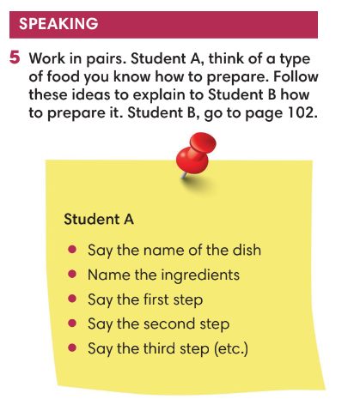
WRAP-UP & HOME WORK (3’)
- T asks Ss to talk about what they have learnt in the lesson.
- Review Unit 8 vocabulary and grammar.
- How to make a dish.
* HOMEWORK
- Do exercises in the workbook page 89
- Prepare for Unit 9 – Lesson 1: Vocabulary

