Date of preparing: ………………………………….
Date of teaching: ………………………………….

Period …
UNIT 1: HOME
Lesson 1 - Part 2 (Page 7) - Grammar

I. OBJECTIVES
By the end of the lesson, Ss will be able to…
1. Knowledge
- use the Present Simple to talk about things that are facts or are true for a long time.
2. Ability
- improve speaking skills, writing skills.
- improve the use of English.
3. Quality
- have positive attitude in English language learning so that they actively participate in all classroom activities.

II. TEACHING AIDS AND LEARNING MATERIALS
Lesson plan, PPT slides, student’s book, workbook, notebook, personal computer (if any), projector/ TV, speakers, DCR & DHA on EDUHOME, handouts…

III. PROCEDURES
A. Warm up: (5’)
a) Objective: Introduce the new lesson and set the scene for Ss to acquire new language; get students' attention at the beginning of the class by means of enjoyable and short activities as well as to engage them in the steps that follow.
b) Content: Jumbled word or rearranging words to make a meaningful sentence.
c) Product: Ss review vocabularies about home or Ss have general ideas about the grammar point they are going to study in the new lesson.
d) Competence: collaboration, guessing.
e) Organization of the activity:
Teacher’s Activities | Students’ Activities
- Give greetings  - Check attendance  - Option 1: Game “JUMBLED WORD”  - Have Ss rearrange letters to make a meaningful word  - Call Ss to give answers  - Check Ss’ answers, give feedback and lead to the new lesson  1. dary 2. areagg 3. calnoby  4. oolp 5. dargne 6. tikench  - Lead to the new lesson  - Option 2: REARRANGING  - Have Ss rearrange the words to make a meaningful English sentence  1. you / a / do / live / in / house?  2. apartment / I / an / in / live  3. doesn’t / live / USA / the / in / she  4. is / gym / my / there / house / a / in  5. the / the / is / garage / in / car  - Have Ss read their answers  - Tell Ss about the grammar point they are going to study in the new lesson  Lead to the new lesson | - Greet T  - Take part in the game  - Give answers (write on the board)  Answers keys  1. yard 2. garage 3. balcony  3. pool 4. garden 5. kitchen  - Work in pairs  Answers keys  1. Do you live in a house?  2. I live in an apartment.  3. She doesn’t live in the USA.  4. There is a gym in my house.  5. The car is in the garage.  - Give answers  - Listen

B. New lesson (36’)
- Activities 1: Grammar: The Present Simple (18’)
a) Objective: Ss know how to use the Present Simple.
b) Content:
- The usage of the Present Simple
- Filling in the blanks
c) Products: Ss can use the Present Simple in everyday communication.
d) Competence: Communication, collaboration, presentation.
e) Organization of the activity:
Teacher’s Activities | Students’ Activities
a. Listen and repeat  - Have Ss look at the picture  - Play audio (CD1 – Track 05) and have Ss listen and read the speech bubbles  - Play audio again and have Ss listen and repeat  Grammar box  - Option 1:  - Have Ss look at the grammar explanation  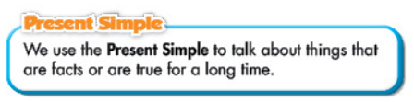  - Have Ss look at the box with the different forms  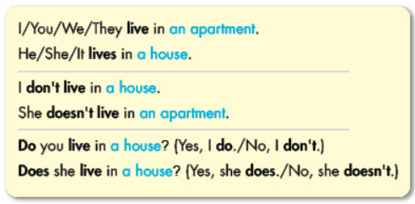  - Explain more about the form and the usage of the Present Simple, have Ss pay attention to the negative and the question form  Form:  Be: (+) S + am / is / are + …  (-) S + am / is / are + not + …  (?) Am / Is / Are + S + …  Normal verb: (+) S + V _{s/es}  (-) S + don’t / doesn’t + V _{bare infinitive}  (?)Do / Does + S + V _{bare infinitive}  Usage: to talk about things that are facts or are true for a long time  - Have some Ss read the sentences in the Grammar Box aloud  - Ask Ss to give more examples using the Present Simple  - Option 2:  - Have Ss close books  - Give some model sentences, have Ss tell form of the Present Simple  - Call Ss to give answers, comment on Ss’ answers  - Then have Ss open the books and read the grammar box  - Have Ss give more examples of the Present Simple,  encourage them to make sentences with their own ideas  - Give feedback and evaluation  b. Fill in the blanks with the correct form of the verbs.  - Demonstrate the activity, using the example  - Have Ss fill in the blanks with the correct form of the verbs  - Have Ss work in pairs to check each other’s work  - Have some Ss share their answers with the whole class  - Give feedback, correct Ss’ answers if necessary | - Look  - Listen, then read  - Listen and repeat  - Look and read  - Read  - Listen and take notes.  - Read  - Give examples  - Close all books  - Look and answer  - Read  - Give examples  - Look and listen  - Work individually  - Work in pairs  - Read answers  Answer keys  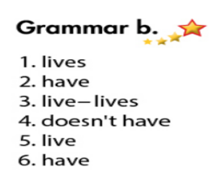
- Activity 2: Practice - Writing and Speaking (18’)
a) Objective: Ss can write sentences, using the Present Simple.
b) Content: Looking at the table and writing Alex’s answers.
c) Products: Ss produce the new language successfully, and they can apply the Present Simple in everyday speaking and writing.
d) Competence: Collaboration, writing, communication.
e) Organization of the activity:
Teacher’s Activities | Students’ Activities
c. Look at the table and write Alex’s answers  - Demonstrate the activity, using the table  - Have Ss write Alex’s answers  - Have Ss work in pairs to check each other’s work  - Have some Ss share their answers with the whole class (Write on the board)  - Check, correct Ss’ answers  d. Practice the conversation with your partner  - Option 1:  - Have Ss do the task in pairs, then swap the roles  - Call Ss to demonstrate the activity in front of the class  - Give feedback and evaluation  - Option 2:  - First, follow the same steps as option 1  - Then, have Ss do the task in pairs to ask and answer about their house  - Encourage Ss to use their own ideas to make up a dialogue-using the Present Simple  - Call Ss to demonstrate the activity in front of the class  - Give feedback and evaluation | - Look and listen  - Work individually  - Work in pairs  - Write answers  Answer keys  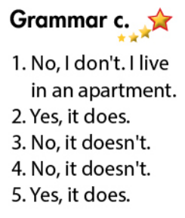  - Work in pairs  - Present  - Work in pairs  - Present

C. Consolidation (2’)
* The Present Simple
Form:
Be: (+) S + am / is / are + …
(-) S + am / is / are + not + …
(?) Am / Is / Are + S + …
Normal verb: (+) S + V _{s/es}
(-) S + don’t / doesn’t + V _{bare infinitive}
(?)Do / Does + S + V _{bare infinitive}
Usage: to talk about things that are facts or are true for a long time.

D. Homework (2’)
- Make 3 sentences, use the Present Simple to talk about your house.
- Do exercise in Workbook: Lesson 1 - Grammar (page 5).
- Prepare: Lesson 1 – Pronunciation and Speaking (page 8 – SB).

