Date of preparing: ………………………………….
Date of teaching: ………………………………….

Period …
UNIT 1: HOME
Lesson 2 - Part 3 (Page 11) – Pronunciation and Speaking

I. OBJECTIVES
By the end of the lesson, Ss will be able to…
1. Knowledge
- pronounce the sound /ɪ/ correctly.
- talk about housework their family members do.
2. Ability
- improve speaking skills.
3. Quality
- have positive attitude in English language learning so that they actively participate in all classroom activities.
- love family and share household chores with family members.

II. TEACHING AIDS AND LEARNING MATERIALS
Lesson plan, PPT slides, student’s book, workbook, notebook, personal computer (if any), projector/TV, speakers, DCR & DHA on EDUHOME, handouts…

III. PROCEDURES
A. Warm up: (5’)
a) Objective: Introduce the new lesson and set the scene for Ss to acquire new language; get students' attention at the beginning of the class by means of enjoyable and short activities as well as to engage them in the steps that follow.
b) Content: Introduction the sound /ɪ/.
c) Product: Ss have general ideas about the sound they are going to study in the new lesson.
d) Competence: Collaboration, observation.
e) Organization of the activity:
Teacher’s Activities | Students’ Activities
- Give greetings  - Check attendance  - Option 1:  - Give Ss a sentence:  My sister, Lily, is cooking dinner in the kitchen  - Have Ss read the sentence as fluently as possible  - Ask Ss to find out words containing the sound /ɪ/ in the sentence  - Give feedback, correct Ss’ answers if necessary  - Introduce the sound of the pronunciation part: /ɪ/  Lead to the new lesson  - Option 2:  - Have Ss close all books  - Show 6 pictures and have Ss give name of the pictures  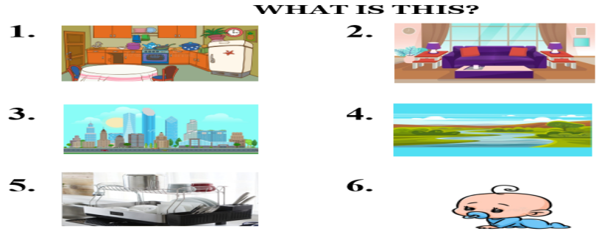  - Check answers as a whole class  - Have Ss make comments on the 6 words under the pictures (Suggestion: What is the similarity of these 6 words)  - Call Ss to give answers  - Give feedback, introduce the sound /ɪ/  Lead to the new lesson | - Greet T  - Read  - Find words with the sound /ɪ/  Answer keys  My sister, Lily, is cooking dinner in the kitchen.  - Close books  - Look and give answers  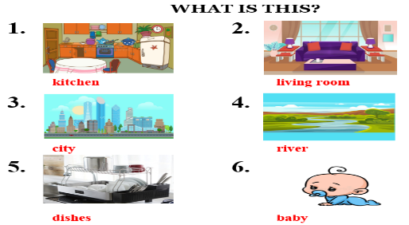  Answers keys  Suggested answers: All 6 words contain the sound /ɪ/  - Listen

B. New lesson (35’)
- Activities 1: Pronunciation (10’)
a) Objective: Ss know how to pronounce the sound /ɪ/.
b) Content:
- Recognizing the sound /ɪ/.
- Listening and focusing pronunciation feature, finding and correcting mistakes.
- Practicing the sound.
c) Products: Ss can pronounce the sound /ɪ/ correctly in their speaking.
d) Competence: Communication, collaboration, listening.
e) Organization of the activity:
Teacher’s Activities | Students’ Activities
a + b. Listen. Notice the sound /ɪ/ of the underlined words  - Play the recording (CD1, track 10)  - Ask Ss to listen and pay attention to the sound /ɪ/  - Briefly explain how to pronounce the sound /ɪ/  - Call Ss to make their comments on the letter that helps them notice the sound /ɪ/  - Play the recording again, have Ss listen and repeat with a focus on the pronunciation feature  c + d. Listen and cross out the one with different sound, then read the sentences with the correct sound to a partner  - Play the recording, have Ss listen and cross out the option that uses different sound  - Call Ss to give answers  - Play the recording again and check answers as a whole class  - Then have Ss practice saying the words with a partner, using the correct sound /ɪ/  - Have Ss find more words with the sound /ɪ/  - Call some Ss to read their words in front of the class  - Check and correct Ss’ pronunciation | - Listen  Suggested answers: the /ɪ/ sound often happens with words containing letters i or y (balcony, village, …) or sometimes letter e (emergency, event, …)  - Listen again and repeat  - Listen and cross out  - Give answers  Answer key  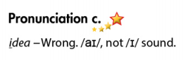  - Listen again and check  - Work in pairs  - Read answers  Suggested words: live, family, give, balcony, shopping, village, …
- Activity 2: Practice (10’)
a) Objective: Ss can ask and answer questions about “Who does housework?”
b) Content: Pointing to the pictures, asking and answering.
c) Products: Ss practice and produce the target language presented fluently and confidently.
d) Competence: Collaboration, communication, creativity.
e) Organization of the activity:
Teacher’s Activities | Students’ Activities
Point, ask and answer (controlled practice)  - Option 1:  - Demonstrate the activity by practicing role-play with a student  - Remind Ss to use the right collocation of “make” or “do”  - Have pairs point to the pictures, practice asking and answering about the family members and housework  - Call some pairs to read in front of the class  - Check Ss’ pronunciation  - Option 2: free practice (for class with better students)  - Follow the same steps as option 1  - Then give Ss an extra activity: Practice the conversation in the textbook; however, they try to remember the conversation content  - Have Ss use their own ideas with other housework  - Have some pairs demonstrate the activity in front of the class, not looking at the textbook; encourage Ss to present as naturally as possible  - Give feedback and evaluation | - Listen  - Work in pairs  Suggested answers  1. Who does the laundry?  - My mother (does)  2. Who vacuum – clean the living room?  - My sister (does)  3.Who cleans the kitchen?  - My mother (does)  4. Who washes the dishes?  - My father (does)  …  - Listen to the instruction and work in pairs. Practice the new conversation with the information in the pictures or use their own ideas  - Act out the conversation
- Activity 3: Speaking (15’)
a) Objective: Ss can discuss the roles of family members in sharing the housework.
b) Content: Asking and answering questions about activities.
c) Products: Ss can apply the target language to producing the language successfully.
d) Competence: Collaboration, communication, creativity and presentation.
e) Organization of the activity:
Teacher’s Activities | Students’ Activities
a. You are doing a survey about housework in Teen World Magazine. Work in groups. Fill in the information for yourself, then ask 2 friends  - Demonstrate the activity by practicing role-play with a student  - Have Ss work in groups of 3  - Have Ss complete the table with information about doing the housework in their family, ask 2 friends and complete the survey  - Go round and give help if necessary  - Have Ss share their findings with the class  - Give feedback and evaluation  b. Discuss who does the most housework in your families  - Have Ss discuss who does the most housework in their families  - Have some Ss share their ideas with the class, follow the example:  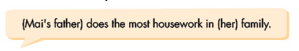  - Have Ss add more information about the person who does the most housework in their families (What housework does he / she do? How often does he / she …?  - Give feedback and evaluation | - 1 S practice role-play with the teacher  - Work in groups  - Present  - Discuss in groups / pairs  - Present

C. Consolidation (3’)
* Pronunciation: the sound /ɪ/: live, dishes, kitchen, village, city, laundry, dinner, …
* Asking about doing housework
Who does … / Who makes … / Who cleans …?

D. Homework (2’)
- Practice pronouncing words with the sound /ɪ/.
- Practice asking and answering about household chores.
- Prepare: Lesson 3: Geography – New Words and Listening (page 12 – SB).

