THE SECOND SEMESTER
----------- ----------
Teaching date : ……………………………
Period: 55
UNIT 6: A QUESTION OF SPORT
Lesson 6.1: Vocabulary (Time: 1 period)
I. OBJECTIVES
By the end of the lesson, students are expected to achieve the following objectives:
Knowledge:
Vocabulary:
Sports: archery, baseball, basketball, cycling, football, ice hockey, judo, running, swimming, tennis
Sportspeople: cyclist, player, runner, swimmer
Competencies:
General competencies:
Form and improve such competencies as group work, independent working, pair work, linguistic competence, cooperative learning and communicative competence.
Specific competencies:
Improve communicative competencies related to the use of language (vocabulary, phonetics, grammar)
For a language lesson: Students are expected to know the meaning of the keywords about sports and sportspeople, and understand the main grammatical points, then do the tasks assigned in the textbook.
For a skills lesson: Students are expected to use the vocabulary about sports to practice talking about the sports they play.
Qualities:
Being hard-working and attentive in class
Being collaborative while doing in-class exercises
Have a positive attitude about sports in general and the hobbies of playing sports
II. PREPARATIONS
Teacher: Textbooks, paper, TV, projector, loudspeaker
Students: Textbooks, notebooks
III. PROCEDURE
ACTIVITY 1: WARM-UP (5’)
Aim: To attract Ss’ attention to the lesson and review the previous unit.
Content: Ss working in groups of 4 to play the game called “Jumbled words” as instructed by T.
Products: Ss are able to guest as many words as they can based on their vocabulary learned from previous lessons.
Implementation:
TEACHER AND STUDENTS’ ACTIVITIES | CONTENTS
JUMBLED WORDS  Step 1: Task delivering  T puts Ss into 4 groups.  T explains that Ss are going to play the Jumbled Words game  Step 2: Task performance  Ss choose a word from the previous unit and spell it backward.  Ss from other groups will try to guess the word. If their guess is correct, they win a point, but if their guess is incorrect, the other groups should continue to guess the word.  Repeat the process.  Step 3: Judgment  T checks the performance with the whole class.  Step 4: Report and discussion  T develops further discussion if needed. | Suggested words: noidrocca (accordion), tnaillirb (brilliant), resopmoc (composer), citsatnaf (fantastic), naicisum (musician), …
ACTIVITY 2: KNOWLEDGE FORMATION (5’)
Aim: To introduce the objectives of the lesson with a can-do statement.
Content: The objective of the lesson is listed below
I can talk about sports and sportspeople.
Products: Ss acknowledge the lesson’s objectives.
Implementation: T introduces objectives to Ss.
ACTIVITY 3: PRESENTATION 1 (10’)
Aim: To teach some words about sports and sportspeople.
Content: Ss work individually to work on the Vocabulary box in the textbook under the guidance of T.
Products: Ss are able to not only accomplish the given exercise but also can add more words about sports.
Implementation:
TEACHER AND STUDENTS’ ACTIVITIES | CONTENTS
Set the scene  Step 1: Task delivering  T instruct S to do the task  Step 2: Task performance  T asks Ss to read the words in the box chorally.  T asks Ss to match the words in the Vocabulary box with the photos to answer question 1.  After that, T asks Ss what they know about the four sports that are not shown in the photos (baseball, basketball, football, swimming).  Step 3: Judgment  T asks Ss to discuss and answer question 2 then T checks and explains for them if necessary.  Step 4: Report and discussion  T asks Ss to think of other sports that they know and enjoy. | Exercise 1: Study the Vocabulary A box. In pairs, ask and answer the questions.  1. Which sports can you see in the photos?  2. Which are team sports and which are usually individual sports?  Answers:  1. A. archery, B. ice hockey, C. cycling, D. judo, E. running, F. tennis.  2. Team sports: ice hockey, cycling, judo, running, tennis.  Individual sports: archery, cycling, running, tennis, judo.
Step 1: Task delivering  T asks Ss to read the Vocabulary B box and match the sportspeople with the right sports in the Vocabulary A box.  Step 2: Task performance  Ss finish the exercise  Step 3: Judgment  T checks for them.  Step 4: Report and discussion  T explains that they can use the word “player” to go with some sports. | Exercise 2: Study the Vocabulary B box. Match the sportspeople with the right sports in the Vocabulary A box. Which word can go with more than one sport?  Answers:  Cyclist: cycling.  Player: baseball, basketball, football, ice hockey, tennis.  Runner: running.  Swimmer: swimming.
ACTIVITY 4: PRACTICE 1 (15’)
Aim: To learn some more facts about sports and practise making sentences about sports.
Content: Ss work in groups of 4 under the instruction from T to do the assigned exercises in their textbooks.
Products: Ss are able to accomplish the given exercise using their listening skills and complete the sentences with the vocabulary they learned in activity 3.
Implementation:
Step 1: Task delivering  T asks Ss to work in groups of 4.  T sets a time limit for Ss to read the questions and to try to guess the answers.  Step 2: Task performance  Ss read the questions and to try to guess the answers.  T elicits ideas but doesn’t confirm answers.  Step 3: Judgment  T plays audio track 6.01 for Ss to listen and check their answers.  Step 4: Report and discussion  T develops further discussion if needed. | Exercise 3: In groups, do Part 1 of the quiz. Listen and check.  Answers:  1-a, 2-c, 3-b, 4-a, 5-b, 6-b.
Step 1: Task delivering  T asks Ss to read the questions in Part 2 and try to complete the questions with the correct forms of the words in the Vocabulary B box.  Step 2: Task performance  Ss read the questions in Part 2 and try to complete the questions with the correct forms of the words in the Vocabulary B box.  Step 3: Judgment  T elicits the answer to complete the questions and asks Ss to discuss the use of plural forms in questions 7 and 9.  Step 4: Report and discussion  T explains that in question 7, we could either use a singular form if we are talking about specific cyclists in general.  T points out that in question 9, we have to use a plural form because the use of “usually” shows that we are talking generally, and if we use a singular form, we would have to say “comes from”, not “come from”. | Exercise 4: Complete the questions in Part 2 of the quiz with the correct forms of the words in the Vocabulary B box.  Answer:  8-player, 9-runners, 10-swimmer.
Step 1: Task delivering  T asks Ss to work in pairs and read the words in the box.  Step 2: Task performance  T asks Ss to complete the sentences with the words given in the box.  T explains that sometimes the sentences may refer to more than one sport.  Step 3: Judgment  After that, T elicits the completed sentences and the sports they refer to and ask Ss to explain their thinking.  Step 4: Report and discussion  Ss discuss and explain. | Exercise 5: In pairs, complete the sentences with the words given in the box.  Answers:  2. race, win (running)  3. sport, points (basketball)  4. play, match (tennis)
ACTIVITY 5: PRESENTATION 2 (10’)
Aim: To ask and answer about the sportiest person in the group.
Content: Ss work in 4 groups to work on Exercise 6 and practice speaking about sports with the instruction from T.
Products: Ss are able to carry on the conversation in their groups about being a sporty person and playing sports.
Implementation:
Step 1: Task delivering  T asks Ss to work in 4 groups.  Step 2: Task performance  Ss ask and answer the questions.  After that, T asks Ss to work alone to think of another sport-related question that they could ask other Ss.  Example: Are you in a school sport team?  T sets a time limit for Ss to mingle and ask as many of their classmates as possible their questions.  Step 3: Report and discussion  After that, T invites Ss to say their questions and what they found out.  Step 4: Judgment  Check with the whole class. | Exercise 6: In groups, ask and answer the questions. Who is the sportiest person in your group?  1. How often do you play/do your favourite sports? How often do you win?  2. What other sports do you play/do?
HOME ASSIGNMENT  - T assigns the home assignments.  - Ss copy their home assignments.  - T explains it carefully. | Do exercises on Workbook pages 52.  Prepare Lesson 6.2 – Grammar 1.
----------- ----------
Teaching date : ……………………………
Period: 56
UNIT 6: A QUESTION OF SPORT
Lesson 6.2: Grammar 1 (Time: 1 period)

I. OBJECTIVES
By the end of the lesson, students are expected to achieve the following objectives:
Knowledge:
Grammar: Was/ Were
Competencies:
General competencies:
Form and improve group work and independent working, pair work, linguistic competence, cooperative learning and communicative competence.
Specific competencies:
Improve communicative competencies related to the use of language (vocabulary, phonetics, grammar)
For a language lesson: Students are expected to know the meaning of the keywords used to talk about things happening now, and understand the main grammatical points, then do the tasks assigned in the textbook.
For a skills lesson: Students are expected to use the grammar structure of Present Continuous to practice talking about what others are doing at the moment.
Qualities:
Being hard-working and attentive in class
Have a positive attitude towards the lesson
Being open-minded and understand that sports is for everyone
II. PREPARATIONS
Teacher: Textbooks, paper, TV, projector, loudspeaker
Students: Textbooks, notebooks
III. PROCEDURE
ACTIVITY 1: WARM-UP (5’)
Aim: To review the previous lesson and lead in the new lesson.
Content: Ss work in pairs to add words to the rest of the letters under the instruction of T.
Products: Ss are able to use the vocabulary from previous lessons to finish the challenge.
Implementation:
TEACHER AND STUDENTS’ ACTIVITIES | CONTENTS
Step 1: Task delivering  T writes the word SPORTS vertically on the board and adds words to the first 2 letters.  Examples:  baSeball  Play  O  R  T  S  T puts Ss into pairs and tells them to add words to the rest of the letters.  Step 2: Task performance  T sets a time limit and then elicits Ss’ words.  Ss write the words on the board.  Step 3: Judgment  T checks the exercise with the whole class.  Step 4: Report and discussion  T develops further discussion if needed. | Review of Food, drinks and meals vocabulary  Suggested words:  O - score  R - race  T - tennis  S - swimming.
ACTIVITY 2: KNOWLEDGE FORMATION (5’)
Aim: To introduce the objectives of the lesson with a can-do statement.
Content: The objective of the lesson is listed as below
I can use was/ were to talk about events in the past.
Products: Ss acknowledge the lesson’s objectives.
Implementation: T introduces objectives to Ss.
ACTIVITY 3: PRESENTATION (15’)
Aim: To teach how to use was/were to talk about events in the past.
Content: Ss work individually and in pairs under the guidance of T to perform the tasks and complete the exercises.
Products: Ss are able to grasp the meaning, usage and form of grammar structures of was and were.
Implementation:
TEACHER AND STUDENTS’ ACTIVITIES | CONTENTS
Lead-in  Step 1: Task delivering  T asks Ss to keep their books closed and asks Ss to discuss some questions related to football.  T asks Ss who likes watching football on TV and asks about the World Cup and the names of the current world champions.  After that, T tells Ss they are going to listen to a recording about the first World Cup for women’s football.  Step 2: Task performance  T puts Ss into pairs and asks them to look at the words in the table and identify the word forms they need (a number, a month …)  T plays the audio track 6.02 and asks Ss to open their books to listen and read.  Ss find the missing words to fill in the table.  T elicits the words “stadium” and “crowd”.  Step 3: Judgment  T checks the performance with the whole class.  Step 4: Report and discussion  T develops further discussion if needed. | Exercise 1: Read and listen to the interview. Complete the following table.  Answers:  2. China  3. 12  4. Norway vs the USA  5. 63,000  6. the USA
Set the scene  Step 1: Task delivering  T says: You’ve read an interview about women’s football. Study the Grammar box and find examples of “was/ were” and “there was/ there were” in the interview.  Step 2: Task performance  When Ss have found the examples in the interview, T asks which verb “was/ were” comes from.  Step 3: Report and discussion  - Ss answer: the verb “to be”  Step 4: Judgment  T points out that “was” is the past form of “is” and “am” and “were” is the past form of “are”. T elicits the correct forms for “I, he, she, it, you, we, they”. | Exercise 2: Study the Grammar box. Find examples of “was/ were” and “there was/ there were” in the interview.  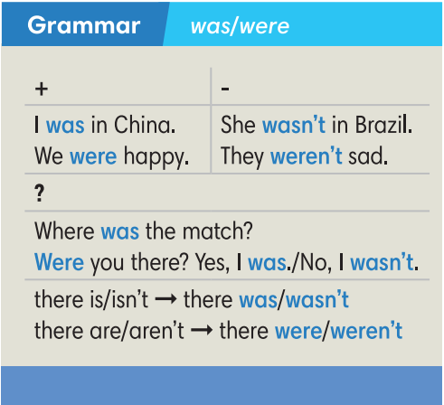
ACTIVITY 4: PRACTICE (10’)
Aim: To practice using “was/were” to talk about events in the past.
Content: Ss work in pairs to do Exercise 3 in the textbook and then work individually to complete exercise 4 under the instruction of T.
Products: Ss are able to apply what they’ve learned about the grammatical points in the previous activity to accomplish the given tasks.
Implementation:
Step 1: Task delivering  T asks Ss to work in pairs to complete the second part of the interview with the correct forms of “was” or “were”.  Step 2: Task performance  Ss work in pairs to complete the second part of the interview with the correct forms of “was” or “were”.  Step 3: Report and discussion  T calls some pairs to read the interview.  Step 4: Judgment  T plays audio track 6.03 to check their answers. | Exercise 3: Complete the second part of the interview with the correct forms of “was” or “were”. Listen and check.  Answers:  2. was  3. wasn’t  4. was  5. were  6. weren’t  7. were  8. was  9. was
Step 1: Task delivering  T instruct S to do the task  Step 2: Task performance  Ss work individually to complete exercise 4. They may swap the books to check with their partners.  Step 3: Judgment  T calls some Ss to go to the board to check their answers.  Step 4: Report and discussion  T develops further discussion if needed | Exercise 4: Complete the dialogue between Lisa and her gran with the correct forms of “there was” or “there were”.  Answers:  2. there wasn’t 3. there was  4. Were there 5. there weren’t  6. there weren’t 7. there was  8. Was there  9. there was.
ACTIVITY 5: FURTHER PRACTICE (10’)
Aim: To apply “was/were” in a situation.
Content: Ss work in pairs to roleplay and talk about time when you were a player in a sports match with the guidance of T.
Products: Ss are able to use the grammar structure of was and were to perform the task.
Implementation:
Step 1: Task delivering  T instruct S to do the task  Step 2: Task performance  Ss work in pairs to roleplay: one is a grandchild and one is grandpa/ grandma.  Context: grandchild makes at least 4 questions to ask about grandpa/ grandpa schooldays.  T walks around to help where necessary.  Step 3: Report and discussion  T invites some pairs to roleplay in front of the class.  Step 4: Judgment  T and other Ss give comments. | Exercise 6: In pairs, use the questions in Exercise 5 to ask and answer about time when you were a player in a sports match. (Adaptation)  Suggested answers:  A: Were there 50 students in your class?  B: No, there weren’t.
HOME ASSIGNMENT  - T assigns the home assignments.  - Ss copy their home assignments.  - T explains it carefully. | Do exercises on Workbook page 53.  Prepare Lesson 6.3 – Reading and Vocabulary.
----------- ----------
Teaching date : ……………………………
Period: 57
UNIT 6: A QUESTION OF SPORT
Lesson 6.3: Reading and Vocabulary (Time: 1 period)
I. OBJECTIVES
By the end of the lesson, students are expected to achieve the following objectives:
Knowledge:
Vocabulary (Places to play sport): basketball court, tennis court, football field/pitch, swimming pool, running track.
Competencies:
General competencies:
Strengthen group work and independent working, pair work, linguistic competence, cooperative learning and communicative competence.
Specific competencies:
Improve communicative competencies related to reading skills and use of language (vocabulary, phonetics, grammar)
For a language lesson: Students are expected to know the meaning of the keywords and phrases used to talk about their favorite sports, and understand the main grammatical points, then do the tasks assigned in the textbook.
For a skills lesson: Students are expected to find specific details in a text and talk about places to play sports.
Qualities:
Being hard-working and attentive in class
Being collaborative while doing in-class exercises
Being respectful and active listening when having a conversation about each other's favorite sport.
II. PREPARATIONS
Teacher: Textbooks, paper, TV, projector, loudspeaker
Students: Textbooks, notebooks
III. PROCEDURE
ACTIVITY 1: WARM-UP (5’)
Aim: To attract Ss’ attention to the lesson and review the previous lesson.
Content: Ss work as a whole class to play the game under instruction of T.
Products: Ss are able to make as many sentences using was/were to show the differences between 2 pictures.
Implementation:
TEACHER AND STUDENTS’ ACTIVITIES | CONTENTS
Find the differences  Step 1: Task delivering  T shows 2 pictures on the Resource 67 worksheet on the screen.  Step 2: Task performance  Ss work in pairs to make as many sentences using was/were to show the differences between 2 pictures as they can in 3 minutes.  Step 3: Report and discussion  T calls some pairs to share their ideas.  Step 4: Judgment  Check with the whole class. | RESOURCE 67 Unit 6 Lesson 2  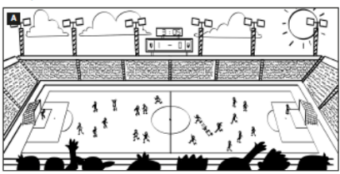  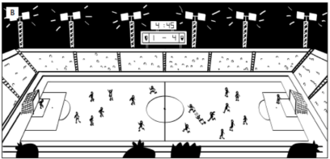  Answers (in any order):  In picture A it was five past three, but in picture B it is a quarter to five.  In picture A there were lots of/a lot of people/fans, but in picture B there aren’t (many).  In picture A the lights were off, but in picture B they are on.  In picture A there were eleven players on both teams, but in picture B one team has only nine players.  In picture A the score was 1–0 but in picture B it is 1–4.
ACTIVITY 2: KNOWLEDGE FORMATION (5’)
Aim: To introduce the objectives of the lesson with a can-do statement.
Content: The objective of the lesson is listed as below
I can find specific details in a text and talk about places to play sports.
Products: Ss acknowledge the lesson’s objectives.
Implementation: T introduces objectives to Ss.
ACTIVITY 3: PRE-READING (10’)
Aim: To get students’ interest in the topic “sports star”.
Content: Ss work in groups with the guidance from T to discuss and vote for the mostpopular sports stars in Vietnam.
Products: Ss are able to ask and explain to each other about their memories of their first day at school, as well as recall related vocabulary.
Implementation:
TEACHER AND STUDENTS’ ACTIVITIES | CONTENTS
Set the scene  Step 1: Task delivering  T raises the question: What kinds of sports are you interested in?  Step 2: Task performance  Ss discuss with friends to vote for the most popular sports stars in Vietnam.  Step 3: Report and discussion  Invite some Ss to present their works.  Step 4: Judgment  Check with the whole class. | Exercise 1: Who is the most popular sports star in your country?  The answers may vary.
ACTIVITY 4: WHILE-READING (20’)
Aim:To help students practice reading skills with some reading comprehension tasks.
Content: Ss work individually and in pairs under the instruction from T to do the given reading-related exercises respectively.
Products: Ss are able to accomplish the given exercises as much as they can.
Implementation:
Step 1: Task delivering  T elicits the sports shown in the photos before Ss do the exercise.  T asks Ss to read the texts and complete the exercise individually.  Step 2: Task performance  Ss to read the texts and complete the exercise individually.  Step 3: Judgment  Ss swap to compare the answers.  T checks their answers.  Step 4: Report and discussion  T develops further discussion if needed. | Exercise 2: Read the texts and complete the table. If you can’t find the information in the texts, try to guess the answers from the photos.  Answers:  *Age of sportspeople is due to the year the lesson is taught.
   | Country | Sports | Age
  Lan’s mother | Vietnam | swimming | Vary
  Garnine Muguruza | Spain | tennis | Vary
  Dina Asher Smith | Britain | running | Vary
  Kristaps Porzingis | Latvia | basketball | Vary
Step 1: Task delivering  T instruct S to do the task  Step 2: Task performance  T asks Ss to read the texts again and tell Ss that they should look for information in the texts which shows whether the sentences are true or false.  T explains that if they can’t find the information in the texts, the correct answers are probably “doesn’t say”.  Step 3: Judgment  After that, T elicits the answers and the references from the texts.  Step 4: Report and discussion  T develops further discussion if needed | Exercise 3: Read the texts again. Match the sentences ✓ (right), X (wrong) or ? (doesn’t say)  Answers:  1. X  2. ✓  3. ?  4. ✓  5. X  6. ?  7. ✓  8. ?
Step 1: Task delivering  T asks Ss to read all the words in the Vocabulary Box.  T asks Ss to match the words with the photos.  Step 2: Task performance  Ss do the exercise as guided by T.  Step 3: Judgment  T checks by a game: Ss match the definitions to the words.  Step 4: Report and discussion  T develops further discussion if needed. | Exercise 4: Study the Vocabulary Box. Which places can you see in the photos?  Answers:  A. swimming pool  B. tennis court  C. running track  D. basketball court.
Quiz  Step 1: Task delivering  T adapts this exercise into a quiz.  T shows sentences one by one, giving some minutes to write the answers in pairs.  Step 2: Task performance  Ss write the answers in pairs.  Step 3: Judgment  T shows the answers to check.  Step 4: Report and discussion  T develops further discussion if needed. | Exercise 5: In pairs, complete the text with one word in each gap.  Answers:  2. track  3. courts  4. court  5. pool
ACTIVITY 5: POST READING (5’)
Aim: To practice speaking in pairs to talk about favourite sports and sportspeople.
Content: Ss work in groups of 3 to practice to ask and answer the given questions in Exercise 6.
Products: Ss are able to get the idea of how to develop a short speech about sports in general.
Implementation:
Interview  Step 1: Task delivering  T instruct S to do the task  Step 2: Task performance  Ss find 3 partners to ask and answer the questions in exercise 6, then fill in the table.  T elicits some expressions to answer the questions.  Ss complete the task within about 5 minutes.  Step 3: Report and discussion  T calls some to report to the class.  Step 4: Judgment  Check with the whole class. | Exercise 6: In pairs, ask and answer the questions below.  Suggestion:  My favourite sport is … and my favourite star is …  Sports stars earn a lot of money. They are very popular.  Sports stars work very hard. They can get injured.
  Questions | F1 | F2 | F3
  1.
  2.
HOME ASSIGNMENT  - T assigns the home assignments.  - Ss copy their home assignments.  - T explains it carefully. | Do exercises on Workbook page 54.  Prepare Lesson 6.4 – Grammar 2.
----------- ----------
Teaching date : ……………………………
Period: 58
UNIT 6: A QUESTION OF SPORTS
Lesson 6.4: Grammar 2 (Time: 1 period)
I. OBJECTIVES
By the end of the lesson, students are expected to achieve the following objectives:
Knowledge:
Grammar: Past Simple affirmative (regular and irregular forms)
Competencies:
General competencies:
Form and improve such competencies as group work and independent working, pair work, linguistic competence, cooperative learning and communicative competence.
Specific competencies:
Improve communicative competencies related to the use of language (vocabulary, phonetics, grammar)
For a language lesson: Students are expected to understand the main grammatical points, then do the tasks assigned in the textbook.
For a skills lesson: Students are expected to use the main grammatical structure to practice talking about events in the past.
Qualities:
Being hard-working and attentive in class
Have a positive attitude towards the lesson
II. PREPARATIONS
Teacher: Textbooks, paper, TV, projector, loudspeaker
Students: Textbooks, notebooks
III. PROCEDURE
ACTIVITY 1: WARM-UP (5’)
Aim: To attract Ss’ attention to the lesson and review the previous lessons.
Content: Ss work in 4 big groups to play the game called “Hot seat” under the monitor of T.
Products: Ss are able to use the vocabulary from the previous lesson to guess the words.
Implementation:
TEACHER AND STUDENTS’ ACTIVITIES | CONTENTS
Hot seat  Step 1: Task delivering  T shows things related to some sports.  Step 2: Task performance  4 Ss from 4 big groups play at a time. They are not allowed to see the pictures on the screen. The others do actions as clues for them to guess.  Step 3: Judgment  T checks the performance with the whole class.  Step 4: Report and discussion  T develops further discussion if needed. | Review of the Sport Vocabulary  Suggested answers: basketball, tennis, football, swimming, running, …
ACTIVITY 2: KNOWLEDGE FORMATION (5’)
Aim: To introduce the objectives of the lesson with a can-do statement.
Content: The objective of the lesson is listed below. I can use Past Simple to talk about events in the past.
Products: Ss acknowledge the lesson’s objectives.
Implementation:
ACTIVITY 3: PRESENTATION (10’)
Aim: To teach Past simple forms with regular and irregular verbs and how to pronounce “V-ed”.
Content: Ss work individually and in pairs under the instruction of T to complete the given exercises respectively.
Products: Ss are able to accomplish the given exercises, grasp the pronunciation of the -ed sounds in past regular verbs, and how to form verbs in past tense.
Implementation:
TEACHER AND STUDENTS’ ACTIVITIES | CONTENTS
Set the scene  Step 1: Task delivering  T shows the photo in the book and introduces the context.  Step 2: Task performance  T plays the audio track 6.05 for Ss to read and listen to find out the sport Sol is doing.  T goes through the Out of class Box with Ss.  Step 3: Report and discussion  T asks Ss to explain the expressions in the box.  Step 4: Judgment  Check with the whole class. | Exercise 1: Look at the photo. What sport is Sol doing? Listen and check.  Answers: Sol is jogging/ running.  Out of class box explanation:  “Good shot!” is used when someone kicks or hits a ball very well (i.e in football).  “What’s wrong?” is asked when you see someone sad or ill.  “Poor you!” is used to show sympathy.  “When’s it on?” is used to find out about the time of a film at the cinema, a program on TV or a show on the radio.
Step 1: Task delivering  T asks Ss to find the verbs in the dialogue: ask, happen, move, start, stop, try, walk, want.  Step 2: Task performance  T elicits regular verbs from these examples.  T explains to Ss that to put the sentences into Past simple tense we add “-ed” at the end of regular verbs.  T goes through the examples in the Grammar box with Ss.  T asks Ss to write the past form of the verbs in the list on the board.  T asks Ss to try to work out how to spell the past form in the exercise without looking at the dialogue.  Step 3: Judgment  T checks the performance with the whole class.  Step 4: Report and discussion  When they are ready, T goes through the correct spelling for each past form and elicits the spelling rules they correspond to. | Exercise 2: Study the Grammar A box. Write the Past Simple form of the verbs below. Find them in the dialogue and check.  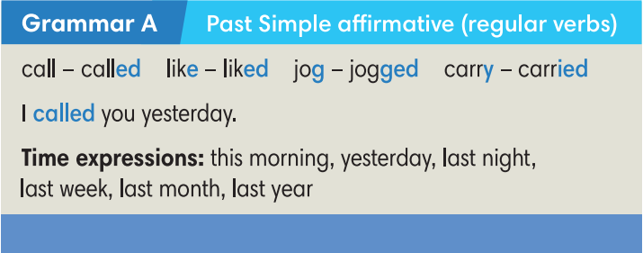  Answers: asked, happened, moved, started, stopped, tried, walked, wanted.
Step 1: Task delivering  T discusses the pronunciation rules with Ss.  Step 2: Task performance  T asks Ss to put their fingers against the throat to feel the difference between the vibrations that accompany voiced consonants and the lack of vibrations that accompany voiceless consonants.  T uses drilling and correction to help Ss to remember the correct pronunciation for the different past form verbs.  T plays audio track 6.06 for Ss to listen and repeat the words.  Step 3: Judgment  T checks the performance with the whole class.  Step 4: Report and discussion  T develops further discussion if needed.  Try Me  Step 1: Task delivering  T asks Ss to apply spelling rules to change some verbs into Past simple forms.  Step 2: Task performance  Ss work in pairs to sort these regular verbs into 3 categories and practice pronouncing them.  Step 3: Judgment  T checks by odd one out activity.  Step 4: Report and discussion  T develops further discussion if needed. | Exercise 3: Look at the table. Listen and repeat.  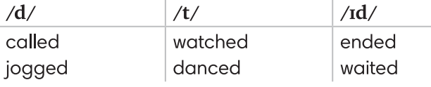  Verb list: play, cook, work, study, stop, want, arrive, learn, add, look, ask, smile, start, brush, listen, love
Step 1: Task delivering  T shows a sentence and asks Ss to decide if it’s true or false and why.  Step 2: Task performance  T elicits irregular verbs.  T explains that there are no real patterns for irregular verbs, they just need to learn them as individual vocabulary items.  T asks Ss to try to find the past forms of these irregular verbs in the dialogue. It’s OK if they can’t find them.  Step 3: Judgment  T plays audio track 6.07 for Ss to listen and check.  Step 4: Report and discussion  T develops further discussion if needed | Exercise 4: Find the Past Simple form of these verbs in the dialogue and complete the Grammar B box. Listen and check.  Sentence to elicit can be: My dad comed home late yesterday.  Answers:
  come - came  do - did  get - got  go - went  have - had | put - put  run - ran  see - saw  take - took  win - won
ACTIVITY 4: PRACTICE (15’)
Aim: To practice completing sentences with Past simple forms of the verbs.
Content: Ss work individually to complete the given tasks and then in 4 groups to play the game to strengthen their grammar skills.
Products: Ss are able to complete the tasks with correct answers and apply what they’ve learned about regular verbs in past tense to play the game.
Implementation:
Step 1: Task delivering  T asks Ss to do the exercise individually.  T tells Ss that if there are any verbs they don’t know the past forms, they can refer to the irregular verbs list on page 110.  T explains that if they can’t find the verbs in that list, they are regular verbs.  Step 2: Task performance  Ss do the exercise individually.  Step 3: Report and discussion  T calls some Ss to go to the board and write their answers.  Step 4: Judgment  T plays the audio track 6.08 for Ss to check.  T elicits the correct answers and checks the pronunciation. | Exercise 5: Complete Lily’s story with the Past Simple form of the verbs in brackets. Listen and check.  Answers:  2. stopped  3. started  4. found  5. saw  6. asked  7. said  8. gave  9. smiled
Pennalism  Step 1: Task delivering  The class plays in 4 groups.  Step 2: Task performance  Ss take turns to turn over 2 random cards: one infinitive card and one past form card. If they match, Ss get a point. If they can make a sentence with that verb, they get an extra point.  Step 3: Judgment  T checks the performance with the whole class.  Step 4: Report and discussion  T develops further discussion if needed. | Teacher Resource’s Book Unit 6_4: Resource 69  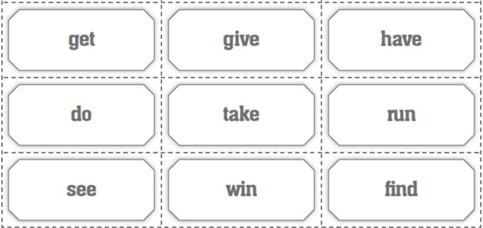  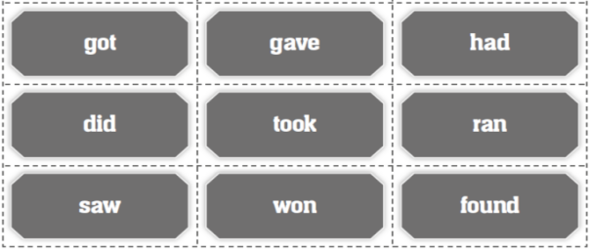
ACTIVITY 5: FURTHER PRACTICE (5’)
Aim: To write sentences in Past simple forms.
Content: Ss work as a whole class to carry out the Exercise 6 with the guidance from
Products: Ss are able to use grammar structure and vocabulary from the lesson
Implementation:
Step 1: Task delivering  T instruct S to do the task  Step 2: Task performance  Each student writes 2 sentences about themselves using Past Simple tense. One sentence is true and one sentence is false.  Ss walk around the class and read their two sentences for their friends to decide which is true and which is false and identify the wrong information.  Step 3: Judgment  Ss get 1 point when their friends make wrong guesses.  T monitors and helps where necessary.  Step 4: Report and discussion  T develops further discussion if needed. | Exercise 6: Let’s play the truth game! Work in pairs. Go to page 111.  Student A: Write two sentences about yourself in the Past Simple. Make sure one sentence is true. One sentence is false. Read them aloud to Student B.  Student B: Guess the false one. Then change the role.  Suggestion:  A: I went jogging in the park yesterday. I had Pho this morning  B: “You went jogging in the park yesterday” is true. “You had Pho this morning” is false. You had bread.
HOME ASSIGNMENT  - T assigns the home assignments.  - Ss copy their home assignments.  - T explains it carefully. | Do exercises on Workbook page 55.  Prepare Unit 6.5 – Listening and Vocabulary.
----------- ----------
Teaching date : ……………………………
Period: 59
UNIT 6: A QUESTION OF SPORTS
Lesson 6.5: Listening and Vocabulary (Time: 1 period)
I. OBJECTIVES
By the end of the lesson, students are expected to achieve the following objectives:
Knowledge:
Vocabulary (Sport competitions): Cup, league, tournament, final, semi-final
Grammar: Past Simple affirmative
Competencies:
General competencies:
Form and improve such competencies as group work and independent working, pair work, linguistic competence, cooperative learning and communicative competence.
Specific competencies:
Improve communicative competencies related to listening skills and use of language (vocabulary, phonetics, grammar)
For a language lesson: Students are expected to know the meaning of the keywords used to talk about sports competition, and understand the main grammatical points, then do the tasks assigned in the textbook.
For a skills lesson: Students are expected to find specific details in a radio programme, and use speaking skills to practice talking about a sporting moment.
Qualities:
Being hard-working and attentive in class
Being collaborative while doing in-class exercises
Being active when sharing memorable sporting moments.
II. PREPARATIONS
Teacher: Textbooks, paper, TV, projector, loudspeaker
Students: Textbooks, notebooks
III. PROCEDURE
ACTIVITY 1: WARM-UP (5’)
Aim: To attract Ss’ attention to the lesson and review the previous lesson.
Content: Ss work in pairs to play the game called “Wheel of fortune”.
Products: Ss are able to use the grammar structure they’ve learned to play the game and try to win.
Implementation:
TEACHER AND STUDENTS’ ACTIVITIES | CONTENTS
Wheel of fortune  Step 1: Task delivering  T instruct S to do the task  Step 2: Task performance  Ss contribute verbs (regular and irregular) to the wheel.  Ss pair up to play this game.  T spins the wheel to choose the verbs.  Step 3: Judgment  Ss make sentences in Past simple to get the points.  Step 4: Report and discussion  T develops further discussion if needed | Review of the Past Simple.  The verbs can vary, due to Ss’ ideas.
ACTIVITY 2: KNOWLEDGE FORMATION (5’)
Aim: To introduce the objectives of the lesson with a can-do statement.
Content: The objective of the lesson is listed below
I can identify specific details in a sports program and talk about a sports match.
Products: Ss acknowledge the lesson’s objectives.
Implementation: T introduces objectives to Ss.
ACTIVITY 3: PRE-LISTENING (5’)
Aim: To provide some words about sports competitions.
Content: Ss work in pairs to study the Vocabulary Box with the help from T and then discuss in groups of 4 to answer given questions.
Products: Ss are able to grasp the meaning of the vocabulary related to the topic and use them in their group discussion.
Implementation:
TEACHER AND STUDENTS’ ACTIVITIES | CONTENTS
Step 1: Task delivering  T elicits to the topic.  Step 2: Task performance  T shows words in the Vocabulary box and asks Ss to read the words.  T gives and checks their meanings by asking Ss to do a matching activity.  Ss write their answers in their notebooks.  Step 3: Judgment  T and Ss check.  Step 4: Report and discussion  Ss discuss in groups of 4 to answer 2 questions in exercise 1. | Exercise 1: Study the Vocabulary Box. Check if you understand the words. In pairs, answer the questions below.
  cup | is made of gold or silver and given as a prize of a competition
  league | A group of sports teams taking part in competitions between each other
  tournament | A sports competition that teams must leave when they lose. The competition continues until there is only the winner left.
  final | the last of a series of games or competitions, in which the winner is decided
  semi-final | one of the two games that are played to decide who will take part in the final round.
ACTIVITY 4: WHILE-LISTENING (20’)
Aim: To practice listening skills with listening comprehension tasks.
Content: Ss listen to the audio and then work in pairs to do the given tasks with the guidance from T.
Products: Ss are able to accomplish the given exercise and strengthen their vocabulary and knowledge in grammar.
Implementation:
Set the scene  Step 1: Task delivering  T says: “You are going to listen to a radio phone-in. There are 5 speakers: an interview and 4 different people there.”  Lead to the listening: T asks Ss to listen to audio track 6.09 and match the speakers with the information.  Step 2: Task performance  T plays the audio track.  Ss listen and take notes.  Step 3: Judgment  T checks the answers.  Step 4: Report and discussion  T develops further discussion if needed | Exercise 2: Listen to a radio phone-in and match the speakers (1-4) with the information (a-d).  Answers:  1-c, 2-a, 3-d, 4-b.
Step 1: Task delivering  Before Ss listen again, T asks them to read the questions and to look at the pictures carefully.  Step 2: Task performance  T plays audio track 6.10 for them to listen.  Ss listen, take notes and choose the correct answers.  Step 3: Report and discussion  After that, T calls some Ss to give their answers and explain why they choose.  Step 4: Judgment  T elicits the answers and explains more if necessary. | Exercise 3: Listen again and choose the correct answers.  Answers:  C  C  B  A
Step 1: Task delivering  T asks Ss to review the Present Simple and the Past Simple before they do the exercise, especially the forms and signals.  T asks Ss to read the sentences and use the correct form of the verbs to complete the sentences.  Step 2: Task performance  Ss work in pairs.  Step 3: Judgment  T plays audio track 6.11 to check.  Step 4: Report and discussion  T develops further discussion if needed.  True or False Game  Step 1: Task delivering  T gives Ss 20 seconds to review sentences in Exercise 4.  Step 2: Task performance  Ss play the game with their books closed.  T shows wrong sentences on the screen. They can be wrong in tense, spelling, etc….  Ss say “BINGO” when they know what makes the sentences wrong and how to correct them.  Step 3: Judgment  T checks the performance with the whole class.  Step 4: Report and discussion  T develops further discussion if needed. | Exercise 4: Complete the sentences with the correct form of the verbs below. Listen and check.  Answers:  goes, won  lost  goes, plays, does, plays  Sentences:  Ferrari won the Wimbledon tennis tournament in 2016.  Andy Murray  Emma often went running.  goes  Liverpool was in the cup final but they lose the game 2-1.  lost  Jim has jogging every morning.  goes  At weekends, he does badminton and plays judo.  plays/ does
Step 1: Task delivering  T tells the Ss to work individually to do the exercise.  Step 2: Task performance  Ss work individually to do the exercise.  Step 3: Judgment  After that, T asks Ss to compare their answers with their partners.  T plays audio track 6.12 to check their answers.  Step 4: Report and discussion  T develops further discussion if needed. | Exercise 5: Choose the correct options. Listen and check.  Answers:  2. do  3. play  4. play for  5. won  6. scored  7. lost
ACTIVITY 5: POST-LISTENING (10’)
Aim: To talk about a sporting moment when you were really happy or sad.
Content: Ss work in groups of 4 to talk about a sporting moment when they were really happy or sad.
Products: Ss are able to share their ideas with the class using correct grammar structure and the vocabulary they’ve learned in the lesson.
Implementation:
Step 1: Task delivering  T guides how to complete the task and then gives Ss some suggestions to use.  Step 2: Task performance  Ss may use their imagination to make up a story about a sporting moment.  T gives them a minute to think of their ideas and puts them into groups of 4.  T walks around for help.  Step 3: Report and discussion  T calls some groups to share their ideas with the class.  Step 4: Judgment  The whole class vote for the most interesting sporting moment. | Exercise 6: In groups, talk about a sporting moment when you were really happy or sad. Use these ideas below to help you.  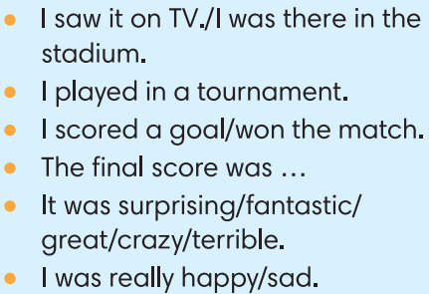
HOME ASSIGNMENT  - T assigns the home assignments.  - Ss copy their home assignments.  - T explains it carefully. | Do exercises on Workbook page 56.  Prepare Lesson 6.6 – Speaking.
----------- ----------
Teaching date : ……………………………
Period: 60
UNIT 6: A QUESTION OF SPORTS
Lesson 6.6: Speaking (Time: 1 period)
I. OBJECTIVES
By the end of the lesson, students are expected to achieve the following objectives:
Knowledge:
Vocabulary: Sports
Grammar: Present simple
Competencies:
General competencies:
Form and improve group work and independent working, pair work, linguistic competence, cooperative learning and communicative competence.
Specific competencies:
Improve communicative competencies related to speaking skills and use of language (vocabulary, phonetics, grammar)
For a language lesson: Students are expected to know the meaning of the key phrases used in talking about what and how interested they are in some activities, and understand the main grammatical points, then do the tasks assigned in the textbook.
For a skills lesson: Students are expected to use their speaking skills to practice talking about hobbies and interests.
Qualities:
Being hard-working and attentive in class
Have a positive attitude towards the lesson
Being polite and open-minded when listening to others’ hobbies and interests

II. PREPARATIONS
Teacher: Textbooks, TV, projector, loudspeaker
Students: Textbooks, notebooks
III. PROCEDURE
ACTIVITY 1: WARM-UP (10’)
Aim: To attract Ss’ attention to the lesson and review the previous lesson.
Content: Ss work in groups of 4 to work on the worksheet under the instruction of T.
Products: Ss are able to match the given verbs with corresponding nouns to make phrases about sports.
Implementation:
TEACHER AND STUDENTS’ ACTIVITIES | CONTENTS
Add three  Step 1: Task delivering  T instruct S to do the task  Step 2: Task performance  Ss work in groups of 4.  T gives each group a Worksheet (RESOURCE 71).  T guides how to complete the worksheet.  Ss discuss in groups and complete the task.  Step 3: Judgment  T and Ss check together.  Step 4: Report and discussion  T develops further discussion if needed. | Teacher’s resource book Unit 6_6: Resource 71  Match two of the words below with each verb. Then write three more words of your own for  each verb.  Answers:  play: football, ice hockey (basketball, tennis, golf, cricket, rugby, badminton)  do: aerobics, gymnastics (karate, judo, exercise, archery)  go: cycling, swimming (sailing, jogging, running, walking, climbing, skiing, skateboarding)  win/lose: 3–0, the cup (the tournament, 2–1, 34 points to 17, in the final)  play for: the school team, England (your local club, your country, a new team)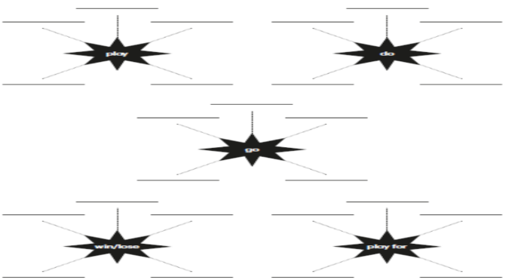
ACTIVITY 2: KNOWLEDGE FORMATION (5’)
Aim: To introduce the objectives of the lesson with a can-do statement.
Content: The objective of the lesson is listed below
I can talk about hobbies and interests.
Products: Ss acknowledge the lesson’s objectives.
Implementation: T introduces objectives to Ss.
ACTIVITY 3: PRE-SPEAKING (15’)
Aim: To learn some phrases to talk about hobbies and interests.
Content: Ss work individually under the instruction of T to do the given exercises and learn the speaking box.
Products: Ss know the meaning of phrases and grammatical structures used to talk about hobbies and interests.
Implementation:
TEACHER AND STUDENTS’ ACTIVITIES | CONTENTS
Set the scene  Step 1: Task delivering  T asks Ss if anyone in the class has ever been interviewed for a radio show or by a newspaper reporter.  Step 2: Task performance  Ss answer.  T asks Ss how they felt when they have been interviewed.  T asks Ss to look at the photo and answer  the questions.  Step 3: Judgment  T elicits the correct answers for Ss.  Step 4: Report and discussion  T develops further discussion if needed | Exercise 1: Look at the photo and answer the questions. Go to page 112 and check.  Answers:  1. Max is in the skateboard park.  2. He’s talking to a reporter from South radio.
Step 1: Task delivering  T asks Ss to listen and read the interview.  Step 2: Task performance  T plays audio track 6.13 for Ss to listen to answer the question in exercise 2.  Step 3: Judgment  T confirms the answer.  Step 4: Report and discussion  T goes through the Out of class box, explains that we use “to be honest, ...” when we are giving our opinion and know that it might not be what the other person wants to hear. | Exercise 2: Read or listen. What does Max do in his free time?  Answer:  He hangs out with friends, dances, plays football, goes cycling and goes skateboarding.
Step 1: Task delivering  T asks Ss to study the Speaking box and underline examples of the phrases in the dialogue.  Step 2: Task performance  T asks Ss to read aloud all the sentences and phrases in the box.  Step 3: Judgment  T points out the meanings of the phrases in the box.  Step 4: Report and discussion  T develops further discussion if needed. | Exercise 3: Study the speaking box. Find examples of the phrases in the dialogue.  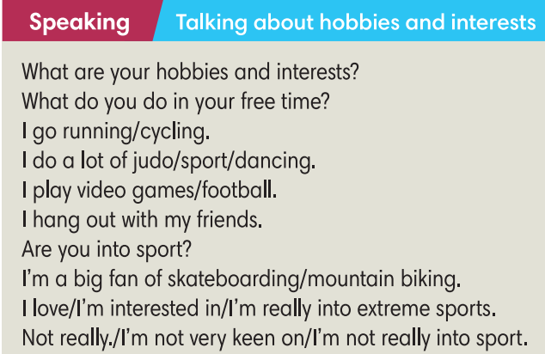
ACTIVITY 4: WHILE SPEAKING (10’)
Aim: To practise using the phrases to talk about hobbies and interests in context.
Content: Ss work in pairs and individually as instructed by T to complete exercises.
Products: Ss are able to complete the dialogue with appropriate phrases and then practice the dialogue.
Implementation:
Step 1: Task delivering  T asks Ss to work in pairs to complete the text.  Step 2: Task performance  Ss work in pairs to complete the text.  Step 3: Judgment  T calls some Ss to give their answers and checks for them.  Step 4: Report and discussion  T asks Ss if anyone in the class is a sports fanatic and explains that word for them. | Exercise 4: In pairs, complete the text with one verb in each gap.  Answers:  2. does  3. goes  4. is  5. is  6. hangs
Step 1: Task delivering  T guides Ss how to do this exercise and asks them to do it individually.  Step 2: Task performance  Ss do this exercise individually.  Step 3: Judgment  Ss swap their books to compare the answers.  T confirms the answers.  Step 4: Report and discussion  T puts Ss into pairs and tells them to roleplay: one plays as Jay and the other gives their own response.  T calls some pairs to share their unique dialogue. | Exercise 5: Complete the dialogue with sentences a-h. There are 3 extra sentences. Listen and check.  Answers: 2-d, 3-h, 4-a, 5-g
ACTIVITY 5: POST-SPEAKING (5’)
Aim: To act out a dialogue of hobbies and interests.
Content: Ss work in pairs for further practice as instructed by T.
Products: Ss are able to talk about your hobbies and interests using the correct grammar structures and vocabulary.
Implementation:
Step 1: Task delivering  T asks Ss to work in pairs to ask and answer questions in a similar way to what was done in Exercise 5.  T brainstorms some questions they may use in their dialogues.  Step 2: Task performance  Ss work in pairs to ask and answer questions in Exercise 5.  T walks around and helps if necessary.  Step 3: Report and discussion  After 5 mins, T calls some pairs to act out the dialogue.  Step 4: Judgment  T gives feedback. | Exercise 5: In pairs, talk about your hobbies and interests. Tell the class about your partner.  Suggested questions:  What do you do in your free time?  Do you do a lot of exercise?  Do you play for a school team?
HOME ASSIGNMENT  - T assigns the home assignments.  - Ss copy their home assignments.  - T explains it carefully. | Do exercises on Workbook page 76.  Prepare Lesson 6.7 – English in use.
----------- ----------
Teaching date : ……………………………
Period: 61
UNIT 6: A QUESTION OF SPORTS
Lesson 6.7: English in Use (Time: 1 period)
I. OBJECTIVES
By the end of the lesson, students are expected to achieve the following objectives:
Knowledge:
Grammar: Past Simple
Competencies:
General competencies:
Form and improve group work and independent working, pair work, linguistic competence, cooperative learning and communicative competence.
Specific competencies:
Improve communicative competencies related to writing skills and use of language (vocabulary, phonetics, grammar)
For a language lesson: Students are expected to know the usage of “ago” in past tense, and understand the main grammatical points, then do the tasks assigned in the textbook.
For a skills lesson: Students are expected to use their writing skills to practice writing about a sport game they played recently.
Qualities:
Being hard-working and attentive in class
Being collaborative while doing in-class exercises
II. PREPARATIONS
Teacher: Textbooks, paper, handouts of Teacher’s Resource Book 41, TV, projector, loudspeaker
Students: Textbooks, notebooks
III. PROCEDURE
ACTIVITY 1: WARM-UP (5’)
Aim: To attract Ss’ attention to the lesson and review the previous lesson.
Content: Ss work in groups of 4 to brainstorm ideas compared themselves when they were 7 to they are now under the instruction of T.
Products: Ss are able to use the Past Simple tense to complete the speech and present in the class.
Implementation:
TEACHER AND STUDENTS’ ACTIVITIES | CONTENTS
Step 1: Task delivering  T gives Ss a task: compare when you were 7 and you are now.  Step 2: Task performance  Ss work in groups of 4 to brainstorm ideas.  T elicits the tense to use when they talk about the past and present.  T walks around to take notes.  Step 3: Report and discussion  T calls some volunteers to present in the class.  Step 4: Judgment  Check with the whole class. | Example:  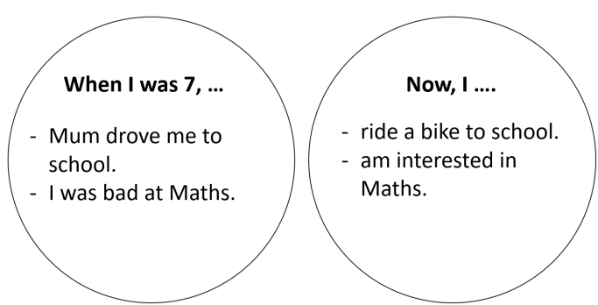
ACTIVITY 2: KNOWLEDGE FORMATION (10’)
Aim: To introduce the objectives of the lesson with a can-do statement.
Content: The objective of the lesson is listed as below
I can use “ago” to talk about events in the past.
Products: Ss acknowledge the lesson’s objectives.
Implementation: T introduces objectives to Ss.
ACTIVITY 3: PRESENTATION (15’)
Aim: To teach how to use “ago” to talk about events in the past.
Content: Ss work as a whole class to do the assigned tasks with the instruction from T.
Products: Ss are able to accomplish the given exercises and get the grammar rules of “ago”.
Implementation:
TEACHER AND STUDENTS’ ACTIVITIES | CONTENTS
Set the scene  Step 1: Task delivering  People in the past were big fans of sports. Lots of sports today started a thousand years ago.  T shows 2 sets of pictures for Ss to match: set 1 concludes 4 pictures in Exercise 1. Set 2 are their corresponding pictures nowadays.  T gives 4 phrases to match these pictures: motor racing, team sports, running, weight training.  T checks if Ss know the meanings of the words “prehistoric”, “Ancient Romans” and “Ancient Egyptians”.  Step 2: Task performance  T asks Ss to open their books and tells them that they are going to find out some interesting events in the past. T asks them to describe the pictures.  A- People are running away from a bear.  B- People are pulling stones to build pyramids.  C- The teams are gladiators or slaves fighting against wild animals.  D- The cars are travelling very slowly, following the man with the red flag.T asks Ss to do Exercise 1 individually.  Ss work individually to complete Exercise 1.  Step 3: Judgment  T confirms the answers.  Step 4: Report and discussion  T develops further discussion if needed. | Exercise 1: Match pictures A-D with captions 1-4.  Answers:  1. C  2. D  3. A  4. B
Step 1: Task delivering  T instruct S to do the task  Step 2: Task performance  T asks when the events in these pictures took place and elicits the time expressions for Past simple.  Step 3: Judgment  T checks the meaning and use of “ago”.  Step 4: Report and discussion  T develops further discussion if needed. | Exercise 2: Study the Language Box. How do you say the phrases in your language?  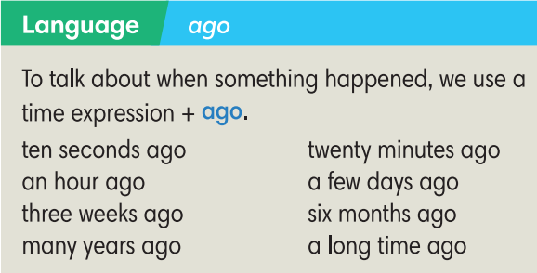
ACTIVITY 4: PRACTICE (10’)
Aim: To practice making sentences with “ago”.
Content: Ss work individually then in pairs under the instruction of T to complete the given exercises.
Products: Ss can strengthen their knowledge about grammatical points.
Implementation:
Step 1: Task delivering  T guides how to complete Exercise 3.  Step 2: Task performance  Ss work individually then in pairs to compare the answers.  Step 3: Judgment  T confirms the answers.  Step 4: Report and discussion  T develops further discussion if needed. | Exercise 3: In pairs, work out how long ago these things happened.  Answers depend on the year the lesson is taught.
Step 1: Task delivering  T puts Ss into pairs and tells them to work together to think of the missing words.  T explains that the missing words could be grammatical or prepositions or vocabulary items relating to the topic of sports.  Step 2: Task performance  Ss to work together to think of the missing words.  Step 3: Report and discussion  T calls some Ss to go to the board and write their answers.  Step 4: Judgment  T plays audio track 6.15 to check the answers on the board. | Exercise 4: Complete the text with one word in each gap. Listen and check.  Answers:  2. do  3. ago  4. medal  5. Last  6. court  7. was  8. for  9. match  10. goals  11. of
ACTIVITY 5: FURTHER PRACTICE (5’)
Aim: To write sentences about a sports game that students played recently.
Content: Ss work in pairs to do the writing task with the help of T.
Products: Ss can write a short paragraph about a sports game that they played recently.
Implementation:
Step 1: Task delivering  T elicits questions as clues for Ss to write.  Step 2: Task performance  T sets a time limit for the writing and walks around to help if necessary.  Step 3: Judgment  After that, T asks Ss to exchange their writings with their partners.  Ss check the grammar and vocabulary for their partners.  Step 4: Report and discussion  T asks some Ss to read aloud their writings.  T gives feedback. | Exercise 5: Write 5-8 sentences about a sports game that you played recently. You can use the text in Exercise 4 as an example. You may answer these questions:  How long ago did you play that sport?  Who did you play with?  Did you win or lose the game?  Why did you stop playing that sport?
HOME ASSIGNMENT  - T assigns the home assignments.  - Ss copy their home assignments.  - T explains it carefully. | Do Exercise 1,2 Students’ Book page 68; Workbook page 58.  Prepare Lesson 6.8 – Pronunciation and Review vocabulary.

----------- ---------
Teaching date : ……………………………
Period: 62
UNIT 6: A QUESTION OF SPORTS
Lesson 6.8: Pronunciation and Vocabulary Revision (Time: 1 period)
I. OBJECTIVES
By the end of the lesson, students are expected to achieve the following objectives:
Knowledge:
Vocabulary: Sports, sportspeople, places to play sports, sports competitions
Pronunciation: 2 sounds /ɪ/ and /aɪ/
Competencies:
General competencies:
Strengthen group work and independent working, pair work, linguistic competence, cooperative learning and communicative competence.
Specific competencies:
Strengthen communicative competence related to pronunciation skills and use of language (vocabulary, phonetics, grammar)
For a language lesson: Students are expected to recall the essential vocabulary of the whole unit, then do the tasks assigned in the textbook.
For a skills lesson: Students are expected to improve their pronunciation by listening to the audio.
Qualities:
Being hard-working and attentive in class
Have a positive attitude towards the lesson
Being collaborative while doing in-class exercises
II. PREPARATIONS
Teacher: Textbooks, handouts from Teacher’s Resource Book 49, bells, paper, TV, projector, loudspeaker
Students: Textbooks, notebooks
III. PROCEDURE

ACTIVITY 1: WARM-UP (5’)
Aim: To attract Ss’ attention to the lesson and review the previous lesson
Content: Ss work in pairs to complete the sentences given by T with one word.
Products: Ss are able to give as many correct answers as they can.
Implementation:
TEACHER AND STUDENTS’ ACTIVITIES | CONTENTS
Quiz  Step 1: Task delivering  T adapts exercise 1 into an interactive activity.  T shows 8 sentences in turns for Ss to write the answer in pairs.  Step 2: Task performance  Ss write the answer in pairs.  Step 3: Judgment  T shows the correct answers on the screen.  Step 4: Report and discussion  T develops further discussion if needed. | Exercise 3 (p.68): In pairs, complete the sentences with one word. (Adaptation)  Answers:  2. in  3. on  4. of  5. go  6. does  7. for  8. match
ACTIVITY 2: KNOWLEDGE FORMATION (5’)
Aim: To introduce the objectives of the lesson.
Content: The objective of the lesson is listed as below
I can pronounce and distinguish 2 sounds /ɪ/ and /aɪ/ and reinforce the vocabulary in Unit 6.
Products: Ss acknowledge the lesson’s objectives.
Implementation:
ACTIVITY 3: PRONUNCIATION (15’)
Aim: To learn how to pronounce 2 sounds /ɪ/ and /aɪ/.
Content: Ss work individually to accomplish the given exercises about pronunciation as instructed by T.
Products: Ss are able to pronounce the sound /ɪ/ and /aɪ/ clearly.
Implementation:
TEACHER AND STUDENTS’ ACTIVITIES | CONTENTS
Presentation  Step 1: Task delivering  T elicits the sounds of the letter I.  Step 2: Task performance  T shows 2 videos about how to pronounce 2 sounds /ɪ/ and /aɪ/.  T asks Ss to watch the video and practise the sounds.  Step 3: Judgment  T checks the performance with the whole class.  Step 4: Report and discussion  T develops further discussion if needed.  Practice  Step 1: Task delivering  T instruct S to do the task  Step 2: Task performance  T plays audio track 6.16 of Exercise 4 twice and asks Ss to listen and find one word in each group with a different pronunciation from the others.  Step 3: Judgment  T elicits the correct answers.  T plays audio track 6.17 of Exercise 5 and asks Ss to listen and repeat  T checks for pronunciation.  Step 4: Report and discussion  T develops further discussion if needed.  Further Practice: Cross the river  Step 1: Task delivering  T shows a word and Ss decide how the letter “i” is pronounced.  Step 2: Task performance  Ss raise their right hands for /ɪ/ sound and left hands for /aɪ/ sound.  Step 3: Judgment  T checks the performance with the whole class.  Step 4: Report and discussion  T develops further discussion if needed. | Exercise 4 (p.68): In pairs, listen and find one word in each group with a different pronunciation from the others. Use the underlined letters to help you.  Answers:  1. fit  2. the Olympics  3. biking  Exercise 5 (p.68): Listen, check and repeat.  Wordlist:  T may choose any words from the list below.  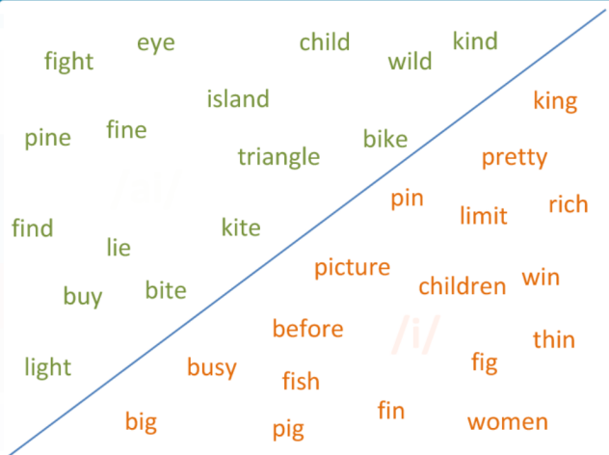
ACTIVITY 4: VOCABULARY (15’)
Aim: To reinforce the vocabulary in Unit 6.
Content: Ss work individually to do the given exercises with the guidance of T.
Products: Ss are able to recall the wordlist of the unit and are able to accomplish the given exercises.
Implementation:
Step 1: Task delivering  T asks Ss to read the sentences in the exercise.  Step 2: Task performance  Ss work individually to do the exercise.  Step 3: Report and discussion  After 3 minutes, T calls some Ss to give their answers.  Step 4: Judgment  T checks for Ss. | Exercise 2 (p.69): Choose the correct options.  Answers:  1. crowd 2. team  3. pool 4. score  5. won 6. play  7. race
HOME ASSIGNMENT  - T assigns the home assignments.  - Ss copy their home assignments.  - T explains it carefully. | Do exercise 1,2,3 Workbook page 59.  Prepare Lesson 6.9 Review grammar.

----------- ---------

