Teaching date : ……………………………
Period 81
UNIT 9: GETTING AROUND
Lesson 9.1: Vocabulary (Time: 1 period)

I. OBJECTIVES
By the end of the lesson, students are expected to achieve the following objectives:
Knowledge:
Vocabulary:
Means of transport: bicycle/bike, bus, car, coach, motorbike, taxi, train, tram, underground/metro
Places in town: bike lane, bus station, bus stop, car park, train station, university
Competencies:
General competencies:
Form and improve such competencies as group work, independent working, pair work, linguistic competence, cooperative learning and communicative competence.
Specific competencies:
Improve communicative competencies related to the use of language (vocabulary, phonetics, grammar)
For a language lesson: Students are expected to know the meaning of the keywords used to talk about transportation and travel, and understand the main grammatical points, then do the tasks assigned in the textbook.
For a skills lesson: Students are expected to use the verbs and phrases about means of transport to practice talking about how to get to school.
Qualities:
Being hard-working and attentive in class
Have a high awareness on traffic issue and transportation safety
II. PREPARATIONS
Teacher: Textbooks, PowerPoint slides, TV, projector, loudspeaker
Students: Textbooks, notebooks
III. PROCEDURE
ACTIVITY 1: WARM-UP (5’)
Aim: To attract Ss’ attention to the lesson and to lead in the new lesson.
Content: Ss work in 2 big groups to take turns to guess the missing letters under the instruction from T.
Products: Ss are able to make as many correct sentences as they can using their vocabulary to win the game and to grasp the meaning of “means of transport”.
Implementation:
TEACHER AND STUDENTS’ ACTIVITIES | CONTENTS
Step 1: Task delivering  T divides the class into two groups.  T shows 3 gapped words and explains that the groups should take turns to guess the missing letters. They win a point for each letter they guess correctly.  Step 2: Task performance  Ss do five rounds.  Step 3: Judgment  The winner is the team with the most points after the last round.  Step 4: Report and discussion  T asks Ss to look at the phrase in Round 5  T elicits what this phrase means and explains that they will be discussing different means of transport in this lesson. | Round 1: north, south, west  Round 2: Antarctica, Europe, Africa  Round 3: island, ocean, mountain  Round 4: email, conversation, tweet  Round 5: means of transport
ACTIVITY 2: KNOWLEDGE FORMATION (10’)
Aim: To introduce the objectives of the lesson with a can-do statement.
Content: The objective of the lesson is listed below
I can talk about means of transport and travel.
Products: Ss acknowledge the lesson’s objectives.
Implementation: T introduces objectives to Ss.
ACTIVITY 3: PRESENTATION (5’)
Aim: To reinforce some means of transport words and teach some new means of transport words.
Content: Ss work individually to study the Vocabulary box and then in pairs to match the words with the photos with the guidance of T.
Products: Ss are able to match the correct words with corresponding photos and grasp the English name of each vehicle.
Implementation:
TEACHER AND STUDENTS’ ACTIVITIES | CONTENTS
Lead-in  Step 1: Task delivering  T asks Ss to look at the interview from the reporter and 2 founders of Travel Challenge about travel.  Step 2: Task performance  T asks Ss to find means of transport in the interview.  T tells Ss to look at pictures A-I on Student’s book on page 90.  T puts Ss in pairs to match the words with the photos.  Step 3: Report and discussion  Invite some Ss to present their works.  Step 4: Judgment  Check with the whole class | Exercise 1: Study the Vocabulary A box. Match the words with photos A-I. Which of these means of transport do you use?  Answers  tram  motorbike  bus  train  taxi  car  bicycle/bike  underground/metro  coach
ACTIVITY 4: PRACTICE 1 (5’)
Aim: To practice making sentences with means of transport.
Content: Ss work in pairs with the guidance from T to take turns to ask and answer about the different means of transport.
Products: Ss are able to accomplish the given exercises using correct grammatical points and the vocabulary related to means of transport.
Implementation:
Step 1: Task delivering  T writes two questions on the board:  How often do you use a/an….?  When did you last use a/an…?  Step 2: Task performance  T asks some Ss to stand up and answer.  The pairs use these question stems to take turns to ask and answer about the different means of transport.  Step 3: Report and discussion  T invites some pairs to share any interesting answers they received.  Step 4: Judgment  Check with the whole class. | I often ride a bike every day.  The last time I used a tram was on holiday last year.  - David uses a bike every day. The last time Sara used a tram was on holiday last year.
ACTIVITY 5: PRESENTATION 2 (5’)
Aim: To reinforce some places in town and teach some new words.
Content: Ss work individually to do the given exercise and give more examples with the guidance from T.
Products: Ss are able to grasp the meaning of the words in the Vocabulary box B and use their listening skills to accomplish the exercise.
Implementation:
Step 1: Task delivering  T elicits the meaning of the words in the Vocabulary box B.  Step 2: Task performance  T asks Ss to give more examples of each in the Ss' town.  T asks Ss to read the notes and to decide what kind of information they should listen out for.  T plays the audio track 9.01 and asks Ss to listen and complete the note.  Step 3: Report and discussion  Invite some Ss to present their works.  Step 4: Judgment  Check with the whole class. | Exercise 2:  Kind of information:  a type of transport  the name of their cousin  a number  a place  a relationship  a type of transport  Answer:  bike  Tom  5  bus station  teacher  bus
ACTIVITY 6: PRACTICE 2 (10’)
Aim: To practice making sentences with means of transport and places in context.
Content: Ss work in pairs to brainstorm the answer for Exercise 3 and individually in Exercise 4 under the guidance of T.
Products: Ss are able to accomplish the exercise as much as they can.
Implementation:
Step 1: Task delivering  T puts Ss into pairs and tells them to think about which verbs in the box could match the phrases below.  Step 2: Task performance  T asks Ss to listen to the audio track 9.02 and complete the Word friends.  Step 3: Judgment  T re-elicits Ss sentences from Exercise 1.  Step 4: Report and discussion  T asks how Ss could say these sentences using Word friends. | Exercise 3: Listen again and complete the phrases with the verbs below.  Answer:  Go  Ride  Go  Drive  Park  Get  Take  Wait  Get  Wait  - David uses a bike every day.  🢡 David rides a bike every day.
Step 1: Task delivering  T instruct S to do the task  Step 2: Task performance  T asks Ss to complete the comments individually.  Step 3: Judgment  T plays the audio track 9.03 to check.  Step 4: Report and discussion  T develops further discussion if needed. | Exercise 4: Complete the comments with one word in each gap. Listen and check.  Answer:  By , On, For, Get, Take  Station, Get, Gives, Out  Park, By, Go, by
ACTIVITY 7: FURTHER PRACTICE (5’)
Aim: To practice asking and answering questions about how they get to school.
Content: Ss work in groups of 3 or 4 to carry out the conversation talking about how they get to school under the guidance of T.
Products: Ss are able to develop a conversation with other students and present their work with the class.
Implementation:
Step 1: Task delivering  T reviews some useful phrases that Ss might use: I have to…., I never have to…., It isn’t far…., I never/sometimes….  Step 2: Task performance  T puts Ss in groups of three or four to ask and answer questions: How do you get to school?  Step 3: Report and discussion  T invites some groups to tell the class about one of the journeys they describe and say this is the easiest, most difficult, most exciting, or most boring trip in the group.  Step 4: Judgment  Check with the whole class. | Exercise 5: In groups, talk about how you get to school.  A: How do you get to school?  B: I usually go on foot but in bad weather, I sometimes get a lift.
HOME ASSIGNMENT  T assigns the home assignments.  Ss copy their home assignments.  T explains it carefully. | Do exercises 1,2,3,4,6 on Workbook page 79.  Prepare Unit 9 – Lesson 9.2
----------- ----------

Teaching date : ……………………………
Period 82
UNIT 9: GETTING AROUND
Lesson 9.2: Grammar 1 (Time: 1 period)

I. OBJECTIVES
By the end of the lesson, students are expected to achieve the following objectives:
Knowledge:
Grammar: Present continuous
Competencies:
General competencies:
Form and improve group work and independent working, pair work, linguistic competence, cooperative learning and communicative competence.
Specific competencies:
Improve communicative competencies related to the use of language (vocabulary, phonetics, grammar)
For a language lesson: Students are expected to know and understand the main grammatical points of Present continuous for future arrangements, then do the tasks assigned in the textbook.
For a skills lesson: Students are expected to use the grammatical points of Present continuous to practice talking and writing about plans.
Qualities:
Being hard-working and attentive in class
Being collaborative while doing in-class exercises
Being polite and active when practicing conversation in class
II. PREPARATIONS
Teacher: Textbooks, PowerPoint slides, TV, projector, loudspeaker
Students: Textbooks, notebooks
III. PROCEDURE
ACTIVITY 1: WARM-UP (10’)
Aim: To revise the previous lesson.
Content: Ss work in pairs to do the activity given by T to warm up, using the vocabulary and grammar structure they’ve learned.
Products: Ss are able to recall the vocabulary about means of transport.
Implementation:
TEACHER AND STUDENTS’ ACTIVITIES | CONTENTS
Step 1: Task performance  T writes the words for different means of transport on small pieces of paper.  Step 2: Task performance  T divides the class into nine groups and gives one word to each group.  T tells Ss that they should not show their word to other groups.  T invites the groups to take turns to draw their item on the board. The other groups have to race to be the first group to write a true sentence that includes the word.  Step 3: Judgment  When a group has written their sentence, they should put their hands up. The first group to put their hands up wins a point.  Step 4: Report and discussion  T develops further discussion if needed. | Wordlist:  Bike  Bus  Car  Coach  Motorbike  Taxi  Train  Tram  Underground  Picture:    Sentence: I often ride my bike to school.
ACTIVITY 2: KNOWLEDGE FORMATION (5’)
Aim: To introduce the objectives of the lesson with a can-do statement.
Content: The objective of the lesson is listed as below
I can use Present Continuous to talk about future arrangements.
Products: Ss acknowledge the lesson’s objectives.
Implementation: T introduces objectives to Ss.
ACTIVITY 3: PRESENTATION (15’)
Aim: To teach how to make sentences about future arrangements with Present Continuous.
Content: Ss work individually to complete the exercises and study the Grammar box under the guidance of T.
Products: Ss are able to grasp the form, the usage of Present Continuous for future arrangements.
Implementation:
TEACHER AND STUDENTS’ ACTIVITIES | CONTENTS
Step 1: Task delivering  T shows a picture and asks Ss if they know this man. If they know, T elicits any information Ss know about him.  Step 2: Task performance  T tells Ss to open their books and to read the posts to find out:  Who is going to the concert?  Who isn’t going to the concert?  When is the Bristal concert?  Who plans to go to the concert by car?  Where do they agree to meet? What time?  T reviews Present Continuous discussing how we form it and what we use it for:  Form:  (+) S + tobe + Ving.  (-) S + tobe + not + Ving.  (?) Tobe + S + Ving?  (?) Wh-question + to be + S +Ving?  Usage: for things happening now or around now.  T asks Ss to find examples of the present continuous in the posts.  T asks if the sentences refer to now or to the future.  T explains that we use this form to discuss future arrangements.  T points out that when we use the Present Continuous for future arrangements, we usually state the time of arrangement.  Step 3: Judgment  T checks the performance with the whole class.  Step 4: Report and discussion  T develops further discussion if needed. | Exercise 1: Do you know the photo? Read the posts and check.  Answer: The person in the photo is singer Ed Sheeran.  Edfan1, Cara, Pablo  Jimbo  22 June  Cara, with Pablo and his mum  Perfect Pizza, at 7 o’clock  They refer to the future.
ACTIVITY 4: PRACTICE (10’)
Aim: To practice making future arrangements using Present Continuous in both written and spoken language.
Content: Ss work individually in Exercise 4 and in pairs to perform their role plays under the instruction of T.
Products: Ss are able to complete the text with the Present Continuous forms, and deliver conversations about plans.
Implementation:
Step 1: Task delivering  T asks Ss to identify the future time that each of the different events refers to.  Step 2: Task performance  T gives Ss some time to do exercise 4 individually.  T divides the class into 2 groups and asks Ss to take turns to answer questions.  Step 3: Judgment  T spins the wheel to give points.  Step 4: Report and discussion  T develops further discussion if needed. | Gaps 1-5 refer to Thursday evening  Gap 6 refers to Saturday  Gap 7 refers to Sunday  Exercise 4: Complete the text with the Present Continuous form of the verbs in brackets.  Answers:  is giving  am going  are singing  am not going  is seeing  is going  is playing
Step 1: Task delivering  T asks Ss to discuss the instructions.  Step 2: Task performance  T elicits how Ss could suggest doing something.  Let’s….  Why don’t we….?  How about …..V-ing?  Step 3: Report and discussion  T invites some pairs to perform their role plays in front of the class.  Step 4: Judgment  Check with the whole class. | Exercise 5: In pairs, plan an afternoon in town. Student A, follow the instructions below. Student B, go to page 112.  Possible answers:  A: The Superman film is opening at the cinema this week. Are you doing anything on Friday?  B: Yes, I am. I am visiting my aunt on Friday. Why don’t we go on Saturday?  A: My family and I are traveling to the capital city to see a musical. What about Sunday?  B: It’s ok.  A: Let’s go to the cinema at 6 p.m. on Sunday.  B: Great.
ACTIVITY 5: FURTHER PRACTICE (5’)
Aim: To practice making future arrangements using present continuous in writing.
Content: Ss work in pairs to discuss the information they should include in their writing exercise under the guidance of T.
Products: Ss are able to use the grammar structure of Present Continuous for future plans to write a plan for the next few weeks.
Implementation:
Step 1: Task delivering  T asks Ss to discuss the examples and points out that they include information about who the arrangement is with and the time when the arrangement is taking place.  Step 2: Task performance  T elicits more examples:  I'm going to the hairdresser tonight.  I’m flying to Australia tomorrow.  Ss discuss the idea in pairs and do the exercise.  Step 3: Report and discussion  T invites some pairs to share their ideas with the rest of the class.  Step 4: Judgment  Check with the whole class. | Exercise 6: Write about your plan for the next few weeks.  My family and I are having lunch with my grandparents on Sunday. I’m meeting Adrian to play tennis next week.
HOME ASSIGNMENT  T assigns the home assignments.  Ss copy their home assignments.  T explains it carefully. | Do exercises on WorkBook page 80.  Prepare Unit 9 Lesson 3 Reading and Vocabulary.
----------- ----------
Teaching date : ……………………………
Period 83
UNIT 9: GETTING AROUND
Lesson 9.3: Reading and Vocabulary (Time: 1 period)

I. OBJECTIVES
By the end of the lesson, students are expected to achieve the following objectives:
Knowledge:
Vocabulary: Places, holiday activities
Grammar: Present continuous
Competencies:
General competencies:
Strengthen group work and independent working, pair work, linguistic competence, cooperative learning and communicative competence.
Specific competencies:
Improve communicative competencies related to reading skills and use of language (vocabulary, phonetics, grammar)
For a language lesson: Students are expected to know the meaning of the keywords used to talk about holiday activities, and understand the main grammatical points, then do the tasks assigned in the textbook.
For a skills lesson: Students are expected to find specific details in a text and talk about holidays.
Qualities:
Being hard-working and attentive in class
Being polite when making suggestion about the holidays and the holiday activities
Being active listening in a discussion and sharing in class.
II. PREPARATIONS
Teacher: Textbooks, PowerPoint slides, worksheet, TV, projector, loudspeaker
Students: Textbooks, notebooks
III. PROCEDURE
ACTIVITY 1: WARM-UP (5’)
Aim: To introduce the topic and warm Ss up.
Content: Ss work individually on the worksheet and ask their friends where they prefer to spend their holidays under the instruction of T.
Products: Ss are able to carry out a survey and practice asking and answering questions about holidays, using the grammar structure from the previous lesson.
Implementation:
TEACHER AND STUDENTS’ ACTIVITIES | CONTENTS
Class vote  Step 1: Task delivering  T gives each S a worksheet to do a survey.  Step 2: Task performance  Ss walk around and ask their friends where they prefer to spend their holidays.  T may explain the word “mountain, village, city, beach, and lake”.  Step 3: Judgment  T checks the performance with the whole class.  Step 4: Report and discussion  T develops further discussion if needed | Exercise 1  Survey:  Suggested dialogue:  A: Where do you prefer to spend your holidays?  B: I prefer to spend my holidays in the mountains.
  No | Friend | Where do you prefer to spend your holidays?
  1 | B | In the mountain
  2
  3
ACTIVITY 2: KNOWLEDGE FORMATION (5’)
Aim: To introduce the objectives of the lesson with a can-do statement.
Content: The objective of the lesson is listed as below
I can find specific details in a text and talk about holidays.
Products: Ss acknowledge the lesson’s objectives.
Implementation: T introduces objectives to Ss.
ACTIVITY 3: PRE-READING (10’)
Aim: To get students' interest in the topic.
Content: Ss work in pairs with the guidance from T to study the Vocabulary box and prepare for the reading exercise.
Products: Ss are able to guess the meaning of the words in the Vocabulary box using context and accompanying photos.
Implementation:
TEACHER AND STUDENTS’ ACTIVITIES | CONTENTS
Lead-in:  Step 1: Task delivering  T shows three pictures and tells Ss that they are some places in a holiday advert. They are used to suggest holidays for people.  Step 2: Task performance  T puts Ss in pairs and encourages them to guess the meaning of the words in the Vocabulary box using context and accompanying photos.  Step 3: Judgment  T elicits the translations.  Step 4: Report and discussion  T sets a gist task: finding these words in adverts. | Exercise 4:  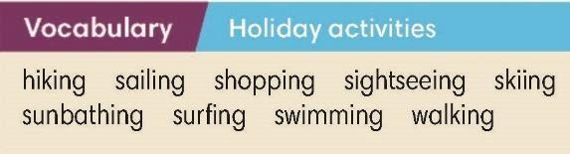
ACTIVITY 4: WHILE-READING (20’)
Aim: To read and find specific details in a text.
Content: Ss work individually and in pairs to do the given reading-related exercises respectively under the instruction from T.
Products: Ss are able to accomplish the given exercises as much as they can to further their understanding in the meaning of the words.
Implementation:
Step 1: Task delivering  T asks Ss to read the descriptions of people looking for holidays.  Step 2: Task performance  T elicits the answer to the question: “What do they like?”  Step 3: Report and discussion  Invite some Ss to present their works.  Step 4: Judgment  Check with the whole class.  Super eyes – Super hand  T asks Ss what each of the people either can’t do or doesn’t like. | Exercise 2: Read the descriptions of people looking for a holiday. What do they like?  Answers:  Kristy and Evan like trying new things.  Minh and his family love nature.  Kristy and Evan can’t go on holiday with their parents.  Minh and his family don’t want to travel far.
Step 1: Task delivering  T asks Ss to suggest a holiday for each of the people in Exercise 2:  Kristy and Evan could find things to do near home or they could go to an organized camp for children.  Minh and his family found a nice place in the countryside near Ha Noi.  Step 2: Task performance  T asks Ss to read the holiday adverts and asks Ss to match them with people in Exercise 2.  Step 3: Judgment  T elicits answers and asks Ss where they want to go and the reasons.  Step 4: Report and discussion  T develops further discussion if needed. | Exercise 3: Read the holiday adverts (A–C) and match them with the people in Exercise 2 (1–2). There is one extra advert. Which holiday sounds the most interesting to you?  Answers: 1 – B; 2 – C
Step 1: Task delivering  T asks Ss to find the words in the adverts and explains new words where necessary.  T divides Ss into groups of four and gives them Activity cards and sentence cards.  Step 2: Task performance  T asks Ss to group a set of sentences with the correct activity.  Example: “I need to buy some sun cream.” is in group sunbathing.  When a group has finished collecting sets, they have to put their hands up.  Step 3: Judgment  The first group to have the correct answer wins the game.  Step 4: Report and discussion  T develops further discussion if needed. | Exercise 4: Study the Vocabulary box. In pairs, find the words in the adverts. In your opinion, which holiday activities are the most fun? (Adaptation)  Answers:  Hiking:  I've got a backpack for my lunch and a map.  I’ve got some new boots and a waterproof coat  Sailing  My cousin is the captain. He is going to steer the boat.  We're going to cross the lake and sleep onboard.  Shopping  I want to get some souvenirs.  I haven’t got much money but I like looking at clothes and trying on them.  Sightseeing:  I've got a good guidebook.  I'm reading about the historic buildings and places to visit.  I want to take lots of photos and upload them to the internet.
ACTIVITY 5: POST READING (5’)
Aim: To talk about your holidays.
Content: Ss work in groups of 8 to to write 2-3 sentences to describe a friend in their group.
Products: Ss are able to describe their group mates using the correct grammar structure and vocabulary they’ve learned so far.
Implementation:
Step 1: Task delivering  T reviews different means of transport that could be used on holiday  T elicits structures and tenses students can use when they present their holidays.  Step 2: Task performance  T divides the class into groups of 8. Gives each student a piece of paper to write 2-3 sentences to describe a friend in their group.  Step 3: Report and discussion  Ss in each group take turns to read their sentences for the others to guess who he/she is.  Step 4: Judgment  Check with the whole class | Exercise 6 (adaptation)  Where are you going?  Mountain  Beach  Lake  City / Countryside  How are you getting there?  Tram  Train  Plane  Car  Motorbike ….  Which activities do you do each day?  Surfing, swimming, sunbathing  Hiking, walking, sailing, sightseeing  Shopping…
HOME ASSIGNMENT  T assigns the home assignments.  Ss copy their home assignments.  T explains it carefully. | Do exercises on WorkBook page 9.  Prepare Unit 9 Lesson 4 Grammar 2.
----------- ----------
Teaching date : ……………………………
Period 85
UNIT 9: GETTING AROUND
Lesson 9.4: Grammar 2 (Time: 1 period)

I. OBJECTIVES
By the end of the lesson, students are expected to achieve the following objectives:
Knowledge:
Grammar: "Going to" to talk about future plans.
(+) S + to be + going to V.
(-) S + to be + not + going to V.
(?) To be + S + going to V? – Yes, S + to be./ No, S + tobe + not.
(?) Wh-question + to be + S + going to V?
Competencies:
General competencies:
Form and improve such competencies as group work and independent working, pair work, linguistic competence, cooperative learning and communicative competence.
Specific competencies:
Improve communicative competencies related to the use of language (vocabulary, phonetics, grammar)
For a language lesson: Students are expected to understand the main grammatical points, then do the tasks assigned in the textbook.
For a skills lesson: Students are expected to use the main grammatical structure to talk about plans for the next ten years.
Qualities:
Being hard-working and attentive in class
Being collaborative while doing in-class exercises
Being polite, respectful when making a conversation about each other’s plans for the next ten years.
II. PREPARATIONS
Teacher: Textbooks, PowerPoint slides, TV, projector, loudspeaker
Students: Textbooks, notebooks
III. PROCEDURE
ACTIVITY 1: WARM-UP (5’)
Aim: To revise the previous lesson.
Content: Ss work as 4 big groups to play the game called “Mime” under the instruction of T.
Products: Ss are able to use the grammar structure and vocabulary from the previous lesson to give the answers for the given questions.
Implementation:
TEACHER AND STUDENTS’ ACTIVITIES | CONTENTS
Game: Mime  Step 1: Task delivering  T puts Ss into four groups.  Step 2: Task performance  T asks Ss to take turns to mime activities.  The rest of the group guesses the activities. Each Ss mimes two activities.  Step 3: Report and discussion  After 3 mins, T invites Ss to mime the activities in front of the class for the other Ss to guess.  Step 4: Judgment  Check with the whole class. | Wordlist:  Hiking  Sailing  Shopping  Sightseeing  Skiing  Sunbathing  Surfing  Swimming  Walking
ACTIVITY 2: KNOWLEDGE FORMATION (10’)
Aim: To introduce the objectives of the lesson with a can-do statement.
Content: The objective of the lesson is listed below
I can use "be going to" to talk about future plans.
Products: Ss acknowledge the lesson’s objectives.
Implementation: T introduces objectives to Ss.
ACTIVITY 3: LEAD-IN AND PRESENTATION (15’)
Aim: To teach how to talk about plans with “be going to” and use some phrases in talking.
Content: Ss work individually to complete the given exercises respectively under the instruction of T.
Products: Ss are able to accomplish the given exercises, grasp the meaning of new words, and usage and form of target grammar structures.
Implementation:
TEACHER AND STUDENTS’ ACTIVITIES | CONTENTS
Step 1: Task delivering  T has Ss look at the photo of Eva, Sol, and Max, and describe them.  Lead-in: They are thinking about summer, they are relaxed and happy, but also a little thoughtful and unsure about what is going to happen.  Step 2: Task performance  T asks Ss to listen to the audio track 9.04 then elicits not only Max’s plans but also Eva’s and Sol's plans. T asks Ss to listen to the audio and answer question:  Why is Max planning to go to London this summer?  What is Eva’s plan?  What’s Sol’s plan?  T explains the Out of Class to Ss.  Tell me about it: is an informal expression that means you understand what someone is complaining about.  Believe it or not: we start a sentence with this phrase when we introduce surprising and usually positive news  Lucky you: when someone tells us about something good that has happened or is going to happen to them.  Step 3: Judgment  T checks the performance with the whole class.  Step 4: Report and discussion  T develops further discussion if needed. | Exercise 1: Listen. Why is Max planning to go to London this summer?  They are talking about their plans.  Answers:  Max is planning to go to London because he's got an audition at the National Youth Theatre.  Eva is going to visit her grandparents in Brazil.  Sol isn’t going to do anything for a week.
Step 1: Task delivering  T draws on the text to figure out the meaning, usage, and form of target structures.  Step 2: Task performance  T asks Ss to find examples of "be going to" in the dialogue.  Step 3: Report and discussion  T explains that it is often possible to use either going to (for plans) or Future Continuous (for future arrangements) in some cases because an arrangement always involves a plan but a plan doesn't always involve an arrangement.  T asks Ss to check which of the examples that they found in dialogue could also be written in the Present continuous.  Step 4: Judgment  Check with the whole class. | Meaning: to talk about plans  Usage:  I + am going to V  You/We/They + are going to V  She/He/It + is going to V.  Form:  (+) S + to be + going to V.  (-) S + to be + not + going to V.  (?) To be + S + going to V? – Yes, S + to be./ No, S + tobe + not.  (?) Wh-question + to be + S + going to V?  Exercise 2: Study the Grammar box. Find examples of the dialogue.  Answer:  ‘m not going to do  What are you going to do?  How are you going to get it?  is going to take  ‘re going to leave  ‘re going to spend  ‘m not going to be  When Eva and Max talk about Max going to London, they could also use the Present Continuous because they are referring to an arrangement between Max and his father.
ACTIVITY 4: PRACTICE (10’)
Aim: To practice giving the correct form of "be going to" and the verbs.
Content: Ss work individually to complete the given task and strengthen their grammar skills by joining the game as instructed by T.
Products: Ss are able to complete the tasks using “be going to” correctly.
Implementation:
Step 1: Task delivering  T guides Ss to do exercise 3.  Step 2: Task performance  Ss complete the task individually.  Step 3: Report and discussion  T asks them to explain their answers.  T asks Ss to identify which sentence could also be written in the Present Continuous.  Step 4: Judgment  Check with the whole class. | Exercise 3: Complete the sentences with the correct form of be going to and the verbs in brackets. Listen and check.  Answers:  ‘re going to work  isn’t going to go  are you going to go  are going to travel  am not going to buy  Sentence 5
Finding friends  Step 1: Task delivering  T gives numbers 1-5 for each Ss.  Step 2: Task performance  T gives a task for each number.  Number 1 has to write one positive sentence for either Sol or Eva.  Number 2: one negative sentence for either Sol or Eva.  Number 3: One positive sentence for Max and Lily.  Number 4: One negative sentence for Max and Lily  Number 5: can write any of the characters that can be either positive or negative.  After that, T gives Ss 2 mins to find friends to make a group of 5 that has correct sentences.  Step 3: Judgment  T gives points for 2 or 3 first groups.  Step 4: Report and discussion  T develops further discussion if needed | Exercise 4: Use the information in the table and write five sentences about the people’s plans for the summer. Use be going to.  Possible answers:  Eva is going to get up early.  Sol isn’t going to visit family.  Max and Lily are going to help in the garden.  Max and Lily aren’t going to visit their family.  Sol isn’t going to help in the garden.
ACTIVITY 5: FURTHER PRACTICE (5’)
Aim: To use “be going to” to make plans in real situations.
Content: Ss work in pairs to carry out a survey under the guidance of T.
Products: Ss are able to use grammar structure and vocabulary from the lesson to talk about their plan for the next 10 years.
Implementation:
Find someone who…  Step 1: Task delivering  T instruct S to do the task  Step 2: Task performance  T elicits that going to is the only correct tense for these ideas because they are all plans rather than arrangements.  T asks Ss to work in pairs to talk about their plan for the next 10 years.  T reminds Ss that when they have discussed all of the ideas, they should choose one idea and give more details about it.  Step 3: Report and discussion  Invite some Ss to present their works.  Step 4: Judgment  Check with the whole class. | Exercise 5: In pairs, talk about your plans for the next ten years. Use these ideas or your own.  Example: I’m going to learn to drive when I’m eighteen years old. I’m not going to buy an expensive car and I’m going to drive along in Viet Nam with my friends.
HOME ASSIGNMENT  T assigns the home assignments.  Ss copy their home assignments.  T explains it carefully. | Do exercises on WorkBook page 82.  Prepare Unit 9 Lesson 5 Listening and Vocabulary.
----------- ----------
Teaching date : ……………………………
Period 86
UNIT 9: GETTING AROUND
Lesson 9.5: Listening and Vocabulary (Time: 1 period)

I. OBJECTIVES
By the end of the lesson, students are expected to achieve the following objectives:
Knowledge:
Vocabulary: Present continuous
Grammar: Hot, cold, sunny, cloudy, windy, snowy, foggy, rainy, warm
Competencies:
General competencies:
Form and improve such competencies as group work and independent working, pair work, linguistic competence, cooperative learning and communicative competence.
Specific competencies:
Improve communicative competencies related to listening skills and use of language (vocabulary, phonetics, grammar)
For a language lesson: Students are expected to know the meaning of the keywords used to talk about weather, and understand the main grammatical points, then do the tasks assigned in the textbook.
For a skills lesson: Students are expected to find specific details in conversations, and use their listening skills and speaking skills to practice talking about weather.
Qualities:
Being hard-working and attentive in class
Have a positive attitude towards the lesson
II. PREPARATIONS
Teacher: Textbooks, PowerPoint slides, worksheet, TV, projector, loudspeaker
Students: Textbooks, notebooks

III. PROCEDURE
ACTIVITY 1: WARM-UP (5’)
Aim: To introduce the topic and warm Ss up.
Content: Ss works in groups of 4 and do the “Mind map” as instructed by T.
Products: Ss are able to to brainstorm all words about weather that they know to participate in the game.
Implementation:
TEACHER AND STUDENTS’ ACTIVITIES | CONTENTS
Mind map  Step 1: Task delivering  T divides the class into groups of 4.  Step 2: Task performance  T asks them to draw a mind map to brainstorm all words about Weather that they know.  Step 3: Judgment  T checks the performance with the whole class.  Step 4: Report and discussion  T develops further discussion if needed. | The answer may vary.
ACTIVITY 2: KNOWLEDGE FORMATION (5’)
Aim: To introduce the objectives of the lesson with a can-do statement.
Content: The objective of the lesson is listed below
I can identify specific details in a conversation and talk about the weather.
Products: Ss acknowledge the lesson’s objectives.
Implementation: T introduces objectives to Ss.
ACTIVITY 3: PRE-LISTENING (5’)
Aim: To get student's interest in the topic.
Content:Ss work individually to do Exercise 1 in the textbook under the guidance of T.
Products: Ss are able to understand the essential vocabulary for the next listening exercise.
Implementation:
TEACHER AND STUDENTS’ ACTIVITIES | CONTENTS
Pre-teach new words  Step 1: Task delivering  T goes through all words in the Vocabulary box to check if they know what they mean.  Step 2: Task performance  T asks Ss to match them with pictures (include 6 pictures in the book).  T puts Ss in pairs and asks them to open their books.  T asks Ss to take turns to describe the photos using the words.  Step 3: Report and discussion  Invite some Ss to present their works.  Step 4: Judgment  Check with the whole class.  Set gist-task  Step 1: Task delivering  T asks Ss if they recognize any of the cities in the photos.  Step 2: Task performance  T gives them the task: guess three cities are being talked about. They can discuss in teams.  Step 3: Report and discussion  Invite some Ss to present their works.  Step 4: Judgment  Check with the whole class. | Exercise 1: Study the Vocabulary box. Match the words with the photos. There are three extra words.  Foggy  Snowy  Sunny  Windy  Cloudy  Rainy  Example: The weather in Paris is foggy.
ACTIVITY 4: WHILE-LISTENING (25’)
Aim: To teach listening skills and guide students to do some listening comprehension tasks.
Content: Ss listen to the audio to do the given tasks and study the Vocabulary box with the guidance from T.
Products: Ss are able to accomplish the given exercise and grasp the meaning of the vocabulary mentioned in the listening exercises.
Implementation:
Step 1: Task delivering  T plays the audio track 9.06 for students to listen and check their guessing.  Step 2: Task performance  T elicits the answers and discusses that two feet of snow are approximately 60 centimeters of snow.  Step 3: Judgment  T checks the exercise with the whole class.  Step 4: Report and discussion  T develops further discussion if needed. | Exercise 2: Listen to three people talking about today’s weather in their city. Write the names of the cities and match them with the photos.  Answers:  1 – New York, B  2 – Da Nang, D  3 – Mexico City, C
Step 1: Task delivering  T asks them to guess the answer.  Step 2: Task performance  T guides them to underline the keywords in the sentences, i.e. high/flying…  Step 3: Judgment  T plays the audio track 9.07 to check the sentences.  Step 4: Report and discussion  T develops further discussion if needed. | Exercise 3: Listen to three recordings and answer the questions.  Answers:  10,000 meters  She’s visiting the Acropolis.  He’s going hiking in the mountains.
Step 1: Task delivering  T instruct S to do the task  Step 2: Task performance  After the 1st listening, T asks them to guess the correct options.  Step 3: Judgment  T plays the audio track 9.08 to check the guessing and asks why the other options are not correct.  Step 4: Report and discussion  T develops further discussion if needed. | Exercise 4: Listen again and choose the correct answers.  Answers:  B (a. It is sunny. c. It is windy in the air but not in London).  C (a. Athens is great, but the weather is terrible. b. It was foggy last night.)  C ( a. Struan says this, and his grandfather says that it isn’t true. b. The summer is warm.)
ACTIVITY 5: POST-LISTENING (5’)
Aim: To practice asking and answering questions about weather and places.
Content: Ss work in groups to write a short text which describes what the weather is like and what they did or saw this morning.
Products: Ss are able to write a short text about the weather in the photo using grammar structure and vocabulary they’ve learnt.
Implementation:
Guessing competition  Step 1: Task delivering  T shows six pictures of places and weather.  Step 2: Task performance  T puts Ss in groups and asks them to choose one of the photos.  T tells them to imagine that they have taken the photo. They should work together to write a short text which describes what the weather is like and what they did or saw this morning.  Step 3: Report and discussion  When they are already, invite them to read their text to the rest of the class. The other Ss should guess which photo they choose.  Step 4: Judgment  Check with the whole class. | Exercise 5 (Adaptation)  Example:  - I had a great holiday in Sapa. The weather was fine. In the morning, it was foggy but after an hour, it was sunny. Sometimes, it was rainy but we all love it.
HOME ASSIGNMENT  T assigns the home assignments.  Ss copy their home assignments.  T explains it carefully. | Do exercises on WorkBook page 83.  Prepare Unit 9 Lesson 6 Speaking.
----------- ----------
Teaching date : ……………………………
Period 87
UNIT 9: GETTING AROUND
Lesson 9.6: Speaking (Time: 1 period)

I. OBJECTIVES
By the end of the lesson, students are expected to achieve the following objectives:
Knowledge:
Excuse me. Where’s the….?
How do I get to…..?
Is there a ….. near here?
There is a ….in ….street.
Go to the end of the road.
Go straight on.
Go past the…
Turn left/right…
It’s next to/opposite the…
Competencies:
General competencies:
Form and improve group work and independent working, pair work, linguistic competence, cooperative learning and communicative competence.
Specific competencies:
Improve communicative competencies related to speaking skills and use of language (vocabulary, phonetics, grammar)
For a language lesson: Students are expected to know the meaning of the key phrases used to ask for and give directions, and understand the main grammatical points, then do the tasks assigned in the textbook.
For a skills lesson: Students are expected to use their speaking skills to practice asking for and giving directions.
Qualities:
Being hard-working and attentive in class
Being collaborative while doing in-class exercises
Being polite when asking for and giving directions
II. PREPARATIONS
Teacher: Textbooks, PowerPoint slides, TV, projector, loudspeaker
Students: Textbooks, notebooks
III. PROCEDURE
ACTIVITY 1: WARM-UP (5’)
Aim: To recall words to describe people that they've learned in this unit.
Content: Ss work into 2 big groups to do the activity called “Guessing game” under the instruction of T.
Products: Ss are able to review the vocabulary used to describe people.
Implementation:
TEACHER AND STUDENTS’ ACTIVITIES | CONTENTS
Guessing game  Step 1: Task delivering  T divides the class into 2 groups and lets them play a small game: Guessing game.  Step 2: Task performance  T gives 3 pictures related to London (one by one) and asks “Which city is this?  Ss guess the name of the place and explain their guess.  Step 3: Judgment  T checks the performance with the whole class.  Step 4: Report and discussion  T develops further discussion if needed. | It’s London.
ACTIVITY 2: KNOWLEDGE FORMATION (10’)
Aim: To introduce the objectives of the lesson with a can-do statement.
Content: The objective of the lesson is listed below
I can ask for and give directions.
Products: Ss acknowledge the lesson’s objectives.
Implementation: T introduces objectives to Ss.
ACTIVITY 3: PRE-SPEAKING (15’)
Aim: To get students’ interest in the topic.
Content: Ss work individually to do the exercises and study the Speaking box, and then in groups for further practice under the instruction of T
Products: Ss know the meaning of phrases and grammatical structures used when they want to ask or give directions.
Implementation:
TEACHER AND STUDENTS’ ACTIVITIES | CONTENTS
Step 1: Task delivering  T leads students into the lesson by showing a photo of Max, Sol, and Eva and asks Ss some questions:  Where are they?  What are they looking for?  Why are they worried?  Why aren’t they in the car?  Step 2: Task performance  T checks that Ss understand the meaning of the audition.  T plays the audio track 9.09.  When the Ss have listened to the audio, T elicits the answers to the questions and what is happening in the photo.  Step 3: Judgment  T checks the exercise with the whole class.  Step 4: Report and discussion  T develops further discussion if needed. | Exercise 1: Listen to Part 1. Why do Max, Eva and Sol decide to get out of the car?  - They are in London.  - They are looking for theater.  - They could be late.  - They decide to get out of the car because the sat-nav isn’t working.
Step 1: Task delivering  T asks Ss one more question: Are they near the theater?  Step 2: Task performance  T asks Ss to read the dialogue and checks that they understand left, right, and traffic lights.  Step 3: Judgment  T elicits the answer.  Step 4: Report and discussion  T discusses the Out of class box with students, asks if they can guess what sec is short for (second). T elicits other phrases that are similar to this. (Just a minute, Just a moment)  T asks Ss when they think they would say Good thinking! to someone. (when someone has had a good idea). | Exercise 2: Read or listen to Part 2. Are they far from the theatre?  - Answer: No, they aren’t.
Step 1: Task delivering  T goes through the different phrases in the Speaking box.  Step 2: Task performance  T asks Ss to find an example of the phrases in the dialogue.  Step 3: Judgment  Check with the whole class.  Step 4: Report and discussion  T discusses what each of the phrases means and the use of prepositions (Turn left at the crossroads, turn left into…, on the left)  T points out that we say Take the first turning on the left but Turn left.  Finding friends  Step 1: Task delivering  T tells Ss to look at the map in Exercise 5 and read instructions in the dialogue.  Step 2: Task performance  T asks Ss to work in groups and asks Ss where Max, Sol, and Eva could be.  Step 3: Judgment  The first group to have the correct answer wins the game.  Step 4: Report and discussion  T develops further discussion if needed. | Exercise 3: Study the Speaking box. Find the phrases in the dialogue.  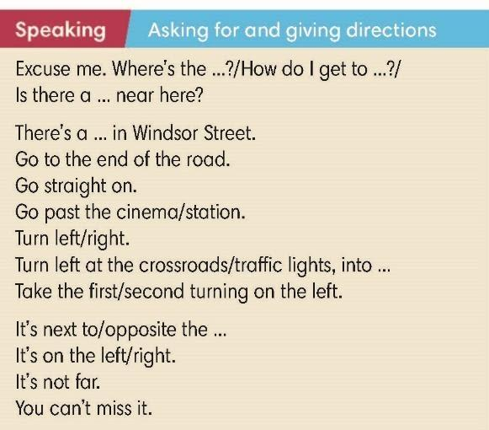  They are on Tufnell Park Road.
ACTIVITY 4: WHILE-SPEAKING (10’)
Aim: To practice using words and phrases to ask for and give directions.
Content: Ss work individually and in pairs to complete exercises as instructed by T.
Products: Ss are able to complete the exercises as best as they can.
Implementation:
Step 1: Task delivering  T tells Ss to complete exercise 4 on their own.  Step 2: Task performance  Ss complete the exercise as instructed by T.  Step 3: Judgment  T asks Ss to listen to audio track 9.11 and check their answers.  Step 4: Report and discussion  T invites a student to come to the board and gives an instruction: Go to the end of the road. The student draws a road that comes to an end at a T-junction.  T asks the student to draw arrows to show the direction of movement.  T invites the second student to come to the board and gives another instruction: Turn left. The student draws an arrow turning left from the first road into the second one.  T repeat the process with different students and these instructions in Exercise 4:  Go past the library (the student draws a library and an arrow going past it)  Take the third turning on the left. (the student draws three roads on the left and an arrow pointing down on the third)  On the left. (the student should draw a cross on the left of the road they are on). | Task performance  Answers:  end  Turn  past  Take  on  not  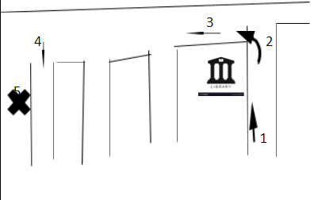
Step 1: Task delivering  T asks Ss to find the National Youth Theater on the map in Exercise 5.  Step 2: Task performance  T plays audio track 9.12 and asks Ss to follow instructions on the map to find where Dad parked his car.  Step 3: Judgment  T elicits the answers. If any Ss have a different answer, T asks a student with the correct answer to use the phrases in the Speaking box to explain how they found Dad's car.  Step 4: Report and discussion  T develops further discussion if needed. | Exercise 5: You’re outside the National Youth Theatre. Find it on the map. Listen again. Where did Dad park his car?  Answer: The car is on Tavistock Terrace
ACTIVITY 5: POST SPEAKING (5’)
Aim: To apply expressions in the Speaking box in real situations.
Content: Ss work in pairs for further practice as instructed by T.
Products: Ss are able to make an instruction about direction using the correct grammar structure and vocabulary.
Implementation:
Step 1: Task delivering  T asks students to work in pairs and look at the map in Exercise 5.  Step 2: Task performance  Before the pairs begin, T tells the Ss that as they are giving the instructions, they should rotate their books so that their direction of travel is always upwards.  T explains that this will make it easier for Ss to decide whether to use left or right.  Step 3: Report and discussion  T invites pairs to give individual instructions and tells the rest of the class to follow the instructions on the maps in their books.  Step 4: Judgment  Check with the whole class. | Exercise 6: In pairs, look at the map in Exercise 5. You’re at the school on Manor Gardens. Ask for and give directions. Use the Speaking box to help you.  Possible answers:  To the swimming pool: Come out of the school and turn left. Go to the end of the road and turn left into Holloway Road. Go past the supermarket. The swimming pool is on the left opposite the Odeon Cinema.  To the Indian restaurant: Come out of the school and turn left. Go to the end of the road and turn right into Holloway Road. Take the second turn on the left. The Indian restaurant is on the right.  To the bookshop: Come out of the school and turn left. Go to the end of the road and turn right into Holloway Road. The bookshop is on the left. It is after the first turning on the left.  To the bank: Come out of the school and turn left. Go to the end of the road and turn left into Holloway Road. Take the second turning on the right then turn right into Tufnell Park Road. Go past the bus stop. The bank is on the left.  Ss may have different answers.
HOME ASSIGNMENT  T assigns the home assignments.  Ss copy their home assignments.  T explains it carefully. | Do exercises on Workbook page 84.  Prepare Unit 9 Lesson 9.7 Writing.
----------- ----------
Teaching date : ……………………………
Period 88
UNIT 9: GETTING AROUND
Lesson 9.7: English in use (Time: 1 period)

I. OBJECTIVES
By the end of the lesson, students are expected to achieve the following objectives:
Knowledge:
Vocabulary: Text languages, meeting arrangements
Grammar: Past simple, be going to for plans, suggestions, present continuous for arrangements
Competencies:
General competencies:
Form and improve group work and independent working, pair work, linguistic competence, cooperative learning and communicative competence.
Specific competencies:
Improve communicative competencies related to writing skills and use of language (vocabulary, phonetics, grammar)
For a language lesson: Students are expected to know the meaning of the common vocabulary and phrases used in an invitation email, and understand the main grammatical points, then do the tasks assigned in the textbook.
For a skills lesson: Students are expected to use their writing skills to practice writing an birthday invitation email.

Qualities:
Being hard-working and attentive in class
Have a positive attitude towards the lesson
Being polite and respectful when writing an invitation email
II. PREPARATIONS
Teacher: textbooks, PowerPoint slides, Resource 113 Worksheets (Teacher’s resource book Unit 9_9), TV, projector, loudspeaker
Students: Textbooks, notebooks
III. PROCEDURE
ACTIVITY 1: WARM-UP (5’)
Aim: To recall words to describe people that they've learned in this unit.
Content: Ss work in 2 big groups to play the game called “Guessing game” with the instruction from T.
Products: Ss are able to use the vocabulary they’ve learned to give the correct answer and win points.
Implementation:
TEACHER AND STUDENTS’ ACTIVITIES | CONTENTS
Guessing Game  Step 1: Task delivering  T divides the class into 2 groups and asks Ss to play a game.  Step 2: Task performance  T shows pictures of celebrations one by one and asks Ss to guess: What celebration is this?  Ss have to put their hands up to answer. The first group to put their hands up and to give the correct answer wins a point.  Step 3: Judgment  The winning group is the one that has won the most points.  Step 4: Report and discussion  T develops further discussion if needed. | Answer:  Birthday  New year  Halloween  Thanksgiving  Christmas
ACTIVITY 2: KNOWLEDGE FORMATION (5’)
Aim: To introduce the objectives of the lesson with a can-do statement.
Content: The objective of the lesson is listed as below
I can write an invitation email.
Products: Ss acknowledge the lesson’s objectives.
Implementation: T introduces objectives to Ss.
ACTIVITY 3: PRE-WRITING (15’)
Aim: To analyze the writing samples.
Content: Ss work in pairs and in groups of 6 to do the assigned tasks with the instruction from T.
Products: Ss are able to accomplish the given exercises and get the structure of an invitation email.
Implementation:
TEACHER AND STUDENTS’ ACTIVITIES | CONTENTS
Step 1: Task delivering  T checks that Ss understand the difference between celebrate (verb) and celebration (noun).  Step 2: Task performance  T sets a time limit for the pairs to discuss their story of the last good news and invites pairs to share their stories with the rest of the class.  Step 3: Report and discussion  Invite some Ss to present their works.  Step 4: Judgment  Check with the whole class. | Exercise 1:  - The answer may vary.
Step 1: Task delivering  T asks Ss to read the email quickly and answer the questions in pairs.  Step 2: Task performance  Ss read the email quickly and answer the questions in pairs.  Step 3: Judgment  T elicits the answers.  Step 4: Report and discussion  T develops further discussion if needed.  Think – Pair – Share  Step 1: Task delivering  T asks Ss to look in the email again and find an example of something that happened in the past, a future plan, a suggestion, and text language.  Step 2: Task performance  T asks Ss to work in groups of 4 to share their ideas.  Step 3: Report and discussion  T calls some volunteers to share with the whole class.  Step 4: Judgment  Check with the whole class. | Exercise 2: In pairs, read the email quickly and answer the questions.  Eva  Max passed his audition.  Sol, Lily, and Max's dad.  At a quarter to six, on Friday.  A card.  In the past: Max passed his audition.  Future plan: I’m going to invite Lily and Max’s dad.  A suggestion: Let’s meet under the bus station clock.  Text language: BTW – which means by the way.
Step 1: Task delivering  T asks Ss to find examples of phrases in Eva’s mail.  Step 2: Task performance  Ss find examples of phrases in Eva’s mail  Step 3: Judgment  T elicits the answers.  Step 4: Report and discussion  T develops further discussion if needed.  Writing Race  Step 1: Task delivering  T gives an unfinished table about the structure of an invitation email.  Step 2: Task performance  T divides the class into groups of six and asks Ss to complete the task.  Step 3: Judgment  The first group to have the correct answers wins the game.  Step 4: Report and discussion  T develops further discussion if needed. | Exercise 3: Study the Writing box. Find examples of the phrases in Eva’s email.  Possible answer:
  Information | Tense/ Structure | Part
  To giving recent news | Past simple | Greeting/News
  To say what is happening now
  To talk about plans
  To talk about arrangements
  To make suggestions
  To invite
  Information | Tense/ Structure | Part
  To giving recent news | Past simple | Greeting/News
  To say what is happening now | Present continuous | Invitation
  To talk about plans | Be going to | Invitation/ Other plans
  To talk about arrangements | Present continuous | Meeting arrangements
  To make suggestions | Let’s | Meeting arrangements
  To invite | Would you like | Invitation
ACTIVITY 4: WHILE-WRITING (15’)
Aim: To practice writing short sentences or a completed invitation email.
Content: Ss work individually do the Writing exercises and then in pairs to check under the instruction of T.
Products: Ss are able to apply the structure of an invitation email in their writing piece.
Implementation:
Step 1: Task delivering  T shows the photo in Exercise 4 and discusses the photo with the class. T asks Ss if anyone has been karting.  Step 2: Task performance  T asks Ss to read the text quickly and complete the sentences.  Step 3: Judgment  T elicits the answers and checks that Ss understand the differences between minimum and maximum.  Step 4: Report and discussion  T develops further discussion if needed. | Exercise 4: Read the advert and complete the sentences. Write no more than three words in each gap.  Answers:  10 a.m  Thirteen  2.30  Food or drink  Minimum: used after amounts to show that the amount is the lowest possible  Maximum: used after amounts to show that the amount is the highest possible
Step 1: Task delivering  T instruct S to do the task  Step 2: Task performance  T and Ss discuss the given sentences.  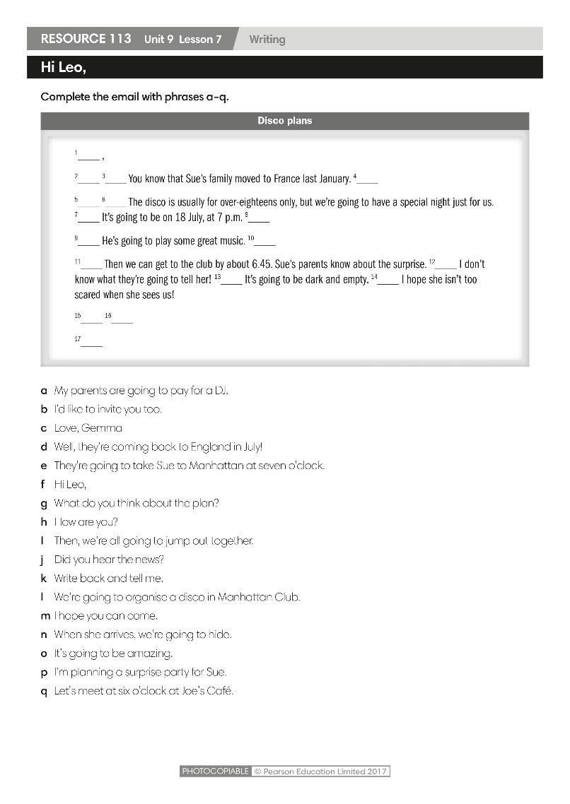  T guides Ss to complete the email within RESOURCE 113.  Step 3: Judgment  T and Ss check.  Step 4: Report and discussion  T develops further discussion if needed. | RESOURCE 113 Worksheet (Teacher’s resource book Unit 9_9)  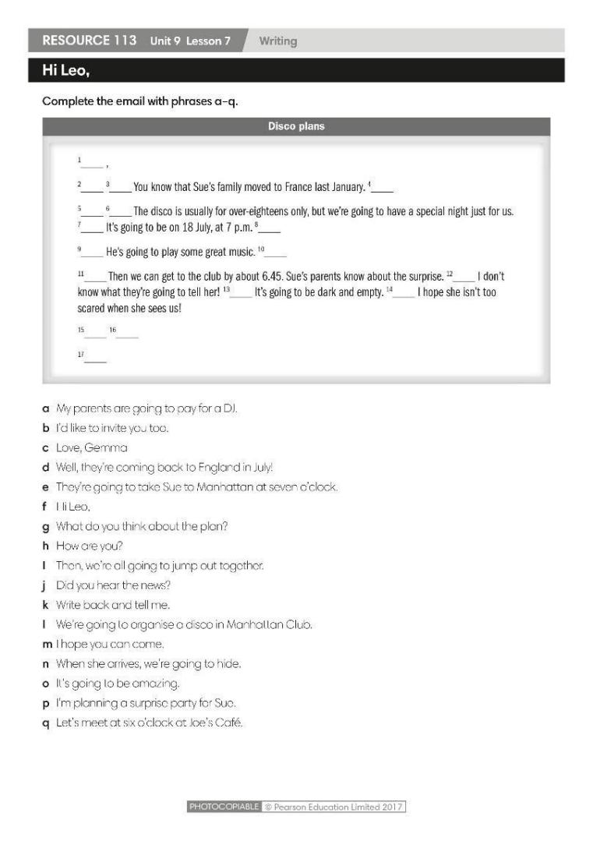
Step 1: Task delivering  T elicits ideas for possible news that they could include at the start of their email.  T sets a time limit for Ss to write their email.  Step 2: Task performance  T puts Ss in pairs and asks them to swap emails. Ss should read their partner’s email and ask if it was written specifically to them.  The pairs take turns to thank each other and say whether they can come.  Step 3: Report and discussion  Invite some Ss to present their works.  Step 4: Judgment  Check with the whole class. | Exercise 5: You’re celebrating your birthday this Saturday. Write an email inviting a friend to come.
ACTIVITY 5: POST-WRITING (5’)
Aim: To give comments for the writings.
Content: Ss work in pairs to check emails for their partners using the writing rubric.
Products: Ss can strengthen their writing skills and improve it for future use.
Implementation:
Step 1: Task delivering  T gives Ss the writing rubric to check their writings themselves, then give comments to partners.  Step 2: Task performance  Ss to check their writings and their partners’ works as guided by T.  Step 3: Judgment  T checks the performance with the whole class.  Step 4: Report and discussion  T develops further discussion if needed. | Writing rubric:  Does your writing follow the right format of an invitation email?  Do you use correct punctuation?  Do you use the correct forms of the verbs?  Do you have a greeting and closing?
HOME ASSIGNMENT  T assigns the home assignments.  Ss copy their home assignments.  T explains it carefully. | Do exercises on Workbook page 85.  Prepare Unit 9 Lesson 8 Pronunciation and Revision.
----------- ----------
Teaching date : ……………………………
Period 89
UNIT 9: GETTING AROUND
Lesson 9.8: Pronunciation and Revision (Time: 1 period)

I. OBJECTIVES
By the end of the lesson, students are expected to achieve the following objectives:
Knowledge:
Vocabulary: Review transport, travel, holiday activities, the weather.
Grammar: Present Continuous for future arrangements, “be going to” for plans
Competencies:
General competencies:
Strengthen group work and independent working, pair work, linguistic competence, cooperative learning and communicative competence.
Specific competencies:
Strengthen communicative competencies related to pronunciation skills and use of language (vocabulary, phonetics, grammar)
For a language lesson: Students are expected to recall the essential vocabulary of the whole unit, then do the tasks assigned in the textbook.
For a skills lesson: Students are expected to improve their pronunciation by listening to the audio, and their speaking skills by further practicing as guided.
Qualities:
Being hard-working and attentive in class
Have a positive attitude towards the lesson
Being collaborative while doing in-class exercises
II. PREPARATIONS
Teacher: Textbooks, pictures, word cues, PowerPoint slides, TV, projector, loudspeaker
Students: Textbooks, notebooks
III. PROCEDURE
ACTIVITY 1: WARM-UP (5’)
Aim: To attract Ss’ attention to the lesson and to lead in the new lesson.
Content: Ss work in pairs to play the Pictionary game with the guidance from T.
Products: Ss are able to recall the vocabulary of the previous lessons to find all the hidden words.
Implementation:
TEACHER AND STUDENTS’ ACTIVITIES | CONTENTS
Game: Pictionary  Step 1: Task delivering  T explains how to play the game: there are 6 missing words in 6 sentences. T shows sentence by sentence. Ss work in pairs to write the answers on mini-boards or paper.T divides the class into groups of 4.  Step 2: Task performance  T says a word and Ss have to race to find that word in the worksheet. When a group has found the word, they should raise their hands.  T calls the first raising group to go to the board and shows the word on the board.  Step 3: Judgment  T call some Ss to share about each word.The first team to find the correct answer gets a point.  Which group gets more points will be the winner.  Step 4: Report and discussion  T develops further discussion if needed. | Wordlist:  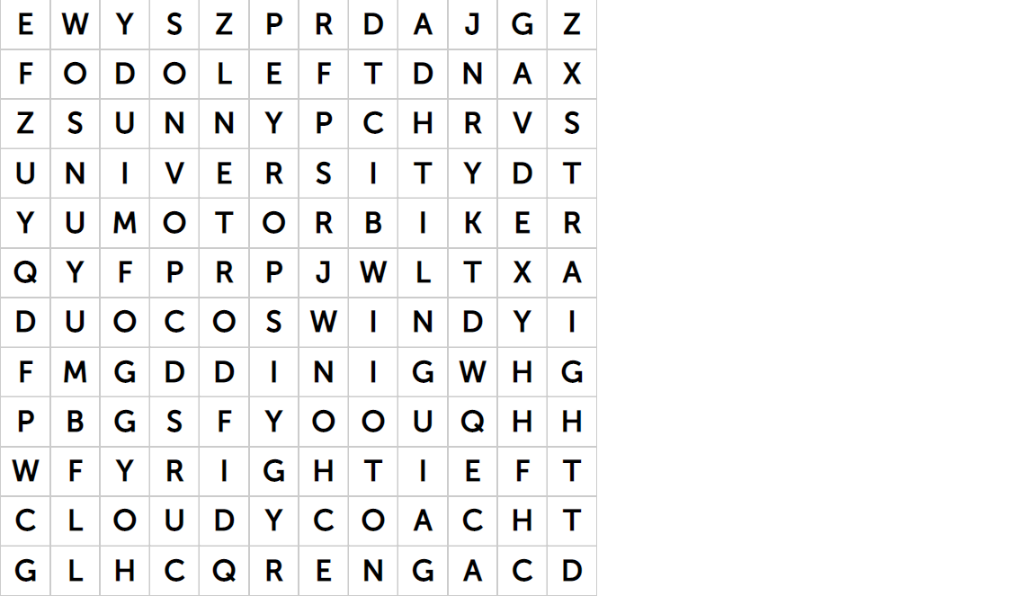  Foggy Windy Sunny  Cloudy University Coach  Right Left Straight  Motorbike
ACTIVITY 2: KNOWLEDGE FORMATION (5’)
Aim: To introduce to Ss what they can do after the lesson
Content: The objectives of the lesson are listed as below:
I can pronounce the /ei/ and /a:/ sound.
I can use Present Continuous, “be going to” to talk about the future.
I can ask for and give directions.
Products: Ss acknowledge the lesson’s objectives.
Implementation:
ACTIVITY 3: PRONUNCIATION (10’)
Aim: To teach Ss how to pronounce the /ei/ and /a:/ sound.
Content: Ss work in pairs to do the exercises and in groups to play the game as instructed by T.
Products: Ss are able to differentiate the /ei/ and /a:/ sound and pronounce them correctly.
Implementation:
TEACHER AND STUDENTS’ ACTIVITIES | CONTENTS
Presentation  Step 1: Task delivering  T introduces two sounds to Ss and lets them listen and repeat words in Exercise 4. T stops the recording to let Ss repeat each word.  Step 2: Task performance  T asks Ss to work in pairs to write the words in the correct column.  Step 3: Report and discussion  Invite some Ss to present their works.  Step 4: Judgment  Check with the whole class. | Exercise 4 (SB p.98): Listen to how we pronounce the /ei/ and /a:/ sound. Look at the underlined letters and decide which sound you hear. Write the words in the correct column.  Answer:  /ei/: accommodation, bike lane, celebrate, dangerous, make, place, rainy.  /a:/: car, car park, past.
Practice  Step 1: Task delivering  T asks Ss to say the sentences in pairs.  Step 2: Task performance  T plays the audio track 9.14 and asks Ss to listen and check.  Step 3: Report and discussion  T calls some Ss to stand up and say sentences.  Step 4: Judgment  Check with the whole class.  Game: “Up and down”  Step 1: Task delivering  T explains the rules: T says 1-15 words containing the sound /ei/ and /a:/. Ss stand up for the words with the /ei/ sound and sit down for ones with /a:/ sound.  Step 2: Task performance  Ss plays in groups.  Step 3: Judgment  T checks the performance with the whole class.  Step 4: Report and discussion  T develops further discussion if needed. | Exercise 5 (SB p.98): In pairs, say the sentences. Listen, check and repeat.  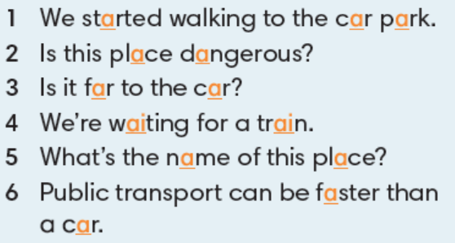  Accommodation Bike lane  Rainy Dangerous  Car Make  Park Place  Past Celebrate  Train Fast  Far  Start  Wait
ACTIVITY 4: REVIEW (20’)
Aim: To review describing a person and making sentences with ‘can, have got’.
Content: Ss complete assigned tasks respectively and reviews the meaning, usage, and form of Present Continuous, “be going to” with the guidance of T.
Products: Ss are able to complete the dialogue with the Past Simple forms of the verbs, and strengthen their grammar in a further speaking exercise about agreeing and disagreeing.
Implementation:
Step 1: Task delivering  T asks Ss to work in pairs to explain the words in English.  Step 2: Task performance  Ss work in pairs to explain the words in English  Step 3: Judgment  T checks by asking Ss to match the words with their definitions.  Step 4: Report and discussion  T develops further discussion if needed. | Exercise 2 (SB p.99): In pairs, explain the words below. Choose the two activities that you like best.  Answers:  Hiking: the activity of going for long walks in the country for pleasure.  Shopping: the activity of going to shops and buying things or ordering them online  Sightseeing: the activity of visiting interesting buildings and places as a tourist  Skiing: the sport or activity of moving over snow on skis  Sunbathing: to sit or lie in the sun, especially to go brown
Step 1: Task delivering  T reviews the meaning, usage, and form of Present Continuous.  Meaning: to talk about future arrangements.  Usage: I am + V ing  He/She/It + is + Ving  You/We/They + are + Ving  Form:  (+) S + to be + Ving .  (-) S + to be + not + Ving.  (?) To be + S + Ving?  (?) Wh-question + to be + S + Ving?  Step 2: Task performance  T asks Ss to look at Exercise 5.  T asks Ss to work in pairs, use the table and words to make their arrangements.  Step 3: Report and discussion  Invite some Ss to present their works.  Step 4: Judgment  Check with the whole class.  Game: Writing race  Step 1: Task delivering  T divides the class into 4 big teams.  Step 2: Task performance  Each member of each team will go to the board and write answers.  Step 3: Judgment  Which team has the correct answer in the shortest time will be the winner.  Step 4: Report and discussion  T develops further discussion if needed. | Exercise 5 (SB p.99): Phong and Chi live in Hai Phong. They are planning a holiday in Ha Noi this Saturday. Look at the table and write about their arrangements.  Answers:  At 7 a.m they’re taking a taxi to Niem Nghia bus station.  At 7.30 a.m they’re getting the coach to Ha Noi.  At 5 p.m they’re leaving Ha Noi.  At 8 p.m they’re arriving back in Hai Phong.
Step 1: Task delivering  T reviews meaning, usage, and form of be going to:  Meaning: to talk about future plans  Usage:  I am + going to V  You/We/They + are going to V  He/She/It + is going to V  Form:  (+) S + to be going to + V.  (-) S + to be + not + going to V.  (?) To be + S + going to + V?  (?) What + to be + S + going to V?  Step 2: Task performance  T asks Ss to look at Exercise 6.  T asks Ss to look at the list and write full sentences  Game: Lucky number  Step 1: Task delivering  T divides the class into 2 groups.  Step 2: Task performance  T asks Ss to choose numbers and answer the questions quickly in 3 seconds.  Step 3: Judgment  If Ss choose the lucky number, they don’t have to answer.  Step 4: Report and discussion  T develops further discussion if needed. | Exercise 6 (SB p.99): Look at the list of what Phong and Chi want to do in Ha Noi. Write about their plans.  Answer:  They’re going to visit Ho Chi Minh Mausoleum. Then they’re going to meet Tom’s brother for lunch. Then they’re going to visit Thu Le zoo. They’re going to go walking around Hoan Kiem lake.
  1 | 2 | 3
  4 | 5 | 6
ACTIVITY 5: FURTHER PRACTICE (5’)
Aim: To practice asking for and giving directions.
Content: Ss draw a map of their neighbourhood and then work in pairs to practice asking and giving directions.
Products: Ss are able to deliver a conversation about asking and giving directions using the correct vocabulary and grammatical points they’ve learnt in the previous lessons.
Implementation:
Step 1: Task delivering  T has each Ss draw a map of their neighbourhood with the name of at least 4 places on their map. (school, town centre, bus/train station).  T may have Ss prepare their map at home.  Step 2: Task performance  T asks Ss to work in pairs, taking turns to ask for and give directions to the places on their maps.  T goes around and offers help if necessary.  Step 3: Report and discussion  If there is time, have some pairs practise in front of the whole class.  Step 4: Judgment  Check with the whole class | Exercise 8 (SB p.99): In pairs, ask for and give directions.  - Ss’ answers may vary.
HOME ASSIGNMENT  T assigns the home assignments.  Ss copy their home assignments.  T explains it carefully. | Do self – check on Workbook page 14.  Prepare CLIL 5.

----------- ----------

