UNIT 0: WELCOME
PERIOD 2. LESSON 0.1: INTRODUCING NAM

I. OBJECTIVES
By the end of the lesson, Ss are able to:
1. Knowledge
- Vocabulary:
- name the family members in Nam’s family.
- pronounce vocabulary of family members correctly.
- Grammar:
- remember the forms of possessive adjectives and possessive ’s.
- use possessive adjectives and possessive ’s to talk about family members.
2. Core competences
- General competences: form and / or improve such competencies as group work, independent working, pair work, linguistic competence, and cooperative learning.
- Specific competences:
- Improve communicative competence related to the use of language (vocabulary, phonetics, grammar):
- For a language lesson: Ss are expected to use vocabulary to talk about family members, and understand the main grammatical points, then do the tasks assigned in the textbook.
- For a skills lesson: Ss are expected to use the vocabulary and grammar points to talk about their family members.
3. Personal qualities
- Being hard-working and attentive in class.
- Have a positive attitude towards the lesson.
II. MATERIALS
- Grade 7 textbook, Unit 0 (SB p. 4-5)
- Computer connected to the Internet
- Projector / TV/ PPT slides / Active teach
Language analysis
- Vocabulary:
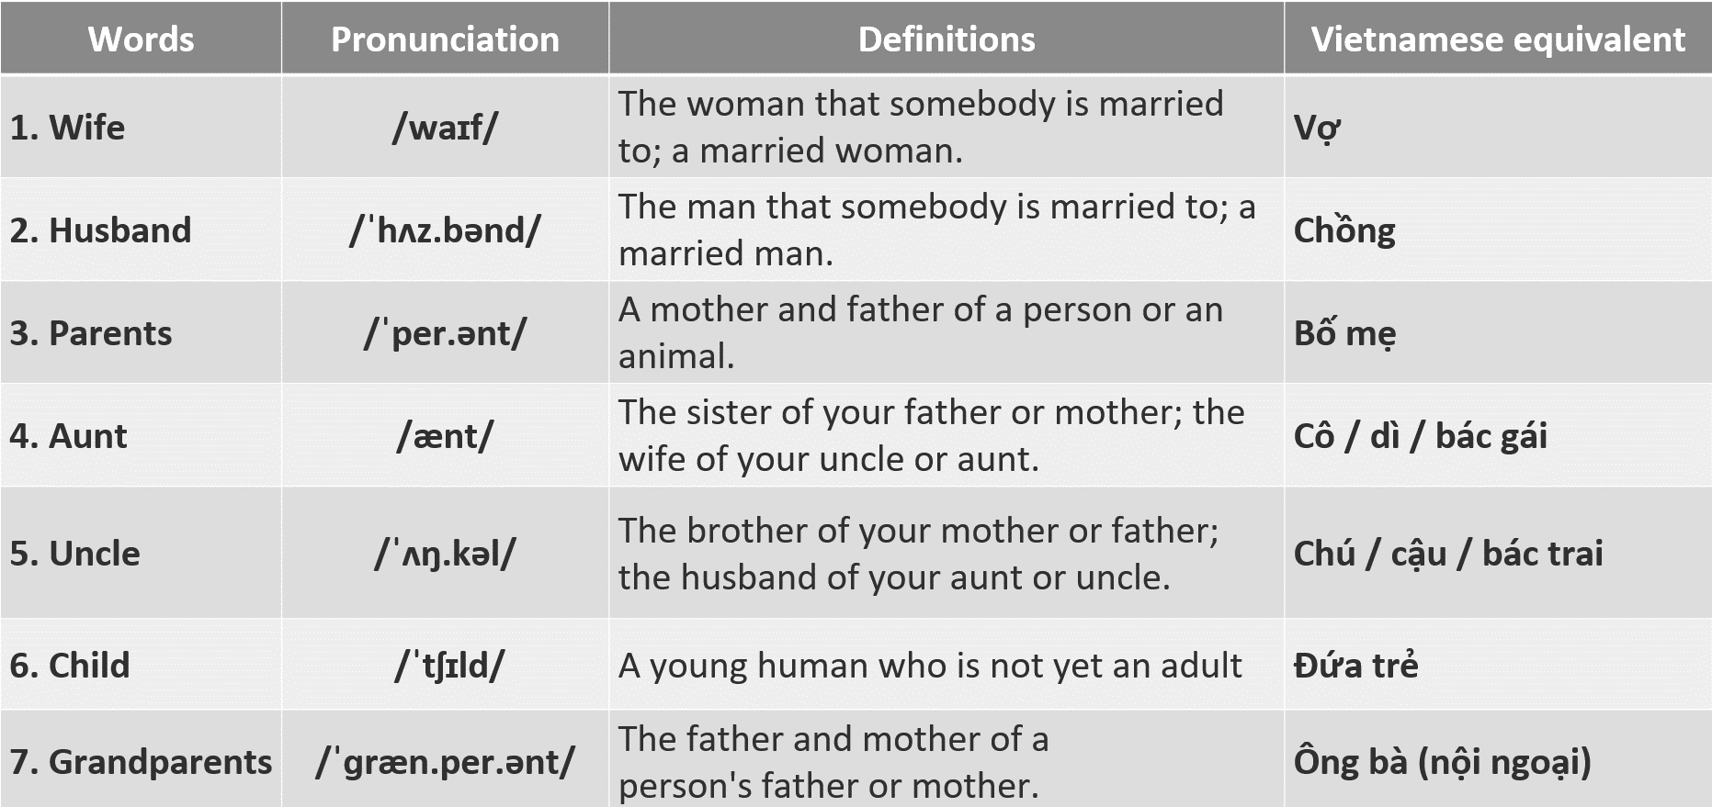

- Grammar:
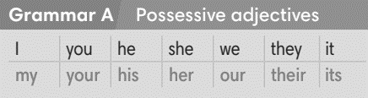
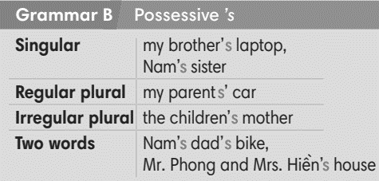

Assumptions
Anticipated difficulties | Solutions
1. Ss may not pronounce the vocabulary correctly. | Reinforce the pronunciation of target vocabulary.
2. Ss may not have sufficient speaking and co-operating skills. | Give clear instructions, give examples before letting Ss work in pairs / groups.  Provide feedback and help if necessary.

