UNIT 1: CULTURAL INTERESTS
PERIOD 12. LESSON 1.6: SPEAKING

I. OBJECTIVES
By the end of the lesson, Ss are able to:
1. Knowledge
- Vocabulary: use vocabulary of types of films, time expression.
- Grammar: make dialogue in the Present Simple with cinema expressions.
2. Core competences
- General competences: form and / or improve such competences as group work, independent working, pair work, linguistic competence, and cooperative learning.
- Specific competences:
- Improve communicative competence related to the use of language (vocabulary, phonetics, grammar):
- For a language lesson: Ss are expected to use vocabulary of types film and other related topics to the lesson content, do the tasks assigned in the textbook.
- For a skills lesson: Ss are expected to listen for comprehension and say cinema expression to buy tickets.
3. Personal qualities
- Being hard-working and attentive in class
- Have a positive attitude towards the lesson

II. MATERIALS
- Grade 7 textbook, Unit 1 (SB p. 16, WB p.12)
- Computer (accessible to the Internet is the best)
- Projector / TV/ PPT slides / Active teach
III. LANGUAGE ANALYSIS
Vocabulary: Types of films (fantasy films, action films, cartoons, horror films)
Expressions:
- To show opinions: I think “The Jungle Book” is an interesting fantasy film. I’d like to see it.
- Cinema dialogue to buy tickets
IV. ASSUMPTIONS
Anticipated difficulties | Solutions
1. Ss may write the structures incorrectly. | Keep the useful expressions on the board for reference.  Encourage peer-check.
2. Ss may not have sufficient speaking and co-operating skills. | Give clear instructions, give examples before letting Ss work in pairs / groups.  Provide feedback and help if necessary.

V. BOARD PLAN
UNIT 1: CULTURAL INTERESTS
PERIOD 12. LESSON 1.6: SPEAKING

I. Vocabulary
horror films | cartoons | fantasy films
action films | tickets | front row/ row ___
II. Class Work: Listening task and exercises in Student Book page 16
II. Homework
- Do exercises on workbook page 12.
- Prepare Unit 1 – Lesson 1.7: Writing
VI. PROCEDURE
Stage | Stage aim | Procedure | Interaction
WARM-UP  &  LEAD - IN | - To create a positive classroom atmosphere to start a new lesson.  - To review types of films  - To lead in to the topic | Activity 1: Mind-map  - T writes the words “TYPES OF FILMS” on board and asks students to work in pairs/small group.  - Students discuss and list out all words they remember from previous lesson.  - Students use a mind-map to present their ideas.  - Teacher encourages students to stand up and share their answers in front of the class.  - Teachers explains that students will use their knowledge about types of film to complete some tasks of the new lesson.  Unit 1 – Lesson 6: Speaking (At the cinema) | T-Ss  Ss - Ss  Ss-T
PRE-LISTENING | - To activate Ss’ prior knowledge of the topic.  - To reinforce types of film  - To start a class discussion | Activity 2: Class vote (SB p.16 – Ex 1)  - Set the scene: T tells Ss to look at the cinema program in Student book page 16. T asks some questions to elicit that the program tell students about the titles or the movies and when they start.  - Teacher introduces the Class Vote task in student book.  - T explains How-to-vote steps then checks instructions.  How to vote:  - Read the program  - Say what types of film are on  - Answer the question for yourself “Which ones would you like to see”  - Use the given expression:  “I think the … is a/an … film. I’d like to see it.”  - Ss join in the survey in pairs or in small groups.  - T sets the transition for the next step of the lesson: “Now, let’s do a listening task to know Nam and Mai’s plan.” | T-Ss  T-Ss  Ss-T  T-Ss
PRE-LISTENING | - To listen and identify specific information to answer the questions | Activity 3: Listen and answer the questions.  (SB p.16 – Ex 2)  - T asks students to look at the cinema program again and elicits some information about the program, tickets, seats and rows. (pre-teach the words if needed)  - T asks Ss to look at exercise 2.  - T calls a student to read the instruction then checks Ss’ understanding of it.  - T asks Ss to work in groups of three to listen for the first time  - Students works in pair to listen, answer, and compare their answers.  - T allows students to listen again, read the dialogue to double check their answers.  - T calls groups to give answers to check as the whole class.  Answer keys:  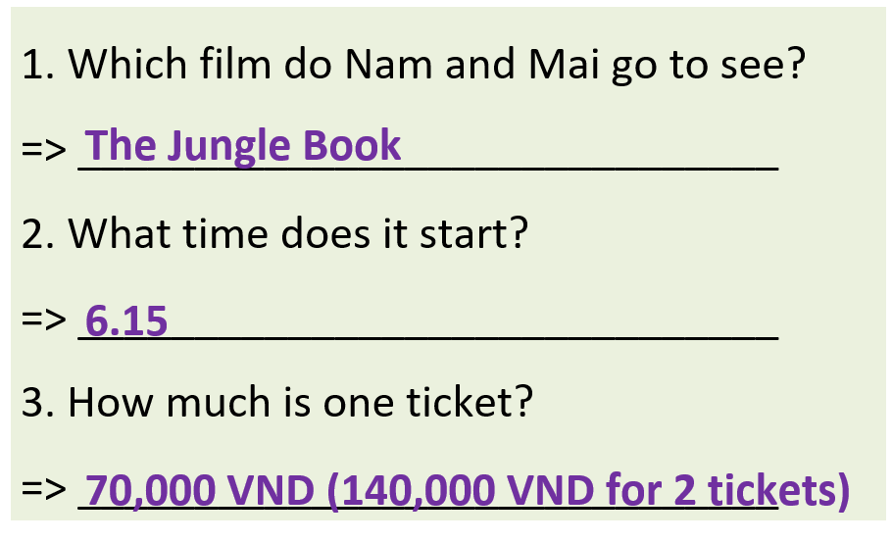  - T tell students to practice reading the dialogue again in a limited time | T-Ss  Pair/Group work  Ss-T  T-Ss  Ss-T
WHILE-SPEAKING | - To reinforce the cinema expressions  - To practice the “buy ticket” dialogue | Activity 4: Exercise 3 (SB p.16)  Complete the dialogue below with one word in each gap. Listen again and check.  - T asks Ss to look at exercise 3.  - T goes through the Speaking box with students.  - T calls a student to read the instruction then checks Ss’ understanding of it  - Students find examples of the phrases in the dialogue.  - T asks Ss to work in pairs to read then complete the activity.  - T checks as the whole class.  Answer keys:  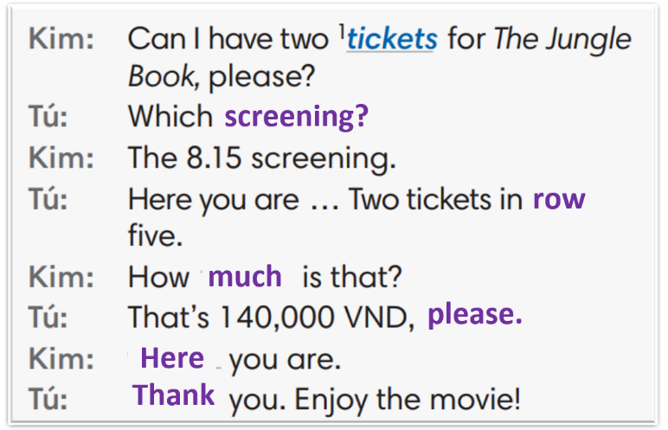  - T sets a limit for students to work in pairs to practice the dialogue as a role play.  - T invites some pairs of students to act out the roleplay in front of the class.  - Ss work in pair, practice the dialogue, then act out. | T-Ss  Pair work  T-Ss  Ss-T  Ss - Ss
POST-SPEAKING | - To help students applying the new language and skills related to the topic in communicating. | Activity 5: Adaptation for Exercise 4 (SB p.16):  In pairs, ask and answer to buy tickets for a film.  - T tells student to look at the speaking box in their student book again and prepare for the task.  - T gives students time to think about what they are going to say in their roleplays.  - T encourages stronger students to introduce a problem into their role play, e.g. the film is sold out, the only seats leaf are in the front row, there are two tickets left but they aren’t seated together.  - Students work in the same pairs from the last activity and practice their role plays, focus on using the correct intonation.  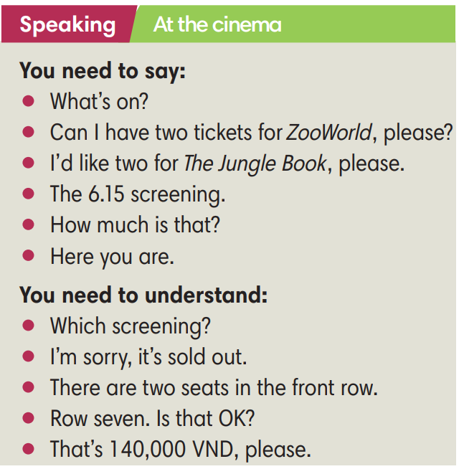  - Teacher invites pairs to act out their roleplays in front of the class. | T-Ss  Ss-Ss  T-Ss
WRAP-UP | To consolidate what Ss have learnt in the lesson. | - T asks Ss to talk about what they have learnt in the lesson.  - Cinema expression | T-Ss  Ss-T
HOMEWORK | To review the lesson and prepare for the next lesson. | - Do exercises in the workbook page 12.  - Prepare for Lesson 1.7: Writing. | T-Ss

……………………………………………………………………………………………
Date of preparing: ………………………………………
Date of teaching: ………………………………………

