UNIT 1: CULTURAL INTERESTS
PERIOD 15. LESSON 1.9: REVISION
I. OBJECTIVES
By the end of the lesson, Ss are able to:
1. Knowledge
- Vocabulary: revise words related to cultures, cultural activities, likes and dislikes, age groups, news and entertainment
- Grammar: review present simple tense to talk about habits and routines, likes and dislikes, media habits.
2. Core competences
- General competences: form and / or improve such competences as group work, independent working, pair work, linguistic competence, and cooperative learning.
- Specific competences:
- Improve communicative competence related to the use of language (vocabulary, phonetics, grammar)
- For a language lesson: Ss are expected to use vocabulary of the unit, do the tasks assigned in the textbook.
- For a skills lesson: Ss are expected to write a personal introduction for a webpage.
3. Personal qualities
- Being hard-working and attentive in class
- Have a positive attitude towards the lesson
II. MATERIALS
- Grade 7 textbook, Unit 1 (SB p. 17, WB p.13)
- Computer (accessible to the Internet is the best)
- Projector / TV/ PPT slides / Active teach
Language analysis
Vocabulary: words of cultures, cultural activities, likes and dislikes, age groups, news and entertainment
Grammar: Present simple tense – all forms (affirmative, negative, question)
Assumptions
Anticipated difficulties | Solutions
1. Ss may write the structures incorrectly. | Keep the useful expressions on the board for reference.  Encourage peer-check.
2. Ss may not have sufficient speaking and co-operating skills. | Give clear instructions, give examples before letting Ss work in pairs / groups.  Provide feedback and help if necessary.

Board Plan
UNIT 1: CULTURAL INTERESTS
PERIOD 15. LESSON 1.9: REVISION
I. Vocabulary: words of cultures, cultural activities, likes and dislikes, age groups, news and entertainment
II. Grammar: Present simple tense – all forms (affirmative, negative, question)
III. Book work: Student Book page 19
IV. Homework
- Finish the writing task
- Prepare Unit 2 – Lesson 2.1: Vocabulary

III. PROCEDURES
Stage | Stage aim | Procedure | Interaction
WARM-UP | - To create a positive classroom atmosphere to start a new lesson.  - To lead into the review lesson. | Activity 1: SUPER EYES  - Set the scene: T asks students to do quick exercises for eyes such as look up and down, look left and right, row the eyes  - T tells students that they are going to play a game called SUPER EYES  - T explains the game rules then checks instructions.  Game rules:  - Look carefully at a collage of different small pictures  - The collage will disappear in a few seconds  - Recall as many words about the collage as you can remember.  - Teacher uses the slides to show the collages  - Ss join in the game in pairs or in small groups.  - Teacher shows the collage again with displayed answers to check for the whole class.  - T tells Ss that they are going to review Unit 1 | T-Ss  Ss - Ss  Ss-T
REVIEW VOCABULARY | - To help students reviews topic words and word friends from the unit | Activity 2: SUPER MIND  - T tells students to open the Glossary box in student book page 18  - T introduces the SUPER MIND game and rules  How to play:  - Play in team  - Choose a number to open a block  - Read the topic word  - Write as many words related to the topic as you can  - The faster finisher gets points  - T shows the slides of the game  - Ss take turns to choose the numbers for their teams.  - Ss discuss and list out all words related to the topic they get.  - T calls some Ss to give answers and confirms the winner. | T-Ss  Ss - Ss  Ss-T
REVIEW VOCABULARY | - To review vocabulary in context | Activity 3: Exercise 1 – Student Book page 19  Write the correct word for each definition  - T asks Ss to look at exercise 1 in student book page 19  - T calls a student to read the instruction then checks Ss’ understanding of it.  - T asks Ss to work in pairs to read then complete the activity.  - T checks as the whole class.  Answer keys:  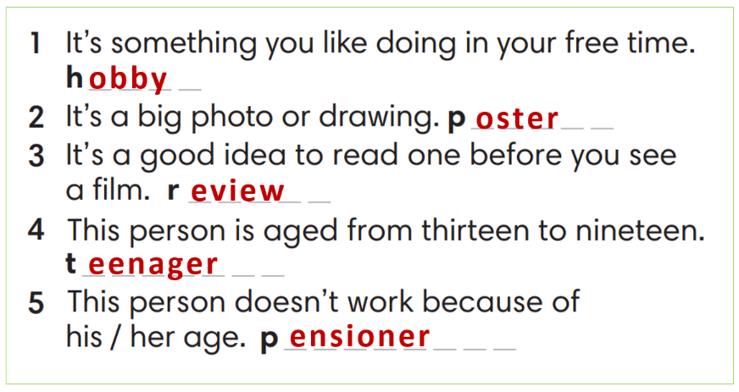 | T-Ss  T-Ss  Ss-T
REVIEW VOCABULARY | - To review vocabulary in context | Activity 4: Exercise 2 – Student Book page 19  Complete the word friends in the text. Then ask and answer the questions in pairs.  - T asks Ss to look at exercise 2 in student book page 19  - T calls a student to read the instruction then checks Ss’ understanding of it.  - T asks Ss to work in pairs to read then complete the activity.  - Ss work in pairs to complete the task and compare the answers.  - T checks as the whole class.  Answer keys:  1-news/ 2- forecast/ 3-soap/ 4-talk/ 5-game/ 6-reality/ 7-magazines | T-Ss  Ss-Ss  Ss-T
 | - To review vocabulary in context | Activity 5: Exercise 3 – Student Book page 19  Complete the poem with the words below.  - T asks Ss to look at exercise 3 in the student book on page 19  - T calls a student to read the instruction and then checks Ss’ understanding of it.  - T asks Ss to work in pairs to read and then complete the activity.  - Ss work in pairs to complete the task and compare the answers.  - T checks as the whole class.  Answer keys:  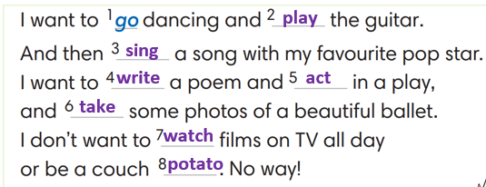 | T-Ss  Pair work  T-Ss  Ss-T
REVIEW GRAMMAR | To help students revise the form and use of the present simple. | Activity 6: Read the grammar box and complete the sentences  (Extra activity)  - T asks Ss to look at the grammar box and read the example.  - T asks Ss to work individually to apply the grammar to complete three sentences with given words.  - Students think and write the sentences  - T sets a time limit for the activity.  - T shows the slide and checks as the whole class. | T-Ss  Ss-T
REVIEW GRAMMAR | - To help students practice the present simple. | Activity 7: Exercise 4 – Student Book page 19  Complete the sentences with Present Simple form of verbs in brackets  - T asks Ss to look at exercise 4 in student book page 19  - T calls a student to read the instruction then checks Ss’ understanding of it.  - T asks Ss to work in pairs to read then complete the activity.  - Ss work in pairs to complete the task and compare the answers.  - T checks as the whole class.  Answer keys:  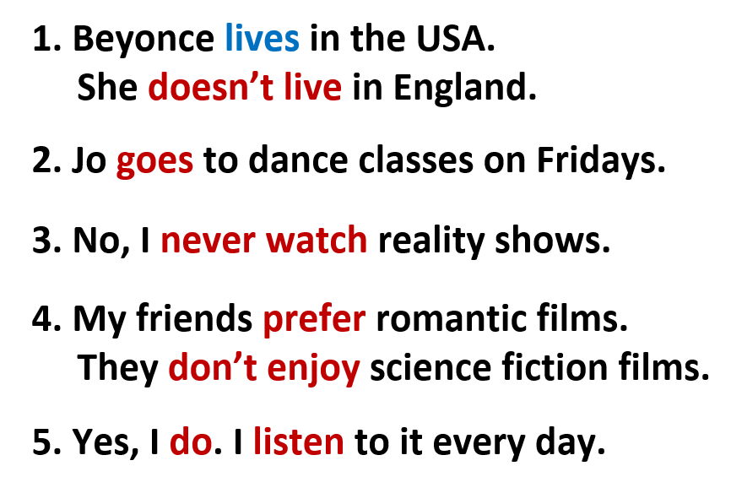 | T-Ss  Ss-Ss  T-Ss  T-Ss
 | - To help students practice the present simple in a communicative activity | Activity 8: Exercise 5 – Student Book page 19  In pairs, use the words in A and B to write five sentences about a classmate. Then ask your classmate questions with How often to check.  Step 1: Time to write  T tells students to read words in part A and B.  T reminds them that they belong to 2 groups: Adverbs of frequency and verbs.  T elicits the form of the sentence and gives an example.  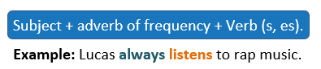  Ss work in pairs to write.  Step 2: Time to talk  T calls a pair of strong students to demonstrate the dialogue in front of the class.  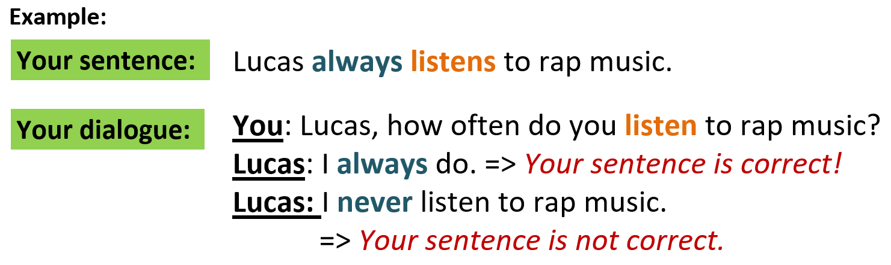  Ss work in pairs to practice asking and answering.  T encourages some pairs to roleplay the dialogue in front of the class.
 | - To help students practice writing a personal introduction for a webpage. | Activity 9: Exercise 6 – Student Book page 19  Your class has a new webpage. Write a text (60-80 words) to introduce a member from your class and post it on the webpage.  - T asks Ss to look at exercise 6.  - T calls a student to read the instruction then checks Ss’ understanding of it.  - T asks Ss to work individually to write based on the writing box in the student book page 17  - T sets a time limit and walks around as a monitor while Ss are writing.  - T asks Ss to swap their writing pieces for peer check.  - Ss work in pairs to write and give feedback for their partner’s writing product.  - T may collect Ss’ writing for detailed comments. | T-Ss  Ss - Ss
WRAP-UP | To consolidate what Ss have learned in the lesson. | - T asks Ss to talk about what they have learned in the lesson.  - Review Unit 1 vocabulary and grammar.  - Write a personal introduction for a webpage. | T-Ss  Ss-T
HOMEWORK | To review the lesson and prepare for the next lesson. | - Do exercises in the workbook page 13.  - Prepare for Unit 2/Lesson 2.1: Vocabulary | T-Ss

…………………………………………………………………………………………………
Date of preparing: ………………………………………
Date of teaching: ………………………………………

