Date of planning: …………….  Date of teaching: …………….. | UNIT 2: FAMILY AND FRIENDS  PERIOD 21 . LESSON 2.5 LISTENING & VOCABULARY

I. OBJECTIVES:
By the end of the lesson student will be able to:
- identify specific details in a conversation and talk about personalities.
1. Knowledge:
* Vocabulary: use vocabulary of personalities to describe people.
* Grammar: make sentences in the Present Simple and Present Continuous to describe people’s interest and habit correctly.
2. Competence: Understand and use adjectives of personalities, do the tasks assigned in the textbook. Listen and identify specific details in a conversation and talk about personalities.
3. Quality/ behavior: To teach Ss to be hard-working and attentive in class. Ss have a positive attitude to working in groups, individual work, pair work, cooperative learning and working.
II. TEACHING AIDS:
- Teacher: Grade 7 textbook, Unit 2 (SB p. 25, WB p.20), laptop/computer connected to the Internet, loudspeaker, projector/TV, PPT slides…
- Students: Text books, studying equipment…
- Method: Active teach, T-WC; group works; individual ……
III. PROCEDURE:
1. WARM UP + LEAD-IN (10’)
ACTIVITY 1:
* Aim:
- To activate students’ prior knowledge and get students involved in the lesson.
- To set the context for introducing new words.
- To get students to think about the topic.
- To provide Ss with reasons for more discussions
* Content: Play SONGS game to practice the listening skill.
* Outcome: Know more new words in context. Improve pronunciation.
* Organisation: T, Ss ..
Teacher’s &Student’s activities | Content
Extra activity 1 (5’): SONGS  - T greets students  - T introduces the Warm-up song  - T explains How-to-play steps then checks instructions.  - Ss join the activity as the whole class.  - T uses slides to conduct the activity.  - T introduces that all the words are adjectives of Personalities.  - T elicits the meaning and drill the pronunciation of the words.  - T sets the scene for the new lesson: T tells Ss that they are going to learn more words of personalities by doing a listening task.  - T writes the title on the board Unit 2: Family and Friends / Lesson 2.5: Listening and Vocabulary. | How to play:  - Read the list of given words  - Listen to a song, put a tick next to the word you hear.  - 1 correct answer = 1 point
1. (5’) Tell your partner about the personalities of two people in your family.  (Exercise 1 – SB p.25)  - T asks students to work in pairs to talk about the personalities  of two people in their family.  - Ss work in pairs to think and share.  - T invites some students to share with the class.  - T notes down the adjectives that students used to talk about  personalities on the board.  - T tells Ss that they’re going to learn adjectives in the next steps of the lesson. | 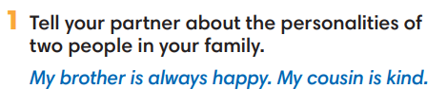
2. PRE-LISTENING (18’)
ACTIVITY 2 + 3:
*Aim:
- To activate Ss’ prior knowledge of the topic.
- To pre-teach words of personalities
- Introduce the Vocabulary Box
- To reinforce words of personalities
- To develop Critical Thinking
- To reinforce words of personalities
* Content: Some brief notes; vocabulary about personalities. Use them to complete the exercise.
* Outcome: Know some more new words about personalities. Chose the correct words to answer the questions.
* Organisation: T, Ss …
Teacher’s &Student’s activities | Content
Extra activity 2 (10’): Multiple Choice Game  (pre-teach vocabulary)  - Teacher introduces that Ss will learn more words of personalities by joining a game.  - T explains the game rules then checks instructions.  - Ss join the game in team. Ss take turns to answer each question.  - Teacher leads the game and asks students to read aloud each word or phrase.  - When the game ends, teacher shows all the new words again for students to read. | How to play:  - Look at the slides and read the definitions  - Read the words of personalities  - Choose 1, 2 or 3 to match the word with the definition  - 1 correct answer = 1 point
2. (4’) Tick (V) the positive adjectives and cross (X) the negative ones.  (Exercise 2 - SB p.252)  - T asks Ss to look at exercise 2.  - T calls a student to read the instruction then checks Ss’ understanding of it.  - T elicits the meaning of Positive and Negative  - T asks Ss to work in pairs or small groups to read then complete the activity.  - T calls groups to give answers to check as the whole class.  - T encourages students to make sentences with these adjectives. | 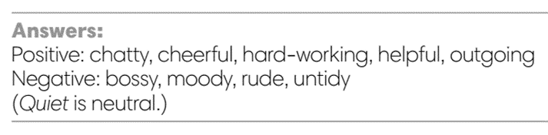
3. (4’) Minh, Nam and Linh are talking about Mai. Read their opinions and complete each gap with a word from the Vocabulary box. Listen and check.  (Exercise 3 - SB p.25)  - T asks Ss to look at exercise 3.  - T calls a student to read the instruction then checks Ss’ understanding of it.  - T asks students to look at the photo of Mai and discuss Mai's  personality in groups of three or four.  - T plays the audio and ask students to complete the gaps.  - T plays the audio again for Ss to check with the answers.  - T checks as the whole class. | Answer keys:  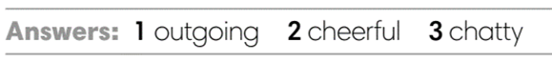
3. WHILE-LISTENING (8’)
ACTIVITY 4:
* Aim:
- To help Ss identify specific details in a conversation.
- To provide Ss with chances to think and talk about personalities.
* Content: Listen and understand the audio track to complete the exercise.
* Outcome: Understanding the personalities by matching the correct answers.
* Organisation: T_ Ss …
Teacher’s &Student’s activities | Content
4. Listen to a talk between Minh and Nam. Mark the sentences V (right), X (wrong), ? (doesn’t say).  (Exercise 4 - SB p.25)  - T asks Ss to look at exercise 4 in student book page 25.  - T calls a student to read the instruction then checks Ss’ understanding of it.  - T tells students to read the statements before listening.  - T asks students to listen and mark the sentences (i.e., v, x, ?).  - T plays the audio and have students do the exercise.  - T tells Ss to check their answers in pairs.  - T plays the audio again and checks the answers with the  whole class.  - Teacher encourages students to give the evidence that they hear from the audio track to prove their answer. | 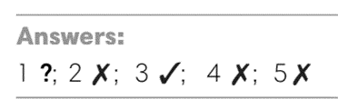
4. POST-LISTENING (6’)
ACTIVITY 5:
*Aim: TTo help students applying the vocabulary items related to the topic in communicating.
* Content: Work in pairs to describe one’s personalities by using adjectives.
* Outcome: Think and share about individual personality.
* Organisation : T, Ss ..
Teacher’s &Student’s activities | Content
5. In pairs, choose three adjectives from the Vocabulary Box to describe.  (Exercise 5 - SB p.25)  - T asks Ss to look at exercise 5 in student book page 25.  - T calls a student to read the instruction then checks Ss’ understanding of it.  - T asks Ss to work in pairs to read then complete the activity.  - T sets a time limit for students.  - Students work in pair to think and share.  - Teacher invites different students to talk about their partner. | 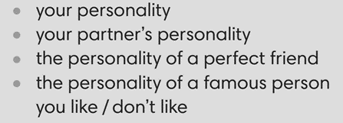
WRAP-UP & HOME WORK ( 2’)

- T asks Ss to talk about what they have learnt in the lesson.
- Vocabulary of personalities
* HOME WORK
- Do exercises in the workbook page 20.
- Prepare for Lesson 2.6: Speaking.

………………………………………………………………………….

