UNIT 0: WELCOME
PERIOD 3. LESSON 0.2: INTRODUCING MAI

I. OBJECTIVES
By the end of the lesson, Ss are able to:
1. Knowledge
- Vocabulary:
- name favourite activities in their free time.
- tell key information about Mai.
- Grammar:
- use useful expressions to talk about free time.
2. Core competences
- General competences: form and / or improve such competencies as group work, independent working, pair work, linguistic competence, and cooperative learning.
- Specific competences:
- Improve communicative competence related to the use of language (vocabulary, phonetics, grammar):
- For a language lesson: Ss are expected to use vocabulary to talk about free time, and understand the main grammatical points, then do the tasks assigned in the textbook.
- For a skills lesson: Ss are expected to use the vocabulary and grammar points to talk about their favourite activities in their free time.
3. Personal qualities
- Being hard-working and attentive in class.
- Have a positive attitude towards the lesson.
II. MATERIALS
- Grade 7 textbook, Unit 0 (SB p. 6)
- Computer connected to the Internet
- Projector / TV/ PPT slides / Active teach
Language analysis
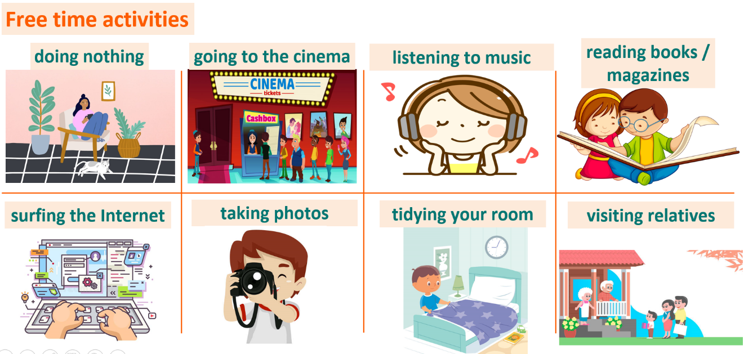
Assumptions
Anticipated difficulties | Solutions
1. Ss may not pronounce the vocabulary correctly. | Reinforce the pronunciation of target vocabulary.
2. Ss may not have sufficient speaking and co-operating skills. | Give clear instructions, give examples before letting Ss work in pairs / groups.  Provide feedback and help if necessary.

Board Plan
UNIT 0: WELCOME
PERIOD 3. LESSON 0.2: INTRODUCING MAI
I. Vocabulary
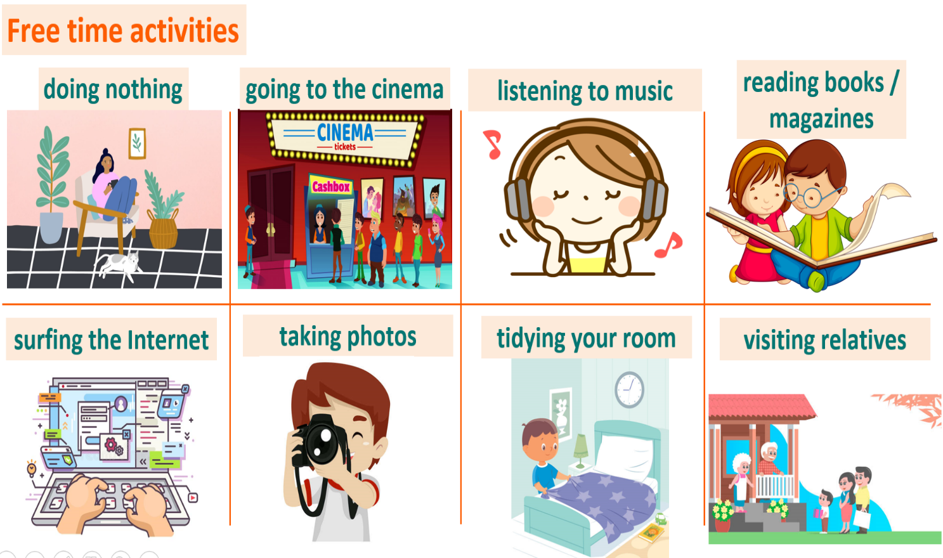
II. Homework
- Do exercises on workbook page 3.
- Prepare Unit 0 – Lesson 0.3: Mai’s Home.

III. PROCEDURE
Stage | Stage aim | Procedure | Interaction
INTRODUCE MAI | - To introduce Mai.  - To present vocabulary of hobbies and interests in context. | Activity 1: Read the text. In pairs, ask and answer questions below.  (Ex 1, p. 6)  - T asks Ss to open their SB page 6, look at exercise 1.  - T calls a student to read the instruction then checks Ss’ understanding of it.  - T sets a time limit and asks Ss to work in pairs to complete the activity.  - T calls some pairs to give answers then shows the answers on the slide.  Answer keys:  1. Yes, they are.  2. Yes, they are.  3. Yes, she is. – swimming, cycling. | T-Ss  Pair work  T-Ss  Ss-T
INTRODUCE MAI |  | Activity 2: Read the text about Mai again. What are her hobbies and interests?  (Ex 2, p. 6)  - T asks Ss to open their SB page 6, look at exercise 2.  - T calls a student to read the instruction then checks Ss’ understanding of it.  - T sets a time limit and asks Ss for answers.  - T calls some Ss to give answers then shows the answer on the slide.  Answer keys:  She likes surfing the Internet, taking photos, swimming, and in summer, cycling. | T-Ss  Pair work  T-Ss  Ss-T
 |  | Activity 3: Listen and check. If you understand the words below.  (Ex 3, p. 6)  - T asks Ss to open their SB page 6, look at exercise 3.  - T calls a student to read the instruction then checks Ss’ understanding of it.  - T lets Ss to listen once then elicits the meaning of phrases from Ss through the picture cues on the slide.  - T confirms the meaning of phrases then drills them. | T-Ss  T-Ss  Ss-T  T-Ss
PRACTICE VOCABULARY | - To help Ss practice using vocabulary in context. | Activity 4: Gift Box Secret Game  (Adapted from ex.2 WB p.3)  - T explains the game rules then checks instructions.  Game rules:  - Read the sentence carefully.  - Fill in the blank with a word.  - 1 correct answer = the candles in the gift box.  - Ss join in the game individually.  - T corrects Ss if any. | T-Ss  T-Ss  Ss-T  T-Ss
PRESENT STRUCTURES | - To present expressions to talk about hobbies and interests in context. | Activity 5: Listen to Mai and Nam. What is Nam’s free time activity? Choose the correct answer.  (Ex 4, p. 6)  - T asks Ss to look at excersise 4 (SB page 6).  - T calls a student to read the instruction then checks Ss’ understanding of it.  - T plays the audio, lets Ss listen and answer the question.  - T elicits answers from Ss then checks as the whole class.  Answer keys:  C. Doing nothing. | T-Ss  T-Ss  T-Ss  Ss-T
PRACTICE STRUCTURES | - To help Ss practice building sentences about hobbies and interests. | Activity 6: Hard Working Ants Game  (Adapted from ex4 WB p.3)  - T explains the game rules then checks instructions.  Game rules:  - Reorder the given words to make correct sentences.  - 1 correct answer = 2 points.  - Ss join in the game individually.  - T corrects Ss if any. | T-Ss  T-Ss
PRODUCE | - To help Ss apply what they have learnt to talk about favourite activity in their free time. | Activity 7: Work in groups of three. Ask and answer about each other’s interests. Complete the table below then report to the class.  (Ex 5, p. 6)  - T asks Ss to look at exercise 5 (SB page 6).  - T calls a student to read the instruction then checks Ss’ understanding of it.  - T asks a student to read the sample report.  - T divides Ss into groups of three, then sets a time limit for them to complete the activity.  - T walk around to listen and notes down common mistakes for delayed feedback.  - T calls some groups to come to the front of the class and report.  - T asks the rest to give comments on their classmates’ performance.  - T gives feedback on Ss’ work. | T-Ss  Group work  Ss-T  T-Ss  Ss-Ss  T-Ss
WRAP-UP | To consolidate what Ss have learnt in the lesson. | - T asks Ss to talk about what they have learnt in the lesson.  - Mai’s information.  - Free time activities. | T-Ss  Ss-T
ASSIGN HOMEWORK | To review the lesson and prepare for the next lesson. | - Do exercises in the workbook page 3.  - Prepare for Lesson 0.3: Mai’s Home. | T-Ss

…………………………………………………………………………………………

Date of preparing: …………………………………………….
Date of teaching: …………………………………………….

