UNIT 0: WELCOME
PERIOD 4. LESSON 0.3: MAI ‘S HOME

I. OBJECTIVES
By the end of the lesson, Ss are able to:
1. Knowledge
- Vocabulary:
- Identify key information about Mai.
- Name possessions.
- Grammar:
- use there is / there are with some / any to talk about their possessions.
2. Core competences
- General competences: form and / or improve such competencies as group work, independent working, pair work, linguistic competence, and cooperative learning.
- Specific competences:
- Improve communicative competence related to the use of language (vocabulary, phonetics, grammar):
- For a language lesson: Ss are expected to use vocabulary to talk about possessions, and understand the main grammatical points, then do the tasks assigned in the textbook.
- For a skills lesson: Ss are expected to use the vocabulary and grammar points to talk about their possessions.
3. Personal qualities
- Being hard-working and attentive in class.
- Have a positive attitude towards the lesson.

II. MATERIALS
- Grade 7 textbook, Unit 0 (SB p. 7)
- Computer connected to the Internet
- Projector / TV/ PPT slides / Active teach
Language analysis
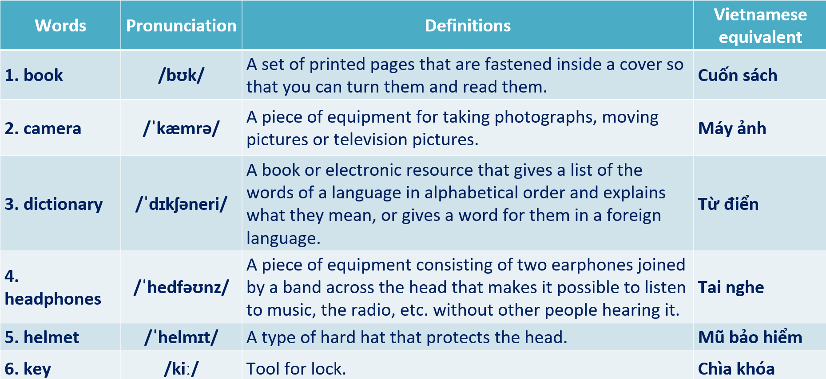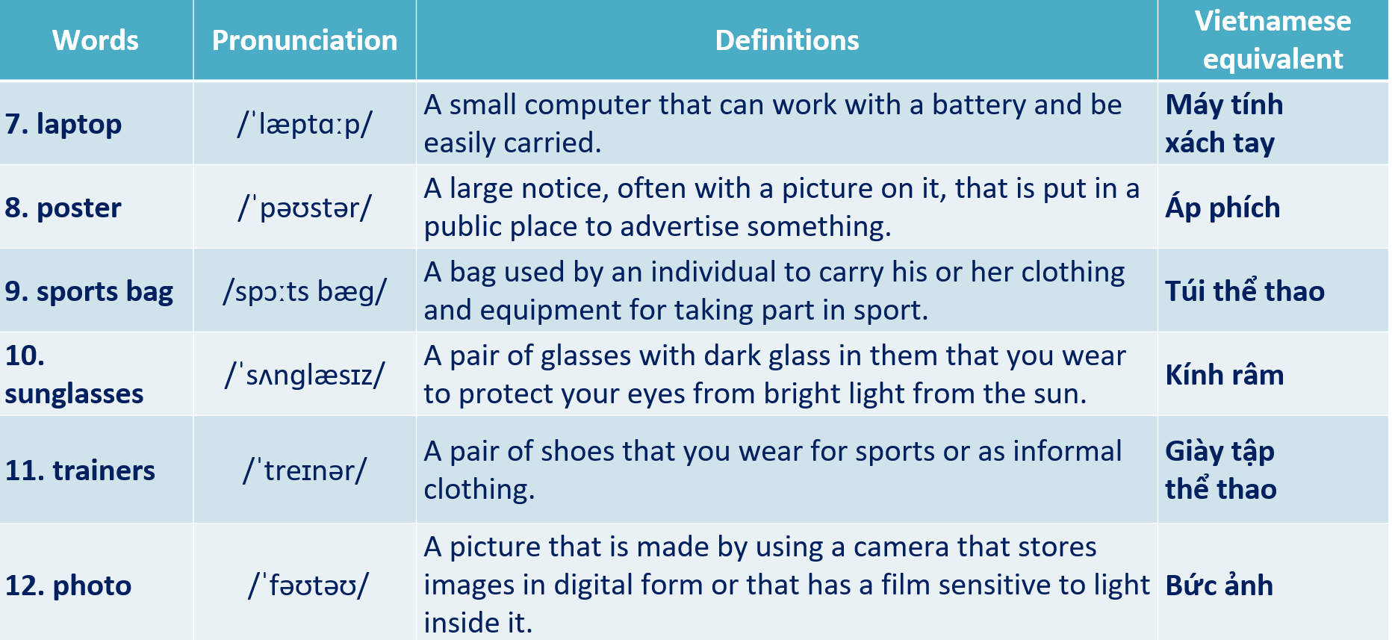
Assumptions
Anticipated difficulties | Solutions
1. Ss may not pronounce the vocabulary correctly. | Reinforce the pronunciation of target vocabulary.
2. Ss may not have sufficient speaking and co-operating skills. | Give clear instructions, give examples before letting Ss work in pairs / groups.  Provide feedback and help if necessary.

Board Plan
UNIT 0: WELCOME
PERIOD 4. LESSON 0.3: MAI ‘S HOME
I. Vocabulary
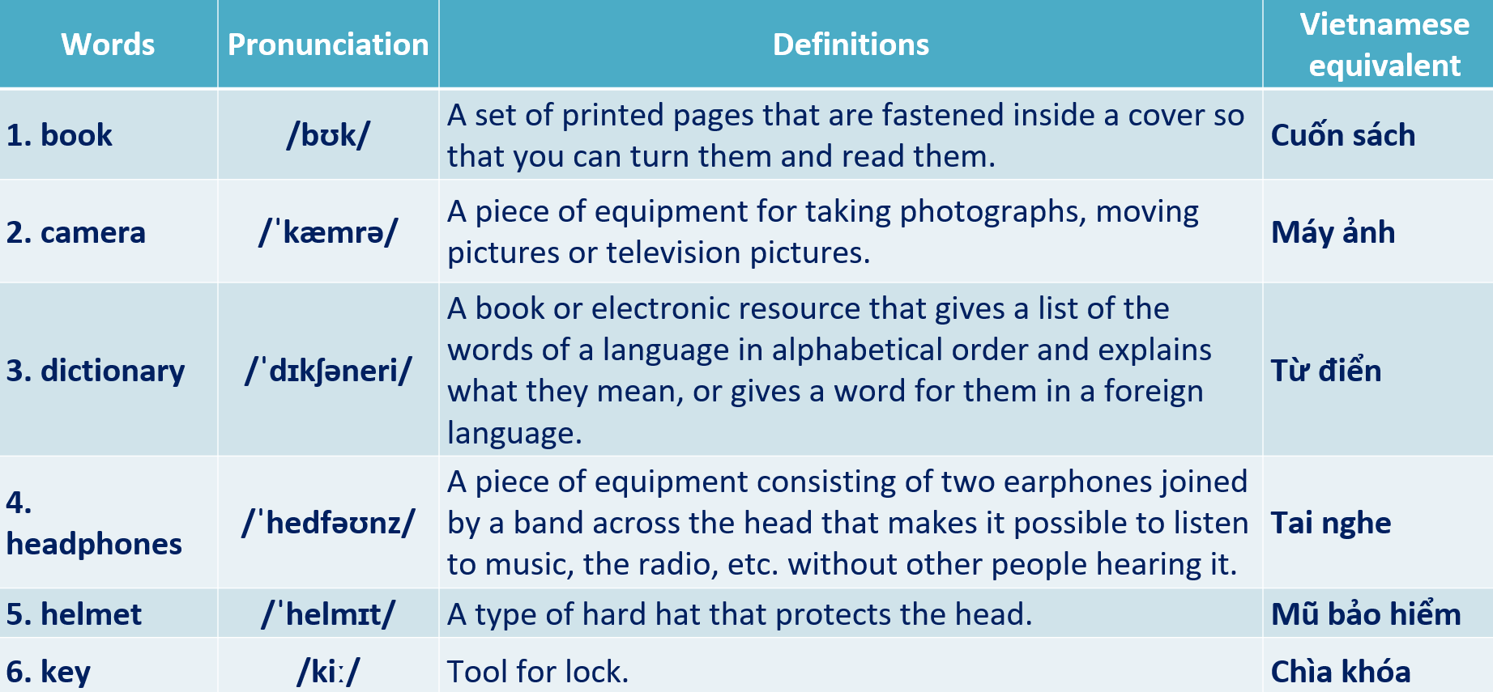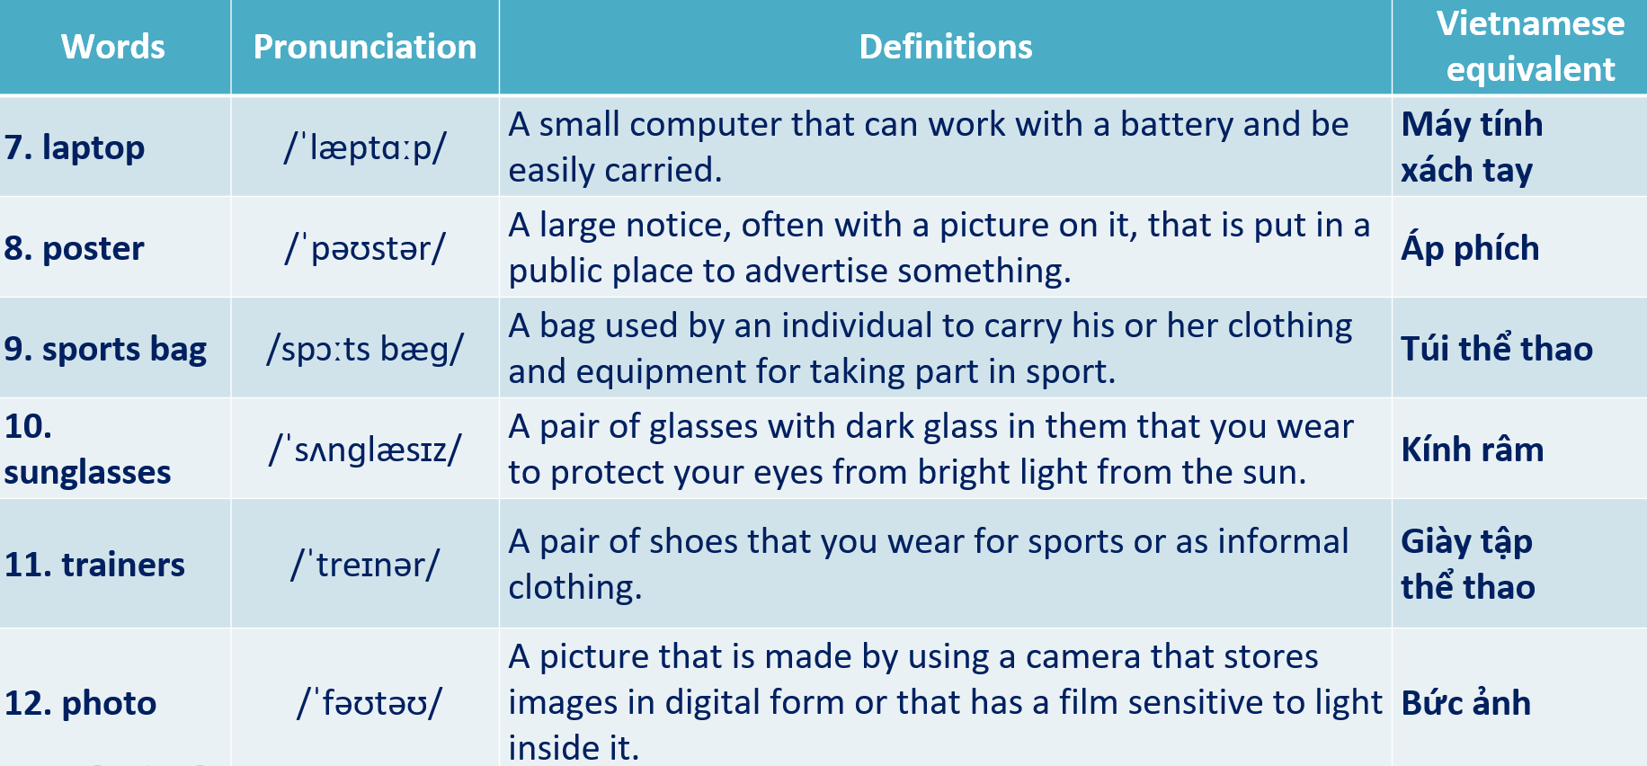
II. Homework
- Do exercises on workbook page 4.
- Prepare Unit 0 – Lesson 0.4: Introducing Kim.

III. PROCEDURE
Stage | Stage aim | Procedure | Interaction
WARM-UP | - To help Ss review information about Mai that they have learnt in the previous lesson. | Activity 1: Read and tick 5 correct sentences about Mai.  (Extra activity)  - T asks Ss to read the instruction on the slide then check their understanding.  - T calls students to read the sentences about Mai.  - T sets a time limit and asks Ss to work in pairs to complete the activity.  - T calls some pairs to give answers then shows the answers on the slide. | T-Ss  Pair work  T-Ss  Ss-T
PRESENT VOCABULARY | - To present vocabulary of possessions in context. | Activity 2: Read about Mai’s bedroom. Mark the sentences T (true), F (false)  (Ex 1, p. 7)  - T asks Ss to open their SB page 7, look at exercise 1.  - T calls a student to read the instruction then checks Ss’ understanding of it.  - T lets Ss read the short text and all the sentences.  - T calls Ss to give answers and asks them to explain their answers.  - T checks as the whole class.  Answer keys:  Activity 3: Guessing Game  (Adapted from ex.1 WB p.4)  - T explains the game rules then checks instructions.  Game rules:  - Look at the picture.  - Guess the thing.  - Choose 1, 2 or 3 then read the word  - 1 correct answer = 1 point  - Ss join in the game individually.  - T corrects Ss if any. | T-Ss  T-Ss  Ss-T  T-Ss  T-Ss  T-Ss  Ss-T  T-Ss
  2. F | 4. T
  3. T | 5. T
PRACTICE VOCABULARY | - To help Ss identify and name possessions.  - To help Ss correct their pronunciation of target vocabulary.  - To provide Ss with a chance to talk about their possessions. | Activity 4: Listen and underline the things you can see in the photo.  (Ex 2, p. 7)  - T asks Ss to open their SB page 7, look at exercise 2.  - T calls a student to read the instruction then checks Ss’ understanding of it.  - T lets Ss listen and underline things they see in the photo.  - T calls Ss to give answers.  - T correct Ss’ pronunciation if any.  Answer keys:  Activity 5: In pairs, use vocabulary box to tell your partner three things you have / haven’t got / would like to have.  (Ex 3, p. 7)  - T asks Ss to open their SB page 7, look at exercise 3.  - T calls a student to read the instruction then checks Ss’ understanding of it.  - T sets time limit and asks Ss to work in pairs to complete the activity.  - T calls some pairs to practice speaking in front of the class.  - T correct Ss’ pronunciation if any. | T-Ss  T-Ss  Ss-T  T-Ss  T-Ss  T-Ss  Pair work  T-Ss
  book, camera, dictionary, headphones, helmet, keys, laptop, photo, poster, sports bag, sunglasses, trainers.
PRESENT GRAMMAR | - To present the use of there is / there are with a / an / some / any. | Activity 6: Study the grammar box. Use there is / there are with a / an / some / any to write sentences about your bedrooms.  (Ex 4, p. 7)  - T asks Ss to look at excersise 4 (SB page 7).  - T calls a student to read the instruction then checks Ss’ understanding of it.  - T lets Ss work in groups, study the grammar box, read the model sentences then make some new sentences about their bedrooms.  - T elicits answers from groups then shows some suggestions. | T-Ss  T-Ss  Group work  Ss-T  T-Ss  Ss-T
PRACTICE STRUCTURES | - To help Ss practice building sentences about hobbies and interests. | Activity 7: Bomb Stars Game  (Adapted from ex4 WB p.4)  - T explains the game rules then checks instructions.  Game rules:  - Make sentences with There is / There are  - 1 correct answer => choose a star for point(s).  - Ss join in the game individually.  - T corrects Ss if any. | T-Ss  T-Ss
PRODUCE | - To help Ss apply what they have learnt to talk about their possessions. | Activity 8: In pairs, ask and answer questions about your bedrooms. Use the items from vocabulary box or your own ideas.  (Ex 5, p. 7)  - T asks Ss to look at exercise 5 (SB page 7).  - T calls a student to read the instruction then checks Ss’ understanding of it.  - T asks a student to read the sample dialogue.  - T divides Ss into new pairs, then sets a time limit for them to complete the activity.  - T walk around to listen and notes down common mistakes for delayed feedback.  - T calls some pairs to come to the front of the class and make conversations.  - T asks the rest to give comments on their classmates’ performance.  - T gives feedback on Ss’ work. | T-Ss  Pair work  Ss-T  T-Ss  Ss-Ss  T-Ss
WRAP-UP | To consolidate what Ss have learnt in the lesson. | - T asks Ss to talk about what they have learnt in the lesson.  - Possessions.  - There is / There are with some / any. | T-Ss  Ss-T
ASSIGN HOMEWORK | To review the lesson and prepare for the next lesson. | - Do exercises in the workbook page 4.  - Prepare for Lesson 0.4: Introducing Kim | T-Ss

……………………………………………………………………………………………
Date of preparing: …………………………………………….
Date of teaching: …………………………………………….

