Date of planning: ……………………  Date of teaching: …………………… | UNIT 4: HEALTH AND FITNESS  PERIOD 41. LESSON 4.3. READING & VOABULARY
I. OBJECTIVES:
By the end of the lesson ss will be able to:
- find main ideas and specific details in a text about sleeping habits.
1. Knowledge:
*Vocabulary: an understanding of the vocabulary about sleeping habits.
New words | Vietnamese meaning
1. fall asleep | ngủ gục
2. go to bed/sleep | đi ngủ
3. feel tired | cảm thấy mệt/buồn ngủ
4. get up early/late | thức dậy sớm/ muộn
5. stay up late | thức khuya
6. have a dream | ngủ mơ
7. get ready for bed | sửa soạn đi ngủ
9. sleep well/badly | ngủ ngon/ không ngon

* Grammar: Reading skills: the ability to find main and specific details in a letter.
2. Competence: Understand and know the meaning of the keywords used to talk about sleeping habits; locate information and find specific details in a letter (scanning skill); identify the main ideas of the paragraphs in the text or the text itself (skimming skill).
3. Quality/ behavior: To teach Ss to be hard-working and attentive in class. Ss have a positive attitude to working in groups, individual work, pair work, cooperative learning and working.
II. TEACHING AIDS:
- Teacher: Grade 7 textbook, Unit 4 (SB p.43, WB p.36), laptop/computer connected to the Internet, loudspeaker, projector/TV, PPT slides…
- Students: Text books, studying equipment…
- Method: Active teach, T-WC; group works; individual ……
III. PROCEDURE:

1. WARM-UP (5’)
* Aim:
- To help Ss review some phrases they have known.
- To lead in to the next activity.
* Content: Game: LUCKY PHOTO GAME (about sleeping habits)
* Outcome: Ss can talk about their sleeping habits.
* Organisation: T_ Ss …
Teacher’s &Student’s activities |  | Content
Extra activity 1: LUCKY PHOTO GAME  - T explains the game rules then checks instructions.  - T uses slide to lead the game.  - T asks Ss to Choose the correct phrase  - T elicits the picture and ask student to guess the meaning before they choose.  - Ss raise their hands if they have the answer.  - T asks students to read aloud the phrase after each play.  - T tells students that they’ve just play a game with words about sleeping and they are reading about sleeping today.  - T writes the title for the new lesson:  Unit 4/Lesson 3: Reading and vocabulary. |  | Game rules:  - Look at the picture  - Read the given phrases  - Choose randomly to see your luck (you may know the answer already)
2. PRE-READING (6’)
ACTIVITY 1:
* Aim:
- To activate Ss’ background knowledge of the topic.
- To get student think about their sleeping habits
- To provide Ss with reasons for reading the text in the next stage.
* Content: To discuss Ss’s sleeping habits by doing the exercise.
* Outcome: Know new words, and grammar points when talking about sleeping habits.
* Organisation: T, Ss …
Teacher’s & Student’s activities | Content
1. (3’) CLASS VOTE – Do you agree with statements a – c  a. It’s hard to get up in the morning.  b. I sleep more than my parents.  c. I never want to go to bed before 11.00 p.m.  (Exercise 1 – SB p.43)  - T tells students how to vote  - T shows each of the statements and asks students to read aloud.  - T tells Ss that they to put up their hands if they agree.  - T asks students who don’t raise their hands why they disagree. | 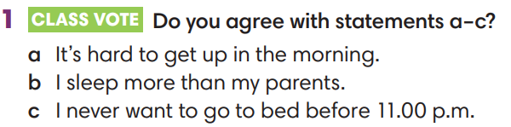
Extra activity 2 (3’): SEE – THINK - WONDER  - T shows the slide, asks Ss to read aloud the questions  - What do you see in the picture?  - What’s the boy problem?  - T asks a students to look at the photos and find the answers.  - 1. A boy, day, night, play on phone, sleep in class, etc.  - 2. He stays up late at night and sleeps at daytime.  - T emphasizes about the photo “This is Karl. He has unhealthy sleeping habits, so he needs some advice.”  - T provides more information about Karl and Polly is the one who replies to Karl’s letter. | 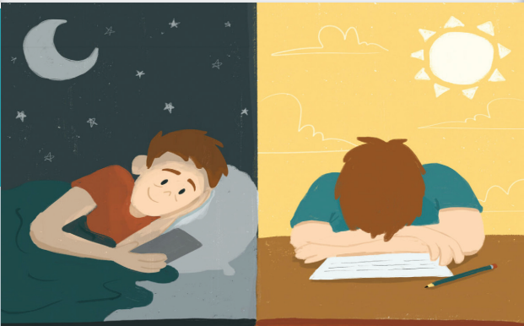
3. WHILE-READING 1 (5’)
ACTIVITY 2:
*Aim:
- To read two letters and do some reading tasks.
- To help students practice finding main ideas and specific details in the texts.
- To present word friends of sleeping habits.
* Content: Read about the sleeping habits.
* Outcome: To know more new words about sleeping habits. Understand more about using the words in contexts.
* Organisation: T, Ss …
Teacher’s & Student’s activities | Content
2. (5’) Read the text. What’s Polly’s advice  (Exercise 2 – SB p.43)  - T asks Ss to look at excersise 2 (SB page 43).  - T calls a student to read the instructions then checks Ss’ understanding of it.  - T tells Ss to read the text and asks what Karl’s problems are  (He has to go to bed when he isn’t tired. He has to get up when his parents tell him to at the weekend.).  - T asks what they think Polly’s advice might be and allows Ss to continue reading.  - T sets a time limit and asks Ss to work in pairs to complete the activity by sharing the answers.  - T elicits the ideas from Ss, asks them in which line of the paragraph they see the answers.  - T asks Ss to explain their answers by referring to the clues the text.  - T confirms the answers then drills the pronunciation of the phrases and corrects Ss’ pronunciation if any. | Answer keys:  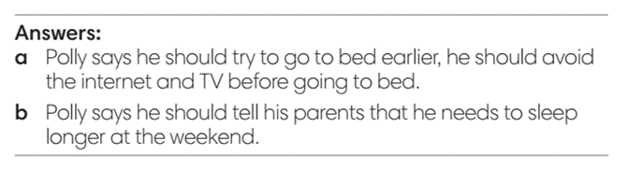
4. WHILE-READING 2 (5’)
ACTIVITY 3:
*Aim: To help students practice reading for specific information in a letter.
* Content: Read about the sleeping habits in the letter.
* Outcome: To know more new words about sleeping habits. Understand more about using the words in contexts.
* Organisation: T, Ss …
Teacher’s & Student’s activities | Content
3. (5’) Read the text again. Choose the correct answer.  (Exercise 3 – SB p.43)  - T asks Ss to look at excersise 4 (SB page 43).  - T calls a student to read the instruction then checks Ss’ understanding of it.  - T and Ss review TIPS: reading for specific information.  (Ss learnt the TIPS from Unit 1 already)  - T tells student to read the text again individually to  complete Exercise 4.  - When finished, T asks them to compare their answers in pairs  and check with them.  - T asks students to point to relevant details in the text. | 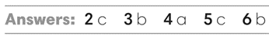
5. POST-READING (15’)
ACTIVITY 4 + 5:
* Aim:
- To provide more word friends and practice talking about sleeping habits.
- To reinforce word friends and practice talking about sleeping habits.
* Content: To discuss the sleeping habits.
* Outcome: Making sentences to talk about their sleeping habits. Commenting about the sentences of others.
* Organization: T, Ss...
Teacher’s & Student’s activities | Content
4. (5’) How do you day these phrases in your own language?
(Exercise 4 – SB p.43)
- T asks students to find the highlighted words in the text
and discuss in groups of three the meanings of these
words.
- T tells Ss to work in pair to do the same with phrases in Exercise 4
- T checks the answers with the whole class and elicit the meaning of these phrases in Vietnamese.
- When Ss finish, T asks further questions using phrases.
Eg:
How do you get ready for bed?
Do you put on your pyjamas before or after you clean your teeth?
Extra activity 3 (5’): HAPPY BOB GAME  - T tells Ss that they are play a game to reinforce word friends and practice talking about sleeping habits  - T tells the game rules  - T uses slides to lead the game.  - Ss are allowed to raise hands and share their answers massively  - T checks Ss’ pronunciation if needed | Game rules:  - Read the sentences  - Choose a word to complete the sentence  - Click on pic of Bob to see the points
5. (5’) In pairs, read the Sleep Quiz and choose the correct option. Then interview each other.  (Exercise 5 – SB p.43)  - T asks Ss to look at excersise 5 (SB page 43).  - T calls a student to read the instruction then checks Ss’ understanding of it.  - T asks a student to read the example then models the activity in front of the class.  - T asks students to work in pairs to circle the correct option.  - Ss work in pairs and do the task.  - T uses the slides to check the correct answer for the whole class.  Interview time  - T records the Sleep Quiz on board/screen and tell students to pair and interview each other.  - After 1 minute, Ss swap and interview a new classmate.  - T sets a time limit and monitors Ss while they are carrying out their interviews  - T notes down common mistakes for delayed feedback.  - When Ss finish, T invites some volunteers to role play the interview in front of the class.  - T asks the rest to give comments on their classmates’ performance.  - T gives feedback on Ss’ work. | 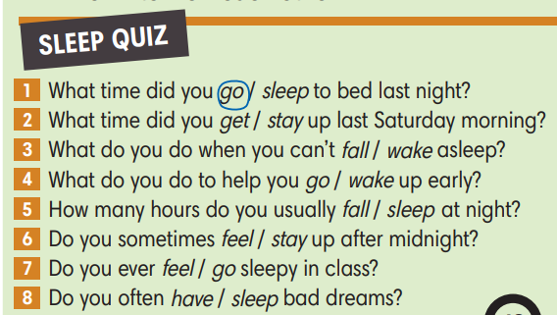
WRAP-UP & HOME WORK 4’)
- T asks Ss to talk about what they have learnt in the lesson.
- Vocabulary of sleeping habits
- Reading a letter about sleeping problems.
- Join a Sleep Quiz
* HOME WORK
- Do exercises in the workbook page 36.
- Prepare for Lesson 4.4: Grammar 2.

……………………………………………………………………………………..

