Date of planning: …………………  Date of teaching: …………………. | UNIT 4: HEALTH AND FITNESS  PERIOD 43.LESSON 4.5.LISTENING & VOCABULARY
I. OBJECTIVES:
By the end of the lesson student will be able to:
- identify specific details in a conversation and talk about illnesses.
1. Knowledge:
* Vocabulary: use vocabulary of symptoms and illnesses.
* Grammar: make sentences in the Present Simple and Present Continuous to describe people’s health problems.
2. Competence: Understand and use words of illnesses, do the tasks assigned in the textbook. Listen and identify specific details in a conversation and talk about illnesses.
3. Quality/ behavior: To teach Ss to be hard-working and attentive in class. Ss have a positive attitude to working in groups, individual work, pair work, cooperative learning and working.
II. TEACHING AIDS:
- Teacher: Grade 7 textbook, Unit 4 (SB p. 45, WB p.38), laptop/computer connected to the Internet, loudspeaker, projector/TV, PPT slides…
- Students: Text books, studying equipment…
- Method: Active teach, T-WC; group works; individual ……
III. PROCEDURE:
1. WARM UP + LEAD-IN (5’)
* Aim:
- To activate students’ prior knowledge and get students involved in the lesson.
- To early introduce some words of illnesses
* Content: Play Doctor Pikachu game (about illnesses).
* Outcome: Know more new words in context. Improve pronunciation.
* Organisation: T, Ss ..
Teacher’s &Student’s activities | Content
Extra activity 1: Doctor Pikachu  - T greets students  - T introduces the Warm-up game  - T explains How-to-play steps then checks instructions.  - Ss join the activity as the whole class.  - T uses slides to conduct the activity  - T introduces that all the words are about illnesses  - T elicits the meaning and drill the pronunciation of the words  - T sets the scene for the new lesson: T tells Ss that they are going to learn more words of illnesses and symptoms by doing a listening task.  - T writes the title on the board Unit 4: Health and Fitness Lesson 4.5: Listening and Vocabulary | How to play:  - Look at the picture  - Choose the correct sentence to meet Doctor Pikachu  - 1 correct answer = 1 point
2. PRE-LISTENING (18’)
ACTIVITY 1 + 2 + 3:
*Aim:
- To lead into the topic
- To set the scene for the new content and introduce Vocabulary Box
- To introduce the Vocabulary Box
- To develop critical thinking through a group activity
- To reinforce words of symptoms and illnesses
- To practice using new words in context
* Content: Some brief notes; vocabulary about pets. Use them to complete the exercise.
* Outcome: Know some more new words about pets. Chose the correct words to answer the questions.
* Organisation: T, Ss …
Teacher’s &Student’s activities | Content
1. (10’) Look at the picture. Why is tomorrow a big day for Bridgeton United?  (Exercise 1 – SB p. 45)  - T asks the students to look at the picture and the text and  answer the question.  - T elicits the answer and then asks students if anyone has taken part in the final of a sports competition.  - T asks how they felt and what happened.  - T asks Ss to look at the picture of Bridgeton United football team again and says “LOOK! WHAT’ WRONG WITH THE FOOTBALL TEAM?”  - Then teacher tells Ss to look at the Vocabulary Box in Exercise 2 to find the suitable describing words. | 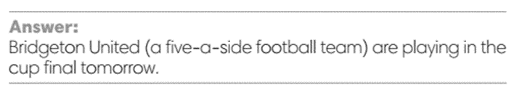
2. (4’) How do you say the phrases below in your language?  (Exercise 2 - SB p.45)  - T asks Ss to look at exercise 2.  - T calls a student to read the instruction then checks Ss’ understanding of it.  - T elicits the meaning of Symptoms and Illnesses.  Example: A high temperature and headache are the usual symptoms of flu.  - T asks Ss to work in pairs or small groups to read the other phrases and work out their meanings.  - T calls groups to give answers and provides the support if needed.  - T encourages students to make sentences with these phrases.  - Critical thinking: T asks students to work in groups and think of the answer for a critical thinking question.  Can you say the symptoms of….?  a hay fever  a flu  a cold  a type of allergy | 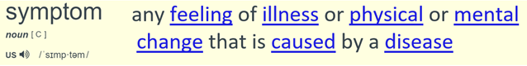  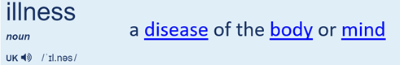
3. (4’) Use the vocabulary box to complete the sentences.  (Exercise 3 - SB p.45)  - T asks Ss to look at exercise 3.  - T calls a student to read the instruction then checks Ss’ understanding of it.  - T asks students to work individually to complete the task  - T calls volunteers to say the answer for each sentence.  - T checks as the whole class.  - T encourages Ss to read aloud the sentences and corrects pronunciation if needed. | Answer keys:  1. sneeze; hay fever  2. high temperature; flu  3. stomachache  4. cough / 5. sore throat
3. WHILE-LISTENING (5’)
ACTIVITY 4 + 5:
* Aim:
- To help Ss identify specific details in a conversation
- To provide practice of using vocabulary in context
- To provide practice of using vocabulary in questions and answers
* Content: Listen and understand the audio track to complete the exercise.
* Outcome: Think and talk about pets by matching the correct answers.
* Organisation: T_ Ss …
Teacher’s &Student’s activities | Content
4. (3’) Listen to five short extracts between the coach and the players. Complete the sentences.  (Exercise 4 - SB p.45)  - T asks Ss to look at exercise 4 in student book page 45.  - T calls a student to read the instruction then checks Ss’ understanding of it.  - T tells students to read the statements before listening.  - T checks that students understand coach (= trainer).  - T checks answers and elicit ideas about how Jerry might cope on his own in the match.  - T plays the audio and have students do the exercise.  - T tells Ss to check their answers in pairs.  - Students work individually then in pairs to complete the task.  - T plays the audio again and checks the answers with the  whole class.  - Teacher encourages students to give the evidence that they hear from the audio track to prove their answer. | Answer keys:  1. ready – 2. high – 3. Sneezing – 4. Terrible – 5. a cough
5. (2’) Listen again and answer the questions  (Exercise 5 - SB p.45)  - T asks Ss to look at exercise 4 in student book page 45.  - T calls a student to read the instruction then checks Ss’ understanding of it.  - Before students listen, T asks them to read the questions and  underline key words.  - T plays the audio once, elicits the answers  and then checks with the whole class. | Answer keys:  - Yes, he can.  - He has got a flu.  - He has got a hay fever.  - He has a stomachache.  - He got on the wrong train.
4. POST-LISTENING (6’)
ACTIVITY 6:
*Aim: To help students applying the vocabulary items related to the topic in communicating.
* Content: Work in pairs to talk about illness.
* Outcome: Think and talk about illness.
* Organisation: T, Ss ..
Teacher’s &Student’s activities | Content
6. In pairs, ask and answer the questions.  1. How often do you have a cold or the flu?  2. Are you allergic to anything?  3. What kind of things can give you a headache?  (Exercise 6 - SB p.45)  - T asks Ss to look at exercise 5 in student book page 45.  - T calls a student to read the instruction then checks Ss’ understanding of it.  - T provides some prompts for this activity.  Example: I have a cold once or twice a year.  I’m allergic to ____  ___ can give me a headache.  - T asks Ss to work in pairs to read then complete the activity.  - T sets a time limit for students.  - Students work in pair to think and share.  - Teacher invites different students to talk about their partner. | 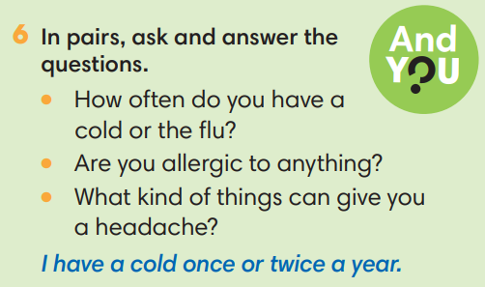
WRAP-UP & HOME WORK ( 2’)

- T asks Ss to talk about what they have learnt in the lesson.
- Vocabulary of illness
* HOME WORK
- Do exercises in the workbook page 38.
- Prepare for Lesson 4.6: Speaking.

……………………………………………………………………………

