Date of planning: …………………..  Date of teaching: ………………… | PERIOD 49: REVIEW 2 (UNIT 3-4)
I. OBJECTIVES:
1. Knowledge: By the end of this review, students will be able to revise the language they have learnt and the skills they have practiced in Units 3 - 4.
a) Vocabulary: revise the vocabulary which students have learnt in unit 3 and 4: words related to animals and health problems.
b) Grammar: review the grammar points which students have learnt in units 3 and 4: Past simple tense (irregular verbs and to be).
c) Writing: Writing a biography.
d) Speaking: Talking about animals; Talking about behaviors, and making and responding to apologies; Talking about health, food, sleeping habits, illnesses and asking about how someone is feeling.
2. Competence: Ss use the vocabulary of the unit, and do the tasks assigned in the textbook. Participate in a guided conversation to give and respond to the news using the given information.
3. Quality/ behavior: Having a positive attitude towards the lesson and a good relationship with friends. The love of learning English. Hard-working; attentive; cooperative; sociable; good communication in class.
II. TEACHING AIDS:
- Teacher: Textbook, laptop, loudspeaker, projector…
- Students: Grade 7 textbook, Unit 3&4 (SB p. 38, 48), studying equipment….
- Method: T-WC; group works; individual ……
III. PROCEDURE:
1. REVIEW VOCABULARY UNIT 3 (14’)
ACTIVITY 1 + 2:
* Aim:
- To help students reviews topic words and word friends from the unit.
- To review vocabulary in context.
* Content: Glossary of unit 3, Find the Treasure Game: vocabulary of unit 3.
* Outcome: Students’ correct pronunciation and answers.
* Organization of implementation:
Teacher’s & Student’s activities |  | Content
1. (7’) Activity 1:  - T tells students to open the Glossary box in student book page 38.  - T asks Ss work in pairs: 1 student points to the word, 1 student pronounces it. Then they swap their roles.  - T corrects Ss’ pronunciation if any.  * Circle the odd one out.  - T gives and checks the instruction.  - T set a time limit and asks Ss to work in pairs to read then complete the activity.  - T encourages students to give the reason for their answer.  - T checks as the whole class.  *Circle the word which has the underlined part pronounced differently.  - T asks Ss to work in pairs, discuss and give answers.  - Ss work in pairs to discuss and answer.  - T corrects Ss’ pronunciation if any. |  | 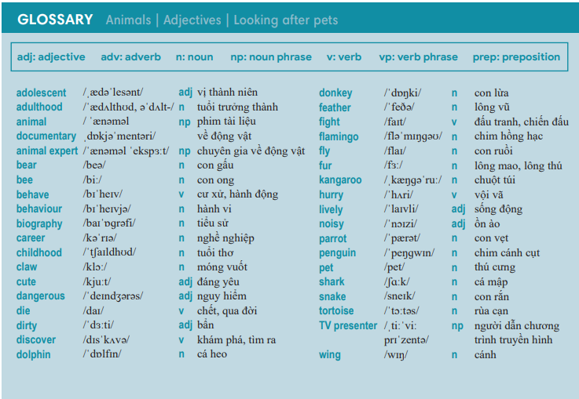  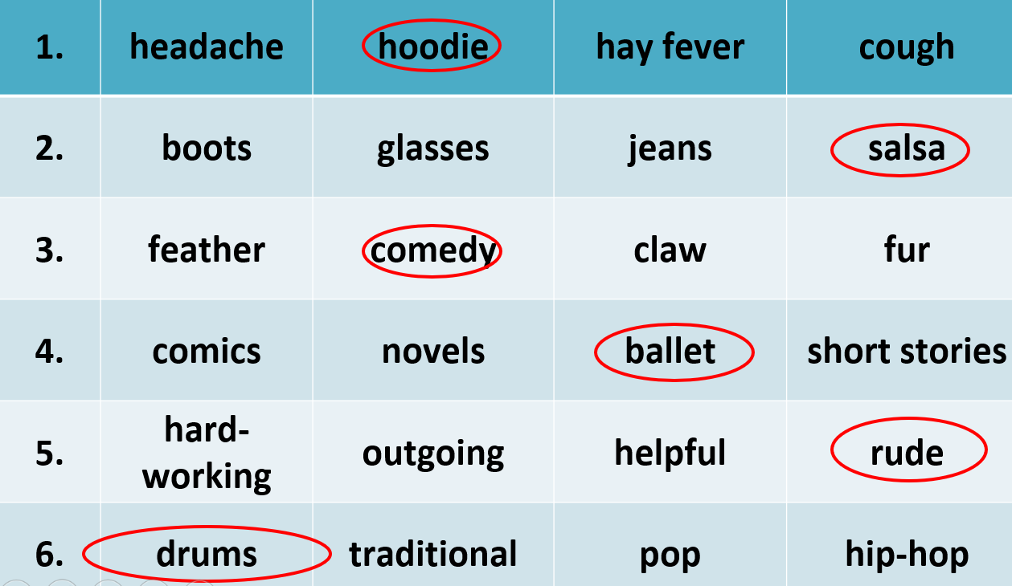  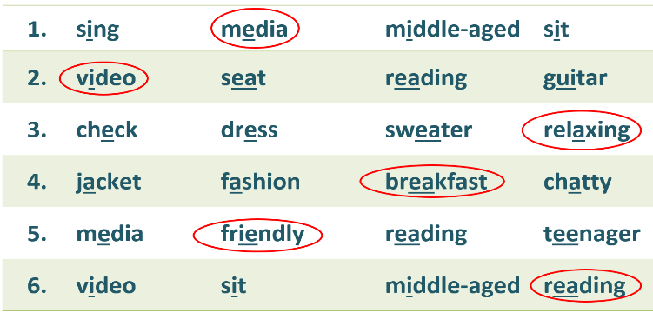
2. (7’) Find the Treasure Game:  - T gives and checks instructions for the game.  - T corrects Ss’ pronunciation if any. |  | How to play:  - Read the sentences.  - Choose A, B, C or D for answers.  - - 1 correct answer => a key to open a chest.
2. REVIEW GRAMMAR UNIT 3 (7’)
ACTIVITY 3:
*Aim: To help students revise past simple tense.
* Content: Mystery Box Game: sentences use past simple tense.
* Outcome: Complete the sentences by filling in the blanks correctly.
* Organisation: Teacher’s instructions…..
3. Mystery Box Game  - T gives and checks instructions for the game.  - T corrects Ss if any. | How to play:  - Read the sentences.  - Fill in the blank.  - 1 correct answer => choose a gift.
3. REVIEW VOCABULARY UNIT 4 (14’)
ACTIVITY 4 + 5:
Aim:
- To help students review topic words and word friends from the unit.
- To review vocabulary in context.
* Content: Glossary of unit 4, Lucky Stars Game: vocabulary have learnt in the unit 4.
* Outcome: Call out the vocabulary. Revision. Do exercises correctly.
* Organisation : Teacher’s instructions…...

4. (7’) Activity 4:  - T tells students to open the Glossary box in student book page 48.  - T asks Ss work in pairs: 1 student points to the word, 1 student pronounces it. Then they swap their roles.  - T corrects Ss’ pronunciation if any. | 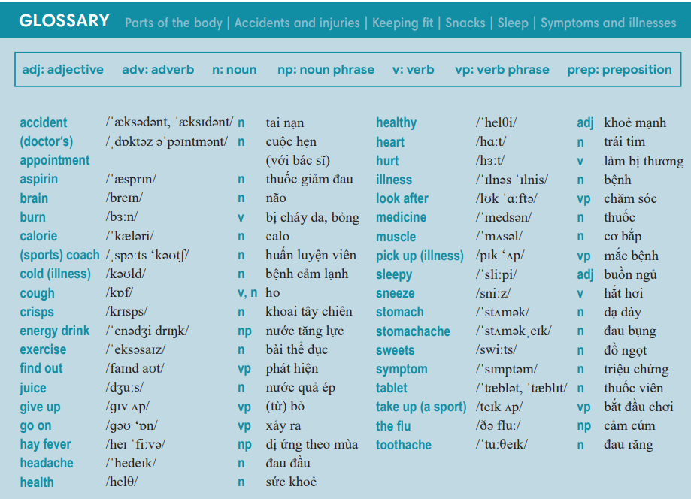
5. (7’) Lucky Stars Game:  - T gives and checks instructions for the game.  - T corrects Ss’ pronunciation if any. | How to play:  - Read the sentences.  - Choose a correct word to fill in the blank.  - 1 correct answer => choose a lucky star for points.
4. REVIEW GRAMMAR UNIT 4 (7’)
ACTIVITY 6:
* Aim: To help students revise the form and use of the past simple.
* Content: Review grammar elements taught in unit 4 by playing Go fishing Game.
* Outcome: Remember how to form and use past simple. Do exercises correctly.
* Organisation : Teacher’s instructions…..

Teacher’s & Student’s activities | Content
6. Go fishing Game.  - T gives and checks instructions for the game.  - T corrects Ss if any. | How to play:  - Read the sentences.  - Put the verbs in brackets into the correct form.  - 1 correct answer => get things under the sea.
WRAP-UP & HOME WORK (3’)
- T asks Ss to talk about what they have learnt in the lesson.
- Review Unit 3&4 vocabulary and grammar.
- Review Unit 3&4 vocabulary and grammar.
* HOME WORK
- Prepare for PREPARATION FOR 1st TERM TEST.

