UNIT 0: WELCOME
PERIOD 5. LESSON 0.4: INTRODUCING KIM

I. OBJECTIVES
By the end of the lesson, Ss are able to:
1. Knowledge
- Vocabulary:
- remember key information about Kim.
- name school subjects.
- Grammar:
- make sentences with can / can’t to talk about skills / abilities.
2. Core competences
- General competences: form and / or improve such competencies as group work, independent working, pair work, linguistic competence, and cooperative learning.
- Specific competences:
- Improve communicative competence related to the use of language (vocabulary, phonetics, grammar):
- For a language lesson: Ss are expected to use vocabulary to talk about skills / abilities, and understand the main grammatical points, then do the tasks assigned in the textbook.
- For a skills lesson: Ss are expected to use the vocabulary and grammar points to talk about their skills / abilities.
3. Personal qualities
- Being hard-working and attentive in class.
- Have a positive attitude towards the lesson.
II. MATERIALS
- Grade 7 textbook, Unit 0 (SB p. 8)
- Computer connected to the Internet
- Projector / TV/ PPT slides / Active teach
Language analysis
- Vocabulary:
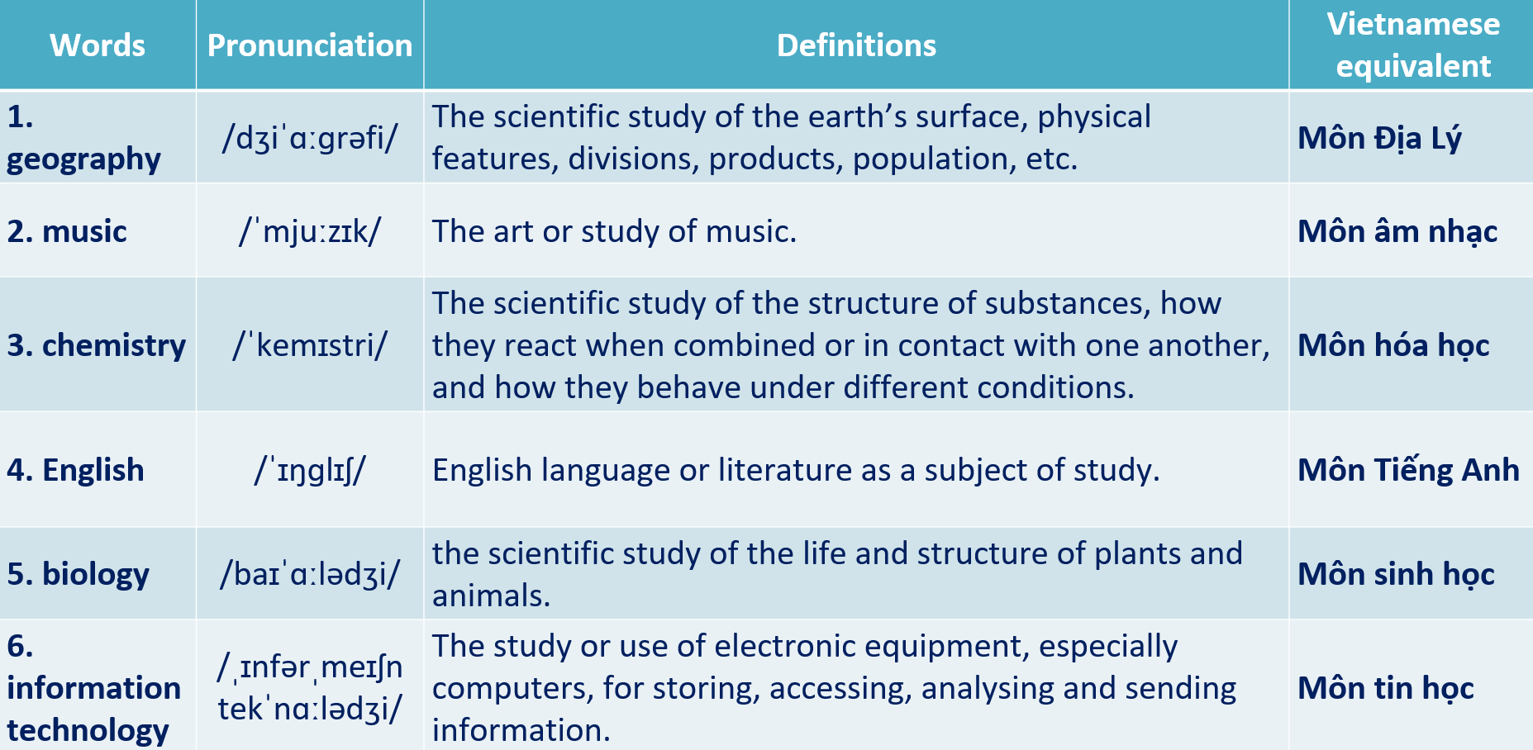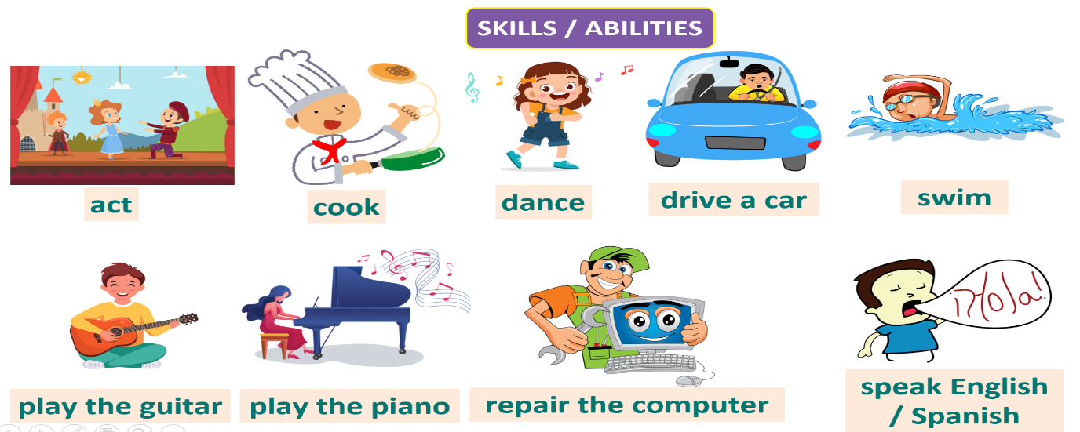
- Grammar:
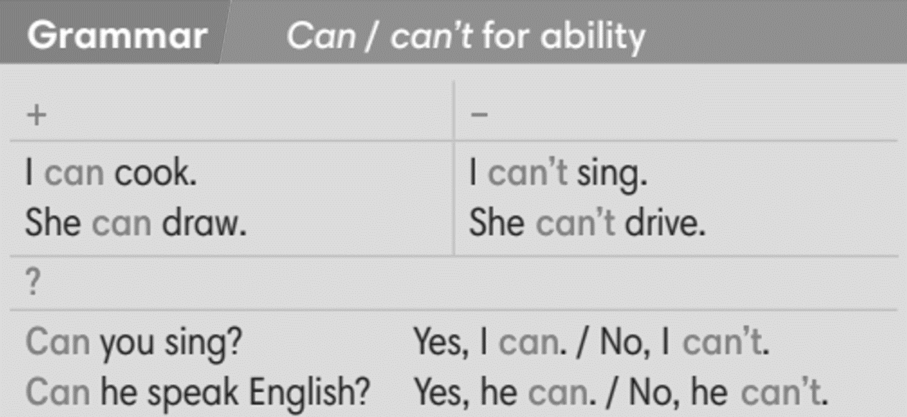
Assumptions
Anticipated difficulties | Solutions
1. Ss may not pronounce the vocabulary correctly. | Reinforce the pronunciation of target vocabulary.
2. Ss may not have sufficient speaking and co-operating skills. | Give clear instructions, give examples before letting Ss work in pairs / groups.  Provide feedback and help if necessary.

Board Plan
UNIT 0: WELCOME
PERIOD 5. LESSON 0.4: INTRODUCING KIM
I. Vocabulary
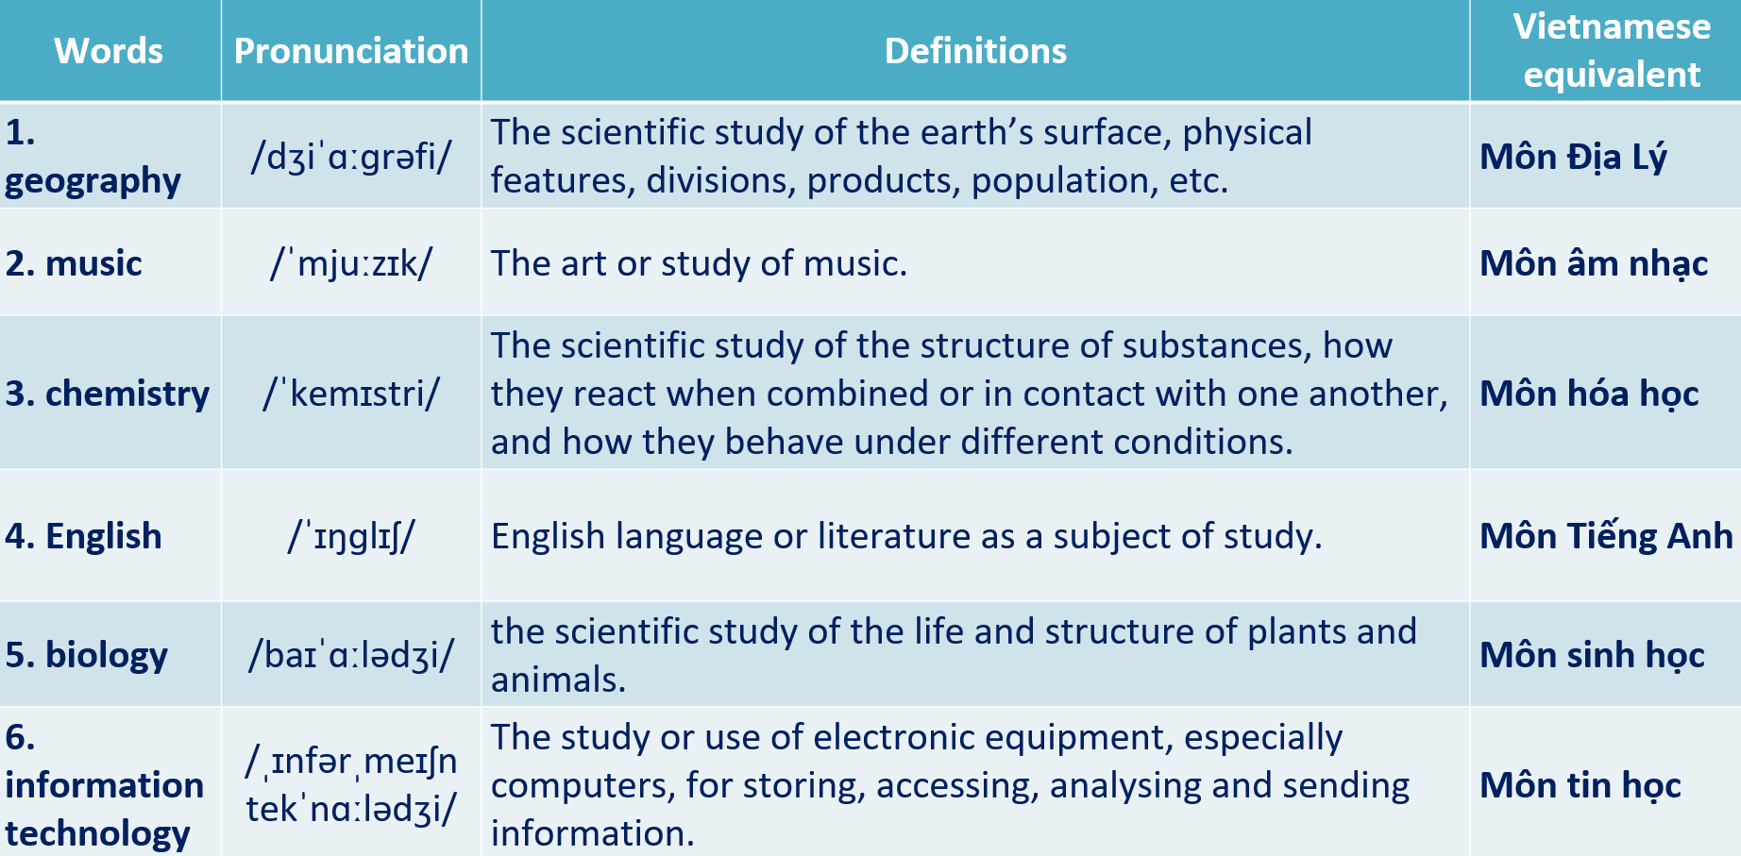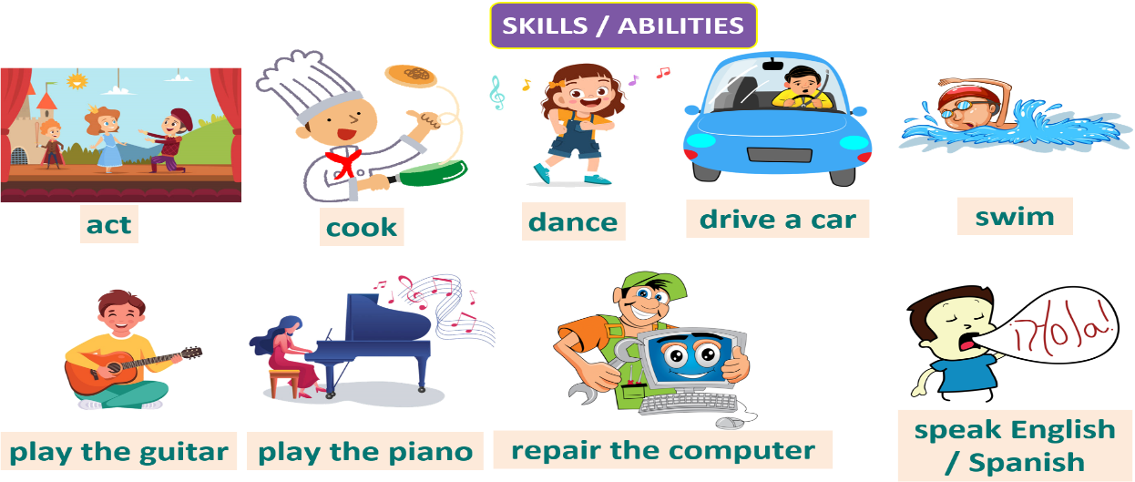
II. Grammar
II. Homework
- Do exercises on workbook page 4.
- Prepare Unit 0 – Revision.

III. PROCEDURE
Stage | Stage aim | Procedure | Interaction
INTRODUCE KIM  & PRESENT VOCABULARY 1  PRACTICE VOCABULARY 1 | - To introduce Kim.  - To activate Ss’ knowledge of school subjects and teach them.  - To help Ss practice vocabulary of school subjects. | Activity 1: In pairs, match school subjects 1-6 with A-F. What are Kim’s favourite subjects?  (Ex 2, p. 8)  - T asks Ss to open their SB page 8, look at exercise 2.  - T calls a student to read the instruction then checks Ss’ understanding of it.  - T sets a time limit and asks Ss to work in pairs to complete the activity.  - T calls some pairs to give answers then shows the answers on the slide.  - T drills all the subjects.  Answer keys:  Kim’s favourite subjects are English and history. | T-Ss  Pair work  T-Ss  Ss-T  T-Ss
  2. A | 4. E | 6.C
  3. F | 5. D
INTRODUCE KIM  & PRESENT VOCABULARY 1  PRACTICE VOCABULARY 1 |  | Activity 2: Angry Birds Game  (Extra activity)  - T explains the game rules then checks instructions.  Game rules:  - Read the definition.  - Choose the correct subject.  - 1 correct answer = 5 points.  - Ss join in the game individually.  - T corrects Ss’ pronunciation if any.  - T drills all the subjects. | T-Ss  T-Ss  Ss-T
PRESENT GRAMMAR | - To present the grammar points in context. | Activity 3: Read the text, answer the questions in pairs.  (Ex 1, p. 8)  - T asks Ss to open their SB page 8, look at exercise 1.  - T calls a student to read the instruction then checks Ss’ understanding of it.  - T sets a time limit and ask Ss to work in pairs to complete the activity.  - T calls some pairs to give answers then checks as the whole class.  Answer keys:  1. She can play the piano. / 2. She can’t sing. | T-Ss  Pair work  T-Ss  Ss-T  T-Ss
PRACTICE GRAMMAR | - To help Ss practice building sentences about hobbies and interests. | Activity 4: Complete the sentences with can or can’t.  (Ex 3, p. 8)  - T asks Ss to open their SB page 8, look at exercise 3.  - T calls a student to read the instruction then checks Ss’ understanding of it.  - T sets a time limit and ask Ss to work in groups to complete the activity.  - T calls some groups to give answers then checks as the whole class.  Answer keys: | T-Ss  Group work  T-Ss
  2. can’t | 4. can’t | 6. can’t
  3. can | 5. can’t
PRESENT VOCABULARY 2 | - To present vocabulary of skills and abilities in context. | Lead-in:  - T shows the slide and elicits the vocabulary and its meaning from the students.  - T confirms the meaning and tell Ss that they can use these verb phrases to talk about their skills / abilities.  Activity 5: Listen to Kim and underline the things in the Vocabulary box that she can do.  (Ex 4, p. 8)  - T asks Ss to open their SB page 8, look at exercise 4.  - T calls a student to read the instruction then checks Ss’ understanding of it.  - T plays the audio for Ss to complete the activity.  - T calls some Ss to give answers then checks as the whole class.  - T drills the vocabulary.  - T correct Ss’ pronunciation if any.  Answer key:  Play the piano | T-Ss  T-Ss  Ss-T  T-Ss  Ss-T  T-Ss
PRACTICE VOCABULARY 2 | - To help Ss practice vocabulary of skills and abilities in context. | Activity 6: Mystery Box Game  (Adapted from ex2 WB p.5)  - T explains the game rules then checks instructions.  Game rules:  - Look at the picture and the given word.  - Make a sentence with can / can’t.  - 1 correct answer => Choose to keep or give the mystery box.  - Ss join in the game individually.  - T corrects Ss’ pronunciation if any.  - T drills all the subjects.  - T correct Ss’ pronunciation if any. | T-Ss  Ss-T  T-Ss  Ss-T  T-Ss  T-Ss
PRODUCE | - To help Ss apply what they have learnt to talk about their skills and abilities. | Activity 7: Work in pairs, ask and answer questions.  (Ex 5, p. 8)  - T asks Ss to look at excersise 5 (SB page 8).  - T calls a student to read the instruction then checks Ss’ understanding of it.  - T asks a pair to read the sample question and answer.  - T divides Ss into new pairs, then sets a time limit for them to complete the activity.  - T walk around to listen and notes down common mistakes for delayed feedback.  - T calls some pairs to come to the front of the class and report.  - T asks the rest to give comments on their classmates’ performance.  - T gives feedback on Ss’ work. | T-Ss  Pair work  Ss-Ss  Ss-T  T-Ss
WRAP-UP | To consolidate what Ss have learnt in the lesson. | - T asks Ss to talk about what they have learnt in the lesson.  - Kim’s information.  - School subjects.  - Skills / abilities. | T-Ss  Ss-T
ASSIGN HOMEWORK | To review the lesson and prepare for the next lesson. | - Do exercises in the workbook page 4.  - Prepare for Revision Unit 0. | T-Ss

……………………………………………………………………………………………

Date of preparing: …………………………………………….
Date of teaching: …………………………………………….

