Date of planning: ……………  Date of teaching: ……………. | UNIT 5: FOOD AND DRINK  PERIOD 59. LESSON 5.5  LISTENING AND VOCABULARY

I. OBJECTIVES:
By the end of the lesson, students will be able to:
- identify specific details in a TV program and talk about food recipe.
1. Knowledge:
* Vocabulary: Use vocabulary to talk about food and cooking instructions.
New words | Vietnamese meaning
1. liter(s) of water | lít nước
2. spoon(s) of fish sauce | thìa nước mắm
3. lime leave(s) | lá chanh
4. stalk(s) of lemongrass | cọng xả
5. clove(s) of garlic | tép tỏi
6. gram(s) of shrimp | lạng tôm
7. chopped green onion(s) | hành thái nhỏ
8. gram of mushroom(s) | lạng nấm
9. lime(s) | chanh
10. sliced chillies | ớt thái mỏng

* Grammar: Make sentences using quantifiers and articles.
2. Competence: Understand and use the vocabulary of food and cooking instructions, then do the tasks assigned in the textbook. Listen and identify specific details in a TV program and talk about food recipe.
3. Quality / behavior: To teach Ss to be hard-working and attentive in class. Ss have a positive attitude to working in groups, individual work, pair work, cooperative learning and working.
II. TEACHING AIDS:
- Teacher: Grade 7 textbook, Unit 5 (SB p.55, WB p.47), laptop/computer connected to the Internet, loudspeaker, projector/TV, PPT slides …
- Students: Text books, studying equipment …
- Method: Active teach, T-WC; group works; individual …
III. PROCEDURE:
1. WARM UP + LEAD-IN (5’)
Game: Word chain – Let’s go to the supermarket.
* Aim:
- To activate Ss’ prior knowledge and get students involved in the lesson.
- To early introduce some words of food recipe.
* Content: Ss play Word chain game.
* Outcome: Ss can name different types of ingredients.
* Organisation: T-Ss, Ss-T.
Teacher’s & Student’s activities | Content
Extra activity 1: Game: Word chain – Let’s go to the supermarket.  - T divides the class into 4 groups and introduces the Warm-up game  - T explains How-to-play steps then checks instructions.  - T sets the scene for the new lesson: T tells Ss that they are going to learn more how to cook a dish by listening for details.  - T writes the title on the board Unit 5: Food and drink / Lesson 5.5: Listening and Vocabulary | Game rules:  - One student starts: I went to the supermarket. I bought a sack of rice.  - The second student: I went to the supermarket. I bought a sack of rice and four tins of tuna.  - The next student continues to add more ingredients.  - Game ends when one student fails to remember all ingredients.
2. PRE-LISTENING (15’)
ACTIVITIES 1 + 2:
*Aim:
- To lead into the topic.
- To set the scene for the new content and introduce the vocabulary.
- To practise using vocabulary to make sentences.
* Content:
- Ss discuss which foreign foods they’d like to eat.
- Ss listen and fill in the blanks with the correct amount of ingredients.
- Guessing game.
* Outcome: Know some more new words about news and entertainment. Chose the correct words to answer the questions.
* Organisation: T-Ss, Ss-T, Group work.
Teacher’s &Student’s activities | Content
1. (5’) Are there any foreign foods you like to eat? What are they? What do they taste like?  Ex 1 - SB p.55  - T asks Ss to work in pairs and answer those questions.  - T conducts a quick class vote to find out what is the most favorite food? What are ingredients?  - T asks Ss to look at the picture to describe the dish and ingredients. | 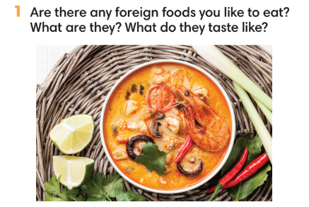
2. (5’) Listen and write the amount of each ingredient you hear.  Ex 2 - SB p.55  - Ss close the book. T plays the recording.  - Ss note down all ingredients that they hear.  - Ss open the book and check the answers.  - T plays the recording. Ss listen and write the amount of each ingredient.  - T plays the recording again. Ss repeat each sentence and check the answer.  - T encourages students to make sentences with these  phrases. | Answer keys:  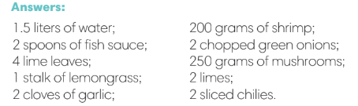
(5’) Extra activity 2: Guessing game.  - T explains the rules to Ss. | Game rules:  ✔ 2 Ss from 2 teams get 1 dish.  ✔ These Ss describe the ingredients, others guess the name of the dish.  ✔ The faster team gets 1 point.
3. WHILE-LISTENING (14’)
ACTIVITIES 3 & 4:
* Aim:
- To help Ss identify specific details in a conversation.
- To provide practice of using vocabulary in contexts.
* Content: Listen and understand to the audio track and complete the exercises.
* Outcome: Identify specific details in a cooking instruction.
* Organisation: T-Ss, Ss-T, Ss-Ss.
Teacher’s & Student’s activities | Content
3. (7’) Listen to how to cook the dish. Choose the correct answer.  Ex 3 - p.55  - T asks Ss to look at Exercise 3 in SB p.55.  - T calls a student to read the instruction then checks Ss’ understanding of it.  - T explains that Ss are listening for details including amounts, ingredients, time, steps…  - T asks Ss to look at the questions and underline key words.  - T encourages Ss to guess the answers.  - T provides meanings of all new words.  - T plays the audio and have students do the exercise.  - T tells Ss to check their answers in pairs.  - Ss work individually then in pairs to complete the task.  - T plays the audio again and checks the answers with the whole class.  - T encourages Ss to give the evidences that they hear from the audio track to prove their answers. | Answer keys:  
4. (7’) Listen again. Number the words in the order you hear them.  - T asks Ss to look at Exercise 4 in SB p.55.  - T calls a student to read the instruction then checks Ss’ understanding of it.  - Before Ss listen, T asks them to number the words from memory.  - T plays the audio and stops by one sentence. Ss repeat and check the answers. | Answer keys:  
4. POST-LISTENING (8’)
ACTIVITY 5:
*Aim: To help students applying the vocabulary items related to the topic in communicating.
* Content: Work in pairs to describe how to cook a dish.
* Outcome: Can use vocabulary about food and cooking instruction to describe how to cook a dish.
* Organisation: T-Ss, Ss-Ss
Teacher’s &Student’s activities | Content
5. In pairs, describe how to cook a dish.  Ex 5 - SB p.55  - T asks Ss to look at Exercise 5 in SB p.55.  - T calls a student to read the instruction then checks Ss’ understanding of it.  - T asks one student to read the example.  Example: First, you heat the pan, and then you add two raw eggs. You cook it for 1 - 3 minutes. Then, you…  - T asks Ss to work in pairs.  - T sets a time limit for Ss.  - T invites some pairs to share in front of the class. | 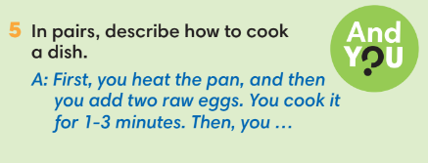
WRAP-UP & HOME WORK ( 3’)

- T asks Ss to talk about what they have learnt in the lesson.
- How to cook a dish.
* HOME WORK
- Do exercises in the workbook page 47.
- Prepare for Lesson 5.6: Speaking.

