Date of planning: ……………  Date of teaching: ……………. | UNIT 5: FOOD AND DRINK  PERIOD 60. LESSON 5.6 SPEAKING

I. OBJECTIVES:
By the end of the lesson, students will be able to:
- use vocabulary and phrases to make conversations at a restaurant.
1. Knowledge:
* Vocabulary: Use the phrases to order food at a restaurant.
* Grammar: Make a conversation to order food at a restaurant using vocabulary and phrases.
2. Competence: Ss can use vocabulary and phrases to order food, and do the tasks assigned in the textbook. Ss can make conversations at a restaurant.
3. Quality/behavior: To teach Ss to be hard-working and attentive in class. Ss have a positive attitude to working in groups, individual work, pair work, cooperative learning and working.
II. TEACHING AIDS:
- Teacher: Grade 7 textbook, Unit 5 (SB p.56, WB p.48), laptop/computer connected to the Internet, loudspeaker, projector/TV, PPT slides…
- Students: Text books, studying equipment…
- Method: Active teach, T-WC; group works; individual ……
III. PROCEDURE:
1. WARM UP + LEAD-IN (5’)
* Aim:
- To create a positive classroom atmosphere to start a new lesson.
- To review words of food and drink.
- To lead in to the topic.
* Content: Pictionary Game
* Outcome: Ss review vocabulary about food and drink
* Organization of implementation: T-Ss, Ss-Ss, Ss-T.
Teacher’s & Student’s activities |  | Content
Extra activity 1: Pictionary Game  - T divides Ss into 2 teams.  - When Ss finish the game, T tells Ss that, they are using the vocabulary to do some speaking tasks today.  - T writes the title of new lesson: Unit 5/ Lesson 5.6 - Speaking |  | Game rules:  - 2 representatives from 2 teams go to the board and receive a word from T (food and drink vocabulary).  - 2 Ss draw and the team will guess.  - 1 correct answer = 1 point.  - After one word, change the person who draws.
2. PRE-LISTENING (19’)
ACTIVITY 1 + 2:
* Aim:
- To activate Ss’ prior knowledge of the topic.
- To lead into the topic.
- To present phrases of ordering food at a restaurant.
- To introduce the Speaking Box.
* Content: Some vocabularies related to films, and types of films. Listen to the conversation to answer the questions about Nam and Mai’s plan.
* Outcome: Knowledge about types of films. Understand the conversation.
* Organisation: T-Ss, Ss-T, Pair work

Teacher’s & Student’s activities |  |  | Content
1. (5’) What do you usually order when you go to a restaurant?
Ex 1 - SB p.56

- T asks Ss if they have been to a restaurant and which food they ordered.
- T notes down Ss’ answers on the board for next activities.
- T asks if Ss know any phrases/ structures to order food at a restaurant.
- T introduces to Ss that they will learn how to order food at a restaurant in this lesson.
2. (6’) Listen to the dialogue between the waiter and the customers at a restaurant. Tick () the questions you hear.  Ex 2 - SB p.56  - T asks Ss to look at Exercise 2, SB p.56.  - T calls a student to read the instruction then checks Ss’ understanding of it.  - T asks Ss to look at the questions, underline key words and explain all new words.  - T asks Ss to guess the answers before listening.  - T plays the audio, Ss listen and finish exercise 2.  - T asks Ss to work in pairs and read the conversation, underline useful structures to order food. |  |  | Answer keys:  Tick: 1, 4, 5
(8’) Extra activity 2: Speaking box.  - T goes through the Speaking box and asks Ss to find the phrases that are used in the dialogue.  - When Ss have finished, T asks them to work in pairs to create a short conversation using these phrases.  - T invites different pairs to act out their dialogues in front of the class and then provide feedbacks. |  |  | 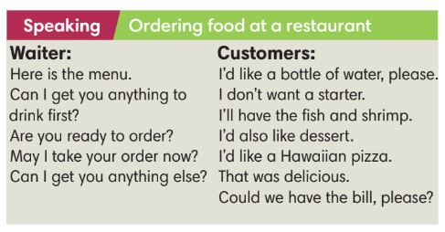
3. WHILE-SPEAKING (10’)
ACTIVITY 3:
* Aim:
- To reinforce the expressions of ordering food at a restaurant.
- To practise using the new expressions in contexts.
* Content: Complete the dialogue about ordering food at a restaurant.
* Outcome: Understanding more about cinema expressions. Knowing the dialogue to buy movie tickets.
* Organisation: T-Ss, Ss-T, Ss-Ss
Teacher’s & Student’s activities |  |  |  | Content
3. (5’) Complete the dialogue with the sentences a-f. Listen and check.  (SB p.56 - Exercise 3)  - T asks Ss to complete the exercises individually and the check with partners.  - T plays the audio for Ss to check. |  |  |  | Answer keys:  1 e 2 c 3 a 4 b 5 f 6 d
(5’) Extra activity 3: Game
- T divides the class into 2 groups. Ss make 2 lines facing each other.
- Each pair includes one customer and one waiter. Ss take turns to say phrases and structure to order food at a restaurant. The S of that pair needs to respond.
4. POST-SPEAKING ( 8’)
ACTIVITY 4:
*Aims: To help Ss applying the new language and skills related to the topic in communicating.
* Content: Work in groups to practise a conversation at a restaurant.
* Outcome: Ss can use the expressions correctly to order food at restaurants.
* Organisation: T-Ss, Ss-Ss.

Teacher’s & Student’s activities | Content
4. Work in groups of three. One person is the waiter and the other two are customers. Practice a conversation at a restaurant.  (Exercise 4 - SB p.56)  - T asks Ss to work in groups of three. Ss prepare a menu for a restaurant first.  - T invites 3 random Ss to make a conversation in front of the class. Other Ss listen and provide feedback.  - T tells Ss to look at the Speaking box in their student books again and work in groups to prepare for the task.  - T set time for Ss to prepare and practise speaking.  - T walks around the class to listen and provide feedback.  - T asks 5 groups to practise the conversation in front of the class.  - T do a quick class vote to find the most favorite group with the best menu and speaking skills. | 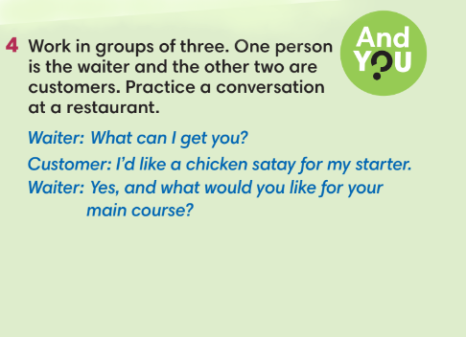
WRAP-UP & HOME WORK (3’)
- T asks Ss to talk about what they have learnt in the lesson.
phrases to order food at a restaurant.
* HOME WORK
- Do exercises in the workbook page 48.
- Prepare for Lesson 5.7: Writing.

=====================

