Date of planning: ……………  Date of teaching: ……………. | UNIT 5: FOOD AND DRINK  PERIOD 61. LESSON 5.7 WRITING

I. OBJECTIVES:
By the end of the lesson, Ss are able to:
- write an email of invitation.
1. Knowledge:
* Vocabulary: use vocabulary and structures to write an email of invitation.
* Grammar: make sentences using food quantifiers correctly.
2. Competence: Ss can use vocabulary of food and quantifiers in sentences, and do the tasks assigned in the textbook. Ss can write an email of invitation.
3. Quality/behavior: To teach Ss to be hard-working and attentive in class. Ss have a positive attitude to working in groups, individual work, pair work, cooperative learning and working.
II. TEACHING AIDS:
- Teacher: Grade 7 textbook, Unit 5 (SB p.57, WB p.49), laptop/computer connected to the Internet, loudspeaker, projector/TV, PPT slides …
- Students: Text books, studying equipment …
- Method: Active teach, T-WC; group works; individual …
III. PROCEDURE:
1. WARM UP (5’)
* Aim:
- To create a positive classroom atmosphere to start a new lesson.
- To lead into the sample writing.
* Content: Extra activity: Prepare for an upcoming birthday party.
* Outcome: Ss understand the background of the lesson.
* Organization of implementation: T-Ss, Ss-T
Teacher’s & Student’s activities | Content
Extra activity 1:
- T asks Ss to find a few Ss whose birthdays coming soon.
- T tell Ss to imagine what they need to prepare for a birthday party.
(1) Location, date, time.
(2) Food and drink.
(3) Decoration.
(4) Guest list.
- When Ss mention about inviting friends for birthday party, T asks Ss to tell which information they need to provide?
- T writes the title on the board Unit 5: Food and drink. Lesson 5.7: Writing.
2. LEAD-IN (5’)
ACTIVITY 1
* Aim:
- To get Ss to think about the topic.
- To provide Ss with reasons for reading the sample writing in Exercise 2 (SB p.57).
* Content: Discuss in groups and answer the questions about the people.
* Outcome: Guess the correct answers to the questions.
* Organisation: T-Ss, Ss-T, Pair work
Teacher’s & Student’s activities | Content
1. What are they cooking? Why are they cooking outside?  (Ex 1 – SB p.57)  - T asks Ss to look at pictures and answers questions.  - T sets a time limit for Ss’ quick discussion.  - Ss work in pairs to make guesses about the pictures then give answers.  - T calls some Ss to give answers then note them down on the board for checking later.  - T tells Ss that they’re going to read the email in Exercise 2 (SB p.57) to check all the answers. | Answer keys:  They are cooking chicken barbecue.  Because they are having a barbecue party.
3. PRE-WRITING (16’)
ACTIVITIES 2 + 3:
Aim:
- To activate Ss’ prior knowledge of the topic.
- To lead into the next activity.
- To study the structure of an email.
- To help Ss focus on detailed information while reading the sample.
- To provide Ss an outline and phrases before writing.
* Content: Work in pairs, read the email and answer the questions.
* Outcome: Understand the main points and structure of the sample email.
* Organisation: T-Ss, Ss-T.
Teacher’s & Student’s activities | Content
2. (6’) In pairs, read the email and answer the questions.  (Ex 2 – SB p.57)  - T calls a S to read the instruction then checks Ss’ understanding of it.  - T asks Ss to underline key words of questions.  - T has Ss work in pairs and find the answers for the questions  - T encourages Ss to underline the key sentences in the reading.  - T calls some volunteer Ss to give their answers then checks for the whole class. | Answer keys:  1. Richard  2. Because he wanted to invite Thanh to a barbecue at his house next Saturday.  3. A barbecue party at Richard’s house next Saturday.  4. Thanh should dessert.
3. (6’) Answer the questions about the structure of the email.  (Ex 3 – SB p.57)  - T asks Ss to look at Exercise 3 SB p.57.  - T calls a S to read the instruction then checks Ss’ understanding of it.  - T asks Ss to work finish Exercise 3 and underline the information from the email.  - T shows the answers on the slide to check as the whole class. | Answer keys:  1 b 2 b 3 b 4 a 5 a
(4’) Extra activity 2: An email outline and useful language.  - T asks Ss to look at the sample email again.  - T asks Ss to work in pairs, make the outline for the sample email and underline useful phrases that they can use.  - T sets a time limit for the activity.  - T collect Ss answer and check. | 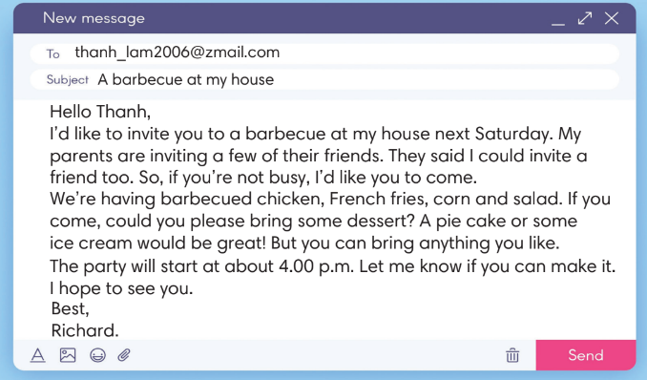
4. WHILE-WRITING (10’)
ACTIVITY 4:
Aim:
- To provide Ss task to apply useful expressions from Writing Box in writing an email.
* Content: Use the Writing Box to practise writing an invitation email.
* Outcome: Write an invitation email.
* Organisation: T_ Ss.. ….

Teacher’s & Student’s activities | Content
4. It’s your birthday next week. You want to invite your friend, Minh. Write an email (60-80 words) to invite him to the party.  (Ex 4 – SB p.57)  - T calls a student to read the instructions then checks Ss’ understanding of it.  - T asks Ss to brainstorm and make an outline basing on these questions:  (1) where / when it is?  (2) how to get there?  (3) what dishes there will be?  (4) what to bring?  - T sets a time limit for the task and walk around as a monitor while Ss are writing. | 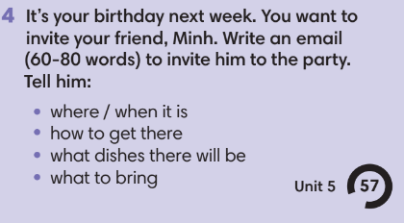
5. POST-WRITING (6’)
*Aim:
- To let Ss do peer-check.
- To give general comments on Ss’ writing pieces.
* Content: Ss swapping their writing in pairs.
* Outcome: Cross-check writing pieces and follow the writing rubric.
* Organisation: T_ Ss .…….

Teacher’s & Student’s activities | Content
Extra activity 3: In pairs, swap your writing then check.  - T explains the writing rubric before checking.  - T asks Ss to swap their writing pieces, use the given writing rubric then do cross-check.  Writing rubric:  (1) where / when it is?  (2) how to get there?  (3) what dishes there will be?  (4) what to bring?  - T gives feedback on common mistakes of Ss’ works.  - T may collect Ss’ writing for detailed comments. | Writing rubric:  (1) where / when it is?  (2) how to get there?  (3) what dishes there will be?  (4) what to bring?
WRAP-UP & HOME WORK (3’)
- T asks Ss to talk about what they have learnt in the lesson.
- A personal introduction for a webpage.
* HOME WORK:
- Do exercises in the workbook page 49.
- Prepare for Lesson 5.8: Vocabulary in action and pronuciation.

