Date of planning: …………………..  Date of teaching: ………………….. | UNIT 6: SCHOOLS  PERIOD 68. LESSON 6.5  LISTENING AND VOCABULARY

I. OBJECTIVES:
By the end of the lesson, Ss will be able to:
- identify specific details in a conversation and talk about schools.
1. Knowledge:
* Vocabulary:
New words | Vietnamese meaning
1. breakfast club | câu lạc bộ bữa sáng
2. indoor gym | phòng gym trong nhà
3. music club | câu lạc bộ âm nhạc
4. sport club | câu lạc bộ thể thao
5. photography club | câu lạc bộ nhiếp ảnh
6. swimming pool | bể bơi

* Grammar: My school has a computer room and a basketball court…
2. Competence: Understand and use the vocabulary about school activities, then do the tasks assigned in the textbook. Listen and identify specific details in a a conversation and talk about schools.
3. Quality / behavior: To teach Ss to be hard-working and attentive in class. Ss have a positive attitude to working in groups, individual work, pair work, cooperative learning and working.
II. TEACHING AIDS:
- Teacher: Grade 7 textbook, Unit 6 (SB p.65, WB p.56), laptop/computer connected to the Internet, loudspeaker, projector/TV, PPT slides …
- Students: Text books, studying equipment …
- Method: Active teach, T-WC; group works; individual …
III. PROCEDURE:
1. WARM UP + LEAD-IN (5’)
* Aims:
- To activate Ss’ prior knowledge and get students involved in the lesson.
- To early introduce some vocabulary about school activities.
* Content: Ss review how to use used to.
* Outcome: Ss can recall how to use used to in sentences
* Organisation: T-Ss, Ss-T.
Teacher’s & Student’s activities | Content
Extra activity 1: Game – Review grammar used to.  - T reminds Ss about the usage of used to to talk about routines and states that finished in the past and are no longer true.  - T divides the class into 2 teams.  - T sets the scene for the new lesson: T tells Ss that they are going to learn more about school activities.  - T writes the title on the board Unit 6: Schools. Lesson 6.5: Listening and Vocabulary | Game rules:  - 1 student from team A makes a sentence with used to then choose randomly.  - 1 student from team B to make another sentence.  - 1 correct answer = 1 point.
2. PRE-LISTENING (5’)
ACTIVITY 1:
*Aims:
- To lead into the topic.
- To set the scene for the new content and introduce the vocabulary.
* Content: Look at the pictures and compare these activities to Ss’ school.
* Outcome: Ss can guess the activities shown in the pictures.
* Organisation: T-Ss, Ss-T.
Teacher’s & Student’s activities | Content
1. Look at these pictures. How is this school similar to yours?  (Ex 1 – SB p.65)  - T asks Ss to work in pairs and describe the pictures and find similarities and differences between their schools and the school in the book.  - T collects Ss’ answers and find out what is their most favorite activity at school. | 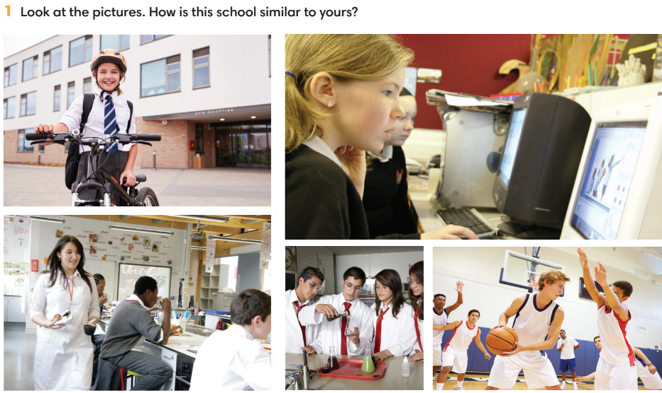
3. WHILE-LISTENING (19’)
ACTIVITIES 2, 3 & 4:
* Aims:
- To help Ss identify specific details in a conversation.
- To introduce the vocabulary.
- To practice using vocabulary to make sentences.
* Content: Listen and understand to the audio track and complete the exercises.
* Outcome: Identify specific details in a conversation.
* Organisation: T-Ss, Ss-T, Ss-Ss.
Teacher’s & Student’s activities | Content
2. (7’) Listen and complete the notes about schools in the UK. Fill in each blank with ONE word or number.  (Ex 2 – SB p.65)  - T calls a S to read the instruction then checks Ss’ understanding of it.  - T explains that Ss are listening for details including numbers, dates, names, places and important things.  - T asks Ss to look at the questions and underline key words.  - T encourages Ss to guess the answers.  - T provides meanings of all new words.  - T plays the audio and have Ss do the exercise.  - T tells Ss to check their answers in pairs.  - T plays the audio again and checks the answers with the whole class.  - T encourages Ss to give the evidence that they hear from the audio track to prove their answers. | Answer keys:  1. 22  2. 08.30; 4.00  3. music; drama; international  4. sport; photography; music  5. three/ 3
3. (5’) Listen again and mark the sentences T (true) or F (false).  (Ex 3 – SB p.65)  - T calls a S to read the instruction then checks Ss’ understanding of it.  - T asks Ss to finish exercise 3 basing on their memory.  - T plays the audio for Ss to check answers.  - T pauses the audio and ask Ss to repeat evidence.  - T asks Ss to correct all false statements. | Answer keys:  1. True  2. True  3. False  4. True  5. False
4. (7’) Put the following words into the correct column.  (Ex 4 – SB p.65)  - T explains the meaning of all words.  - Ss listen and repeat. T check Ss pronunciation.  - Ss do Exercise 4.  - T collects Ss answer and checks.  - T encourages Ss to work in pairs and make sentences using these words.  - T calls a few Ss to give examples and get feedback from the rest of the class. | Answer keys:  Before school: breakfast club  After school: indoor gym, music club, sport club, photography club, swimming pool
4. POST-LISTENING (13’)
ACTIVITY 5:
*Aims:
- To reinforce word friends.

- To practice using new words in context.
* Content:
- Play Game – Hot seat to review vocabulary.
- Use Word Friends to describe Ss’ school.
* Outcome: Can use vocabulary about school activities to talk about schools.
* Organisation: T-Ss, Ss-Ss, Ss-T, Group work.
Teacher’s & Student’s activities | Content
(5’) Extra activity 2: Game – Hot seat  - T divides the class into 2 teams and then explains the rule. | Game rules:  ✔ 2 Ss from 2 teams go to the board, back against the board.  ✔ 2 teams get one word from T (Word friends or from listening conversation).  ✔ Each team needs to describe until that S can guess the correct word.  ✔ The faster team gets 1 point.
5. (8’) Use the Word Friends and other words you know to describe your school.  (Ex 5 – SB p.65)  - T asks Ss to read the instructions and examples.  - Ss work in groups of four to describe their school using word friends.  - T walks around to provide feedback.  - T asks 2-3 groups to share their answers in front of the class. | 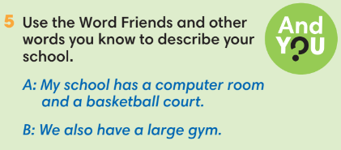
WRAP-UP & HOME WORK ( 3’)

- T asks Ss to talk about what they have learnt in the lesson.
- Describe a school.
* HOME WORK
- Do exercises in the workbook page 56.
- Prepare for Lesson 6.6: Speaking.

………………………………………………………………………………..

