Date of planning: …………………..  Date of teaching: ………………….. | UNIT 6: SCHOOLS  PERIOD 72. LESSON 6.9 REVISION

I. OBJECTIVES:
By the end of the lesson, Ss are able to:
1. Knowledge:
* Vocabulary: Review vocabulary and grammar in the unit.
* Grammar: Practice making a dialogue about what should/ shouldn’t/ must/ mustn’t be done at school.
2. Competence: Ss understand and use the vocabulary of the unit to do the tasks assigned in the textbook. Ss can participate in a guided conversation to talk about school.
3. Quality/ behavior : To teach Ss to be hard-working and attentive in class. Ss have a positive attitude to working in groups, individual work, pair work, cooperative learning and working.
II. TEACHING AIDS:
- Teacher: Grade 7 textbook, Unit 6 (SB p.69, WB p.59), laptop/computer connected to the Internet, loudspeaker, projector/TV, PPT slides …
- Students: Textbooks, studying equipment …
- Method: Active teach, T-WC; group works; individual …
III. PROCEDURE:

- WARM-UP (4’)
*Aims:
- To create a positive classroom atmosphere to start a new lesson.
- To lead into the review lesson.
* Content: Game: SUPER EYES
* Outcome: Ss understand that they are going to review Unit 6.
* Organisation: T-Ss, Ss-Ss, Ss-T.
Teacher’s & Student’s activities | Content
Extra activity 1: SUPER EYES  - Set the scene: T asks Ss to do quick exercises for eyes such as look up and down, look left and right, row the eyes  - T tells Ss that they are going to play a game called SUPER EYES  - T explains the game rules then checks instructions.  - T uses the slides to show the collages.  - Ss join in the game in pairs or in small groups.  - T shows the collage again with displayed answers to check for the whole class.  - T tells Ss that they are going to review Unit 6. | Game rules:  - Look carefully at a collage of different small pictures.  - The collage will disappear in a few seconds.  - Recall as many words about the collage as you can remember.
- REVIEW VOCABULARY (19’)
ACTIVITIES 1 + 2:
* Aims:
- To help students reviews vocabulary and word friends from the unit.
- To review vocabulary in contexts.
* Content: Play a game and do the exercises to revise the vocabulary of Unit 5.
* Outcome: Understand the vocabulary to do the exercises correctly.
* Organisation: T-Ss, Ss-Ss, Ss-T.
Teacher’s & Student’s activities | Content
(4’) Extra activity 2: Game  - T asks Ss to look at vocabulary of school subject and class activities.  - T introduces game rules. | Game rules:  - T writes 2 words on the board.  - 2 Ss from 2 teams go to the board to guess the words by asking their teams questions (How many letters? Is it a school subject? etc.)  - 1 correct answer = 1 point.
1. (5’) Write the correct word for each definition.  (Ex 1 – SB p.69)  - T asks Ss to look at Exercise 1 in student book page 69.  - T calls a student to read the instruction then checks Ss’ understanding of it.  - T asks Ss to work in pairs to read then complete the activity.  - T encourages students to give the reason for their answers.  - T checks as the whole class. | Answer keys:  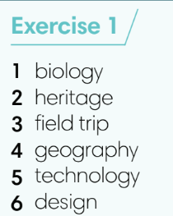
2. (5’) In pairs, ask and answer the following questions.  (Ex 2 – SB p.69)  - T asks Ss to look at Exercise 2 in student book page 69.  - T calls a S to read the instruction then checks Ss’ understanding of it.  - T asks Ss to work in pairs to read then complete the activity.  - Ss work in pair to complete the task and compare the answers.  - T checks as the whole class. | 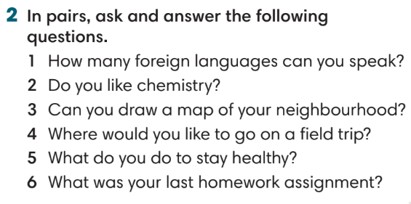
(5’) Extra activity 3: Game – Unscramble words.  - T divides the class into 4 teams and explains game rule.  - T prepare a few sentences using word friends in Unit 6. | Game rules:  - Ss receive 10 bags with unscramble words of 10 sentences. (Words are written and cut into pieces)  - 1 correct sentence = 1 point.
3. REVIEW GRAMMAR ( 12’)
ACTIVITIES 3 + 4:
*Aims:
- To reinforce the grammar of Unit 6: should/ shouldn’t/ must/ mustn’t.
* Content: Use should/ shouldn’t/ must/ mustn’t correctly to complete the tasks.
* Outcome: Ss can use should/ shouldn’t/ must/ mustn’t correctly in sentences.
* Organisation: T-Ss, Ss-T, Pair work.
Teacher’s & Student’s activities | Content
3. (4’) Complete the dialogue with the words below.  (Ex 3 – SB p.69)  - T helps Ss to review grammar before doing this task.  - Ss work individually.  - T checks Ss’ answers. | 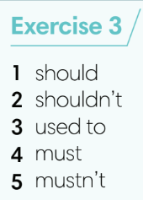
4. (5’) Choose the correct options.  (Ex 4 – SB p.69)  - T asks Ss to look at Exercise 4 in student book page 69.  - T calls a student to read the instruction then checks Ss’ understanding of it.  - T asks Ss to work individually and then share the answers in pairs.  - T checks as the whole class, asks Ss for the reasons of their answers. | Answer keys:  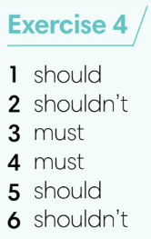
(4’) Extra activity 4: Game – Whisper.  - T divides the class into 4 teams and explains game rule.  - T prepares a few sentences with should/ shouldn’t/ must/ mustn’t. | Game rules:  - T gives 1 sentence to 1 student of each team.  - Ss take turn to whisper until the last student of the team get it and write on the board.  - 1 correct sentence = 1 point.
4. SPEAKING (7’)
ACTIVITY 5:
*Aims:
- To help Ss practice speaking skill in a conversation about which things they can do/ cannot do.
* Content: Discuss school rules using should/ shouldn’t/ must/ mustn’t.
* Outcome: Ss can use should/ shouldn’t/ must/ mustn’t in conversation.
* Organisation: T-Ss, Ss-T, Pair work.
Teacher’s & Student’s activities | Content
5. Work in pairs. Student A, tick four of the  boxes below and answer Student B’s  questions. Use should, shouldn’t, must, or  mustn’t in your responses.  (Ex 5 – SB p.69)  - T asks Ss to look at Exercise 5.  - T calls a S to read the instruction then checks Ss’ understanding of it.  - T sets a time limit and walks around as a monitor while Ss are discussing.  - Ss work in pairs to practice the speaking task.  - T moves around and takes notes for any issues that need improving from students work.  - T encourages some strong Ss to share in front of the class.  - T gives some general feedback for Ss’ performances. | 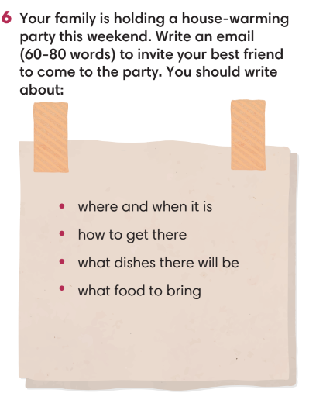
WRAP-UP & HOME WORK (3’)
T asks Ss to talk about what they have learned in the lesson.
- Review vocabulary and grammar of Unit 6.
- Conversation using should/ shouldn’t/ must/ mustn’t.
* HOMEWORK
- Do exercises in the workbook page 59.
- Prepare for Unit 7/Lesson 7.1: Vocabulary.

………………………………………………………………………………………..

