Date of planning: ..............................  Date of teaching: .............................. | UNIT 7: SHOPPING AROUND  PERIOD 76. LESSON 7.4  GRAMMAR 2
I. OBJECTIVES:
By the end of the lesson, Ss will be able to:
- Use “be going to” and Present Continuous to talk about intentions and arrangements.
1. Knowledge:
* Vocabulary:
* Grammar:
- Use “be going to” and Present Continuous to talk about intentions and arrangements.
2. Competence:
- General competences: form and / or improve such competencies as group work, independent working, pair work, linguistic competence, and cooperative learning.
- Specific competences:
- Improve communicative competence related to the use of language (vocabulary, phonetics, grammar):
- For a language lesson: Ss are expected to use “be going to” and Present Continuous to talk about intentions and arrangements.
For a skills lesson: Ss are expected to use “be going to” and Present Continuous to talk about intentions and arrangements.
3. Quality/ behavior:
- Being hard-working and attentive in class.
- Have a positive attitude towards the lesson.

II. TEACHING AIDS:
- Grade 7 textbook, Unit 7 (SB p. 74)
- Computer (connected to the Internet is the best)
- Projector / TV/ PPT slides / Active teach
Language analysis
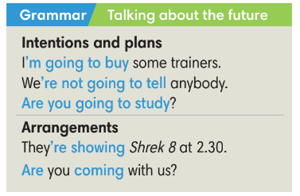
Assumptions
Anticipated difficulties | Solutions
1. Ss may use “be going to” and Present Continuous incorrectly. | Remind students the difference of “be going to” and Present Continuous.  Provide activities for practice.
2. Ss may not have sufficient speaking and co-operating skills. | Give clear instructions, give examples before letting Ss work in pairs / groups.  Provide feedback and help if necessary.

III. PROCEDURE:

1. WARM UP (5’)
* Aim:
- To create a positive classroom atmosphere to start a new lesson.
- To review the previous lesson.
* Content: Game (shop/ market)
* Outcome: Ss review vocabulary about shop and market.
* Organisation: T-Ss, Ss-T.
Teacher’s & Student’s activities |  | Content
Activity 1: Game  - T explains the game rules then checks instructions.  - T divides Ss into 4 groups. Time limitation is 2 minutes.  - T tells Ss that, today they will learn about “be going to” and Present Continuous to talk about intentions and arrangements. |  | Game rules:  - 4 groups note down all sentences to describe one shop or one market.  - 1 correct answer = 1 point.  - T corrects Ss if necessary.
2. LEAD-IN (4’)
*Aim:
- To lead into the new lesson.
* Content: Ss list activities they will do next week.
* Outcome: Ss prepare for the new lesson about intentions and arrangements.
* Organisation: T-Ss, Ss-T.
Teacher’s & Student’s activities | Content
Activity 2:
- T asks Ss to list activities they will do next week.
- T divides the board into 2 to record all answers for following activities.
3. PRESENTATION (13’)
ACTIVITY 3 + 4:
*Aim:
- To present the grammar point in context.
- To lead into the next activity.
- To introduce the Grammar Notes and explain grammar points.
* Content:
- Ss listen to a dialogue.
- Ss study the Grammar box to learn how to use “be going to” and Present Continuous to talk about intentions and arrangements.
* Outcome: Ss understand how to use “be going to” and Present Continuous to talk about intentions and arrangements.
* Organisation: T-Ss, Ss-T,
Teacher’s & Student’s activities | Content
Activity 3: Exercise 1 - SB p74  Listen. Tick () the activities Nam and Mai plan to do on Saturday.  - T asks Ss to look, describe the picture and then guess what they are talking about.  - Ss read all activities in Exercise 1, guess the answer.  - T plays the audio, Ss listen and finish Exercise 1.  - T check Ss answers. | Answer keys:  - T plays the audio again. Ss listen and say “stop” when they hear the evidence from the recording.
Activity 4: Exercise 2 - SB p74  Find more examples of be going to and Present Continuous in the voicemail message.  - T asks Ss to look at the Grammar Box in SB p.74 and explain the usage of “be going to” and Present Continuous to talk about the future. | 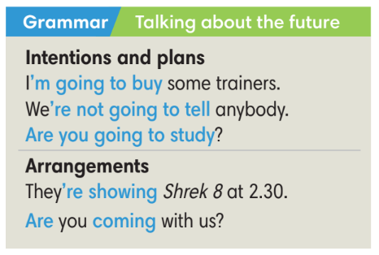  - T asks Ss to read the text again and underline be going to and Present Continuous to finish exercise 2.  - T checks Ss answers.
4. PRACTICE (15’)
ACTIVITIES 5 + 6 + 7:
* Aims:
- To provide Ss with language notes.
- To help Ss practice making sentences using be going to and Present Continuous.
- To help Ss practice new grammar points in context.
- To practice solving some types of grammar exercises.
* Content:
- Ss study the Language notes.
- Ss use be going to and Present Continuous to make sentences.
- Play Game: Hot potato (practice using be going to and Present Continuous.).
* Outcome: Ss can use be going to and Present Continuous correctly to make sentences.
* Organisation: T-Ss, Ss-T, Ss-Ss.
Teacher’s & Student’s activities | Content
Activity 5: Language notes
- T shows language notes on the slide.
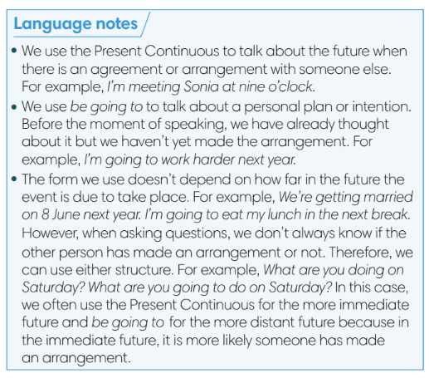
- T asks Ss to provide examples using be going to and Present Continuous to talk about the future.
Activity 6: Exercise 3 – SB p. 74  Complete the sentences with be going to and the verbs in brackets. Listen to Mai and Nam and check.  - T asks Ss to read the instructions and checks their understanding.  - Ss work individually to finish exercise 3 and then check in pairs.  - T plays the recording and ask Ss to repeat to check Ss answers and pronunciation. | Answer keys:  
Activity 7: GAME: HOT POTATO  - T explains the game rules then checks instructions. | Game rules:  - The student has the ball needs to make a sentence with be going to or Present Continuous to talk about the future.  - The next student receives the ball and make another sentence.  - 1 correct answer = 1 point.  - T collects Ss answer and checks.
5. Production (5’)
ACTIVITY 8:
* Aims: To help Ss applying the vocabulary items and grammar points related to the topic in communicating.
* Content: Ss ask and answer about intentions and arrangements.
* Outcome: Ss can use be going to and Present Continuous in conversation.
* Organisation: T-Ss, Ss-T, Ss-Ss, Pair work.

Teacher’s & Student’s activities | Content
Activity 8: Exercise 4 – SB p.74  Work in pairs.  - T asks Ss to look at exercise 4 (SB page 74).  - T calls a student to read the instructions.  - T explains to the students that they are going to do the task in pairs.  - T sets time limitation of 3 minutes for Ss to prepare and work in pairs.  - T asks 3 groups to model the activity in front of the class.  - T asks the other students to give comments on their classmates’ performance.  - T asks Ss to line up into 2 lines, facing each other. Ss takes turn to say the sentence to their partner.  - After each 20 seconds, T say “switch”, Ss move one step to change the partner.  - T walks around to note down any mistakes for delayed feedback. | 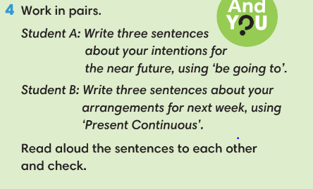
WRAP-UP & HOME WORK (3’)
- T asks Ss to talk about what they have learnt in the lesson.
- Be going to and Present Continuous.

* HOME WORK
- Do exercises in the workbook page 63.
- Prepare for Lesson 7.5: Listening and vocabulary.

……………………………………………………………………………..

