UNIT 1: PEOPLE ARE PEOPLE
Period 12: Lesson 1.6: Speaking
I. OBJECTIVES
By the end of the lesson, Ss are expected to achieve the following objectives:
- Knowledge:
Understanding of the keywords or word collocations below:
- What about her?
- Excuse me.
- Really cool!
- No worries.
- Hello! / Hi!
- How are you? / How’s it going?
- I’m fine/ good, thanks.
- My name’s … / I’m …
- Pleased/ nice to meet you.
- This is my friend, Sol.
- Bye. / Goodbye. / See you (later).
- Competencies:
- General competencies:
Form and improve group work and independent working, pair work, and cooperative learning.
- Specific competencies:
Improve communicative competence related to speaking skills and use of language (vocabulary, phonetics, grammar)
- For a language lesson: Ss are expected to know the meaning of the key phrases in a greeting dialogue and understand the main grammatical points, then do the tasks assigned in the textbook.
- For a skills lesson: Ss are expected to use their speaking skills to practice greeting and introducing each other in groups.
- Qualities:
- Have a positive attitude towards the lesson
- Understand and actively respond to relevant matters or situations
- Be polite and friendly when greet and introduce people
II. PREPARATIONS
Teacher: Textbooks, PowerPoint slides, worksheet 1, TV, projector, loudspeaker
Students: Textbooks, notebooks
III. PROCEDURE
ACTIVITY 1: WARM-UP
- Aim: To recall words to describe people that they’ve learned in this unit.
- Content: Ss work individually with instruction from T
- Products: Ss are able to greet each other using the words that they’ve learned.
- Implementation:
TEACHER AND STUDENTS’ ACTIVITIES | CONTENTS
Dating (Worksheet 1)  Step 1: Task delivering  - T gives each student a clock without hands and asks them to circle numbers 2, 4, 6, 8, 10, 12.  - T explains that they’re going to meet their friends, greet and introduce their names. They have to write the name of a friend they meet at a circled time. The rule is you cannot meet the same people at different times. It means each student needs to greet 6 people in total.  i.e., At 2 o’clock, I meet Jane. I will write her name next to number 2.  Step 2: Task performance  - Ss do the activity as guided by T.  Step 3: Judgment  - The winner is the first one who meets 6 people at the circled time.  Step 4: Report and discussion  - T develops further discussion if needed. | Example:  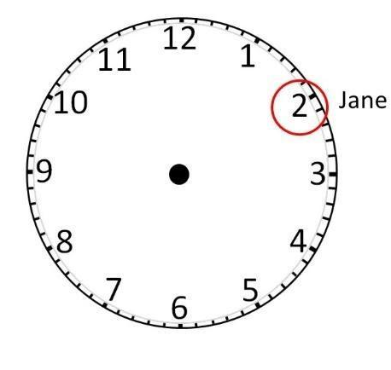  A: Hi, my name is A. Nice to meet you.  B: Hi A. I’m B. Nice to meet you too.
ACTIVITY 2: KNOWLEDGE FORMATION
- Aim: To introduce the objectives of the lesson with a can-do statement.
- Content: The objective of the lesson is listed below
- I can greet and introduce people.
- Products: Ss acknowledge the lesson’s objectives
- Implementation: T introduces objectives to students
ACTIVITY 3: PRE-SPEAKING
- Aim: To analyze the speaking samples.
- Content: Ss work individually and in groups under the instruction of T to learn key phrases used in greeting and introducing people.
- Products: Ss know the meaning of phrases and grammatical structures used to greet and introduce people
- Implementation:
TEACHER AND STUDENTS’ ACTIVITIES | CONTENTS
Step 1: Task delivering  - T asks Ss to look at the photo on page 16 of Student’s Book and describe it in groups of 4 in 3 minutes.  Step 2: Task performance  - Competition: each group has 2 minutes to describe the photo. The teacher counts how many correct sentences they have made. The winner group is the one who has more correct sentences.  - T asks Ss to read 3 sentences in exercise 1 and share their guesses.  Step 3: Judgment  - T plays the recording 1.13 to check the answers.  Step 4: Report and discussion  - T develops further discussion if needed. | Exercise 1: Look at the photo and choose the correct option. Read or listen and check. (Adaptation)  Example:  - They’re in the park.  - The boy with light brown hair is asking the woman something.  Answers:  1 in the park  2 isn’t  3 isn’t
Step 1: Task delivering  - T explains that they can find lots of expressions to introduce names and greet people.  Step 2: Task performance  - T asks them to find the phrases in the Speaking box in the dialogue and tell how much they know about when they use these phrases.  Step 3: Judgment  - T checks the performance with the whole class.  Step 4: Report and discussion  - T plays the audio again and asks them to focus on the stress of the phrases they’ve found and the phrases in the ‘OUT of class’ box. i.e., the stress in “What about her?” is on the word “about”.  - T explains that we use this phrase to ask why the person you are speaking with has mentioned someone or something (e.g., Do you see this pen? Yes, what about it?).  - T explains that the phrase “Come on!” means come with me or let’s go.  - T explains that we say “Excuse me.” to get someone’s attention before we start talking to them.  - T explains that “Really cool!” means very cool, and that we can use really before an adjective (e.g., really good, really bad).  - T explains that we say “I’m sorry” to apologize for doing or saying something wrong (e.g., I’m sorry I’m late.) and that we can respond to “I’m sorry’’ by saying “No worries!’’, which means “It’s OK”, “Don’t worry’’ or “It doesn’t matter.” | Exercise 2: Study the Speaking box. Find the phrases in the dialogue.  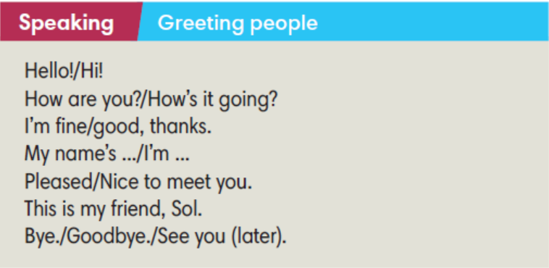
ACTIVITY 4: WHILE SPEAKING
- Aim: To practice using words and phrases to greet people and introduce their names.
- Content: Ss work individually and in pairs to complete exercises as instructed by T.
- Products: Ss are able to use descriptive phrases appropriately to describe people
- Implementation:
Step 1: Task delivering  - T tells Ss to complete exercise 3 on their own and to check their answers in pairs.  Step 2: Task performance  - Ss complete exercise 3 on their own.  Step 3: Judgment  - Ss check their answers in pairs.  Step 4: Report and discussion  - T develops further discussion if needed. | Exercise 3: Complete the sentences with the words below.  Answers:  b I’m c How d meet  e fine f Hi g Bye h it
Step 1: Task delivering  - T has Ss work in pairs to complete exercise 4.  Step 2: Task performance  - Ss work in pairs to complete exercise 4.  Step 3: Judgment  - T plays audio track 1.13 to check the answers.  Step 4: Report and discussion  - Ss work in pairs again to role-play the dialogue. | Exercise 4: Complete the dialogue with sentences from Exercise 3. Listen and check.  Answers:  2 c 3 e 4 b 5 f 6 d 7 g
ACTIVITY 5: POST SPEAKING
- Aim: To apply expressions in the Speaking box in real situations.
- Content: Ss work in groups for further practice.
- Products: Students’ conversations get out of the given sample and contain interesting situations.
- Implementation:
Step 1: Task delivering  - T asks Ss to work in groups of 3 to make a conversation for the meeting at the school canteen. The steps are clear in exercise 6.  Step 2: Task performance  - T encourages the groups to think of ways of making their conversations more interesting (e.g., one of them could get a name wrong or they could find out that the other two already know each other).  Step 3: Report and discussion  - When they are ready, T invites groups to act out their conversations in front of the class.  Step 4: Judgment  - Check with the whole class.  - T walks around to help if necessary. | Exercise 6: In groups of three, have a conversation. Follow these steps. Then swap roles.  Example:  A: Hello.  B: Hi.  A: Are you a new student?  B: Yes. Today is my first day.  A: My name’s Bill.  B: Hi Bill. I’m Bond. And this is my best friend, Charlie.  A: Hi Charlie. Nice to meet you.  C: Hi Bill. Me too.  B: We have to go and see the teacher. Talk later.  A: No worries. See you later.  B and C: See you.
HOME ASSIGNMENT  - T assigns the home assignments.  - Ss copy their home assignments.  - T explains it carefully. | - Do exercises 1, 2, 3, 4, 5 on Workbook page 12.  - Prepare Unit 1 Lesson 7 Writing.
____________________________________________________

