UNIT 6: A QUESTION OF SPORTS
Period 58: Lesson 6.4: Grammar
I. OBJECTIVES
By the end of the lesson, students are expected to achieve the following objectives:
- Knowledge:
- Grammar: Past Simple affirmative (regular and irregular forms)
- Competencies:
- General competencies:
Form and improve such competencies as group work and independent working, pair work, linguistic competence, cooperative learning and communicative competence.
- Specific competencies:
Improve communicative competencies related to the use of language (vocabulary, phonetics, grammar)
- For a language lesson: Students are expected to understand the main grammatical points, then do the tasks assigned in the textbook.
- For a skills lesson: Students are expected to use the main grammatical structure to practice talking about events in the past.
- Qualities:
- Being hard-working and attentive in class
- Have a positive attitude towards the lesson
II. PREPARATIONS
Teacher: Textbooks, paper, TV, projector, loudspeaker
Students: Textbooks, notebooks
III. PROCEDURE
ACTIVITY 1: WARM-UP
- Aim: To attract Ss’ attention to the lesson and review the previous lessons.
- Content: Ss work in 4 big groups to play the game called “Hot seat” under the monitor of T.
- Products: Ss are able to use the vocabulary from the previous lesson to guess the words.
- Implementation:
TEACHER AND STUDENTS’ ACTIVITIES | CONTENTS
Hot seat  Step 1: Task delivering  - T shows things related to some sports.  Step 2: Task performance  - 4 Ss from 4 big groups play at a time. They are not allowed to see the pictures on the screen. The others do actions as clues for them to guess.  Step 3: Judgment  - T checks the performance with the whole class.  Step 4: Report and discussion  - T develops further discussion if needed. | Review of the Sport Vocabulary  Suggested answers: basketball, tennis, football, swimming, running, …
ACTIVITY 2: KNOWLEDGE FORMATION
- Aim: To introduce the objectives of the lesson with a can-do statement.
- Content: The objective of the lesson is listed below
- I can use Past Simple to talk about events in the past.
- Products: Ss acknowledge the lesson’s objectives.
- Implementation:
ACTIVITY 3: PRESENTATION
- Aim: To teach Past simple forms with regular and irregular verbs and how to pronounce “V-ed”.
- Content: Ss work individually and in pairs under the instruction of T to complete the given exercises respectively.
- Products: Ss are able to accomplish the given exercises, grasp the pronunciation of the -ed sounds in past regular verbs, and how to form verbs in past tense.
- Implementation:
TEACHER AND STUDENTS’ ACTIVITIES | CONTENTS
Set the scene  Step 1: Task delivering  - T shows the photo in the book and introduces the context.  Step 2: Task performance  - T plays the audio track 6.05 for Ss to read and listen to find out the sport Sol is doing.  - T goes through the Out of class Box with Ss.  Step 3: Report and discussion  - T asks Ss to explain the expressions in the box.  Step 4: Judgment  - Check with the whole class. | Exercise 1: Look at the photo. What sport is Sol doing? Listen and check.  - Answers: Sol is jogging/ running.  - Out of class box explanation:  - “Good shot!” is used when someone kicks or hits a ball very well (i.e in football).  - “What’s wrong?” is asked when you see someone sad or ill.  - “Poor you!” is used to show sympathy.  - “When’s it on?” is used to find out about the time of a film at the cinema, a program on TV or a show on the radio.
Step 1: Task delivering  - T asks Ss to find the verbs in the dialogue: ask, happen, move, start, stop, try, walk, want.  Step 2: Task performance  - T elicits regular verbs from these examples.  - T explains to Ss that to put the sentences into Past simple tense we add “-ed” at the end of regular verbs.  - T goes through the examples in the Grammar box with Ss.  - T asks Ss to write the past form of the verbs in the list on the board.  - T asks Ss to try to work out how to spell the past form in the exercise without looking at the dialogue.  Step 3: Judgment  - T checks the performance with the whole class.  Step 4: Report and discussion  - When they are ready, T goes through the correct spelling for each past form and elicits the spelling rules they correspond to. | Exercise 2: Study the Grammar A box. Write the Past Simple form of the verbs below. Find them in the dialogue and check.  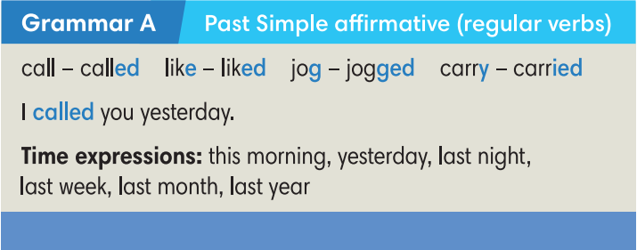  Answers: asked, happened, moved, started, stopped, tried, walked, wanted.
Step 1: Task delivering  - T discusses the pronunciation rules with Ss.  Step 2: Task performance  - T asks Ss to put their fingers against the throat to feel the difference between the vibrations that accompany voiced consonants and the lack of vibrations that accompany voiceless consonants.  - T uses drilling and correction to help Ss to remember the correct pronunciation for the different past form verbs.  - T plays audio track 6.06 for Ss to listen and repeat the words.  Step 3: Judgment  - T checks the performance with the whole class.  Step 4: Report and discussion  - T develops further discussion if needed.  Try Me  Step 1: Task delivering  - T asks Ss to apply spelling rules to change some verbs into Past simple forms.  Step 2: Task performance  - Ss work in pairs to sort these regular verbs into 3 categories and practice pronouncing them.  Step 3: Judgment  - T checks by odd one out activity.  Step 4: Report and discussion  - T develops further discussion if needed. | Exercise 3: Look at the table. Listen and repeat.  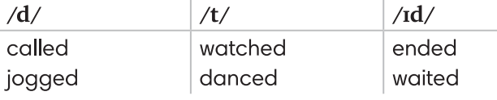  - Verb list: play, cook, work, study, stop, want, arrive, learn, add, look, ask, smile, start, brush, listen, love
Step 1: Task delivering  - T shows a sentence and asks Ss to decide if it’s true or false and why.  Step 2: Task performance  - T elicits irregular verbs.  - T explains that there are no real patterns for irregular verbs, they just need to learn them as individual vocabulary items.  - T asks Ss to try to find the past forms of these irregular verbs in the dialogue. It’s OK if they can’t find them.  Step 3: Judgment  - T plays audio track 6.07 for Ss to listen and check.  Step 4: Report and discussion  - T develops further discussion if needed | Exercise 4: Find the Past Simple form of these verbs in the dialogue and complete the Grammar B box. Listen and check.  - Sentence to elicit can be: My dad comed home late yesterday.  - Answers:
  come - came  do - did  get - got  go - went  have - had | put - put  run - ran  see - saw  take - took  win - won
ACTIVITY 4: PRACTICE
- Aim: To practice completing sentences with Past simple forms of the verbs.
- Content: Ss work individually to complete the given tasks and then in 4 groups to play the game to strengthen their grammar skills.
- Products: Ss are able to complete the tasks with correct answers and apply what they’ve learned about regular verbs in past tense to play the game.
- Implementation:
Step 1: Task delivering  - T asks Ss to do the exercise individually.  - T tells Ss that if there are any verbs they don’t know the past forms, they can refer to the irregular verbs list on page 110.  - T explains that if they can’t find the verbs in that list, they are regular verbs.  Step 2: Task performance  - Ss do the exercise individually.  Step 3: Report and discussion  - T calls some Ss to go to the board and write their answers.  Step 4: Judgment  - T plays the audio track 6.08 for Ss to check.  - T elicits the correct answers and checks the pronunciation. | Exercise 5: Complete Lily’s story with the Past Simple form of the verbs in brackets. Listen and check.  Answers:  2. stopped  3. started  4. found  5. saw  6. asked  7. said  8. gave  9. smiled
Pennalism  Step 1: Task delivering  - The class plays in 4 groups.  Step 2: Task performance  - Ss take turns to turn over 2 random cards: one infinitive card and one past form card. If they match, Ss get a point. If they can make a sentence with that verb, they get an extra point.  Step 3: Judgment  - T checks the performance with the whole class.  Step 4: Report and discussion  - T develops further discussion if needed. | Teacher Resource’s Book Unit 6_4: Resource 69  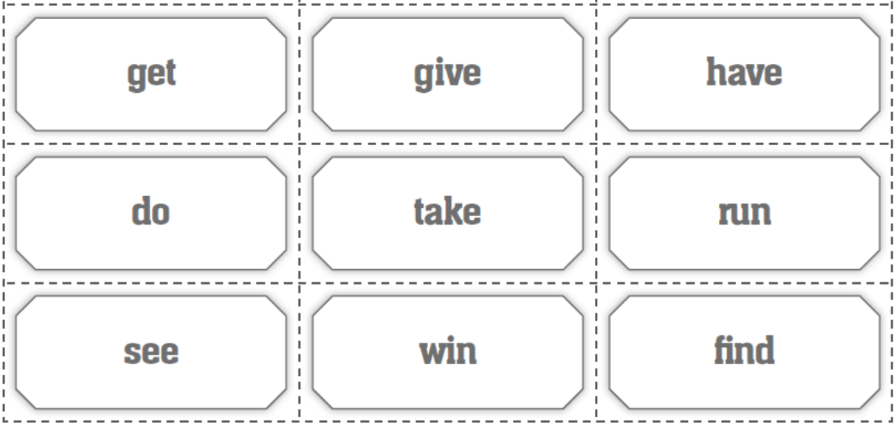  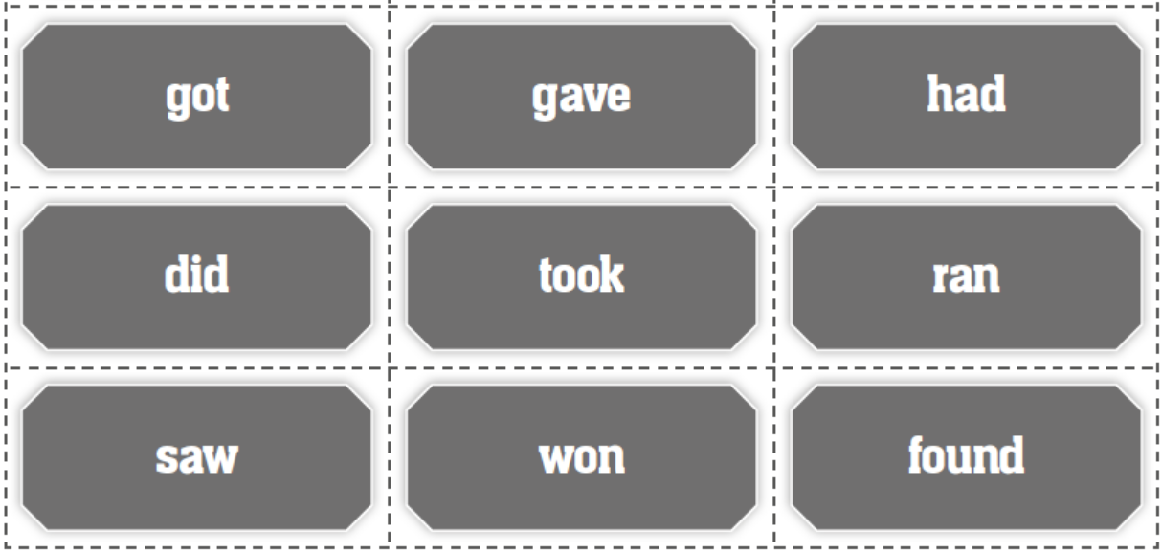
ACTIVITY 5: FURTHER PRACTICE
- Aim: To write sentences in Past simple forms.
- Content: Ss work as a whole class to carry out the Exercise 6 with the guidance from T.
- Products: Ss are able to use grammar structure and vocabulary from the lesson to accomplish the exercise.
- Implementation:
Step 1: Task delivering  - T instruct S to do the task  Step 2: Task performance  - Each student writes 2 sentences about themselves using Past Simple tense. One sentence is true and one sentence is false.  - T does a demo about how to make wrong sentences.  - Ss walk around the class and read their two sentences for their friends to decide which is true and which is false and identify the wrong information.  Step 3: Judgment  - Ss get 1 point when their friends make wrong guesses.  - T monitors and helps where necessary.  Step 4: Report and discussion  - T develops further discussion if needed. | Exercise 6: Let’s play the truth game! Work in pairs. Go to page 111.  Student A: Write two sentences about yourself in the Past Simple. Make sure one sentence is true. One sentence is false. Read them aloud to Student B.  Student B: Guess the false one. Then change the role.  Suggestion:  A: I went jogging in the park yesterday. I had Pho this morning  B: “You went jogging in the park yesterday” is true. “You had Pho this morning” is false. You had bread.
HOME ASSIGNMENT  - T assigns the home assignments.  - Ss copy their home assignments.  - T explains it carefully. | - Do exercises on Workbook page 55.  - Prepare Unit 6.5 – Listening and Vocabulary.

