UNIT 6: A QUESTION OF SPORTS
Period 60: Lesson 6.6: Speaking
I. OBJECTIVES
By the end of the lesson, students are expected to achieve the following objectives:
- Knowledge:
- Vocabulary: Sports
- Grammar: Present simple
- Competencies:
- General competencies:
Form and improve group work and independent working, pair work, linguistic competence, cooperative learning and communicative competence.
- Specific competencies:
Improve communicative competencies related to speaking skills and use of language (vocabulary, phonetics, grammar)
- For a language lesson: Students are expected to know the meaning of the key phrases used in talking about what and how interested they are in some activities, and understand the main grammatical points, then do the tasks assigned in the textbook.
- For a skills lesson: Students are expected to use their speaking skills to practice talking about hobbies and interests.
- Qualities:
- Being hard-working and attentive in class
- Have a positive attitude towards the lesson
- Being polite and open-minded when listening to others’ hobbies and interests
II. PREPARATIONS
Teacher: Textbooks, TV, projector, loudspeaker
Students: Textbooks, notebooks
III. PROCEDURE
ACTIVITY 1: WARM-UP
- Aim: To attract Ss’ attention to the lesson and review the previous lesson.
- Content: Ss work in groups of 4 to work on the worksheet under the instruction of T.
- Products: Ss are able to match the given verbs with corresponding nouns to make phrases about sports.
- Implementation:
TEACHER AND STUDENTS’ ACTIVITIES | CONTENTS
Add three  Step 1: Task delivering  - T instruct S to do the task  Step 2: Task performance  - Ss work in groups of 4.  - T gives each group a Worksheet (RESOURCE 71).  - T guides how to complete the worksheet.  - Ss discuss in groups and complete the task.  Step 3: Judgment  - T and Ss check together.  Step 4: Report and discussion  - T develops further discussion if needed. | Teacher’s resource book Unit 6_6: Resource 71  Match two of the words below with each verb. Then write three more words of your own for  each verb.  Answers:  play: football, ice hockey (basketball, tennis, golf, cricket, rugby, badminton)  do: aerobics, gymnastics (karate, judo, exercise, archery)  go: cycling, swimming (sailing, jogging, running, walking, climbing, skiing, skateboarding)  win/lose: 3–0, the cup (the tournament, 2–1, 34 points to 17, in the final)  play for: the school team, England (your local club, your country, a new team)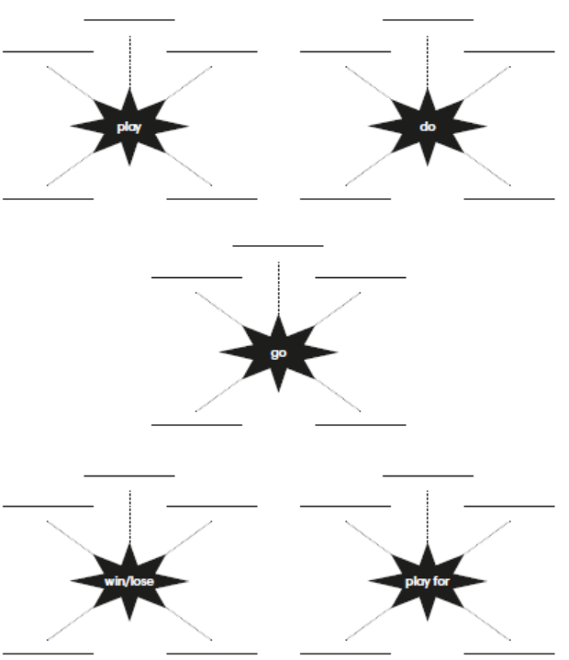
ACTIVITY 2: KNOWLEDGE FORMATION
- Aim: To introduce the objectives of the lesson with a can-do statement.
- Content: The objective of the lesson is listed below
- I can talk about hobbies and interests.
- Products: Ss acknowledge the lesson’s objectives.
- Implementation: T introduces objectives to Ss.
ACTIVITY 3: PRE-SPEAKING
- Aim: To learn some phrases to talk about hobbies and interests.
- Content: Ss work individually under the instruction of T to do the given exercises and learn the speaking box.
- Products: Ss know the meaning of phrases and grammatical structures used to talk about hobbies and interests.
- Implementation:
TEACHER AND STUDENTS’ ACTIVITIES | CONTENTS
Set the scene  Step 1: Task delivering  - T asks Ss if anyone in the class has ever been interviewed for a radio show or by a newspaper reporter.  Step 2: Task performance  - Ss answer.  - T asks Ss how they felt when they have been interviewed.  - T asks Ss to look at the photo and answer the questions.  Step 3: Judgment  - T elicits the correct answers for Ss.  Step 4: Report and discussion  - T develops further discussion if needed | Exercise 1: Look at the photo and answer the questions. Go to page 112 and check.  Answers:  1. Max is in the skateboard park.  2. He’s talking to a reporter from South radio.
Step 1: Task delivering  - T asks Ss to listen and read the interview.  Step 2: Task performance  - T plays audio track 6.13 for Ss to listen to answer the question in exercise 2.  Step 3: Judgment  - T confirms the answer.  Step 4: Report and discussion  - T goes through the Out of class box, explains that we use “to be honest, ...” when we are giving our opinion and know that it might not be what the other person wants to hear. | Exercise 2: Read or listen. What does Max do in his free time?  Answer:  He hangs out with friends, dances, plays football, goes cycling and goes skateboarding.
Step 1: Task delivering  - T asks Ss to study the Speaking box and underline examples of the phrases in the dialogue.  Step 2: Task performance  - T asks Ss to read aloud all the sentences and phrases in the box.  Step 3: Judgment  - T points out the meanings of the phrases in the box.  Step 4: Report and discussion  - T develops further discussion if needed. | Exercise 3: Study the speaking box. Find examples of the phrases in the dialogue.  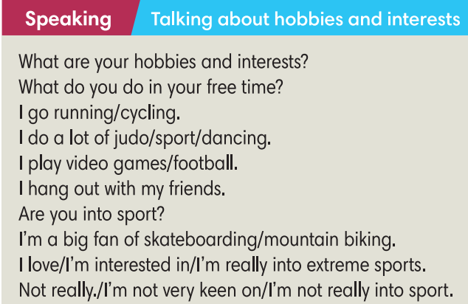
ACTIVITY 4: WHILE SPEAKING
- Aim: To practise using the phrases to talk about hobbies and interests in context.
- Content: Ss work in pairs and individually as instructed by T to complete exercises.
- Products: Ss are able to complete the dialogue with appropriate phrases and then practice the dialogue.
- Implementation:
Step 1: Task delivering  - T asks Ss to work in pairs to complete the text.  Step 2: Task performance  - Ss work in pairs to complete the text.  Step 3: Judgment  - T calls some Ss to give their answers and checks for them.  Step 4: Report and discussion  - T asks Ss if anyone in the class is a sports fanatic and explains that word for them. | Exercise 4: In pairs, complete the text with one verb in each gap.  Answers:  2. does  3. goes  4. is  5. is  6. hangs
Step 1: Task delivering  - T guides Ss how to do this exercise and asks them to do it individually.  Step 2: Task performance  - Ss do this exercise individually.  Step 3: Judgment  - Ss swap their books to compare the answers.  - T confirms the answers.  Step 4: Report and discussion  - T puts Ss into pairs and tells them to roleplay: one plays as Jay and the other gives their own response.  - T calls some pairs to share their unique dialogue. | Exercise 5: Complete the dialogue with sentences a-h. There are 3 extra sentences. Listen and check.  Answers: 2-d, 3-h, 4-a, 5-g
ACTIVITY 5: POST-SPEAKING
- Aim: To act out a dialogue of hobbies and interests.
- Content: Ss work in pairs for further practice as instructed by T.
- Products: Ss are able to talk about your hobbies and interests using the correct grammar structures and vocabulary.
- Implementation:
Step 1: Task delivering  - T asks Ss to work in pairs to ask and answer questions in a similar way to what was done in Exercise 5.  - T brainstorms some questions they may use in their dialogues.  Step 2: Task performance  - Ss work in pairs to ask and answer questions in Exercise 5.  - T walks around and helps if necessary.  Step 3: Report and discussion  - After 5 mins, T calls some pairs to act out the dialogue.  Step 4: Judgment  - T gives feedback. | Exercise 5: In pairs, talk about your hobbies and interests. Tell the class about your partner.  Suggested questions:  - What do you do in your free time?  - Do you do a lot of exercise?  - Do you play for a school team?
HOME ASSIGNMENT  - T assigns the home assignments.  - Ss copy their home assignments.  - T explains it carefully. | - Do exercises on Workbook page 76.  - Prepare Lesson 6.7 – English in use.

