UNIT 6: A QUESTION OF SPORTS
Period 61: Lesson 6.7: English in Use
I. OBJECTIVES
By the end of the lesson, students are expected to achieve the following objectives:
- Knowledge:
- Grammar: Past Simple
- Competencies:
- General competencies:
Form and improve group work and independent working, pair work, linguistic competence, cooperative learning and communicative competence.
- Specific competencies:
Improve communicative competencies related to writing skills and use of language (vocabulary, phonetics, grammar)
- For a language lesson: Students are expected to know the usage of “ago” in past tense, and understand the main grammatical points, then do the tasks assigned in the textbook.
- For a skills lesson: Students are expected to use their writing skills to practice writing about a sport game they played recently.
- Qualities:
- Being hard-working and attentive in class
- Being collaborative while doing in-class exercises
II. PREPARATIONS
Teacher: Textbooks, paper, handouts of Teacher’s Resource Book 41, TV, projector, loudspeaker
Students: Textbooks, notebooks
III. PROCEDURE
ACTIVITY 1: WARM-UP
- Aim: To attract Ss’ attention to the lesson and review the previous lesson.
- Content: Ss work in groups of 4 to brainstorm ideas compared themselves when they were 7 to they are now under the instruction of T.
- Products: Ss are able to use the Past Simple tense to complete the speech and present in the class.
- Implementation:
TEACHER AND STUDENTS’ ACTIVITIES | CONTENTS
Step 1: Task delivering  - T gives Ss a task: compare when you were 7 and you are now.  Step 2: Task performance  - Ss work in groups of 4 to brainstorm ideas.  - T elicits the tense to use when they talk about the past and present.  - T walks around to take notes.  Step 3: Report and discussion  - T calls some volunteers to present in the class.  Step 4: Judgment  - Check with the whole class. | Example:  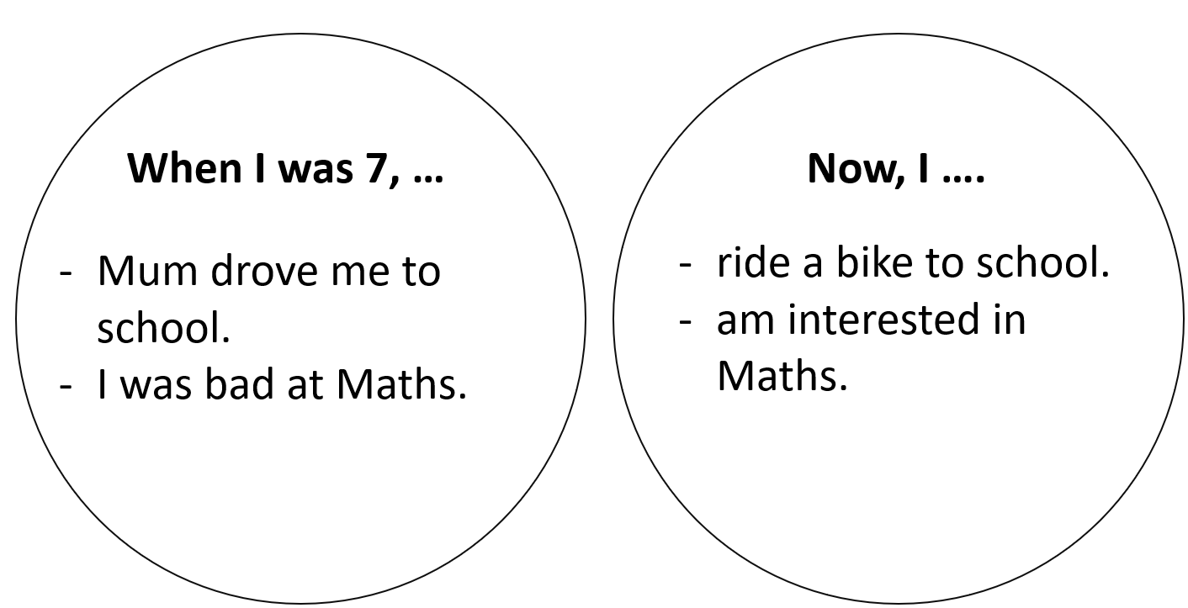
ACTIVITY 2: KNOWLEDGE FORMATION
- Aim: To introduce the objectives of the lesson with a can-do statement.
- Content: The objective of the lesson is listed as below
- I can use “ago” to talk about events in the past.
- Products: Ss acknowledge the lesson’s objectives.
- Implementation: T introduces objectives to Ss.
ACTIVITY 3: PRESENTATION
- Aim: To teach how to use “ago” to talk about events in the past.
- Content: Ss work as a whole class to do the assigned tasks with the instruction from T.
- Products: Ss are able to accomplish the given exercises and get the grammar rules of “ago”.
- Implementation:
TEACHER AND STUDENTS’ ACTIVITIES | CONTENTS
Set the scene  Step 1: Task delivering  - People in the past were big fans of sports. Lots of sports today started a thousand years ago.  - T shows 2 sets of pictures for Ss to match: set 1 concludes 4 pictures in Exercise 1. Set 2 are their corresponding pictures nowadays.  - T gives 4 phrases to match these pictures: motor racing, team sports, running, weight training.  - T checks if Ss know the meanings of the words “prehistoric”, “Ancient Romans” and “Ancient Egyptians”.  Step 2: Task performance  - T asks Ss to open their books and tells them that they are going to find out some interesting events in the past. T asks them to describe the pictures.  A- People are running away from a bear.  B- People are pulling stones to build pyramids.  C- The teams are gladiators or slaves fighting against wild animals.  D- The cars are travelling very slowly, following the man with the red flag.T asks Ss to do Exercise 1 individually.  - Ss work individually to complete Exercise 1.  Step 3: Judgment  - T confirms the answers.  Step 4: Report and discussion  - T develops further discussion if needed. | Exercise 1: Match pictures A-D with captions 1-4.  Answers:  1. C  2. D  3. A  4. B
Step 1: Task delivering  - T instruct S to do the task  Step 2: Task performance  - T asks when the events in these pictures took place and elicits the time expressions for Past simple.  Step 3: Judgment  - T checks the meaning and use of “ago”.  Step 4: Report and discussion  - T develops further discussion if needed. | Exercise 2: Study the Language Box. How do you say the phrases in your language?  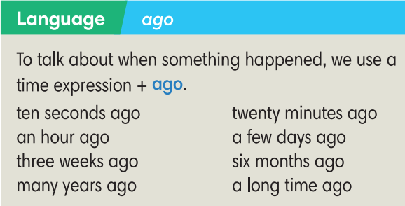
ACTIVITY 4: PRACTICE
- Aim: To practice making sentences with “ago”.
- Content: Ss work individually then in pairs under the instruction of T to complete the given exercises.
- Products: Ss can strengthen their knowledge about grammatical points.
- Implementation:
Step 1: Task delivering  - T guides how to complete Exercise 3.  Step 2: Task performance  - Ss work individually then in pairs to compare the answers.  Step 3: Judgment  - T confirms the answers.  Step 4: Report and discussion  - T develops further discussion if needed. | Exercise 3: In pairs, work out how long ago these things happened.  Answers depend on the year the lesson is taught.
Step 1: Task delivering  - T puts Ss into pairs and tells them to work together to think of the missing words.  - T explains that the missing words could be grammatical or prepositions or vocabulary items relating to the topic of sports.  Step 2: Task performance  - Ss to work together to think of the missing words.  Step 3: Report and discussion  - T calls some Ss to go to the board and write their answers.  Step 4: Judgment  - T plays audio track 6.15 to check the answers on the board. | Exercise 4: Complete the text with one word in each gap. Listen and check.  Answers:  2. do  3. ago  4. medal  5. Last  6. court  7. was  8. for  9. match  10. goals  11. of
ACTIVITY 5: FURTHER PRACTICE
- Aim: To write sentences about a sports game that students played recently.
- Content: Ss work in pairs to do the writing task with the help of T.
- Products: Ss can write a short paragraph about a sports game that they played recently.
- Implementation:
Step 1: Task delivering  - T elicits questions as clues for Ss to write.  Step 2: Task performance  - T sets a time limit for the writing and walks around to help if necessary.  Step 3: Judgment  - After that, T asks Ss to exchange their writings with their partners.  - Ss check the grammar and vocabulary for their partners.  Step 4: Report and discussion  - T asks some Ss to read aloud their writings.  - T gives feedback. | Exercise 5: Write 5-8 sentences about a sports game that you played recently. You can use the text in Exercise 4 as an example. You may answer these questions:  - How long ago did you play that sport?  - Who did you play with?  - Did you win or lose the game?  - Why did you stop playing that sport?
HOME ASSIGNMENT  - T assigns the home assignments.  - Ss copy their home assignments.  - T explains it carefully. | - Do Exercise 1,2 Students’ Book page 68; Workbook page 58.  - Prepare: Lesson 6.8 – Pronunciation and Review vocabulary.

