UNIT 7: THE TIME MACHINE
Period 63: Lesson 7.1: Vocabulary
I. OBJECTIVES
By the end of the lesson, students are expected to achieve the following objectives:
- Knowledge:
- Vocabulary: Talking about history, computers and Information Technology.
- Competencies:
- General competencies:
Form and improve such competencies as group work, independent working, pair work, linguistic competence, cooperative learning and communicative competence.
- Specific competencies:
Improve communicative competencies related to the use of language (vocabulary, phonetics, grammar)
- For a language lesson: Students are expected to know the meaning of the keywords used to talk about technology and history, and understand the main grammatical points, then do the tasks assigned in the textbook.
- For a skills lesson: Students are expected to use the verbs and phrases about computers and information technology to practice talking about technology.
- Qualities:
- Being hard-working and attentive in class
- Have a positive attitude and approach towards technology and social networking site
II. PREPARATIONS
Teacher: Textbooks, PowerPoint slides, worksheets, TV, projector, loudspeaker
Students: Textbooks, notebooks
III. PROCEDURE
ACTIVITY 1: WARM-UP
- Aim: To attract Ss’ attention to the lesson and review the previous unit.
- Content: Ss work in groups of 8 to make sentences with the time cards under the instruction from T.
- Products: Ss are able to make as many correct sentences as they can using the structure they’ve learnt to win the game.
- Implementation:
TEACHER AND STUDENTS’ ACTIVITIES | CONTENTS
Step 1: Task delivering  - T gives Ss a set of time cards and asks them to put these cards in order of time.  Step 2: Task performance  - Ss work in groups of 8 and make sentences with the time cards.  Step 3: Judgment  - The winner is the team that finishes fastest with the most correct sentences.  For stronger class: T may require the numbers of words in a sentence, for example, there are at least 7 words in a sentence.  Step 4: Report and discussion  - T develops further discussion if needed. | 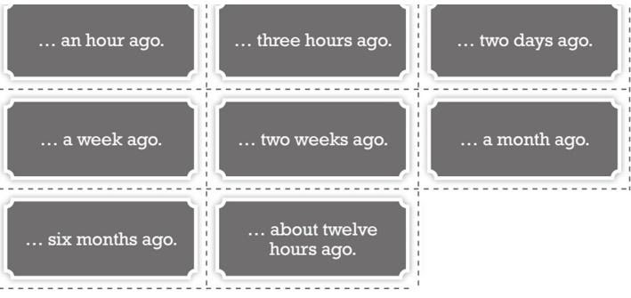  - Example: I had a big breakfast an hour ago.
ACTIVITY 2: KNOWLEDGE FORMATION
- Aim: To introduce the objectives of the lesson with a can-do statement.
- Content: The objective of the lesson is listed below
- I can talk about technology and important moments in the past.
- Products: Ss acknowledge the lesson’s objectives.
- Implementation: T introduces objectives to Ss.
ACTIVITY 3: PRESENTATION
- Aim: To teach some date phrases to talk about the history and phrases about computers and Information and Technology.
- Content: Ss work individually to study the Vocabulary box with the guidance of T.
- Products: Ss are able to put the time phrases in order and grasp the background knowledge about the years and century.
- Implementation:
TEACHER AND STUDENTS’ ACTIVITIES | CONTENTS
Set the scene  Step 1: Task delivering  - T says: “We have just discussed what we did some times ago, now we are going to find out more phrases in the past.”  Step 2: Task performance  - T asks Ss to read the words in the box chorally and gives them more background knowledge about the years and century.  - T asks Ss to order the phrases from the oldest to the most recent.  Step 3: Judgment  - T elicits the correct answers.  Step 4: Report and discussion  - T develops further discussion if needed. | Exercise 1: Study the Vocabulary A box. How do you say the phrases in your language? Order the phrases (1-the oldest, 6-the most recent).  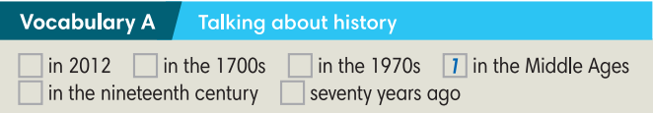  Answers:  - in the Middle Ages  - in the 1700s  - in the nineteenth century  - seventy years ago  - in the 1970s  - in 2012
ACTIVITY 4: PRACTICE
- Aim: To help Ss practice the Past Simple and teach words about Computer and Information Technology.
- Content: Ss work individually with the guidance from T to do the exercises in the textbook and then in pairs to check answers.
- Products: Ss are able to accomplish the given exercises using correct grammatical points and grasp the meaning of the vocabulary related to computers and technology.
- Implementation:
Step 1: Task delivering  - T asks Ss to read the texts on the website and underline the time mentioned.  Step 2: Task performance  - Ss order the events on the timeline.  - T elicits the correct answers and provides the exact years the events happened.  Step 3: Report and discussion  - T asks Ss to work in pairs to discuss which they think was the most important event.  - When they have finished, T invites pairs to share their ideas and give reasons why.  Step 4: Judgment  - Check with the whole class. | Exercise 2: Read the texts on the website and put the ideas on this timeline. In pairs, say which idea you think was the most important.  Answers:  - 3 (1543)  - 1 (1865)  - 2 (1910)  - 4 (1981)
Step 1: Task delivering  - T asks Ss to look at the highlighted irregular Past Simple forms in the texts and match them with the infinitives in Exercise 3.  Step 2: Task performance  - T sets a time limit for Ss to answer.  Step 3: Judgment  - T elicits the correct answers.  Step 4: Report and discussion  - T develops further discussion if needed. | Exercise 3: Look at the highlighted irregular Past Simple forms in the texts. Match them with the infinitives below. How do you say the verbs in your language?  - Answers:
  become-became  begin-began  buy-bought  write-wrote | sell-sold  think-thought  understand-understood
Step 1: Task delivering  - T asks Ss to work in pairs to complete the blog post with the Past Simple forms of the verbs in brackets.  Step 2: Task performance  - T calls some pairs to give their answers.  - T elicits the answer.  Step 3: Report and discussion  - T asks Ss to discuss which date they think is the most important and give reasons why.  - T calls some Ss to give their ideas.  Step 4: Judgment  - Check with the whole class.  Challenge  Step 1: Task delivering  - T divides the class into 2 big groups and gives each student a piece of paper.  Step 2: Task performance  - Ss in group 1 write sentences using infinitive verbs in exercise 3 and Present simple. The rest write sentences using the Past simple forms of the verbs in exercise 3. Each St writes one sentence with a random verb.  Step 3: Report and discussion  - After they have finished, T lets Ss swap paper and change the sentences into Past/ Present simple.  - Ss find partners to share their sentences when they finish.  Step 4: Judgment  - Check with the whole class. | Exercise 4: Complete the blog post with the Past Simple form of the verbs in brackets. Which of the dates was most important in your opinion?  Answers:  - became  - became  - began  - wrote  - could  - sold  - bought  - could  - T’s guidance for the Challenge game:  - I/She/ … usually …….  - Today I/she/…. …….
Step 1: Task delivering  - T asks Ss to study the words in the Vocabulary B box and read the words chorally.  Step 2: Task performance  - T asks Ss to guess the meanings of the words, using the words/phrases in the blog post.  - T explains more for Ss if necessary.  Step 3: Report and discussion  - Ss discuss and explain.  Step 4: Judgment  - Check with the whole class. | Exercise 5: Study the words in Vocabulary B box. These words are highlighted in the blog post in Exercise 4. Find the words/ phrases in the blog post that can help you guess the meanings of these words.  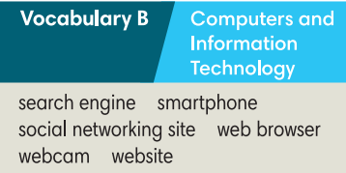  The words/phrases can help Ss find the meanings of the words:  - Web browser: the World Wide Web  - Webcam: a camera  - Search engine: Google  - Website: Wikipedia  - Social networking site: Facebook  - Smartphones: phones to get on the web, play games, take photos and watch videos.
ACTIVITY 5: FURTHER PRACTICE
- Aim: To talk about favourite search engines, websites to study English and social networking sites.
- Content: Ss work as a whole class to carry out the survey about technology under the guidance of T.
- Products: Ss are able to develop a conversation with other students to carry out a survey and get the answers to fill in the table.
- Implementation:
Step 1: Task delivering  - T explains the activity “Class survey” to Ss.  Step 2: Task performance  - Ss interview three students in the class using the questions in the table and write the names and answers in the columns.  - T encourages Ss to interview 3 friends who don’t sit next to them.  - T may make an example for Ss.  - T sets a time limit for Ss to the activity.  Step 3: Report and discussion  - T asks Ss to report the results of their survey.  Step 4: Judgment  - T corrects for Ss.  - Then the whole class finds out the most interesting answers at the end of the task. | Exercise 6: Interview three students in your class using the questions below. Write the names and answers in the column. Then report to the class.  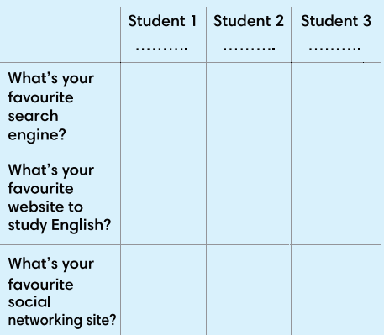
HOME ASSIGNMENT  - T assigns the home assignments.  - Ss copy their home assignments.  - T explains it carefully. | - Do exercises on Workbook pages 60-61.  - Prepare Lesson 7.2 – Grammar 1.

