Teaching date: 16/01/2023
Period 55 UNIT 6: EDUCATION
Lesson 1.1 – Vocabulary and Listening (page 44)
I. OBJECTIVES
By the end of the lesson, Ss will be able to:
1.1. Language knowledge and skills
- know more words relating to school tasks and school activities (essay, project, homework, book report, test, presentation).
- talk about things they have to do at school.
- listen to and understand a conversation of two students trying to make plans (for general and specific details).
- know how to decline an invitation.
1.2. Competences
- improve communication, collaboration, and critical thinking skills.
1.3. Attributes
- love school and schooling.
- have a balance between studying and relaxing.
II. TEACHING AIDS AND LEARNING MATERIALS
1. Teacher’s aids: Student book and Teacher’s book, class CDs, Digital Book (DCR phần mềm tương tác SB, DHA (từ vựng/ cấu trúc) phần mềm trò chơi tương tác), projector/interactive whiteboard / TV (if any), PowerPoint slides.
2. Students’ aids: Student’s book, workbook, notebook.
III. ASSESSMENT EVIDENCE

Performance Tasks | Performance Products | Assessment Tools
- Match the words with the descriptions. | - Ss’ answers. | - T’s feedback/Peers’ feedback.
- Listen and repeat. | - Ss’ presentation. | - T’s feedback/Peers’ feedback.
- Say which things you have to do at school. | - Ss’ presentation. | - T’s feedback/Peers’ feedback.
- Listen to two students trying to make plans. Who is busier? | - Ss’ answers. | - T’s feedback/Peers’ feedback.
- Listen and fill in the blanks. | - Ss’ answers. | - T’s feedback/Peers’ feedback.
- Speak: Does your life sound more like Alan's or Lucy's? Why? | - Ss’ answers/ presentation. | - T’s observation and feedback.
IV. PROCEDURES
A. Warm up:
a) Objective: Introduce the new lesson and set the scene for Ss to acquire new language; get students' attention at the beginning of the class by enjoyable and short activities as well as to engage them in the follow-up steps.
b) Content: Introduce words about school tasks / Introduce the new topic: Education.
c) Expected outcomes: Ss get to know some new words they are going to study in the lesson.
d) Organization of the activity:
TEACHER’S ACTIVITIES | STUDENTS’ ACTIVITIES
Option 1: Match the words with the descriptions. Listen and repeat.  - Use the “New words” part a – page 44 for the warm-up activity.  - Show words and definitions using DCR, have Ss look and match the words with the descriptions (in pairs).  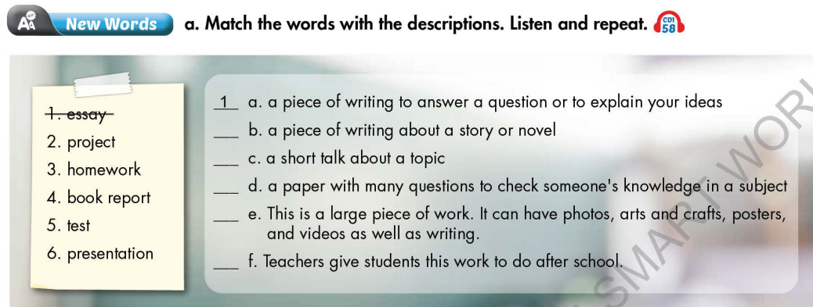  - Call Ss to give answers.  - Give feedback and show correct answers using DCR.  - Lead to the new lesson.  - Play the audio (CD1 – Track 58), have Ss listen and repeat.  - Correct Ss’ pronunciation if necessary.  Option 2: Letter Lingo.  - Show 9 pictures.  - Have Ss give name of each picture (randomly) and use the red and underlined letter of each answer to form a new English word.  - The first S to give the right key word will be the winner.  - Lead to the new lesson.  *Illustration:  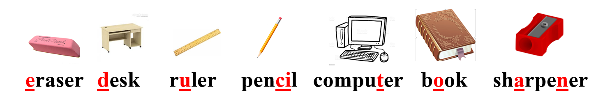 | - Work in pairs to match the words with the descriptions.  - Give answers.  - Listen.  - Listen and repeat.  Answer keys  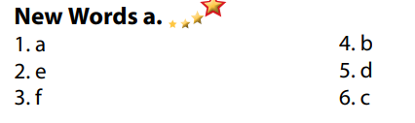  - Take part in the class’s activity.  - Give answers.  - Listen.  Answer key  Key word: Education

B. New lesson
Activity 1: Pre-Listening (Vocabulary)
a) Objective: Ss get to know words about school tasks.
b) Content:
- Vocabulary study (essay, project, homework, book report, test, presentation).
- Speaking: Say which things you have to do at school.
c) Expected outcomes: Ss know how to pronounce the new words correctly and use them when talking about school tasks.
d) Organization of the activity:
TEACHER’S ACTIVITIES | STUDENTS’ ACTIVITIES
Task a. Match the words with the descriptions. Listen and repeat.  Option 1 (If the teacher hasn’t used this part for the Warm-up activity)  - Demonstrate the activity on DCR, using the example.  - Have Ss match the words with the descriptions.  - Divide class into pairs and have them check their answers with their partners.  - Call Ss to give answers.  - Check answers as a whole class using DCR.  - Play audio (CD1 – Track 58). Have Ss listen and repeat.  - Correct Ss’ pronunciation.  Option 2: (If the teacher has used part a. for the Warm-up activity.)  - Give some pictures, have Ss look and give names of the pictures, using new words in Task a. (T uses different pictures from those in Task a.)  - Have Ss give answers and tell the meaning of words / phrases again.  - Check answers as a whole class.  - Call some Ss to read the words again.  - Correct Ss’ pronunciation if necessary.  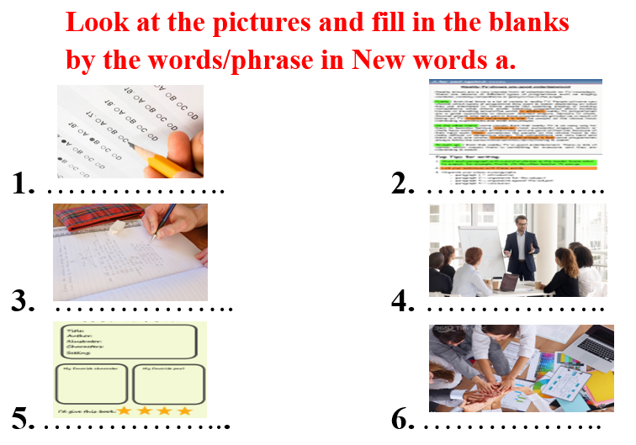  Task b. In pairs: Say which things you have to do at school.  - Have Ss work in pairs to say which things they have to do at school.  - Go round and give help if necessary.  - Have some pairs demonstrate the activity in front of the class.  - Give feedback and evaluation. | - Look and listen.  - Work individually.  - Work in pairs.  - Give answers.  - Listen and repeat.  Answer keys  - Work in pairs.  - Give answers, meaning.  - Read.  Answer keys  1 test  2 essay  3 homework  4 presentation  5 book report  6 project  - Work in pairs.  - Present.  Sample answers  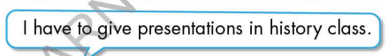
Activity 2: While - Listening
a) Objective: Students can develop their listening skill.
b) Content:
- Listen to two students trying to make plans. Who is busier?
- Listen and fill in the blanks.
c) Expected outcomes: Students can listen and understand general and specific information about trying to make plans.
d) Organization of the activity:
TEACHER’S ACTIVITIES | STUDENTS’ ACTIVITIES
Task a. Listen to two students trying to make plans. Who is busier?  - Have Ss read the question, guess the answer.  - Play audio (CD1 - Track 59).  - Have Ss listen and circle the correct answer.  - Check answer as a whole class using DCR.  Task b. Now, listen and fill in the blanks.  - Have Ss read the through the content of Task b, underline the key words.  - Play the audio again (CD1 - Track 59).  - Have Ss listen and fill in the blanks.  - Have Ss check answers with their partners.  - Call Ss to give answers.  - Give feedback and show correct answers using DCR. | -Work individually.  - Listen.  - Circle the correct answers.  Answer keys  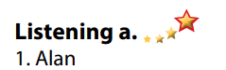  - Read, underline the key words.  - Do the task.  - Exchange answers.  Answer keys  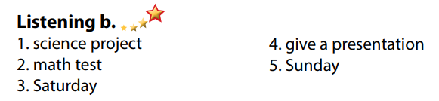
Activity 3: Post - Listening (6’)
a) Objective: Students can use the vocabulary and the content in listening part to develop their speaking skill.
b) Content: Speaking: Does your life sound more like Alan's or Lucy's? Why?
c) Expected outcomes: Students can express their own ideas about school life and activities after school.
d) Organization of the activity:
TEACHER’S ACTIVITIES | STUDENTS’ ACTIVITIES
Conversation skill  - Have Ss look at the Conversation skill box and read.  - Play audio (CD 1 - Track 60) using DCR, have Ss listen and repeat.  - Ask Ss to find more ways to decline an invitation.  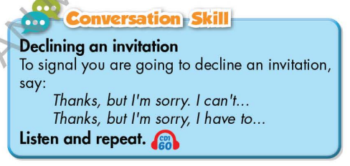  Task c. In pairs: Does your life sound more like Alan's or Lucy's? Why?  - Have Ss work in pairs to discuss.  - Observe and give help if necessary.  - Call some pairs to share their ideas with the class.  - Give feedback and evaluation. | - Look and read.  - Listen and repeat.  - Give answers.  - Work in pairs.  - Present.
C. Consolidation and homework assignments (5’)
* Consolidation:
- Words relating to school tasks and school activities. (essay, project, homework, book report, test, presentation).
- Language to ask for declining an invitation: Thanks, but I’m sorry I can’t / Thanks a lot, but I’m sorry, I have to …
Homework
- Learn the new words by heart.
- Practice talking about things you have to do at school.
- Do the exercises in WB: New words and Listening (pages 32, 33).
- Do the vocabulary exercise in Tiếng Anh 7 i-Learn Smart World Notebook (page 36).
- Play consolation games in Tiếng Anh 7 i-Learn Smart World DHA App on www.eduhome.com.vn
- Prepare: Lesson 1.2 – Grammar (page 45 – SB).
.................................................................................................................................
Teaching date: 27/01/2023
Period 56 UNIT 6: EDUCATION
Lesson 1.2 - Grammar (page 45)
I. OBJECTIVES
By the end of the lesson, Ss will be able to:
1.1. Language knowledge and skills
- listen to 2 people asking and answering about making a plan.
- use “have to”, “has to” for obligation expression.
- talk about things they have to / don’t have to do at home or at school.
1.2. Competences
- improve speaking, listening skills.
- improve the use of English.
1.3. Attributes
- be responsible for school work and housework.
- have a balance between studying and relaxing.
II. TEACHING AIDS AND LEARNING MATERIALS
1. Teacher’s aids: Student book and Teacher’s book, class CDs, Digital Book (DCR phần mềm tương tác SB, DHA (từ vựng/ cấu trúc) phần mềm trò chơi tương tác), projector/interactive whiteboard / TV (if any), PowerPoint slides, handouts.
2. Students’ aids: Student’s book, workbook, notebook, handouts.
III. ASSESSMENT EVIDENCE
Performance Tasks | Performance Products | Assessment Tools
- Listen and repeat. | - Ss’ performance. | - T’s feedback.
- Write sentences with have to using the prompts. | - Ss’ answers. | - T’s feedback/Peers’ feedback.
- Fill in the blanks with have to, has to, don't have to, or doesn't have to. | - Ss’ answers. | - T’s feedback/Peers’ feedback.
- Speak: What things do/don't you have to do at home or at school? | - Ss’ answers/ presentation. | - T’s observation, T’s feedback/Peers’ feedback.
IV. PROCEDURES
A. Warm up:
a) Objective: Introduce the new lesson and set the scene for Ss to acquire new language; get students' attention at the beginning of the class by enjoyable and short activities as well as to engage them in the follow-up steps.
b) Content: Review words about school tasks.
c) Expected outcomes: Ss review old vocabularies which are very useful for them in the new lesson.
d) Organization of the activity:
TEACHER’S ACTIVITIES | STUDENTS’ ACTIVITIES
Option 1: Phone code  - Have Ss close books and notebooks.  - Have Ss look at the phone code and write the correct words.  - Call Ss to give answers.  - Check Ss’ answers, give feedback.  *Codes:  1. 33 7777 7777 2 999  2. 8 33 7777 8  3. 44 666 6 33 9 666 777 55  4. 7 777 666 5 33 222 8  5. 44 2 888 33 8 666    - Have Ss make sentences, using the words they have just made.  - Lead to the new lesson.  Option 2: Matching  - Have Ss close all books and notebooks.  - Have Ss do the matching activity.  - Call Ss to give answers, tell the meaning of the phrases again.  - Check Ss’ answers, give feedback.  - Lead to the new lesson.  *Illustration  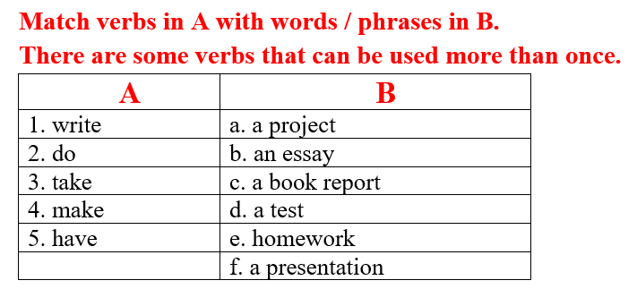 | - Close books and notebooks.  - Work in pairs.  - Give answers.  Answers keys  1. essay  2. test  3. homework  4. project  5. have to  - Make sentences.  - Close books and notebooks.  - Work in pairs to match.  - give answers, tell the meaning of the phrases.  - Listen and write the new lesson.  Answers keys  1. write: an essay, a book report  2. do: a project, a test, homework  3. take: a test  4. make: a presentation  5. have: a project, an essay, a book report, a test, homework, a presentation
B. New lesson
Activity 1: Presentation
a) Objective: Introduce: “have to” and “has to”.
b) Content:
- Listen and repeat.
- Introduce the grammar points.
c) Expected outcomes: Ss know the new grammar points (“have to” and “has to”) and use them in some exercises that follow.
d) Organization of the activity:
TEACHER’S ACTIVITIES | STUDENTS’ ACTIVITIES
Task a. Listen and repeat  - Have Ss look at the picture using DCR.  - Play audio (CD1 – Track 61) and have Ss listen and read the speech bubbles.  - Play the audio again and have Ss listen and repeat.  Grammar box  Option 1:  - Have Ss look at the grammar explanation and read.  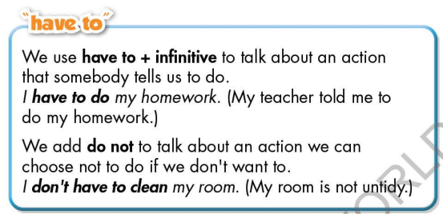  - Have Ss look at the box and read examples of different forms.  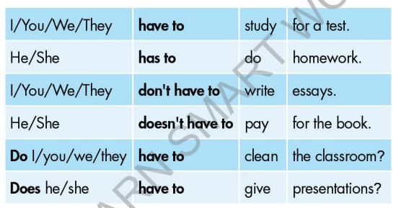  - Explain more about “have to”, “has to” to express obligation.  - Ask Ss to make more sentences using “have to”, “has to” to express obligation.  - Give feedback and evaluation.  Option 2:  - Have Ss look at the sentences in the speech bubbles in Task a and read them again.    - Have Ss make comments on the verb in bold.  - Give feedback.  - Have Ss look at the examples, read and answer the question: Does teacher often ask you to do these activities at school?  - Then, lead to the grammar box, briefly explain the way to use “have to” and “has to”.  - Have Ss read the grammar box again.  - Ask Ss to make more sentences using “have to”, “has to” to express obligation.  - Give feedback and evaluation. | - Look.  - Listen, then read.  - Listen and repeat.  - Look and read.  - Read examples of different forms.  - Listen.  - Give more examples.  - Look and read.  - Comment.  - Read.  - Give more examples.  - Listen.
Activity 2: Practice
a) Objective: Students can use “have to”, “has to” to do the given exercises.
b) Content:
- Write sentences with have to using the prompts.
- Fill in the blanks with have to, has to, don't have to, or doesn't have to.
c) Expected outcomes: Students can get used to the form and usage of use “have to”, “has to” and use them correctly.
d) Organization of the activity:
TEACHER’S ACTIVITIES | STUDENTS’ ACTIVITIES
Task b. Write sentences with “have to” using the prompts.  - Demonstrate the activity on DCR, using the example.  - Have Ss write sentences with “have to” using the prompts.  - Have Ss work in pairs to check each other’s work.  - Have some Ss share their answers with the whole class.  - Give feedback, correct Ss’ answers if necessary.  Task c. Fill in the blanks with have to, has to, don't have to, or doesn't have to.  - Demonstrate the activity on DCR using the example.  - Have students fill in the blanks with have to, has to, don't have to, or doesn't have to.  - Have pairs check each other's work.  - Have some students share their answers with the class. | - Look and listen.  - Work individually.  - Work in pairs.  - Write answers.  Answer keys  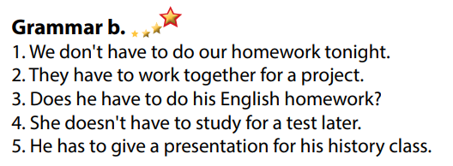  - Look and listen.  - Work individually.  - Work in pairs.  - Read answers, explain.  Answer keys  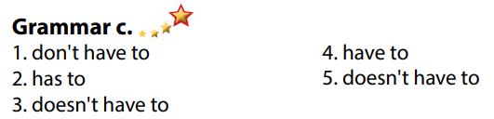
Activity 3: Production
a) Objective: Students master the grammar points they study in the lesson.
b) Content: Speaking: What things do/don't you have to do at home or at school?
c) Expected outcomes: Ss produce the new language successfully, and they can use the grammar point in the lesson in everyday speaking and writing.
d) Organization of the activity:
TEACHER’S ACTIVITIES | STUDENTS’ ACTIVITIES
Task d. In pairs: What things do/don't you have to do at home or at school?  - Divide class into pairs.  - Have Ss take turns asking their partner about what things do/don't they have to do at home or at school?  - Have some pairs demonstrate the activity in front of the class.  - Give feedback and evaluation. | - Have conversation in pairs.  - Present.  - Listen.  Suggested answers  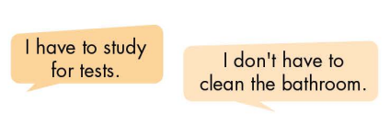
C. Consolidation and homework assignments
* Consolidation:
*Homework:
- Make 4 sentences using have to / has to / don’t have to / doesn’t have to.
- Do the exercises in WB: Grammar (page 33).
- Complete the grammar notes in Tiếng Anh 7 i-Learn Smart World Notebook (page 37).
- Play consolation games in Tiếng Anh 7 i-Learn Smart World DHA App on www.eduhome.com.vn
- Prepare: Lesson 1.3 – Pronunciation and Speaking (page 46 – SB).
****************************************************************
Teaching date: 31/01/2023
Period 57 UNIT 6: EDUCATION
Lesson 1.3 – Pronunciation and Speaking (page 46)
I. OBJECTIVES
By the end of the lesson, Ss will be able to:
1.1. Language knowledge and skills
- distinguish and use sound changes of “…have to…” correctly.
- give thanks and decline an invitation.
- make plans.
1.2. Competences
- improve listening and speaking skills.
1.3. Attributes
- be responsible for school work and housework.
- have a balance between studying and relaxing.
II. TEACHING AIDS AND LEARNING MATERIALS
1. Teacher’s aids: Student book and Teacher’s book, class CDs, Digital Book (DCR phần mềm tương tác SB, DHA (từ vựng/ cấu trúc) phần mềm trò chơi tương tác), projector/interactive whiteboard / TV (if any), PowerPoint slides, handouts.
2. Students’ aids: Student’s book, workbook, notebook.
III. ASSESSMENT EVIDENCE
Performance Tasks | Performance Products | Assessment Tools
- Listen to the sound changes of the underlined words. | - Ss’ performance and answers. | - T’s observation.
- Listen and cross out the sentence that doesn’t follow the note in “a”. | - Ss’ answers. | - T’s feedback/Peers’ feedback.
- Read the sentences with the sound changes noted in “a” with a partner. | - Ss’ performance. | - T’s feedback/Peers’ feedback.
- Ask and answer. | - Ss’ performance. | - T’s feedback/Peers’ feedback.
- Practice with your own ideas. | - Ss’ performance. | - T’s feedback/Peers’ feedback.
- Make plans with your classmate. In pairs: Student B, turn to page 119, File 4. Student A, write the activities you want to do and invite Student B to join you. Swap roles and repeat. Student A, turn to page 120, File 5 Did you draw your partner’s kitchen correctly? | - Ss’ performance /  Presentation. | - T’s observation, T’s feedback/Peers’ feedback.
- Decide a time to meet. | - Ss’ answers. | - T’s feedback/Peers’ feedback.
IV. PROCEDURES
A. Warm up:
a) Objective: Introduce the new lesson and set the scene for Ss to acquire new language; get students' attention at the beginning of the class by enjoyable and short activities as well as to engage them in the follow-up steps.
b) Content: Introduce: have to / Review vocabularies about school tasks.
c) Expected outcomes: Ss remember old knowledge and use them in other speaking activities.
d) Organization of the activity:
TEACHER’S ACTIVITIES | STUDENTS’ ACTIVITIES
Option 1:  - Have Ss close all books.  - Show 4 sentences with a blank inside each.  - Have Ss read these uncompleted sentences and think of a word / phrase that can be filled in all 4 sentences.  - Call Ss to give answers.  - Give feedback and show correct answer.  - Lead to the new lesson: The sound changes in “have to”.  *Suggested sentences:  1. I _____do my essay.  2. I _____give a presentation tomorrow.  3. I _____do my math homework tonight.  4. I _____write a book review next week.  Option 2: Review vocabularies about school tasks  - Have Ss close all books.  - Give Ss 6 sets of words. Each set contains 3 to 4 subordinating words.  - Have Ss use the words given to guess key words.  - Call Ss to give answers.  - Give feedback.  - Lead to the new lesson.  *Illustration:  1. mid-term, multiple choice, speaking  2. characters, author, plot  3. speech, confidence, body language  4. team work, deadline, meeting  5. literature, paragraph, thesis statement  6. math, extra exercises, after school | - Work in pairs, then give answers.  Answer keys  The missing word / phrase: have to  - Close books.  - Work in groups of 3-4 and guess key words.  Answer keys  1. mid-term, multiple choice, speaking: TEST  2. characters, author, plot: BOOK REVIEW  3. speech, confidence, body language: PRESENTATION  4. team work, deadline, meeting: PROJECT  5. literature, paragraph, thesis statement: ESSAY  6. math, extra exercises, after school: HOMEWORK
B. New lesson
Activity 1: Pre-Speaking: Pronunciation
a) Objective: Introduce sound changes of “have to”.
b) Content:
- recognize sound changes of “have to”.
- listen and check, find the sentence that doesn’t follow the note in “a”.
- practice.
c) Expected outcomes: Ss distinguish and use sound changes of “have to” correctly in their speaking.
d) Organization of the activity:
TEACHER’S ACTIVITIES | STUDENTS’ ACTIVITIES
Task a + b. Listen to the sound changes and focus on the underlined words.  - Play the recording (CD1, track 62).  - Ask Ss to listen and focus on the sound changes of the underlined words.  - Play the recording again, have Ss listen and repeat with a focus on the pronunciation feature.  Task c + d. Listen and cross out the sentence that doesn’t follow the note in “a”.  - Play the recording (CD 1 – Track 63), have Ss listen and cross out the option that doesn’t follow the note in “a”.  - Call Ss to give answers.  - Play the recording again and check answers as a whole class using DCR.  - Give feedback and evaluation. | - Listen.  - Listen again and repeat.  - Listen and give answers.  Answer keys  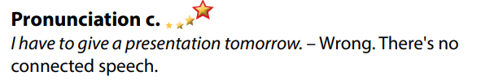
Activity 2: While-speaking
a) Objective: Students can give thanks and decline an invitation.
b) Content:
- Ask and answer, then practice with your own ideas.
- Make plans with your classmate. In pairs: Student B, turn to page 119, File 4. Student A, write the activities you want to do and invite Student B to join you. Swap roles and repeat. Student A, turn to page 120, File 5 Did you draw your partner’s kitchen correctly?
c) Expected outcomes: Ss produce the new language successfully.
d) Organization of the activity:
TEACHER’S ACTIVITIES | STUDENTS’ ACTIVITIES
PRACTICE  * Ask and answer  - Demonstrate the activity using the example.  - Divide the class into pairs.  - Have pairs ask and answer about plans.  - Observe, give help if necessary.  - Remind Ss to give thanks and decline an invitation politely.  - Have some pairs demonstrate the activity in front of the class.  - Give feedback and evaluation.  *Practice with your own ideas  - Have pairs continue practice asking and answering about making plans, using their own ideas.  - Call some pairs to share their ideas with the whole class.  - Give feedback and evaluation.  SPEAKING: Do You Want To Go Out?  Task a. Make plans with your classmate. In pairs: Student B, turn to page 119, File 4. Student A, write the activities you want to do and invite Student B to join you. Swap roles and repeat. Student A, turn to page 120, File 5 Did you draw your partner’s kitchen correctly?  - Demonstrate the activity by practicing the example with a student.  - Have Ss work in pairs: Student B, turn to page 119, File 4. Student A, write the activities he / she wants to do and invite Student B to join him / her.  - Have Ss swap the roles and repeat.  - Observe, give help if necessary. | - Observe, listen.  - Work in pairs.  - Present.  Suggested conversation  - Work in pairs.  - Present.  - Observe and listen.  - Work in pairs.  - Swap roles and repeat.
Activity 3: Production
a) Objective: Students report their results to the class.
b) Content: Decide a time to meet.
c) Expected outcomes: Ss produce the new language successfully in everyday speaking and writing.
d) Organization of the activity:
TEACHER’S ACTIVITIES | STUDENTS’ ACTIVITIES
SPEAKING: Do You Want To Go Out?  Task b. Decide a time to meet.  - Have pairs decide a time to meet.  - Have some pairs share their ideas with the class.  - Give feedback and evaluation. | - Give answers.  - Present.  - Listen.

C. Consolidation and homework assignments (5’)
* Consolidation: Sound changes of “have to”
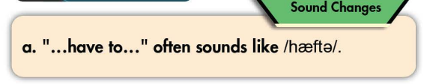
* Homework:
- Practice: sound changes of “have to”.
- Prepare: Unit 6 - Lesson 2 – New words and Reading (page 47 – SB).
- Review the vocabulary and grammar notes in Tiếng Anh 7 i-Learn Smart World Notebook
(pages 36 & 37).
- Play consolation games in Tiếng Anh 7 i-Learn Smart World DHA App on www.eduhome.com.vn
****************************************************************
Teaching date: 01/02/2023
Period 58 UNIT 6: EDUCATION
Lesson 2.1 – New words and Reading (page 47)
I. OBJECTIVES
By the end of the lesson, Ss will be able to:
1.1. Language knowledge and skills
- know some words about feelings (pleased, disappointed, surprised, delighted, annoyed, upset, frustrated).
- talk about how they feel at school.
- read a letter from James to his aunt about his studying to understand general and specific information.
1.2. Competences
- Improve communication, collaboration, analytical and critical thinking skills.
1.3. Attributes
- Overcome studying pressure and negative feelings.
- Have a balance between studying and relaxing.
II. TEACHING AIDS AND LEARNING MATERIALS
1. Teacher’s aids: Student book and Teacher’s book, class CDs, Digital Book (DCR phần mềm tương tác SB, DHA (từ vựng/ cấu trúc) phần mềm trò chơi tương tác), projector/interactive whiteboard / TV (if any), PowerPoint slides.
2. Students’ aids: Student’s book, workbook, notebook.
III. ASSESSMENT EVIDENCE
Performance Tasks | Performance Products | Assessment Tools
- Number the pictures. | - Ss’ answers. | - T’s feedback/Peers’ feedback.
- Listen and repeat. | - Ss’ answers/ presentation. | - T’s observation / feedback.
- When did you feel like the people in the pictures? | - Ss’ answers. | - T’s feedback/Peers’ feedback.
- Read the letter from James to his aunt. Is James doing well in school? | - Ss’ answers. | - T’s feedback/Peers’ feedback.
- Read and circle the correct answer. | - Ss’ answers. | - T’s feedback/Peers’ feedback.
- What subjects do you find the easiest? What do you find the most difficult? | - Ss’ answers/ presentation. | - T’s feedback/Peers’ feedback.
IV. PROCEDURES
A. Warm up:
a) Objective: Introduce the new lesson and set the scene for Ss to acquire new language; get students' attention at the beginning of the class by enjoyable and short activities as well as to engage them in the follow-up steps.
b) Content: Introduce some words about feelings (pleased, disappointed, surprised, delighted, annoyed, upset, frustrated).
c) Expected outcomes: Ss have general ideas about the topic of the new lesson: feelings at school.
d) Organization of the activity:
TEACHER’S ACTIVITIES | STUDENTS’ ACTIVITIES
Option 1:  - Use the “New words” part a – page 47 for the warm-up activity.  - Show pictures and words using DCR, have Ss number the pictures (in pairs).  - Call Ss to give answers.  - Give feedback and show correct answers using DCR.  - Lead to the new lesson.  - Play the audio (CD1 – Track 64), have Ss listen and repeat.  - Correct Ss’ pronunciation if necessary.  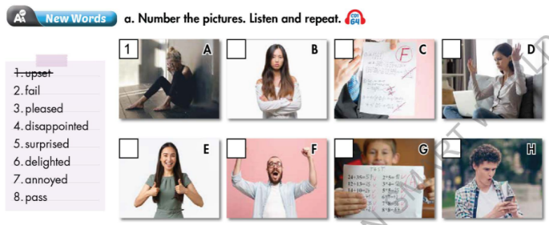  Option 2: Chatting  - Ask Ss some questions:  How do you feel when …  1. … you get bad marks  2 … you win a competition?  3. … you meet a new nice classmate?  4. … you fail the exam?  5. … you pass an exam with flying colors?  6. … you cheat in an exam?  7. … you have too much homework to do?  8 … your parents misunderstand you?  9. … a friend asks you to lend him / her some money?  - Call Ss to give answers.  - Give feedback.  - Introduce the new lesson: feeling about school and other school activities. | - Work in pairs to number the pictures.  - Give answers.  - Listen.  Answer keys  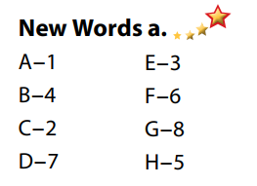  - Listen and give answers.
B. New lesson
Activity 1: Pre- Reading (Vocabulary)
a) Objective: Ss know some words about feelings about school.
b) Content:
- Vocabulary study: Number the pictures (pleased, disappointed, surprised, delighted, annoyed, upset, frustrated, fail, pass).
- Listen and repeat.
- Speaking: When did you feel like the people in the pictures?
c) Expected outcomes: Ss know how to pronounce the new words correctly and use them in appropriate situations.
d) Organization of the activity:
TEACHER’S ACTIVITIES | STUDENTS’ ACTIVITIES
Task a. Number the pictures. Listen and repeat.  Option 1 (If the teacher hasn’t used this part for the Warm-up activity.)  - Demonstrate the activity on DCR, using the example.  - Have Ss look at the pictures and phrases, then number the pictures.  - Divide class into pairs and have them check their answers with their partners.  - Call Ss to give answers (read or write).  - Check answers as a whole class using DCR.  - Play audio (CD1 – Track 64). Have Ss listen and repeat.  - Correct Ss’ pronunciation.  Option 2: (If the teacher has used part a. for the Warm-up activity.)  - Have Ss review the words they have known in the warm-up activity by labeling the pictures. (T uses different pictures from those in the textbook and add more icons.)  - Call Ss to give answers (read or write).  - Check answers as a whole class.  - Call some Ss to read the words again.  - Correct Ss’ pronunciation if necessary.  *Illustration:  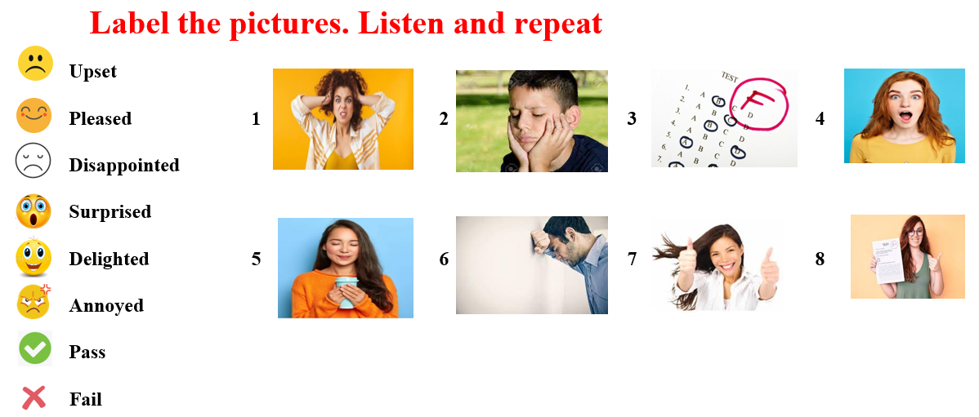  Task b. When did you feel like the people in the pictures?  - Have students tell when they felt like the people in the pictures.  - Have Ss share their stories in front of the class.  - Give feedback and evaluation. | - Look and listen.  - Work individually.  - Work in pairs.  - Give answers.  - Listen and repeat.  Answer keys  - Work in pairs.  - Give answers.  - Read.  Answer keys  - Work in pairs.  - Present.  Sample answers  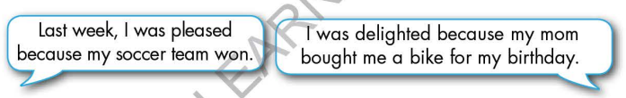
Activity 2: While - Reading
a) Objective: Students can develop their reading skill.
b) Content:
- Read the letter from James to his aunt. Is James doing well in school?
- Read and circle the correct answer.
c) Expected outcomes: Students can read a paragraph and understand more about the studying of a student.
d) Organization of the activity:
TEACHER’S ACTIVITIES | STUDENTS’ ACTIVITIES
Task a. Read the letter from James to his aunt. Is James doing well in school?  - Ask Ss to scan the paragraph, then choose the best answer.  - Remind Ss to underline or highlight the keywords or supporting ideas for their answers.  - Have some Ss share their answers with the class (read), explain for their answers.  - Give feedback.  - Give feedback and correct Ss’ answers if necessary.  Task b. Now, read the paragraph and circle the correct answer.  - Have Ss look at sentences and underline the key words.  - Have Ss work in pairs to circle the best answer.  - Elicit answers from different pairs.  - Give feedback and evaluation | - Work individually.  - Read answers, explain.  - Check answers.  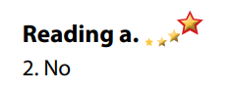  Answer keys  - Work in pairs to circle the best answer.  - Read answers.  Answer keys  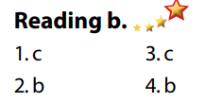
Activity 3: Post - Reading
a) Objective: Students can use the vocabulary and ideas from the reading text to develop their speaking skill.
b) Content: Speaking: What subjects do you find the easiest? What do you find the most difficult?
c) Expected outcomes: Students can talk about their easiest and most difficult subjects at school.
d) Organization of the activity:
TEACHER’S ACTIVITIES | STUDENTS’ ACTIVITIES
Task c. In pairs: What subjects do you find the easiest? What do you find the most difficult?  - Have Students work in pairs to answer the questions.  - Go round and give help if necessary.  - Call some Ss to share their ideas with the whole class.  - Give feedback and evaluation. | - Discuss in pairs.  - Present.  - Listen.
C. Consolidation and homework assignments
* Consolidation:
- Words about feelings (pleased, disappointed, surprised, delighted, annoyed, upset, frustrated) and verbs (pass, fail).
*Homework:
- Learn the new words by heart.
- Practice talking about favorite subject at school.
- Do the exercises in WB: New words + Reading (pages 34, 35).
- Complete the grammar notes in Tiếng Anh 7 i-Learn Smart World Notebook (page 38).
- Play consolation games in Tiếng Anh 7 i-Learn Smart World DHA App on www.eduhome.com.vn
- Prepare: Unit 6 - Lesson 2.2 – Grammar (page 48 – SB).
*****************************************************************
Teaching date: 03/02/2023
Period 59 UNIT 6: EDUCATION
Lesson 2.2 - Grammar (Page 48)
I. OBJECTIVES
By the end of the lesson, Ss will be able to:
1.1. Language knowledge and skills
- listen to and understand a short conversation between 2 people talking about feeling.
- use subordinating conjunction “because” and intensifiers “so”, “really” correctly.
1.2. Competences
- improve speaking, listening and writing skills.
- improve the use of English.
1.3. Attributes
- overcome studying pressure and negative feelings.
- have a balance between studying and relaxing.
II. TEACHING AIDS AND LEARNING MATERIALS
1. Teacher’s aids: Student book and Teacher’s book, class CDs, Digital Book (DCR phần mềm tương tác SB, DHA (từ vựng/ cấu trúc) phần mềm trò chơi tương tác), projector/interactive whiteboard / TV (if any), PowerPoint slides, handouts.
2. Students’ aids: Student’s book, workbook, notebook.
III. ASSESSMENT EVIDENCE
Performance Tasks | Performance Products | Assessment Tools
- Listen and repeat. | - Ss’ performance. | - T’s feedback.
- Study the grammar box. | - Ss’ task. | - T’s observation.
- Unscramble the sentences. | - Ss’ answers. | - T’s feedback/Peers’ feedback.
- Write sentences using the pictures and the prompts. | - Ss’ answers. | - T’s feedback/Peers’ feedback.
- Talk about how you feel at school and why. Use the adjectives in the box. | - Ss’ performance/ presentation. | - T’s observation, T’s feedback/Peers’ feedback.
IV. PROCEDURES
A. Warm up:
a) Objective: Introduce the new lesson and set the scene for Ss to acquire new language; get students' attention at the beginning of the class by enjoyable and short activities as well as to engage them in the follow-up steps.
b) Content: Review words about feelings / Introduce: because.
c) Expected outcomes: Ss review old knowledge and have general ideas about the grammar point they are going to study in the new lesson.
d) Organization of the activity:
TEACHER’S ACTIVITIES | STUDENTS’ ACTIVITIES
Option 1: Introduce “because”  - Have Ss do the matching exercise: Match the consequences with the causes.  - Call Ss to give answers.  - Check Ss’ answers, correct Ss’s answers if necessary  - Have Ss think of a word / phrase to connect clause of consequences with clause of causes.  - Lead to the new lesson: We use subordinating conjunction “because” to join consequences and causes clauses.  *Illustration:  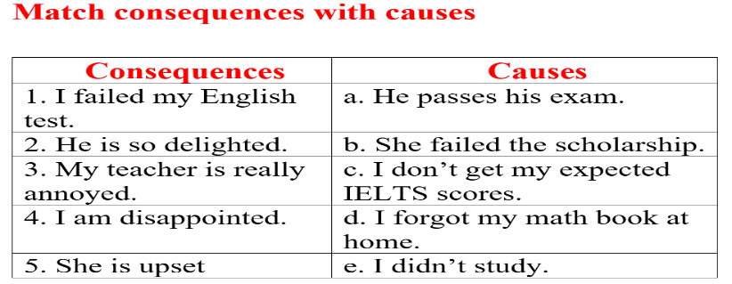  Option 2: Review vocabularies about feelings  - Give some adjectives about feelings Ss have learnt in the previous lesson, have some volunteers express that feeling by using body language in front of the class.  - Have the whole class guess the adjectives.  - Call Ss to give answers.  - Give feedback and evaluation.  - Lead to the new lesson.  *Suggested adjectives: annoyed, delighted, surprised, pleased, upset, disappointed | - Work in groups.  - Give answers.  - Listen.  Answers keys  1e 2a 3d 4c 5b  - Do the task.  - Give answers.
B. New lesson
Activity 1: Presentation
a) Objective: Introduce “because”, “so” and “really”.
b) Content:
- Listen and repeat.
- Introduce the grammar point: “because”, “so” and “really”.
c) Expected outcomes: Ss know how to use “because”, “so” and “really” to do some following exercises.
d) Organization of the activity:
TEACHER’S ACTIVITIES | STUDENTS’ ACTIVITIES
Task a. Listen and repeat  - Have Ss look at the picture using DCR.  - Play audio (CD1 – Track 65) and have Ss listen and read the speech bubbles.  - Play the audio again and have Ss listen and repeat.  Grammar box  - Have Ss look at the grammar explanation and read: Because  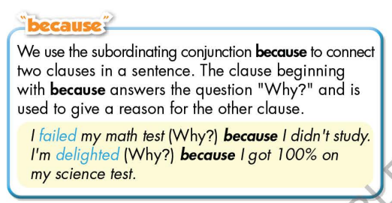  - Have Ss look the grammar explanation and read: Intensifiers  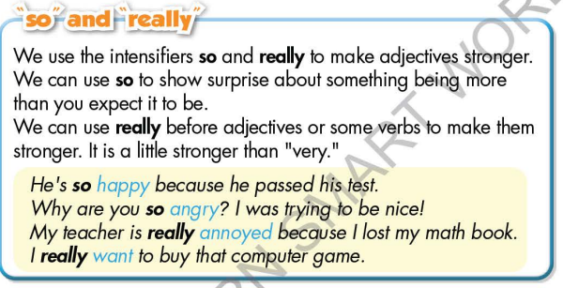  - Briefly explain the grammar point.  - Ask Ss to make sentences with “because”, “so” and “really”. | - Look.  - Listen, then read.  - Listen and repeat.  - Look and read.  - Look and read.  - Listen and take notes.  - Make sentences, using “because”, “so” and “really”.
Activity 2: Practice
a) Objective: Students can use “because”, “so” and “really” correctly.
b) Content:
- Unscramble the sentences.
- Write sentences using the pictures and the prompts.
c) Expected outcomes: Students can use “because”, “so” and “really” in their speaking.
d) Organization of the activity:
TEACHER’S ACTIVITIES | STUDENTS’ ACTIVITIES
Task b. Unscramble the sentences  - Demonstrate the activity on DCR, using the example.  - Have Ss unscramble the sentences.  - Have Ss work in pairs to check each other’s work.  - Have some Ss share their answers with the whole class.  - Give feedback, correct Ss’ answers if necessary.  Task c. Write sentences using the pictures and the prompts  - Demonstrate the activity on DCR, using the example.  - Have students write sentences using the pictures and the prompts.  - Have Ss check answers with their partners.  - Call Ss to read or write answers.  - Check Ss’ answers, give feedback. | - Look and listen.  - Work individually.  - Work in pairs.  - Write answers on the board.  Answer keys  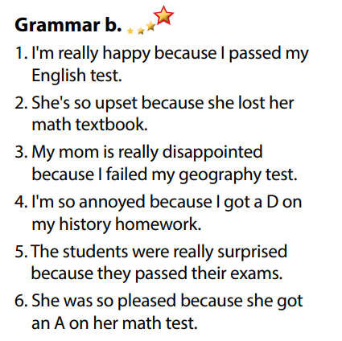  - Look and listen.  - Work individually.  - Work in pairs.  - Read or write answers.  Answer keys  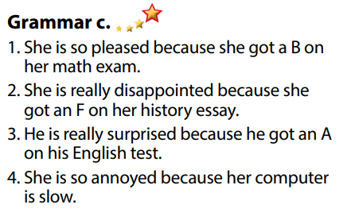
Activity 3: Production
a) Objective: Students master the grammar point they study in the lesson.
b) Content: Speaking: Talk about how you feel at school and why. Use the adjectives in the box.
c) Expected outcomes: Ss produce the new language successfully, and they can apply the grammar point they have learnt in speaking and writing.
d) Organization of the activity:
TEACHER’S ACTIVITIES | STUDENTS’ ACTIVITIES
Task d. Talk about how you feel at school and why. Use the adjectives in the box.  - Divide class into pairs.  - Have Ss ask and answer, explain.  - Have some pairs demonstrate the activity in front of the class.  - Give feedback and evaluation. | - Work in pairs.  - Have conversation in pairs.  - Present.  - Listen.  Suggested idea  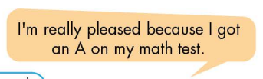
C. Consolidation and homework assignments
*Consolidation
- Because
Intensifiers
Homework:
- Make 3 sentences, use “because”, “so” and “really”.
- Do the exercises in WB: Grammar (page 35).
- Complete the grammar notes in Tiếng Anh 7 i-Learn Smart World Notebook (page 39).
- Play consolation games in Tiếng Anh 7 i-Learn Smart World DHA App on www.eduhome.com.vn
- Prepare: Lesson 2.3 – Pronunciation and Speaking (page 49 – SB).
***************************************************************
Teaching date: 07/02/2023
Period 60 UNIT 6: EDUCATION
Lesson 2.3 – Pronunciation and Speaking (page 49)
I. OBJECTIVES
By the end of the lesson, Ss will be able to:
1.1. Language knowledge and skills
- distinguish and put stress on intensifiers for emphasis correctly.
- talk about feelings.
- act out the situations for partners to guess how they feel and give reason.
1.2. Competences
- improve listening and speaking skills.
1.3. Attributes
- overcome studying pressure and negative feelings.
- have a balance between studying and relaxing.
II. TEACHING AIDS AND LEARNING MATERIALS
1. Teacher’s aids: Student book and Teacher’s book, class CDs, Digital Book (DCR phần mềm tương tác SB, DHA (từ vựng/ cấu trúc) phần mềm trò chơi tương tác), projector/interactive whiteboard / TV (if any), PowerPoint slides, handouts.
2. Students’ aids: Student’s book, workbook, notebook, pens, pencils, crayons.
III. ASSESSMENT EVIDENCE
Performance Tasks | Performance Products | Assessment Tools
- Listen to the sentences and focus on the underlined word. | - Ss’ performance and answers. | - T’s observation.
- Listen and cross out the sentence that doesn’t follow the note in “a”. | - Ss’ answers. | - T’s feedback/Peers’ feedback.
- Read the sentences with the sentence stress noted in “a” to a partner. | - Ss’ performance. | - T’s feedback/Peers’ feedback.
- Practice the conversation. Swap roles and repeat. | - Ss’ performance. | - T’s feedback/Peers’ feedback.
- Practice with your own ideas. | - Ss’ performance. | - T’s feedback/Peers’ feedback.
- You're at school and want to know why your friend feels good or bad. In pairs: Take turns acting out the situations in the pictures while your partner guesses how you feel and why | - Ss’ performance /  Presentation. | - T’s observation, T’s feedback/Peers’ feedback.
- Join another pair and a play again using your own ideas. | - Ss’ performance /  Presentation. | - T’s observation, T’s feedback/Peers’ feedback.
IV. PROCEDURES
A. Warm up:
a) Objective: Introduce the new lesson and set the scene for Ss to acquire new language; get students' attention at the beginning of the class by enjoyable and short activities as well as to engage them in the follow-up steps.
b) Content: Review: Intensifiers / Review words about feelings in studying.
c) Expected outcomes: Ss remember old knowledge and use them in other speaking activities.
d) Organization of the activity:
TEACHER’S ACTIVITIES | STUDENTS’ ACTIVITIES
Option 1: Error recognition  - Give some sentences, have Ss read the sentences and circle a word / phrase in each sentence that needs correcting.  - Have Ss try to make the sentences right.  - Call Ss to read answers or write answers on the board.  - Give feedback.  - Lead to the new lesson:  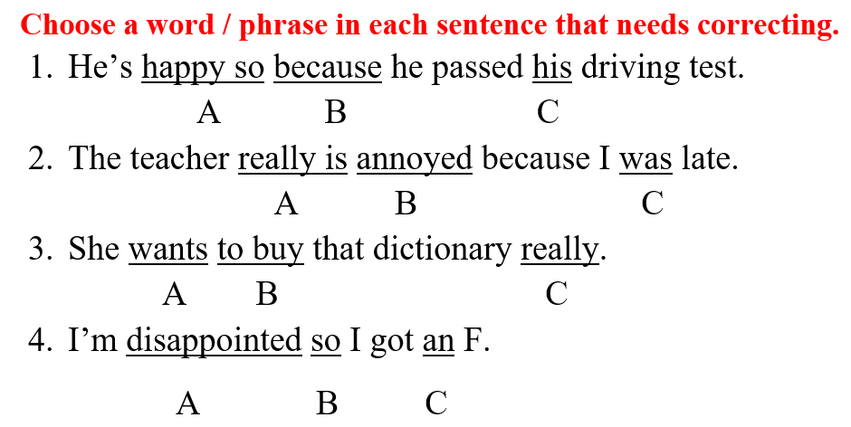  Option 2: Review words about feelings in studying.  - Have Ss close all books.  - Show 6 pictures, have Ss look at the pictures and use an adjective to describe the feeling of the person in each picture.  - Call Ss to give answers.  - Give feedback.  - Lead to the new lesson.  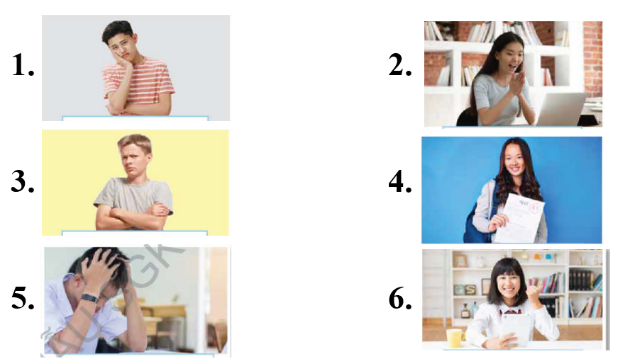 | - Work in pairs, then give answers.  Answer keys  1A: so happy  2A: is really  3C: She really wants to buy that dictionary.  4B: because  - Close books.  - Observe and give answers.  Answer keys  1 upset  2 surprised  3 annoyed  4 pleased  5 disappointed  6 delighted  The answers may vary.
B. New lesson
Activity 1: Pre-Speaking: Pronunciation
a) Objective: Introduce stress on intensifiers for emphasis.
b) Content:
- recognize: stress on intensifiers for emphasis.
- listen and check, cross out the sentence that doesn’t follow the note in “a”.
- practice.
c) Expected outcomes: Ss distinguish and put stress on intensifiers for emphasis correctly in their speaking.
d) Organization of the activity:
TEACHER’S ACTIVITIES | STUDENTS’ ACTIVITIES
Task a + b. Listen to the sentence and focus on the underlined words.  - Play the recording (CD1, track 66).  - Ask Ss to listen and focus on the stress of the underlined words.  - Play the recording again, have Ss listen and repeat with a focus on the stress feature.  Task c + d. Listen and cross out the sentence that doesn’t follow the note in “a”.  - Play the recording (CD 1 – Track 67), have Ss listen and cross out the option that doesn’t follow the note in “a”.  - Call Ss to give answers.  - Play the recording again and check answers as a whole class using DCR.  - Give feedback and evaluation. | - Listen.  - Listen again and repeat.  - Listen and give answers.  Answer keys  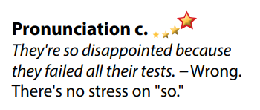
Activity 2: While-speaking
a) Objective: Students can talk about feeling and express their feelings in studying.
b) Content:
- Practice the conversation. Swap roles and repeat.
- You're at school and want to know why your friend feels good or bad. In pairs: Take turns acting out the situations in the pictures while your partner guesses how you feel and why.
c) Expected outcomes: Ss produce the new language successfully.
d) Organization of the activity:
TEACHER’S ACTIVITIES | STUDENTS’ ACTIVITIES
PRACTICE  * Task a. Practice the conversation. Swap roles and repeat.  - Demonstrate the activity by practicing the role-play with a student.  - Divide the class into pairs.  - Have pairs practice the conversation.  - Swap roles and repeat using the ideas on the right.  - Have some pairs demonstrate the activity in front of the class.  - Give feedback and evaluation.  * Task b. Practice with your own ideas.  - Have students practice the conversation with their own ideas. Swap roles.  - Have some pairs demonstrate the activity in front of the class.  - Give feedback and evaluation.  SPEAKING: What’s Up?  Task a. You're at school and want to know why your friend feels good or bad. In pairs: Take turns acting out the situations in the pictures while your partner guesses how you feel and why.  - Demonstrate the activity by practicing the activity with a student.  - Divide the class into pairs.  - Have Ss take turns choosing one of the pictures and acting out the situation.  - Have the other student try to guess how they feel and why.  - Observe, give help if necessary. | - Observe, listen.  - Work in pairs.  - Swap the roles and repeat.  - Present.  - Work in pairs.  - Present.  - Observe and listen.  - Work in pairs.  - Do the task.  - Guess.
Activity 3: Production
a) Objective: Students can have a free talk about their feelings in studying.
b) Content: Join another pair and play again using your own ideas.
c) Expected outcomes: Ss produce the new language successfully in everyday speaking and writing.
d) Organization of the activity:
TEACHER’S ACTIVITIES | STUDENTS’ ACTIVITIES
SPEAKING: What’s Up?  Task b. Join another pair and play again using your own ideas.  - Have pairs join another pair and continue to act out.  - Have some pairs act out the situation in front of the class.  - Give feedback and evaluation. | - Join another pair and continue acting out the situation.  - Present.
C. Consolidation and homework assignments
* Consolidation: Stress on intensifiers for emphasis.
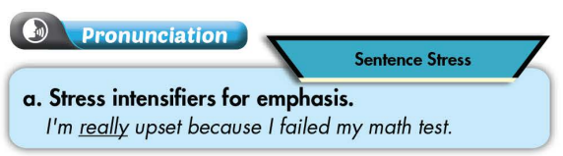

* Homework:
- Practice: putting tress on intensifiers for emphasis.
- Review words about feelings.
- Prepare: Unit 6 - Lesson 3 –Listening and Reading (page 50 – SB).
- Review the vocabulary and grammar notes in Tiếng Anh 7 i-Learn Smart World Notebook
(pages 38 & 39).
- Play consolation games in Tiếng Anh 7 i-Learn Smart World DHA App on www.eduhome.com.vn
********************************************************************************
Teaching date: 08/02/2023
Period 61 UNIT 6: EDUCATION
Lesson 3.1 - Listening and Reading (page 50)
I. OBJECTIVES
By the end of the lesson, Ss will be able to:
1.1. Language knowledge and skills
- talk about studying abroad.
- practice listening and understanding a recording about studying abroad (for general and specific information).
- read and understand an article about experiences during the time studying abroad (for gist and details).
1.2. Competences
- improve communication, collaboration, analytical and critical thinking skills.
1.3. Attributes
- overcome studying pressure and negative feelings.
- be independent and know how to take care of themselves when studying away from home.
II. TEACHING AIDS AND LEARNING MATERIALS
1. Teacher’s aids: Student book and Teacher’s book, class CDs, Digital Book (DCR phần mềm tương tác SB, DHA (từ vựng/ cấu trúc) phần mềm trò chơi tương tác), projector/interactive whiteboard / TV (if any), PowerPoint slides.
2. Students’ aids: Student’s book, workbook, notebook.
III. ASSESSMENT EVIDENCE
Performance Tasks | Performance Products | Assessment Tools
- Let’s Talk: Do you know the building in the picture? What do you think is good or bad about studying abroad? | - Ss’ answers / presentation. | - T’s feedback/Peers’ feedback.
- Listening: Listen to a teacher giving a presentation about studying abroad. What grade do you think her class is? | - Ss’ answers. | - T’s feedback/Peers’ feedback.
- Listen and answer the questions. | - Ss’ answers. | - T’s feedback/Peers’ feedback.
- Reading: Read the article. Did Anna have more good or bad experiences during her time in Spain? | - Ss’ answers. | - T’s feedback/Peers’ feedback.
- Now, read and write True or False. | - Ss’ answers. | - T’s feedback/Peers’ feedback.
-Speaking: Would you like to study abroad? What problems do you think you would have? | - Ss’ answers / presentation. | - T’s observation/ DCR and T’s feedback.
IV. PROCEDURES
A. Warm up:
a) Objective: Introduce the new lesson and set the scene for Ss to acquire new language; get students' attention at the beginning of the class by giving enjoyable and short activities as well as to engage them in the follow-up steps.
b) Content: Introduce the topic: Studying abroad (its advantages and drawbacks, countries to apply for).
c) Expected outcomes: Ss have general ideas about the topic “studying abroad”, which they are going to listen and read in the new lesson.
d) Organization of the activity:
TEACHER’S ACTIVITIES | STUDENTS’ ACTIVITIES
Option 1: Let’s Talk!  Do you know the building in the picture? What do you think is good or bad about studying abroad?  - Use the “Let’s talk!” part in the textbook– page 50 for warm-up activity.  - Ask Ss to work in pairs to answer the question: Do you know the building in the picture? What do you think is good or bad about studying abroad?  - Call Ss to share their answers with the whole class.  - Give feedback and evaluation.  - Lead to the new lesson.  Option 2:  - Divide class into 4 groups.  - Have Ss work in groups to list top 5 countries Vietnamese students often choose to study abroad (in order).  - Call Ss to give answers.  - Compare Ss’ answers, then ask Ss some more questions:  1. Do you want to study abroad in the future?  2. Which country would you like to study in?  3. Which subject / major do you want to study for higher education?  4. What do you need to prepare for studying abroad?  - Give feedback and lead to the new lesson. | - Work in pairs to discuss.  - Present.  - Work in groups, list top 5 countries Vietnamese students often choose to study abroad.  - Give answers.  - Listen and answer.  Suggested answers  - Top 5 countries Vietnamese students often choose to study abroad: Australia, the USA, Canada, England, South Korea (Source: https://cuocsong.giaoducthoidai.vn/top-10-quoc-gia-duoc-du-hoc-sinh-viet-nam-lua-chon-nhieu-nhat-n566.html)  - Top 5 ideal countries for Vietnamese students to study abroad: Finland, Australia, The USA, England, Canada. ( Source: https://toplist.vn/top-list/quoc-gia-ly-tuong-cho-du-hoc-sinh-viet-nam-9170.htm)
B. New lesson
Activity 1: Listening
a) Objective: Students can develop their listening skill.
b) Content:
- Listen to a teacher giving a presentation about studying abroad. What grade do you think her class is?
- Listen and answer the questions.
c) Expected outcomes: Students can practice listening and understanding general + specific information about studying abroad.
d) Organization of the activity:
TEACHER’S ACTIVITIES | STUDENTS’ ACTIVITIES
Task a. Listen to a teacher giving a presentation about studying abroad. What grade do you think her class is?  - Have Ss read the question.  - Play audio (CD1 - Track 68).  - Have Ss listen and circle the correct answer.  - Call Ss to give answer, explain.  - Play the audio again and check the answer as a whole class using DCR.  Task b. Listen and answer the questions.  - Have Ss read through the questions in Task b first, underline the key words.  - Play the audio again (CD1 - Track 68).  - Have Ss listen and answer the questions.  - Remind Ss to give short answers (main ideas to answer the questions, it’s not necessary to write in full sentences).  - Have Ss check answers with their partners.  - Call Ss to give answers, explain.  - Check the answer as a whole class using DCR. | - Listen and take notes.  - Read.  - Listen and circle the correct answer.  - Give answer, explain.  Answer keys  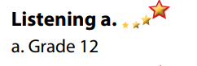  - Read, find and underline the key words.  - Listen and answer the questions.  - Exchange answers.  - Give answers.  Answer keys  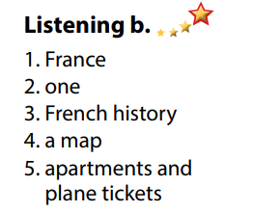
Activity 3: Reading
a) Objective: Students can develop their reading skill.
b) Content:
- Read the article. Did Anna have more good or bad experiences during her time in Spain?
- Now, read and write True or False.
- Would you like to study abroad? What problems do you think you would have?
c) Expected outcomes: Students can read an article about studying abroad for gist and detail, and they can talk about problems they may encounter when studying abroad.
d) Organization of the activity:
TEACHER’S ACTIVITIES | STUDENTS’ ACTIVITIES
Task a. Read the article. Did Anna have more good or bad experiences during her time in Spain?  - Have Ss read the question in Task a.  - Ask Ss to scan the article to choose the correct answer.  - Have Ss underline the supporting ideas.  - Call a student to give answer.  - Check answer as a whole class using DCR.  Task b. Now, read and write True or False.  - Have Ss read the content in Task b and underline the key words.  - Have Ss read the article again and write True or False.  - Have Ss check their answers with a partner.  - Call Ss to give answers.  - Check answer as a whole class using DCR.  Task c. Speaking: In pairs: Would you like to study abroad? What problems do you think you would have?  - Have Ss discuss the questions in pairs.  - Call some Ss to share their answers with the whole class.  - Give feedback and evaluation. | - Scan the article to choose the correct answer.  - Underline the supporting ideas.  - Give answer.  Answer keys    - Read and underline the key words.  - Read the article again for details.  - Exchange answers.  - Give answers.  Answer keys  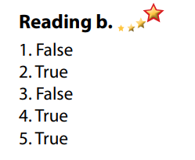  - Discuss in pairs.  - Present.
C. Consolidation and homework assignments
*Consolidation:
- Possible problems when studying abroad:
1. Language barriers
2. Currency differences
3. Day-to-day finances
4. Culture differences (cultural shock)
5. Homesickness
6. Solitude
*Homework
- Do the exercises in WB: Listening and Reading (page 36).
- Do the vocabulary exercise in Tiếng Anh 7 i-Learn Smart World Notebook (page 40).
- Play consolation games in Tiếng Anh 7 i-Learn Smart World DHA App on www.eduhome.com.vn
- Prepare: Lesson 3 – Writing and Speaking (page 51 – SB).
***************************************************************
Teaching date: 10/02/2023
Period 62 UNIT 6: EDUCATION
Lesson 3.2 Writing (page 51)
I. OBJECTIVES
By the end of the lesson, Ss will be able to:
1.1. Language knowledge and skills
- use conjunctions “however”, “although” to show contrast.
- talk about positive and negative experiences of studying abroad.
- write a paragraph about studying abroad.
1.2. Competences
- improve communication, collaboration, writing and critical thinking skills.
1.3. Attributes
- overcome studying pressure and negative feelings.
- be independent and know how to take care of themselves when studying away from home.
II. TEACHING AIDS AND LEARNING MATERIALS
1. Teacher’s aids: Student book and Teacher’s book, class CDs, Digital Book (DCR phần mềm tương tác SB, DHA (từ vựng/ cấu trúc) phần mềm trò chơi tương tác), projector/interactive whiteboard / TV (if any), PowerPoint slides, handouts.
2. Students’ aids: Student’s book, workbook, notebook.
III. ASSESSMENT EVIDENCE
Performance Tasks | Performance Products | Assessment Tools
- Speaking: You just finished a year studying abroad. In pairs: Ask and answer the questions below. | - Ss’ answers / presentation. | - T’s feedback/Peers’ feedback.
- Talk about two positive and two negative experiences when you studied abroad. Then, fill in the table. | - Ss’ answers / presentation. | - T’s feedback/Peers’ feedback.
- Writing: Read about using conjunctions. Then, read Anna's paragraph again and underline the ideas linked with conjunctions. | - Ss’ answers. | - T’s feedback/Peers’ feedback.
- Read and circle Yes or No. | - Ss’ answers. | - T’s feedback/Peers’ feedback.
- Underline and correct the mistakes. Then, rewrite the correct sentences with however and although in your notebook. | - Ss’ answers. | - T’s feedback/Peers’ feedback.
- Now, write a paragraph about studying abroad. Use the Feedback form to help you. Write 60 to 80 words. | - Ss’ answers. | - T’s observation and feedback.
IV. PROCEDURES
A. Warm up:
a) Objective: Introduce the new lesson and set the scene for Ss to acquire new language; get students' attention at the beginning of the class by enjoyable and short activities as well as to engage them in the follow-up steps.
b) Content: Introduce “however” and “Although” / adjectives of feelings.
c) Expected outcomes: Ss know about the topic that they are going to talk and write about in new the lesson.
d) Organization of the activity:
TEACHER’S ACTIVITIES | STUDENTS’ ACTIVITIES
Option 1: Introduce “however” and “although”  - Give 3 sets of letters.  - Have Ss use the letters given in each set to make a meaningful English word.  - Have Ss give answers. The first student to give a right answer will be given a small present.  - Give feedback and evaluation.  - Lead to the new lesson: However and although to show contrast.  Set 1    Set 2    Set 3    Option 2: Adjectives of feelings / activity  - Have Ss close books.  - Give Ss some adjectives of feelings / activities.  - Have Ss put them into 2 categories: negative and positive (in 2 minutes).  - Have Ss give answers.  - Check Ss’ answers, give feedback and evaluation  - Lead to the new lesson.  *Suggested adjectives: bored, annoyed, delighted, happy, lonely, independent, lazy, sociable, active, fantastic, tired, pleased, homesick… | - Do the task.  - Give answers.  - Listen.  Answer keys  1. HOWEVER  2. ALTHOUGH  3. CONTRAST  - Close all books and notebooks.  - Do the task in pairs.  - Read answers.  - Listen.  Answer keys  - Adjectives of positive feelings / activities: delighted, happy, independent, sociable, active, fantastic, pleased  - Adjectives of negative feelings / activities: bored, annoyed, lonely, lazy, tired, homesick
B. New lesson
Activity 1: Pre-Writing
a) Objective: Ss prepare for what they are going to write about.
b) Content:
- Speaking: You just finished a year studying abroad. In pairs: Ask and answer the questions below.
- Talk about two positive and two negative experiences when you studied abroad. Then, fill in the table.
c) Expected outcomes: Ss have more ideas and language for their writing.
d) Organization of the activity:
TEACHER’S ACTIVITIES | STUDENTS’ ACTIVITIES
Task a. In pairs: You just finished a year studying abroad. In pairs: Ask and answer the questions below.  - Divide the class into pairs.  - Have students discuss in pairs using the questions.  - Go round and support Ss if necessary.  - Have some students share their ideas with the class.  - Give feedback and evaluation.  Task b. Talk about two positive and two negative experiences when you studied abroad. Then, fill in the table.  - Have students continue to work in pairs to talk about two positive and two negative experiences when they studied abroad. Then, fill in the table.  - Go round and give help if necessary.  - Have Ss exchange their answers with another pair.  - Have some pairs read their answers.  - Give feedback and evaluation. | - Work in pairs.  - Present.  - Discuss and fill in the table.  - Exchange.  - Present.
Activity 2: While - Writing
a) Objective: Students can develop their writing skill.
b) Content: - Read about using conjunctions. Then, read Anna's paragraph again and underline the ideas linked with conjunctions.
- Read and circle Yes or No.
- Underline and correct the mistakes. Then, rewrite the correct sentences with however and although in your notebook.
- Now, write a paragraph about studying abroad. Use the Feedback form to help you. Write 60 to 80 words.
c) Expected outcomes: Students can write a paragraph about good and bad sides of studying abroad, using right format and rich vocabulary.
d) Organization of the activity:
TEACHER’S ACTIVITIES | STUDENTS’ ACTIVITIES
Task a. Read about using conjunctions. Then, read Anna's paragraph again and underline the ideas linked with conjunctions.  -Briefly explain the Writing skill box and have some Ss read it aloud.  - Have Ss read Anna’s paragraph again (page 50) and underline the ideas linked with conjunctions.  - Have Ss check their answers with a partner.  - Call Ss to give answers.  - Check answers as a whole class using DCR.  Task b. Read and circle Yes or No.  - Have students read the prompts.  - Have students read the questions and circle Yes or No.  - Have students check their answers with a partner.  - Check answer as a whole class using DCR.  Task c. Underline and correct the mistakes. Then, rewrite the correct sentences with however and although in your notebook.  - Have students read the sentences.  - Have students underline and correct the mistakes.  - Have students check their answers with a partner.  - Call Ss to read their answers and explain.  - Check answers as a whole class using DCR.  - Then, have Ss rewrite the correct sentences with “however” and “although” in their notebook.  *Let’s Write: Write a paragraph about studying abroad. Use the Feedback form to help you. Write 60 to 80 words.  - Draw Ss’ attention to the feedback form.  - Have Ss use their notes in speaking part and the instruction in the Writing box to write a paragraph about studying abroad.  - Go round, observe and give help if necessary.  - Have some Ss write their paragraph on the board. | - Listen and read.  -Work in pairs.  - Exchange their answers with a partner.  - Give answers.  Answer keys  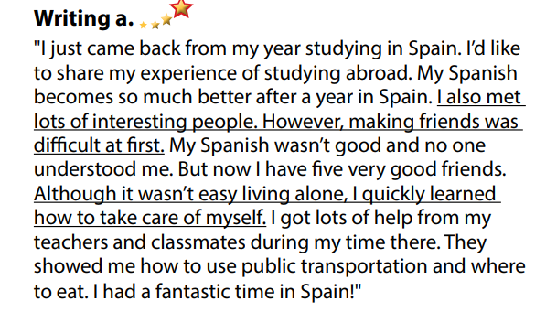  - Read the prompts and circle Yes or No.  - Exchange answers.  - Read answers.  Answer keys  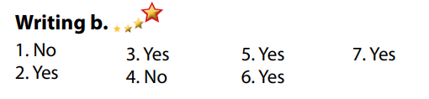  - Read, underline and correct the mistakes.  - Give answers.  - Rewrite the correct sentences with “however” and “although” in the notebook.  Answer keys  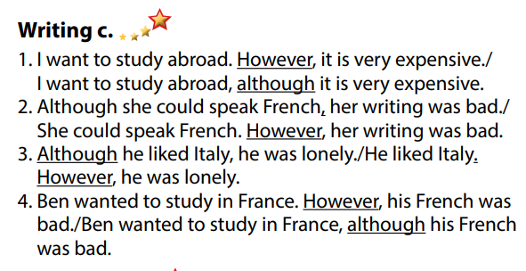  - Do the writing part.  -Write.
Activity 3: Post - Writing
a) Objective: Help Ss realize their mistakes in writing and correct them.
b) Content: Correcting Ss’ writings.
c) Expected outcomes: Students know whether their writings follow the model and use the correct structures and language, whether their writings are interesting and understandable or not.
d) Organization of the activity:
TEACHER’S ACTIVITIES | STUDENTS’ ACTIVITIES
- Give feedback, correct Ss’ mistakes.  - Use the feedback form to give evaluation. Focus on:  + the format, the structures, the punctuation  + the understandability  + the coherence and cohesion  + the spelling | - Look, listen and correct mistakes.  Suggested writing  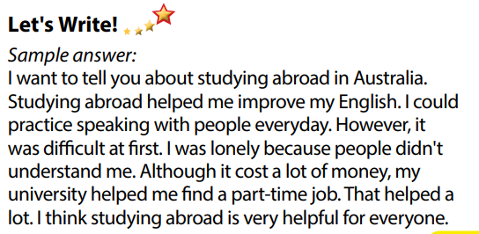
C. Consolidation and homework assignments
* Consolidation:
- Writing Skill:
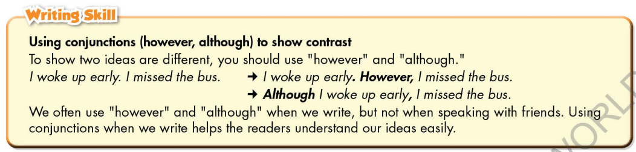
Homework
- Remember how to write a paragraph about benefits and drawbacks of studying abroad.
- Finish the writing part.
- Do the exercises in WB: Writing part, page 37.
- Complete grammar notes in Tiếng Anh 7 i-Learn Smart World Notebook (pages 41).
- Play consolation games in Tiếng Anh 7 i-Learn Smart World DHA App on www.eduhome.com.vn
- Prepare: Unit 6 – Review, pages 100, 101.
****************************************************************
Teaching date: 13/02/2023
Period 63 UNIT 6: EDUCATION
Lesson 4 – Review (pages 100, 101)
I. OBJECTIVES
By the end of the lesson, Ss will be able to:
1.1. Language knowledge and skills
- review words about feelings and school tasks (disappointed, excited, delighted, annoyed, surprised, test, presentation, book report, project, homework, fail, pass, …) and talk about them.
- review grammar: “however” and “although” to show contrast, “because” to show causes /reasons, and intensifiers “so”, “really”.
- review: talk about school life.
- pronoun the ending sounds correctly: “ed” endings.
- put stress on nouns and adjectives with two and three syllables.
1.2. Competences
- improve speaking, listening, reading and writing skills.
- improve the use of English.
1.3. Attributes
- have positive attitude in English language learning so that they actively participate in all classroom activities.
- review the old lesson and have good preparation for any test.
II. TEACHING AIDS AND LEARNING MATERIALS
1. Teacher’s aids: Student book and Teacher’s book, class CDs, Digital Book (DCR phần mềm tương tác SB, DHA (từ vựng/ cấu trúc) phần mềm trò chơi tương tác), projector/interactive whiteboard / TV (if any), PowerPoint slides, handouts.
2. Students’ aids: Student’s book, workbook, notebook.
III. ASSESSMENT EVIDENCE
Performance Tasks | Performance Products | Assessment Tools
- Listening: You will hear five short conversations. You will hear each conversation twice. There is one question for each conversation. For each question, choose the correct answer (A, B or C). | - Ss’ answers. | - T’s feedback/Peers’ feedback.
- Reading: Read the article about Anna's school year. Choose the correct answer (A, B, or C). | - Ss’ answers. | - T’s feedback/Peers’ feedback.
- Vocabulary: Circle the correct words. | - Ss’ answers. | - T’s feedback/Peers’ feedback.
- Grammar: Underline the mistakes and write the correct answers on the lines. | - Ss’ answers. | - T’s feedback/Peers’ feedback.
- Pronunciation: Circle the word that has the underlined part pronounced differently from the others.  + Circle the word that differs from the other three in the position of primary stress in each of the following questions. | - Ss’ answers/ presentation. | - T’s observation, T’s feedback/Peers’ feedback.
IV. PROCEDURES
A. Warm up:
a) Objective: Introduce the new lesson and set the scene for Ss to acquire new language; get students' attention at the beginning of the class by enjoyable and short activities as well as to engage them in the follow-up steps.
b) Content: Review vocabulary about school subjects / names of some countries Vietnamese students often apply for higher education.
c) Expected outcomes: Ss are ready for the new lesson.
d) Organization of the activity:
TEACHER’S ACTIVITIES | STUDENTS’ ACTIVITIES
Option 1: Review: School subjects  - Have Ss look at the pictures and give names of school subjects.  - Call Ss to give answers, then pronounce the words and give meaning.  - Correct Ss’ pronunciation if necessary.  - Lead to the new lesson.  *Illustration:  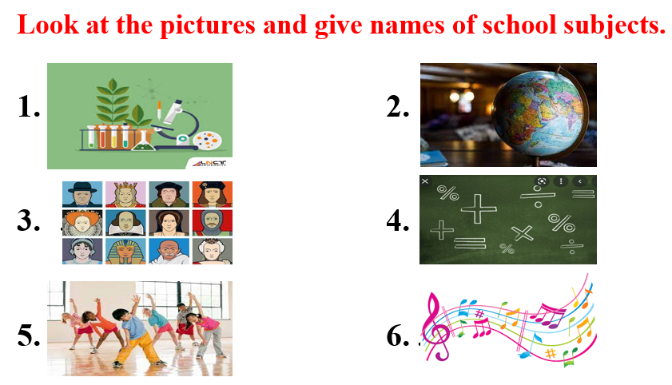  Option 2: Review: Ideal countries for studying abroad.  - Have Ss look at the flags and give names of some countries that Vietnamese students often choose for their studying.  - Call Ss to give answers, then pronounce the words and give meaning.  - Correct Ss’ pronunciation if necessary.  - Lead to the new lesson.  *Illustration:  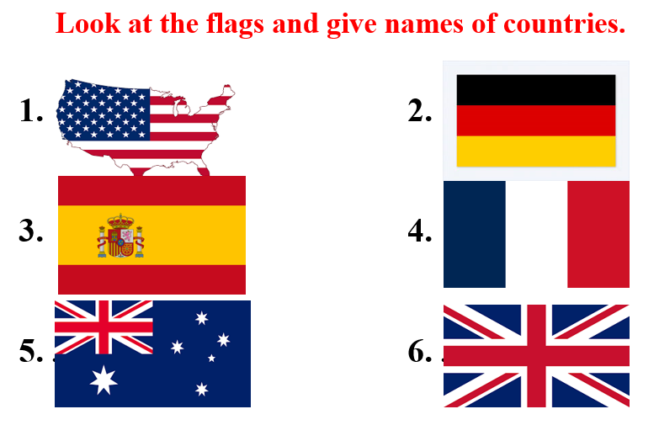 | - Look at the pictures and give names of school subjects.  - Give answers, pronounce the words.  - Listen.  Answer keys  1. Biology  2. Geography  3. History  4. Math  5. Physical Education  6. Music  - Look at the pictures and give names of the countries.  - Give answers, pronounce the words.  - Listen  Answer keys  1. The USA  2. Spain  3. Australia  4. Germany  5. France  6. The UK
B. New lesson
Activity 1: Listening
a) Objective: Help Ss improve their listening skill.
b) Content:
- You will hear five short conversations. You will hear each conversation twice. There is one question for each conversation. For each question, choose the correct answer (A, B or C).
c) Expected outcomes: Ss listen in details and get familiar with the listening test format.
d) Organization of the activity:
TEACHER’S ACTIVITIES | STUDENTS’ ACTIVITIES
You will hear five short conversations. You will hear each conversation twice. There is one question for each conversation. For each question, choose the correct answer (A, B or C).  - Have Ss read through the listening part.  - Demonstrate the activity by using the example.  - Play the audio (CD 2 – Track 40). Have Ss listen and choose the correct answer.  - Have Ss check answers with pairs, then read answers  - Check answers as a whole class using DCR. | - Read in silence.  - Listen and read answers.  Answer keys  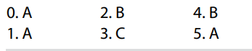
Activity 2: Reading
a) Objective: Students can improve their reading skill.
b) Content:
- Read the article about Anna's school year. Choose the correct answer (A, B, or C).
c) Expected outcomes: Ss read for comprehension and get familiar with the reading test format.
d) Organization of the activity:
TEACHER’S ACTIVITIES | STUDENTS’ ACTIVITIES
Read the article about Anna's school year. Choose the correct answer (A, B, or C).  - Demonstrate the activity on DCR by using the example.  - Have Ss look and read, then choose the correct answer, underline the supporting ideas for their answers.  - Call Ss to give answers, explain.  - Give feedback and evaluation. | - Observe and listen.  - Work individually.  - Give answers, explain.  Answer keys  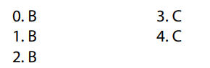
Activity 3: Vocabulary
a) Objective: Ss can review vocabulary about feelings and school tasks.
b) Content: Circle the correct words.
c) Expected outcomes: Ss produce the new language successfully, and they can use these words in speaking and writing.
d) Organization of the activity:
TEACHER’S ACTIVITIES | STUDENTS’ ACTIVITIES
Circle the correct words.  - Have Ss read the sentences.  - Ask Ss to work in pairs to circle the correct words.  - Have Ss give answers, tell the meaning of the words /phrase again.  - Check answers as a whole class using DCR. | - Read the sentences.  - Work in pairs to match.  - Give answers.  Answer keys  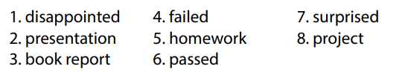
Activity 4: Grammar
a) Objective: Ss can review the use of English: “however” and “although” to show contrast, “because” to show causes /reasons, and intensifiers “so”, “really”.
b) Content:
- Underline the mistakes and write the correct answers on the lines.
c) Expected outcomes: Ss produce the new language successfully, and they can use the grammar points in speaking and writing.
d) Organization of the activity:
TEACHER’S ACTIVITIES | STUDENTS’ ACTIVITIES
Underline the mistakes and write the correct answers on the lines.  - Ask Ss to work individually to underline the mistakes and write the correct answers on the lines.  - Have Ss work in pairs to check each other’s work.  - Call Ss to give answers, explain for their choice.  - Check answers as a whole class using DCR. | - Work individually.  - Work in pairs.  - Give answers.  Answer keys  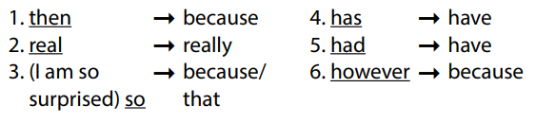
Activity 5: Pronunciation
a) Objective: Ss can review the stress of nouns and adjectives with 2 and 3 syllables, last consonant of “ed” endings.
b) Content:
- Circle the word that has the underlined part pronounces differently from the others.
- Circle the word that differs from the other three in the position of primary stress in each of the following questions.
c) Expected outcomes: Ss produce the new language successfully.
d) Organization of the activity:
TEACHER’S ACTIVITIES | STUDENTS’ ACTIVITIES
Task a. Circle the word that has the underlined part pronounced differently from the others.  - Have Ss distinguish 3 ways to pronoun “ed” endings (review).  - Ask Ss to work individually to circle the answer  - Have Ss work in pairs to check each other’s work.  - Call Ss to give answers, pronounce the words again.  - Give feedback, correct Ss’ pronunciation if necessary.  Task b. Circle the word that differs from the other three in the position of primary stress in each of the following questions.  - Remind Ss some basic rules of putting stress on nouns and adjectives with 2 or 3 syllables.  - Ask Ss to work individually.  - Have Ss work in pairs to check each other’s work.  - Call Ss to give answers, pronounce the words again.  - Give feedback, correct Ss’ pronunciation if necessary. | - Review.  - Work individually.  - Work in pairs.  - Give answers.  Answer keys  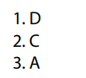  - Listen.  - Work individually.  - Work in pairs.  - Give answers.  Answer keys  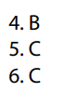
C. Consolidation and homework assignments
*Consolidation:
*Grammar of Unit 6: “however” and “although” to show contrast, “because” to show causes /reasons, and intensifiers “so”, “really”.
*Vocabulary of Unit 6: Words about feelings and school tasks (disappointed, excited, delighted, annoyed, surprised, test, presentation, book report, project, homework, fail, pass, …).
*Homework:
- Review vocabulary, grammar of unit 6.
- Do the exercises in WB: Review of Unit 6 (page 67).
- Prepare: Unit 7 – New words and Listening (page 52 – SB).
***************************************************************

