Teaching date: 14/02/2023
Period 64 UNIT 7: TRANSPORTATION
Lesson 1.1 New words and Listening (page 52)
I. OBJECTIVES
By the end of the lesson, Ss will be able to:
1.1. Language knowledge and skills
- know more words relating to personal belongings and places in the airport (luggage, boarding pass, backpack, suitcase, passport, customs, baggage claim).
- describe and identify personal belongings.
- listen to and understand a conversation of two people in an airport (for general and specific details).
- know how to ask for confirmation.
1.2. Competences
- improve communication, collaboration, and critical thinking skills.
1.3. Attributes
- take care of personal belongings.
- carefully prepare for any trip.
II. TEACHING AIDS AND LEARNING MATERIALS
1. Teacher’s aids: Student book and Teacher’s book, class CDs, Digital Book (DCR phần mềm tương tác SB, DHA (từ vựng/ cấu trúc) phần mềm trò chơi tương tác), projector/interactive whiteboard / TV (if any), PowerPoint slides.
2. Students’ aids: Student’s book, workbook, notebook.
III. ASSESSMENT EVIDENCE
Performance Tasks | Performance Products | Assessment Tools
- Number the pictures. | - Ss’ answers. | - T’s feedback/Peers’ feedback.
- Listen and repeat. | - Ss’ presentation. | - T’s feedback/Peers’ feedback.
- Discuss adjectives you could use for these items: suitcase, backpack, and luggage. | - Ss’ presentation / answers. | - T’s feedback/Peers’ feedback.
- Listen to Jenny and Fred at the airport. What are they doing? | - Ss’ answers. | - T’s feedback/Peers’ feedback.
- Listen and fill in the blanks. | - Ss’ answers. | - T’s feedback/Peers’ feedback.
- Speak: What type of luggage do you like to travel with? Why? | - Ss’ answers/ presentation. | - T’s observation and feedback.
IV. PROCEDURES
A. Warm up:
a) Objective: Introduce the new lesson and set the scene for Ss to acquire new language; get students' attention at the beginning of the class by enjoyable and short activities as well as to engage them in the follow-up steps.
b) Content: Introduce words about personal belongings.
c) Expected outcomes: Ss get to know some new words they are going to study in the lesson.
d) Organization of the activity:
TEACHER’S ACTIVITIES | STUDENTS’ ACTIVITIES
Option 1: Number the pictures. Listen and repeat.  - Use the “New words” part a– page 52 for the warm-up activity.  - Show words and pictures using DCR, have Ss look and number the pictures (in pairs).  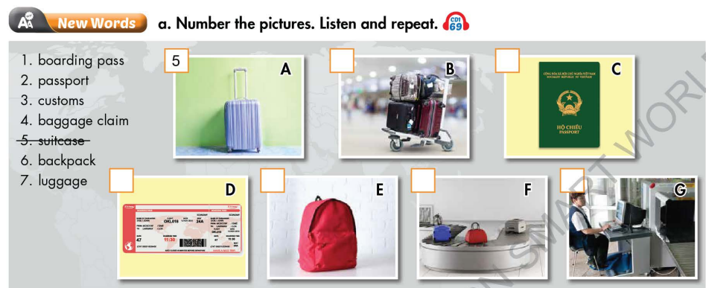  - Call Ss to give answers.  - Give feedback and show correct answers using DCR.  - Lead to the new lesson.  - Play the audio (CD1 – Track 69), have Ss listen and repeat.  - Correct Ss’ pronunciation if necessary.  Option 2:  - Divide class into 4-5 groups.  - Have Ss work in groups to list things people often need when they travel abroad (in about 1-2 minutes).  - Have a representative in each group write answers on the board.  - Check Ss’s answers and give feedback.  - The group with the most correct answers will be the winner.  - Lead to the new lesson. | - Work in pairs to number the pictures.  - Give answers.  - Listen.  - Listen and repeat.  Answer keys  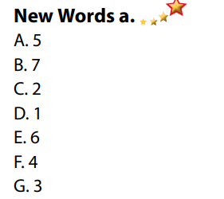  - Take part in the class’s activity.  - Write answers.  - Listen.  Suggested answers: passport, luggage, boarding pass, headphone, earphone, backpack, phone and device chargers, daily medication, clothes, water,…
B. New lesson
Activity 1: Pre-Listening (Vocabulary)
a) Objective: Ss get to know words about personal belongings.
b) Content:
- Vocabulary study (luggage, boarding pass, backpack, suitcase, passport, customs, baggage claim).
- Speaking: Discuss adjectives you could use for these items: suitcase, backpack, and luggage.
c) Expected outcomes: Ss know how to pronounce the new words correctly and use them when they do some listening tasks.
d) Organization of the activity:
TEACHER’S ACTIVITIES | STUDENTS’ ACTIVITIES
Task a. Number the pictures. Listen and repeat.  Option 1 (If the teacher hasn’t used this part for the Warm-up activity.)  - Demonstrate the activity on DCR, using the example.  - Have Ss number the pictures.  - Divide class into pairs and have them check their answers with their partners.  - Call Ss to give answers.  - Check answers as a whole class using DCR.  - Play audio (CD1 – Track 69). Have Ss listen and repeat.  - Correct Ss’ pronunciation.  Option 2: (If the teacher has used part a for the warm-up activity.)Matching  - Have Ss match the words they have known in Task a (from Warm up activity) by matching words with their definitions.  - Have Ss give answers and tell the meaning of words / phrases again.  - Check answers as a whole class.  - Call some Ss to read the words again.  - Correct Ss’ pronunciation if necessary.  *Illustration:  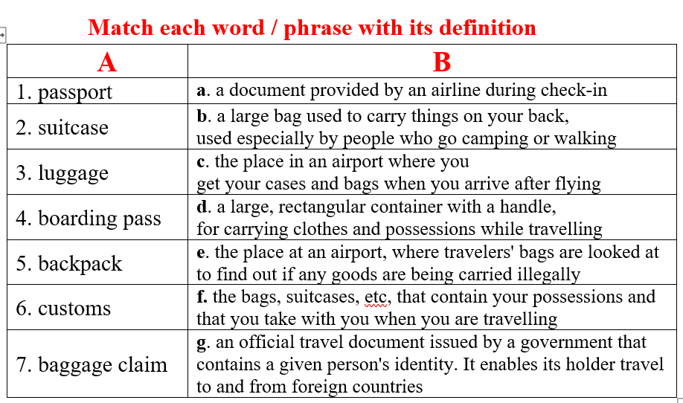  Task b. In pairs: Discuss adjectives you could use for these items: suitcase, backpack, and luggage.  - Have Ss work in pairs to discuss adjectives they could use for these items: suitcase, backpack, and luggage.  - Go round and give help if necessary.  - Have some pairs demonstrate the activity in front of the class.  - Give feedback and evaluation. | - Look and listen.  - Work individually.  - Work in pairs.  - Give answers.  - Listen and repeat.  Answer keys  - Work in pairs.  - Give answers, meaning.  - Read.  Answer keys  1 g  2 d  3 f  4 a  5 b  6 e  7 c  - Work in pairs to discuss.  - Present.  Sample answers  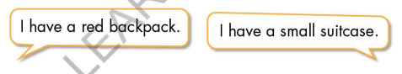
Activity 2: While - Listening
a) Objective: Students can develop their listening skill.
b) Content:
- Listen to Jenny and Fred at the airport. What are they doing?
- Listen and fill in the blanks.
c) Expected outcomes: Ss can listen to and understand a conversation of two people in an airport (for general and specific details).
d) Organization of the activity:
TEACHER’S ACTIVITIES | STUDENTS’ ACTIVITIES
Task a. Listen to Jenny and Fred at the airport. What are they doing?  - Have Ss read the question, guess the answer.  - Play audio (CD1 - Track 70).  - Have Ss listen and circle the correct answer.  - Check answers as a whole class using DCR.  Task b. Now, listen and fill in the blanks  - Have Ss read the through the content of Task b, underline the key words.  - Play the audio again (CD1 - Track 70).  - Have Ss listen and fill in the blanks.  - Have Ss check answers with their partners.  - Call Ss to give answers.  - Give feedback and show correct answers using DCR. | - Work individually.  - Listen.  - Circle the correct answers.  Answer keys  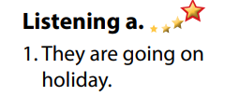  - Read, underline the key words.  - Do the task.  - Exchange answers.  Answer keys  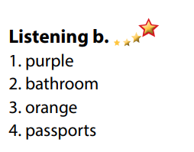
Activity 3: Post - Listening
a) Objective: Students can use the vocabulary and the content in listening part to develop their speaking skill.
b) Content: Speaking: What type of luggage do you like to travel with? Why?
c) Expected outcomes: Students can talk about their personal belongings for travelling.
d) Organization of the activity:
TEACHER’S ACTIVITIES | STUDENTS’ ACTIVITIES
Conversation skill  - Have Ss look at the Conversation skill box and read (using DCR).  - Play audio (CD 1 - Track 71), have Ss listen and repeat.  - Ask Ss to find more ways to ask for confirmation.  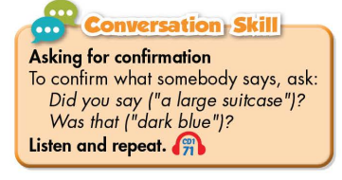  Task c. In pairs: What type of luggage do you like to travel with? Why?  - Have Ss work in pairs to discuss.  - Observe and give help if necessary.  - Call some pairs to share their ideas with the class  - Give feedback and evaluation. | - Look and read.  - Listen and repeat.  - Give answers.  - Work in pairs.  - Present.
C. Consolidation and homework assignments
* Consolidation:
- Words relating to personal belongings and places in the airport. (luggage, boarding pass, backpack, suitcase, passport, customs, baggage claim…).
- Language for asking for confirmation: Did you say …? / Was that …?
*Homework
- Learn the new words by heart.
- Practice talking about things you need when traveling abroad.
- Do the exercises in WB: New words and Listening (page 38).
- Do the vocabulary exercise in Tiếng Anh 7 i-Learn Smart World Notebook (page 42).
- Play consolation games in Tiếng Anh 7 i-Learn Smart World DHA App on www.eduhome.com.vn
- Prepare: Lesson 1.2 – Grammar (page 53 – SB).
***************************************************************
Teaching date: 15/02/2023
Period 65 UNIT 7: TRANSPORTATION
Lesson 1.2 - Grammar (page 53)
I. OBJECTIVES
By the end of the lesson, Ss will be able to:
1.1. Language knowledge and skills
- listen to 2 people asking and answering about personal belongings.
- use order of adjectives and possessive pronouns correctly.
- describe their own personal belongings and others’.
1.2. Competences
- improve speaking, listening skills.
- improve the use of English.
1.3. Attributes
- take care of personal belongings.
- carefully prepare for any trip.
II. TEACHING AIDS AND LEARNING MATERIALS
1. Teacher’s aids: Student book and Teacher’s book, class CDs, Digital Book (DCR phần mềm tương tác SB, DHA (từ vựng/ cấu trúc) phần mềm trò chơi tương tác), projector/interactive whiteboard / TV (if any), PowerPoint slides, handouts.
2. Students’ aids: Student’s book, workbook, notebook, handouts.
III. ASSESSMENT EVIDENCE
Performance Tasks | Performance Products | Assessment Tools
- Listen and repeat. | - Ss’ performance. | - T’s feedback.
- Study the grammar box. | - Ss’ answers/ presentation. | - T’s feedback.
- Fill in the blanks with the correct order of adjectives. | - Ss’ answers. | - T’s feedback/Peers’ feedback.
- Fill in the blanks with the correct possessive pronouns to complete the conversation. | - Ss’ answers. | - T’s feedback/Peers’ feedback.
- Speak: Ask your partner about the luggage. Use the prompts. | - Ss’ answers/ presentation. | - T’s observation, T’s feedback/Peers’ feedback.
IV. PROCEDURES
A. Warm up:
a) Objective: Introduce the new lesson and set the scene for Ss to acquire new language; get students' attention at the beginning of the class by enjoyable and short activities as well as to engage them in the follow-up steps.
b) Content: Review words about personal belongings / Review adjectives to describe things.
c) Expected outcomes: Ss review old words which are very useful for them in the new lesson.
d) Organization of the activity:
TEACHER’S ACTIVITIES | STUDENTS’ ACTIVITIES
Option 1:  - Have Ss close books and notebooks.  - Have Ss look at the pictures and give names of personal belongings.  - Call Ss to give answers.  - Check Ss’ answers, give feedback.  - Have Ss make sentences, using the words they have just made.  - Lead to the new lesson.  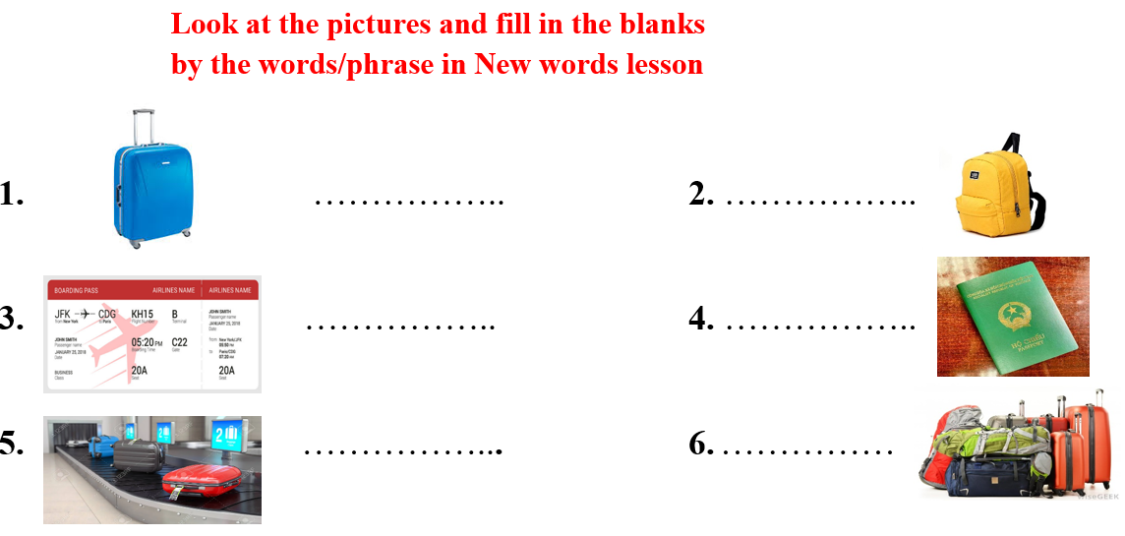  Option 2: Adjectives to describe things  - Have Ss close all books and notebooks.  - T uses pictures or cards.  - Have Ss look at the pictures (or take cards) and divide them into 3 categories: size, color, age.  - Call Ss to give answers.  - Check Ss’ answers, give feedback.  - Lead to the new lesson.  *Illustration   | - Close books and notebooks.  - Work in pairs.  - Give answers.  - Make sentences.  Answers keys  1. suitcase  2. backpack  3. boarding pass  4. passport  5. baggage claim  6. luggage  - Close books and notebooks.  - Work in groups.  - Give answers.  - Listen and write the new lesson.  Answers keys  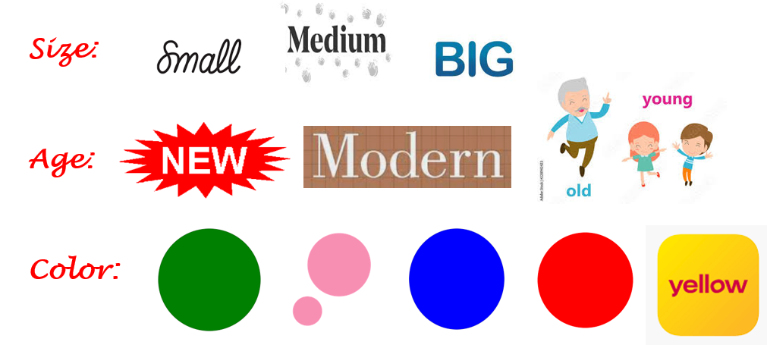
B. New lesson
Activity 1: Presentation
a) Objective: Introduce: “order of adjectives” and “possessive pronouns”.
b) Content:
- Listen and repeat.
- Introduce the grammar points.
c) Expected outcomes: Ss know the new grammar points “order of adjectives” and “possessive pronouns” and use them in some exercises that follow.
d) Organization of the activity:
TEACHER’S ACTIVITIES | STUDENTS’ ACTIVITIES
Task a. Listen and repeat  - Have Ss look at the picture using DCR.  - Play audio (CD1 – Track 72) and have Ss listen and read the speech bubbles.  - Play the audio again and have Ss listen and repeat.  Grammar box  Option 1:  - Have Ss look at the grammar explanation and read: Order of adjectives.  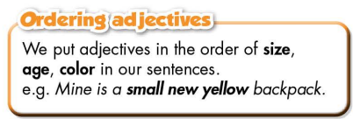  - Have Ss look at the grammar explanation and read: Possessive Pronouns.  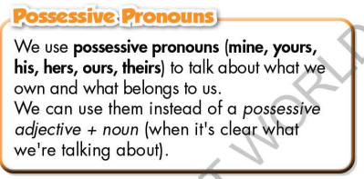  - Have Ss read the examples:  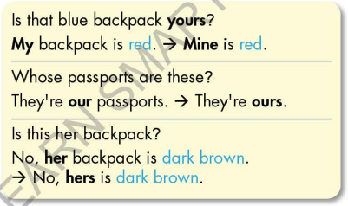  - Explain more about “order of adjectives” and “possessive pronouns”.  - Ask Ss to make more sentences using “order of adjectives” and “possessive pronouns”.  - Give feedback and evaluation.  Option 2:  - Have Ss look at the sentences in the speech bubbles in Task a and read them again.  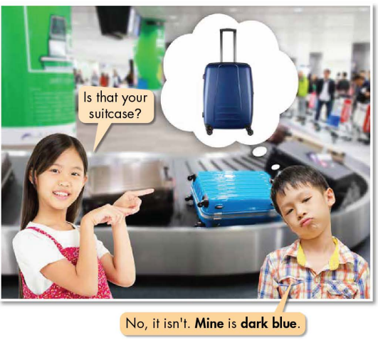  - Have Ss make comments on the words in bold (mine / dark blue).  - Ask Ss some questions:  1 What do you think “mine” means?  2 What does it replace?  3 Why do they write “dark blue”, not “blue dark”?  - Call Ss to give answers and give feedback.  - Then, lead to the grammar box, briefly explain the way to use “order of adjectives” and “possessive pronouns”.  - Have Ss read the grammar box and examples.  - Ask Ss to make more sentences using “order of adjectives” and “possessive pronouns”.  - Give feedback and evaluation. | - Look.  - Listen, then read.  - Listen and repeat.  - Look and read.  - Read examples of different forms.  - Listen.  - Give more examples.  - Look and read.  - Comment.  Expected answers  1. It means: “của tôi” (something that belongs to me).  2. It replaces “my suitcase”.  3. Ss’ answers.  - Read.  - Give more examples.  - Listen.
Activity 2: Practice
a) Objective: Students can use “order of adjectives” and “possessive pronouns” to do the given exercises.
b) Content:
- Fill in the blanks with the correct order of adjectives.
- Fill in the blanks with the correct possessive pronouns to complete the conversation.
c) Expected outcomes: Students can get used to the usage of “order of adjectives” and “possessive pronouns” and use them correctly.
d) Organization of the activity:
TEACHER’S ACTIVITIES | STUDENTS’ ACTIVITIES
Task b. Fill in the blanks with the correct order of adjectives.  - Demonstrate the activity on DCR, using the example.  - Have Ss fill in the blanks with the correct order of adjectives.  - Have Ss work in pairs to check each other’s work.  - Have some Ss share their answers with the whole class.  - Give feedback, correct Ss’ answers if necessary.  Task c. Fill in the blanks with the correct possessive pronouns to complete the conversation.  - Demonstrate the activity on DCR using the example.  - Have students fill in the blanks with the correct possessive pronouns to complete the conversation.  - Have pairs check each other's work.  - Have some students share their answers with the class. | - Look and listen.  - Work individually.  - Work in pairs.  - Write answers.  Answer keys  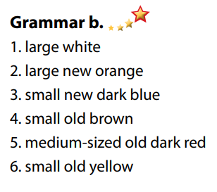  - Look and listen.  - Work individually.  - Work in pairs.  - Read answers, explain.  Answer keys  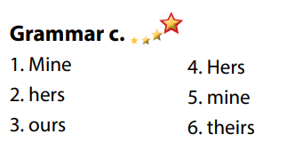
Activity 3: Production
a) Objective: Students master the grammar points they study in the lesson.
b) Content: Speaking: Ask your partner about the luggage. Use the prompts.
c) Expected outcomes: Ss produce the new language successfully, and they can use the grammar point in the lesson in everyday speaking and writing.
d) Organization of the activity:
TEACHER’S ACTIVITIES | STUDENTS’ ACTIVITIES
Task d. In pairs: Ask your partner about the luggage. Use the prompts.  - Divide class into pairs.  - Have Ss take turns asking their partner about the luggage. Use the prompts.  - Have some pairs demonstrate the activity in front of the class.  - Give feedback and evaluation. | - Have conversation in pairs.  - Present.  - Listen.  Suggested answers  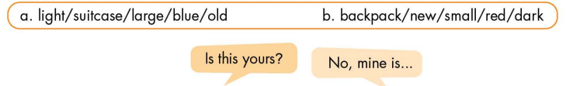
C. Consolidation and homework assignments
*Consolidation:
*Homework:
- Make 2 sentences, use “order of adjectives” and “possessive pronouns”.
- Do the exercises in WB: Grammar and Writing (page 39).
- Complete the grammar notes in Tiếng Anh 7 i-Learn Smart World Notebook (page 43).
- Play consolation games in Tiếng Anh 7 i-Learn Smart World DHA App on www.eduhome.com.vn
- Prepare: Lesson 1.3 – Pronunciation and Speaking (page 54 – SB).

Teaching date: 17/02/2023
Period 66 UNIT 7: TRANSPORTATION
Lesson 1.3 – Pronunciation and Speaking (page 54)
I. OBJECTIVES
By the end of the lesson, Ss will be able to:
1.1. Language knowledge and skills
- distinguish and put stress on the first syllable for most two-syllable nouns.
- describe luggage.
- talking about collecting luggage at the baggage claim.
1.2. Competences
- improve listening and speaking skills.
1.3. Attributes
- take care of personal belongings.
- carefully prepare for any trip.
II. TEACHING AIDS AND LEARNING MATERIALS
1. Teacher’s aids: Student book and Teacher’s book, class CDs, Digital Book (DCR phần mềm tương tác SB, DHA (từ vựng/ cấu trúc) phần mềm trò chơi tương tác), projector/interactive whiteboard / TV (if any), PowerPoint slides, handouts.
2. Students’ aids: Student’s book, workbook, notebook, paper, colored pencils (crayons), rubbers.
III. ASSESSMENT EVIDENCE
Performance Tasks | Performance Products | Assessment Tools
- Listen to the words and focus on the underlined letters. | - Ss’ performance and answers. | - T’s observation.
- Listen and cross out the word that doesn’t follow the note in “a”. | - Ss’ answers. | - T’s feedback/Peers’ feedback.
- Read the words with the stress changes noted in “a” with a partner. | - Ss’ performance. | - T’s feedback/Peers’ feedback.
- Point, ask and answer. | - Ss’ performance. | - T’s feedback/Peers’ feedback.
- You're at the baggage claim collecting your friends' luggage. In pairs: Student B, turn to page 120, File 6. Student A, ask which luggage your friends have. Point and guess. Then, number the boxes. | - Ss’ performance /  Presentation. | - T’s observation, T’s feedback/Peers’ feedback.
- Swap roles and repeat. Student A, turn to page 121, File 7. Student B, ask which luggage their friends have. Point and guess. Then, number the boxes. | - Ss’ performance /  Answers. | - T’s feedback/Peers’ feedback.
IV. PROCEDURES
A. Warm up:
a) Objective: Introduce the new lesson and set the scene for Ss to acquire new language; get students' attention at the beginning of the class by enjoyable and short activities as well as to engage them in the follow-up steps.
b) Content: Vocabulary: Nouns with two syllables / Chinese whisper.
c) Expected outcomes: Ss remember old knowledge and use them in other speaking activities.
d) Organization of the activity:
TEACHER’S ACTIVITIES | STUDENTS’ ACTIVITIES
Option 1: Nouns with two syllables  - Have Ss close all books.  - Divide Ss into 4 groups.  - Have Ss work in groups to write nouns with 2 syllables as many as possible.  - Call Ss to write answers on the boards.  - Check Ss’ answers, give feedback and announce the winning group.  - Lead to the new lesson: How to put stress on most two-syllable nouns.  Option 2: Chinese whisper  - Divide class into 4-5 groups.  - Have Ss in each group stand in a straight line.  - Give a sentence, have the last student in each line whisper this sentence to the student standing before; continue until the first student in the line can hear the sentence and write it on the board.  - Check Ss’ answers.  - The group which has the closest sentence to the original one will be the winner (T also checks spelling).  - Announce the winner and give a small present.  - Lead to the new lesson.  *Suggested sentence: I have a dark blue backpack and a big old pink suitcase. | - Close all books.  - Work in groups, then give answers.  Suggested answers  Nouns with two syllables: passport, luggage, candy, backpack, suitcase, airport, ticket, paper, lesson, teacher, doctor, partner, ruler, custom, people, …  - Form groups.  - Work in groups to take part in the game.  - The first student of each line writes answer on the board.  - Listen.
B. New lesson
Activity 1: Pre-Speaking: Pronunciation
a) Objective: Introduce: stress on most two-syllable nouns.
b) Content:
- recognize: stress on most two-syllable nouns.
- listen and check, find the word that doesn’t follow the note in “a”.
- practice.
c) Expected outcomes: Ss distinguish and put stress on most two-syllable nouns correctly in their speaking.
d) Organization of the activity:
TEACHER’S ACTIVITIES | STUDENTS’ ACTIVITIES
Task a + b. Listen to the words and focus on the underlined letters.  - Play the recording (CD1, track 73).  - Ask Ss to listen and focus on the underlined letters.  - Play the recording again, have Ss listen and repeat with a focus on the stress feature.  Task c + d. Listen and cross out the word that doesn’t follow the note in “a”.  - Play the recording (CD 1 – Track 74), have Ss listen and cross out the option that doesn’t follow the note in “a”.  - Call Ss to give answers.  - Play the recording again and check answers as a whole class using DCR.  - Give feedback and evaluation. | - Listen.  - Listen again and repeat.  - Listen and give answers.  Answer keys  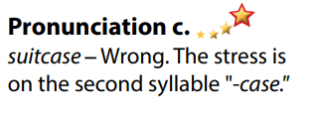
Activity 2: While-speaking
a) Objective: Students can describe luggage.
b) Content:
- Point, ask and answer.
- You're at the baggage claim collecting your friends' luggage. In pairs: Student B, turn to page 120, File 6. Student A, ask which luggage your friends have. Point and guess. Then, number the boxes.
- Swap roles and repeat. Student A, turn to page 121, File 7. Student B, ask which luggage their friends have. Point and guess. Then, number the boxes.
c) Expected outcomes: Ss produce the new language successfully.
d) Organization of the activity:
TEACHER’S ACTIVITIES | STUDENTS’ ACTIVITIES
PRACTICE  * Point, ask and answer.  - Demonstrate the activity on DCR using the example.  - Divide the class into pairs.  - Have pairs point, ask and answer about luggage.  - Observe, give help if necessary.  - Remind Ss to use language of asking for confirmation.  - Have some pairs demonstrate the activity in front of the class.  - Give feedback and evaluation.  SPEAKING: That’s Not My Bag!  Task a. You're at the baggage claim collecting your friends' luggage. In pairs: Student B, turn to page 120, File 6. Student A, ask which luggage your friends have. Point and guess. Then, number the boxes.  - Demonstrate the activity by practicing the role-play with a student.  - Divide the class into pairs.  - Have Student B turn to page 120, File 6.  - Have Student A ask which luggage their friends have and Student B answer.  - Have Student A number the boxes.  - Observe, give help if necessary.  Task b. Swap roles and repeat. Student A, turn to page 121, File 7. Student B, ask which luggage their friends have. Point and guess. Then, number the boxes.  - Have Student A turn to page 121, File 7 and Student B turn back to page 54.  - Swap roles and repeat.  - Have some pairs demonstrate the activity in front of the class. | - Observe, listen.  - Work in pairs.  - Present.  - Observe and listen.  - Work in pairs.  - Student A number the boxes.  Examples  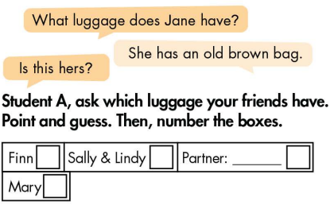  - Work in pairs.  - Swap roles and repeat.  - Present.
Activity 3: Production
a) Objective: Students relax after the lesson.
b) Content: Drawing: Draw luggage.
c) Expected outcomes: Ss produce the new language successfully in everyday speaking and writing and develop their drawing skill.
d) Organization of the activity:
TEACHER’S ACTIVITIES | STUDENTS’ ACTIVITIES
Extra activity: Draw luggage.  - Have a student describe a kind of luggage (of his / her own or others’).  - Have 5 Ss volunteers to listen and draw that kind of luggage as described on the board.  - Check Ss’ drawings and give feedback.  - Have class vote for the best picture.  - Announce the winner. | - 1 student describes a kind luggage (a suitcase, a bag, a backpack, …).  - Listen and draw.  - Listen.  Sample description  I have a big old blue backpack. It has an elephant on it. There are also some heart symbols on it, …  Sample drawing / picture  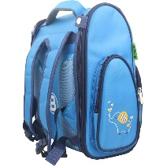

C. Consolidation and homework assignments
* Consolidation: stress on the first syllable for most two-syllable nouns.
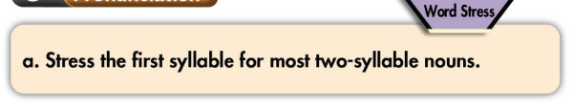
* Homework:
- Practice: stress on the first syllable for most two-syllable nouns.
- Find more nouns with 2 syllables and practice pronouncing them.
- Prepare: Unit 7 - Lesson 2 – New words and Reading (page 55 – SB).
- Review the vocabulary and grammar notes in Tiếng Anh 7 i-Learn Smart World Notebook
(pages 42 & 43).
- Play consolation games in Tiếng Anh 7 i-Learn Smart World DHA App on www.eduhome.com.vn
***************************************************************
Teaching date: 21/02/2023
Period 67 UNIT 7: TRANSPORTATION
Lesson 2.1 – New words and Reading (page 55)
I. OBJECTIVES
By the end of the lesson, Ss will be able to:
1.1. Language knowledge and skills
- know some new words relating to means of transportation (frequent, eco-friendly, comfortable, convenient, public, ticket, reliable).
- describe different types of transportation.
- read a paragraph about Vietnam Travel Guide to understand general and specific information.
1.2. Competences
- improve communication, collaboration, analytical and critical thinking skills.
1.3. Attributes
- be careful and safe road users.
- love hometown and country.
- use public transport to protect the environment.
II. TEACHING AIDS AND LEARNING MATERIALS
1. Teacher’s aids: Student book and Teacher’s book, class CDs, Digital Book (DCR phần mềm tương tác SB, DHA (từ vựng/ cấu trúc) phần mềm trò chơi tương tác), projector/interactive whiteboard / TV (if any), PowerPoint slides, pictures.
2. Students’ aids: Student’s book, workbook, notebook.
III. ASSESSMENT EVIDENCE
Performance Tasks | Performance Products | Assessment Tools
- Fill in the blanks. | - Ss’ answers. | - T’s feedback/Peers’ feedback.
- Listen and repeat. | - Ss’ answers/ presentation. | - T’s observation / feedback.
- Use adjectives to describe different types of transportation. | - Ss’ answers. | - T’s feedback/Peers’ feedback.
- Read the travel guide and choose the best title. | - Ss’ answers. | - T’s feedback/Peers’ feedback.
- Read and fill in the blanks. | - Ss’ answers. | - T’s feedback/Peers’ feedback.
- Speak: What types of transportation are there in your neighborhood? | - Ss’ answers/ presentation. | - T’s feedback/Peers’ feedback.
IV. PROCEDURES
A. Warm up:
a) Objective: Introduce the new lesson and set the scene for Ss to acquire new language; get students' attention at the beginning of the class by enjoyable and short activities as well as to engage them in the follow-up steps.
b) Content: Review: Means of transport.
c) Expected outcomes: Ss have general ideas about the topic of the new lesson: Means of transport.
d) Organization of the activity:
TEACHER’S ACTIVITIES | STUDENTS’ ACTIVITIES
Option 1: Cool pair matching  - Show pictures and words, have Ss look + read and find 6 pairs of means of transportation.  - Call Ss to give answers.  - Give feedback and show correct answers.  - Have Ss pronounce the words.  - Correct Ss’ pronunciation if necessary.  - Lead to the new lesson.  *Illustration:  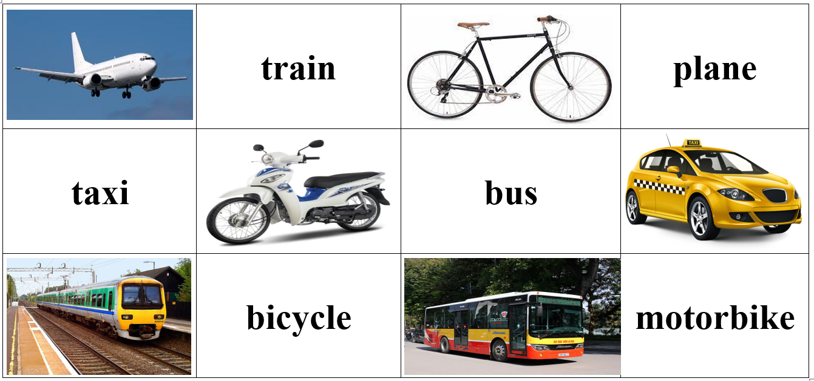  Option 2: Matching  - Have Ss look at the map of Vietnam and match 5 busiest airports in Vietnam with the places in number (work in pairs).  - Call Ss to give answers.  - Give feedback.  - Introduce the new lesson: Plane is one of many popular means of transport in Vietnam.  *Illustration: Match 5 busiest airports in Vietnam with the places in number: Liên Khương Airport, Nội Bài Airport, Đà Nẵng Airport, Tân Sơn Nhất Airport, Vinh Airport  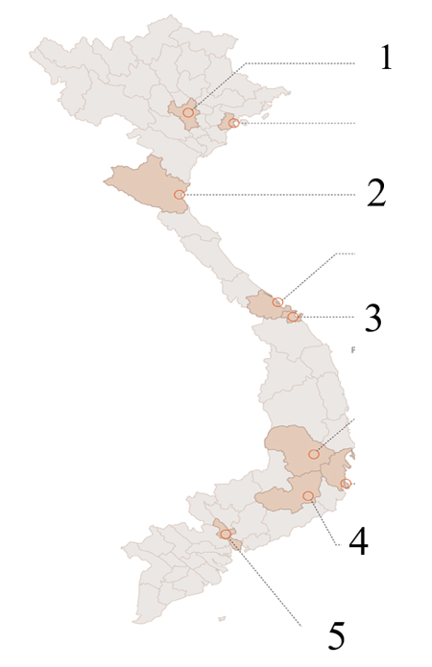 | - Look and find 6 pairs (a word+ a picture).  - Give answers.  - Read words.  - Listen.  Answer keys  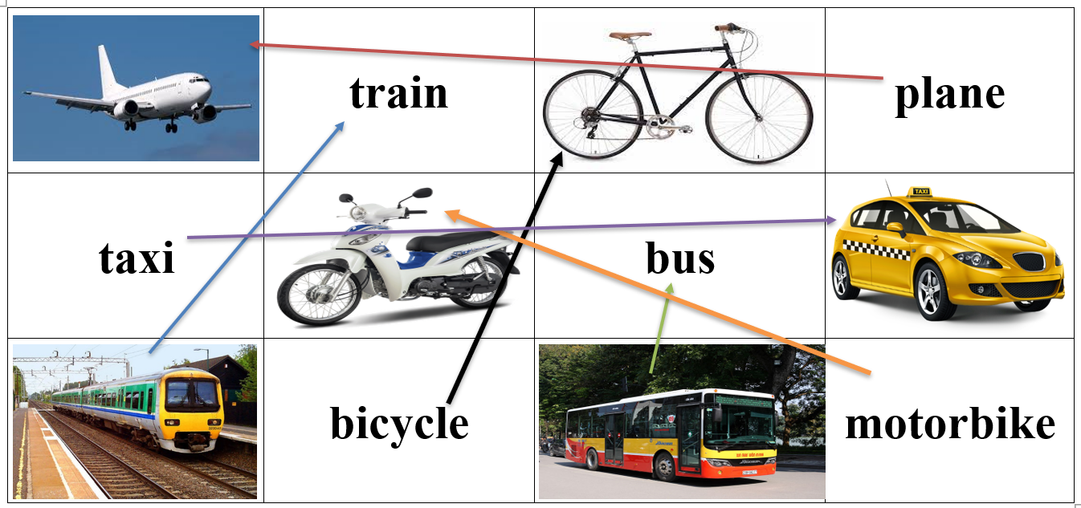  - Look and match (in pairs).  - Give answers.  Answer keys  1. Nội Bài Airport  2. Vinh Airport  3. Đà Nẵng Airport  4. Liên Khương Airport  5. Tân Sơn Nhất Airport
B. New lesson
Activity 1: Pre-Reading (Vocabulary)
a) Objective: Ss know some words relating to means of transportation and their characteristics.
b) Content:
- Vocabulary study: frequent, eco-friendly, comfortable, convenient, public, ticket, reliable.
- Fill in the blanks. Listen and repeat.
- Speaking: Use adjectives to describe different types of transportation.
c) Expected outcomes: Ss know how to pronounce the new words correctly and use them in appropriate situations.
d) Organization of the activity:
TEACHER’S ACTIVITIES | STUDENTS’ ACTIVITIES
Task a. Fill in the blanks. Listen and repeat.  Option 1  - Demonstrate the activity on DCR, using the example  - Have students fill in the blanks.  - Divide the class into pairs and have them check their answers with their partners.  - Call Ss to give answers (read or write).  - Check answers as a whole class using DCR.  - Play audio (CD1 – Track 75). Have Ss listen and repeat.  - Correct Ss’ pronunciation.  Option 2: (for Ss with high level)  - Introduce new words by giving a matching exercise.  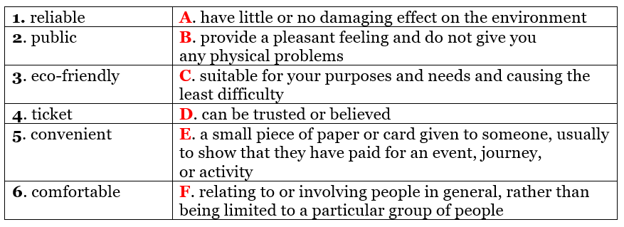  - Have Ss do the matching and give the meaning of the words in the first column.  - Call Ss to give answers (read or write).  - Check answers as a whole class.  - Call some Ss to read the words again.  - Play audio (CD1 – Track 75). Have Ss listen and repeat.  - Correct Ss’ pronunciation.  Task b. Use adjectives to describe different types of transportation.  - Have pairs use adjectives to describe different types of transportation.  - Have Ss share their answers in front of the class.  - Give feedback and evaluation. | - Look and listen.  - Work individually.  - Work in pairs.  - Give answers.  - Listen and repeat.  Answer keys  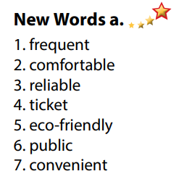  - Work in pairs.  - Give answers.  - Read.  - Listen.  Matching: Answer keys  1D 2F 3A 4E 5C 6B  - Work in pairs.  - Present.  Sample answers  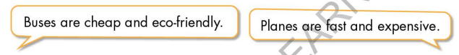
Activity 2: While - Reading
a) Objective: Students can develop their reading skill.
b) Content:
- Read the travel guide and choose the best title.
- Read and fill in the blanks.
c) Expected outcomes: Students can read a paragraph and understand more about means of transport in Vietnam.
d) Organization of the activity:
TEACHER’S ACTIVITIES | STUDENTS’ ACTIVITIES
Task a. Read the travel guide and choose the best title.  - Ask Ss to scan the paragraph, then choose the best title.  - Remind Ss to underline or highlight the keywords or supporting ideas for their answers.  - Have some Ss share their answers with the class (read), explain for their answers.  - Give feedback.  - Give feedback and correct Ss’ answers if necessary.  Task b. Now, read the paragraph and fill in the blanks.  - Have Ss look at sentences and underline the key words.  - Have Ss work in pairs to fill in the blanks. Remind Ss to use short answers for each blank (1-2 words).  - Elicit answers from different pairs.  - Give feedback and evaluation. | - Work individually.  - Read answers, explain.  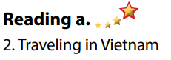  - Check answers.  Answer keys  - Work in pairs to circle the best answer.  - Read answers.  Answer keys  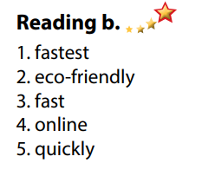
Activity 3: Post - Reading
a) Objective: Students can use the vocabulary and ideas from the reading text to develop their speaking skill.
b) Content: Speaking: What types of transportation are there in your neighborhood?
c) Expected outcomes: Students can talk about their types of transportation in your neighborhood.
d) Organization of the activity:
TEACHER’S ACTIVITIES | STUDENTS’ ACTIVITIES
Task c. In pairs: What types of transportation are there in your neighborhood?  - Have Ss work in pairs to answer the questions.  - Go round and give help if necessary.  - Call some Ss to share their ideas with the whole class.  - Give feedback and evaluation. | - Discuss in pairs.  - Present.  - Listen.
C. Consolidation and homework assignments
* Consolidation:
- Words relating to means of transportation and their characteristics (frequent, eco-friendly, comfortable, convenient, public, ticket, reliable).
- Some adjectives to describe different types of transportation: expensive, cheap, eco-friendly, fast, slow, dangerous, safe, modern.
* Homework:
- Learn the new words by heart.
- Practice talking about your favorite means of transport.
- Do the exercises in WB: Unit 7 - Lesson 2 - New words + Reading (Page 40).
- Do the vocabulary exercise in Tiếng Anh 7 i-Learn Smart World Notebook (page 44).
- Play consolation games in Tiếng Anh 7 i-Learn Smart World DHA App on www.eduhome.com.vn
- Prepare: Unit 7 - Lesson 2.2 – Grammar (page 56 – SB).
*******************************************************************
Teaching date: 22/02/2023
Period 68 UNIT 7: TRANSPORTATION
Lesson 2.2 - Grammar (page 56)
I. OBJECTIVES
By the end of the lesson, Ss will be able to:
1.1. Language knowledge and skills
- listen to and understand a short conversation between 2 people talking about speed of some means of transport.
- use equal comparison correctly.
1.2. Competences
- improve speaking, listening and writing skills.
- improve the use of English.
1.3. Attributes
- be careful and safe road users.
- choose suitable means of transport for travelling.
II. TEACHING AIDS AND LEARNING MATERIALS
1. Teacher’s aids: Student book and Teacher’s book, class CDs, Digital Book (DCR phần mềm tương tác SB, DHA (từ vựng/ cấu trúc) phần mềm trò chơi tương tác), projector/interactive whiteboard / TV (if any), PowerPoint slides, handouts.
2. Students’ aids: Student’s book, workbook, notebook.
III. ASSESSMENT EVIDENCE
Performance Tasks | Performance Products | Assessment Tools
- Listen and repeat. | - Ss’ performance. | - T’s feedback.
- Study the grammar box. | - Ss’ task. | - T’s observation.
- Rewrite sentences using (not) as…as… | - Ss’ answers. | - T’s feedback/Peers’ feedback.
- Write sentences using the information in the table. | - Ss’ answers. | - T’s feedback/Peers’ feedback.
- Write: Make more sentences about transportation from the table. Use the prompts. | - Ss’ performance/ presentation. | - T’s observation, T’s feedback/Peers’ feedback.
IV. PROCEDURES
A. Warm up:
a) Objective: Introduce the new lesson and set the scene for Ss to acquire new language; get students' attention at the beginning of the class by enjoyable and short activities as well as to engage them in the follow-up steps.
b) Content: Review adjectives.
c) Expected outcomes: Ss review old knowledge and have general ideas about the grammar points they are going to study in the new lesson.
d) Organization of the activity:
TEACHER’S ACTIVITIES | STUDENTS’ ACTIVITIES
Option 1: Review adjectives  - Have Ss close all books.  - Have Ss use the words in the box to fill in the blanks.  - Call Ss to give answers.  - Check Ss’ answers, correct Ss’s answers if necessary.  - Lead to the new lesson: adjectives used to compare things in equal comparison.  *Illustration:  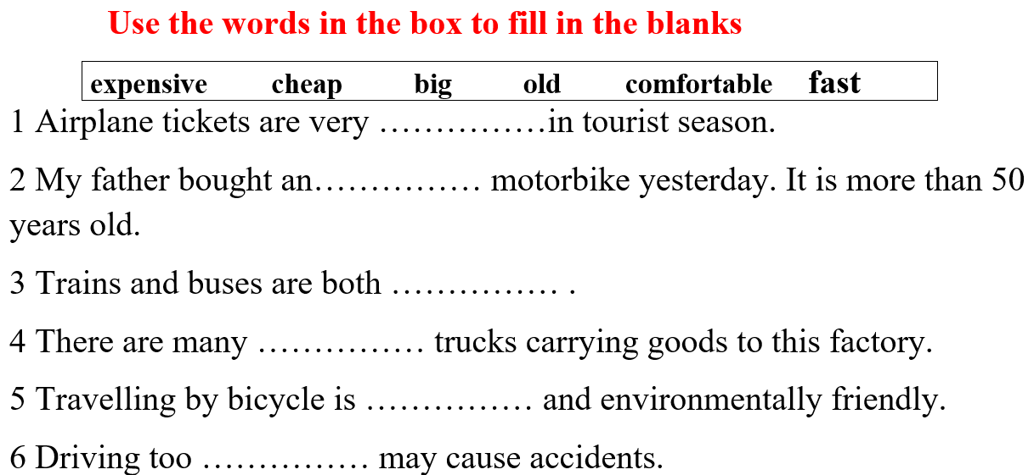  Option 2: Word Dictation  - Prepare the mp3 files of some adjectives which are used in the lesson.  - Play the sound, have Ss listen and write the words they can hear.  - Call some Ss to write answers on the board.  - Check Ss’ answers.  - Give feedback and evaluation.  - Lead to the new lesson.  *Suggested adjectives: expensive, cheap, old, new, big, small, comfortable, convenient, fast, slow, … | - Close books.  - Work in pairs.  - Give answers.  - Listen.  Answers keys  1. expensive  2. old  3. comfortable  4. big  5. cheap  6. fast  - Listen and write the words they can hear.
B. New lesson
Activity 1: Presentation
a) Objective: Introduce: Equal comparison.
b) Content:
- Listen and repeat.
- Introduce the grammar point: Equal comparison.
c) Expected outcomes: Ss know how to use equal comparison to do some following exercises.
d) Organization of the activity:
TEACHER’S ACTIVITIES | STUDENTS’ ACTIVITIES
Task a. Listen and repeat  - Have Ss look at the picture using DCR.  - Play audio (CD1 – Track 76) and have Ss listen and read the speech bubbles.  - Play the audio again and have Ss listen and repeat.  Grammar box  Option 1:  - Have Ss look at the grammar explanation and read: Equal comparison  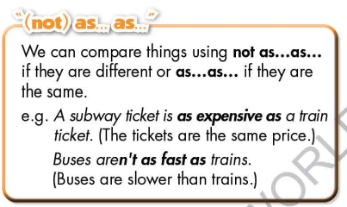  - Have Ss look at the examples with different forms and read:  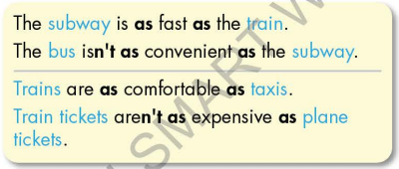  - Briefly explain the grammar point.  - Ask Ss to make sentences with equal comparison  - Give feedback and evaluation.  Option 2:  - Have Ss look at the picture and read the example.  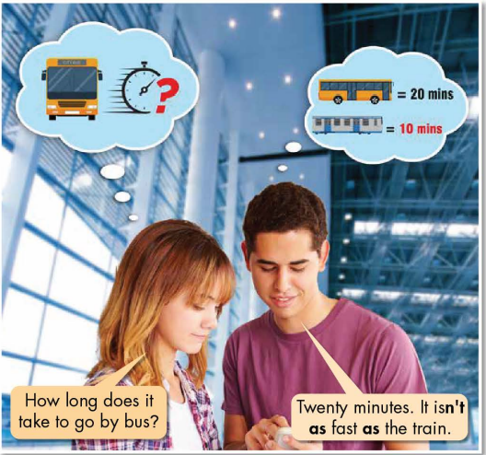  - Ask Ss to pay attention to the bold words.  - Ask Ss extra questions:  1. Which runs faster: a bus or a train?  2. Which words are used to express comparison in the example?  - Lead to the grammar box, have Ss read the grammar box and the examples.  - Briefly explain the grammar point.  - Ask Ss to make sentences with equal comparison, use their own ideas.  - Give feedback and evaluation. | - Look.  - Listen, then read.  - Listen and repeat.  - Look and read.  - Look and read.  - Listen and take notes.  - Make sentences, equal comparison.  - Look, read.  - Give answers.  Expected answers  1. a train  2. “isn’t as fast as”  - Listen and take notes.  - Make sentences.
Activity 2: Practice
a) Objective: Students can use equal comparison correctly.
b) Content:
- Rewrite sentences using (not) as…as…
- Write sentences using the information in the table.
c) Expected outcomes: Students can use equal comparison in their speaking.
d) Organization of the activity:
TEACHER’S ACTIVITIES | STUDENTS’ ACTIVITIES
Task b. Rewrite sentences using (not) as…as…  - Demonstrate the activity on DCR, using the example.  - Have Ss rewrite sentences using (not) as…as…  - Have Ss work in pairs to check each other’s work.  - Have some Ss share their answers with the whole class.  - Give feedback, correct Ss’ answers if necessary.  Task c. Write sentences using the information in the table.  - Demonstrate the activity on DCR, using the example.  - Have students write sentences using the information in the table.  - Have Ss check answers with their partners.  - Call Ss to read or write answers.  - Check Ss’ answers, give feedback. | - Look and listen.  - Work individually.  - Work in pairs.  - Write answers on the board.  Answer keys  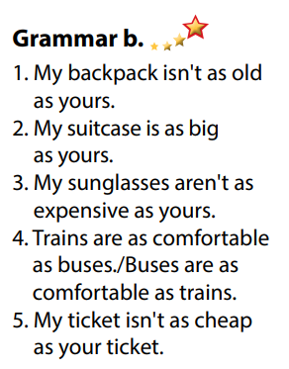  - Look and listen.  - Work individually.  - Work in pairs.  - Give answers.  Answer keys  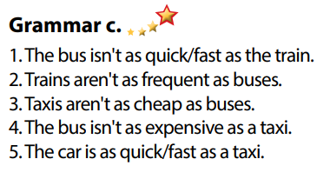
Activity 3: Production
a) Objective: Students master the grammar point they study in the lesson.
b) Content: Writing: Make more sentences about transportation from the table. Use the prompts.
c) Expected outcomes: Ss produce the new language successfully, and they can apply the grammar point they have learnt in speaking and writing.
d) Organization of the activity:
TEACHER’S ACTIVITIES | STUDENTS’ ACTIVITIES
Task d. Make more sentences about transportation from the table. Use the prompts.    - Divide class into pairs.  - Have Ss make more sentences about transportation from the table. Use the prompts.  - Have some pairs demonstrate the activity in front of the class.  - Give feedback and evaluation. | - Work in pairs.  - Have conversation in pairs.  - Present.  - Listen.
C. Consolidation and homework assignments
*Consolidation
- Equal comparison
*Homework:
- Make 3 sentences, use equal comparison.
- Do the exercises in WB: Grammar and Writing (page 41).
- Complete the grammar notes in Tiếng Anh 7 i-Learn Smart World Notebook (page 45).
- Play consolation games in Tiếng Anh 7 i-Learn Smart World DHA App on www.eduhome.com.vn
- Prepare: Lesson 2.3 – Pronunciation and Speaking (page 57 – SB).
*****************************************************************
Teaching date: 24/02/2023
Period 69 UNIT 7: TRANSPORTATION
Lesson 2.3 – Pronunciation and Speaking (page 57)
I. OBJECTIVES
By the end of the lesson, Ss will be able to:
1.1. Language knowledge and skills
- distinguish and pronounce the cluster /st/ correctly.
- talk about means of transport and compare them.
- compare different ways to travel.
1.2. Competences
- improve listening and speaking skills.
1.3. Attributes
- be careful and safe road users.
- choose suitable means of transport for travelling.
II. TEACHING AIDS AND LEARNING MATERIALS
1. Teacher’s aids: Student book and Teacher’s book, class CDs, Digital Book (DCR phần mềm tương tác SB, DHA (từ vựng/ cấu trúc) phần mềm trò chơi tương tác), projector/interactive whiteboard / TV (if any), PowerPoint slides, handouts.
2. Students’ aids: Student’s book, workbook, notebook, pens, pencils, crayons.
III. ASSESSMENT EVIDENCE
Performance Tasks | Performance Products | Assessment Tools
- Listen to the words and focus on the underlined letters. | - Ss’ performance and answers. | - T’s observation.
- Listen to the /st/ sound. Find and note down three more words with the same sound. | - Ss’ answers. | - T’s feedback/Peers’ feedback.
- Read the words in “c” with the sound noted in “a” to a partner. | - Ss’ performance. | - T’s feedback/Peers’ feedback.
- Practice the conversation. Swap roles and repeat. | - Ss’ performance. | - T’s feedback/Peers’ feedback.
- Practice with your own ideas. | - Ss’ performance /  Presentation. | - T’s feedback/Peers’ feedback.
- You are deciding how to get to Richmond Park. In pairs: Student B, turn to page 121, File 8. Student A, ask your partner about the bus and answer their questions about the train. Then, compare the different ways to travel and decide how you will get to the park. | - Ss’ performance /  Presentation. | - T’s observation, T’s feedback/Peers’ feedback.
- Join another pair. Will they use the same type of transportation? Why (not)? | - Ss’ performance /  Presentation. | - T’s observation, T’s feedback/Peers’ feedback.
IV. PROCEDURES
A. Warm up:
a) Objective: Introduce the new lesson and set the scene for Ss to acquire new language; get students' attention at the beginning of the class by enjoyable and short activities as well as to engage them in the follow-up steps.
b) Content: Introduce the cluster /st/.
c) Expected outcomes: Ss get to know what they are going to study in the new lesson and use them in other speaking activities.
d) Organization of the activity:
TEACHER’S ACTIVITIES | STUDENTS’ ACTIVITIES
Option 1: Introduce the cluster /st/  - Play a video clip to introduce the cluster /st/.  - Have Ss watch the video clip and sing.  - Lead to the new lesson:  *Illustration:  Link: https://www.youtube.com/watch?v=lJb-iI-Rc9s  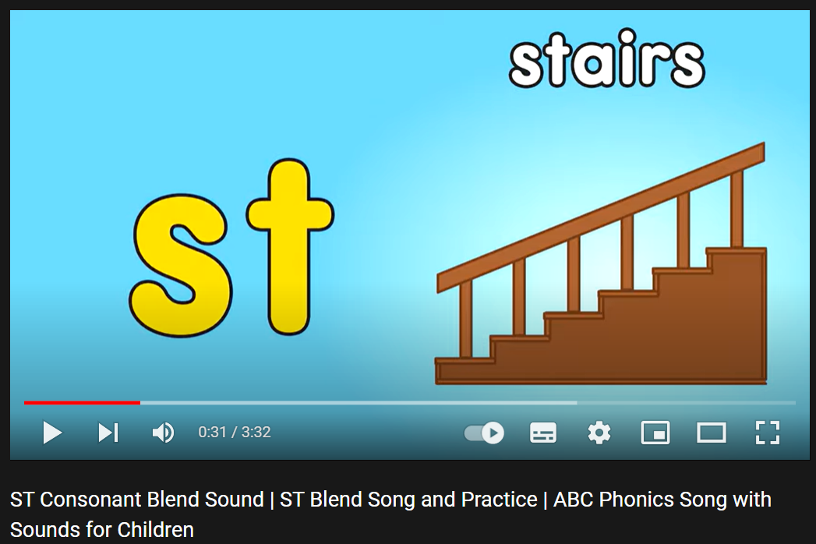  Option 2: Brainstorming  - Have Ss close all books.  - Divide class into 4 groups.  - Ask Ss to think of words in English containing the letters “st”.  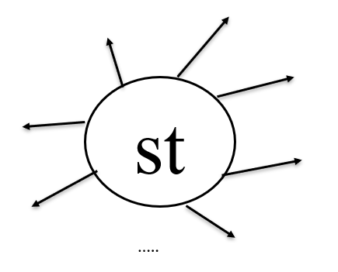  - Call Ss to write answers on the board.  - The group with the most correct answers will be the winner.  - Check Ss’ answers, give feedback, announce the winner.  - Lead to the new lesson. | - Watch and sing together.  - Close books.  - Work in groups to write words with letters “st” inside.  Suggested answers  Stay, step, first, last, steal, style, stole, stolen, stairs, station, fast, tourist, festival, stamp, stew, stone, stele, astounding, …
B. New lesson
Activity 1: Pre-Speaking: Pronunciation
a) Objective: Introduce the cluster /st/.
b) Content:
- recognize: cluster /st/.
- listen to the /st/ sound. Find and note down three more words with the same sound.
- practice.
c) Expected outcomes: Ss distinguish and use the cluster /st/ correctly in their speaking.
d) Organization of the activity:
TEACHER’S ACTIVITIES | STUDENTS’ ACTIVITIES
Task a + b. Listen to the words and focus on the underlined letters.  - Play the recording (CD1, track 77).  - Ask Ss to listen and focus on the underlined letters.  - Play the recording again, have Ss listen and repeat with a focus on the sound feature.  Task c + d. Listen to the /st/ sound. Find and note down three more words with the same sound; then read them  - Play the recording (CD 1 – Track 78), have Ss listen to the /st/ sound. Find and note down three more words with the same sound; then read them.  - Remind Ss to remember words in the warm up activity.  - Call Ss to give answers.  - Play the recording again and check answers as a whole class using DCR.  - Give feedback and evaluation. | - Listen.  - Listen again and repeat.  - Listen and give answers.  Suggested answers  Stay, step, first, last, steal, style, stole, stolen, stairs, station, fast, tourist, festival, stamp, stew, stone, stele, astounding, …
Activity 2: While-speaking
a) Objective: Students can talk about means of transport and compare them.
b) Content:
- Practice the conversation. Swap roles and repeat.
- You are deciding how to get to Richmond Park. In pairs: Student B, turn to page 121, File 8. Student A, ask your partner about the bus and answer their questions about the train. Then, compare the different ways to travel and decide how you will get to the park.
c) Expected outcomes: Ss produce the new language successfully.
d) Organization of the activity:
TEACHER’S ACTIVITIES | STUDENTS’ ACTIVITIES
PRACTICE  * Task a. Practice the conversation. Swap roles and repeat.  - Demonstrate the activity by practicing the role-play with a student.  - Divide the class into pairs.  - Have pairs practice the conversation.  - Swap roles and repeat using the ideas on the right.  - Have some pairs demonstrate the activity in front of the class.  - Give feedback and evaluation.  * Task b. Practice with your own ideas.  - Have students practice the conversation with their own ideas. Swap roles.  - Have some pairs demonstrate the activity in front of the class.  - Give feedback and evaluation.  SPEAKING: How Do We Get To The Park?  Task a. You are deciding how to get to Richmond Park. In pairs: Student B, turn to page 121, File 8. Student A, ask your partner about the bus and answer their questions about the train. Then, compare the different ways to travel and decide how you will get to the park.  - Demonstrate the activity by practicing the activity with a student.  - Divide the class into pairs.  - Have Student B turn to page 121, File 8.  - Have students ask and answer to complete the table. - Have students compare the information and choose how they will get to the park.  - Call some pairs to answers.  - Observe, give help if necessary. | - Observe, listen.  - Work in pairs.  - Swap the roles and repeat.  - Present.  - Work in pairs.  - Present.  - Observe and listen.  - Work in pairs.  - Do the task.  - Give answers.  Suggested conversation
Activity 3: Production
a) Objective: Students can have a free talk about means of transport and choose a suitable one for their travelling.
b) Content: Join another pair. Will they use the same type of transportation? Why (not)?
c) Expected outcomes: Ss produce the new language successfully in everyday speaking and writing.
d) Organization of the activity:
TEACHER’S ACTIVITIES | STUDENTS’ ACTIVITIES
SPEAKING: How Do We Get To The Park?  Task b. Join another pair. Will they use the same type of transportation? Why (not)?  - Have students join another pair.  - Have students check if they will use the same or different type of transportation and why.  - Have some students share their decisions with the class.  - Give feedback and evaluation. | - Join another pair and continue acting out the situation.  - Present.
C. Consolidation and homework assignments
* Consolidation: Some words with /st/ sound: stamp, stapler, star, starfish, statue, steak, steam, stem, stick, stingray, stone, stool, stop, stork, strawberry, and stump, …
* Homework:
- Practice: reading words with /st/ sound.
- Prepare: Unit 7 - Lesson 3 –Listening and Reading (page 58 – SB).
- Review the vocabulary and grammar notes in Tiếng Anh 7 i-Learn Smart World Notebook
(pages 44 & 45).
- Play consolation games in Tiếng Anh 7 i-Learn Smart World DHA App on www.eduhome.com.vn
*******************************************************************
Teaching date: 28/02/2023
Period 70 UNIT 7: TRANSPORTATION
Lesson 3.1 - Listening and Reading (page 58)
I. OBJECTIVES
By the end of the lesson, Ss will be able to:
1.1. Language knowledge and skills
- talk about transportation.
- practice listening and understanding a recording about two types of transportation (for general and specific information).
- read and understand an opinion paragraph about a mean of transportation (for gist and details).
1.2. Competences
- improve communication, collaboration, analytical and critical thinking skills.
1.3. Attributes
- be careful and safe road users.
- choose suitable means of transport for travelling.
II. TEACHING AIDS AND LEARNING MATERIALS
1. Teacher’s aids: Student book and Teacher’s book, class CDs, Digital Book (DCR phần mềm tương tác SB, DHA (từ vựng/ cấu trúc) phần mềm trò chơi tương tác), projector/interactive whiteboard / TV (if any), PowerPoint slides.
2. Students’ aids: Student’s book, workbook, notebook.
III. ASSESSMENT EVIDENCE
Performance Tasks | Performance Products | Assessment Tools
- Let’s Talk: Look at the pictures. What are the two kinds of transportation? Which would you most like to try? Why? | - Ss’ answers / presentation. | - T’s feedback/Peers’ feedback.
- Listening: Listen to Matt’s vlog about two types of transportation. Which is better for kids? | - Ss’ answers | - T’s feedback/Peers’ feedback.
- Listen and tick (✓ ) the advantages for each kind of transportation. | - Ss’ answers. | - T’s feedback/Peers’ feedback.
- Reading: Look at the opinion paragraph. Who wrote the paragraph? | - Ss’ answers. | - T’s feedback/Peers’ feedback.
- Now, read and write True or False. | - Ss’ answers. | - T’s feedback/Peers’ feedback.
-Speaking: Would the Wowscoot be convenient for where you live? Why (not)? | - Ss’ answers / presentation. | - T’s observation/ DCR and T’s feedback.
IV. PROCEDURES
A. Warm up:
a) Objective: Introduce the new lesson and set the scene for Ss to acquire new language; get students' attention at the beginning of the class by giving enjoyable and short activities as well as to engage them in the follow-up steps.
b) Content: Introduce the topic: Two kinds of transportation (monowheel and two wheels).
c) Expected outcomes: Ss have general ideas about the topic “transportation”, which they are going to listen and read in the new lesson.
d) Organization of the activity:
TEACHER’S ACTIVITIES | STUDENTS’ ACTIVITIES
Option 1: Let’s Talk!  Look at the pictures. What are the two kinds of transportation? Which would you most like to try? Why?  - Use the “Let’s talk!” part in the textbook– page 58 for warm-up activity.  - Ask Ss to work in pairs to look at the pictures and answer the questions: What are the two kinds of transportation? Which would you most like to try? Why?  - Call Ss to share their answers with the whole class.  - Give feedback and evaluation.  - Lead to the new lesson.  Option 2:  - Show 2 pictures.  - Have Ss look at the 2 pictures of 2 groups of vehicles.  - Have Ss find the basic difference between 2 groups of vehicles.  - Call Ss to give answers.  - Give feedback and lead to the new lesson: There are 2 kinds of transportation mentioned in the new lesson today.  *Illustration  Picture 1:  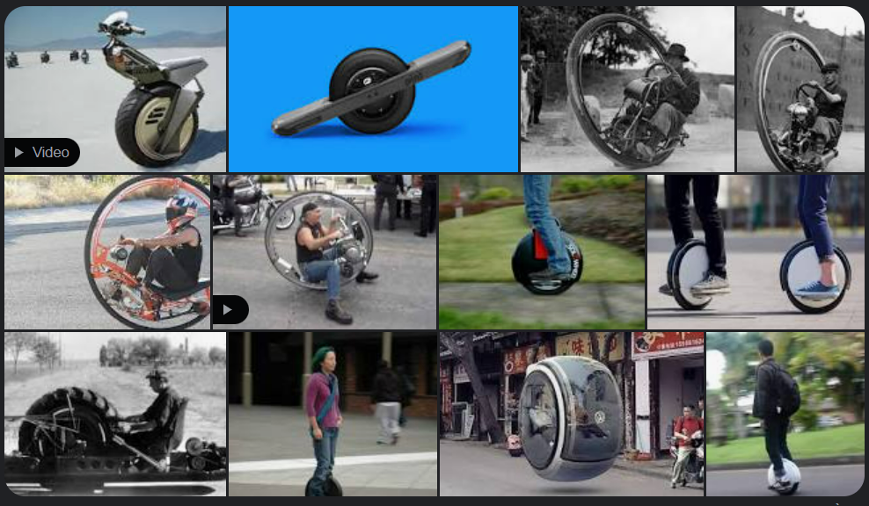  Picture 2:  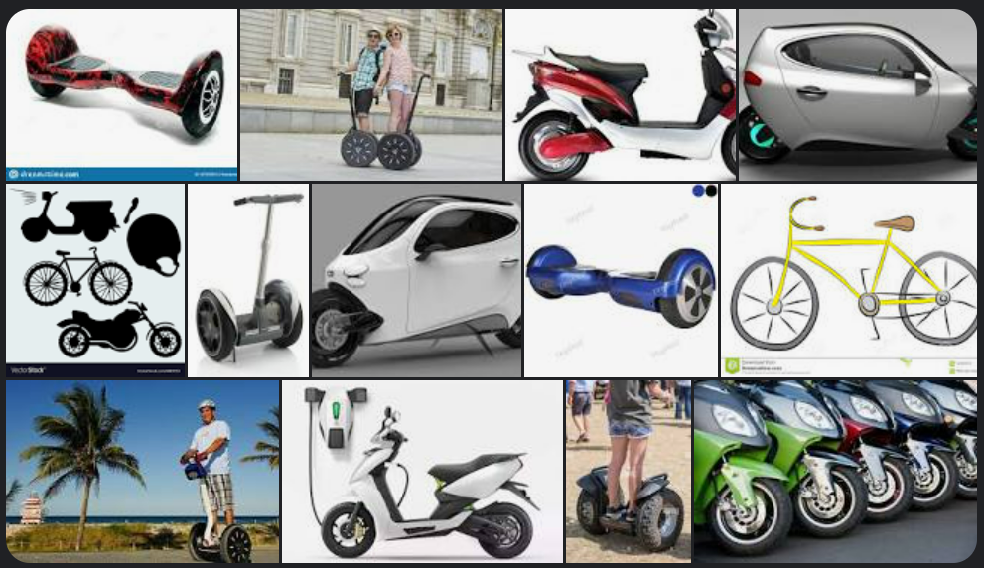 | - Work in pairs to discuss.  - Present.  - Look at the pictures and find the basic difference between 2 groups of vehicles.  - Give answers.  - Listen and answer.  Suggested answers  - Picture 1: Vehicles with only 1 wheel  - Picture 2: Vehicles with 2 wheels
B. New lesson
Activity 1: Listening
a) Objective: Students can develop their listening skill.
b) Content:
- Listen to Matt’s vlog about two types of transportation. Which is better for kids?
- Listen and tick (✓ ) the advantages for each kind of transportation.
c) Expected outcomes: Students can practice listening and understanding general + specific information about transportation.
d) Organization of the activity:
TEACHER’S ACTIVITIES | STUDENTS’ ACTIVITIES
Task a. Listen to Matt’s vlog about two types of transportation. Which is better for kids?  - Have Ss read the question.  - Play audio (CD1 - Track 79).  - Have Ss listen and circle the correct answer.  - Call Ss to give answer, explain.  - Play the audio again and check the answer as a whole class using DCR.  Task b. Listen and tick (✓ ) the advantages for each kind of transportation.  - Have Ss read through the content in Task b first, underline the key words.  - Play the audio again (CD1 - Track 79).  - Have Ss listen and tick (✓ ) the advantages for each kind of transportation.  - Have Ss check answers with their partners.  - Call Ss to give answers, explain.  - Check answers as a whole class using DCR. | - Listen and guess the answer.  - Read.  - Listen and circle the correct answer.  - Give answer, explain.  Answer keys  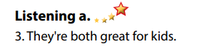  - Read, find and underline the key words.  - Listen and tick (✓ ) the advantages for each kind of transportation.  - Exchange answers.  - Give answers.  Answer keys  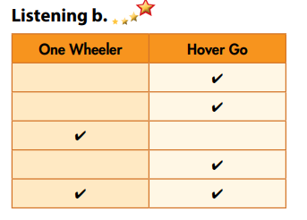
Activity 3: Reading
a) Objective: Students can develop their reading skill.
b) Content:
- Look at the opinion paragraph. Who wrote the paragraph?
- Now, read and write True or False.
- Would the Wowscoot be convenient for where you live? Why (not)?
c) Expected outcomes: Students can read an opinion paragraph for gist and detail, and they can give their opinion about a type of transport.
d) Organization of the activity:
TEACHER’S ACTIVITIES | STUDENTS’ ACTIVITIES
Task a. Look at the opinion paragraph. Who wrote the paragraph?  - Have Ss read the content in Task a.  - Ask Ss to scan the paragraph to choose the correct answer.  - Have Ss underline the supporting ideas.  - Call a student to give answer.  - Check answers as a whole class using DCR.  Task b. Now, read and write True or False.  - Have Ss read the content in Task b and underline the key words.  - Have Ss read the article again and write True or False.  - Have Ss check their answers with a partner.  - Call Ss to give answers.  - Check answer as a whole class using DCR.  Task c. Speaking: In pairs: Would the Wowscoot be convenient for where you live? Why (not)?  - Have Ss discuss the questions in pairs.  - Call some Ss to share their answers with the whole class.  - Give feedback and evaluation. | - Scan the article to choose the correct answer.  - Underline the supporting ideas.  - Give answer.  Answer keys  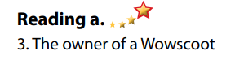  - Read and underline the key words.  - Read the article again for details.  - Exchange answers.  - Give answers.  Answer keys  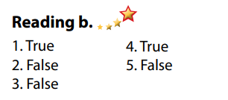  - Discuss in pairs.  - Present.
C. Consolidation and homework assignments
*Consolidation:
*Homework
- Do the exercises in WB: Listening and Reading (page 42).
- Do the vocabulary exercise in Tiếng Anh 7 i-Learn Smart World Notebook (page 46).
- Play consolation games in Tiếng Anh 7 i-Learn Smart World DHA App on www.eduhome.com.vn
- Prepare: Unit 7 - Lesson 3 – Writing and Speaking (page 59 – SB).
******************************************************************
Teaching date: 01/03/2023
Period 71 UNIT 7: TRANSPORTATION
Lesson 3.2 Writing (page 59)
I. OBJECTIVES
By the end of the lesson, Ss will be able to:
1.1. Language knowledge and skills
- use some phrases to give opinion (In my opinion, ... / I think …).
- discuss different kinds of transportation for kids.
- write an opinion paragraph about why every kid in their town should have a type of transportation.
1.2. Competences
- improve communication, collaboration, writing and critical thinking skills.
1.3. Attributes
- be careful and safe road users.
- choose suitable means of transport for travelling.
II. TEACHING AIDS AND LEARNING MATERIALS
1. Teacher’s aids: Student book and Teacher’s book, class CDs, Digital Book (DCR phần mềm tương tác SB, DHA (từ vựng/ cấu trúc) phần mềm trò chơi tương tác), projector/interactive whiteboard / TV (if any), PowerPoint slides, handouts.
2. Students’ aids: Student’s book, workbook, notebook.
III. ASSESSMENT EVIDENCE
Performance Tasks | Performance Products | Assessment Tools
- Speaking: Your town is going to buy one type of transportation for all the kids. In pairs: Look at the pictures. Discuss the different kinds of transportation and choose one for the kids in your town. | - Ss’ answers / presentation. | - T’s feedback/Peers’ feedback.
- Choose one of the products above or make up your own. Use your own ideas to fill in the table. | - Ss’ answers / presentation. | - T’s feedback/Peers’ feedback.
- Writing: Read about writing opinion paragraphs. Then, read Tony’s paragraph again and underline the reason he gives. | - Ss’ answers. | - T’s feedback/Peers’ feedback.
- Write full sentences using the prompts. Then, number the sentences (1–4) to match them with the parts of an opinion paragraph. Use the skill box to help you. | - Ss’ answers. | - T’s feedback/Peers’ feedback.
- Now, write an opinion paragraph about why every kid in your town should have this type of transportation. Use the Feedback form to help you. Write 60 to 80 words. | - Ss’ answers. | - T’s observation and feedback.
IV. PROCEDURES
A. Warm up:
a) Objective: Introduce the new lesson and set the scene for Ss to acquire new language; get students' attention at the beginning of the class by enjoyable and short activities as well as to engage them in the follow-up steps.
b) Content: Introduce Mean of transport / Review the old lesson.
c) Expected outcomes: Ss know about the topic that they are going to talk and write about in new the lesson.
d) Organization of the activity:
TEACHER’S ACTIVITIES | STUDENTS’ ACTIVITIES
Option 1: Drawing (for this Warm up activity, T can ask Ss to prepare at home before the lesson.)  - Divide class into 4-5 groups.  - Have each group draw a future mean of transport, using their imagination (Ss prepare at home).  - Have Ss hang their picture on the board.  - Give feedback and evaluation.  - Have the whole class vote for the best picture.  - Lead to the new lesson: Writing an opinion paragraph about a mean of transport.  Option 2: Multiple choice  - Have Ss close books.  - Give Ss some multiple-choice questions (basing on the opinion paragraph of Tony Thompson on page 58).  - Have Ss work in pairs to give answers.  - Check Ss’ answers, give feedback and evaluation.  - Lead to the new lesson.  *Multiple choice question:  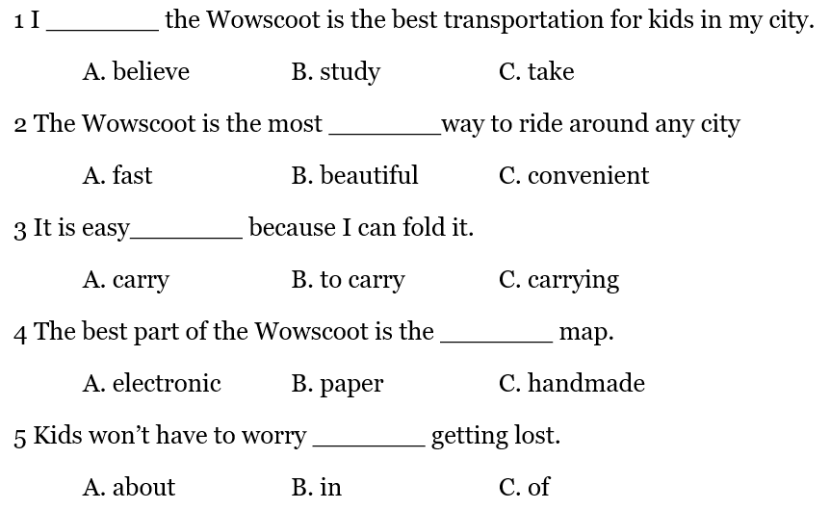 | - Work in groups.  - Vote.  - Listen.  - Close books.  - Work in pairs.  - Listen.  Answer keys  - A  - C  - B  - A  - A
B. New lesson
Activity 1: Pre-Writing
a) Objective: Ss prepare for what they are going to write about.
b) Content:
- Speaking: Your town is going to buy one type of transportation for all the kids. In pairs: Look at the pictures. Discuss the different kinds of transportation and choose one for the kids in your town.
- Choose one of the products above or make up your own. Use your own ideas to fill in the table.
c) Expected outcomes: Ss have more ideas and language for their writing.
d) Organization of the activity:
TEACHER’S ACTIVITIES | STUDENTS’ ACTIVITIES
Task a. In pairs: Your town is going to buy one type of transportation for all the kids. In pairs: Look at the pictures. Discuss the different kinds of transportation and choose one for the kids in your town.  - Divide the class into pairs.  - Have students look at the pictures and discuss the questions.  - Go round and support Ss if necessary.  - Have some students share their ideas with the class.  - Give feedback and evaluation.  Task b. Choose one of the products above or make up your own. Use your own ideas to fill in the table.  - Have students choose one of the products above or make up their own. Use their own ideas to fill in the table.  - Go round and give help if necessary.  - Have Ss exchange their answers with another pair. | - Work in pairs.  - Present.  - Discuss and fill in the table.  - Exchange.
Activity 2: While - Writing
a) Objective: Students can develop their writing skill.
b) Content: - Read about writing opinion paragraphs. Then, read Tony’s paragraph again and underline the reason he gives.
- Write full sentences using the prompts. Then, number the sentences (1–4) to match them with the parts of an opinion paragraph. Use the skill box to help you.
- Now, write an opinion paragraph about why every kid in your town should have this type of transportation. Use the Feedback form to help you. Write 60 to 80 words.
c) Expected outcomes: Students can write an opinion paragraph, using right format and rich vocabularies.
d) Organization of the activity:
TEACHER’S ACTIVITIES | STUDENTS’ ACTIVITIES
Task a. Read about writing opinion paragraphs. Then, read Tony’s paragraph again and underline the reason he gives.  -Briefly explain the Writing skill box and have some Ss read it aloud.  - Have Ss read Tony’s paragraph again (page 58) and underline the reason he gives.  - Have Ss check their answers with a partner.  - Call Ss to give answers.  - Check answer as a whole class using DCR.  Task b. Write full sentences using the prompts. Then, number the sentences (1–4) to match them with the parts of an opinion paragraph. Use the skill box to help you.  - Have students read the prompts.  - Have students write full sentences using the prompts. Then, number the sentences (1–4) to match them with the parts of an opinion paragraph.  - Remind Ss to use information in the skill box.  - Have students check their answers with a partner.  - Check answer as a whole class using DCR.  *Let’s Write: Write an opinion paragraph about why every kid in your town should have this type of transportation. Use the Feedback form to help you. Write 60 to 80 words.  - Draw Ss’ attention to the feedback form.  - Have Ss use their notes in speaking part and the instruction in the Writing box to write an opinion paragraph about why every kid in your town should have this type of transportation.  - Go round, observe and give help if necessary.  - Have some Ss write their paragraph on the board. | - Listen and read.  -Work in pairs.  - Exchange their answers with a partner.  - Give answers.  Answer keys  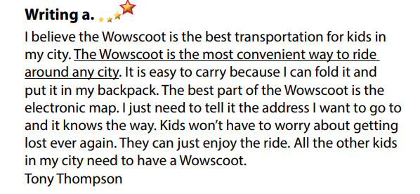  - Read the prompts and write full sentences. Then, number the sentences (1–4) to match them with the parts of an opinion paragraph.  - Exchange answers.  - Read answers.  Answer keys  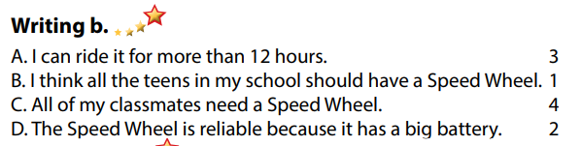  - Do the writing part.  -Write.
Activity 3: Post - Writing
a) Objective: Help Ss realize their mistakes in writing and correct them.
b) Content: Correcting Ss’ writings.
c) Expected outcomes: Students know whether their writings follow the model and use the correct structures and language, whether their writings are interesting and understandable or not.
d) Organization of the activity:
TEACHER’S ACTIVITIES | STUDENTS’ ACTIVITIES
- Give feedback, correct Ss’ mistakes.  - Use the feedback form to give evaluation. Focus on:  + the format, the structures  + the understandability  + the coherence and cohesion  + the punctuation and the spelling | - Look, listen and correct mistakes.  Suggested writing  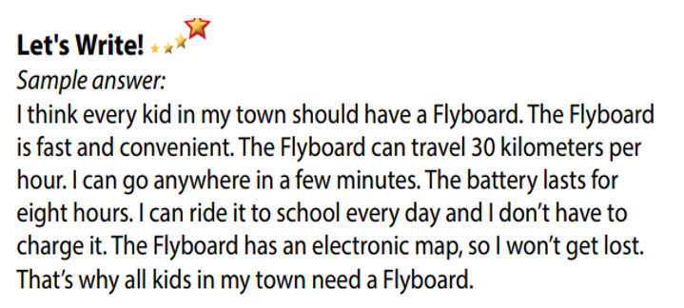
C. Consolidation and homework assignments
* Consolidation:
- Writing Skill

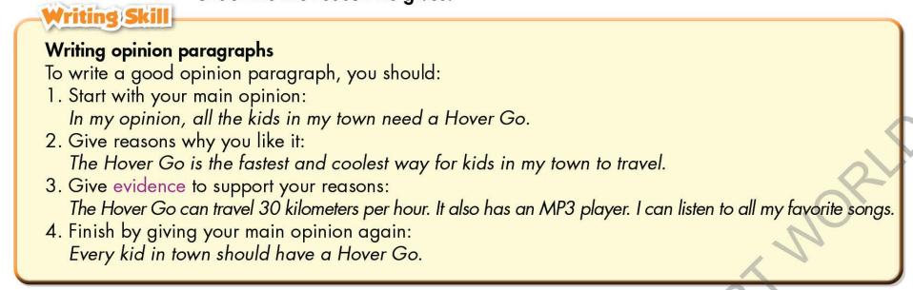
*Homework
- Remember how to write a paragraph to give opinion.
- Finish the writing part.
- Do the exercises in WB: Writing part, page 43.
- Complete grammar notes in Tiếng Anh 7 i-Learn Smart World Notebook (page 47).
- Play consolation games in Tiếng Anh 7 i-Learn Smart World DHA App on www.eduhome.com.vn
- Prepare: Unit 7 – Review, pages 102, 103.
********************************************************************Teaching date: 02/03/2023
Period 72 UNIT 7: TRANSPORTATION
Lesson 4 – Review (pages 102, 103)
I. OBJECTIVES
By the end of the lesson, Ss will be able to:
1.1. Language knowledge and skills
- review words about personal belongings and means of transportation (customs, passport, suitcase, baggage claim, boarding pass, frequent, sunglasses, subway, …) and talk about them.
- review grammar: possessive pronouns, order of adjectives, equal comparison.
- review: describe and identify personal belongings, compare different types of transportation.
- pronoun the ending sounds correctly: “s” endings.
- put stress on nouns and adjectives with two and three syllables.
1.2. Competences
- improve speaking, listening, reading and writing skills.
- improve the use of English.
1.3. Attributes
- have positive attitude in English language learning so that they actively participate in all classroom activities.
- review the old lesson and have good preparation for the second mid-term test.
II. TEACHING AIDS AND LEARNING MATERIALS
1. Teacher’s aids: Student book and Teacher’s book, class CDs, Digital Book (DCR phần mềm tương tác SB, DHA (từ vựng/ cấu trúc) phần mềm trò chơi tương tác), projector/interactive whiteboard / TV (if any), PowerPoint slides, handouts.
2. Students’ aids: Student’s book, workbook, notebook.
III. ASSESSMENT EVIDENCE
Performance Tasks | Performance Products | Assessment Tools
- Listening: You will hear a man talking about transportation in London. Listen and fill in the blanks. You will hear the information twice. | - Ss’ answers. | - T’s feedback/Peers’ feedback.
- Reading: Read the email about a trip to an amusement park. Write one word for each blank. | - Ss’ answers. | - T’s feedback/Peers’ feedback.
- Vocabulary: Match the words with the descriptions. | - Ss’ answers. | - T’s feedback/Peers’ feedback.
- Grammar: Circle the correct words.  - Write sentences using the prompts. | - Ss’ answers. | - T’s feedback/Peers’ feedback.
- Pronunciation: Circle the word that has the underlined part pronounced differently from the others.  + Circle the word that differs from the other three in the position of primary stress in each of the following questions. | - Ss’ answers/ presentation. | - T’s observation, T’s feedback/Peers’ feedback.
IV. PROCEDURES
A. Warm up:
a) Objective: Introduce the new lesson and set the scene for Ss to acquire new language; get students' attention at the beginning of the class by enjoyable and short activities as well as to engage them in the follow-up steps.
b) Content: Review: Means of transport.
c) Expected outcomes: Ss are ready for the new lesson.
d) Organization of the activity:
TEACHER’S ACTIVITIES | STUDENTS’ ACTIVITIES
Option 1: Find the differences  - Have Ss look at 2 pictures and find the differences between them (in 2 minutes).  - Call Ss to give answers.  - Correct Ss’ pronunciation if necessary.  - Lead to the new lesson.  *Illustration:  Picture 1:  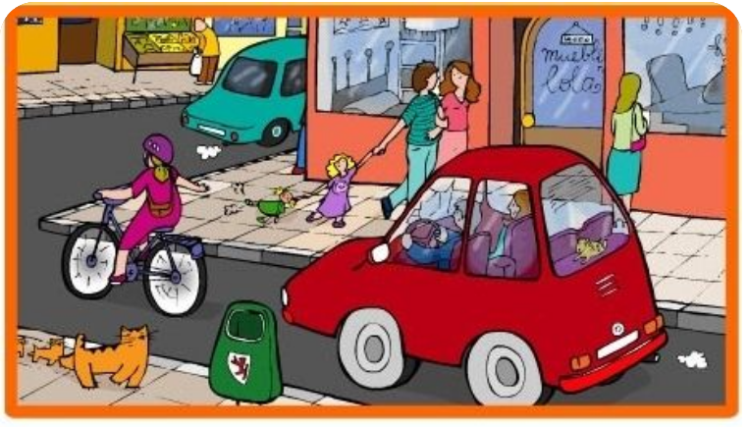  Picture 2  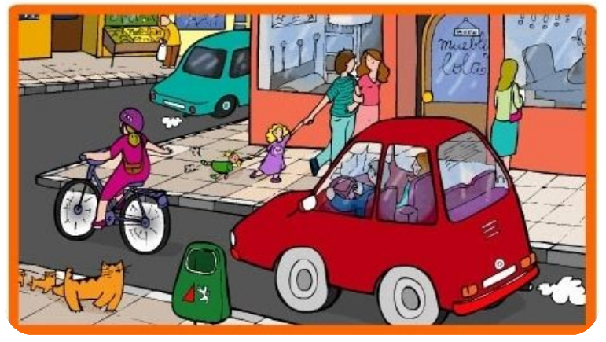  Option 2: Review: Means of Transport  - Have Ss work in groups to list means of transport as many as possible.  - Call Ss to give answers, then pronounce the words and give meaning.  - Correct Ss’ pronunciation if necessary.  - Lead to the new lesson. | - Look at the pictures and find the differences.  - Give answers.  - Listen.  Suggested answer  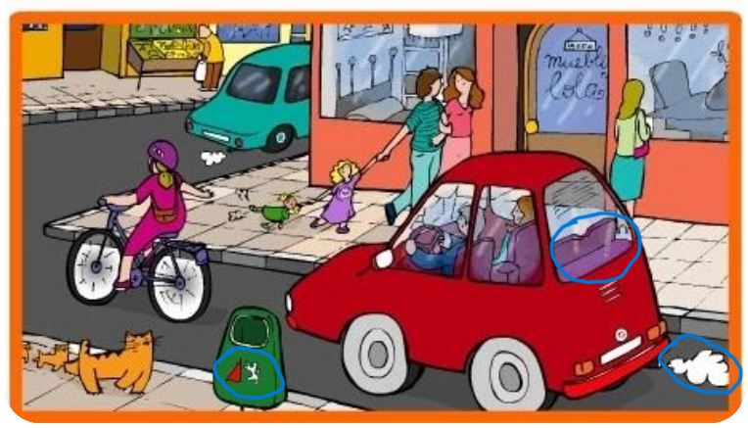  - Work in groups, list means of transport.  - Give answers, pronounce the words.  - Listen.  Some suggested answers  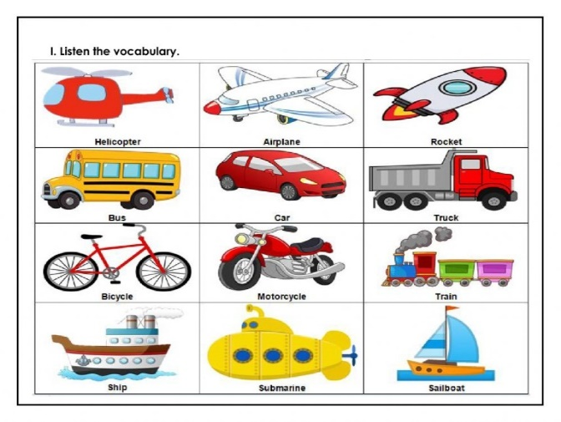
B. New lesson
Activity 1: Listening
a) Objective: Help Ss improve their listening skill.
b) Content:
- You will hear a man talking about transportation in London. Listen and fill in the blanks. You will hear the information twice.
c) Expected outcomes: Ss listen in details and get familiar with the listening test format.
d) Organization of the activity:
TEACHER’S ACTIVITIES | STUDENTS’ ACTIVITIES
You will hear a man talking about transportation in London. Listen and fill in the blanks. You will hear the information twice.  - Have Ss read through the listening part.  - Demonstrate the activity on DCR by using the example.  - Play the audio (CD 2 – Track 41). Have Ss listen and choose the correct answer.  - Have Ss check answers with pairs, then read answers  - Check answers as a whole class using DCR. | - Read in silence.  - Listen and read answers.  Answer keys  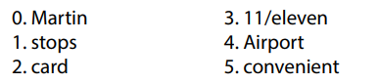
Activity 2: Reading
a) Objective: Students can improve their reading skill.
b) Content:
- Read the email about a trip to an amusement park. Write one word for each blank.
c) Expected outcomes: Ss read for comprehension and get familiar with the reading test format.
d) Organization of the activity:
TEACHER’S ACTIVITIES | STUDENTS’ ACTIVITIES
Read the email about a trip to an amusement park. Write one word for each blank.  - Demonstrate the activity on DCR by using the example.  - Have Ss look and read, then choose the correct answer, underline the supporting ideas for their answers.  - Call Ss to give answers, explain.  - Give feedback and evaluation. | - Observe and listen.  - Work individually.  - Give answers, explain.  Answer keys  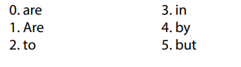
Activity 3: Vocabulary
a) Objective: Ss can review vocabulary about personal belongings.
b) Content: Match the words with the descriptions.
c) Expected outcomes: Ss produce the new language successfully, and they can use these words in speaking and writing.
d) Organization of the activity:
TEACHER’S ACTIVITIES | STUDENTS’ ACTIVITIES
Match the words with the descriptions.  - Have Ss read the sentences.  - Ask Ss to work in pairs match the words with the descriptions.  - Have Ss give answers, tell the meaning of the words /phrase again.  - Check answers as a whole class using DCR. | - Read the sentences.  - Work in pairs to match.  - Give answers.  Answer keys  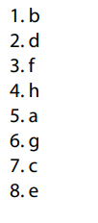
Activity 4: Grammar
a) Objective: Ss can review the use of English: possessive pronouns, order of adjectives, equal comparison.
b) Content:
- Circle the correct words.
- Write sentences using the prompts.
c) Expected outcomes: Ss produce the new language successfully, and they can use the grammar points in speaking and writing.
d) Organization of the activity:
TEACHER’S ACTIVITIES | STUDENTS’ ACTIVITIES
Task a. Circle the correct words.  - Ask Ss to work individually to circle the correct words.  - Have Ss work in pairs to check each other’s work.  - Call Ss to give answers, explain for their choice.  - Check answers as a whole class using DCR.  Task b. Write sentences using the prompts  - Ask Ss to read the prompts.  - Have Ss write sentences using the prompts.  - Have Ss work in pairs to check each other’s work.  - Call Ss to give answers.  - Check answers as a whole class using DCR. | - Work individually.  - Work in pairs.  - Give answers.  Answer keys  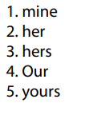  - Work individually.  - Work in pairs.  - Give answers.  Answer keys  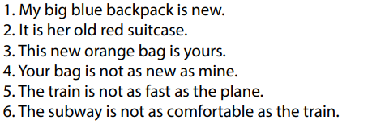
Activity 5: Pronunciation
a) Objective: Ss can review the stress of nouns and adjectives with 2 and 3 syllables, last consonant of “s” endings.
b) Content:
- Circle the word that has the underlined part pronounces differently from the others.
- Circle the word that differs from the other three in the position of primary stress in each of the following questions.
c) Expected outcomes: Ss produce the new language successfully.
d) Organization of the activity:
TEACHER’S ACTIVITIES | STUDENTS’ ACTIVITIES
Task a. Circle the word that has the underlined part pronounced differently from the others.  - Have Ss distinguish 3 ways to pronoun “s” endings (review).  - Ask Ss to work individually to circle the answer.  - Have Ss work in pairs to check each other’s work.  - Call Ss to give answers, pronounce the words again.  - Give feedback, correct Ss’ pronunciation if necessary.  Task b. Circle the word that differs from the other three in the position of primary stress in each of the following questions.  - Remind Ss some basic rules of putting stress on nouns and adjectives with 2 or 3 syllables.  - Ask Ss to work individually.  - Have Ss work in pairs to check each other’s work.  - Call Ss to give answers, pronounce the words again.  - Give feedback, correct Ss’ pronunciation if necessary. | - Review.  - Work individually.  - Work in pairs.  - Give answers.  Answer keys  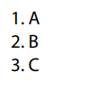  - Listen.  - Work individually.  - Work in pairs.  - Give answers.  Answer keys  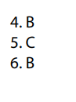
C. Consolidation and homework assignments
*Consolidation:
*Grammar of Unit 7: Possessive pronouns, order of adjectives, equal comparison.
*Vocabulary of Unit 7: Words about personal belongings and means of transportation (customs, passport, suitcase, baggage claim, boarding pass, frequent, sunglasses, subway, …).
*Homework:
- Review vocabulary, grammar of unit 7.
- Do the exercises in WB: Review of Unit 7 (page 68).
- Prepare: Unit 8 – New words and Reading (page 60 – SB).
****************************************************************

