Teaching date: 03/4/2023
Period 85 UNIT 9: ENGLISH IN THE WORLD
Lesson 1.1 Vocabulary and Reading (page 68)
I. OBJECTIVES
By the end of the lesson, Ss will be able to:
1.1. Language knowledge and skills
- know some new words about tourism and cultures. (tour guide, stadium, flight, historic, jog, ferry).
- talk about tourist attractions and cultures of English - speaking countries.
- read an email about tourist attractions and culture of the USA to understand general and specific information.
1.2. Competences
- improve communication, collaboration, analytical and critical thinking skills.
1.3. Attributes
- love studying English.
- respect cultures of other countries in the world.
II. TEACHING AIDS AND LEARNING MATERIALS
1. Teacher’s aids: Student book and Teacher’s book, class CDs, Digital Book (DCR phần mềm tương tác SB, DHA (từ vựng/ cấu trúc) phần mềm trò chơi tương tác), projector/interactive whiteboard / TV (if any), PowerPoint slides, pictures.
2. Students’ aids: Student’s book, workbook, notebook.
III. ASSESSMENT EVIDENCE
Performance Tasks | Performance Products | Assessment Tools
- Match the words with the definitions. | - Ss’ answers. | - T’s feedback/Peers’ feedback.
- Listen and repeat. | - Ss’ answers/ presentation. | - T’s observation / feedback.
- Do you know any historic places? Tell your partner. | - Ss’ answers. | - T’s feedback/Peers’ feedback.
- Read Jane's email to her friend. Where is Jane? | - Ss’ answers. | - T’s feedback/Peers’ feedback.
- Read and circle the correct answer. | - Ss’ answers. | - T’s feedback/Peers’ feedback.
- Speak: What do you know about the United States? Would you like to visit it? | - Ss’ answers/ presentation. | - T’s feedback/Peers’ feedback.
IV. PROCEDURES
A. Warm up:
a) Objective: Introduce the new lesson and set the scene for Ss to acquire new language; get students' attention at the beginning of the class by enjoyable and short activities as well as to engage them in the follow-up steps.
b) Content: Introduce: English speaking countries.
c) Expected outcomes: Ss have general ideas about the topic of the new lesson: English speaking countries.
d) Organization of the activity:
TEACHER’S ACTIVITIES | STUDENTS’ ACTIVITIES
Option 1: Introduce English speaking countries.  - Show flags of some English - speaking countries.  - Have Ss observe the flags and guess the names of these countries.  - Call Ss to give answers.  - Give feedback and show correct answers.  - Lead to the new lesson: English in the world.  *Illustration:  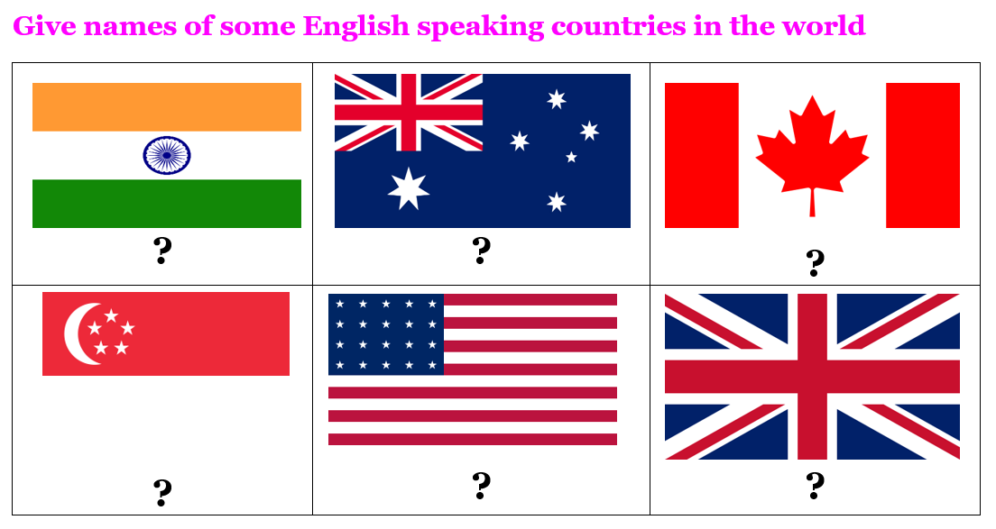  Option 2: Top 10 tourist attractions in the USA  - Have Ss watch a video clip about Top 10 tourist attractions in the USA.  - Then, ask Ss some questions:  1 Can you list some tourist attractions from the clip?  2 Which tourist attraction in the USA impresses you much? Explain for your choice  3 What do you need to travel to the USA?  - Call Ss to give answers.  - Give feedback.  - Introduce the new lesson: English in the world.  *Illustration:  Suggestedlink: https://www.youtube.com/watch?v=98H5AN_vfOY   | - Observe the flags and guess the names of these English - speaking countries.  - Give answers.  Answer keys  From left to right, top to bottom:  1. India  2. Australia  3. Canada  4. Singapore  5. The USA  6. The UK  - Watch the video clip, then give answers.  - Listen.
B. New lesson
Activity 1: Pre-Reading (Vocabulary)
a) Objective: Ss know some words about tourism.
b) Content:
- Vocabulary study: tour guide, stadium, flight, historic, jog, ferry.
- Match the words with the definitions. Listen and repeat.
- Speaking: Do you know any historic places? Tell your partner.
c) Expected outcomes: Ss know how to pronounce the new words correctly and use them in appropriate situations.
d) Organization of the activity:
TEACHER’S ACTIVITIES | STUDENTS’ ACTIVITIES
Task a. Match the words with the definitions. Listen and repeat.  Option 1  - Demonstrate the activity on DCR, using the example.  - Have Ss match the words with the definitions.  - Divide class into pairs and have them check their answers with their partners.  - Call Ss to give answers (read or write).  - Check answers as a whole class using DCR.  - Play audio (CD2 – Track 12). Have Ss listen and repeat.  - Correct Ss’ pronunciation.  Option 2:  - Demonstrate the activity, using the example.  - Have Ss match the words with the definitions.  - T uses pictures to illustrate the definitions.  - Divide class into pairs and have them check their answers with their partners.  - Call Ss to give answers (read or write).  - Check answers as a whole class.  - Play audio (CD2 – Track 12). Have Ss listen and repeat.  - Correct Ss’ pronunciation.  *Illustration:  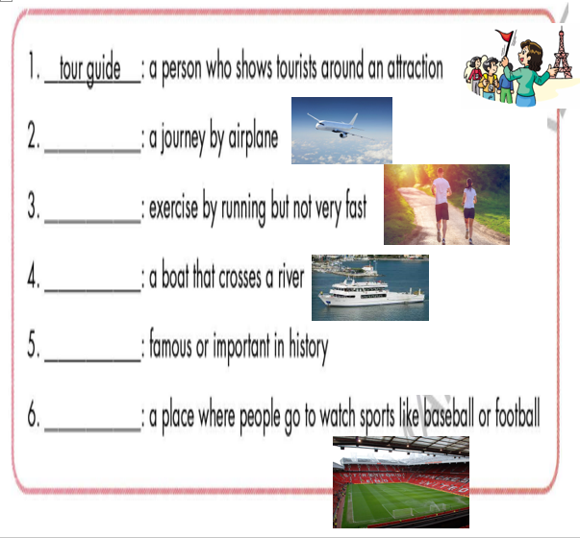  Task b. Do you know any historic places? Tell your partner.  - Have pairs discuss and list some historic places.  - Have Ss share their answers in front of the class.  - Give feedback and evaluation. | - Look and listen.  - Work individually.  - Work in pairs.  - Give answers.  - Listen and repeat.  Answer keys  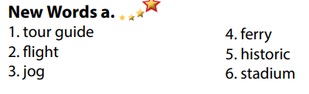  - Look and listen.  - Work individually.  - Work in pairs.  - Give answers.  - Listen and repeat.  Answer keys  - Work in pairs.  - Present.  Sample answers  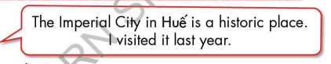
Activity 2: While - Reading
a) Objective: Students can develop their reading skill.
b) Content:
- Read Jane's email to her friend. Where is Jane?
- Read and circle the correct answer.
c) Expected outcomes: Students can read an email and understand more about some tourist attractions in the USA.
d) Organization of the activity:
TEACHER’S ACTIVITIES | STUDENTS’ ACTIVITIES
Task a. Read Jane's email to her friend. Where is Jane?  - Ask Ss to scan the email, then choose the correct answer.  - Remind Ss to underline or highlight the keywords or supporting ideas for their answers.  - Have some Ss share their answers with the class (read), explain for their answers.  - Give feedback.  - Give feedback and correct Ss’ answers if necessary.  Task b. Read and circle the correct answer.  - Have Ss look at the content of task b.  - Have Ss scan the text again and circle the correct answer.  - Elicit answers from different pairs.  - Give feedback and evaluation. | - Work individually.  - Read answers, explain.  - Check answers.  Answer keys    - Read.  - Work in pairs to circle the correct answer.  - Read answers.  Answer keys  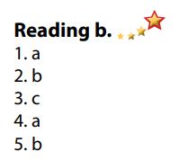
Activity 3: Post - Reading a) Objective: Students can use the vocabulary and ideas from the reading text to develop their speaking skill.
b) Content: Speaking: What do you know about the United States? Would you like to visit it?
c) Expected outcomes: Students can have a free talk about the USA.
d) Organization of the activity:
TEACHER’S ACTIVITIES | STUDENTS’ ACTIVITIES
Task c. In pairs: What do you know about the United States? Would you like to visit it?  - Have Students work in pairs to answer the questions.  - Go round and give help if necessary.  - Call some Ss to share their ideas with the whole class.  - Give feedback and evaluation. | - Discuss in pairs.  - Present.  - Listen.
C. Consolidation and homework assignments
* Consolidation:
- Words about tourism and cultures: (tour guide, stadium, flight, historic, jog, ferry).
* Homework:
- Learn the new words by heart.
- Practice talking about your favorite English - speaking country that you would like to visit.
- Do the exercises in WB: New words + Reading (Page 50).
- Do the vocabulary exercise in Tiếng Anh 7 i-Learn Smart World Notebook (page 54).
- Play consolation games in Tiếng Anh 7 i-Learn Smart World DHA App on www.eduhome.com.vn
- Prepare: Unit 9 - Lesson 1.2 – Grammar (page 69 – SB).
*****************************************************************
Teaching date: 05/4/2023
Period 86 UNIT 9: ENGLISH IN THE WORLD
Lesson 1.2 - Grammar (page 69)
I. OBJECTIVES
By the end of the lesson, Ss will be able to:
1.1. Language knowledge and skills
- use articles correctly. (zero article and “the”).
- talk about plan for a trip.
- know more some famous tourist attractions in London and in the world.
1.2. Competences
- improve speaking, listening skills.
- improve the use of English.
1.3. Attributes
- love studying English.
- respect cultures of other countries in the world.
II. TEACHING AIDS AND LEARNING MATERIALS
1. Teacher’s aids: Student book and Teacher’s book, class CDs, Digital Book (DCR phần mềm tương tác SB, DHA (từ vựng/ cấu trúc) phần mềm trò chơi tương tác), projector/interactive whiteboard / TV (if any), PowerPoint slides, handouts.
2. Students’ aids: Student’s book, workbook, notebook, handouts.
III. ASSESSMENT EVIDENCE
Performance Tasks | Performance Products | Assessment Tools
- Listen and repeat. | - Ss’ performance. | - T’s feedback.
- Study the grammar box. | - Ss’ answers/ presentation. | - T’s feedback.
- Write sentences, using the prompts. | - Ss’ answers. | - T’s feedback/Peers’ feedback.
- Fill in the blanks using “the” or Ø (zero article). | - Ss’ answers. | - T’s feedback/Peers’ feedback.
- Speak: Make sentences with your partner for a trip to London. Use the prompts. | - Ss’ answers/ presentation. | - T’s observation, T’s feedback/Peers’ feedback.
IV. PROCEDURES
A. Warm up:
a) Objective: Introduce the new lesson and set the scene for Ss to acquire new language; get students' attention at the beginning of the class by enjoyable and short activities as well as to engage them in the follow-up steps.
b) Content: Introduce some famous tourist attractions in the world / Introduce some famous tourist attractions London.
c) Expected outcomes: Ss know some famous tourist attractions which are very useful for them in the new lesson.
d) Organization of the activity:
TEACHER’S ACTIVITIES | STUDENTS’ ACTIVITIES
Option 1: Introduce some famous tourist attractions in the world.  - Have Ss close books and notebooks.  - Introduce some famous tourist attractions in the world (using pictures).  - Ask Ss some questions:  1. Do you know anything about these places?  2. Which tourist attractions would you like to visit?  - Call Ss to give answers.  - Check Ss’ answers, give feedback.  - Lead to the new lesson.  *Illustration:  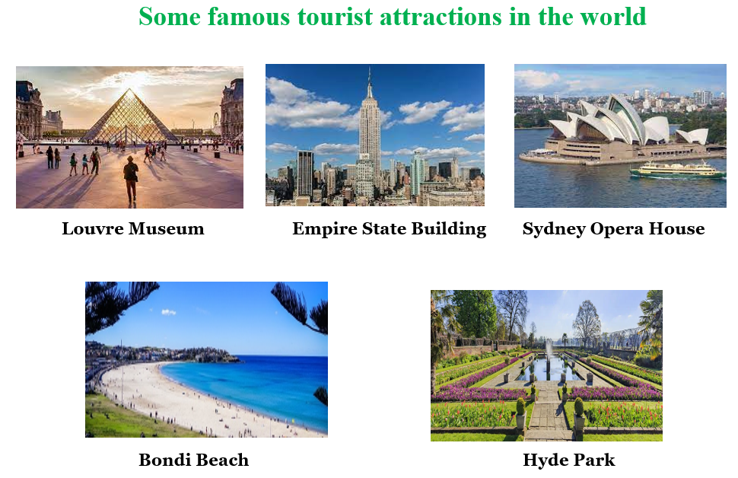  Option 2: Introduce some famous tourist attractions London.  - Have Ss close books and notebooks.  - Introduce some famous tourist attractions in London (using pictures).  - Ask Ss some questions:  1. Do you know anything about these places?  2. Which tourist attractions would you like to visit most?  3. Do you know any other famous places in London?  - Call Ss to give answers.  - Check Ss’ answers, give feedback.  - Lead to the new lesson.  *Illustration  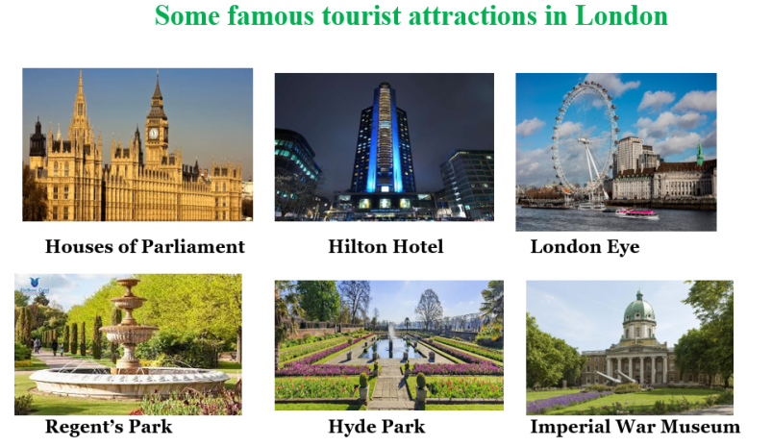 | - Close books and notebooks.  - Look at the pictures, then answer the questions.  - Give answers.  - Close books and notebooks.  - Look at the pictures, then answer the questions.  - Give answers.  - Listen and write the new lesson.
B. New lesson
Activity 1: Presentation
a) Objective: Introduce: Zero article and “the”.
b) Content:
- Listen and repeat.
- Introduce the grammar points.
c) Expected outcomes: Ss know the new grammar points: Zero article and “the” and use them in some exercises that follow.
d) Organization of the activity:
TEACHER’S ACTIVITIES | STUDENTS’ ACTIVITIES
Task a. Listen and repeat.  - Have Ss look at the picture using DCR.  - Play audio (CD2 – Track 13) and have Ss listen and read the speech bubbles.  - Play the audio again and have Ss listen and repeat.  Grammar box  Option 1:  - Have Ss look at the grammar explanation and read: Articles.  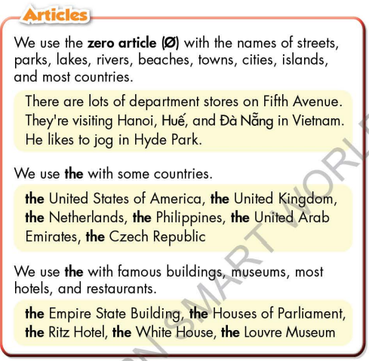  - Have Ss read the examples.  - Explain more about the way to use Zero article and “the”.  - Ask Ss to make more sentences using Zero article and “the”.  - Give feedback and evaluation.  Option 2:  - Have Ss look at the sentences in the speech bubbles in Task a and read them again.  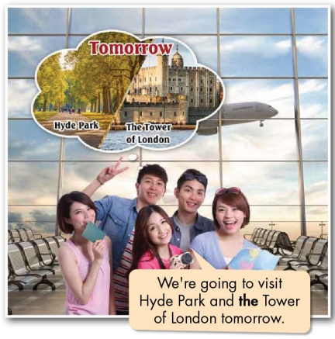  - Have Ss make comments on the words in bold (the).  - Ask Ss some elicit questions:  1 How many articles are there in English?  2 Can you guess: Why do they use “the” in front of Tower of London, but not for Hyde Park?  - Call Ss to give answers.  - Give feedback.  - Then, lead to the grammar box, briefly explain the way to Zero article and “the”.  - Have Ss read the grammar box and examples.  - Ask Ss to make more sentences using Zero article and “the” with proper nouns.  - Give feedback and evaluation. | - Look.  - Listen, then read.  - Listen and repeat.  - Look and read.  - Read examples of different forms.  - Listen and take notes.  - Give more examples.  - Look and read.  - Comment.  - Listen and take notes.  - Read.  - Give more examples.  - Listen.
Activity 2: Practice (19’)
a) Objective: Students can use Zero article and “the” to do the given exercises.
b) Content:
- Write sentences, using the prompts.
- Fill in the blanks using “the” or Ø (zero article).
c) Expected outcomes: Students can get used to the usage of “the” and Ø (zero article).and use them correctly.
d) Organization of the activity:
TEACHER’S ACTIVITIES | STUDENTS’ ACTIVITIES
Task b. Write sentences, using the prompts.  - Demonstrate the activity on DCR, using the example.  - Have Ss read the prompts, then write sentences.  - Have Ss work in pairs to check each other’s work.  - Have some Ss share their answers with the whole class.  - Give feedback, correct Ss’ answers if necessary.  Task c. Fill in the blanks using “the” or Ø (zero article).  - Demonstrate the activity on DCR using the example.  - Have students read the email, fill in the blanks using “the” or Ø (zero article).  - Have pairs check each other's work.  - Have some students share their answers with the class. | - Look and listen.  - Work individually.  - Work in pairs.  - Write answers.  Answer keys  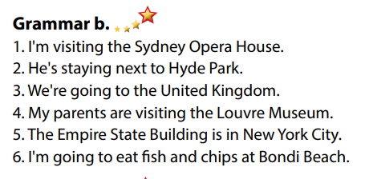  - Look and listen.  - Work individually.  - Work in pairs.  - Read answers, explain.  Answer keys  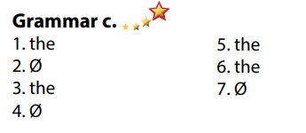
Activity 3: Production
a) Objective: Students master the grammar points they study in the lesson.
b) Content: Speaking: Make sentences with your partner for a trip to London. Use the prompts.
c) Expected outcomes: Ss produce the new language successfully, and they can use the grammar point in the lesson in everyday speaking and writing.
d) Organization of the activity:
TEACHER’S ACTIVITIES | STUDENTS’ ACTIVITIES
Task d. In pairs: Make sentences with your partner for a trip to London. Use the prompts.  - Divide class into pairs.  - Have Ss take turns to make sentences with your partner for a trip to London, use the prompts.  - Have some pairs share their answers with the class.  - Give feedback and evaluation. | - Have conversation in pairs.  - Present.  - Listen.
C. Consolidation and homework assignments
* Consolidation: “the” and Ø (zero article).

* Homework:
- Make 2 sentences using the article “the” and Ø (zero article).
- Do the exercises in WB: Grammar & Writing (page 51).
- Complete the grammar notes in Tiếng Anh 7 i-Learn Smart World Notebook (page 55).
- Play consolation games in Tiếng Anh 7 i-Learn Smart World DHA App on www.eduhome.com.vn
- Prepare: Lesson 1.3 – Pronunciation and Speaking (page 70 – SB).
********************************************************************
Teaching date: 06/4/2023
Period 87 UNIT 9: ENGLISH IN THE WORLD
Lesson 1.3 – Pronunciation and Speaking (page 70)
I. OBJECTIVES
By the end of the lesson, Ss will be able to:
1.1. Language knowledge and skills
- distinguish and use /ð/ sound correctly.
- ask and answer about holiday plan (where to go, where to stay, what to eat, what to do, where to visit).
- make holiday plans.
1.2. Competences
- improve listening and speaking skills.
1.3. Attributes
- love studying English, love travelling.
- respect cultures of other countries in the world.
II. TEACHING AIDS AND LEARNING MATERIALS
1. Teacher’s aids: Student book and Teacher’s book, class CDs, Digital Book (DCR phần mềm tương tác SB, DHA (từ vựng/ cấu trúc) phần mềm trò chơi tương tác), projector/interactive whiteboard / TV (if any), PowerPoint slides, handouts.
2. Students’ aids: Student’s book, workbook, notebook, paper.
III. ASSESSMENT EVIDENCE
Performance Tasks | Performance Products | Assessment Tools
- Listen to the words and focus on the underlined letters. | - Ss’ performance and answers. | - T’s observation.
- Listen and cross out the word that doesn’t follow the note in “a”. | - Ss’ answers. | - T’s feedback/Peers’ feedback.
- Read the words with the sound noted in “a” with a partner. | - Ss’ performance. | - T’s feedback/Peers’ feedback.
- Ask and answer using the questions and the prompts. | - Ss’ performance. | - T’s feedback/Peers’ feedback.
- You're talking to your friend about your holiday plans. In pairs: Student B, turn to page 122, File 9. Student A, answer Student B's questions about Australia. Swap roles. Ask about Canada and complete the table. | - Ss’ performance /  Presentation. | - T’s observation, T’s feedback/Peers’ feedback.
- Which city would be more interesting to visit? Why? | - Ss’ performance /  Answers. | - T’s feedback/Peers’ feedback.
IV. PROCEDURES
A. Warm up:
a) Objective: Introduce the new lesson and set the scene for Ss to acquire new language; get students' attention at the beginning of the class by enjoyable and short activities as well as to engage them in the follow-up steps.
b) Content: Introduce /ð/ sound / Introduce London and Los Angeles.
c) Expected outcomes: Ss know some information that is useful for them in other speaking activities.
d) Organization of the activity:
TEACHER’S ACTIVITIES | STUDENTS’ ACTIVITIES
Option 1: Introduce /ð/ sound: Chinese whisper  - Divide class into 4-5 groups.  - Have Ss in each group stand in a straight line.  - Give a sentence, have the last student in each line. whisper this sentence to the student standing before; continue until the first student in the line can hear the sentence and write it on the board.  - Check Ss’ answers.  - The group which has the closest sentence to the original one will be the winner. (T also checks spelling.)  - Announce the winner and give a small present.  - Lead to the new lesson: /ð/ sound.  *Suggested sentence: They want their fathers and mother take them to their fatherland.  Option 2: Introduce: London and Los Angeles  - T introduces London and Los Angeles, using pictures and questions.  - Have Ss answer the questions to find the hidden cities behind the questions. There are 4 questions in each picture.  - Have Ss answer the questions one by one to find out the name of the city.  - Check Ss’ answers.  - The student who has the correct answer from the very first clue will be the winner.  - Announce the winner and give a small present.  - Lead to the new lesson.  *Illustration:  City 1:  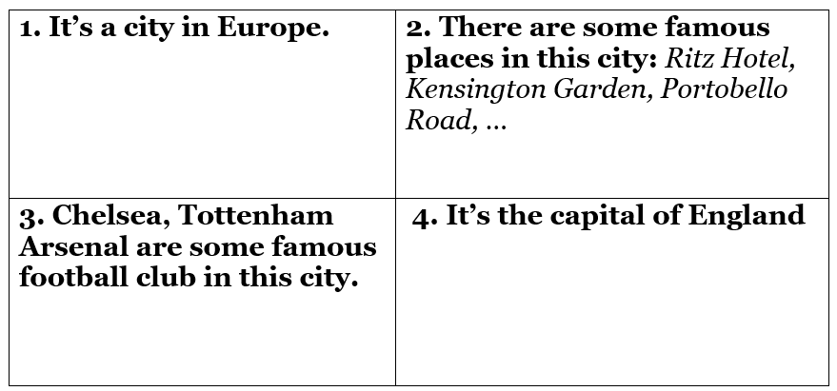  City 2:  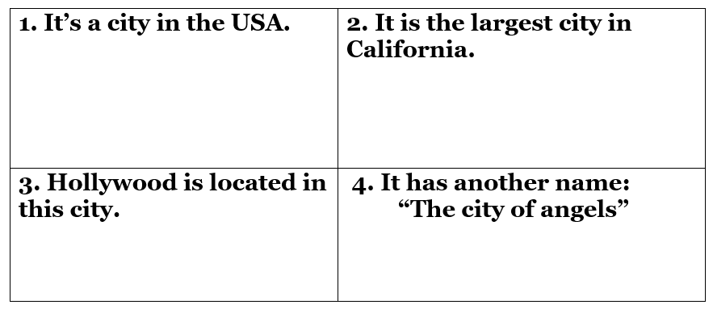 | - Form groups.  - Work in groups to take part in the game.  - The first student of each line writes answer on the board.  - Listen.  - Find the hidden cities behind the questions  - Listen.  Answer keys  City 1: London    City 2: Los Angeles  
B. New lesson
Activity 1: Pre-Speaking: Pronunciation
a) Objective: Introduce: /ð/ sound.
b) Content:
- recognize: /ð/ sound.
- listen and check, cross out the word that doesn’t follow the note in “a”.
- practice.
c) Expected outcomes: Ss distinguish and use /ð/ sound in their speaking.
d) Organization of the activity:
TEACHER’S ACTIVITIES | STUDENTS’ ACTIVITIES
Task a + b. Listen to the words and focus on the underlined letters.  - Play the recording (CD2, track 14) using DCR.  - Ask Ss to listen and focus on the underlined letters.  - Play the recording again, have Ss listen and repeat with a focus on the sound feature.  Task c + d. Listen and cross out the word that doesn’t follow the note in “a”.  - Play the recording (CD 2 – Track 15), have Ss listen and cross out the option that doesn’t follow the note in “a”.  - Call Ss to give answers.  - Play the recording again and check answers as a whole class using DCR.  - Give feedback and evaluation. | - Listen.  - Listen again and repeat.  - Listen and give answers.  Answer keys  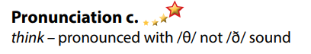
Activity 2: While-speaking
a) Objective: Students can talk about plan for a trip (where to go, where to stay, what to eat, what to do, where to visit, …).
b) Content:
- Ask and answer using the questions and the prompts.
- You're talking to your friend about your holiday plans. In pairs: Student B, turn to page 122, File 9. Student A, answer Student B's questions about Australia. Swap roles. Ask about Canada and complete the table.
c) Expected outcomes: Ss produce the new language successfully.
d) Organization of the activity:
TEACHER’S ACTIVITIES | STUDENTS’ ACTIVITIES
PRACTICE  * Ask and answer using the questions and the prompts.  - Demonstrate the activity by practicing the role-play with a student.  - Divide the class into pairs.  - Have pairs practice the conversation.  - Swap roles and repeat using the ideas in the table.  - Observe, give help if necessary.  - Have some pairs demonstrate the activity in front of the class.  - Give feedback and evaluation.  SPEAKING: What an Amazing Trip!  Task a. You're talking to your friend about your holiday plans. In pairs: Student B, turn to page 122, File 9. Student A, answer Student B's questions about Australia. Swap roles. Ask about Canada and complete the table.  - Demonstrate the activity by practicing the activity with a student.  - Divide the class into pairs.  - Have Student B turn to page 122, File 9.  - Have Student B ask Student A questions and complete the table.  - Have students swap roles and repeat.  - Observe, give help if necessary.  - Have Ss pay attention to the tip:  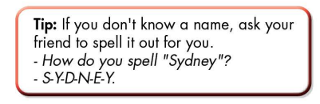 | - Observe, listen.  - Work in pairs.  - Present.  - Observe and listen.  - Work in pairs.  - Discuss and complete the table.
Activity 3: Production
a) Objective: Students report the results.
b) Content: Which city would be more interesting to visit? Why?
c) Expected outcomes: Ss produce the new language successfully in everyday speaking and writing.
d) Organization of the activity:
TEACHER’S ACTIVITIES | STUDENTS’ ACTIVITIES
Task b. Which city would be more interesting to visit? Why?  - Have students discuss in pairs which city would be more interesting to visit.  - Have some students share their findings with the class.  - Give feedback and evaluation. | - Discuss in pairs.  - Present.
C. Consolidation and homework assignments
*Consolidation: Some sords with /ð/ sound: they, them, then, this, that, these, those, father, mother, weather, breathe, other, either, whether, then, although, brother, southern.
*Homework:
- Practice: reading /ð/ sound.
- Find more words with /ð/ sound.
- Prepare: Unit 9 - Lesson 2.1 – New words and Listening (page 71 – SB).
- Review the vocabulary and grammar notes in Tiếng Anh 7 i-Learn Smart World Notebook
(pages 54 & 55).
- Play consolation games in Tiếng Anh 7 i-Learn Smart World DHA App on www.eduhome.com.vn
**************************************************************
Teaching date: 10/4/2023
Period 88 UNIT 9: ENGLISH IN THE WORLD
Lesson 2.1 – New words and Listening (page 71)
I. OBJECTIVES
By the end of the lesson, Ss will be able to:
1.1. Language knowledge and skills
- know more words about tourism (souvenirs, sightseeing, swimsuit, postcards, photos, beach, wallet).
- talk about things to do on holidays and holidays in English speaking countries.
- listen to and understand a conversation of two people talking about their holiday (for general and specific details).
- know how to end a conversation.
1.2. Competences
- improve communication, collaboration, and critical thinking skills.
1.3. Attributes
- love studying English, love travelling.
- have good preparation for any trip.
II. TEACHING AIDS AND LEARNING MATERIALS
1. Teacher’s aids: Student book and Teacher’s book, class CDs, Digital Book (DCR phần mềm tương tác SB, DHA (từ vựng/ cấu trúc) phần mềm trò chơi tương tác), projector/interactive whiteboard / TV (if any), PowerPoint slides.
2. Students’ aids: Student’s book, workbook, notebook.
III. ASSESSMENT EVIDENCE
Performance Tasks | Performance Products | Assessment Tools
- Number the pictures. | - Ss’ answers. | - T’s feedback/Peers’ feedback.
- Listen and repeat. | - Ss’ presentation. | - T’s feedback/Peers’ feedback.
- Talk about the things you do on holiday. | - Ss’ presentation/ answers. | - T’s feedback/Peers’ feedback.
- Listen to Peter and Janet talking about their holidays. Who enjoyed their holiday more? | - Ss’ answers. | - T’s feedback/Peers’ feedback.
- Listen and fill in the blanks. | - Ss’ answers. | - T’s feedback/Peers’ feedback.
- Speak: What did you like most about your last holiday? | - Ss’ answers/ presentation. | - T’s observation and feedback.
IV. PROCEDURES
A. Warm up:
a) Objective: Introduce the new lesson and set the scene for Ss to acquire new language; get students' attention at the beginning of the class by enjoyable and short activities as well as to engage them in the follow-up steps.
b) Content: Introduce words about tourism, holiday / Introduce: Language to begin and end a conversation.
c) Expected outcomes: Ss get to know some new words / structures they are going to study in the lesson.
d) Organization of the activity:
TEACHER’S ACTIVITIES | STUDENTS’ ACTIVITIES
Option 1: Number the pictures. Listen and repeat.  - Use the “New words” part a– page 71 for the warm-up activity.  - Show words and pictures using DCR, have Ss look and number the pictures (in pairs).  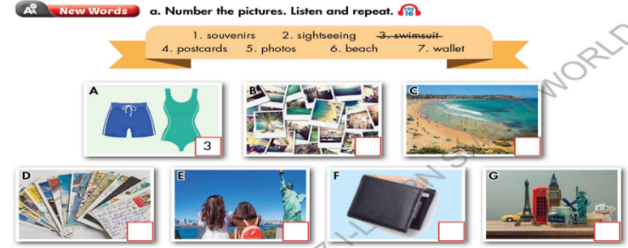  - Call Ss to give answers.  - Give feedback and show correct answers.  - Lead to the new lesson.  - Play the audio (CD2 – Track 16), have Ss listen and repeat.  - Correct Ss’ pronunciation if necessary.  Option 2: Starting a conversation or Ending a conversation?  - Let Ss read the expressions which are commonly used when people are chatting.  - Have Ss work in pairs to place them under the appropriate heading: Starting a conversation or Ending / Closing a conversation.  - Call Ss to give answers.  - Check Ss’s answers and give feedback.  - Lead to the new lesson.  *Illustration:  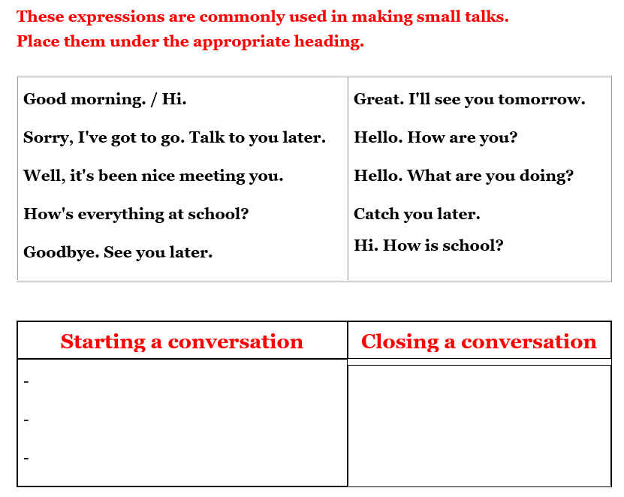 | - Work in pairs to number the pictures.  - Give answers.  - Listen.  - Listen and repeat.  Answer keys  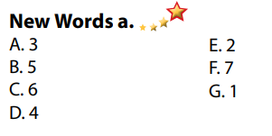  - Work in pairs to place them under the appropriate heading: Starting a conversation or Ending / Closing a conversation.  - Read answers.  - Listen.  Answers keys  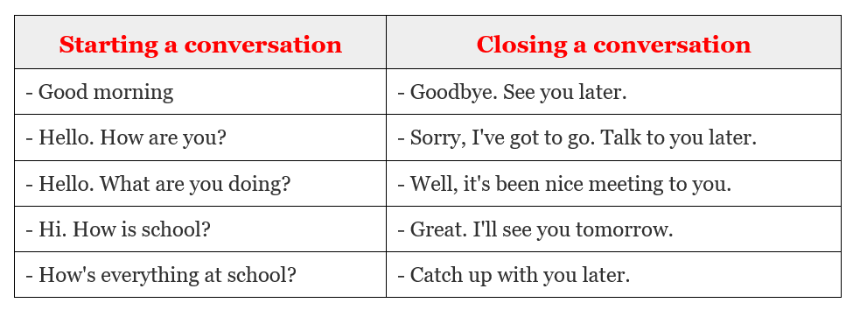
B. New lesson
Activity 1: Pre-Listening (Vocabulary)
a) Objective: Ss get to know words about tourism / holiday.
b) Content:
- Vocabulary study (souvenirs, sightseeing, swimsuit, postcards, photos, beach, wallet).
- Speaking: Talk about the things you do on holiday.
c) Expected outcomes: Ss know how to pronounce the new words correctly and use them when they do some listening tasks.
d) Organization of the activity:
TEACHER’S ACTIVITIES | STUDENTS’ ACTIVITIES
Task a. Number the pictures. Listen and repeat.  Option 1 (If the teacher hasn’t used this part for the Warm-up activity.)  - Demonstrate the activity on DCR, using the example.  - Have Ss number the pictures.  - Divide class into pairs and have them check their answers with their partners.  - Call Ss to give answers.  - Check answers as a whole class using DCR.  - Play audio (CD2 – Track 16). Have Ss listen and repeat.  - Correct Ss’ pronunciation.  Option 2: (If the teacher has used part a. for the Warm-up activity.) Fill in the blanks.  - Have Ss look at the pictures and fill in the blanks by the words they have known in Task a (from Warm up activity. (T uses different pictures from those in the textbook.)  - Have Ss give answers and tell the meaning of words / phrases again.  - Check answers as a whole class.  - Call some Ss to read the words again.  - Correct Ss’ pronunciation if necessary.  *Illustration:  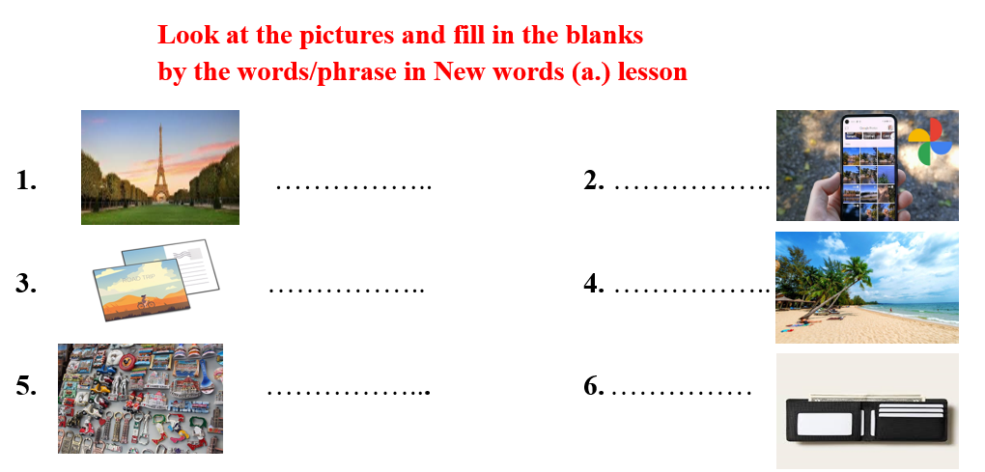  Task b. In pairs: Talk about the things you do on holiday.  - Have Ss work in pairs to talk about the things they do on holiday.  - Go round and give help if necessary.  - Have some pairs demonstrate the activity in front of the class.  - Give feedback and evaluation. | - Look and listen.  - Work individually.  - Work in pairs.  - Give answers.  - Listen and repeat.  Answer keys  - Work in pairs  - Give answers, meaning.  - Read.  Answer keys  1 sightseeing  2 postcards  3 souvenirs  4 photos  5 beach  6 wallet  - Work in pairs to discuss.  - Present.  Sample answers  
Activity 2: While - Listening
a) Objective: Students can develop their listening skill.
b) Content:
- Listen to Peter and Janet talking about their holidays. Who enjoyed their holiday more?
- Listen and fill in the blanks.
c) Expected outcomes: Ss can listen to and understand a conversation of two people talking about their holidays (for general and specific details).
d) Organization of the activity:
TEACHER’S ACTIVITIES | STUDENTS’ ACTIVITIES
Task a. Listen to Peter and Janet talking about their holidays. Who enjoyed their holiday more?  - Have Ss read the question, guess the answer.  - Play audio (CD2 - Track 17).  - Have Ss listen and give answers.  - Check answers as a whole class using DCR.  Task b. Now, listen and fill in the blanks  - Have Ss read the through the content of Task b, underline the key words.  - Play the audio again (CD2 - Track 17).  - Have Ss listen and fill in the blanks.  - Remind Ss to use short answer for each question (ONE word only).  - Have Ss check answers with their partners.  - Call Ss to give answers.  - Give feedback and show correct answers using DCR. | -Work individually.  - Listen.  - Give the correct answers.  Answer keys    - Read, underline the key words.  - Do the task.  - Exchange answers.  Answer keys  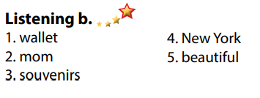
Activity 3: Post - Listening
a) Objective: Students can use the vocabulary and the content in listening part to develop their speaking skill.
b) Content: Speaking: What did you like most about your last holiday?
c) Expected outcomes: Students can talk about their personal belongings for travelling.
d) Organization of the activity:
TEACHER’S ACTIVITIES | STUDENTS’ ACTIVITIES
Conversation skill  - Have Ss look at the Conversation skill box and read.  - Play audio (CD 2 - Track 18), have Ss listen and repeat (using DCR).  - Ask Ss to find more ways to end a conversation.  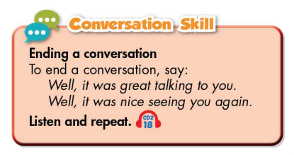  Task c. In pairs: What did you like most about your last holiday?  - Have Ss work in pairs to discuss the question.  - Observe and give help if necessary.  - Call some pairs to share their ideas with the class.  - Give feedback and evaluation. | - Look and read.  - Listen and repeat.  - Give answers.  - Work in pairs.  - Present.
C. Consolidation and homework assignments
* Consolidation:
- Words relating to tourism / holiday (souvenirs, sightseeing, swimsuit, postcards, photos, beach, wallet).
- Language for ending a conversation:
- Well, it was great talking to you
- Well, it was night seeing you again.
- Goodbye. See you later.
- Sorry, I've got to go. Talk to you later.
- Well, it's been nice meeting to you.
- Great. I'll see you tomorrow.
- Catch up with you later.
* Homework
- Learn the new words by heart.
- Practice talking about things you do on holiday.
- Do the exercises in WB: New words and Listening (page 52).
- Do the vocabulary exercise in Tiếng Anh 7 i-Learn Smart World Notebook (page 56).
- Play consolation games in Tiếng Anh 7 i-Learn Smart World DHA App on www.eduhome.com.vn
- Prepare: Lesson 2.2 – Grammar (page 72 – SB).
*******************************************************************
Teaching date: 12/4/2023
Period 89 UNIT 9: ENGLISH IN THE WORLD
Lesson 2.2 Grammar (page 72)
I. OBJECTIVES
By the end of the lesson, Ss will be able to:
1.1. Language knowledge and skills
- use Past Simple with regular verbs correctly.
- talk about their last holiday.
1.2. Competences
- improve speaking, listening and writing skills.
- improve the use of English.
1.3. Attributes
- love studying English, love travelling.
- have good preparation for any trip.
II. TEACHING AIDS AND LEARNING MATERIALS
1. Teacher’s aids: Student book and Teacher’s book, class CDs, Digital Book (DCR phần mềm tương tác SB, DHA (từ vựng/ cấu trúc) phần mềm trò chơi tương tác), projector/interactive whiteboard / TV (if any), PowerPoint slides, handouts.
2. Students’ aids: Student’s book, workbook, notebook.
III. ASSESSMENT EVIDENCE
Performance Tasks | Performance Products | Assessment Tools
- Listen and repeat. | - Ss’ performance. | - T’s feedback.
- Study the grammar box. | - Ss’ task. | - T’s observation.
- Fill in the blanks with the correct form of the verbs in the box. | - Ss’ answers. | - T’s feedback/Peers’ feedback.
- Fill in the blanks with the correct Past Simple form of the verbs. | - Ss’ answers. | - T’s feedback/Peers’ feedback.
- Speak: Ask your partner about their last holiday. Use the prompts to ask the questions. | - Ss’ performance/ presentation. | - T’s observation, T’s feedback/Peers’ feedback.
IV. PROCEDURES
A. Warm up:
a) Objective: Introduce the new lesson and set the scene for Ss to acquire new language; get students' attention at the beginning of the class by enjoyable and short activities as well as to engage them in the follow-up steps.
b) Content: Review words / Introduce: Past simple with irregular verbs.
c) Expected outcomes: Ss review old knowledge and have general ideas about the grammar points they are going to study in the new lesson.
d) Organization of the activity:
TEACHER’S ACTIVITIES | STUDENTS’ ACTIVITIES
Option 1: Matching  - Have Ss close all books.  - Have Ss work in pairs to match verbs in A with words / phrases in B.  - Call Ss to give answers, have Ss read the verb phrases again, tell the meaning.  - Lead to the new lesson.  *Illustration:  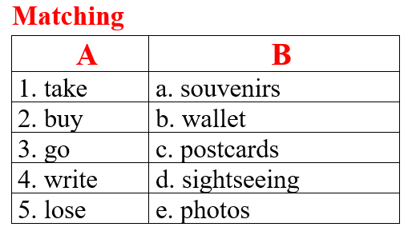  Option 2: Introduce: Past simple with irregular verbs.  - Show the irregular verb lists, briefly introduce this to Ss.  - Lead to the new lesson.  *Illustration:  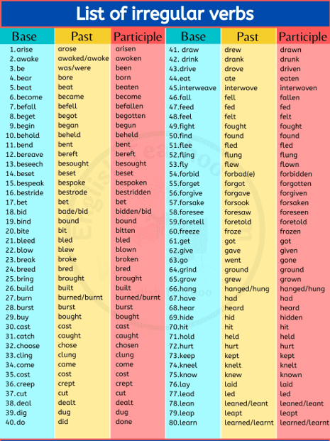 | - Close books.  - Do the matching.  - Give answers.  - Listen.  Answers keys  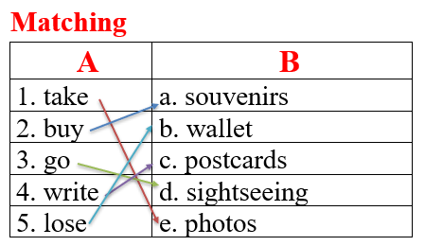  - Listen.
B. New lesson
Activity 1:
a) Objective: Introduce: Past Simple with regular verbs.
b) Content:
- Listen and repeat.
- Introduce the grammar point: Past Simple with regular verbs.
c) Expected outcomes: Ss know how to use Past Simple with regular verbs to do some following exercises.
d) Organization of the activity:
TEACHER’S ACTIVITIES | STUDENTS’ ACTIVITIES
Task a. Listen and repeat  - Have Ss look at the picture using DCR.  - Play audio (CD2 – Track 19) and have Ss listen and read the speech bubbles.  - Play the audio again and have Ss listen and repeat.  Grammar box  - Have Ss look at the grammar explanation, examples and read: Past Simple with regular verbs.  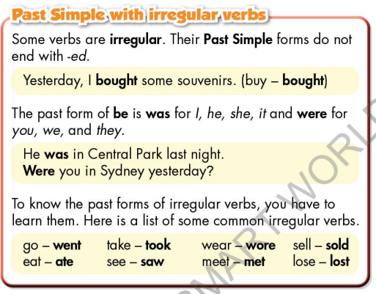  - Briefly explain the grammar point.  - Ask Ss to make sentences with Past Simple with regular verbs.  - Give feedback and evaluation. | - Look.  - Listen, then read.  - Listen and repeat.  - Look and read.  - Listen and take notes.  - Make sentences.
Activity 2: Practice
a) Objective: Students can use Past Simple with regular verbs correctly.
b) Content:
- Fill in the blanks with the correct form of the verbs in the box.
- Fill in the blanks with the correct Past Simple form of the verbs.
c) Expected outcomes: Students can use Past Simple with regular verbs to talk about holidays in their speaking.
d) Organization of the activity:
TEACHER’S ACTIVITIES | STUDENTS’ ACTIVITIES
Task b. Fill in the blanks with the correct form of the verbs in the box.  - Demonstrate the activity using DCR.  - Have students fill in the blanks.  - Have pairs check each other's work.  - Have some students share their answers with the class.  - Check Ss’ answers, give feedback.  Task c. Fill in the blanks with the correct Past Simple form of the verbs.  - Demonstrate the activity using the example.  - Have students read the message and the fill in the blanks with the correct Past Simple form of the verbs. - Have students check their answers with a partner.  - Check answers as a whole class using DCR. | - Look and listen.  - Work individually.  - Work in pairs.  - Write answers on the board.  Answer keys  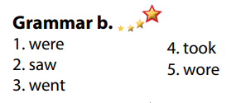  - Look and listen.  - Work individually.  - Work in pairs.  - Give answers.  Answer keys  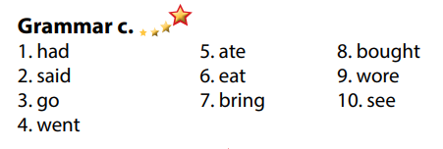
Activity 3: Production
a) Objective: Students master the grammar point they study in the lesson.
b) Content: Speaking: Ask your partner about their last holiday. Use the prompts to ask the questions.
c) Expected outcomes: Ss produce the new language successfully, and they can apply the grammar point they have learnt in speaking and writing.
d) Organization of the activity:
TEACHER’S ACTIVITIES | STUDENTS’ ACTIVITIES
Task d. Ask your partner about their last holiday. Use the prompts to ask the questions.  - Divide class into pairs.  - Have Ss ask each other questions using the prompts.  - Have some pairs demonstrate the activity in front of the class.  - Give feedback and evaluation. | - Have conversation in pairs.  - Present.  - Listen.
C. Consolidation and homework assignments
*Consolidation
- Past Simple with regular verbs
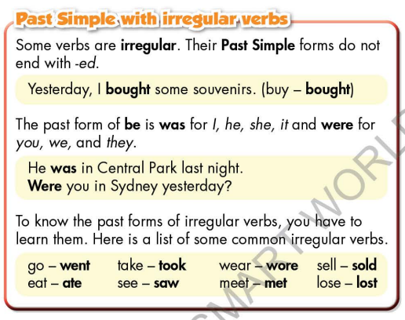
*Homework:
- Make 3 sentences using Past Simple with regular verbs.
- Lean by heart Past Simple with regular verbs: go-went, eat-ate, take-took, see-saw, sell-sold, lost-lost, wear-wore, meet-met, be-was/were, buy-bought.
- Do the exercises in WB: Grammar & Writing (page 53).
- Complete the grammar notes in Tiếng Anh 7 i-Learn Smart World Notebook (page 57).
- Play consolation games in Tiếng Anh 7 i-Learn Smart World DHA App on www.eduhome.com.vn
- Prepare: Lesson 2.3 – Pronunciation and Speaking (page 73 – SB).
*******************************************************************
Teaching date: 13/4/2023
Period 90 UNIT 9: ENGLISH IN THE WORLD
Lesson 2.3 – Pronunciation and Speaking (page 73)
I. OBJECTIVES
By the end of the lesson, Ss will be able to:
1.1. Language knowledge and skills
- distinguish and pronounce the /ə/ sound correctly.
- talk about holiday.
1.2. Competences
- improve listening and speaking skills.
1.3. Attributes
- love studying English, love travelling.
- have good preparation for any trip.
II. TEACHING AIDS AND LEARNING MATERIALS
1. Teacher’s aids: Student book and Teacher’s book, class CDs, Digital Book (DCR phần mềm tương tác SB, DHA (từ vựng/ cấu trúc) phần mềm trò chơi tương tác), projector/interactive whiteboard / TV (if any), PowerPoint slides, handouts.
2. Students’ aids: Student’s book, workbook, notebook.
III. ASSESSMENT EVIDENCE

Performance Tasks | Performance Products | Assessment Tools
- Listen to the words and focus on the underlined letters. | - Ss’ performance and answers. | - T’s observation.
- Listen to the /ə/ sound. Cross out the word that doesn’t follow the note in “a”. | - Ss’ answers. | - T’s feedback/Peers’ feedback.
- Read the words with the sound noted in “a” to a partner | - Ss’ performance. | - T’s feedback/Peers’ feedback.
- Practice the conversation. Swap roles and repeat. | - Ss’ performance. | - T’s feedback/Peers’ feedback.
- Make two more conversations using the ideas on the right. | - Ss’ performance /  Presentation. | - T’s observation, T’s feedback/Peers’ feedback.
- You just returned home from a holiday. In pairs: Student B, turn to page 122, File 10. Student A, answer Student B's questions about your trip. Then, swap roles. Ask questions and complete the table about Student B's holiday | - Ss’ performance /  Presentation. | - T’s observation, T’s feedback/Peers’ feedback.
- Discuss which city you would like to visit and why. | - Ss’ performance /  Presentation. | - T’s observation, T’s feedback/Peers’ feedback.
IV. PROCEDURES
A. Warm up:
a) Objective: Introduce the new lesson and set the scene for Ss to acquire new language; get students' attention at the beginning of the class by enjoyable and short activities as well as to engage them in the follow-up steps.
b) Content: Introduce the /ə/ sound.
c) Expected outcomes: Ss get to know what they are going to study in the new lesson and use them in other speaking activities.
d) Organization of the activity:
TEACHER’S ACTIVITIES | STUDENTS’ ACTIVITIES
Option 1: Introduce the /ə/ sound.  - Play a video clip to introduce the /ə/ sound.  - Have Ss watch the video clip and repeat/sing together.  - Lead to the new lesson: how to pronounce the /ə/ sound.  *Illustration:  Link:  https://www.youtube.com/watchfE  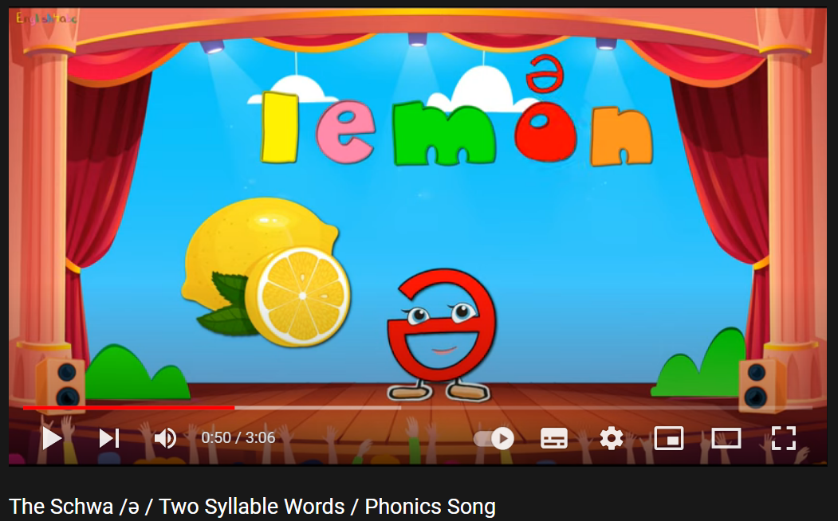  Option 2: Let Me In  - Give Ss some words with a missing letter.  - Have Ss find the missing letters to make these words meaningful.  - Ask Ss to give answers.  - Have Ss make comments on the sound of letters they have just added.  - Give feedback.  - Lead to the new lesson.  *Illustration:  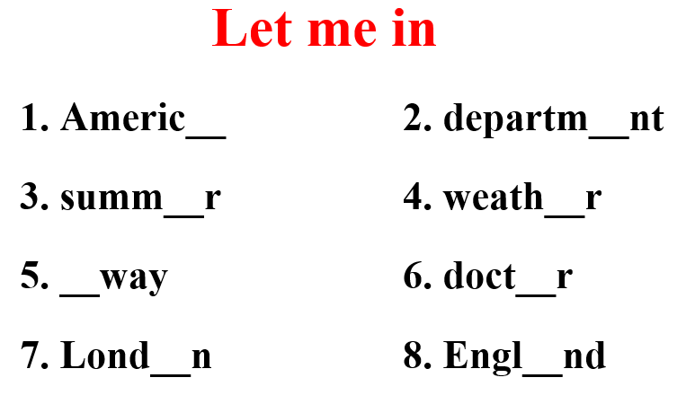 | - Watch and sing together.  - Find the missing letters.  - Give answers.  Suggested comment: They have the same sound: /ə/  Answer keys  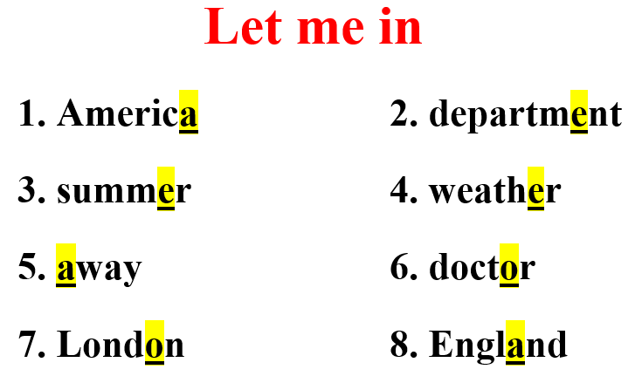
B. New lesson
Activity 1: Pre-Speaking: Pronunciation
a) Objective: Introduce the /ə/ sound.
b) Content:
- recognize: the /ə/ sound.
- listen to the /ə/ sound. Cross out the word that doesn’t follow the note in “a”.
- practice.
c) Expected outcomes: Ss distinguish and pronounce the /ə/ sound correctly in their speaking.
d) Organization of the activity:
TEACHER’S ACTIVITIES | STUDENTS’ ACTIVITIES
Task a + b. Listen to the words and focus on the underlined letters.  - Play the recording (CD2, track 20) using DCR.  - Ask Ss to listen and focus on the underlined letters.  - Play the recording again, have Ss listen and repeat with a focus on the sound feature.  - Explain more about how to pronounce the /ə/ sound:  The mouth position for /ə/ is neutral – the lips are relaxed, not rounded, the jaw is roughly half way open, and the tongue is flat, not forward or back. It is very similar to the long thinking vowel sound /ɜː/ as in BIRD, but it is always weak, so it’s short and soft.    Task c + d. Listen to the /ə/ sound. Cross out the word that doesn’t follow the note in “a”.  - Play the recording (CD 2 – Track 21), have Ss listen to the /ə / sound, then cross out the word that doesn’t follow the note in “a”.  - Call Ss to give answers.  - Play the recording again and check answers as a whole class using DCR.  - Give feedback and evaluation. | - Listen.  - Listen again and repeat.  - Listen.  - Listen and give answers.  Answers keys  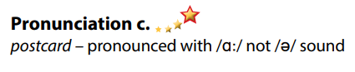
Activity 2: While-speaking
a) Objective: Students can talk about their holidays.
b) Content:
- Practice the conversation. Swap roles and repeat.
- Make two more conversations using the ideas on the right.
- You just returned home from a holiday. In pairs: Student B, turn to page 122, File 10. Student A, answer Student B's questions about your trip. Then, swap roles. Ask questions and complete the table about Student B's holiday.
c) Expected outcomes: Ss produce the new language successfully.
d) Organization of the activity:
TEACHER’S ACTIVITIES | STUDENTS’ ACTIVITIES
PRACTICE  Task a. Practice the conversation. Swap roles and repeat.  - Demonstrate the activity by practicing the role-play with a student.  - Divide the class into pairs.  - Have pairs practice the conversation.  - Swap roles and repeat.  - Have some pairs demonstrate the activity in front of the class.  - Give feedback and evaluation.  Task b. Make two more conversations using the ideas on the right.  - Have pairs make two more conversations using the ideas on the right.  - Have some pairs demonstrate the activity in front of the class.  SPEAKING: How Was Your Holiday?  * Task a. You just returned home from a holiday. In pairs: Student B, turn to page 122, File 10. Student A, answer Student B's questions about your trip. Then, swap roles. Ask questions and complete the table about Student B's holiday.  - Demonstrate the activity by practicing the activity with a student.  - Divide the class into pairs.  - Have Student B turn to page 122, File 10.  - Have Student B ask and Student A answer to complete the table.  - Have students swap roles and repeat.  - Observe, give help if necessary.  - Have some students demonstrate the activity in front of the class.  - Give feedback and evaluation. | - Observe, listen.  - Work in pairs.  - Present.  - Work in pairs.  - Present.  - Observe, listen.  - Work in pairs.  - Present.
Activity 3: Production
a) Objective: Students can share their ideas about the city they would like to visit.
b) Content: Discuss which city you would like to visit and why.
c) Expected outcomes: Ss produce the new language successfully in everyday speaking and writing.
d) Organization of the activity:
TEACHER’S ACTIVITIES | STUDENTS’ ACTIVITIES
SPEAKING: How Was Your Holiday?  Task b. Discuss which city you would like to visit and why.  - Have students discuss which city they would like to visit and give reasons.  - Have some students share their ideas with the class.  - Give feedback and evaluation. | - Discuss in pairs / groups.  - Present.
C. Consolidation and homework assignments
* Consolidation: Some words with the /ə/ sound: America, apartment, away, paper, vacation, London, England, summer.
* Homework:
- Practice: reading words with the /ə / sound.
- Find more words containing the /ə / sound.
- Prepare: Unit 9 - Lesson 3 –Listening and Reading (page 74 – SB).
- Review the vocabulary and grammar notes in Tiếng Anh 7 i-Learn Smart World Notebook
(pages 56 & 57).
- Play consolation games in Tiếng Anh 7 i-Learn Smart World DHA App on www.eduhome.com.vn
****************************************************************

Teaching date: 17/4/2023
Period 91 UNIT 9: ENGLISH IN THE WORLD
Lesson 3.1 - Listening and Reading
I. OBJECTIVES
By the end of the lesson, Ss will be able to:
1.1. Language knowledge and skills
- talk about benefits of speaking English.
- practice listening and understanding a recording about benefits of English (for general and specific information).
- read and understand a postcard about a visit to an English speaking country (for gist and details).
1.2. Competences
- improve communication, collaboration, analytical and critical thinking skills.
1.3. Attributes
- love studying English, love travelling.
- have good preparation for any trip.
II. TEACHING AIDS AND LEARNING MATERIALS
1. Teacher’s aids: Student book and Teacher’s book, class CDs, Digital Book (DCR phần mềm tương tác SB, DHA (từ vựng/ cấu trúc) phần mềm trò chơi tương tác), projector/interactive whiteboard / TV (if any), PowerPoint slides.
2. Students’ aids: Student’s book, workbook, notebook.
III. ASSESSMENT EVIDENCE
Performance Tasks | Performance Products | Assessment Tools
- Let’s Talk: Look at the pictures of people using English. What are they doing? What are some ways speaking English can help you? | - Ss’ answers / presentation. | - T’s feedback/Peers’ feedback.
- Listening: Listen to Minh talking at a school career day. Choose the correct statement. | - Ss’ answers. | - T’s feedback/Peers’ feedback.
- Listen and tick (✓) the things Minh used English for. | - Ss’ answers. | - T’s feedback/Peers’ feedback.
- Reading: Read the postcard. Which country is An visiting? | - Ss’ answers. | - T’s feedback/Peers’ feedback.
- Now, read and write True or False. | - Ss’ answers. | - T’s feedback/Peers’ feedback.
-Speaking: Would you like to visit an English-speaking country? Which one? What problems do you think you would have? | - Ss’ answers / presentation. | - T’s observation/ DCR and T’s feedback.
IV. PROCEDURES
A. Warm up:
a) Objective: Introduce the new lesson and set the scene for Ss to acquire new language; get students' attention at the beginning of the class by giving enjoyable and short activities as well as to engage them in the follow-up steps.
b) Content: Introduce the topic: Benefits of speaking English.
c) Expected outcomes: Ss have general ideas about the topic “Benefits of speaking English”, which they are going to listen and read in the new lesson.
d) Organization of the activity:
TEACHER’S ACTIVITIES | STUDENTS’ ACTIVITIES
Option 1: Let’s Talk!  Look at the pictures of people using English. What are they doing? What are some ways speaking English can help you?  - Use the “Let’s talk!” part in the textbook– page 74 for warm-up activity.  - Ask Ss to work in pairs to answer the questions: Look at the pictures of people using English. What are they doing? What are some ways speaking English can help you?  - Call Ss to share their answers with the whole class.  - Give feedback and evaluation.  - Lead to the new lesson.  Option 2:  - Divide class into 4-5 groups.  - Have Ss work in groups to list as many as possible the advantages of speaking English (in 2 minutes).  - Have Ss write answers on the board.  - Check Ss’ answers.  - Give feedback and evaluation.  - Announce the winner. (The group with most correct answers.)  - Lead to the new lesson. | - Work in pairs to discuss.  - Present.  - Work in groups to list the benefits of speaking English.  - Listen.
B. New lesson
Activity 1: Listening
a) Objective: Students can develop their listening skill.
b) Content:
- Listen to Minh talking at a school career day. Choose the correct statement.
- Listen and tick (✓) the things Minh used English for.
c) Expected outcomes: Students can practice listening and understanding general + specific information about the benefits of speaking English.
d) Organization of the activity:
TEACHER’S ACTIVITIES | STUDENTS’ ACTIVITIES
Task a. Listen to Minh talking at a school career day. Choose the correct statement.  - Have Ss read the question.  - Play audio (CD2 – Track 22).  - Have Ss listen and circle the correct answer.  - Call Ss to give answer, explain.  - Play the audio again and check answers as a whole class using DCR.  Task b. Listen and tick (✓) the things Minh used English for.  - Have Ss read through the content in Task b first, underline the key words for listening.  - Play the audio again (CD2 – Track 22).  - Have Ss listen and tick (✓) the things Minh used English for.  - Have Ss check answers with their partners.  - Call Ss to give answers, explain.  - Check answers as a whole class using DCR. | - Listen and guess the answer.  - Read.  - Listen and circle the correct answer.  - Give answer, explain.  Answer keys  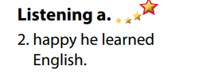  - Read, find and underline the key words.  - Listen and tick (✓).  - Exchange answers.  - Read answers.  Answer keys  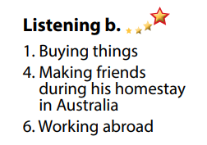
Activity 3: Reading
a) Objective: Students can develop their reading skill.
b) Content:
- Read the postcard. Which country is An visiting?
- Now, read and write True or False.
- Would you like to visit an English-speaking country? Which one? What problems do you think you would have?
c) Expected outcomes: Students can read a festival blog post for gist and detail, and they can give their opinion about this festival.
d) Organization of the activity:
TEACHER’S ACTIVITIES | STUDENTS’ ACTIVITIES
Task a. Read the postcard. Which country is An visiting.  - Have Ss read the content in Task a.  - Ask Ss to scan the postcard to choose the correct answer.  - Have Ss underline the supporting ideas.  - Call a student to give answer.  - Check answers as a whole class using DCR.  Task b. Now, read and write True or False.  - Have Ss guess the meaning of the words in violet.  - Call Ss to give meaning, briefly explain their meaning, part of speech and usage.  - Have Ss read the content in Task b and underline the key words.  - Have Ss read the postcard again and write True or False.  - Have Ss check their answers with a partner.  - Call Ss to give answers.  - Check answers as a whole class using DCR.  Task c. Speaking: In pairs: Would you like to visit an English-speaking country? Which one? What problems do you think you would have?  - Have Ss discuss the questions in pairs.  - Call some Ss to share their answers with the whole class.  - Give feedback and evaluation. | - Scan the postcard to choose the correct answer.  - Underline the supporting ideas.  - Give answers.  Answer keys    Suggested answers  1. aquarium: a glass container in which fish and other water creatures can be kept  2. nervous: worried and anxious  - Read and underline the key words.  - Read the postcard again for details.  - Exchange answers.  - Give answers.  Answer keys  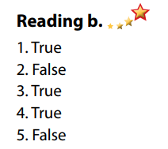  - Discuss in pairs.  - Present.
C. Consolidation and homework assignments
*Consolidation:
*Homework
- Do the exercises in WB: Listening and Reading (page 54).
- Do the vocabulary exercise in Tiếng Anh 7 i-Learn Smart World Notebook (page 58).
- Play consolation games in Tiếng Anh 7 i-Learn Smart World DHA App on www.eduhome.com.vn
- List some English speaking countries in Vietnam.
- Prepare: Unit 9 - Lesson 3 – Writing and Speaking (page 75 – SB).
********************************************************************
Teaching date: 18/4/2023
Period 92 UNIT 9: ENGLISH IN THE WORLD
Lesson 3.2 – Speaking and Writing (page 75)
I. OBJECTIVES
By the end of the lesson, Ss will be able to:
1.1. Language knowledge and skills
- know the format of a postcard.
- talk about a vacation in an English-speaking country (where to go, what to do, who to meet, what to eat).
- write a holiday postcard to a friend.
1.2. Competences
- improve communication, collaboration, writing and critical thinking skills.
1.3. Attributes
- love studying English, love travelling.
- have good preparation for any trip.
II. TEACHING AIDS AND LEARNING MATERIALS
1. Teacher’s aids: Student book and Teacher’s book, class CDs, Digital Book (DCR phần mềm tương tác SB, DHA (từ vựng/ cấu trúc) phần mềm trò chơi tương tác), projector/interactive whiteboard / TV (if any), PowerPoint slides, handouts.
2. Students’ aids: Student’s book, workbook, notebook.
III. ASSESSMENT EVIDENCE
Performance Tasks | Performance Products | Assessment Tools
- Speaking: Imagine you went to an English-speaking country on vacation. In pairs: Talk with your partner. Where did you go? Why? What did you do there? | - Ss’ answers / presentation. | - T’s feedback/Peers’ feedback.
- Make a list of ways you used English on your vacation. Use the table below and the examples to help you. Then, share with your friend. | - Ss’ answers / presentation. | - T’s feedback/Peers’ feedback.
- Writing: Read about writing postcards. Then, read An's postcard again and circle the examples she uses for each point in the Writing Skill box | - Ss’ answers. | - T’s feedback/Peers’ feedback.
- Underline and correct the mistakes. Then, rewrite the postcard in the correct order in your notebook. Use the skill box to help you, | - Ss’ answers. | - T’s feedback/Peers’ feedback.
- Now, write a postcard to your friend using two or three ideas from your notes in Speaking b. or your own ideas. Use the Feedback form to help you. Write 60 to 80 words. | - Ss’ answers. | - T’s observation and feedback.
IV. PROCEDURES
A. Warm up:
a) Objective: Introduce the new lesson and set the scene for Ss to acquire new language; get students' attention at the beginning of the class by enjoyable and short activities as well as to engage them in the follow-up steps.b) Content: Review: English-speaking countries / Introduce: Postcard.
c) Expected outcomes: Ss know about the topic that they are going to talk and write about in new the lesson.
d) Organization of the activity:
TEACHER’S ACTIVITIES | STUDENTS’ ACTIVITIES
Option 1: Game: CROSS WORD  - Have Ss review names of some English-speaking countries by doing the cross word puzzle.  - Call Ss to choose lines and give answers.  - Encourage Ss to guess the keyword as soon as possible.  - Lead to the new lesson: Writing a vacation postcard.  *Illustration:  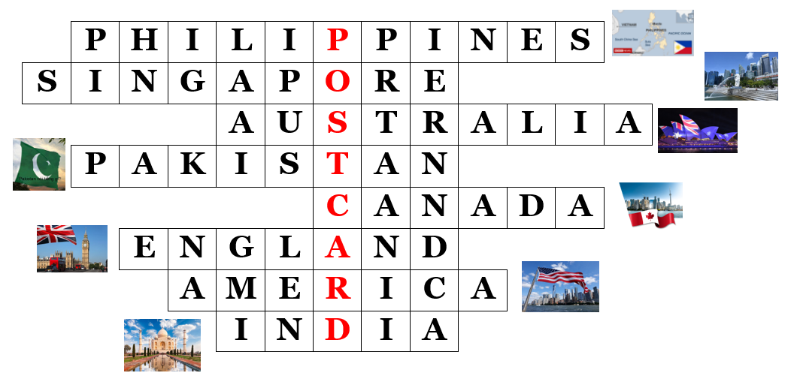  Option 2: Kim’s Game  - Have Ss close books.  - Show some stamps of some English-speaking countries.  - Have Ss look at the pictures and try to remember the country names as many as possible.  - Hide the pictures one by one, have Ss tell the countries of the stamps again.  - Lead to the new lesson.  *Illustration:  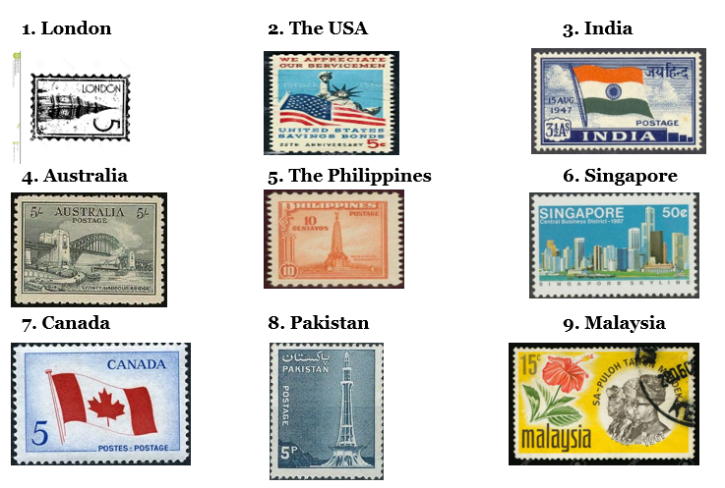 | - Take part in the game.  - Listen.  - Close books.  - Look at the pictures and try to remember the country names.  - Listen.
B. New lesson
Activity 1: Pre-Writing (Speaking)
a) Objective: Ss prepare for what they are going to write about.
b) Content:
- Speaking: Imagine you went to an English-speaking country on vacation. In pairs: Talk with your partner. Where did you go? Why? What did you do there?
- Make a list of ways you used English on your vacation. Use the table below and the examples to help you. Then, share with your friend.
c) Expected outcomes: Ss have more ideas and language for their writing.
d) Organization of the activity:
TEACHER’S ACTIVITIES | STUDENTS’ ACTIVITIES
Task a. Imagine you went to an English-speaking country on vacation. In pairs: Talk with your partner. Where did you go? Why? What did you do there?  - Divide the class into pairs.  - Have Ss think of an English-speaking country, then ask each other the questions.  - Go round and support Ss if necessary.  - Have some students share their ideas with the class.  - Give feedback and evaluation.  Task b. Make a list of ways you used English on your vacation. Use the table below and the examples to help you. Then, share with your friend.  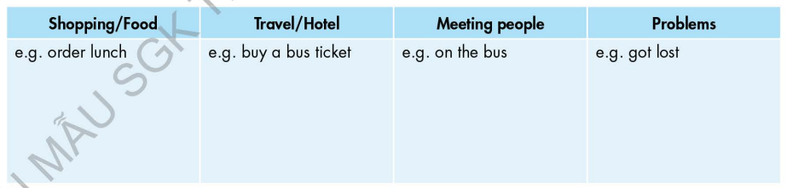  - Draw students' attention to the table and the example answers. Elicit one or two more answers from the whole class.  - Have the students come up with two or three examples for each column. Then, have students share their ideas with their partner.  - Have some students share some of their ideas with the class. | - Work in pairs.  - Present.  - Look and listen.  - Work in pairs.  - Present.
Activity 2: While - Writing
a) Objective: Students can develop their writing skill.
b) Content: - Read about writing postcards. Then, read An's postcard again and circle the examples she uses for each point in the Writing Skill box.
- Underline and correct the mistakes. Then, rewrite the postcard in the correct order in your notebook. Use the skill box to help you.
- Now, write a postcard to your friend using two or three ideas from your notes in Speaking b. or your own ideas. Use the Feedback form to help you. Write 60 to 80 words.
c) Expected outcomes: Students can write a holiday postcard, using right format, structures and rich vocabulary.
d) Organization of the activity:
TEACHER’S ACTIVITIES | STUDENTS’ ACTIVITIES
Task a. Read about writing postcards. Then, read An's postcard again and circle the examples she uses for each point in the Writing Skill box.  -Briefly explain the Writing skill box using DCR and have some Ss read it aloud.  - Have Ss read about writing postcards. Then, read An's postcard again (page 74) and circle the examples she uses for each point in the Writing Skill box.  - Have Ss check their answers with a partner.  - Call Ss to give answers.  - Check answer as a whole class using DCR.  Task b. Underline and correct the mistakes. Then, rewrite the postcard in the correct order in your notebook. Use the skill box to help you.  - Have students read the sentences.  - Have students underline and correct the mistakes. Then, rewrite the postcard in the correct order in Ss’ notebook.  - Remind Ss to use information in the skill box.  - Have students check their answers with a partner.  - Check answer as a whole class using DCR.  *Let’s Write: Write a postcard to your friend using two or three ideas from your notes in Speaking b. or your own ideas. Use the Feedback form to help you. Write 60 to 80 words.  - Draw Ss’ attention to the feedback form.  - Have Ss use their notes in speaking part and the instruction in the Writing box to write a holiday postcard.  - Go round, observe and give help if necessary.  - Have some Ss write their postcard on the board. | - Listen and read.  -Work in pairs.  - Exchange their answers with a partner.  - Give answers.  Answer keys  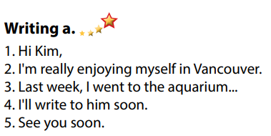  - Read the sentences, underline and correct the mistakes.  - Exchange answers.  - Read answers.  Answer keys 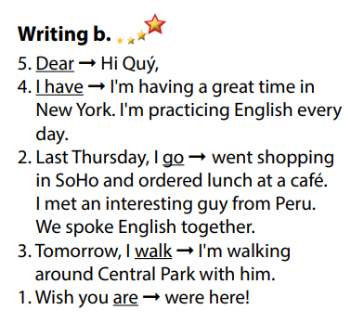  - Do the writing part.  - Write.
Activity 3: Post - Writing
a) Objective: Help Ss realize their mistakes in writing and correct them.
b) Content: Correcting Ss’ writings.
c) Expected outcomes: Students know whether their writings follow the model and use the correct structures and language, whether their writings are interesting and understandable or not.
d) Organization of the activity:
TEACHER’S ACTIVITIES | STUDENTS’ ACTIVITIES
- Give feedback, correct Ss’ mistakes.  - Use the feedback form to give evaluation. Focus on:  + the format, the structures  + the understandability  + the coherence and cohesion  + the punctuation and the spelling | - Look, listen and correct mistakes.  Suggested writing  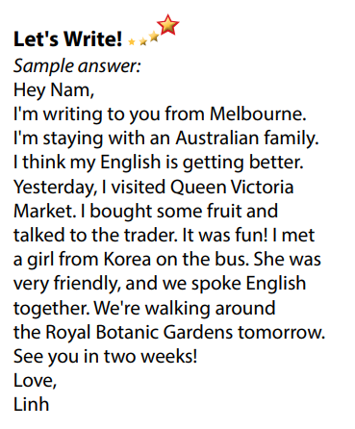
C. Consolidation and homework assignments
* Consolidation:
- Writing Skill:
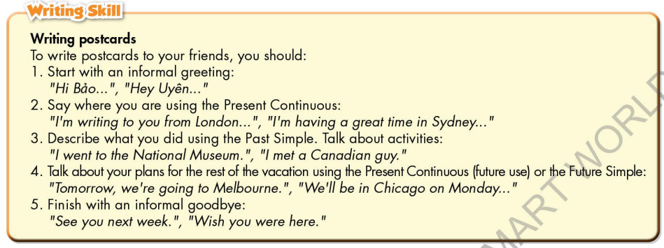

* Homework
- Remember how to write a holiday postcard.
- Finish the writing part.
- Do the exercises in WB: Writing, page 55.
- Complete grammar notes in Tiếng Anh 7 i-Learn Smart World Notebook (page 59).
- Play consolation games in Tiếng Anh 7 i-Learn Smart World DHA App on www.eduhome.com.vn
- Prepare: Unit 9 – Review, pages 108, 109.
*************************************************************
Teaching date: 19/4/2023
Period 93 UNIT 9: ENGLISH IN THE WORLD
Lesson 4 – Review (pages 108, 109)
I. OBJECTIVES
By the end of the lesson, Ss will be able to:
1.1. Language knowledge and skills
- review words about tourism and culture (photos, sightseeing, wallet, historic, tour guide, flight, souvenirs, stadium, …) and talk about them.
- review grammar: Past Simple with irregular verb, articles (“the” and “zero article”).
- talk about tourist attractions, cultures and holiday in English-speaking countries.
- pronoun some vowels and consonants correctly: /ɪ/, /e/, /æ/, /ə, /ð /, / θ /.
- put stress on nouns with two and three syllables.
1.2. Competences
- improve speaking, listening, reading and writing skills.
- improve the use of English.
1.3. Attributes
- have positive attitude in English language learning so that they actively participate in all classroom activities.
- review the old lesson and have good preparation for any assessment.
II. TEACHING AIDS AND LEARNING MATERIALS
1. Teacher’s aids: Student book and Teacher’s book, class CDs, Digital Book (DCR phần mềm tương tác SB, DHA (từ vựng/ cấu trúc) phần mềm trò chơi tương tác), projector/interactive whiteboard / TV (if any), PowerPoint slides, handouts.
2. Students’ aids: Student’s book, workbook, notebook.
III. ASSESSMENT EVIDENCE
Performance Tasks | Performance Products | Assessment Tools
- Listening: You will hear Anna talking to her friend, Jamie, about her trip to the UK. Where's she going to visit on each day? For each question, write a letter (A – H) next to each day. You will hear the conversation twice. | - Ss’ answers. | - T’s feedback/Peers’ feedback.
- Reading: Read about the three people. Choose the correct answer (A, B, or C). | - Ss’ answers. | - T’s feedback/Peers’ feedback.
- Vocabulary: Fill in the blanks with the words in the box. | - Ss’ answers. | - T’s feedback/Peers’ feedback.
- Grammar: Fill in the blanks using the or Ø (zero article).  - Write sentences in the Past Simple using the prompts. | - Ss’ answers. | - T’s feedback/Peers’ feedback.
-Pronunciation: Circle the word that has the underlined part pronounced differently from the others.  + Circle the word that differs from the other three in the position of primary stress in each of the following questions. | - Ss’ answers/ presentation. | - T’s observation, T’s feedback/Peers’ feedback.
IV. PROCEDURES
A. Warm up:
a) Objective: Introduce the new lesson and set the scene for Ss to acquire new language; get students' attention at the beginning of the class by enjoyable and short activities as well as to engage them in the follow-up steps.
b) Content: Review: Past Simple with Irregular verbs / Review: Tourist Attractions in the UK.
c) Expected outcomes: Ss are ready for the new lesson.
d) Organization of the activity:
TEACHER’S ACTIVITIES | STUDENTS’ ACTIVITIES
Option 1: Review: Past Simple with Irregular verbs.  - Have Ss review Past Simple with Irregular verbs by giving the past form of the verbs given.  1. make 2. take  3. come 4. see  5. go 6. buy  7. have 8. be  9. do 10. eat  11. meet 12. sell  13. lose 14. wear  - Give feedback.  - Lead to the new lesson.  Option 2: Review: Tourist Attractions in the UK.  - Introduce Ss to some Tourist Attractions in the UK which are in their listening section.  - Lead to the new lesson.  *Illustration:  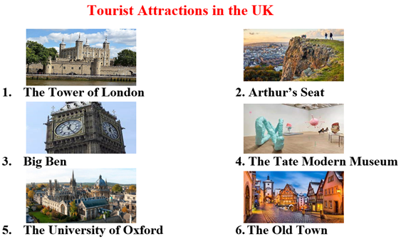 | - Give answers.  Answer keys  1. make – made 2. take - took  3. come – came 4. see - saw  5. go – went 6. buy - bought  7. have – had 8. be – was, were  9. do – did 10. eat - ate  11. meet - met 12. sell - sold  13. lose – lost 14. wear - wore  - Listen.  - Look.  - Listen.
B. New lesson
Activity 1: Listening
a) Objective: Help Ss improve their listening skill.
b) Content:
- You will hear Anna talking to her friend, Jamie, about her trip to the UK. Where's she going to visit on each day? For each question, write a letter (A – H) next to each day. You will hear the conversation twice.
c) Expected outcomes: Ss listen in details and get familiar with the listening test format.
d) Organization of the activity:
TEACHER’S ACTIVITIES | STUDENTS’ ACTIVITIES
You will hear Anna talking to her friend, Jamie, about her trip to the UK. Where's she going to visit on each day? For each question, write a letter (A – H) next to each day. You will hear the conversation twice.  - Have Ss read through the listening part.  - Demonstrate the activity on DCR by using the example.  - Play the audio (CD 2 – Track 43). Have Ss listen and choose the correct answer.  - Have Ss check answers with pairs, then read answers.  - Check answers as a whole class using DCR. | - Read in silence.  - Listen and read answers.  Answer keys  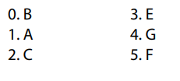
Activity 2: Reading
a) Objective: Students can improve their reading skill.
b) Content:
- Read about the three people. Choose the correct answer (A, B, or C).
c) Expected outcomes: Ss read for comprehension and get familiar with the reading test format.
d) Organization of the activity:
TEACHER’S ACTIVITIES | STUDENTS’ ACTIVITIES
Read about the three people. Choose the correct answer (A, B, or C).  - Demonstrate the activity on DCR by using the example.  - Have Ss look and read, then choose the correct answer (A, B, or C).  - Call Ss to give answers, explain.  - Give feedback and evaluation. | - Observe and listen.  - Listen and choose the correct answer (A, B, or C).  - Give answers, explain.  Answer keys  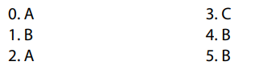
Activity 3: Vocabulary
a) Objective: Ss can review vocabulary about tourism and cultures.
b) Content: Fill in the blanks with the words in the box.
c) Expected outcomes: Ss produce the new language successfully, and they can use these words in speaking and writing.
d) Organization of the activity:
TEACHER’S ACTIVITIES | STUDENTS’ ACTIVITIES
Fill in the blanks with the words in the box.  - Have Ss read the sentences,  - Ask Ss to work in pairs to fill in the blanks with the words in the box.  - Have Ss give answers, tell the meaning of the words /phrase again.  - Check answers as a whole class using DCR. | - Read the sentences.  - Work in pairs to fill in the blanks.  - Give answers.  Answer keys  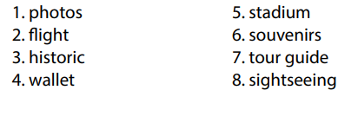
Activity 4: Grammar
a) Objective: Ss can review the use of English: Past Simple with irregular verb, articles (“the” and “zero article”).
b) Content:
- Fill in the blanks using the or Ø (zero article).
- Write sentences in the Past Simple using the prompts.
c) Expected outcomes: Ss produce the new language successfully, and they can use the grammar points in speaking and writing.
d) Organization of the activity:
TEACHER’S ACTIVITIES | STUDENTS’ ACTIVITIES
Task a. Fill in the blanks using the or Ø (zero article).  - Have Ss tell the way to use the or Ø (zero article) again.  - Ask Ss to work individually to fill in the blanks using the or Ø (zero article).  - Have Ss work in pairs to check each other’s work.  - Call Ss to give answers, explain for their choice.  - Check answers as a whole class using DCR.  Task b. Write sentences in the Past Simple using the prompts.  - Ask Ss to read the content of Task b.  - Have Ss write sentences in the Past Simple using the prompts.  - Have Ss work in pairs to check each other’s work.  - Call Ss to give answers.  - Check answers as a whole class using DCR. | - Answer.  - Work individually.  - Work in pairs.  - Give answers.  Answer keys  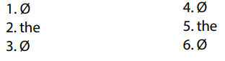  - Read.  - Work individually.  - Work in pairs.  - Give answers.  Answer keys  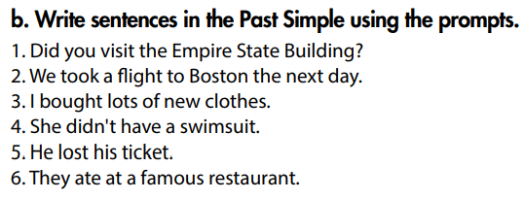
Activity 5: Pronunciation
a) Objective: Ss can review the stress of nouns with 2 and 3 syllables, vowels and consonants: /ɪ/, /e/, /æ/, /ə, /ð /, / θ /.
b) Content:
- Circle the word that has the underlined part pronounces differently from the others.
- Circle the word that differs from the other three in the position of primary stress in each of the following questions.
c) Expected outcomes: Ss produce the new language successfully.
d) Organization of the activity:
TEACHER’S ACTIVITIES | STUDENTS’ ACTIVITIES
Task a. Circle the word that has the underlined part pronounced differently from the others.  - Have Ss distinguish vowels and consonants: /ɪ/, /e/, /æ/, /ə, /ð /, / θ /.  - Ask Ss to work individually to circle the answer.  - Have Ss work in pairs to check each other’s work  - Call Ss to give answers, pronounce the words again.  - Give feedback, correct Ss’ pronunciation if necessary.  Task b. Circle the word that differs from the other three in the position of primary stress in each of the following questions.  - Remind Ss some basic rules of putting stress on nouns with 2 or 3 syllables.  - Ask Ss to work individually.  - Have Ss work in pairs to check each other’s work.  - Call Ss to give answers, pronounce the words again.  - Give feedback, correct Ss’ pronunciation if necessary. | - Review.  - Work individually.  - Work in pairs.  - Give answers.  Answer keys  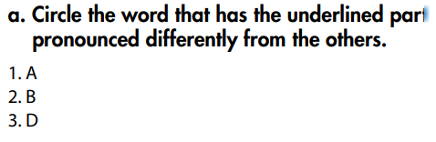  - Listen.  - Work individually.  - Work in pairs.  - Give answers.  Answer keys  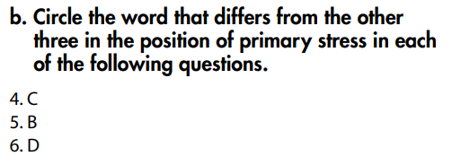
C. Consolidation and homework assignments
* Consolidation:
Grammar of Unit 9: Past Simple with irregular verb, articles (“the” and “zero article”).
Vocabulary of Unit 9: Words about tourism and culture (photos, sightseeing, wallet, historic, tour guide, flight, souvenirs, stadium, etc.).
* Homework:
- Review vocabulary, grammar of unit 9.
- Do the exercises in WB: Review of Unit 9 (page 70).
- Prepare: Unit 10 – New words and Listening (page 76 – SB).

