Date of planning: 9/10/2022  Date of teaching: 15/10/2022 | UNIT 2: FAMILY AND FRIENDS  Period 17: Lesson 1: Vocabulary
I. OBJECTIVES:
By the end of the lesson, students will be able to:
- have an overview of the topic “Family and Friends”.
- use vocabulary and grammar points to talk about clothes and appearance.
1. Knowledge:
*Vocabulary: an understanding of the meaning of keywords or word collocations below:
Type of clothes and footwear | Boots, dress, hoodie, jacket, jeans, pyjamas, shirt, shoes, shorts, T-shirt, tracksuit, trainers
Accessories | Baseball cap, glasses, handbag, necklace, scarf
Describing words | Size/Shape: baggy, tight  Material: leather, woolly, cotton  Colour/Pattern: plain, checked, striped, logo

* Grammar: expressions to talk about clothes and appearance, preference
I prefer ___.
I often wear pyjamas when I go to bed.
2. Competence:
To know the meaning of the keywords used to talk about clothes, and understand the main grammatical points, then do the tasks assigned in the textbook. To use the vocabulary about clothes to practice talking about preference and do a class survey about what the other classmates often wear.
3.Quality/Behavior: To teach Ss to be hard-working and attentive in class. Ss have a positive attitude to working in groups, individual work, pair work, cooperative learning and working.
II. TEACHING AIDS:
- Teacher: Grade 7 textbook, Unit 2 (SB p.20-21, WB p.15-16), laptop/computer connected to the Internet, loudspeaker, projector/TV, PPT slides…
- Students: Text books, studying equipment…
- Method: Active teach, T-WC; group works; individual ……
III. PROCEDURE:
1. WARM UP( 3’)
* Aims:
- To activate Ss’ prior knowledge and get students involved in the lesson.
- To set the context for introducing new words.
* Content: Play Super Eyes game to get students involved in the lesson and to set the context for the lesson.
* Outcome: Students name some types of clothes they’ve already known.
* Organisation: Teacher’s instructions…

Teacher’s & Student’s activities | Content
Extra activity 1: Super Eyes game  - T explains the game rules then checks instructions.  - T uses the PPT slides to lead the game.  - T tells students that they are learning more words of clothes in today lesson.  - T sets the context for the lesson: Write the title on the board Unit 2: Family and Friends / Lesson 2.1: Vocabulary  - T asks Ss to name some more types of clothes they’ve already known. | Game rules:  - Look at the pictures.  - Remember as many clothing items as you can  - Recall the words you remember  - 1 correct words = 1 point.
2. PRESENTATION 1 (11’) VOCABULARY
ACTIVITY 1:
* Aims:
- To reinforce the words of clothes that students have already known.
- To teach more new words
- To lead into the next activity.
- To reinforce the meaning and spelling of the words
* Content: Some brief notes; Some things about types of clothes.
* Outcome: Know new words about clothes.
* Organisation: Teacher’s instructions….

Teacher’s & Student’s activities |  | Content
1. (8’) What clothes can you see in the picture?  Exercise 1 (SBp20)  - T asks Ss to open their SB page 20, look at exercise 1.  - T calls a student to read the instruction then checks Ss’ understanding of it.  - T elicits the meaning of words in the Vocabulary Box and quickly checks Ss’ understanding of vocabulary by asking them to look at the picture in SB and say all the clothing items they see.  - T plays the audio track 2.01 for students to listen and repeat.  - T asks students to work in pairs to find two things from the vocabulary list that are NOT in the picture. |  | Prompts:  What clothes can you see in the picture?  I see ….  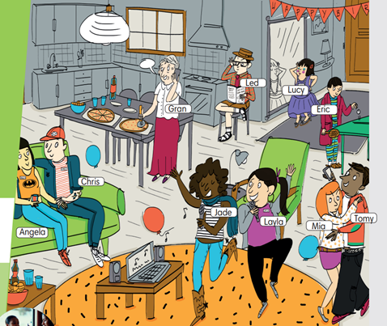  
Extra activity 2 (3’): Look and Say  - T asks Ss to look at the slide, slowly displays the vocabulary  - T tells Ss to say the words one by one  - Ss join the activity as the whole class.  - T tells Ss to remember the words using 3 groups: Clothes, Footwear, Accessories. |  | 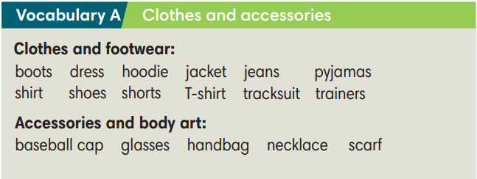
3. PRACTICE 1 (9’)
ACTIVITY 2:
* Aims:
- To provide students with chances to practice pronouncing new words.
* Content: Some brief notes; Some things about types of clothes.
* Outcome: Know new words about clothes and classify them into types.
* Organisation: Teacher’s instructions…

Teacher’s & Student’s activities | Content
Extra activity 3 (5’): Find Someone Who  - T models the activity with the whole class by saying: “Look at the picture in your SB, find someone wearing boots.”  - T divides class into pairs/small groups.  - T gives and checks instructions for the game.  - Ss play the game in pairs/small groups  - T corrects Ss’ pronunciation if any. | Game rules:  - Look at the pictures.  - Student A says: “Find someone wearing…..”  - Student B finds and says the name.  - 1 correct answer = 2 points.
2. (4’) Write the items under each picture (2-6)  (Exercise 2 – SB p.20)  - T asks Ss to look at exercise 2 (SB page 20).  - T calls a student to read the instruction then checks Ss’ understanding of it.  - T sets a time limit and asks Ss to work in groups of five to complete the exercise.  - T calls groups to give answers then checks as the whole class.  - T drills the vocabulary and corrects Ss’ pronunciation if any. | Answer keys:  (1) tracksuit (2) hoodie (3) necklace  (4) trainers (5) pyjamas (6) boots
4. PRACTICE 2 (11’)
ACTIVITY 3 + 4:
* Aims:
- To help Ss use the new vocabulary in collocations.
- To practice the vocabulary and models related to the topic in communication
* Content: Some brief notes about the exercise; some keywords about clothes, type of clothes, preferences; some note about pronunciation.
* Outcome: Have a vocabulary about clothes; know how to talk about clothes and preferences.
* Organisation: Teacher’s instructions…

Teacher’s & Student’s activities | Content
3. (4’) Complete the sentences with the words below.  (Ex 3, p.11)  Activity 6: Exercise 3 – SB p.21  Look at the photos. Choose the correct word.  - T asks Ss to look at exercise 3 (SB page 21).  - T calls a student to read the instruction then checks Ss’ understanding of it.  - T asks Ss to read the given words aloud, checks their understanding of the words.  - T sets a time limit and asks Ss to work in groups of four to complete the exercise.  - T calls groups to give answers then checks as the whole class.  - T corrects Ss’ pronunciation if any. | Answer keys:  a. plain T-shirt  b. striped shirt  c. baggy jeans  d. woolly hat
4. (7’): In pairs, do the Fashion Quiz. Then look at page 101 and check how similar or different you are.  (Exercise 4 – SB p. 21)  - T asks students to look at their SB p.21 – Exercises 4  Step 1:  - T writes the heading words on board:  Size/Shape – Material – Colour/Pattern  - T asks Ss to find the words in the text that match the heading words.  - Ss work individually, find the words.  - Ss raise their hand to give answers.  - T confirms the answers, corrects Ss’ pronunciation if any.  Step 2:  - T presents the Quiz prompts:  - T asks students to do the quiz individually first, then compare  their answers in pairs.  - Ss work individually, find the words.  - Ss raise their hand to share the answers in pairs.  - T checks grammar, corrects Ss’ pronunciation if any. | 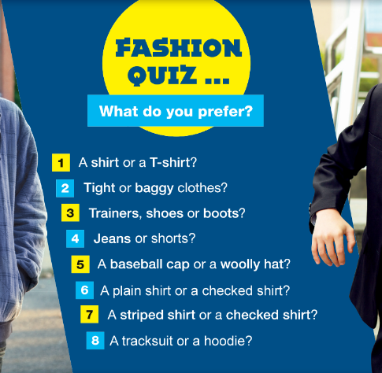  Correct headings:  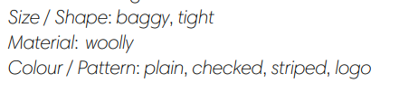
  Student A: What do you prefer? A shirt or a T-shirt?
  Student B: I prefer a T-shirt. What about you?
4. PRODUCTION (7’)
ACTIVITY 5:
* Aims: To help Ss practice applying the vocabulary items and grammar points related to the topic in speaking.
* Content: Ss work in groups to talk about their clothes and appearance.
* Outcome: Ss talk about their clothes and appearance using vocabulary and grammar points.
* Organisation: Teacher’s instructions…..
Teacher’s & Student’s activities | Content
5. Work in group of three. Interview two friends and complete the table.  (Exercise 5 – SB p.21)  - T asks Ss to look at exercise 5 (SB page 21).  - T calls a student to read the instruction then checks Ss’ understanding of it.  - T asks students to work in groups of three to interview each other and complete the table.  - T invites some students to report their results to the class using the present simple statements (i,e., Lan usually goes to bed at 9.30 pm.)  - T asks the rest to give comments on their classmates’ performance. T gives feedback on Ss’ work. | 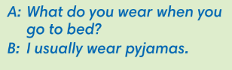  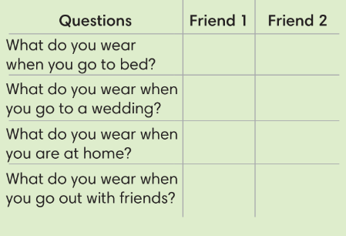

WRAP-UP & HOME WORK (3’)

- T asks Ss to talk about what they have learnt in the lesson.
- Vocabulary of types of clothes and accessories.
- Grammar points: Expressions to talk about preference and daily outfit.
* HOME WORK
- Do exercises in the workbook page 15-16.
- Prepare for Lesson 2: Grammar 1.

**************************************************************************

