Date of planning:16/10/2022  Date of teaching: 17/10/2022 | UNIT 2: FAMILY AND FRIENDS  Period 18: Lesson 2.2: Grammar

I. OBJECTIVES:
By the end of the lesson, students will be able to:
- Use Present Continuous to talk about present activities.
1. Knowledge:
* Grammar:
- write affirmative, negative and question forms of the Present Continuous tense correctly.
- use the Present Continuous tense to talk about present activities and describe friends in class.
2. Competence: Students know to use vocabulary about activities, and understand the main grammatical points, then do the tasks assigned in the textbook; use the Present Continuous tense to talk about present activities and describe friends in class.
3. Quality/ behavior: To teach Ss to be hard-working and attentive in class. Ss have a positive attitude to working in groups, individual work, pair work, cooperative learning and working.
II. TEACHING AIDS:
- Teacher: Grade 7 textbook, Unit2 (SB p. 22), laptop/computer connected to the Internet, loudspeaker, projector/TV, PPT slides…
- Students: Text books, studying equipment…
- Method: Active teach, T-WC; group works; individual ……
III. PROCEDURE:

1. WARM UP (4’)
* Aims:
- To activate students’ prior knowledge and get students involved in the lesson.
- To set the context for introducing new structures.
* Content: Play Guessing game to get students involved in the lesson and to set the context for the lesson.
* Outcome: Students know the context of the lesson.
* Organisation : T_ Ss , …
Teacher’s Student’s activities | Content
Extra activity 1: Guessing Game  - T divides Ss into 2 teams. Team boys and team girls.  - T explains the game rules then checks instructions.  - T corrects Ss if necessary.  - T set the scene for the new lesson: T tells Ss that they can describe what Dr Strange is doing by looking at the pictures.  They will learn more structures to describe people and present activities.  - T writes the title on the board Unit 2: Family and Friends / Lesson 2.2: Grammar | Game rules:  - Look at the pictures.  - Choose A – B - C  - 1 correct answer = 1 point.
2. LEAD-IN (3’)
* Aims: To lead into the new lesson.
* Content: Describe people and their activities in the picture on the slide.
* Outcome: Make guesses about the picture then give answers.
* Organisation : T_ Ss , …
Teacher’s Student’s activities | Content
Extra Activity 2: See – think – wonder.  - T shows a picture on the slide then asks students three questions.  (1) What do you see in the picture?  (2) Who are they?  (3) What are they doing?  - T sets a time limit for Ss’ quick discussion.  - Ss work in pairs to make guesses about the picture then give answers.  - T calls some Ss to give answers then note them down on the board.  - T tells Ss that they’re going to read a dialogue in exercise 1 (SB p.22) to check all the answers. | 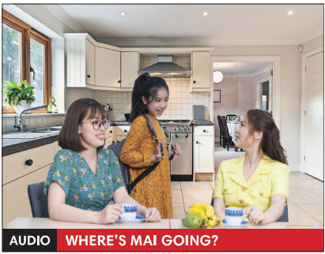
3. PRESENTATION (11’)
(Questions and answers in the Present Continuous tense)
ACTIVITY 1 + 2:
Aims:
- To present the grammar point in context.
- To lead into the next activity.
- To help Ss recognize all the forms of Present Continuous Tense.
- To provide Ss with chances to work cooperatively.
- To explain the grammar point for Ss.
* Content: Read Rose’s blog and find out new words. Learn the Present Simple.
* Outcome: Know more new words. Understanding the reading document; the topic of the lesson, grammar points…
* Organisation : T_ Ss , ..
Teacher’s Student’s activities |  |  | Content
1. (4’) Look at the photo. What is Mai doing? Then read and listen to check.  (Exercise 1 – SB p.22)  - T asks Ss to open their SB page 12, look at exercise 1.  - T calls a student to read the instruction then checks Ss’ understanding of it.  - T asks Ss to read the dialogue to find the answer for the question.  - Ss work individually.  - T calls some Ss to give answers then shows the answers on the slide.  - T asks Ss to look at the sentences and elicits the tense of those for Ss (all forms in the Present Simple Continuous). |  |  | Answer keys:  Mai is getting ready for school.  Some other sentences in the dialogue:  I’m brushing my hair.  I’m going to school.
2. (7’) Find more examples of Present Continuous in the dialogue in Exercise 1.  (Exercise 2 – SB p.22)  - T asks Ss to look at exercise 2.  - T calls a student to read the instruction then checks Ss’ understanding of it.  - T asks Ss to work in groups of three to complete the activity.  - T calls groups to give answers then shows the answers on the slide to check as the whole class.  THE GRAMMAR NOTES  - T shows the Grammar Notes for all forms of the Present Continuous tense then elicits information from Ss.  - T explains the grammar points and tells Ss that they’re going to use the Present Continuous tense to talk about things that happening now.  - T shows the grammar notes again, then Ss can read aloud. |  |  | 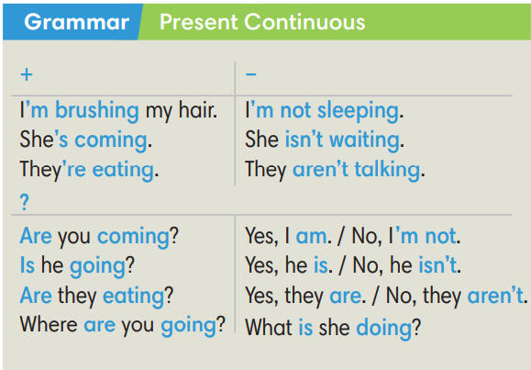
3. PRACTICE (15’)
ACTIVITY 3 + 4:
Aim:
- To help students practice completing the correct forms of the verbs with corresponding singular/plural subjects.
- To help students identify the correct form of the verbs in present continuous tense.
* Content: Complete the text/sentences with the correct form of the verbs.
Understand the text; grammar points; present continuous tense.
* Outcome: Know how to form a sentence with the correct form of the verbs. Understand the conversation; the topic of the lesson, vocabulary, grammar points…
* Organisation : T_ Ss .…..
Teacher’s Student’s activities | Content
Extra activity 3 (6’): Space Mission Game.  - T explains the game rules then checks instructions.  - Ss join in the game individually or in teams.  - T corrects Ss if any. | Game rules:  - Read the sentence  - Put the correct verbs in the brackets.  - Raise your hand to give answers.  - Get points.
3. (4’) Make affirmative and negative sentences in Present Continuous.  (Exercise 3 – SB p.22)  - T asks Ss to look at exercise 3.  - T calls a student to read the instruction then checks Ss’ understanding of it.  - T asks Ss to work in individually.  - T calls students to give answers then shows them on the slide to check as the whole class.  - T corrects Ss if any. | Answer key:  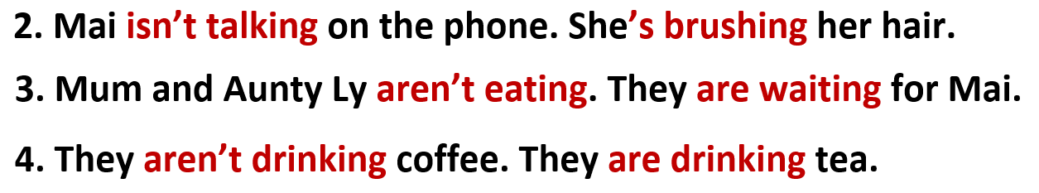
4. (5’) Make questions in Present Continuous. In pairs, look at the photo and answer the questions.  (Exercise 4 – SB p.22)  - T asks Ss to look at exercise 4.  - T calls a student to read the instruction then checks Ss’ understanding of it.  - T asks Ss to work in in pairs.  - T calls some pairs to give answers then shows them on the slide to check as the whole class.  - T corrects Ss if any.  *Extra Activity: Teacher can get some exercises from Workbook page 17 for Ss to practice in class. | Answer key:  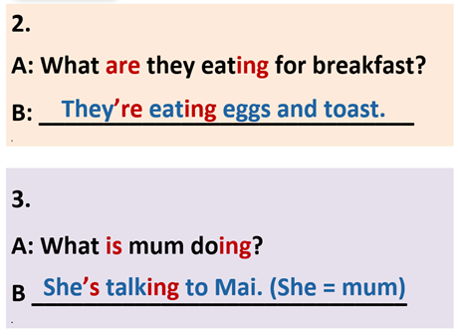
4. PRODUCTION ( 7’)
ACTIVITY 5:
*Aim: To help students applying the vocabulary items and grammar points related to the topic in communicating.
* Content: Ss describe themselves and their partners (what they are doing or wearing).
* Outcome: Ss know how to express themselves and describe others.
* Organisation: T_Ss…

Teacher’s Student’s activities |  | Content
5. Ask and answer about what your friends are doing or wearing.  (Exercise 5 – SB p.22)  - T asks Ss to look at exercise 5 (SB page 22).  - T calls a student to read the instruction then checks Ss’ understanding of it.  - T models the activity in front of the class.  - T divides Ss into new pairs, asks them to make conversations to ask and answer about their classmates.  - T walk around to listen and notes down common mistakes for delayed feedback.  - T calls some groups to come to the front of the class, make conversations.  - T asks the rest to give comments on their classmates’ performance.  - T gives feedback on Ss’ work. |  | 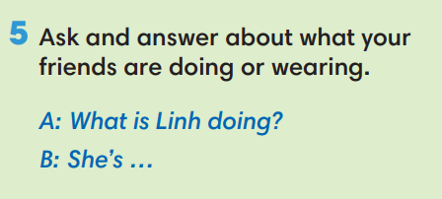
WRAP-UP & HOME WORK (2’)

- T asks Ss to talk about what they have learnt in the lesson.
- The present continuous tense: all forms
* HOME WORK
- Do exercises in the workbook page 17.
- Prepare for Lesson 1.3: Reading.

